Result and analysis:

Results are clearly plotted in graphs.

Linear vs exponential backoff :
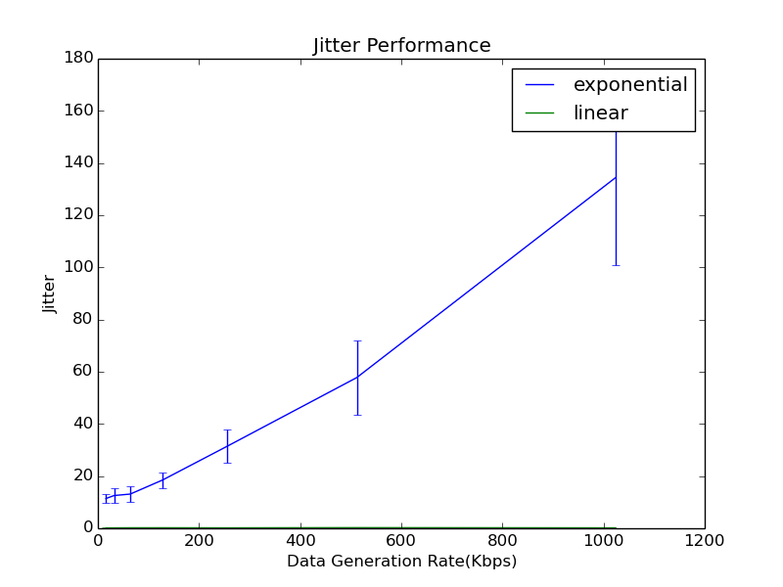

- We observe that all throughput, forward delay as well as jitter reduce by a huge amount by changing the backoff from exponential to linear. Although the variation with application data generation rate still remains the same.

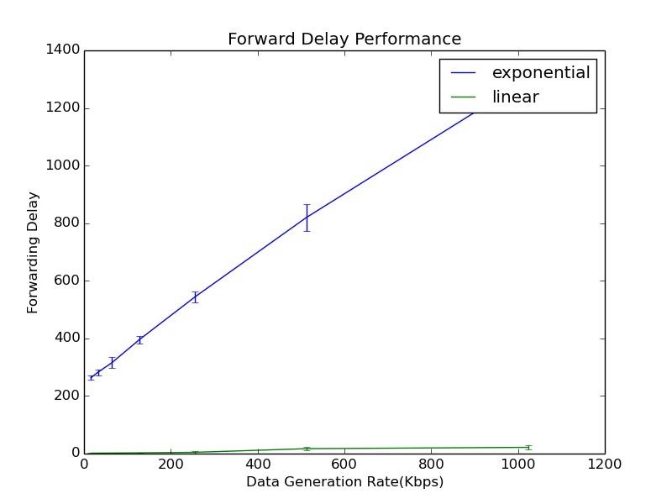

- In case of linear backoff also the throughput increases exponentially to reach a saturation

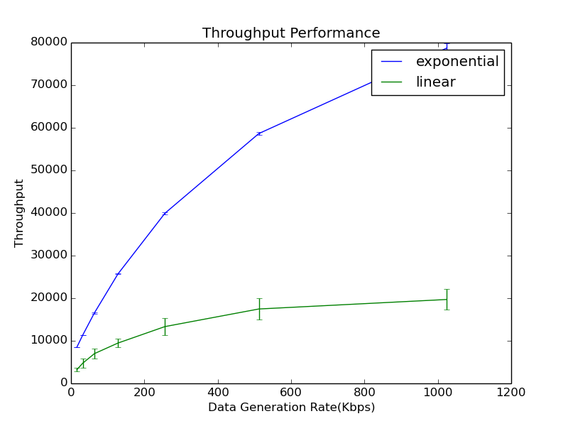
- Forwarding delay is negligible in case of linear back off. This is because backoff time increases linearly with the number of tries. Hence, it is much less than that exponential backoff.

Persistence

Values of p = [0.1,0.5,0.9,1.0]

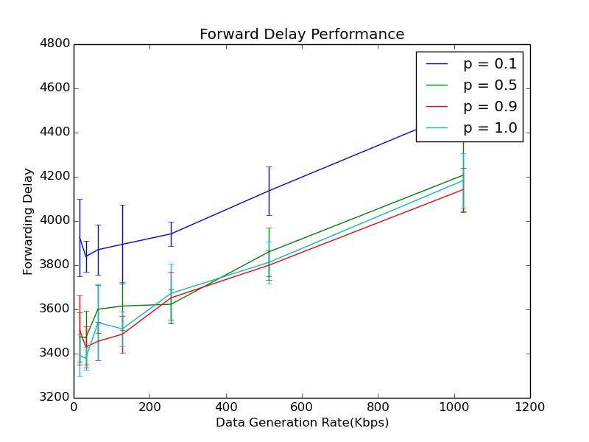
a) Exponential Backoff

1) Forwarding Delay :

forwarding delay is more for p = 0.1, and decreases as p increases, the reason being that the packet has to wait in queue more often even if the channel is free.

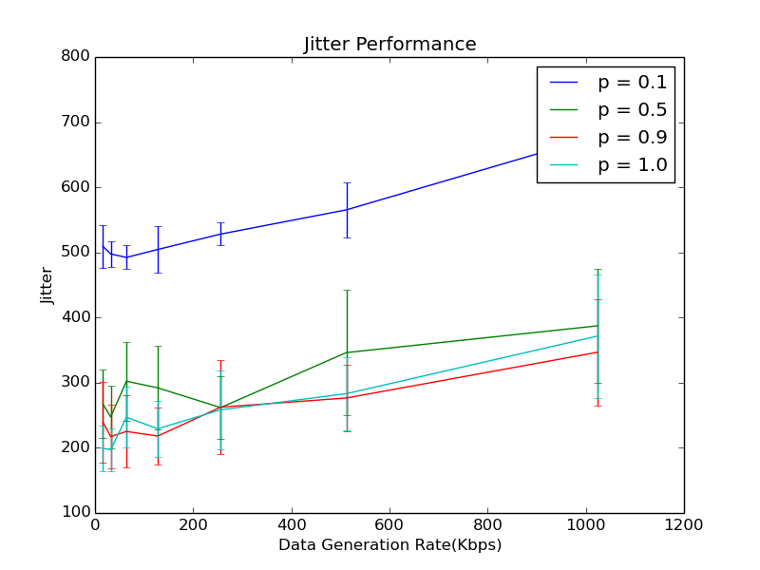
2) Jitter :

Jiter trend is same as forwarding delay with value being more for lesser value of persistence.

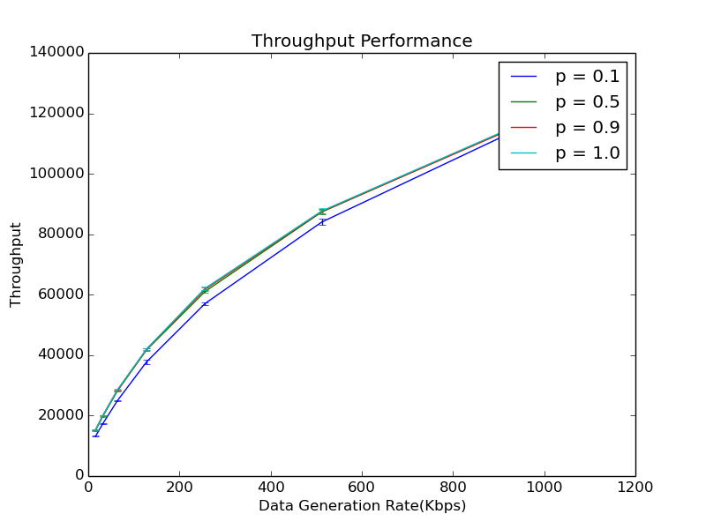
3) Throughput :

Throughput remains almost the same for different p.

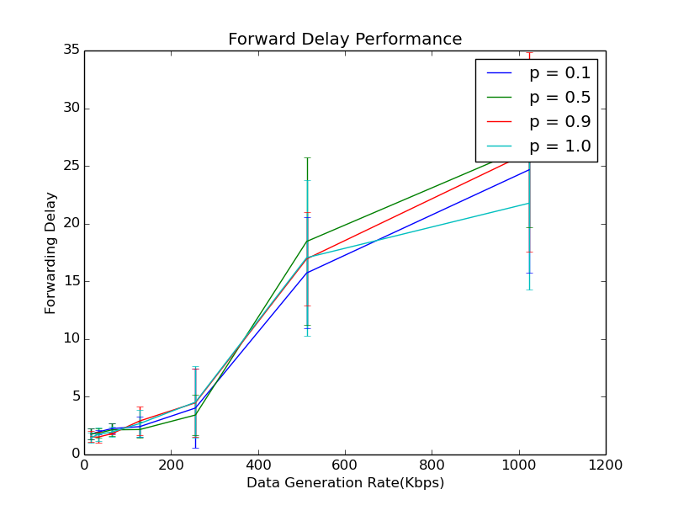
b) Linear Backoff

1) Forwarding Delay :

With increase in data generation rate, the delay increases for all value of persistence but increases more for lesser value of persistence.

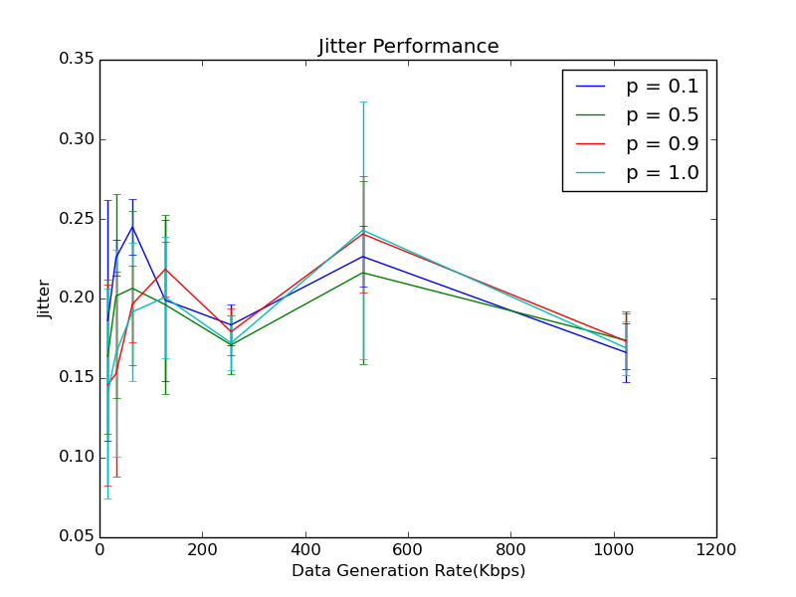
2) Jitter :

There is not much trend in jitter. It increases with increase in data generation rate.

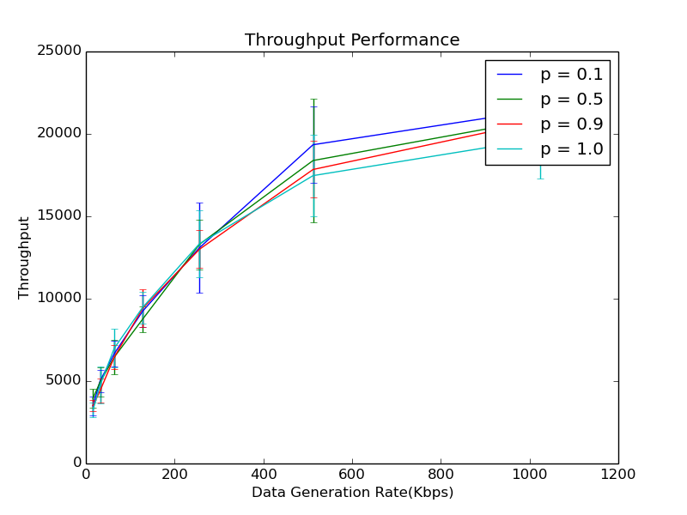
3) Throughput :
The throughput value is more for lesser value of persistance. This is because collisions are more if the persistance value is more.

