Batch OLS internet-related exposures — Top associations

Top 10 associations (by BH-adjusted p)

Perceived Social Stress Score vs Internet Usage Total Score (Weighted)
n=71; adj_beta=1.702; 95%CI=(0.481, 2.923); adj_p=0.00628; BH_adj_p=0.121
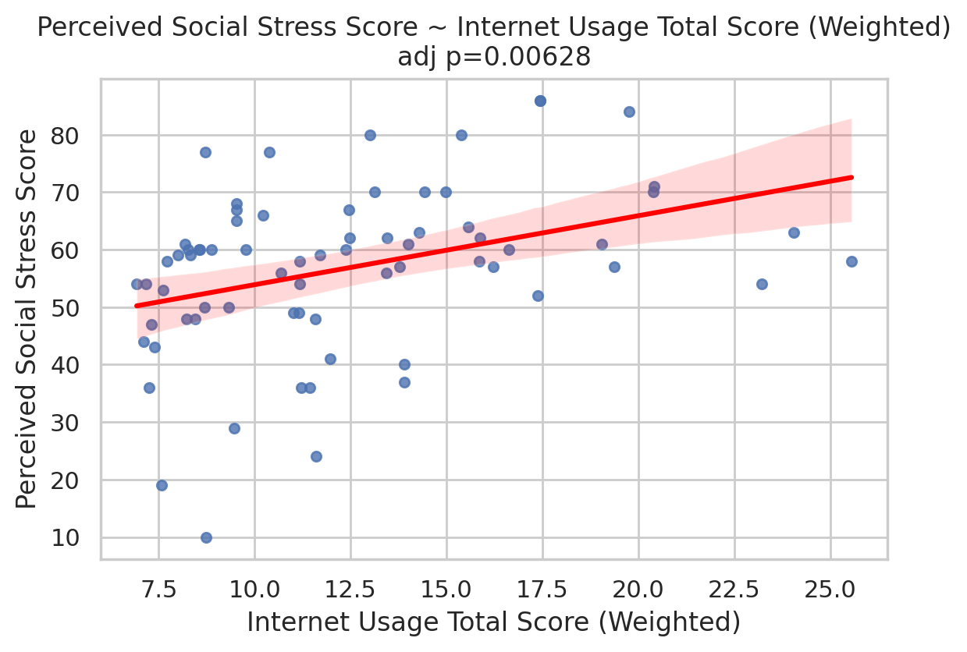

Instrumental Support - T Score vs Obsession with Internet - Raw Score
n=71; adj_beta=-1.136; 95%CI=(-1.956, -0.316); adj_p=0.0066; BH_adj_p=0.121
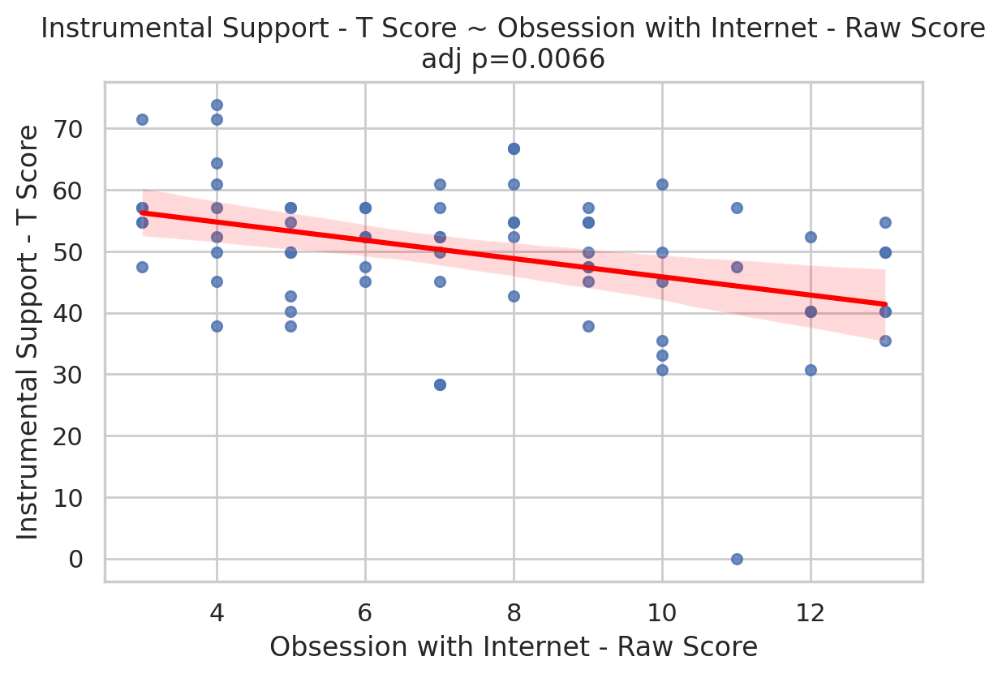

Instrumental Support - T Score vs Obsession with Internet - Weighted Score
n=71; adj_beta=-18.941; 95%CI=(-32.608, -5.275); adj_p=0.0066; BH_adj_p=0.121
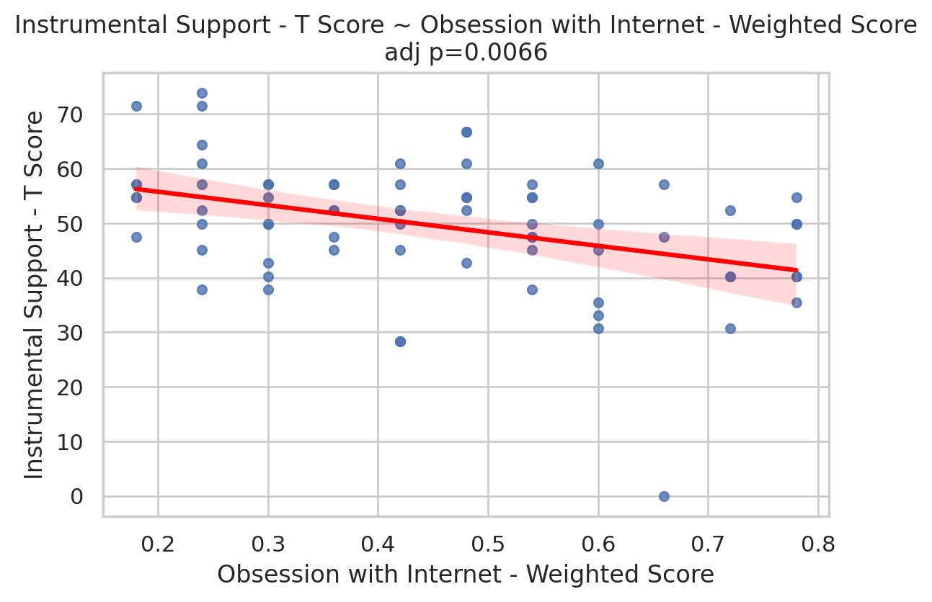

Emotional Support - T Score vs Internet Usage Total Score (Weighted)
n=71; adj_beta=-0.832; 95%CI=(-1.555, -0.110); adj_p=0.0239; BH_adj_p=0.328
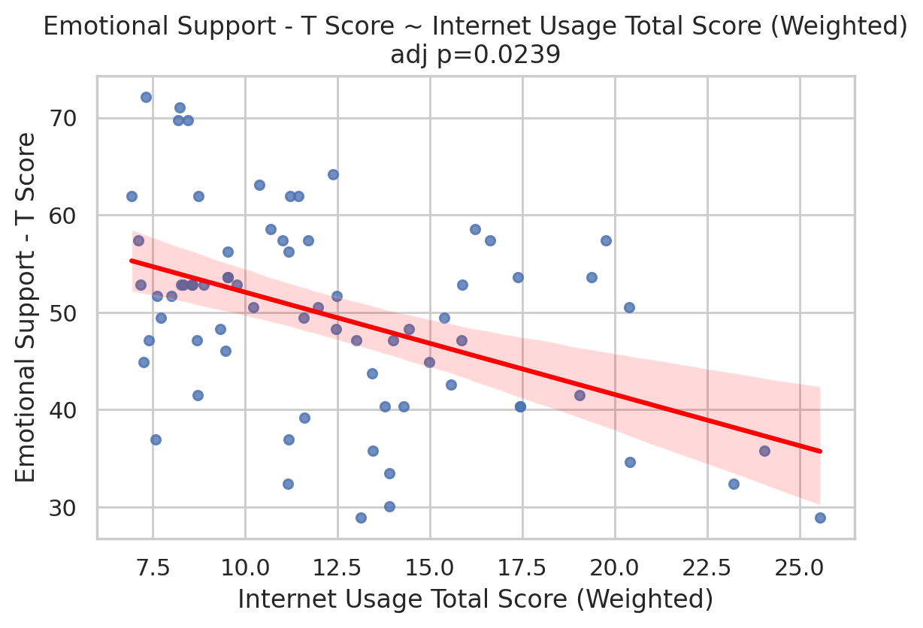

Instrumental Support - T Score vs Internet Usage Total Score (Weighted)
n=71; adj_beta=-0.802; 95%CI=(-1.601, -0.003); adj_p=0.0491; BH_adj_p=0.41
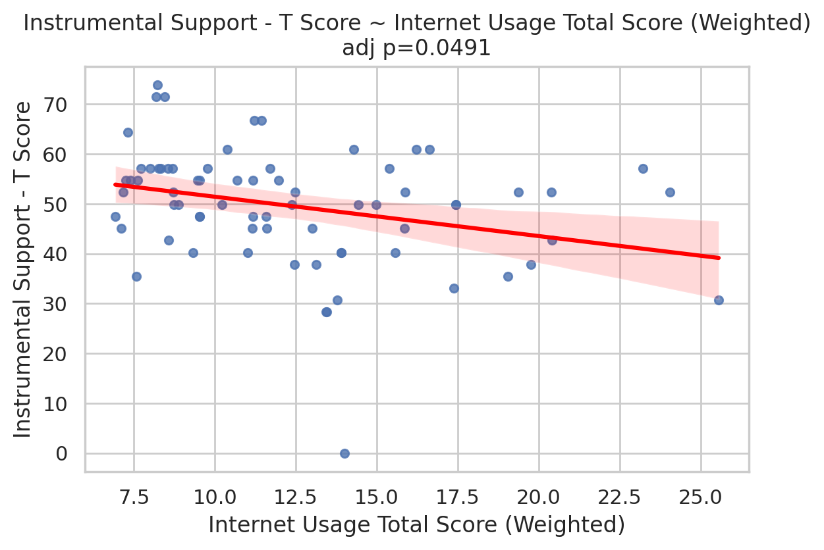

Perceived Social Support Total T Score vs Obsession with Internet - Weighted Score
n=71; adj_beta=-15.833; 95%CI=(-32.305, 0.639); adj_p=0.0596; BH_adj_p=0.41
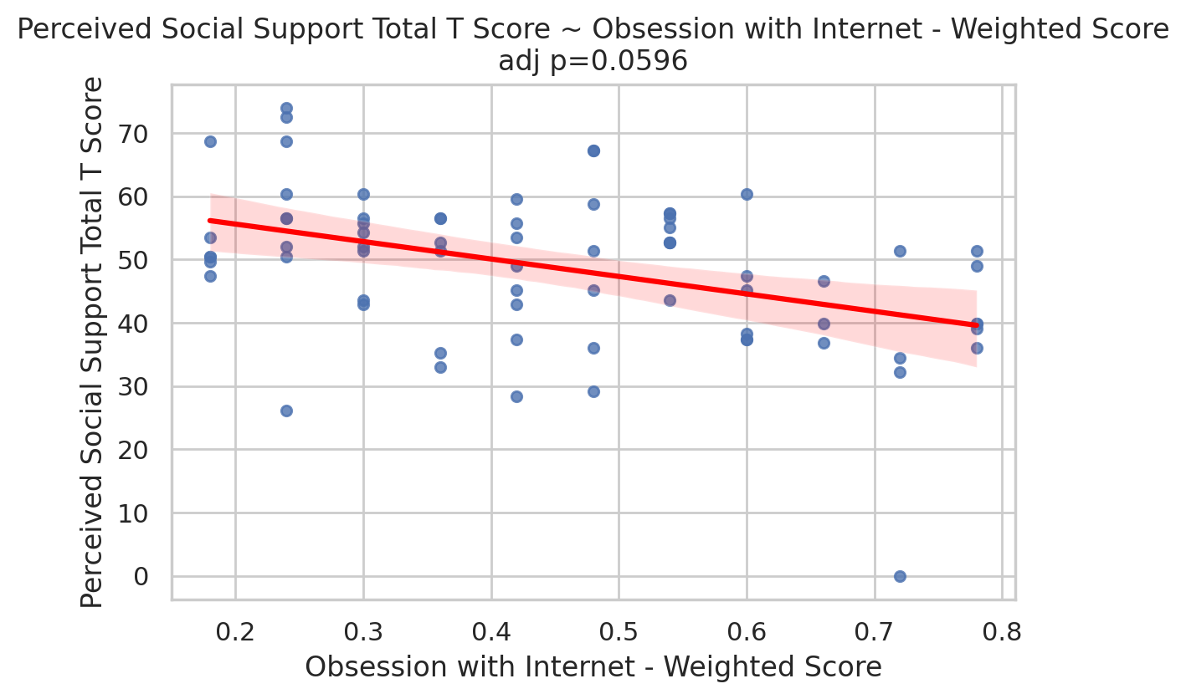

Perceived Social Support Total T Score vs Obsession with Internet - Raw Score
n=71; adj_beta=-0.950; 95%CI=(-1.938, 0.038); adj_p=0.0596; BH_adj_p=0.41
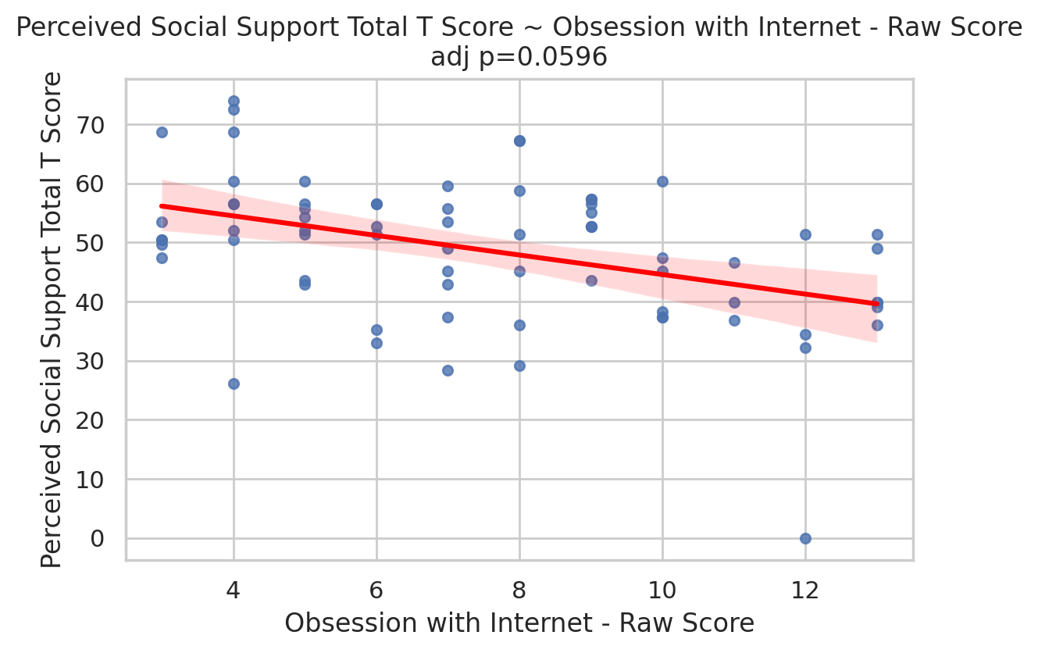

Perceived Social Support Total T Score vs Internet Usage Total Score (Weighted)
n=71; adj_beta=-1.281; 95%CI=(-2.559, -0.002); adj_p=0.0496; BH_adj_p=0.41
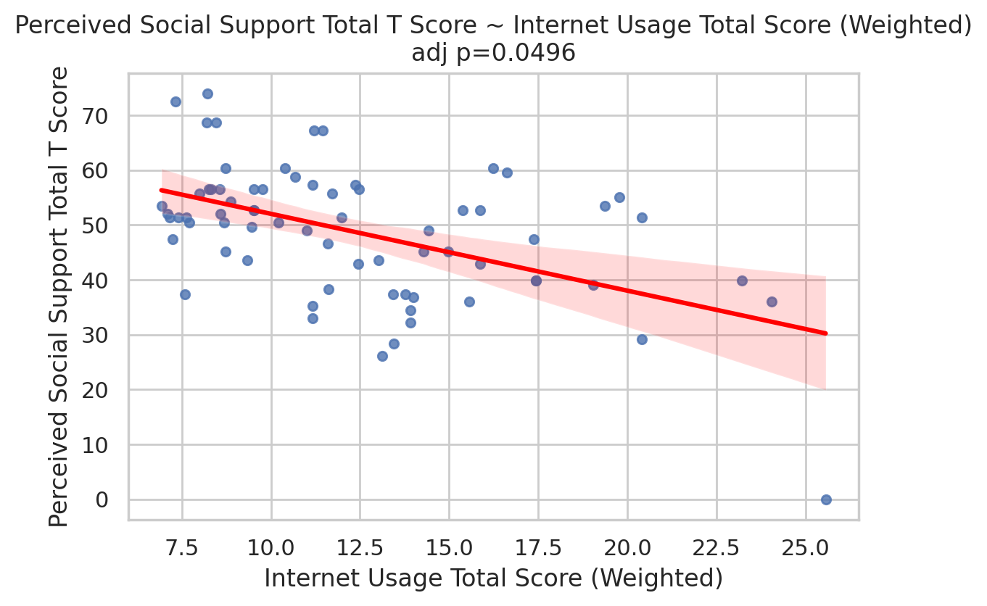

Perceived Social Stress Score vs Perceived Control of Internet Use - Weighted Score
n=71; adj_beta=17.661; 95%CI=(-4.002, 39.324); adj_p=0.11; BH_adj_p=0.605
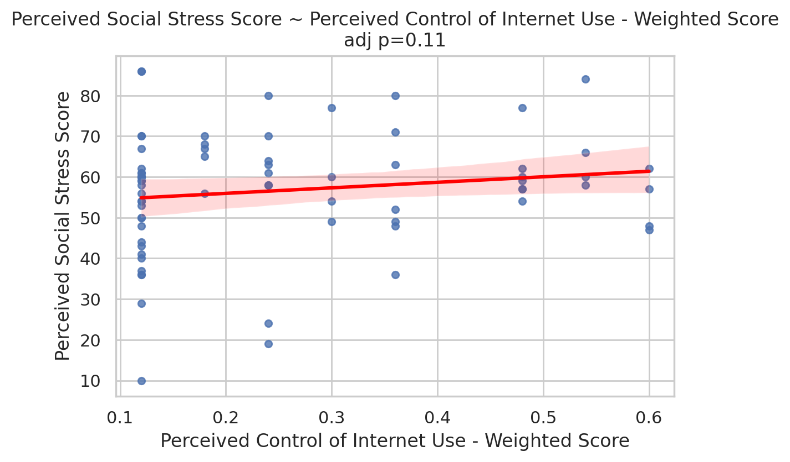

Perceived Social Stress Score vs Perceived Control of Internet Use - Raw Score
n=71; adj_beta=1.060; 95%CI=(-0.240, 2.359); adj_p=0.11; BH_adj_p=0.605
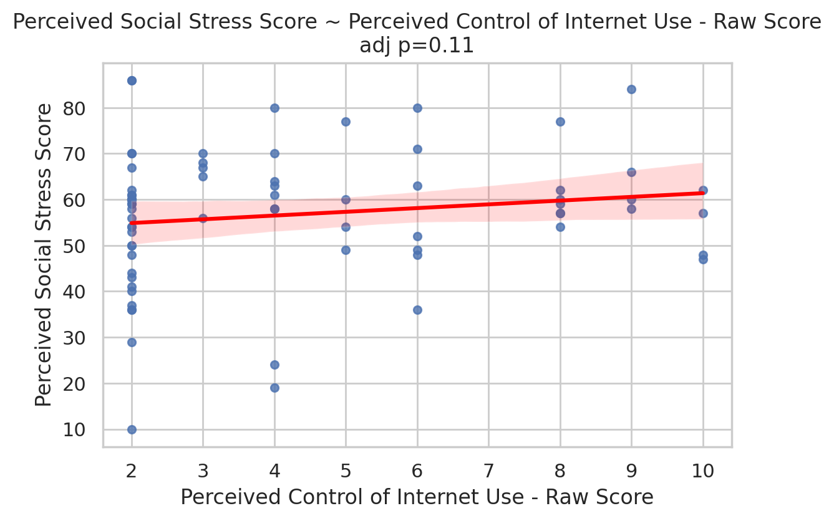

Example adjusted regression model summaries

Adjusted model: Perceived Social Stress Score ~ Internet Usage Total Score (Weighted) + covariates
exposure | n | adj_beta | se | 95% CI | p | adj_r2
Internet Usage Total Score (Weighted) | 71 | 1.7019 | 0.6228 | (0.481, 2.923) | 0.00628 | 0.130
Change-in-estimate (pct): 41.8%

Adjusted model: Instrumental Support - T Score ~ Obsession with Internet - Raw Score + covariates
exposure | n | adj_beta | se | 95% CI | p | adj_r2
Obsession with Internet - Raw Score | 71 | -1.1365 | 0.4184 | (-1.956, -0.316) | 0.0066 | 0.161
Change-in-estimate (pct): -23.6%

Confounding & causal assessment
This automated assessment reports change-in-estimate for the exposure coefficient when adding the default covariates (Age, Income, Education, Marital Status).
Rules used:
- Change-in-estimate >= 10% flagged as evidence of confounding by the adjustment set.
- Results are cross-sectional: causal claims require temporality and stronger designs.
Typical limitations: residual/unmeasured confounding, measurement error, and model misspecification. Interpret effect sizes with confidence intervals and consider triangulation or longitudinal data for causal inference.

