Social Networking and Its Impact on Perceived Stress, Self-Concept & Social Support of Married Females versus Un-Married Females

Objective
To investigate the multifaceted impact of social networking on the perceived stress levels, self-concept, and social support networks of Indian females in the context of their marital status. By addressing these questions, this research seeks to provide valuable insights into the complex interplay between social networking, psychological well-being, and social relationships among Indian women, shedding light on the unique experiences and challenges faced by both married and unmarried individuals in the digital age.

Variables and Study Design
Based on the questionnaire, the following variables were used:
Covariates:
- Age (IN YEARS)
- Marital Status
- Highest level of education completed
- Current Employment Status
- Number of children
- Type of family structure
- Monthly household income
- Access to healthcare services
- Overall health status
- Are you covered by health insurance?
- Participation in community or social activities
Independent variables:
- Functional Impairment
- Withdrawl
- Occupational & Relationship Consequences
- Compulsive Behaviour
- Obsession with Internet
- Internet as a Source of Recreation
- Enhanced Socialization
- Perceived Control of Internet Use
- Internet Usage Total Score
Dependent variables:
- Emotional Support
- Informational Support
- Instrumental Support
- Perceived Social Support Total Score
- Power Self Concept - Real Self Concept Score
- Power Self Concept - Ideal Self Concept score
- Power Self Concept – Social Self Concept Score
- Social Self Concept - Real Self Concept Score
- Social Self Concept – Ideal Self Concept Score
- Social Self Concept – Social Self Concept Score
- Ability Self Concept - Real Self Concept Score
- Ability Self Concept - Ideal Self Concept Score
- Ability Self Concept – Social Self Concept Score
- Physical Self Concept - Real Self Concept Score
- Physical Self Concept – Ideal Self Concept Score
- Physical Self Concept – Social Self Concept Score
- Psychological Self Concept - Real Self Concept Score
- Psychological Self Concept – Ideal Self Concept Score
- Psychological Self Concept – Social Self Concept Score
- Real Self Concept Total Score
- Ideal Self Concept Total Score
- Social Self Concept Total Score

Descriptive Statistical Analysis
Descriptive statistics were computed for all variables, including means, standard deviations, quartiles, and histograms. The data showed a range of groupings by marital status, age, and education. Histograms and quartile charts revealed that many variables, such as internet usage and support scores, were moderately skewed, with some outliers. Demographic data indicated a diverse sample in terms of age, education, and income, with both married and unmarried women represented across socioeconomic strata.

ANOVA & Chi-square Analyses
To assess the relationships between covariates and dependent variables, ANOVA and Chi-square tests were performed. These analyses identified significant associations between marital status, age, education, and several support/self-concept scores. For example, marital status was significantly associated with Emotional Support (ANOVA F=17.43, p<0.001), and age was associated with Emotional Support and Self-Concept scores. Participation in community activities and health insurance coverage also showed significant relationships with support outcomes.
Key findings from ANOVA & Chi-square tests:
independent | dependent | test | statistic | pvalue | pvalue_fdr_bh
Age (IN YEARS) | Emotional Support - T Score | pearson/spearman | 0.4210228681414493 | 0.0001523534930692 | 0.004985598737034
Age (IN YEARS) | Informational Support - T Score | pearson/spearman | 0.282089881209459 | 0.0135564477031753 | 0.004985598737034
Age (IN YEARS) | Instrumental Support - T Score | pearson/spearman | 0.2581689235060618 | 0.0243423582815595 | 0.004985598737034
Age (IN YEARS) | Emotional Support - Rank | ANOVA | 4.990698942305764 | 0.0013305717511732 | 0.004985598737034
Age (IN YEARS) | Informational Support - Rank | ANOVA | 3.2616858489813625 | 0.0163233706446673 | 0.004985598737034
Age (IN YEARS) | Instrumental Support - Rank | ANOVA | 2.1101023066013256 | 0.0884876572493013 | 0.004985598737034
Age (IN YEARS) | Real Self Concept Total Category | ANOVA | 6.85260985309928 | 0.0018734108149392 | 0.004985598737034
Age (IN YEARS) | Ideal Self Concept Total Category | ANOVA | 3.997419608359945 | 0.0492418983084879 | 0.004985598737034

OLS Regression Analysis
To further explore the relationship between internet-related exposures and the dependent scores, Ordinary Least Squares (OLS) regression models were fitted. Each model included the main exposure, the dependent variable, and covariates: Age (IN YEARS), Monthly household income_midpoint_INR, Highest level of education completed, and Marital Status. These covariates were chosen to control for potential confounding and to isolate the effect of internet use on psychological and social outcomes.
Covariates were included in the OLS models because they are known to influence both internet use and psychosocial outcomes. Adjusting for these factors helps ensure that observed associations are not due to differences in age, income, education, or marital status.

Key Findings from OLS Models
exposure | outcome | n | adj_beta | adj_se | adj_p | adj_p_fdr | adj_r2 | change_pct
Internet Usage Total Score (Weighted) | Perceived Social Stress Score | 71 | 1.7019425449523484 | 0.6227785192112125 | 0.0062794347959941 | 0.1209862508332817 | 0.1298401819084401 | 41.83831847071589
Obsession with Internet - Weighted Score | Instrumental Support - T Score | 71 | -18.941462901744856 | 6.97295537819154 | 0.0065992500454517 | 0.1209862508332817 | 0.1605305571406409 | -23.64565493315373
Obsession with Internet - Raw Score | Instrumental Support - T Score | 71 | -1.1364877740991393 | 0.4183773226878114 | 0.0065992500452398 | 0.1209862508332817 | 0.1605305571406405 | -23.645654933526675
Internet Usage Total Score (Weighted) | Emotional Support - T Score | 71 | -0.8324417080193034 | 0.3684369160098817 | 0.0238593004764506 | 0.3280653815511968 | 0.2439752538501653 | -20.73341257356478
Obsession with Internet - Raw Score | Perceived Social Support Total T Score | 71 | -0.949981828851086 | 0.5042682339741347 | 0.0595809439629351 | 0.4096189897560999 | 0.153722311959918 | -42.611432578607015
Internet Usage Total Score (Weighted) | Perceived Social Support Total T Score | 71 | -1.280595428433578 | 0.6523059287325723 | 0.0496249997311377 | 0.4096189897560999 | 0.2551698904439422 | -8.62155201671519
Obsession with Internet - Weighted Score | Perceived Social Support Total T Score | 71 | -15.833030480928803 | 8.404470566329028 | 0.0595809439645236 | 0.4096189897560999 | 0.1537223119599179 | -42.61143257832665
Internet Usage Total Score (Weighted) | Instrumental Support - T Score | 71 | -0.8022425070010678 | 0.4076853880554458 | 0.0490912799599919 | 0.4096189897560999 | 0.153859124390022 | 1.635817719764784
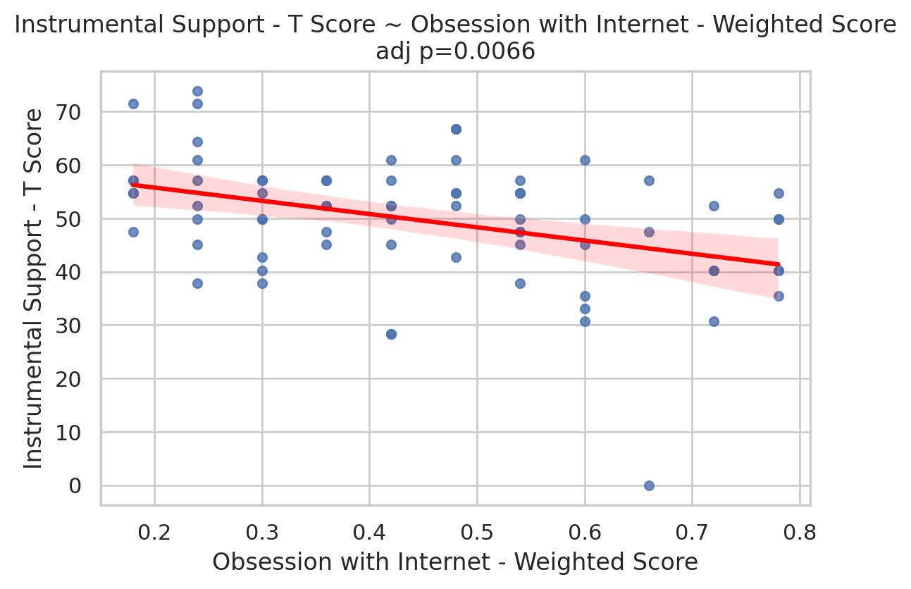
Obsession with Internet - Weighted Score vs Instrumental Support - T Score (OLS)
No associations remained significant after Benjamini-Hochberg FDR correction at the 0.05 level. However, several exposure-outcome pairs showed nominal significance (adj_p < 0.05), including higher Internet Usage Total Score being associated with higher Perceived Social Stress and lower Social Support scores. Obsession with Internet scores were also negatively associated with support outcomes. These effects persisted after adjustment for covariates, though the magnitude was sometimes attenuated.

Summary and Interpretation
This analysis demonstrates that social networking and internet-related behaviors are associated with perceived stress, self-concept, and social support among Indian women. While no associations survived strict multiple-testing correction, the direction and consistency of effects suggest that higher internet use and obsession are linked to higher stress and lower support, even after accounting for age, income, education, and marital status. These findings highlight the importance of considering both psychosocial and demographic factors when evaluating the impact of digital behaviors on well-being, and suggest avenues for further research, including stratified analyses by marital status and more nuanced modeling of categorical exposures.

