THE HIDDEN COST OF DATA PREPARATION
A budget-aware framework for stronger and more transparent machine learning pipelines
Aseem Baji | PhD Candidate, Information Systems | Robert H. Smith School of Business, University of Maryland
Ongoing doctoral research; academic manuscript in preparation | abaji@umd.edu
Executive summary
Machine learning teams usually document model architecture and hyperparameter tuning in detail, but data preparation is often handled through defaults, informal iteration, or undocumented judgment. This creates a measurement problem: a reported performance gain may come from a better model, a better-prepared dataset, or simply more hidden preprocessing effort. Data-quality research has long argued that data are valuable when they are fit for a specific use, while ML reporting research emphasizes that experimental outcomes depend on the full data and implementation process (Wang & Strong, 1996; Dodge et al., 2019; Kühl et al., 2021).
This study introduces randomized GridSearch for data preprocessing as a measurement framework. Preprocessing choices are represented as searchable pipeline parameters, each complete pipeline evaluation counts as one unit of effort, and performance is reported as a function of a trial budget. The study compares preprocessing-only search, hyperparameter-only search, and joint preprocessing plus hyperparameter search across three public datasets, 30 prediction tasks, and approximately 3.6 million trained candidate pipelines.
Main findings
• Joint preprocessing plus hyperparameter search produced stronger performance across the full budget path, not only at the final endpoint.
• Combined search outperformed preprocessing-only search in 23 of 30 contexts and hyperparameter-only search in 26 of 30 contexts.
• The factors that appeared important in isolated searches rarely remained stable when the full pipeline was optimized jointly.
• Preprocessing knowledge transferred best within the same dataset and as broad patterns rather than exact recipes.
Industry takeaway: preprocessing should be planned, budgeted, logged, and reviewed as part of model development rather than treated as invisible setup work.
1. The industry problem
A model score is produced by an end-to-end process: data selection, cleaning, representation, model fitting, tuning, validation, and testing. Yet organizations often attribute the final result to the model family alone. This can create false model comparisons, weak reproducibility, and governance gaps. A model may appear superior because it received more effective preprocessing; a team may be unable to recreate a result because the preprocessing path was not logged; and a data-quality intervention may change model behavior without receiving the same review as model parameters. Missing-value treatment, for example, is not a neutral technical choice because its validity depends on how missingness arose (Peng et al., 2023).
This problem is closely related to underspecification: pipelines with similar development-domain performance can behave differently when deployed under different conditions (D'Amour et al., 2022). It also contributes to hidden technical debt when data dependencies and transformation pipelines are treated as peripheral rather than as core system components (Sculley et al., 2015). A fair comparison therefore requires a visible effort scale for data preparation.
2. The proposed framework
The framework treats preprocessing choices the same way ML teams already treat model hyperparameters: as a documented configuration space explored under an explicit budget. This follows the budgeted-search logic of random search and hyperparameter optimization, but uses search as a measurement design rather than only as an automation tool (Bergstra & Bengio, 2012; Probst et al., 2019). AutoML systems have shown that preprocessors and model choices can be searched together; the present framework focuses on making the effort and interaction structure observable (Feurer et al., 2015).
The three search regimes are:
• Preprocessing-only: vary imputation, encoding, scaling, feature selection, and dimensionality reduction while holding model hyperparameters fixed.
• Hyperparameter-only: vary model settings while holding preprocessing at a baseline.
• Combined search: vary preprocessing and hyperparameters jointly to evaluate the full end-to-end opportunity and interaction structure.
One trial equals one complete pipeline evaluation. At each budget checkpoint, the best pipeline is selected using validation performance and its corresponding held-out test performance is reported. Area Under the Efficiency Curve (AUEC) summarizes how quickly and consistently a search strategy converts additional trials into better performance. This avoids presenting a single best result without disclosing the effort required to find it.
Study design
• Datasets: Airbnb rentals, Kickstarter projects, and Yelp reviews.
• Tasks: five classification and five regression targets per dataset, for 30 tasks total.
• Reported model family: XGBoost.
• Scale: approximately 3.6 million trained candidate pipelines; fair cross-regime comparisons use a common ceiling of 15,000 trials.
• Implementation: Python, scikit-learn, XGBoost, Optuna, and parallel execution on UMD's Zaratan HPC cluster; statistical analysis in R.
3. Results
Finding 1: Joint search delivers more value across the budget path.
The combined regime achieved the strongest average AUEC for both classification and regression. Its mean AUEC advantage was 0.616 over preprocessing-only search and 0.795 over hyperparameter-only search; both comparisons remained statistically significant after adjustment for multiple testing. Combined search won in 76.7% of contexts against preprocessing-only search and 86.7% against hyperparameter-only search. Figure 1 shows that the combined regime is highest across most task contexts.
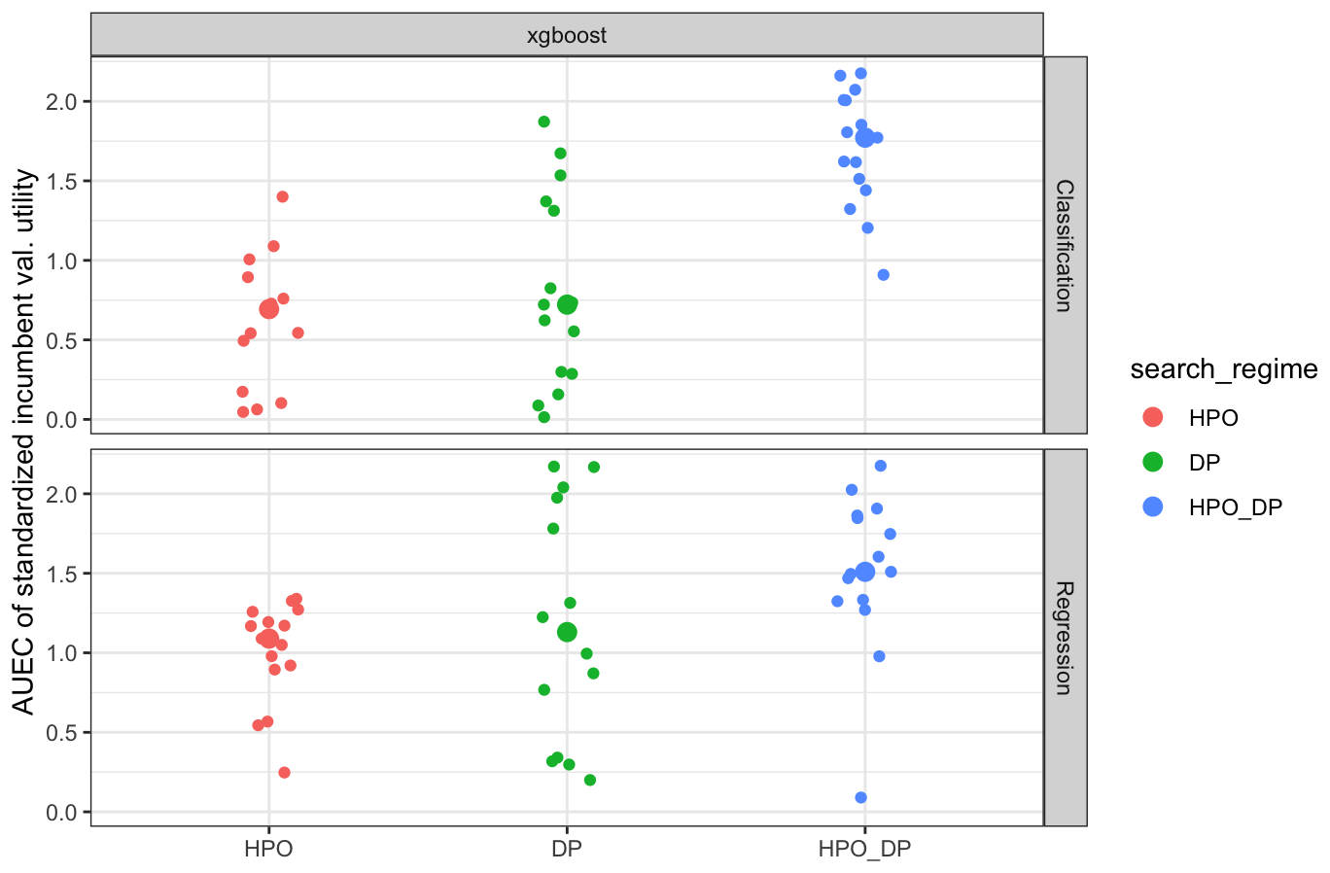
Figure 1. Budget-integrated validation utility by search regime. Each point represents one task context; larger points show regime-level means.
Finding 2: The advantage is budget-dependent, but it persists out of sample.
Joint search explores a larger configuration space, so it can pay an early exploration cost. As the number of trials increases, however, its best-achieved outcomes improve and often exceed the full-budget results of isolated search. Validation-selected pipelines were also evaluated on held-out test data. The combined regime maintained strong test performance and showed the smallest mean validation-test gap at every reported checkpoint. The practical conclusion is not that every project should search everything; it is that teams should compare strategies over the full performance-versus-budget curve and identify when broader search begins to pay off.
Finding 3: Preprocessing and tuning cannot be governed independently.
The study fits tree-based surrogate models to completed trial logs and ranks pipeline choices by their contribution to validation utility, following the general logic of hyperparameter-importance analysis (Hutter et al., 2014). If preprocessing and model tuning were separable, the same factors would remain important when moving from isolated to combined search. Instead, only 2 of 30 preprocessing-side contexts and 3 of 30 hyperparameter-side contexts showed significant positive rank stability. The evidence indicates that the value of a preprocessing choice depends on the hyperparameter region being explored, and vice versa.
Finding 4: Importance becomes more diffuse in the full pipeline.
In preprocessing-only search, a small number of choices explain much of the observed performance variation. In combined search, importance is spread across a broader set of interacting preprocessing and model-tuning decisions. Figure 2 illustrates this pattern: the combined curve rises more gradually, meaning more factors are needed to account for the same cumulative share of importance. For governance, this means that a short list of individually important preprocessing steps may be insufficient once the entire pipeline is opened up.
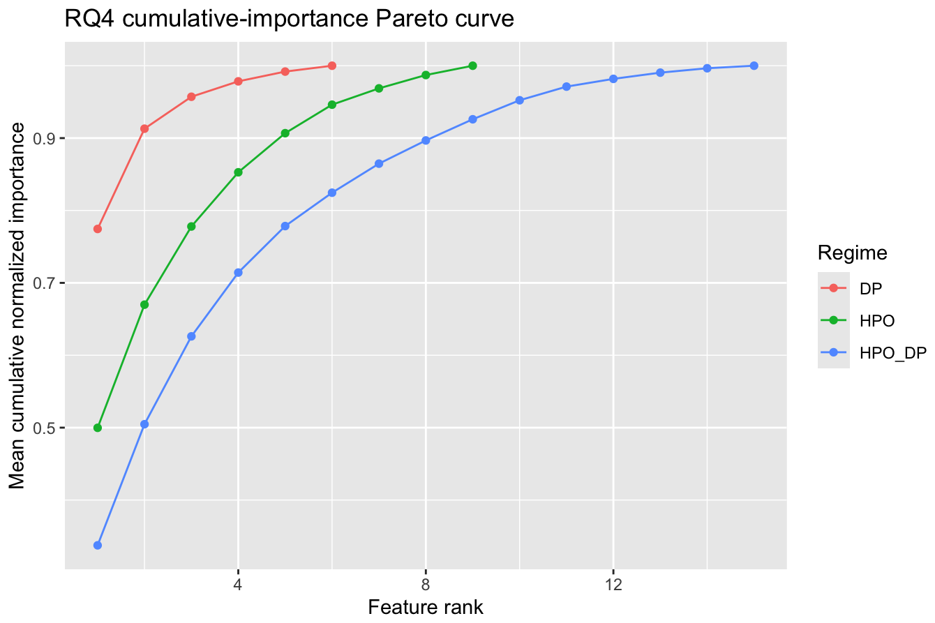
Figure 2. Cumulative normalized importance by factor rank. A flatter curve indicates that performance is distributed across more interacting choices.
Finding 5: Reusable knowledge is usually a pattern, not a recipe.
Preprocessing knowledge transferred most reliably across target problems within the same dataset. Broad patterns - such as families of imputation, encoding, scaling, and reduction choices - transferred better than exact low-level pipeline signatures. Cross-dataset transfer existed, but it was more selective and asymmetric. Teams can reuse evidence-based patterns across related tasks, but exact recipes should be revalidated in the new data context.
4. Implications for ML organizations
1. Track preprocessing as configuration.
Log the preprocessing operators, alternatives considered, trial budget, random seed, and final pipeline signature alongside model hyperparameters.
2. Compare budget curves, not only final scores.
Report performance at multiple trial checkpoints. A stronger endpoint may not justify a strategy that only becomes useful at an impractical budget.
3. Use joint search selectively.
Begin with a documented baseline and expand to joint search where model value, risk, scale, or repeated reuse justifies the additional compute.
4. Review the full pipeline.
Model parameters and feature representation should be reviewed together because isolated importance conclusions may not remain valid in the joint system.
5. Reuse abstractions and revalidate locally.
Transfer broad preprocessing patterns across related tasks, but do not assume that exact settings are portable across datasets or business contexts.
6. Strengthen reporting and governance.
Documentation practices such as model cards are more useful when they include the preprocessing space, search budget, and data-representation decisions that produced the final model (Mitchell et al., 2019).
5. A practical implementation checklist
• Document the current baseline preprocessing pipeline, model defaults, metrics, and data split.
• Define a bounded set of defensible preprocessing alternatives rather than an unrestricted search space.
• Run preprocessing-only, hyperparameter-only, and combined regimes at common budget checkpoints.
• Select incumbents using validation data and report performance only on held-out test data.
• Inspect both the final result and the full budget curve, including variability and validation-test gaps.
• Use trial logs and surrogate models to identify unstable, high-leverage, or interacting choices.
• Store search spaces, budgets, seeds, trial logs, final configurations, and assumptions about transfer.
Current scope and limitations
The reported analysis uses three public datasets and one reported model family, XGBoost. The preprocessing grid is broad but does not include domain-specific text, image, or temporal transformations. Trial budgets measure machine-search effort, not all human effort involved in problem formulation, feature semantics, or domain-specific cleaning. Surrogate importance summarizes the observed search surface and should not be interpreted as causal attribution. Results should therefore be tested across additional datasets, model families, and deployment settings before being treated as universal guidance.
About the research
This white paper summarizes the first essay of Aseem Baji's doctoral dissertation in Information Systems at the University of Maryland's Robert H. Smith School of Business, advised by Dr. Jessica Clark. The work has been presented in peer-reviewed Information Systems research forums and is being prepared for academic journal submission.
References
Bergstra, J., & Bengio, Y. (2012). Random search for hyper-parameter optimization. Journal of Machine Learning Research, 13, 281-305.
D'Amour, A., Heller, K., Moldovan, D., Adlam, B., Alipanahi, B., Beutel, A., Chen, C., Deaton, J., Eisenstein, J., Hoffman, M. D., Hormozdiari, F., Houlsby, N., Hou, S., Jerfel, G., Karthikesalingam, A., Lucic, M., Ma, Y., McLean, C., Mincu, D., Mitani, A., Montanari, A., Nado, Z., Natarajan, V., Nielson, C., Osborne, T. F., Raman, R., Ramasamy, K., Sayres, R., Schrouff, J., Seneviratne, M., Sequeira, S., Suresh, H., Veitch, V., Vladymyrov, M., Wang, X., Webster, K., Yadlowsky, S., Yun, T., Zhai, X., & Sculley, D. (2022). Underspecification presents challenges for credibility in modern machine learning. Journal of Machine Learning Research, 23(226), 1-61.
Dodge, J., Gururangan, S., Card, D., Schwartz, R., & Smith, N. A. (2019). Show your work: Improved reporting of experimental results. Proceedings of EMNLP-IJCNLP, 2185-2194.
Feurer, M., Klein, A., Eggensperger, K., Springenberg, J., Blum, M., & Hutter, F. (2015). Efficient and robust automated machine learning. Advances in Neural Information Processing Systems, 28, 2962-2970.
Hutter, F., Hoos, H. H., & Leyton-Brown, K. (2014). An efficient approach for assessing hyperparameter importance. Proceedings of the 31st International Conference on Machine Learning, 754-762.
Kühl, N., Hirt, R., Baier, L., Schmitz, B., & Satzger, G. (2021). How to conduct rigorous supervised machine learning in information systems research: The supervised machine learning report card. Communications of the Association for Information Systems, 48, 589-615.
Mitchell, M., Wu, S., Zaldivar, A., Barnes, P., Vasserman, L., Hutchinson, B., Spitzer, E., Raji, I. D., & Gebru, T. (2019). Model cards for model reporting. Proceedings of the Conference on Fairness, Accountability, and Transparency, 220-229.
Peng, J., Hahn, J., & Huang, K.-W. (2023). Handling missing values in information systems research: A review of methods and assumptions. Information Systems Research, 34(1), 5-26.
Probst, P., Boulesteix, A.-L., & Bischl, B. (2019). Tunability: Importance of hyperparameters of machine learning algorithms. Journal of Machine Learning Research, 20(53), 1-32.
Sculley, D., Holt, G., Golovin, D., Davydov, E., Phillips, T., Ebner, D., Chaudhary, V., Young, M., Crespo, J.-F., & Dennison, D. (2015). Hidden technical debt in machine learning systems. Advances in Neural Information Processing Systems, 28, 2503-2511.
Wang, R. Y., & Strong, D. M. (1996). Beyond accuracy: What data quality means to data consumers. Journal of Management Information Systems, 12(4), 5-33.

