Shenzhen International FinTech Competition 2026
DELIVERABLE 01
WealthPilot
Technical Documentation
System architecture · Core algorithms · Security design
Team WealthPilot Team
Live application to be added
Source code https://github.com/aseerawsaf45-dev/WealthPilot
Version 1.0 · 2026-10-20

Contents
WealthPilot: Technical Documentation 3
1. Executive summary 3
2. System architecture 3
2.1 Overview 3
2.2 Request lifecycle 4
2.3 Data model 5
2.4 External integrations 6
2.5 Deployment architecture 6
3. Core algorithms 7
3.1 Exact money arithmetic 7
3.2 Statement import: idempotent and reversible 7
3.3 Machine-learning insights (src/lib/ml) 7
3.4 Goal planner 8
3.5 Debt payoff and loans (src/services/debtService.ts, src/lib/planning/loans.ts, link.ts) 8
3.6 Investment projection by country (src/lib/planning/invest.ts, scenarios.ts) 8
3.7 History-based fund mixes (src/lib/planning/markets.ts) 9
3.8 Bank suggestions (src/lib/planning/banks.ts, src/server/repos/banks.ts) 9
3.9 AI copilot: grounding by construction (src/server/ai) 10
3.10 Partner offers near you (src/components/NearbyOffers.tsx, src/server/repos/offers.ts) 11
3.11 Rate limiter and audit chain 11
4. Security design 11
4.1 Permission tiers 11
4.2 Threat model (STRIDE) 12
4.3 Browser hardening 12
4.4 Privacy and data rights 12
4.5 Secrets and supply chain 13
4.6 Known risks and planned fixes 13
5. Quality assurance 13
5.1 Test strategy 13
5.2 Performance 14
5.3 Limitations and roadmap 14

If the contents list is empty, right-click it and choose Update Field.

WealthPilot: Technical Documentation
Deliverable 01 · System architecture, core algorithms and security design
Product | WealthPilot: a personal finance workspace with a grounded AI copilot, debt and wealth planner, and partner offers
Team | WealthPilot Team
Live application | to be added
Source code | https://github.com/aseerawsaf45-dev/WealthPilot
Companion documents | README and deployment guide (deliverable 04), test cases (docs/TEST_CASES.md), sandbox operation logs (deliverable 06)

1. Executive summary
Most personal-finance apps either keep data on one device (no sync, no backup) or send everything to a cloud and to an AI model that can invent numbers. WealthPilot is built on three rules that hold everywhere in the code:
- Money is exact. Every amount is an integer number of minor units (cents, poisha), stored as BigInt in Postgres. Balances are never stored; they are derived from the ledger, so they cannot drift.
- The server computes; the AI only narrates. Every number a user sees comes from deterministic server code. The language model never receives amounts, transaction rows or personal data. It writes sentences with placeholders, and the server fills them in. A sentence that states a number of its own is rejected.
- Every request is scoped to the signed-in user and audited. The user id comes only from a revocable server session. Each write and its audit record commit in one database transaction, and the audit records form a SHA-256 hash chain that exposes any tampering.
On top of a full ledger (accounts in any ISO-4217 currency, transactions, splits, imports, budgets, goals, bills), WealthPilot offers:
- a debt and wealth planner: loans, investment plans by country, history-based fund mixes, and stress tests for war, sanctions or a currency crash;
- bank suggestions from public data;
- on-device document reading (receipts and statements);
- location-aware partner offers in which the location never leaves the device;
- an AI copilot that can answer questions and make changes, but only after the user confirms.
Measure | Value
API route files / HTTP handlers | 54 / 79
Database tables / migrations | 24 / 9
Automated tests | 115 unit and logic, 15 database integration, 57 AI evaluations (all passing)
Sandbox evidence | 63 operations of two simulated users on a production build, 63/63 assertions passed, audit chain verified

2. System architecture

2.1 Overview
WealthPilot is one Next.js 16 application. The React 19 client, the HTTP API (App Router route handlers under src/app/api/v1), and a server layer (src/server) share one TypeScript codebase. They also share the deterministic libraries in src/lib, so the browser and the server compute the same results. Data lives in Neon Postgres, accessed through Prisma 6.
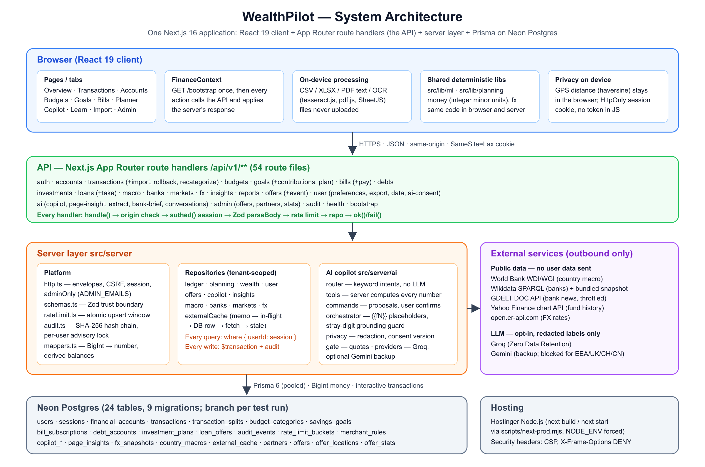
Figure: System architecture
Layer | Location | Responsibility
Client | src/app/page.tsx, src/components/** | Tabs (Overview, Transactions, Accounts, Budgets, Goals, Bills, Planner, Copilot, Learn, Import, Settings, Admin). FinanceContext loads GET /bootstrap once, then every action calls the API and applies the server's response.
On-device processing | src/lib/extract/**, public/vendor | CSV/XLSX parsing, PDF text, OCR (tesseract.js), HEIC conversion, all in Web Workers. Files are never uploaded.
Shared deterministic code | src/lib/ml, src/lib/planning, src/lib/money.ts, src/lib/fx.ts | ML insights, forecast, loan, investment and market maths. Pure functions of (rows, today).
API | src/app/api/v1/**/route.ts | 54 route files, each a thin handler wrapped in handle()/authed()/adminOnly().
Platform | src/server/http.ts, schemas.ts, rateLimit.ts, audit.ts, mappers.ts | Response envelopes, CSRF check, sessions, Zod trust boundary, rate limiting, audit hash chain, BigInt mapping.
Repositories | src/server/repos/*.ts | All database access, always scoped by the session user id. Routes never call Prisma directly (enforced by npm run check:security).
AI | src/server/ai/*.ts | Intent router, server tools, command proposals, grounded narration, privacy gateway, quotas, providers.
Database | prisma/schema.prisma, prisma/migrations/* | Neon Postgres; a branch per test run.

2.2 Request lifecycle
Every route follows the same pipeline, so a security property implemented once applies everywhere.
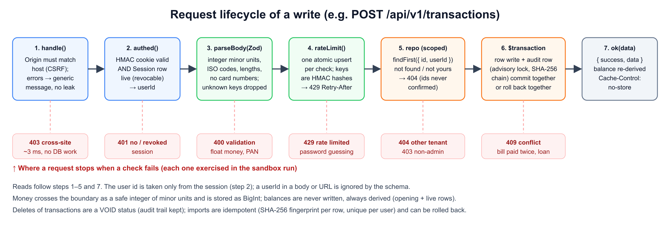
Figure: Request lifecycle
- handle() (src/server/http.ts) rejects a cross-site mutation: Sec-Fetch-Site: cross-site, or an Origin that does not match the host or APP_URL. It turns any thrown error into a generic message; database timeouts become a 503 "nothing was changed".
- authed() verifies the HMAC-signed cookie and that its Session row is still live (not revoked, not expired). Only then does it pass userId to the handler.
- parseBody() validates the JSON with a Zod schema (src/server/schemas.ts). Unknown keys are dropped, so a userId sent by the client is ignored.
- rateLimit() counts the call in Postgres with one atomic upsert.
- A repository function runs with where: { userId } on every query.
- Writes run in prisma.$transaction together with writeAudit().
- ok(data) returns { success: true, data } with Cache-Control: no-store.

2.3 Data model
All money columns are BigInt minor units, all rates are integer basis points (1% = 100 bps) or one-decimal percentages, and every user-owned table cascades on user deletion.
Table | Purpose | Key rules
users | Profile, preferred currency, timezone, region, AI consent (version, providers) | Email unique; passwordHash bcrypt
sessions | Revocable server sessions | Checked on every request; logout and account deletion revoke them
financial_accounts | Accounts in any ISO-4217 currency | openingBalanceCents; the live balance is derived
transactions | Ledger rows | status CLEARED/PENDING/RECONCILED/VOID; importFingerprint unique per user; importBatchId for rollback
transaction_splits | Category splits | Sum must equal the transaction amount
budget_categories | Monthly budgets | Unique (user, category, month)
savings_goals | Goals, saved AI plan snapshot (JSON) | currentCents never below 0
bill_subscriptions | Recurring bills | nextDueDate advanced by a conditional update (idempotent pay)
debt_accounts | Debts | APR as a rate, never summed
investment_plans | Plans by country and risk; fund allocation (JSON, weights = 100) | Scenarios from a fixed catalogue
loan_offers | Offers being compared | considering → taken (creates a debt) atomically
audit_events | Hash-chained audit log | checksumBefore / checksumAfter
rate_limit_buckets | Fixed-window counters | Keys are HMAC hashes, never raw emails or IPs
merchant_rules | The user's categorisation rules | Per user
copilot_conversations, copilot_messages | Saved chats (opt-in) | Deleted when history is turned off
page_insights | Cached AI page summaries | Keyed by a hash of the computed numbers
fx_snapshots | Daily exchange rates | Public data
country_macros, external_cache | World Bank, Wikidata, GDELT, Yahoo caches | Public data only, never user data
partners, offers, offer_locations, offer_stats | Partner discounts and investment opportunities | Stats are anonymous daily counters

2.4 External integrations
Source | Used for | Safeguards
World Bank WDI/WGI | Inflation, lending/deposit/real rates, GDP growth, political stability, FX trend, stock-market returns | 30-day cache; no user data sent
Wikidata SPARQL (CC0) | Banks per country | Bundled snapshot of 158 countries; live refresh waits at most 2.5 s
GDELT DOC API | Recent bank headlines | Global throttle of 1 request per 5.5 s; 6-hour cache; never blocks the page for more than 1.5 s
Yahoo Finance chart API | 10-year monthly history of 14 index funds | 15-minute cache with stale fallback (unofficial API; see risks)
open.er-api.com | Daily FX rates | Cached in fx_snapshots
Groq (primary LLM) / Gemini (backup) | Wording answers, choosing tools, structuring document text | Opt-in, versioned consent; labels and redacted text only; quotas

Every public-data fetch goes through one cache (src/server/repos/externalCache.ts), in this order:
- In-process memo.
- A shared in-flight promise, so concurrent requests make one fetch.
- A database row that is still within its TTL.
- A live fetch.
- The last stored row, if the fetch fails, with a back-off before retrying.
It never throws, so an outside outage degrades a feature instead of breaking a page.

2.5 Deployment architecture
Production runs as a Node.js app on Hostinger:
- next build and next start both run through scripts/next-prod.mjs, which forces NODE_ENV=production and caps thread pools for many-core hosts.
- The app uses Neon Postgres: a pooled URL at runtime, and an unpooled URL for migrations.
- Every test, migration rehearsal and sandbox run uses a separate Neon branch. Production data is never used for testing.
- Security headers come from next.config.ts:
  - a Content-Security-Policy (default-src 'self', connect-src 'self', frame-ancestors 'none', object-src 'none');
  - X-Frame-Options: DENY, X-Content-Type-Options: nosniff and Referrer-Policy;
  - a Permissions-Policy that blocks the camera, microphone and payments, and allows geolocation only for this site.
See docs/DEPLOYMENT.md for the step-by-step guide.

3. Core algorithms
All algorithms below are deterministic and explainable: the same inputs always give the same output, and each insight states its method ("How: modified z-score"). They live in src/lib, so the browser can show results instantly and the server can use the same code for API and AI answers.

3.1 Exact money arithmetic
- Representation. Amounts are integer minor units. Parsing (toMinor, dollarsToCents in src/lib/money.ts) works on the decimal string, not on floating point, so 0.1 + 0.2 problems cannot occur. The currency exponent comes from ISO-4217, so JPY has 0 decimals and BHD has 3. Storage is BigInt; the API boundary accepts only z.number().int().safe(). The sandbox run shows a float amount being refused with a 400.
- Conversion. convertMinor (src/lib/fx.ts) converts between currencies with that day's rate and rounds once at the end. Totals that include converted amounts are labelled estimates. Rates are never mixed silently.
- Derived balances. An account's balance is openingBalanceCents + Σ amountCents of its non-VOID transactions (listAccounts, accountWithBalance in src/server/repos/ledger.ts). "Set my balance to X" is stored as a new opening balance, X − Σ.
- Deletion. Deleting a transaction sets VOID, which keeps the audit trail while the balance updates.

3.2 Statement import: idempotent and reversible
- Each row is validated on its own (ImportRow). Bad rows are reported with their index; they are never dropped silently. At most 2,000 rows per import.
- Fingerprint: sha256(date | lower(merchant) | amount | occurrence-in-file). The occurrence index keeps two identical coffees on one day distinct, while importing the same file again maps to the same fingerprints.
- createMany(..., skipDuplicates) against the unique index (userId, importFingerprint) makes re-imports idempotent. The sandbox run imported a 7-row statement, then imported it again: 6 inserted, 1 rejected, then 0 inserted and 6 duplicates.
- Rollback: every row of a batch shares importBatchId. Undo voids them and clears their fingerprints in one transaction, so the file can be imported again later.

3.3 Machine-learning insights (src/lib/ml)
Model | Method | Guards
Categorisation (ML-01, categorize.ts) | Ordered evidence: the user's own rules, then what the user called this merchant before (share of past rows), then a short global keyword list | Suggestions only; the user confirms each change; confidence 0–100
Recurring detection (ML-02, recurring.ts) | A payee is recurring with ≥ 3 rows, a median gap within ±20% of a cadence (weekly to annual), and amount variation (coefficient of variation) < 0.15 | Offers "Track as a bill" only if no similar bill exists
Unusual spending (ML-03, anomalies.ts) | Modified z-score per category, z = 0.6745 · (x − median) / MAD, flagged when z > 3.5 (Iglewicz & Hoaglin). If MAD = 0, flagged at ≥ 2× the median | Needs ≥ 8 earlier expenses spanning ≥ 60 days
Cash-flow forecast (ML-04, forecast.ts) | 30/60/90 days: balance + expected recurring income − bills due − typical everyday spending. The P10–P90 band comes from the spread of real 30-day everyday-spending totals over the last 180 days, scaled to each horizon | Needs ≥ 60 days of history, otherwise says so; reports the first day the balance would go below zero
Goal ETA (ML-05, monthly.ts) | Months = remaining ÷ monthly saving, with ±20% sensitivity on the saving rate, giving a likely finish window | "Never at this rate" when saving ≤ 0
Budget pacing | Spend projected to month end at the current pace, compared with the same days of the previous month | Like-for-like days, so a half month is compared fairly

Statistics (medians, z-scores) use plain numbers only as ratios; amounts stay integers.

3.4 Goal planner
The planner (planGoal in src/server/ai/tools.ts) works from the user's real history:
- Inputs: average monthly income and spending over the last complete months (up to three), giving the surplus. Other dated goals compete for it: free = surplus − Σ (remaining_g ÷ months_left_g).
- Comfortable rate: comfortable = ⌊free / 2⌋, keeping half of the free money for surprises.
- Verdict with a deadline: required = ⌈remaining ÷ months_left⌉.
  - on track if required ≤ comfortable;
  - stretch if required ≤ free;
  - not reachable otherwise.
- Options when not on track: move the deadline (at the comfortable rate), trim flexible categories (largest first, never fixed costs such as rent), lower the target, or pause other goals. Each option is marked feasible or not.
- Applying an option: applyGoalPlanOption (src/server/repos/planning.ts) applies an option from the stored plan snapshot, never from client input, in one transaction. Budget cuts keep the user's alert thresholds.

3.5 Debt payoff and loans (src/services/debtService.ts, src/lib/planning/loans.ts, link.ts)
- Snowball vs avalanche: a month-by-month simulation. Interest accrues at APR/12 (rounded to minor units) and minimums are paid. Freed-up minimums from paid-off debts roll into the next target (lowest balance first, or highest APR first). The simulation is capped at 360 months.
- Loan payment (EMI): EMI = ⌈P · r / (1 − (1 + r)^−n)⌉, with r = APR/12 and n months. A 0% APR gives P/n. The amortisation schedule lets the last payment absorb rounding, so the balance ends at exactly 0.
- Effective APR including fees: the rate at which the payments repay only the cash actually received (P − fee). It is found by bisection (80 iterations) on the present value of the payment stream.
- Affordability (DTI): (new EMI + existing minimums) ÷ average monthly income. ≤ 36% is healthy, ≤ 43% is stretched (most lenders' limit), above that is risky.
- How much can I borrow: monthly room = ⌊income × 36% (or 43%)⌋ − existing minimums. Then maxPrincipal(room, APR, n) inverts the EMI formula and steps down past the rounding edge, so the EMI of the result never exceeds the room. A unit test proves it is the largest such loan within one minor unit.
- Pay debt or invest? A debt is "pay first" when its APR exceeds the plan's after-tax expected return. The same monthly amount is simulated both ways for the same duration (fair comparison).
- Taking a loan flips the offer from considering to taken with a conditional update. It also creates the debt, with the EMI as its minimum payment, in the same transaction, so a double click cannot create two debts. The sandbox run checks this (second attempt: 409).

3.6 Investment projection by country (src/lib/planning/invest.ts, scenarios.ts)
Expected return.
- The base is the country's deposit rate. If none is published, the lending rate − 3%; if that is missing, inflation + 1%; otherwise 5%. Each fallback is stated in the notes.
- Add a risk premium of 0 / 3 / 5% (conservative / balanced / growth), with yearly volatility of 5 / 10 / 16%.
- Political stability (World Bank WGI, −2.5…+2.5) below 0 lowers the return by 0.5% and widens volatility by 2%. Below −1, the figures are 1.5% and 4%.
- A user-entered return always wins and is labelled.
Projection. Monthly compounding of the balance plus contributions in integer minor units. The range is a deterministic lognormal band, with no random simulation:
P10 / P90 = median × exp(∓ 1.2816 × σ × √T_w)
Here σ is the yearly volatility and T_w is the contribution-weighted time invested. The projection also gives the value in today's money (divided by the cumulative inflation index) and in USD terms (the currency's yearly depreciation trend).
Stress tests. Seven fixed scenarios: regional conflict or war, sanctions and capital controls, oil shock, global rate hikes, local currency crash, political instability, global recession. Each one sets:
- an immediate shock, scaled by the plan's exposure (0.35 / 0.70 / 1.0 by risk);
- a return drift for a number of months;
- extra inflation and currency depreciation.
The reported stress loss is the worst first-year gap against the unstressed path. Politics enters only through the World Bank index and the scenarios the user picks; the AI never states current events.

3.7 History-based fund mixes (src/lib/planning/markets.ts)
Universe. 14 broad index ETFs:
- world, US, Europe, Japan, China, India, Asia ex-Japan, emerging markets, Latin America, Africa;
- gold, US bonds, international bonds, T-bills (cash).
Statistics per fund (computeStats), from 10 years of monthly closes:
- annualised returns over 1, 3, 5 and 10 years: (P_end / P_start)^(1/years) − 1, accepting a series up to 3 months short;
- volatility: the standard deviation of monthly returns × √12;
- maximum drawdown: the worst fall from a running peak.
Five mixes. Each starts from a base split of shares, bonds, gold and cash for the risk level, then applies its own tilt:
Mix | Tilt | Region rule
Core | none | best return-for-risk regions, 40% of shares
Simple global | no gold; 3 funds | world fund only
Lower swings | −20 shares, +12 bonds, +5 gold, +3 cash | lowest-volatility regions
Growth tilt | +15 shares, −10 bonds, −5 cash | best 10-year return that still rose last year
Crisis-resilient | −20 shares, +5 bonds, +10 gold, +5 cash | lowest volatility; suggested when political stability < 0 or stress tests are on

Construction rules.
- Under 3 years, half the shares move to cash.
- Weights are rounded to whole percents that sum to exactly 100 by the largest-remainder method.
- mixStats re-scores any edited mix as weighted averages of return, volatility and drawdown.
- The API refuses allocations that are not exactly 100%, contain unknown funds, or repeat a fund (Allocation Zod schema).

3.8 Bank suggestions (src/lib/planning/banks.ts, src/server/repos/banks.ts)
- Which banks exist. A Wikidata SPARQL query starts from 10 bank types and only then filters by country (hint:Query hint:optimizer "None"). This takes 1–3 s, where the naive subclass walk timed out at 60 s for the US, India, Germany and the UK. It excludes defunct banks. A bank whose parent organisation is in another country is labelled the local arm of an international bank. A bundled snapshot (158 countries, scripts/fetch-banks.mts) is used whenever the live query does not answer within 2.5 s.
- News signal. GDELT headlines from the last 30 days that name the bank, scored with a small, transparent lexicon. Words such as fraud, penalty, losses, probe count −1; profit, expansion, award, partnership count +1.
- Ranking score: 2·log2(1 + fame) + min(articles, 6) + 1.5·signal + (local ? 1 : 0), where fame is the number of Wikipedia language editions.
  - Caution: the worst headline ≤ −2, or ≤ −1 with a negative total.
  - Worth comparing: the top three of the rest.
  - Every pick carries its reasons.
- Rates are not invented. The country's World Bank average lending or deposit rate is shown as the benchmark, and users are told to ask each bank for a quote.

3.9 AI copilot: grounding by construction (src/server/ai)
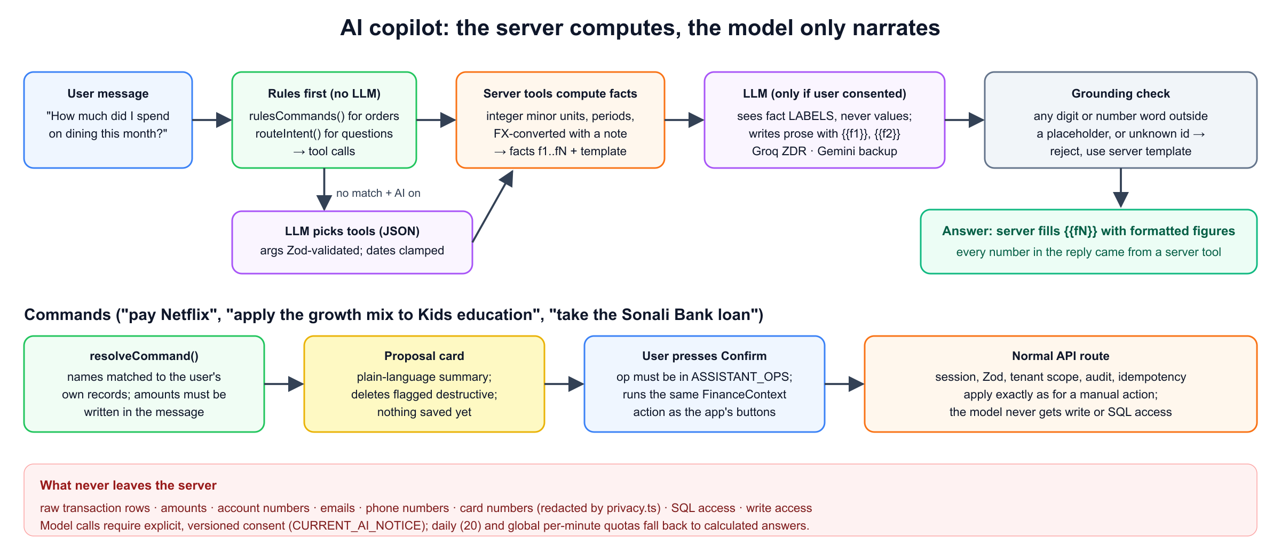
Figure: Copilot grounding
- Rules first. rulesCommands() recognises commands such as "add 450 lunch", "pay Netflix", "apply the growth mix to Kids education" or "take the Sonali Bank loan", including multi-step requests. routeIntent() maps common questions to tools by keyword. These need no model and cost no quota.
- Server tools compute the facts. Thirteen read tools return facts (label, value, unit, kind) and a template with {{#i}} references: financial summary, category breakdown, compare periods, budget status, upcoming bills, possible duplicates, insights, debt summary, compare loans, investment outlook, savings plan, goal plan, partner offers.
- The model only narrates. When the user has consented, the model receives the fact labels, never the values, and writes prose with {{f1}}-style placeholders. If no rule matched, the model only picks tools (strict JSON, validated with Zod). Implausible dates are clamped to the loaded history.
- Grounding check. hasStrayNumber rejects model text that contains any digit or number word outside a placeholder, or a placeholder id that does not exist. In that case the server's own template is used. The server then fills the placeholders with its formatted figures, so every number in an answer came from a server tool. The 57 AI evaluations include hostile fake model replies that try to inject numbers. None succeed.
- Commands need confirmation. resolveCommand() maps a command to a proposal:
  - names are matched only against the user's own records, and an ambiguous or unknown name gets a question back;
  - an amount must literally appear in the user's message, or the copilot asks for it, so the model cannot invent amounts;
  - deletes are flagged destructive.
Nothing is saved until the user presses Confirm. The browser then runs the same FinanceContext action as the app's own buttons, through the normal API with all its checks.
- Document reading (opt-in). The device extracts the text, redactDocumentText removes identifiers, and the model only structures the result. A row is kept only if its amount appears character for character in the text, its merchant appears in the text, and its date falls within −2/+1 years of today. Everything else is dropped and counted.

3.10 Partner offers near you (src/components/NearbyOffers.tsx, src/server/repos/offers.ts)
- Visibility: an offer is shown only when its status is live, today is between its start and end dates, and an admin verified it in the last 90 days.
- Location stays on the device: the browser asks for location only on a click (or if permission was already granted). It computes the great-circle distance with the haversine formula, d = 2R·asin(√(sin²(Δφ/2) + cos φ1 cos φ2 sin²(Δλ/2))) with R = 6,371 km, and sorts nearest first. The server sees only the country.
- Disclosure: every card shows its relationship (Partner, Sponsored or Ad). Sample content is marked "Sample: not a real partner". Investment cards state they are not financial advice. Links carry only utm_source=wealthpilot.
- Sponsor statistics: anonymous daily counters, incremented with an atomic upsert … increment (verified: two simultaneous clicks count 2). No user id and no location are stored.

3.11 Rate limiter and audit chain
- Rate limiter (src/server/rateLimit.ts): a fixed window kept in Postgres, implemented as one atomic INSERT … ON CONFLICT DO UPDATE that resets the counter when the window has expired. It needs no shared memory, so it holds across processes. Keys are scope:HMAC(identifier).
- Audit chain (src/server/audit.ts):
  - Each write inserts checksumAfter = SHA-256(checksumBefore | userId | eventType | actor | details | createdAt) in the same transaction as the change.
  - A per-user pg_advisory_xact_lock serialises concurrent writes, so the chain never forks.
  - Timestamps are strictly increasing.
  - The sandbox run recomputed 29 events end to end and found the chain intact.

4. Security design

4.1 Permission tiers
Tier | Who | Can do | Enforced by
Anonymous | Not signed in | Landing page, sign up, sign in, health check | authed() returns 401 for everything else; app URLs are rewritten to the landing page
User | Valid, unrevoked session | Own data only: every query carries userId from the session | Repositories; cross-tenant access returns 404 (ids are never confirmed)
AI-consented user | User who accepted the current AI notice | Model-worded answers, model tool choice, optional AI document reading | canUseLlm() checks consent, notice version and provider on every call; region rules for Gemini
Admin | Session user whose email is in ADMIN_EMAILS (server environment) | Manage partners and offers, read anonymous offer statistics | adminOnly(); the client's isAdmin flag only shows the tab, every admin API re-checks

4.2 Threat model (STRIDE)
Threat | Example | Controls
Spoofing | Stolen or forged session | HMAC-SHA256 signed token (SESSION_SECRET ≥ 32 bytes, timing-safe compare), HttpOnly, Secure, SameSite=Lax cookie, 7-day expiry, server-side Session row checked on every request, revoked on logout and account deletion (sandbox: replayed cookie gets 401)
Spoofing | Password guessing | bcrypt cost 12, constant-time dummy compare for unknown emails, the same error for both cases, 10 attempts per email per hour, 20 per IP per 15 min (sandbox: 11th attempt gets 429)
Tampering | Changing another user's data (BOLA/IDOR) | Session-scoped queries everywhere, findFirst({ id, userId }) and 404; userId in bodies is ignored (sandbox: 3 cross-tenant attempts get 404)
Tampering | Cross-site request forgery | SameSite=Lax plus an Origin/Sec-Fetch-Site check on every mutation (sandbox: forged Origin gets 403)
Tampering | Malformed or hostile input | Zod on every body: safe integers for money, ISO codes, length caps, https-only links, coordinate ranges, list caps
Tampering | Editing the audit log | SHA-256 hash chain under an advisory lock; any change breaks every later hash
Repudiation | "I never did that" | Audit row for every write with event type and entity id, never personal details; user-visible audit log
Information disclosure | Leaking data to the AI provider | Model sees labels, not values; redaction of SSN/national-id patterns, secrets, account numbers, card numbers (Luhn), emails and phone numbers; long digit runs removed from documents; versioned consent; Groq with zero data retention; Gemini blocked for EEA/UK/CH/CN
Information disclosure | Card numbers in free text | noPan refinement (Luhn) rejects card numbers in merchant and note fields (sandbox: 400)
Information disclosure | Error details | Generic error messages; the server logs only error codes; no-store on all API responses
Information disclosure | Location tracking | Distance computed in the browser; the server never receives coordinates; offer stats have no user id
Information disclosure | Spreadsheet formula injection in exports | Cells beginning with = + - @ are neutralised
Denial of service | API abuse, AI cost exhaustion | Per-user limits on each route family; AI limited to 20 per user per day and a global per-minute cap, falling back to calculated answers
Elevation of privilege | Becoming admin | Admin only via the server environment ADMIN_EMAILS; nothing the client sends can grant it (sandbox: 403)

4.3 Browser hardening
The Content-Security-Policy allows scripts, styles and connections only from this site:
- frame-ancestors 'none' and X-Frame-Options: DENY prevent clickjacking.
- object-src 'none' and base-uri 'self'.
- wasm-unsafe-eval is enabled only so on-device OCR can compile WebAssembly; it does not allow JavaScript eval.
The Permissions-Policy denies the camera, microphone and payment APIs, and limits geolocation to this site.

4.4 Privacy and data rights
- Data minimisation: files are read on the device; location stays on the device; the AI receives labels only; audit details contain no emails or card numbers (verified by the integration tests and the sandbox run).
- Export (GDPR Art. 20): GET /user/export returns all of the user's data as JSON. It is limited to 5 per hour and audited.
- Erasure (GDPR Art. 17): DELETE /auth/account requires the password and cascades through every user-owned table, including sessions and the audit log. It leaves only a pseudonymous receipt (ACCOUNT_ERASED, keyed HMAC of the id). The sandbox run verifies that zero rows remain.
- Chat history is off by default; turning it off deletes saved conversations.

4.5 Secrets and supply chain
- Secrets live only in the host's environment variables: SESSION_SECRET, AUDIT_PEPPER, database URLs and API keys. .env is git-ignored, and .env.example documents names only.
- The app refuses to sign sessions without a strong secret.
- npm run check:security scans for committed secrets and for routes that bypass the repository layer. A pre-commit hook runs the security checks and tests. A pre-push hook rebuilds the pushed commit in a clean worktree (npm ci, tsc, security check, production build), so an undeployable commit cannot be pushed.
- Dependencies are pinned. On-device readers (pdf.js, tesseract.js, heic2any) are self-hosted under /vendor, so no third-party CDN is needed at runtime.

4.6 Known risks and planned fixes
We list these openly; none is hidden by the tests.
# | Risk | Impact | Planned fix
1 | On hosts other than Vercel, clientIp() returns one shared key, so the IP-based sign-up (3/h) and login (20/15 min) limits apply to all visitors together | Legitimate sign-ups can be refused during busy periods, and one attacker can trigger the shared limit | Trust the proxy's forwarding header behind an env flag; keep per-email limits
2 | Moving a transaction to an account in another currency keeps its original currency code | That account's derived balance mixes currencies | Refuse moves between currencies (409)
3 | Budget "spent" adds expenses of different currencies without FX conversion | Wrong pacing for multi-currency users | Convert with the daily rate as the copilot tools already do
4 | "Delete my financial data" (not account deletion) keeps investment plans and loan offers | Incomplete wipe; account deletion is complete | Add the two tables to the wipe and an integration test
5 | Partial PATCH of investment plans or loan offers re-applies schema defaults | A partial update could clear saved fields (the app always sends full objects today) | Define patch schemas without defaults, as the other patch schemas already are
6 | Two simultaneous goal withdrawals can pass the "not below zero" check | A goal could go negative | Make the conditional update itself check the balance
7 | CSP allows inline scripts (required by the framework's static rendering) | Weaker XSS defence-in-depth; HttpOnly cookies limit the damage | Nonce-based CSP when the rendering mode allows it
8 | Yahoo Finance chart API is unofficial | Market history may become unavailable | Cached and degrades gracefully; swap for a licensed data feed in production
9 | Mix volatility is a weighted average (correlations ignored) | Overstates the risk of diversified mixes (conservative) | Use a covariance matrix from the same history
10 | No email verification, password reset or MFA yet | Account recovery is manual | Add verified email and TOTP

5. Quality assurance

5.1 Test strategy
Level | Suite | Count | Purpose
Unit and logic | scripts/test-runner.mts (npm test) | 115 | Money, ML, planner maths, parsers, schemas, router, commands, grounding, security helpers
Database integration | scripts/integration.mts | 15 | Real Postgres on a Neon test branch: tenant isolation, derived balances, idempotent payments, audit chain, session revocation, offer rules, admin guard
AI evaluations | scripts/ai-evals.json (npm run eval:ai) | 57 | Exact figures, tool choice, schema, prompt injection, privacy, with scripted fake models
End-to-end evidence | scripts/sandbox-run.mts | 63 operations | Two simulated users over HTTP against a production build

The full catalogue with per-test results is in docs/TEST_CASES.md, generated by running every suite.

5.2 Performance
On the sandbox run, the test machine and app server were in Bangladesh and the sandbox database in Neon US-East. That gives 274 ms per database round trip. A write makes about 8–12 sequential round trips (session check, ownership check, the audit-locked transaction, then the re-derived balance), so measured latency (p50 2.6 s) is dominated by distance, not computation. Requests rejected before database work (forged Origin, missing cookie) take about 3–5 ms. Hosting the app in the same region as the database removes most of the distance.
Server-side design choices that keep the work small:
- One bootstrap call loads the workspace.
- Balances use a single grouped sum.
- External data is cached at four levels.
- AI results for page insights are cached by a hash of the computed numbers, so unchanged data never calls the model twice.

5.3 Limitations and roadmap
Limitations. Budgets reset each month (no rollover yet). The bootstrap returns the newest 2,000 transactions (cursor pagination planned). Market data covers broad index funds, not individual securities.
Planned work:
- the fixes in §4.6;
- transfer pairing across accounts;
- cursor pagination;
- verified email and MFA;
- a licensed market-data feed;
- covariance-based mix risk.

