AKTCL · Aron field-sales platform
Aron on Azure — final account design pack
Version 1 (full): high-level design, low-level design, resource plan and monthly cost, with Azure-icon diagrams
Prepared by the Aron lead for the owner · 2026-10-29
Prices: Azure Retail Prices API, 2026-10-29, Southeast Asia · list prices, pay-as-you-go
Source: docs/35-final-azure-design-pack/ in the Aron repository (cost-model.py reproduces every figure)

Contents

Aron on Azure — final-account design pack (8,500 field users)
Owner pack, written 2026-10-29 and corrected the same day after three independent review passes (prices and billing rules, every setting against the templates, readability and diagrams). It answers one question: what does AKTCL need in the final Azure account to run Aron for 8,500 sales representatives with no lag and no crash, and what does it cost each month. It is derived from the production templates in infra/ (the single source of truth for every setting), the capacity design in docs/18, the verification pack in docs/33 and the sponsor rules in docs/28. Where this pack and a template disagree, the template wins and this pack is corrected.
Document | What it contains
`01-high-level-design.md` | HLD: what the system must do at 8,500 users, architecture drivers, the context, logical and Azure deployment diagrams, the key runtime flows, capacity against demand, availability and recovery targets, security summary, environments and delivery, what is proven where
`02-low-level-design.md` | LLD: all 26 resources with their exact specification, a short justification and their status, the designed items, network plan, edge and WAF settings, compute and scaling rules, database configuration, storage lifecycle, identities and secrets, alert thresholds, pipeline, runbooks with their status, the move, known gaps
`03-resource-plan-and-cost.md` | Resource plan and monthly cost per resource with the arithmetic, the DR tier, the buffer, optional and one-off lines, the existing sites (Spec+), growth over time, reservations, year one month by month, levers, exclusions
`04-precise-version.md` | The short exact version: HLD and LLD diagrams, one resource table with specification, quantity, why this spec, why this quantity and cost, Spec+ for the existing sites, buffer and budgets, decisions
cost-model.py, assemble-docs.py | the model that produces every figure (Retail Prices API unit prices read 2026-10-29) and the script that assembles documents 03 and 04 from it
diagrams.py, render-png.js, diagrams/ | the diagrams drawn with Microsoft's Azure architecture icons in the Visio style (SVG and PNG)
build-html.py, build-docx.js | the shareable web page and the two Word files (version 1 full, version 2 precise)

Diagrams in this pack
Figure | Level | Shows
HLD 1 diagrams/hld-1-context.png | 0, context | users, phones, printers, the platform, Google Maps, Firebase, GitHub
HLD 2 diagrams/hld-2-logical.png | 1, containers | edge, api, worker, web, jobs, PostgreSQL and replica, Blob and queue, Key Vault, operations
HLD 3 diagrams/hld-3-deployment.png | 2, Azure deployment | the resource group in Southeast Asia, VNet and subnets, every service, the East Asia DR tier
HLD 4 diagrams/hld-4-dr.png | availability and DR | three zones, HA standby, replica, geo backup, the DR region
LLD 1 diagrams/lld-1-network.png | network | Private Link, subnets, NSG, ports, planned private endpoints
LLD 2 diagrams/lld-2-sync-flow.png | data flow | a sale from the offline phone to the dashboard
LLD 3 diagrams/lld-3-photos.png | data flow | SAS upload, Event Grid, queue, consumer
LLD 4 diagrams/lld-4-identity.png | identity and secrets | OIDC deploys, managed identities and their roles, Key Vault
LLD 5 diagrams/lld-5-observability.png | operations | diagnostics, Log Analytics, App Insights, alerts, runbooks
LLD 6 diagrams/lld-6-pipeline.png | delivery | CI, registry, deploy, migrations, health gate, rollback
LLD 7 diagrams/lld-7-scaling.png | scaling | replicas over the field day
Spec+ diagrams/specplus-existing-sites.png | existing sites | App Service plan, MySQL, DNS, shared Front Door

The architecture in six lines
- One entrance. Azure Front Door Premium with a web application firewall terminates TLS near Bangladesh and reaches the application over Private Link; the application network has no public address.
- Stateless compute that follows the day. The Ktor API, the worker and the Next.js web run on a zone-redundant Container Apps environment; the API runs three replicas all day (one per zone), is pre-scaled to eight before the 06:30 bundle storm and the 17:00 check-out, and autoscales to thirty.
- One database, built for the peaks. PostgreSQL 16 General Purpose D8ds_v5 with zone-redundant HA (RPO 0), Premium SSD v2 with 12,000 IOPS included, 35-day point-in-time restore with geo-redundant backup, and a same-size read replica that keeps dashboard readers off the write path.
- Bytes stay out of the database. Photos go straight to geo-zone-redundant Blob by short-lived SAS; events are queued for the (planned) linking consumer; report exports live in Blob for a week.
- Secrets and identity by the platform. Key Vault with purge protection, one managed identity per process, GitHub OIDC for deploys, server-side scope in every token.
- Watched and drilled. Log Analytics with a daily cap, Application Insights, alerts tied to runbooks, a failover drill done once and restore drills planned, a warm East Asia tier designed for wave 2.

Headline numbers
"8,500 simultaneous users" is designed as 8,500 phones that sync in two daily bursts (up to 400 requests/s in the morning and 4,500 rows/s at the 17:00 check-out), with a load-test gate at 12,750 users. The 1,500 dashboard readers are 1,051 AMO + 291 TSO in their apps plus about 150 head-office users on the portal, all watching at once in the worst case.
Item | Value
Users | 8,500 SR + 1,051 AMO + 291 TSO app users (9,842); about 150 web users
Design peaks | 400 requests/s (morning), 4,500 rows/s (17:00), 8,000 rows/s load-test gate, 150,000 photos a day
Region | Southeast Asia (3 zones); DR in East Asia
Availability target | 99.9 % of auth, sync and day-close calls 07:00–21:00 Dhaka on working days
Recovery | zone loss: RPO 0, 60–120 s; data loss: PITR 35 days, RTO 2 h assumed; region loss before the DR tier: geo-restore, RPO about 1 h, RTO unmeasured; with the DR tier: RPO 15 min, RTO 4 h
Monthly cost, Aron core production | about USD 5,490 (list prices, Southeast Asia, 730 h)
Monthly cost, Aron core + DR tier | about USD 6,700
Spec: core + DR + buffer (USD 2,000) | about USD 8,700; recommended budget USD 9,000
Existing sites (aktcl.com, aksilage.com, shahagro.com, arondeepstate.com and two reserve) + their buffer | about USD 840 (342 of resources + 500 buffer; assumptions until inventoried)
Spec+: everything in the final account | about USD 9,540; about 8,370 with 1-year PostgreSQL reservations; recommended budget USD 10,000
Staging-lite (optional, stoppable) | about USD 710 a month
Year one, Aron only (ceiling) | about USD 89,500 without reservations; about 77,300 with

Honesty statement (sponsor rule 6), by layer
- Written as infrastructure code: the platform, the apps, Front Door and WAF, alerts, budget, all in the prod parameter files.
- Rehearsed at pilot size in the test account: the zone-redundant, VNet-injected topology at D2 size; one database failover (about 30 s user-visible); offline sync, memo print and the dashboard tile on every deploy.
- Never run at any size: Front Door Premium with Private Link, an environment with public access off, D8ds_v5 with the read replica, the Multiple-revision rollback, a point-in-time restore.
- Designed only: the DR tier, private endpoints, the signing vault, worker scale rules, the photo-queue consumer, export jobs, the APK channel, the WORM audit export, staging-lite.
- Final account only: the 8,500-user proof (load tests S1–S10), the timed failover and restore drills at D8 size, Private Link and the Premium firewall under real traffic.
Cost figures are list prices read from Microsoft's price API on the date above; the first invoices replace them. Nothing here says "cannot fail"; it says what is provisioned, what each piece is for, how far the headroom goes, which gaps are known (02 section 12) and which drill proves what.

Open decisions for the owner
# | Decision | Default in this pack | Decide by
1 | Build the East Asia DR tier (about USD 1,210 a month) | yes, as designed (D-127, D-420) | before wave 2
2 | Staging-lite in the final account (about USD 710 a month, stoppable) | yes; the proof and the drills run there | before the load-test windows
3 | Buffer amount inside the 1,000–3,000 band | USD 2,000 on Aron, 500 on the sites | at budget creation
4 | Existing sites in the same subscription and edge profile (Spec+) | yes | at the move
5 | BI path (Fabric F2 + Power BI, about USD 460) | deferred until the reporting need is confirmed | when reporting needs it
6 | Load tests: one certified Azure Load Testing run (about USD 1,900) plus Locust runs on Container Apps Jobs (about USD 20 each) | yes | before wave 1
7 | Region: Southeast Asia unless the Dhaka latency bake-off favours Central India by 25 % (all figures are Southeast Asia prices and would be re-priced) | Southeast Asia | before the first prod deploy
8 | 1-year PostgreSQL reservations after 30 stable days (saves about USD 855 a month in Southeast Asia, 315 in East Asia) | recommended | month 2 and when DR is built
9 | Data-lake account zone redundancy (ZRS needs the sponsor's written yes, docs/28) | ZRS | before the first prod deploy
10 | Budget amount for budget-aron-prod | 7,000 now; 9,000 with DR and buffer; 10,000 with the sites | at the move

Glossary
Term | Plain meaning
RPO | recovery point objective: how much data could be lost in a failure (0 = none)
RTO | recovery time objective: how long the server side is unavailable; phones keep selling throughout
HA | high availability: a synchronous standby copy of the database in a second zone that takes over automatically
PITR | point-in-time restore: restoring the database to any minute of the last 35 days, onto a new server
IOPS | input/output operations per second: how many disk reads and writes a second the database disk can do
WAL | write-ahead log: the stream of database changes that the standby and the replicas replay
RA-GZRS | read-access geo-zone-redundant storage: three copies in three zones plus a readable copy in a second region
SAS | shared access signature: a short-lived, write-only link that lets a phone upload one photo straight to storage
WAF | web application firewall: the filter in front of the API that blocks attacks and limits abusive traffic
Private Link | a private network path from Front Door to the application, so the application has no public address
PgBouncer | the connection pooler built into the database that turns hundreds of app connections into a few server connections
KEDA | the scaler that adds worker replicas when a queue or a backlog grows
OIDC | the federation that lets GitHub deploy to Azure without any stored password
BFF | backend-for-frontend: the web server's own calls to the API on behalf of the browser
p95 | the time that 95 % of requests finish within
SLO | service-level objective: the availability or latency target the team commits to
Sev1/2/3 | alert severities: act now / within the hour / next working day
S1–S10 | the ten load-test scenarios of docs/18 section 8 (morning storm, trickle, check-out, dashboards, photos, failover, restore, re-sync)
D-nnn | an entry in DECISIONS.md, the repository's decision log

01 — High-level design (HLD): Aron on Azure, final account, 8,500 field users
Part of the owner pack docs/35-final-azure-design-pack/ (index, totals and glossary in README.md; low-level design in 02-low-level-design.md; resource plan and monthly cost in 03-resource-plan-and-cost.md; the precise version with quantities in 04-precise-version.md). Written 2026-10-29 by the lead from the production templates in infra/, the design in docs/18, the verification pack docs/33 and the sponsor rules in docs/28; corrected the same day after three independent review passes. Diagrams use Microsoft's official Azure architecture icons in the Visio style; the sources are diagrams.py and the PNG files in diagrams/.
Status words used in every table. IaC = the production parameter files create it on the first deploy. designed = decided and documented, not yet in a template. proven-test = exercised in the test account at pilot size. final-only = can only be proven in the final account (load, failover and restore drills at fleet size).

1. What the system must do at 8,500 users
Aron replaces AKTCL's field-sales platform: Android apps for 8,500 sales representatives (SR), about 1,051 area managers (AMO) and 291 territory officers (TSO), a web dashboard and admin portal for about 150 head-office and management users, one API and one database. The apps are offline-first: a rep loads the day's route in the morning, visits outlets, records sales, prints memos and collects dues with no network in the critical path, and the phone syncs when it has signal. The server therefore sees synchronised bursts, not 8,500 constant sessions.
"8,500 simultaneous users, no lag, no crash" is designed as 8,500 phones syncing in two daily bursts, with a load-test gate at 1.5 × the fleet. The design peaks (from docs/18 section 1; the final-account load test is what proves them):
Window (Dhaka time) | What happens | Expected peak | Designed for | Where it lands
06:15–07:45 morning storm | every phone logs in or refreshes its token, downloads its route bundle, checks the app release | 131 requests/s | 400 requests/s, 500 database transactions/s | API, PostgreSQL primary
09:00–17:00 trickle | 60 % of visits upload within minutes of capture | 21 batches/s (about 125 rows/s) | 50 batches/s (about 300 rows/s) | API, primary
17:00–17:30 check-out | reps close the day; phones that were offline push the whole day | 1,667 rows/s sustained for 30 min (3.0 M rows) | 4,500 rows/s for the first 60 s; 3,333 rows/s at 2 × burstiness | primary (writes), worker (aggregation)
17:00–19:00 dashboards | 1,051 AMO + 291 TSO (in their apps, through the API and the read replica) and about 150 head-office users (portal) watch live tiles | about 50 light queries/s | 150 queries/s budget; the web tier is sized for a pessimistic 25 pages/s | API, read replica, web
any time | 150,000 photos a day uploaded straight to Blob by SAS | 2.1 SAS/s, 21 PUT/s | 5 SAS/s, 50 PUT/s | Blob, Event Grid
load-test gate | 1.5 × the fleet (12,750 users), 8,000 rows/s probe |  | primary CPU ≤ 80 %, disk IOPS ≤ 7,200 of 12,000; ack p95 ≤ 12 s at 8,000 rows/s | final-only

Daily volumes behind those peaks: about 500,000 visits, 450,000 memos, 1.1 M memo lines, 3.0 M business rows (about 350 per SR-day), about 0.5 M API requests, 22.5 GB of photos. The database grows about 2.8 GB a day (about 1.0 TB in year one).

2. Architecture drivers
Driver | Consequence in the design
Not one lost sale | Offline-first apps; every record carries a client UUID; the server upserts by UUID, so a retried or duplicated upload never creates a second sale.
No lag at the peaks | Stateless API on Container Apps that scales on request rate, pre-scaled before the two storms; PostgreSQL General Purpose D8ds_v5 with 12,000 IOPS; dashboards read a replica so readers are kept off the write path by design.
No single point of failure inside the region | API and web replicas are spread across three zones; PostgreSQL has a synchronous standby in a second zone (RPO 0); storage is RA-GZRS. The worker runs one replica today and the read replica is single-zone; the region itself is a single point until the DR tier is built.
Survive a region outage | Geo-redundant backup from day one (geo-restore, RPO about 1 h); a warm East Asia environment with a cross-region replica before wave 2 (RTO 4 h, RPO 15 min).
Keep attackers out, keep data private | One entrance (Front Door Premium with WAF); the application network has no public ingress (Private Link); PostgreSQL only on a private subnet; secrets only in Key Vault; scope derived server-side from the token, never sent by the client.
Cheap to run for the size | Consumption-billed compute, one database SKU step that fits with headroom, lifecycle tiers for photos, reservations once stable.
Operable by a small team | Everything is Bicep in Git, deployed by GitHub Actions with a what-if guard and a health gate; one workbook, alerts to e-mail; runbooks for failover, restore and rollback (two written, the rest designed).

3. System context (level 0)
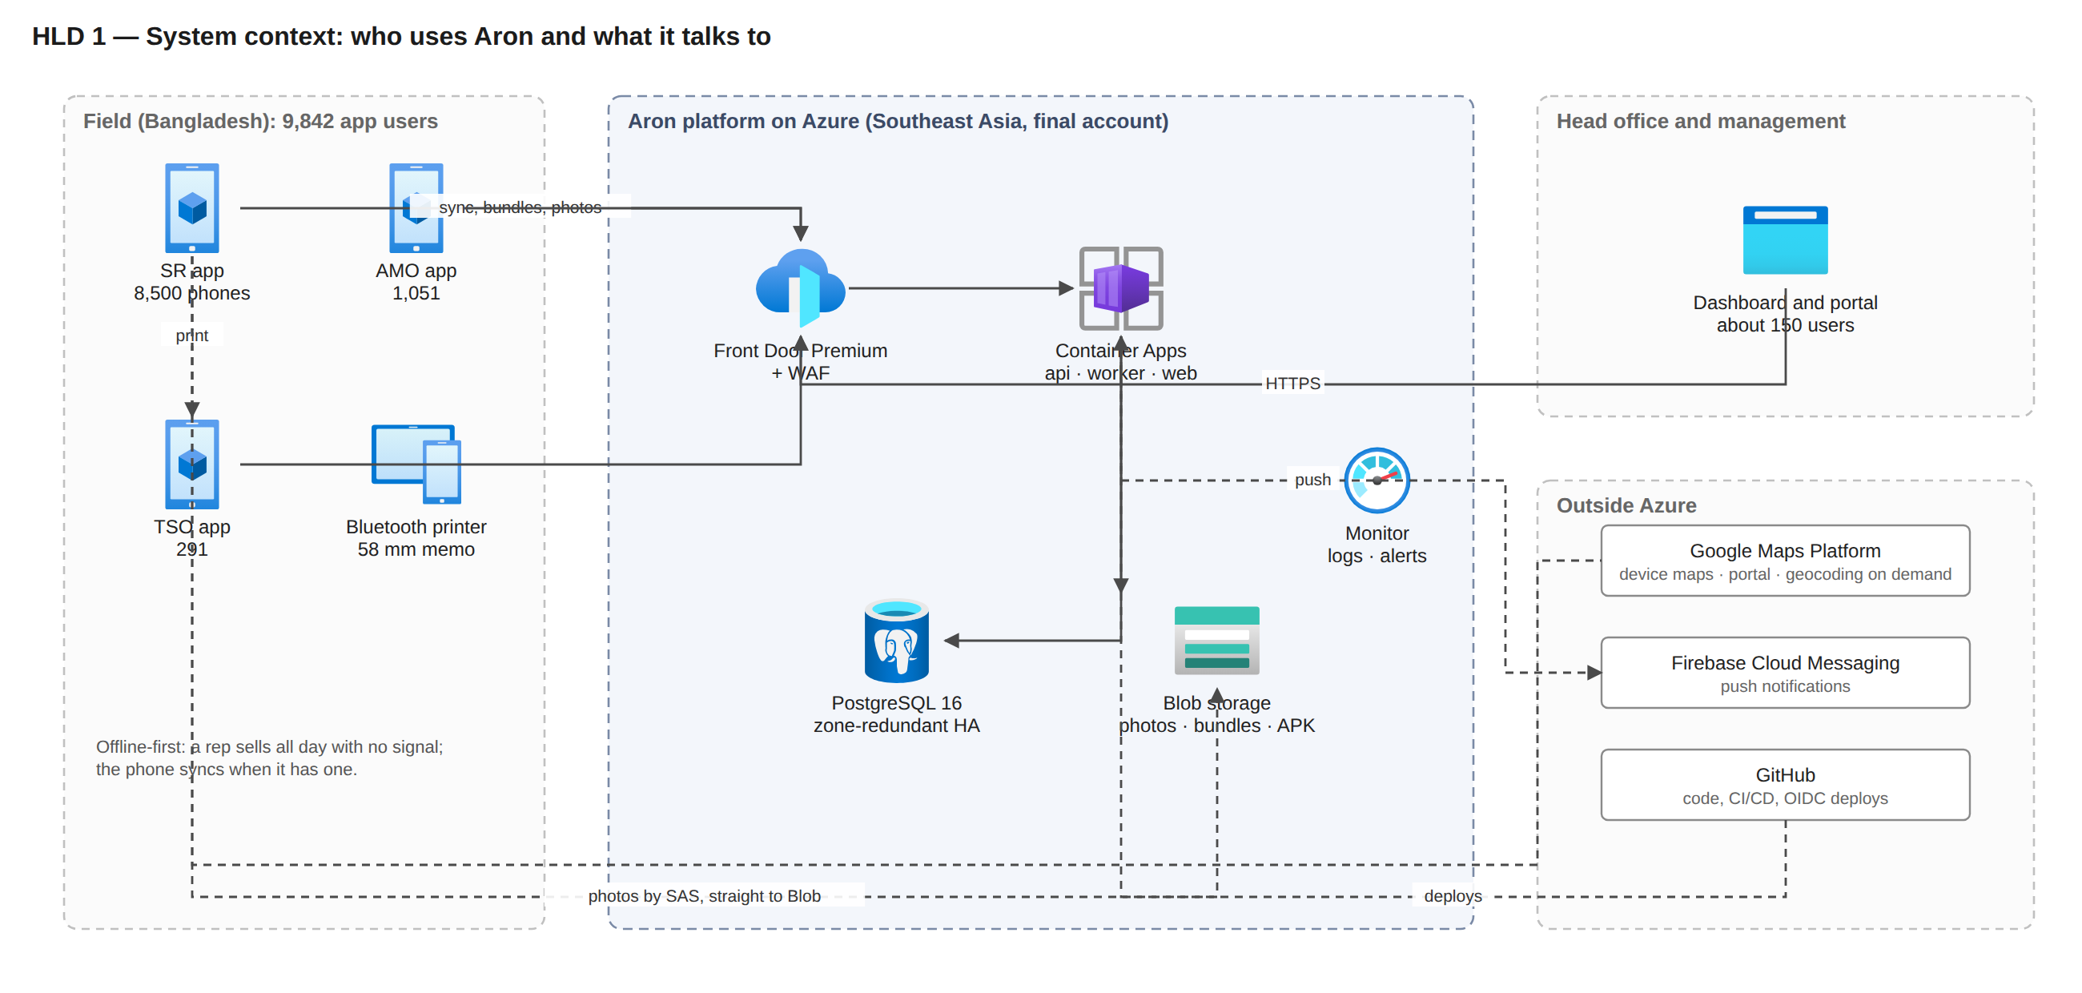
Figure HLD 1. Who uses Aron and what it talks to. Phones sync through Front Door and upload photos straight to Blob by SAS; Google Maps, Firebase and GitHub are outside Azure.
Outside the Azure bill but part of the system: Google Maps Platform (device maps, the portal map once its key is wired, on-demand geocoding; per-key quota and budget alert), Firebase (free tier at this volume), GitHub Actions, the field printers and the phones.

4. Logical architecture (level 1, containers)
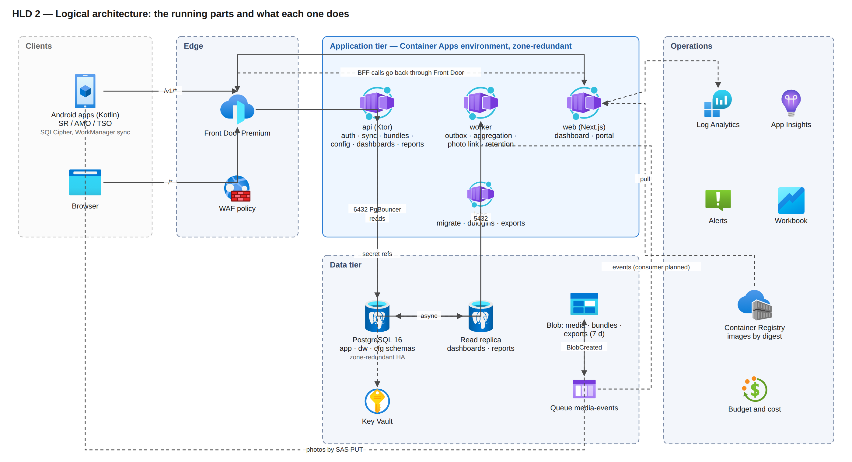
Figure HLD 2. The running parts. The web tier's server-side calls go back through Front Door like every other client.
Container | Responsibility | Why it is separate
api | Login and device binding, token refresh, sync ingest, route bundles, config delta, dashboards and reports, admin portal API, small media uploads (feedback and support JPEGs) | The one thing that must never be slow; stateless so it scales horizontally and survives a zone loss.
worker | Reads the domain-event outbox and recomputes daily aggregates (dw), risk signals, route-day planning, the server geo re-check sweep, retention and partition upkeep; the photo-queue consumer and export jobs are planned | Keeps heavy and bursty work off the request path; scales on backlog depth once the designed KEDA rules exist.
web | Next.js dashboard and admin portal (69 pages), server-side rendering, backend-for-frontend | Different runtime, release cadence and scaling (readers, not reps).
jobs | migrate (Flyway, before any app revision changes), dblogins (per-app PostgreSQL logins), export jobs (designed) | Run-to-completion work must not live in a long-running replica.
PostgreSQL | System of record: schemas app (visits, memos, lines, outlets, routes, devices, config tables app.cfg_*), dw (daily aggregates, stable dw.v_* views), stg (imports) | One relational store keeps idempotency, money and scope rules in one place; the dw layer is the product other dashboards reuse.
Blob + queue | Photos (direct SAS upload), route bundles (container created; bundles are built live today), report exports (7-day expiry); photo events in a queue | Bytes stay out of the database and the API.

5. Azure deployment architecture (level 2, final account)
Region: Southeast Asia (Singapore), the nearest region to Bangladesh with three availability zones and every needed feature (SSD v2, zone-redundant HA, Private Link, geo backup). DR: East Asia (Hong Kong). A latency bake-off against Central India is planned before the move (D-422); the choice changes only if Dhaka-to-Pune is at least 25 % faster, and the cost figures would then be re-priced.
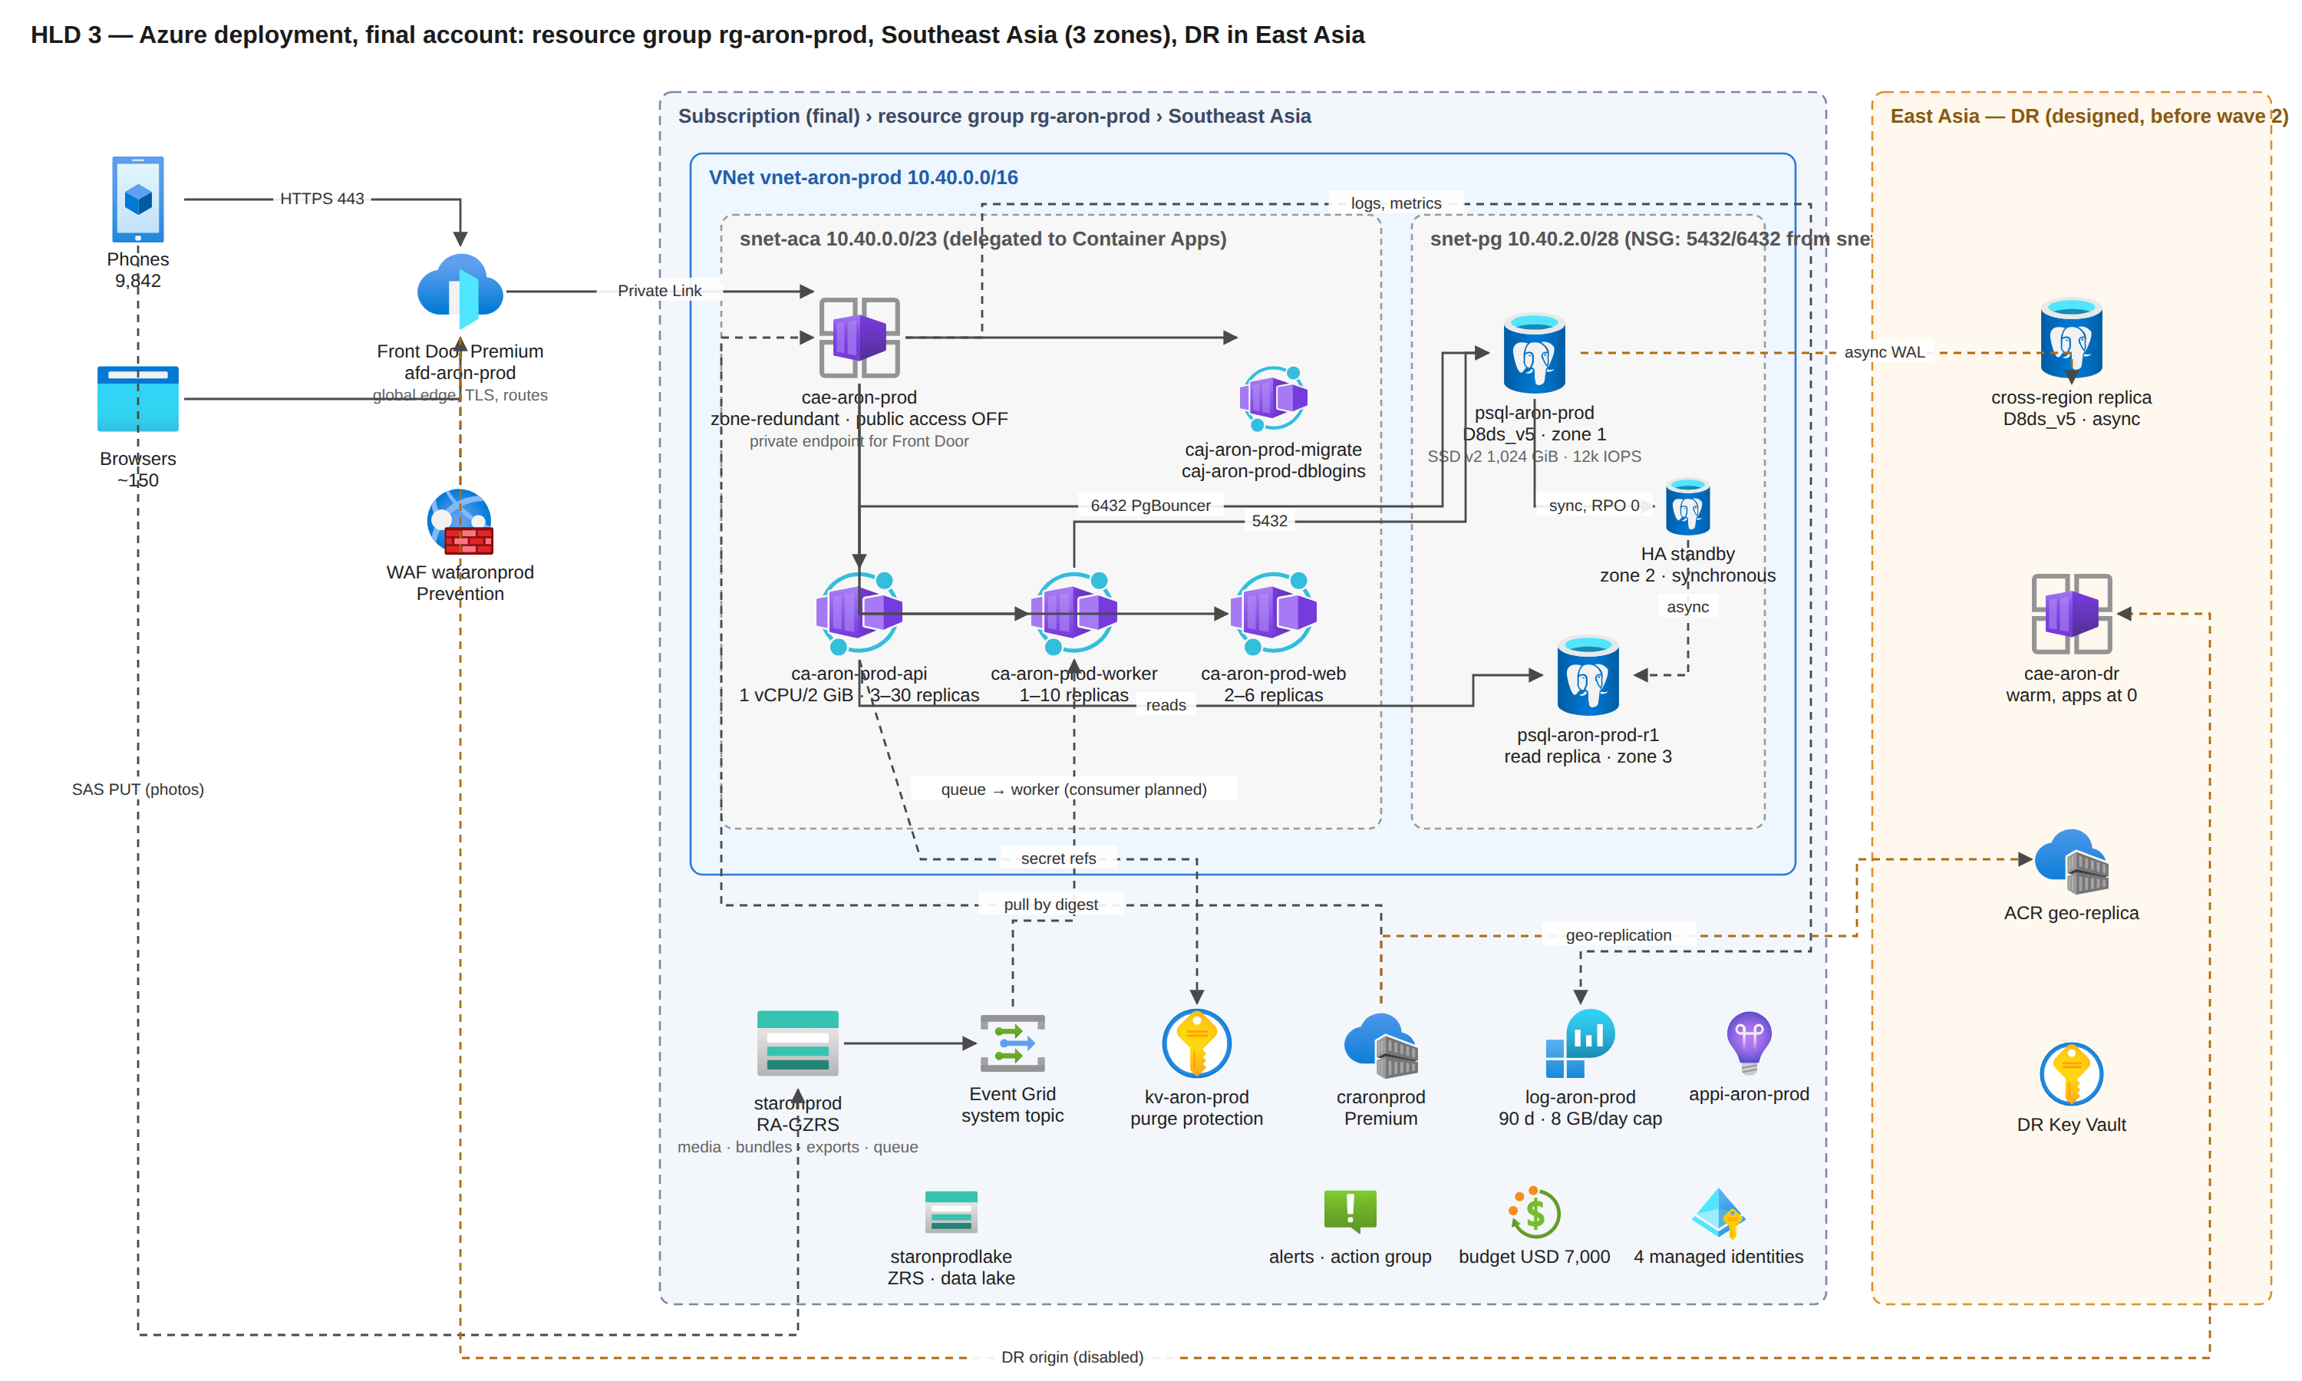
Figure HLD 3. One resource group in Southeast Asia; the East Asia tier is designed and not yet in a template.
Reading the picture: the only public entrance to the application is Front Door; the Container Apps environment refuses public traffic and is reached over Front Door's managed Private Link; PostgreSQL has no public address at all. Storage, Key Vault and the registry keep Entra-protected public endpoints today, with private endpoints planned as hardening after wave 1 (02-low-level-design.md section 2).

6. Key runtime flows

6.1 A sale, offline, then synced (the critical path)
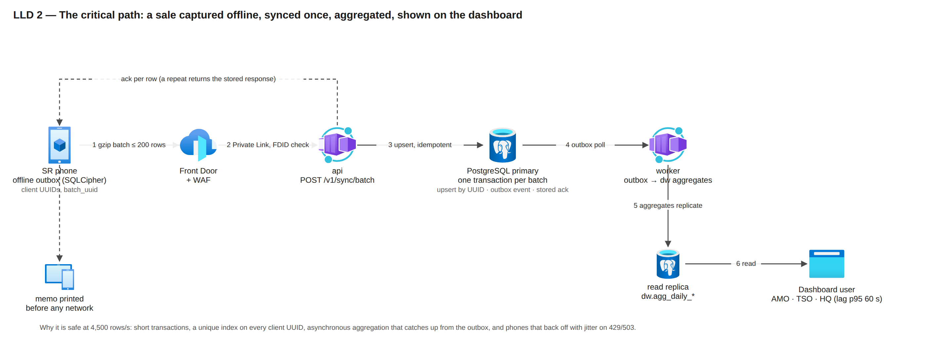
Figure LLD 2. One gzip batch, one short transaction, idempotent by client UUID, aggregated asynchronously, read by AMO, TSO and head-office users.
Why this is safe at 4,500 rows/s: the ingest is one short transaction per batch (no queue to lose), idempotency is a unique index on the client UUID, the aggregation is asynchronous and catches up from the outbox, and the phones back off with jitter when the API sheds load (429 "too fast", 503 "shedding", both retryable). The accepted acknowledgement latency at the 17:00 spike is p95 8 s for a 200-row catch-up batch and 12 s at the 8,000 rows/s gate; the trickle target is 1.5 s.

6.2 Morning bundle (the other storm)
Phones wake between 06:15 and 07:45. Each refreshes its token, downloads one gzip bundle (SR median 25 KB, AMO about 90 KB, TSO about 300 KB) and checks the release channel. The API is pre-scaled to 8 replicas from 06:15 (a cron scale rule) and the autoscaler doubles replicas every 15 s up to 30. Bundles are built live by the API with a per-replica delta cache (1,024 snapshots per replica), so with many replicas most delta requests rebuild the full bundle; pre-generated bundles in Blob (planned, F-SYS-067) are the first scale lever if the load test asks for it.

6.3 Photo upload
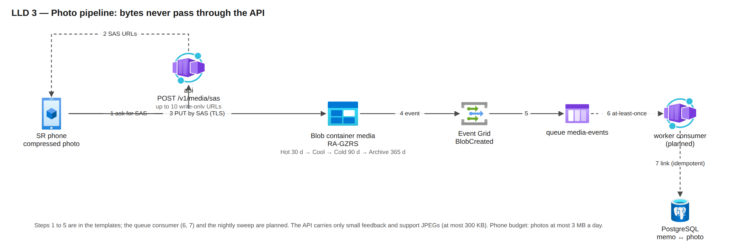
Figure LLD 3. Steps 1 to 5 are in the templates; the queue consumer and the nightly sweep are planned.
The app asks the API for up to ten write-only SAS URLs, uploads straight to Blob (compressed on the phone, mobile-data budget 3 MB a day), and Blob raises a BlobCreated event into a Storage queue. The worker consumer that links the photo to its memo is planned (today the photo row stays pending until it exists); the API carries only small feedback, support and portal JPEGs (at most 300 KB).

6.4 Configuration change from the portal to 8,500 phones
An admin saves a setting in the portal; the API writes the config table with an audit row and bumps the config version; every API response carries X-Config-Version; a phone that sees a newer version pulls a delta on its next natural request. Scheduled values (for example an app-blocking window) are stored on the device and applied offline.

6.5 Zone failure of the database
The standby in zone 2 is synchronous (RPO 0). On failure Azure promotes it under the same name; the API's readiness probe checks the database only, so replicas are not restarted; the apps retry with the same batch_uuid. Documented 60–120 s at size; about 30 s user-visible measured once on the small dev server.

6.6 Region outage
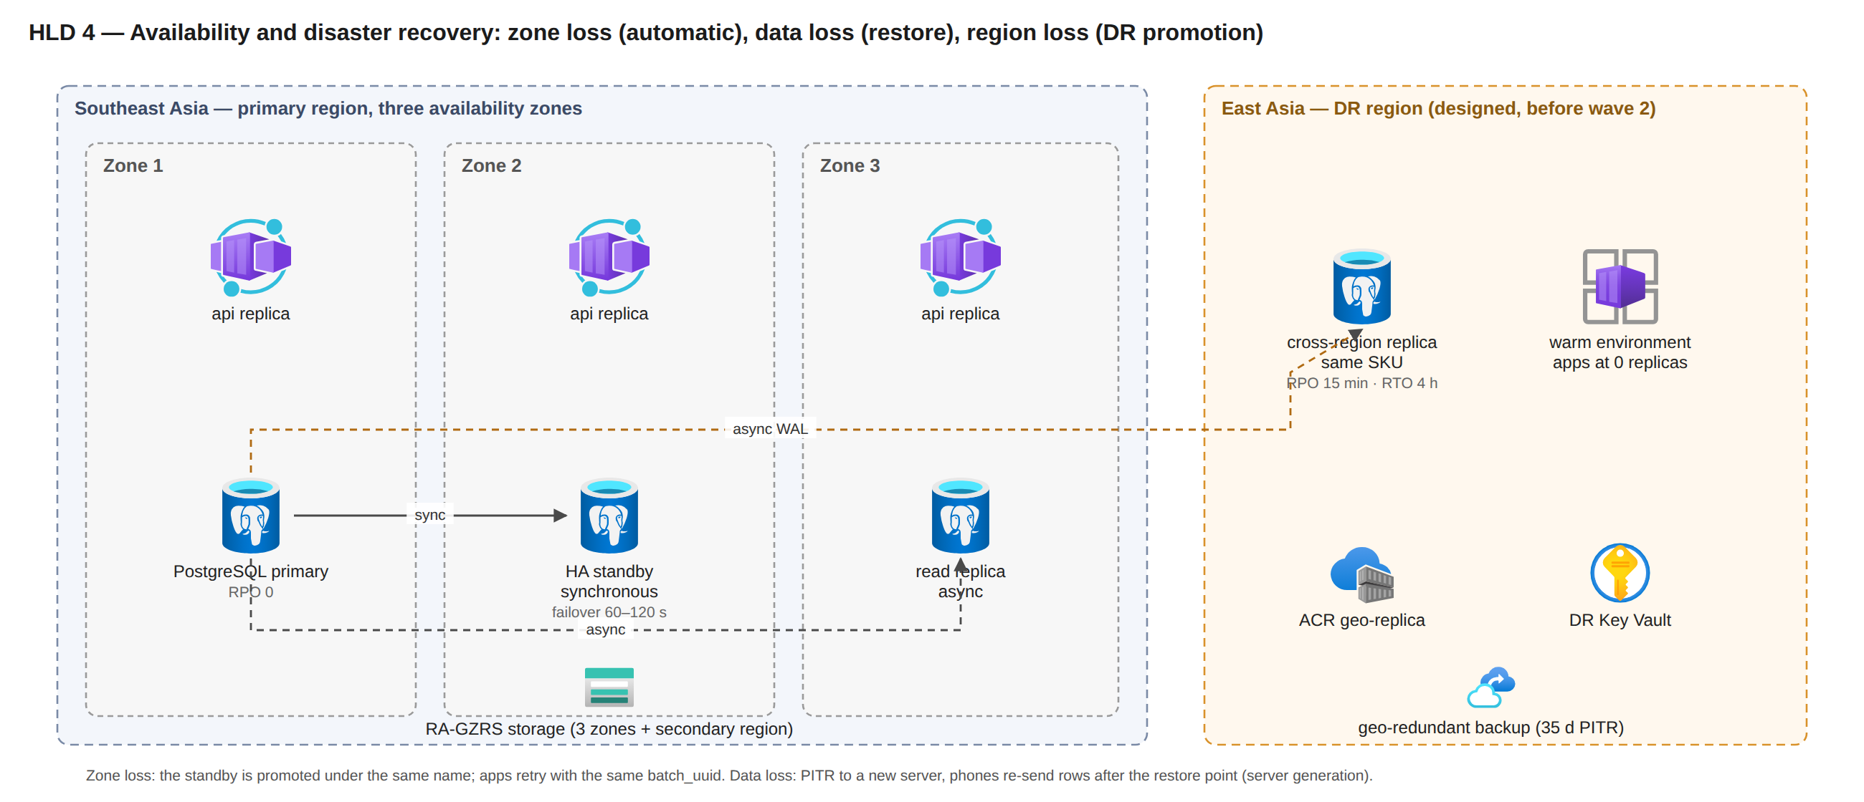
Figure HLD 4. Zone loss is automatic; data loss is a restore; region loss is a DR promotion once the East Asia tier exists.
Before the DR tier: geo-restore of the latest geo-redundant backup into East Asia (RPO about 1 h, RTO to be measured in a timed drill). Target state (before wave 2): forced promotion of the East Asia replica (loss = replication lag, alert above 5 min), a new server generation published to the phones so they re-send anything acknowledged after the restore point, apps scaled up in the warm environment from the registry geo-replica, Front Door switched to the DR origin. Budget 3 h 30 min inside the 4 h RTO; phones keep selling throughout and hold up to 3 days of rows.

7. Capacity: demand against what is provisioned
Tier | Provisioned (final parameters) | Capacity | Peak demand | Headroom | Status
API | 1 vCPU / 2 GiB replicas, min 3, pre-scaled 8 at the storms, max 30; deployed trigger: 50 concurrent requests per replica | design rule 30 requests/s per replica (docs/18): 240 req/s pre-scaled, 360 at 12, 900 at max | 131 req/s expected, 400 design-for | 1.8 × pre-scaled on the expected peak; 2.3 × at max on the design-for peak; the 50-concurrent trigger fires later than the design rule and must be calibrated in S1–S10 | IaC; final-only proof
Database writes | D8ds_v5, 8 vCores, 32 GiB, 12,000 IOPS (cap 12,800), built-in PgBouncer | gate probe 8,000 rows/s; 1.5 × fleet at 5,000 rows/s | 4,500 rows/s for 60 s; 3,333 rows/s burst, 1,667 sustained | 1.8 × on the spike; step-up to D16ds_v5 (same disk, in place) if the load test shows CPU above 80 % or IOPS above about 7,700 | IaC; final-only proof
Database reads | D8 replica, zone 3 | 150 queries/s budget | about 50 light + 0.5 heavy queries/s | 3 × | IaC template; final-only
Connections | 10 write + 10 read per API replica → 300 + 300 at max, pooled by PgBouncer (20 server connections per login) | transaction-mode pooling | 30 replicas | fits; max_connections on D8 confirmed at first deploy | IaC
Worker | 1 vCPU / 2 GiB; deployed 1 replica with no scale rule; designed KEDA to 10 | as deployed about 66 dirty keys/s; with the designed rules about 660/s | about 340 dirty keys/s at the 17:00 spike | as deployed 0.2 × (the backlog clears in minutes, not seconds); designed 1.9 × | IaC (1 replica); scaling designed
Web | 0.5 vCPU / 1 GiB, 2–6 replicas, 50 concurrent each | not derived; S5 (1,500 readers) is the proof | 25 pages/s pessimistic (portal readers are about 150 + 291 TSO; AMOs read through the API) | unproven | IaC; final-only
Edge | Front Door Premium, global | Microsoft-scale | 400 req/s | not a constraint | IaC
Storage | RA-GZRS account | 40,000 requests/s per account | 50 PUT/s photos, 5 SAS/s | not a constraint | IaC
Disk | 1,024 GiB SSD v2, no autogrow | 972 GiB usable | 2.8 GB a day → 70 % (680 GiB) at about day 243 | grow to 2,048 GiB at month 6 (manual, online) on primary, replica and DR replica; alert at 70 % in IaC, 60 % and 90 % designed | IaC alert (70 %)

Honest reading: the platform is designed for these peaks with 1.8–3 × headroom at the API and database tiers and a defined step-up at each; the worker needs its designed scale rule before wave 1; the web tier's capacity is unproven. It is proven only when scenarios S1–S10 of docs/18 section 8 run in the final account (the test account cannot host fleet size by sponsor rule). The first three stable trading days of every rollout wave are the live proof before the next wave.

8. Availability and recovery targets
RPO (recovery point objective) is how much data could be lost; RTO (recovery time objective) is how long selling is interrupted on the server side. Phones keep selling in every case below.
Failure | Mechanism | RPO | RTO | Status
Phone offline | offline-first, outbox with UUIDs | 0 | none (selling continues) | IaC; tested at unit level and in the slice smoke
API replica or zone lost | zone-redundant environment, min 3 replicas, probes | 0 | seconds | IaC; never drilled
Database zone lost | zone-redundant HA, automatic promotion | 0 | 60–120 s | IaC; measured once on a small server
Bad deploy | Multiple revisions, health gate returns traffic; redeploy by digest | 0 | seconds to 15 min | IaC; no rollback drill yet
Bad migration or data loss | PITR to a new server (35 days), server generation re-sync | to the restore point | 2 h (assumed) | IaC procedure; runbook written, never run
Region outage before the DR tier | geo-redundant backup, geo-restore into East Asia | about 1 h | unmeasured (timed drill planned) | backup IaC; runbook not yet written
Region outage, target | cross-region replica, warm environment, DR origin | 15 min | 4 h | designed
Blob loss in region | RA-GZRS, soft delete 14 d | geo-lag | read from secondary | IaC

SLO: 99.9 % availability of auth, sync and day-close calls 07:00–21:00 Dhaka on working days (25 minutes a month; the 06:15–07:00 start of the storm is outside the window and is reported separately); batch ack p95 1.5 s (trickle, ≤ 50 rows) and 8 s (catch-up, 200 rows), bundle p95 2 s, dashboards p95 1 s, aggregation lag p95 60 s, sync success 99.5 %, reconciliation mismatch ≤ 0.1 %.

9. Security architecture (summary)
Layer | Control | Status
Edge | Front Door Premium: TLS 1.2+, WAF in Prevention (managed rule set in Log mode for one wave on real payloads, then Block), bot manager, per-IP backstop 60,000 requests per 5 minutes (carrier NAT puts thousands of phones behind one IP), method allow-list; the API rejects any request without the Front Door ID header | IaC
Network | No public ingress to the application; PostgreSQL on a delegated private subnet with an NSG allowing only the app subnet on 5432/6432; peer traffic encryption in the environment | IaC; private endpoints for Key Vault, registry and Blob designed
Identity | Phones: password + device binding (OTP seen by the TSO) + attestation; admins: TOTP MFA; refresh-token families with reuse detection; lockout per username, device and IP class | IaC
Token signing | ES256 key held as a Key Vault secret today; a non-exportable key in a signing vault with 24-hour per-replica delegations | IaC (secret); signing vault designed
Authorisation | Seven portal levels and the field roles; reach derived on the server from role and assignment and encoded in the token; the client never sends scope IDs | IaC (application level); row-level security designed
Data | TLS everywhere; SQLCipher on the phone; money in integer milli-taka; audit log append-only with a hash chain | IaC; PII envelope encryption (schema exists, no writer) and the WORM audit export designed
Secrets | Only in Key Vault and GitHub secrets (OIDC, no stored cloud credentials); Container Apps secret references; a missing secret fails start-up by name only | IaC; per-secret RBAC designed (today every app identity can read the whole vault)
Database logins | per-app logins (app_api, app_jobs, app_bi, lake_export) built and proven in dev | off in the prod parameters until the owner flips dbPerAppLogins before the first real user
Anti-spoofing | Mock-location detection, implausible-track checks on the device and re-checked on the server at sync; flags surfaced to the TSO | IaC

10. Environments and delivery
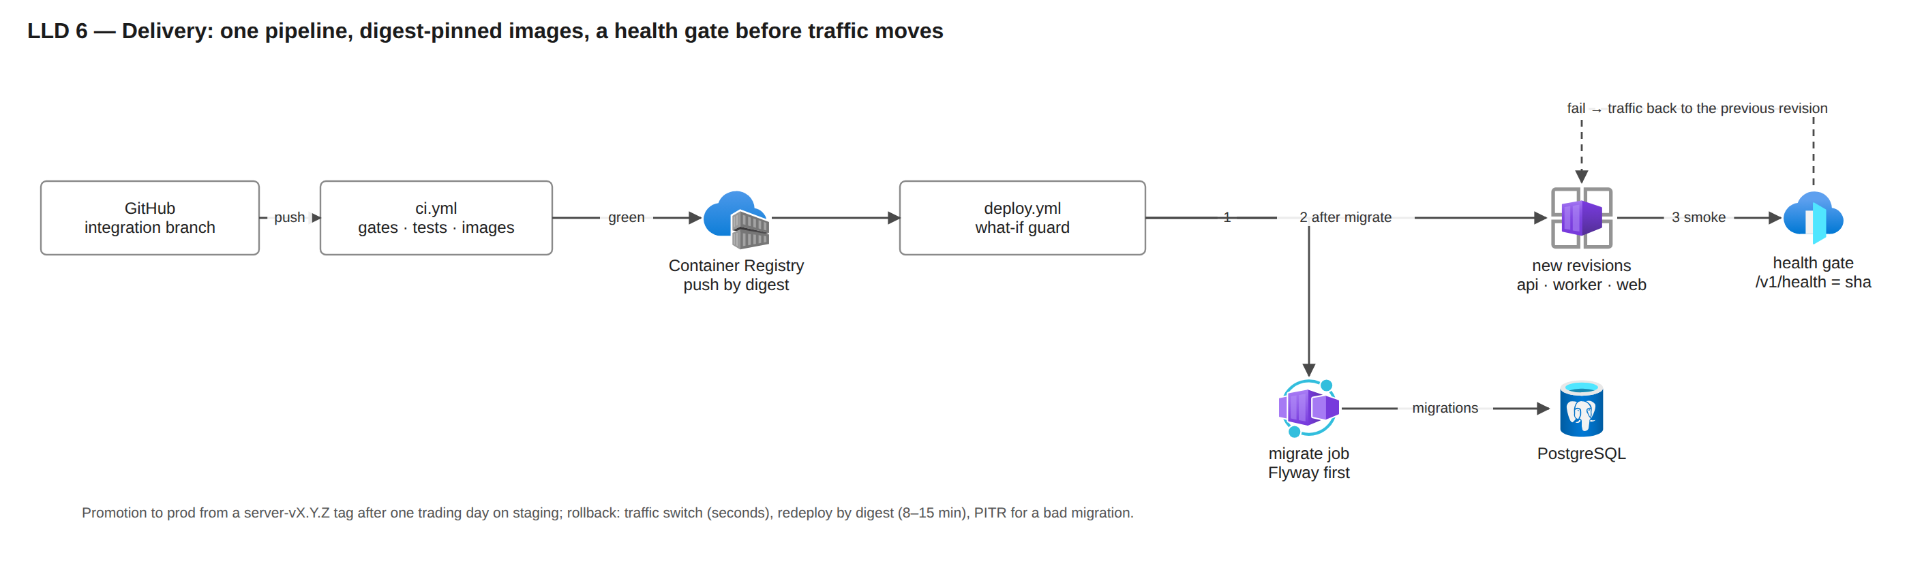
Figure LLD 6. One pipeline, digest-pinned images, migrations first, a health gate before traffic moves.
The same Bicep deploys every environment; only the parameter file differs (dev*.bicepparam versus stage/prod). Staging in the final account is parameters only today: the committed stage file is prod-shaped, the deploy script and the backend settings do not yet accept stage, and a staging-lite parameter file is a prerequisite before the load-test windows. The move to the final account is "new subscription + prod parameters + data restore" (docs/setup/move-to-final-account.md). Rollout to 8,500 reps is in waves (pilot 10–20 routes; wave 1 one territory per wing; then one division per wing; half the fleet; the rest), with a next-wave gate on login rate, reconciliation mismatch, sync success and crash rate.

11. What is proven where
Claim | Proven in the test account | Needs the final account
Idempotent sync, offline day, memo print, dashboard tile | yes (slice smoke on every deploy; device lab) | fleet-size rates
Zone-redundant topology, VNet-injected environment, HA failover | rehearsed at D2 size (sponsor exception, docs/28); one failover measured | D8 size
Front Door Premium with Private Link, environment with public access off, managed WAF rules on real payloads | never run at any size (dev ran Standard without Private Link) | pilot on prod with managed rules in Log mode
400 req/s, 8,000 rows/s, 1,500 readers | no (sponsor rule: no fleet-sized resources in the test account) | load-test windows S1–S10
Point-in-time restore, geo-restore, DR promotion | RB-14 written and never run; RB-52 and RB-13 not yet written | timed drills on staging
Cost | dev about USD 15 a day measured | first invoices

02 — Low-level design (LLD): every Azure resource, its settings and why
Part of the owner pack docs/35-final-azure-design-pack/. Each row names the resource as the production templates create it (infra/main.bicep, infra/apps.bicep, infra/modules/*.bicep, infra/params/prod.bicepparam, infra/params/prod.apps.bicepparam), the specification, a short justification, and whether it is in the templates (IaC) or designed. The monthly cost of every row is in 03-resource-plan-and-cost.md; quantities and the "why this quantity" column are in 04-precise-version.md. Names end in a six-character suffix derived from the resource group (<s>), omitted here except where the suffix sits in the middle of a name. Deeper evidence per setting is in docs/33-final-azure-architecture/part-b-low-level-platform.md. Corrected on 2026-10-29 after review against the templates.

1. Resource catalogue with specification and justification
# | Resource (name) | Specification | Why this specification | Status
1 | Resource group rg-aron-prod | one group per environment, Southeast Asia, tags project=aron, environment=prod, owner=aktcl, managed-by=bicep | one blast radius, one cost view, one RBAC boundary for the deploy identity | IaC (group created by bootstrap)
2 | Virtual network vnet-aron-prod | 10.40.0.0/16; snet-aca 10.40.0.0/23 (delegated to Container Apps); snet-pg 10.40.2.0/28 (delegated to PostgreSQL); stage 10.41, dev 10.51, DR 10.42 (moved from the 10.41 of docs/18 because stage uses it) | a /23 gives 512 addresses for up to about 250 replica IPs during a revision swap; PostgreSQL needs its own delegated subnet for private access; distinct ranges allow peering later | IaC
3 | Network security groups …-snet-pg-nsg, …-snet-aca-nsg | pg NSG, three rules: allow 5432/6432 from snet-aca (100), allow subnet-internal (110, HA replication), deny VirtualNetwork to PostgreSQL (4000); other sources fall to the platform default deny; aca NSG: Azure defaults | the database accepts connections only from the application subnet, which blocks lateral movement from any other workload placed in the VNet later | IaC
4 | Private DNS zone …private.postgres.database.azure.com + VNet link | one zone, one link | required for private-access Flexible Server name resolution from the apps | IaC
5 | Container Apps environment cae-aron-prod | workload-profiles environment, Consumption profile, zone-redundant, VNet-injected into snet-aca, publicNetworkAccess Disabled, peer traffic encryption on, Front Door Private Link connection (a managed private endpoint approved by the deploy script), maxInactiveRevisions 5 | zone redundancy spreads replicas across three zones so one zone loss costs capacity, not availability; disabling public access means the only way in is Front Door's Private Link; Consumption billing means idle hours cost almost nothing | IaC
6 | Container App ca-aron-prod-api | image backend by digest; 1 vCPU / 2 GiB; JVM -XX:MaxRAMPercentage=75 (heap ceiling about 1.5 GiB) and ExitOnOutOfMemoryError; min 3, max 30; HTTP scale rule 50 concurrent requests per replica; cron pre-scale to 8 replicas 06:15–10:00 and 16:45–20:00 Dhaka; revisions mode Multiple (previous revision kept at 0 % traffic); probes: startup GET /v1/health (delay 5 s, every 5 s, up to 30 failures, about 155 s), liveness (10 s, 3 failures), readiness /v1/health/ready (database only); env from Key Vault references; ARON_FRONT_DOOR_ID header check | 1 vCPU / 2 GiB is the smallest step that holds a Ktor JVM at 150–300 requests/s a vCPU; min 3 = one replica per zone; max 30 = 900 requests/s, 2.3 × the design-for storm; pre-scaling removes cold-start and JIT warm-up from the two daily storms; Multiple revisions give a seconds-fast rollback | IaC (the 50-concurrent trigger is to be calibrated in S1–S10)
7 | Container App ca-aron-prod-worker | same image, role worker; 1 vCPU / 2 GiB; min 1, max 10; no ingress; jobs: aggregation from the outbox, risk signals, route-day planning, geo re-check sweep (every 10 min), retention and partition upkeep (every 6 h), outlet-request lapse; KEDA rules (PostgreSQL outbox depth, target 200 rows per replica; Storage queue length, 100 per replica) and the photo-queue consumer | aggregation is bursty (check-out) and must never run inside the request path; backlog-based scaling drains a 30-minute outage (38,000 rows) in about a minute at 10 replicas | IaC (1 replica, no scale rule); KEDA rules and the queue consumer designed
8 | Container App ca-aron-prod-web | Next.js image; 0.5 vCPU / 1 GiB; min 2, max 6; HTTP rule 50 concurrent; its backend-for-frontend calls reach the api through Front Door (ARON_API_BASE_URL = the Front Door host), so they pass the WAF and the per-IP backstop from the environment's shared egress address | server-rendered pages are light; two replicas for zone spread; the portal audience is about 150 head-office users plus 291 TSOs (AMOs read in their app) | IaC (16:45 pre-scale designed; check the BFF rate against the 200 req/s per-IP backstop in S5)
9 | Container Apps Jobs caj-aron-prod-migrate, caj-aron-prod-dblogins (+ export jobs designed) | migrate: Flyway image by digest, manual trigger, timeout 1,800 s, retry 0, runs before any app revision changes; dblogins: psql 16 image, timeout 300 s, creates the per-app logins; exports: concurrency 8, role app_export, results in Blob | migrations and login grants are run-to-completion steps that must not sit in a serving replica; large Excel exports (over 10,000 rows) must not starve the API | IaC (exports designed; today exports above 10,000 rows return 503)
10 | PostgreSQL Flexible Server psql-aron-prod | PostgreSQL 16; GeneralPurpose Standard_D8ds_v5 (8 vCores, 32 GiB); zone-redundant HA (primary zone 1, standby zone 2); Premium SSD v2 1,024 GiB, 12,000 IOPS, 300 MB/s (12,000 IOPS and 500 MB/s are included with a disk of 400 GiB or more; only IOPS above 12,000 would cost extra, and the D8 cap is 12,800), autogrow disabled (SSD v2 has none); backup retention 35 days, geo-redundant; built-in PgBouncer (transaction mode, default_pool_size 20, query_wait_timeout 5 s) on 6432; private access only; maintenance window Friday 01:00–02:00 Dhaka; extensions allow-listed: btree_gist, pgcrypto, pg_stat_statements, pg_trgm, PostGIS (PostGIS and pgcrypto are not used yet) | D8 is the first SKU whose IOPS cap (12,800) covers the 12,000 IOPS the write peaks need and whose 8 vCores hold the 8,000 rows/s gate with CPU under 80 %; zone-redundant HA gives RPO 0 and automatic failover; SSD v2 decouples size from IOPS so the disk is bought for a year's data, not for its IOPS; 1,024 GiB covers the first six months with the grow to 2,048 GiB planned at month 6 (any history loaded later is headroom; the Apsis migration itself is out of scope); 35-day PITR covers a month-end discovered late; geo backup is the wave-1 region-outage fallback; PgBouncer keeps 600 client connections to about 40 server connections | IaC
11 | PostgreSQL read replica psql-aron-prod-<s>-r1 | same SKU and disk, zone 3, asynchronous, own PgBouncer, own parameters | dashboards, reports, exports and BI read here, so readers never compete with 8,500 writers; the same SKU because WAL replay is single-threaded and a smaller replica falls behind at the 17:00 peak | IaC template; the pipeline cannot create it as it stands (the parameter defaults to true, nothing forwards ARON_PG_READ_REPLICA, and the what-if guard refuses a second server): fix before the first prod deploy (docs/33 B13.2 rows 36, 37)
12 | Database aron | UTF8, en_US.utf8; schemas app (operational tables and the config tables app.cfg_*), dw (aggregates and the stable dw.v_* views, contract 1.2), stg (imports); monthly partitions on the fact tables; the retention job creates the next three partitions and prunes the ingest registry at 45 days; migrations V0001–V0122 | one database keeps idempotency, money and scope rules transactional; partitions keep the hot set small and make retention a drop, not a delete | IaC + migrations
13 | Storage account staronprod | StorageV2, Standard_RAGZRS, Hot; TLS 1.2; shared key off; public blob access off; CORS rule for browser uploads; containers media (photos under photos/<business_date>/<device_uuid>/<media_uuid>.jpg, support files, feedback), bundles (created; bundles are built live today), exports (report exports, deleted after 7 days); queue media-events (message TTL 7 days); soft delete 14 days; lifecycle: photos to Cool at 30 days, Cold at 90 days, deleted at 730 days; support files deleted at 30 days; bundles at 3 days. The Archive tier is not available on RA-GZRS | RA-GZRS keeps evidence photos readable even in a region outage (three zones plus a readable secondary region); the tiers cut the stored-data cost of photos by about 70 % (net about 24 % after the tier-move operations, see 03); SAS-only writes keep keys out of the apps | IaC (a WORM audit-export container with 7-year retention is designed)
14 | Data-lake account staronprodlake | StorageV2, Standard_ZRS, hierarchical namespace, container lake, soft delete 14 days; nightly Parquet export of the dw.v_* views and archived partitions; worker identity only | BI and archive reads come from files, never from the live database; ZRS because the lake holds partitions past the 13-month hot window | IaC (the sponsor's written yes to ZRS is still open, docs/28; the writer is planned)
15 | Event Grid system topic evgt-aron-prod-storage | BlobCreated on media/photos/ → queue media-events; 30 delivery attempts, event TTL 24 h | at-least-once delivery with an idempotent consumer; no Service Bus (ingest is synchronous, photo events need no ordering) | IaC (the consumer is designed)
16 | Key Vault kv-aron-prod | Standard; RBAC authorisation; soft delete 90 days; purge protection on; secrets (names only): aron-jwt-signing-key, aron-jwt-kid, aron-mfa-key, aron-web-session-secret, aron-fcm-service-account, aron-play-integrity-service-account, aron-db-admin-password, aron-db-url / -direct-url / -read-url, the per-app aron-db-pw-app-* and aron-db-*-url, the lake and BI secrets | purge protection makes a wrong delete recoverable for 90 days; Container Apps secret references mean the code has no vault client; a missing secret fails start-up naming only the variable | IaC (a separate signing vault with a non-exportable EC P-256 key and 24-hour per-replica delegations, an Argon2 pepper secret and per-secret RBAC are designed)
17 | User-assigned identities id-aron-prod-api, -worker, -web, -migrate | all four: AcrPull and Key Vault Secrets User at vault scope; api: Storage Blob Data Contributor and Storage Blob Delegator on the account; worker: Storage Blob Data Contributor, Storage Queue Data Message Processor, and Blob Data Contributor on the lake account | one identity per process so a role can be tightened without touching the others; each app template references only its own secrets | IaC (per-secret vault RBAC designed; today every identity can read the whole vault)
18 | Container Registry craronprod | Premium, zone-redundant, admin user off, untagged manifests purged after 30 days | Premium is the only tier with zone redundancy, private link and geo-replication; 500 GiB included | IaC (geo-replica to East Asia designed)
19 | Front Door profile afd-aron-prod | Premium_AzureFrontDoor; endpoint fde-aron-prod-<s>.azurefd.net (custom domain when AKTCL names one); routes /v1/* → origin group og-api, /* → og-web; origins = the Container Apps environment over Private Link; probes og-api HEAD /v1/health every 60 s, 3 of 4 samples; og-web HEAD / every 100 s, 3 of 4; origin response timeout 60 s (the API answers in 25 s itself) | Premium is required for Private Link origins and the managed WAF rule sets; a global anycast edge terminates TLS close to Dhaka and absorbs volumetric attacks; one hostname for phones and browsers | IaC (APK route and caching designed)
20 | WAF policy wafaronprod | mode Prevention; managed Microsoft_DefaultRuleSet 2.1 in Log action for the first wave, then Block; Microsoft_BotManagerRuleSet 1.1; exactly two custom rules: per-IP rate backstop 60,000 requests / 5 min and a method allow-list; request-body check on; gzip bodies are not inspected; the 1 MiB compressed / 8 MiB decompressed batch limit is enforced by the API, not the WAF | real sync payloads must be observed before managed rules block them (a false positive on /v1/sync would stop uploads); the IP backstop is high because carrier NAT puts thousands of phones behind one address, so the real limits are per device and per user inside the API | IaC
21 | Log Analytics workspace log-aron-prod | PerGB2018; retention 90 days; daily cap 8 GB; diagnostic settings from Key Vault, ACR, PostgreSQL, Container Apps environment, Front Door (access + WAF), Storage blob and queue, the lake | 90 days covers a quarter-end investigation; the cap protects the bill from a logging bug; design volume 5.5 GB/day | IaC (an alert at 80 % of the cap is designed)
22 | Application Insights appi-aron-prod | workspace-based, Java agent 3.7.10 pinned by hash in the image; release annotations after each deploy | traces and dependency timings without code changes; annotations line up incidents with releases | IaC
23 | Alert rules and action group ag-aron-prod | IaC: five log-search alerts: batch5xx (more than 1 % 5xx on /v1/sync/batch in 5 min, Sev1), batchP95 (p95 above 3 s, Sev2), dashboardsP95 (above 1 s, Sev3), syncErrors (Sev2), aggregationStuck (3 or more worker errors in 15 min, Sev2); PostgreSQL metric alerts: CPU above 80 % for 15 min, storage above 70 %, failed connections, server not alive (Sev1); app alerts: api 5xx, restarts, no replica; Resource Health and recovery; budget 50/90/100 %; e-mail receivers. Designed: replication lag 5/12 min, Front Door origin health, WAF blocks on /v1/sync, sync success, aggregation lag (metric not emitted yet), storage 60 % and 90 %, Log Analytics cap at 80 %, Service Health (needs subscription Reader), SMS and voice | each alert maps to a runbook; thresholds come from the capacity table so an alert means "act now" | IaC + designed as listed
24 | Workbook "Aron operations" | six Application Insights tiles: sync batches per 5 min (total and 5xx), batch latency p50/p95, errors by logger, aggregation failures, slowest endpoints (p95), latest errors | one screen for the war room during rollout waves | IaC (database, edge/WAF, cost and quota workbooks designed)
25 | Budget budget-aron-prod | USD 7,000 a month in the template; alerts at 50, 90, 100 % actual and 100 % forecast; raise to the recommended figure in 03 once the DR tier and the buffer are approved | an early warning that is independent of any alert rule | IaC
26 | GitHub OIDC deploy identity | federated credential for the azure-prod environment; roles on the resource group only: Contributor, AcrPush, Key Vault Secrets Officer, Role Based Access Control Administrator (scoped) | no stored cloud credentials anywhere; the pipeline cannot touch other groups | IaC (bootstrap)

Designed, not yet in a template (DR tier and hardening)
Resource | Specification | Why | When
Cross-region replica psql-aron-prod-dr (East Asia) | D8ds_v5, same disk tier, asynchronous; lag alerts at 5 and 12 minutes | RPO 15 min, RTO 4 h for a region outage without a second writer | before wave 2
Warm environment cae-aron-dr (East Asia) | zone-redundant, VNet 10.42.0.0/16, apps at 0 replicas, same images and secrets | promotion in under 4 h needs the environment to exist already | before wave 2
ACR geo-replica, DR Key Vault, DR Front Door origin (disabled; readiness requires pg_is_in_recovery() = false) |  | pulls and secrets available when Southeast Asia is not | before wave 2
Private endpoints for Key Vault, ACR, Blob (snet-pe 10.40.3.0/24) | three endpoints, private DNS zones | closes the last public endpoints; SAS uploads from phones stay on the public Blob endpoint by design | hardening after wave 1
Signing vault kv-aron-sign, PII key vault, per-secret RBAC, Argon2 pepper | non-exportable EC P-256 key, sign only; envelope-encryption keys for NID, TIN and trade licence | a key that cannot leave the vault; a web replica that cannot read the database secret | before wave 2
WORM audit-export container, 7-year retention | immutable daily export of the hash-chained audit log | tamper-evident record | before wave 2
Worker KEDA rules, photo-queue consumer, nightly photo sweep, export jobs, pre-generated bundles | see rows 7, 9 and 15 | the first items to prove or build in the final account | before wave 1
Staging-lite parameter file; deploy.sh and Settings.kt accepting stage | D2 HA, Standard Front Door; prod shape only inside a test window | the release gate and the drills need a deployable twin | before the load-test windows
Azure Policy, resource locks, Defender for Cloud | deny public PostgreSQL, deny non-ZRS storage, CanNotDelete locks on data | subscription-scope guard rails the final-account owner applies once | at the move
Azure Load Testing resource | 26 engines for 12,750 virtual users (40 requested); Locust scripts S1–S10 | the 8,500-user proof | final account only

2. Network design
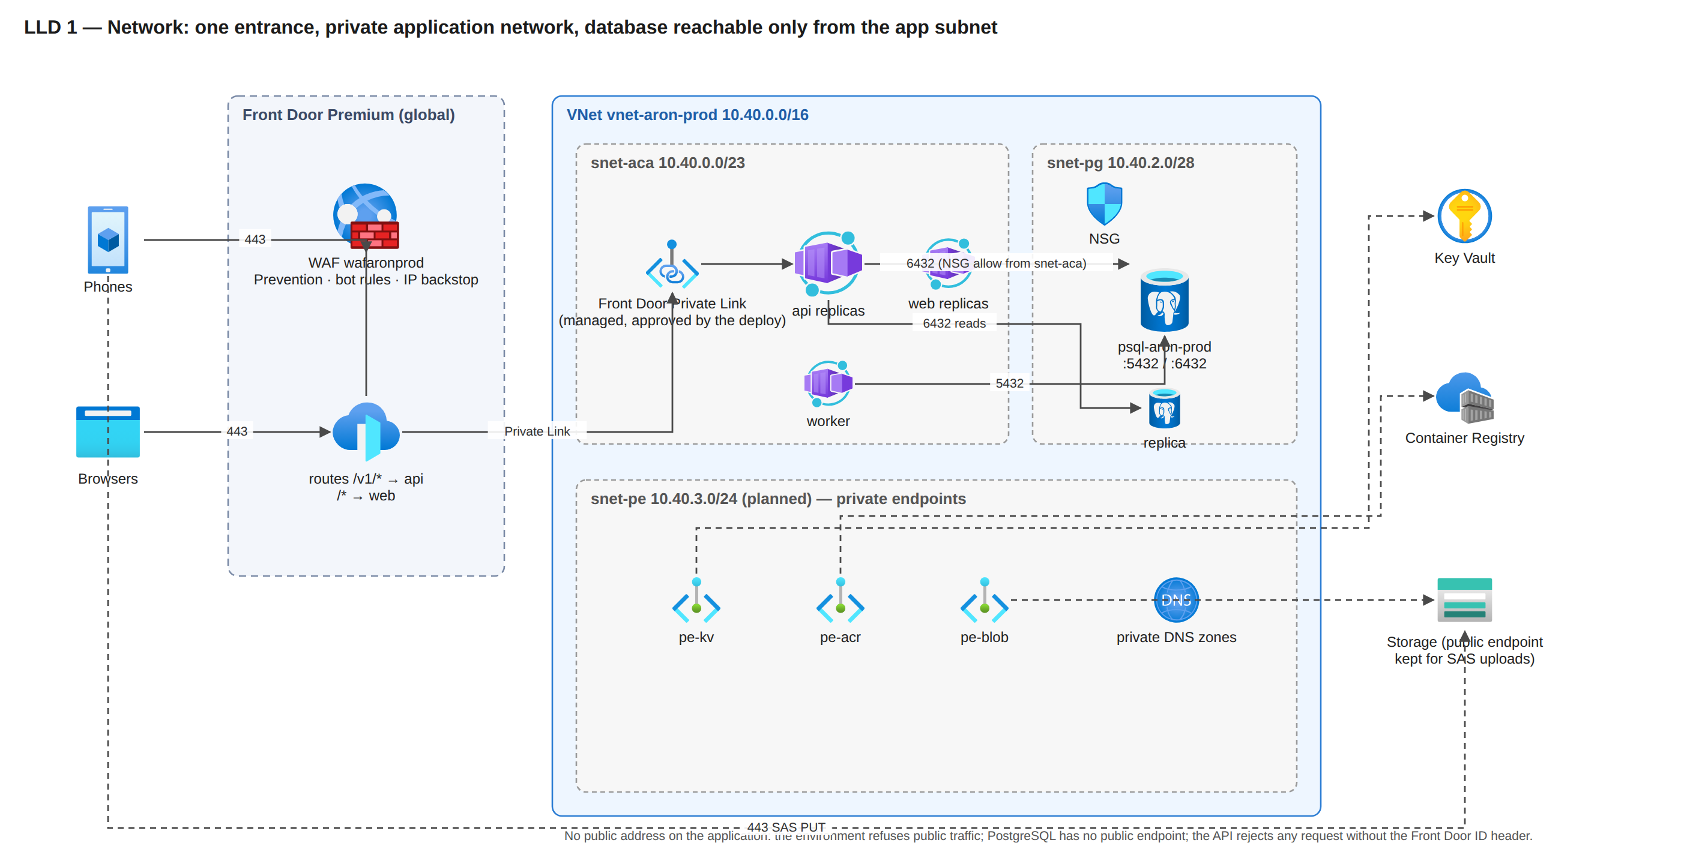
Figure LLD 1. One entrance; the application network has no public address; the database is reachable only from the app subnet. The snet-pe endpoints are planned.
Item | Setting | Why
Address plan | prod 10.40.0.0/16, stage 10.41.0.0/16, dev 10.51.0.0/16, DR 10.42.0.0/16 | non-overlapping so peering or a hub is possible later; DR moved to 10.42 because stage already uses 10.41
Ingress | only Front Door → managed Private Link → environment; environment publicNetworkAccess Disabled | a leaked origin address is useless to an attacker: the environment refuses anything that does not arrive over the Private Link
East-west | NSG on snet-pg (three rules, row 3); the environment encrypts peer traffic | a compromised replica of another workload could not open a database socket
Egress | Container Apps default outbound (platform SNAT) to Azure services (Key Vault, Blob, ACR, Event Grid), to Front Door for the BFF, and to Firebase; no NAT gateway unless a partner needs a fixed IP | nothing in the design needs an allow-listed source address
DNS | private zone for PostgreSQL; Azure-provided DNS otherwise; private zones for the planned endpoints | private resolution without a custom resolver
TLS | TLS 1.2 minimum at Front Door, Storage and PostgreSQL (require_secure_transport on); managed certificate on the custom domain when named | no plaintext anywhere
Header pinning | the API returns 403 unless X-Azure-FDID equals the profile id (health endpoints excepted for probes) | even a request that reaches the origin by another path is refused

3. Edge design (Front Door and WAF)
Setting | Value | Why
Origin groups | og-api: HEAD /v1/health over HTTPS every 60 s, 3 of 4 samples healthy, latency sensitivity 50 ms; og-web: HEAD / every 100 s, 3 of 4 | separate health so a web issue never fails over API traffic
Routes | /v1/* → api, HTTPS only, HTTP redirected; /* → web; /apk/* → Blob (designed) | one hostname; the APK channel from the edge once the container exists
Timeouts | origin response 60 s; the API's own request timeout is 25 s | the API always answers first with its own JSON envelope, so phones never see an edge HTML error for a slow request
Rate limits | WAF custom rule: 60,000 requests / 5 min per IP (backstop); API: per device and per user limits, in-flight limiter per replica, 429 "too fast" and 503 "shedding", both retryable | per-IP limits would punish whole carriers; the real protection is per device inside the API
Managed rules | DRS 2.1 in Log for the first wave on real payloads, then Block; Bot Manager 1.1 | avoid blocking legitimate sync bodies before they have been observed
Body limit | API: 1 MiB compressed, 8 MiB decompressed (a batch is at most 200 rows, about 12 KB gzip); the WAF does not inspect gzip bodies | anything larger than a batch is not a phone
Egress billing | edge-to-client bytes are billed on cache hits too; the billing zone is that of the serving edge (zone 2 assumed; Indian edges are zone 5) | caching the APK does not save egress; it only saves origin load
Logging | access and WAF logs to Log Analytics | every blocked request is reviewable
Propagation | about 15 minutes per configuration change | the deploy script waits up to 45 minutes on the azurefd.net host before smoke

4. Compute design (Container Apps)

4.1 Request pipeline in api
Every request passes, in order: the Front Door id check; the per-replica in-flight limiter; authentication (token verification, device binding, role); scope derivation (reach from role and assignment, never from the client); validation (envelope, units, money in milli-taka, business date in Asia/Dhaka); one transaction through PgBouncer on 6432; the outbox event and the stored response; the JSON envelope with X-Config-Version and the request id.

4.2 Replica profile over a trading day
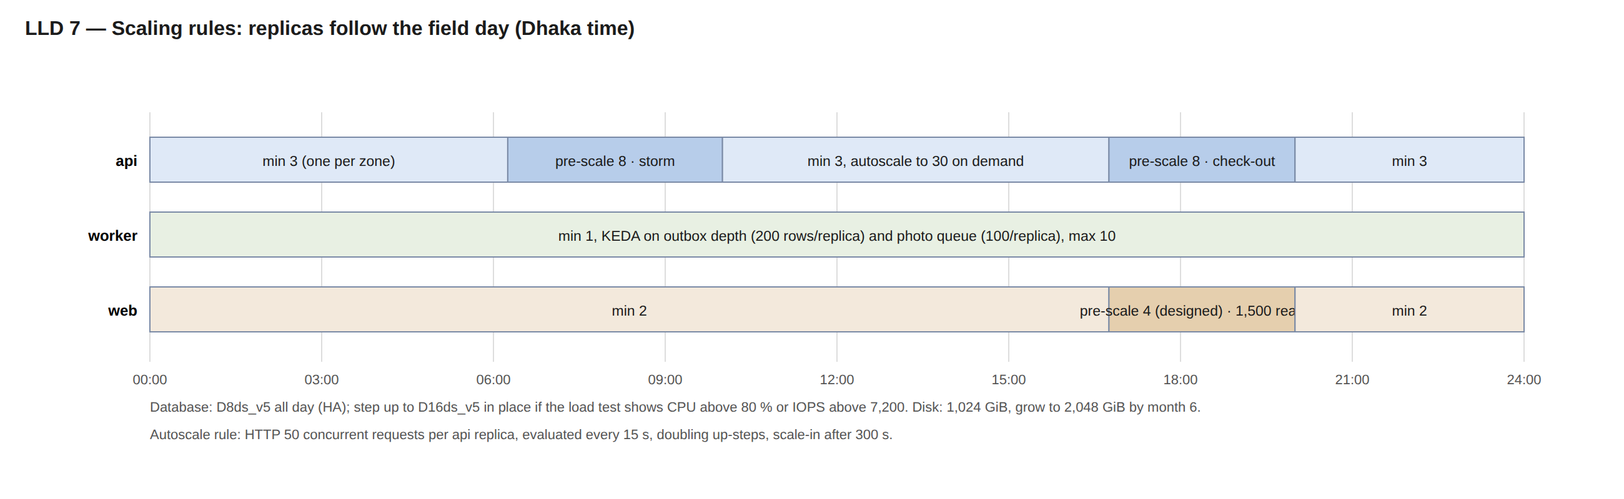
Figure LLD 7. The api follows the field day; the worker scales on backlog once its rules exist; the web pre-scale at 16:45 is designed.
App | Setting | Value | Why
api | resources | 1 vCPU, 2 GiB; JVM MaxRAMPercentage=75 (heap ceiling about 1.5 GiB), ExitOnOutOfMemoryError; no explicit collector flag (verify with -Xlog:gc at the first load test) | one vCPU per replica scales in small steps; about 0.5 GiB stays for metaspace and threads
api | scale rule | HTTP 50 concurrent requests per replica (deployed); design rule 30 requests/s per replica; evaluated every 15 s; up-step doubles; scale-in after 300 s | fast out, slow in, designed to damp flapping; the concurrency value is calibrated in S1–S10
api | pre-scale | cron 06:15–10:00 and 16:45–20:00 → 8 (lever: 12 on wave mornings, about USD 45 a month if used on 20 mornings) | removes JIT and cold start from the storms
api | probes | startup GET /v1/health delay 5 s, every 5 s, up to 30 failures (about 155 s); liveness every 10 s, 3 failures; readiness /v1/health/ready database only | a database hiccup marks replicas unready, never restarts them
api | revisions | Multiple; previous revision 0 % traffic; health gate in the deploy moves traffic back on failure | rollback in seconds
api | pools | 10 write (primary 6432) + 10 read (replica 6432) per replica; PgBouncer transaction mode; no named prepared statements; SET LOCAL inside transactions only | 600 clients at max fit in 40 server connections
worker | scale | min 1, max 10; KEDA postgresql (outbox rows / 200) and azure-queue (messages / 100) designed; deployed today with no rule (1 replica) | backlog, not HTTP, is the signal
worker | polling | own queue every 5 s; KEDA polls every 30 s | trickle backlog stays near zero
web | resources | 0.5 vCPU, 1 GiB; Node.js; BFF calls the api through Front Door | no public API calls from the browser; the BFF is subject to the WAF and the per-IP backstop
jobs | migrate | runs first in every deploy; a failed migration stops the deploy before any revision changes | schema and code never diverge
all | images | pulled by digest from the Premium registry with the app identity (AcrPull) | no latest, no credentials
all | secrets | Key Vault references → environment variables (or <NAME>_FILE) | the code has no vault client; a missing secret fails start-up naming only the variable

4.3 Capacity quota to request in the final subscription
Quota | Request | Arithmetic
Container Apps Consumption cores, prod environment | 100 | replica maxima api 30 + worker 10 + web 3 + migrate 0.5 = 43.5 vCPU (51 with the designed export jobs); a revision swap briefly adds up to 30 → 100 / 73.5 = 1.4 ×
Container Apps cores, stage environment | 100 during test windows | same shape
Managed environments | Southeast Asia: prod + stage = 2; East Asia: DR = 1 | one per environment and region
PostgreSQL General Purpose Ddsv5 vCores, Southeast Asia | 40 (prod alone) or 64 (stage in the same subscription) | prod 8 primary + 8 standby + 8 replica = 24; a restore-drill server 8; stage 8 + 8 + 8 in a test window; zonal access to be requested with it
PostgreSQL vCores, East Asia | 24 | replica 8; after promotion 8 + 8 standby
Azure Load Testing engines | 40 concurrent, 40 per run, 24 h test duration | 26 engines at 12,750 users; 30 at 1.5 × 9,842 app users

5. Database design
Area | Setting | Why
Server parameters (IaC) | PgBouncer enabled, default_pool_size 20, query_wait_timeout 5; log_min_duration_statement 500 ms; track_io_timing on; idle_in_transaction_session_timeout 30 s; Query Store capture top; extensions allow-listed (row 10) | protects the primary from runaway sessions; gives the war room query evidence
Server parameters (designed) | work_mem 16 MB, maintenance_work_mem 512 MB, wal_compression on, pg_stat_statements.track, max_connections and autovacuum tuning after the first load test | set once the load test shows the real profile
Statement timeouts (migration V0020, per role) | api 15 s, web 60 s, worker 10 min, jobs 30 min, BI 10 min | a runaway query cannot hold a pool slot
HA | zone-redundant, synchronous standby, automatic failover; the application reconnects through the same hostname; failover drill RB-02 (one run on dev, about 30 s user-visible) | RPO 0 and an exercised path
Connection pooling | built-in PgBouncer, transaction mode, 20 server connections per login and database; api on 6432; worker, migrate and jobs on 5432 | ten thousand phones must not become ten thousand server connections
Logins and privileges | aronadmin (deploy); per-app logins app_api, app_jobs (used by the worker), app_bi (read on dw.v_* only), lake_export, created by the dblogins job with passwords in Key Vault; `dbPerAppLogins` is off in the prod parameters, so api and worker connect as aronadmin until the owner flips it before the first real user; row-level security designed | least privilege; a BI credential can never see raw PII
Schemas | app (operational tables, config tables app.cfg_*, audit, device registry), dw (aggregates and 8 stable dw.v_* views, contract 1.2), stg (imports) | the dw layer is the reusable product for later dashboards
Idempotency | unique index on every client UUID; sync_batch.response stores the ack; a repeat of the same batch_uuid within 24 h replays the stored response | a retried or duplicated upload never creates a second sale
Partitioning and retention | monthly partitions on visits, memos, lines, attendance, locations; the next three partitions created ahead every 6 h; ingest registry pruned at 45 days; app hot window 13 months, dw 25 months; archived partitions exported to the lake (writer planned) | keeps the hot set and the indexes inside RAM; retention is a partition drop
Money, units, dates | money integer milli-taka; quantities in base units with pack_factor; timestamptz UTC plus business_date in Asia/Dhaka on every transaction | no floating-point money, no time-zone bugs at midnight
Geo | lat/lng index plus haversine distance in the api; server geo re-check sweep in the worker every 10 min; PostGIS allow-listed for later | the same arithmetic as the device, re-checked on sync
Backup and restore | PITR 35 days, geo-redundant; restore always to a new server; server-generation re-sync tells phones to re-send rows acknowledged after the restore point; verification checklist (counts, control totals, audit chain, memo gaps) after every restore | data loss is bounded and visible, and the phones heal the gap
Growth | 2.8 GB a day; alert at 70 % in IaC (60 % and 90 % designed); grow to 2,048 GiB at month 6 online on primary, replica and DR replica | SSD v2 has no autogrow and the server goes read-only at 95 %
Maintenance | custom window Friday 01:00–02:00 Dhaka (the weekly off day); Azure may still apply emergency patches outside it | patches never land on a trading morning by plan
Step-up rule | D16ds_v5 (16 vCores, 64 GiB, cap 25,600 IOPS) when the load test or two consecutive peaks show CPU above 80 % or IOPS above about 7,700 (60 % of the D8 cap); compute scales in place with one short failover | the next step is a parameter change, not a redesign

6. Storage design
Container / queue | Content | Access | Lifecycle | Why
media | photos photos/<business_date>/<device_uuid>/<media_uuid>.jpg, support bundles, feedback and portal JPEGs | phones write with one-blob, write-only SAS (10 per request); api and worker read with identity | Cool 30 d → Cold 90 d → deleted 730 d; support files deleted 30 d; soft delete 14 d | evidence must survive two years, cheaply
bundles | daily route bundles (gzip) | api (writer planned; bundles are built live today) | deleted after 3 days | a bundle is only valid for its day
exports | report exports | export jobs (designed) | deleted after 7 days | results are collected within the week
audit-export (designed) | daily hash-chained audit export | worker writes once; immutable (WORM), 7-year retention | none | tamper-evident record
apk (designed) | signed per-ABI APKs for the in-house channel | Front Door cached reads; SHA-256 verified on the phone | old releases kept 90 days for a rescue release | 8,500 phones update from the edge, not from Play
queue media-events | BlobCreated events | Event Grid writes; worker reads (consumer designed) | message TTL 7 d; event TTL 24 h, 30 attempts | decoupled photo linking

7. Identity, access and secrets
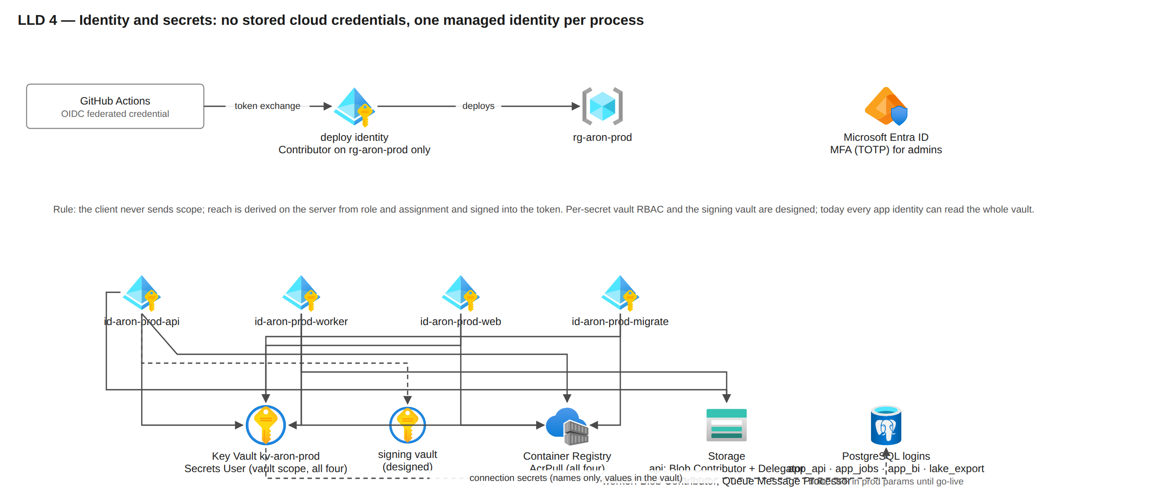
Figure LLD 4. No stored cloud credentials; one managed identity per process; the signing vault and per-secret RBAC are designed.
Human access: portal roles Super Admin, Admin (per-module grants), National, Brand, Wing Manager, DMO, TSO; admins log in with password + TOTP MFA; every admin action writes an audit row. Azure access: the final-account owner is Owner at the subscription; the team gets Reader plus the deploy pipeline; no standing Contributor for people.

8. Observability and alerting
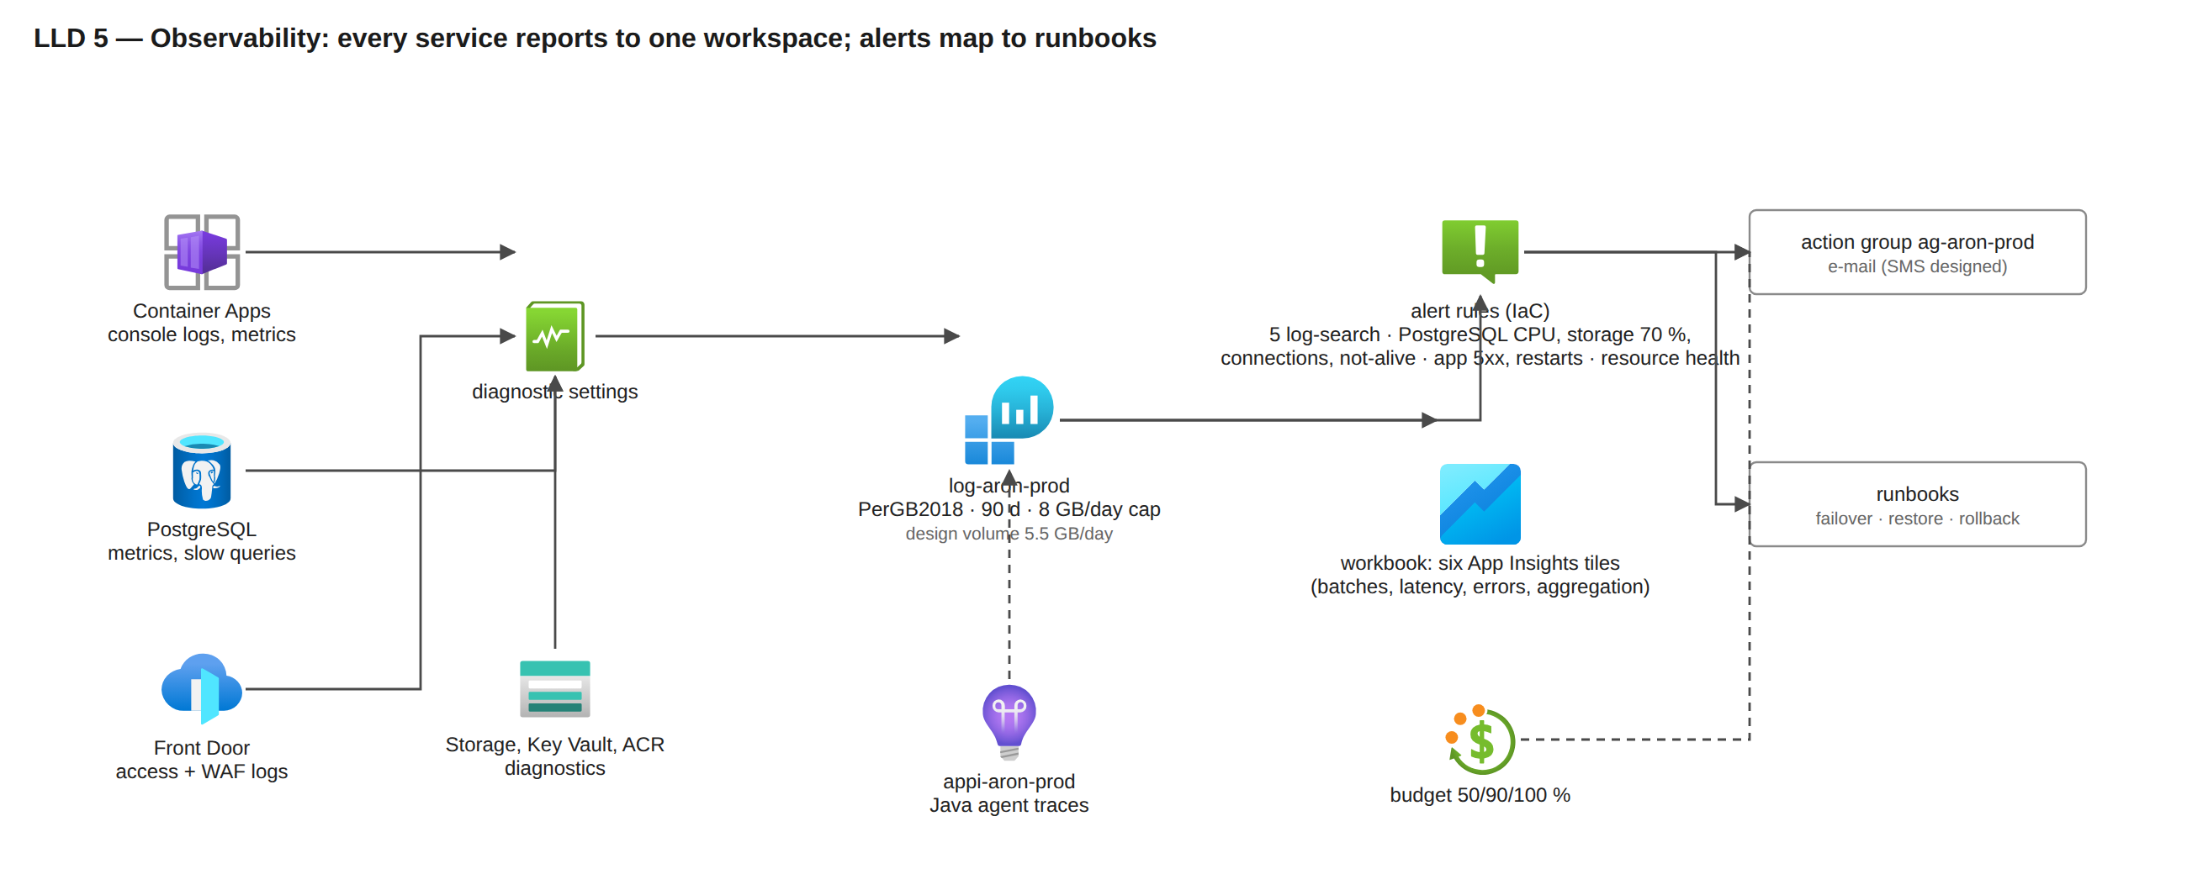
Figure LLD 5. Every service reports to one workspace; the alerts in the templates are listed in row 23, the designed ones beside them.
Signal | Source → sink | Alert (IaC unless marked)
Sync batch 5xx and latency | api JSON log lines; App Insights requests | batch5xx > 1 % in 5 min → Sev1; batchP95 > 3 s → Sev2
Dashboards | App Insights | dashboardsP95 > 1 s → Sev3
Sync errors, aggregation | api and worker logs | syncErrors → Sev2; aggregationStuck (3 worker errors in 15 min) → Sev2; aggregation-lag metric alert designed
Database | platform metrics | CPU > 80 % for 15 min → Sev2; storage > 70 %; failed connections; server not alive → Sev1; replication lag 5/12 min designed; storage 60 % and 90 % designed
Apps | Container Apps metrics | api 5xx, restarts, no replica
Edge | Front Door access + WAF logs | origin health and WAF-block alerts designed
Platform | Resource Health (and recovery); Service Health designed (needs subscription Reader) | any → Sev2
Cost | budget | 50/90/100 % → e-mail
Business | sync-health dashboard reads PostgreSQL, not logs | a log cap can never blind the war room

Telemetry budget: about 5.5 GB a day (request lines about 300 B each × 0.5 M, platform diagnostics, sampled traces); cap 8 GB; retention 90 days.

9. Delivery pipeline
Promotion to production is from a server-vX.Y.Z tag through promote-prod.yml with the same steps against the prod parameters, after staging has run the release for one trading day (once staging is deployable). Rollback paths: traffic switch (seconds), redeploy by digest (8–15 min), PITR for a bad migration (restore to a new server, never in place). Figure LLD 6 is in 01-high-level-design.md section 10.

10. Operations: runbooks and drills
Runbook | Trigger | Steps (summary) | Status | Drill cadence
RB-02 database failover | zone loss or planned | observe automatic promotion; confirm readiness; check PgBouncer pools; record RTO | written; drilled once on dev (about 30 s) | monthly on staging
RB-14 point-in-time restore | bad migration or data corruption | restore to a new server at time T; verification checklist; repoint secrets; mint a server generation; phones re-send; keep the old server read-only 7 days | written; never run (waits for the owner's phrase) | monthly on staging
RB-13 region outage | Service Health + probes agree for 15 min | forced promotion of the East Asia replica; new generation; scale the warm environment; enable the DR origin; reconcile | not yet written | twice a year and before wave 2
RB-52 geo-restore (before the DR tier) | region outage before the replica exists | geo-restore into East Asia (RPO about 1 h); then as RB-13 | not yet written | timed once on staging before wave 1
Rollback bad deploy | health gate fails or Sev1 after release | traffic to the previous revision; redeploy by digest | written; every deploy exercises the gate; no manual drill yet | every release
Disk grow | 70 % alert | grow SSD v2 online to 2,048 GiB on primary, replica and DR replica | designed | once at month 6
Kill switch | bad app build | min_version blocks a new day's login; blocked_versions blocks new captures; uploads of captured rows are never blocked | built; tested in the device lab | per release

Of about 54 runbooks in the plan, four are written (RB-01, RB-02, RB-14, rotate-mfa-key); the rest are designed.

11. Moving from the test account to the final account
- Final-account owner: subscription, resource groups rg-aron-stage and rg-aron-prod, quota requests (section 4.3), Azure Policy and locks, the deploy identity's federated credential, GitHub environment variables (AZURE_LOCATION, AZURE_RESOURCE_GROUP, ARON_ALERT_EMAILS to a monitored address, ARON_NAME_SUFFIX).
- Prerequisite fixes before the first prod deploy: a staging-lite parameter file and stage accepted by deploy.sh and Settings.kt; the read-replica creation path (ARON_PG_READ_REPLICA forwarded, what-if guard exception); dbPerAppLogins flipped to true before the first real user; the worker scale rule.
- Pipeline: deploy stage, run the slice smoke, run the load-test windows S1–S10 against staging scaled to the prod shape, run the failover and restore drills, record the measured RTO and RPO.
- Deploy prod (first deploy without the replica, second with it after the first backup), seed reference data and users, enrol the pilot phones; run the pilot with the managed WAF rules in Log mode to prove the edge path on real traffic.
- Waves: pilot → wave 1 → DR tier built → wave 2 → 3 → 4, each behind the next-wave gate.
Details and the exact commands: docs/setup/move-to-final-account.md.

12. Known gaps at 2026-10-29 (from docs/33 B13.2)
Gap | Severity | Section | Owner
Per-app database logins off in the prod parameters (api and worker run as the admin login) | high | 5 | owner flips before the first real user
Staging not deployable (parameter file prod-shaped; stage not accepted by the deploy path) | high | 10 | infra lane
No DR tier in a template | high | 1 | infra lane, before wave 2
Photo-queue consumer and nightly sweep not built (photo rows stay pending) | high | 6 | backend lane, before wave 1
JWT signing key exportable (a secret, not a vault key) | high | 7 | backend + infra, before wave 2
No row-level security in PostgreSQL (application-level scope only) | medium | 5 | db lane
E-mail-only paging | medium | 8 | owner decision (SMS/voice)
Four of about 54 runbooks written | medium | 10 | lead
Read-replica creation path blocked by the pipeline | high | 1 | infra lane, before the first prod deploy
Worker runs one replica with no scale rule | medium | 4 | infra lane, before wave 1

03 — Resource plan and monthly Azure cost (final account, 8,500 field users)
Part of the owner pack docs/35-final-azure-design-pack/. Every table and every figure in this document is produced by cost-model.py (this file is assembled by assemble-docs.py; run python3 -I docs/35-final-azure-design-pack/cost-model.py to reproduce it). Unit prices were read from the Azure Retail Prices API on 2026-10-29 (USD, pay-as-you-go, Southeast Asia unless stated); the few prices the API does not publish are marked as estimates in their own table. Usage figures are the design load model of docs/18 (8,500 SRs, 9,842 app users, about 150 web users, 3.0 M rows and 150,000 photos a day) and the production parameter files in infra/params/. The model was corrected on 2026-10-29 after an independent review of the prices and the billing rules (the corrections are listed at the top of cost-model.py).

How to read the figures
- Core production is what the templates create on the first final-account deploy (status IaC), the monthly bill for a zone-redundant production platform in one region. It includes about USD 28 for items designed but not yet in a template (private endpoints, signing vault, export jobs).
- Disaster recovery is the East Asia tier the design adds before rollout wave 2. It is decided (D-127, D-420, D-522) but not yet in a template; the owner approves it before it is built.
- Buffer is the owner's contingency band (USD 1,000 to 3,000); the pack carries USD 2,000 a month and says what it covers.
- Spec = Aron core + DR + buffer. Spec+ = Spec + the existing web properties that move into the same account (their own table and their own buffer).
- Figures are list prices for a 730-hour month, before any reservation discount, before taxes and any enterprise agreement. Conservative simplifications are kept as a safety margin (about USD 120 a month: all api replica-hours billed at the active rate, no free log or alert tiers). The first invoices replace these numbers; the budget alert is the control until then.

Headline
Scope | USD a month | Note
Aron core production (day 1, in IaC) | about 5,490 | database 2,683, compute 1,233, logs 552, storage 534, edge 403
Disaster-recovery tier (East Asia, before wave 2) | about 1,212 | the cross-region D8 replica is most of it
Contingency buffer | 2,000 | D16 step-up for a quarter, log overage, extra replicas, unpublished prices, billing-zone differences
Spec: Aron core + DR + buffer | about 8,702 | recommended budget USD 9,000 with alerts at 50/90/100 %
Existing web properties + their buffer | about 842 | 342 of resources (assumptions until inventoried) + 500 buffer
Spec+: everything in the final account | about 9,544
Spec+ with 1-year PostgreSQL reservations (24 vCores Southeast Asia, 8 East Asia) | about 8,374 | buy after 30 stable days at D8
Optional: staging-lite in the final account | about 708 | stoppable between release gates and test windows
One-off: certified load-test run | about 1,905 per run | the default plan is one paid run plus Locust runs at about 20 each

Year one (ceiling): about USD 89,542 without reservations and about USD 77,299 with the 1-year reservations bought in month 2 (Southeast Asia) and month 4 (East Asia): Aron at D8 from month 1, the DR tier from month 4, the disk grow at month 6, the photo archive ramping, staging-lite all year, one paid load-test run; the existing sites and the buffer are not in the year-one figure. The D2 → D4 → D8 ladder of D-06 would make the first months cheaper and is not modelled.

Reconciliation with the earlier design estimate (docs/18 section 3.3)
Line | docs/18 (2026-10-04) | This pack | Why it moved
PostgreSQL primary, HA, 1,024 GiB | 1,780 | 1,829 | same compute and disk; geo-backup priced by Microsoft's formula at month 12
In-region read replica | 850 | 854 | same
Cross-region replica (DR) | 850 | 939 | East Asia prices are about 10 % higher than the Singapore prices docs/18 used
Container Apps compute + fixed fees | 1,000 + 350 (two environments) | 1,233 + 206 (DR) | the retained previous revision and the plan-management fee are now priced; the separate auth app of docs/18 does not exist
Front Door Premium | 430 | 403 | traffic priced from the API
Blob | 190 | 534 | the lifecycle write operations of 4.5 M photos a month and geo-replication at the inter-region rate were missing
Logs | 490 | 552 | retention beyond 31 days and alerts added
ACR, Key Vault, events, network | 160 | 85 | same order
Redis | 120 | optional 59 | not in the as-built design (D24-20)
BI | 400 | optional 461 | deferred
Total | 6,630 (with Redis and BI) | 6,702 core + DR (without them) | like for like, about 10 % above docs/18's 6,110 without Redis and BI; the differences are the Blob operations, the retained revision and the plan-management fee

Sizing in one paragraph per tier (why these SKUs)
- PostgreSQL General Purpose D8ds_v5 with zone-redundant HA is the smallest SKU whose IOPS cap (12,800) holds the 12,000 IOPS the 17:00 write peak needs and whose 8 vCores keep CPU under 80 % at the 8,000 rows/s gate; HA doubles the price but gives RPO 0 and automatic failover, which is what turns a zone failure into a 60–120 s blip while phones keep selling. The same SKU on the read replica keeps dashboard readers off the primary and keeps replay in step. Premium SSD v2 is chosen because a 1,024 GiB disk already includes 12,000 IOPS and 500 MB/s, so nothing is paid for IOPS at this size.
- Container Apps on the Consumption profile bills only the replicas that run: three API replicas all day (one per zone), eight in the two daily storms, more when the autoscaler asks, and the worker and web at their small steady state. There is no cluster to pay for; zone redundancy is free; the Front Door Private Link attracts a fixed plan-management fee.
- Front Door Premium costs 330 a month before traffic; Standard would cost 35 but cannot do Private Link to the application network or run the managed WAF rule sets. The difference buys "no public address on the application" and a managed firewall.
- RA-GZRS storage is about 2.5 × the price of zone-redundant storage per GB, but the tiers make 8 TB of two-year evidence cost about 530 a month at month 12; the Cold step costs more in tier-move operations than it saves in storage at these prices (see the levers).
- Logs at 5.5 GB a day are the fourth-largest line. The cap at 8 GB a day bounds the bill; sampling the traces is the first lever if the real volume is higher.

Core production (what the templates create on the first final-account deploy)
# | Resource | Specification | USD / month | How it is computed | Status
1 | PostgreSQL Flexible Server primary `psql-aron-prod` (Database) | General Purpose D8ds_v5 (8 vCore, 32 GiB), PostgreSQL 16, zone-redundant HA, Premium SSD v2 1,024 GiB at 12,000 IOPS / 300 MB/s (included with the disk size), PITR 35 days, geo-redundant backup, built-in PgBouncer | 1,829 | compute 0.976 x 730 x 2 (HA standby billed) = 1,425; storage 1,024 x 0.138 x 2 = 283; IOPS and throughput 0 (12,000 IOPS and 500 MB/s included from 400 GiB); geo backup at month 12: (2 x 1,150 - 1,024) GB x 0.095 = 121 (0 in the first months) | IaC
2 | PostgreSQL read replica `psql-aron-prod-<s>-r1` (Database) | same SKU and disk as the primary, zone 3, asynchronous, no HA, own PgBouncer | 854 | compute 712; storage 141; IOPS and throughput 0 | IaC template; creation path needs a pipeline fix (docs/33 B13.2 rows 36, 37)
3 | Container App `ca-aron-prod-api` (Compute) | 1 vCPU / 2 GiB per replica (JVM heap ceiling about 1.5 GiB); HTTP scale rule 50 concurrent requests per replica; cron pre-scale 06:15-10:00 and 16:45-20:00 Dhaka; Multiple revisions; startup, liveness and readiness probes | 662 | 3,711 replica-hours x (0.1224 + 2 x 0.0144) = 561; retained previous revision 3 replicas idle x 730 h = 95; HTTP requests (18 M - 2 M free) x 0.4 = 6 | IaC
4 | Container App `ca-aron-prod-worker` (Compute) | 1 vCPU / 2 GiB; no ingress; outbox aggregation, risk signals, route-day planning, geo re-check sweep, retention; KEDA rules on outbox depth and photo queue designed | 221 | 2 replicas x 730 h x 0.1512 = 221 (1 replica would be 110) | IaC (1 replica); scaling designed
5 | Container App `ca-aron-prod-web` (Compute) | 0.5 vCPU / 1 GiB; Next.js dashboard and portal; its server-side calls reach the api through Front Door | 166 | 3 replicas x 730 h x (0.0612 + 0.0144) = 166 | IaC (16:45 pre-scale designed)
6 | Container Apps Jobs `caj-aron-prod-migrate`, `caj-aron-prod-dblogins` (+ export jobs designed) (Compute) | run-to-completion jobs: Flyway migrations before any revision change; per-app database logins; large exports | 9 | 60 h x 0.1512 = 9 | IaC (exports designed)
7 | Container Apps environment `cae-aron-prod` (Compute) | workload-profiles environment, Consumption profile, zone-redundant, VNet-injected, public access off, Front Door Private Link connection | 175 | environment private endpoint 0.14 x 730 = 102; Dedicated Plan Management 0.10 x 730 = 73 (a private endpoint attracts it on any plan; confirm on the first invoice) | IaC
8 | Front Door Premium `afd-aron-prod` + WAF policy `wafaronprod` (Edge) | Premium tier (Private Link origins, managed rule sets), WAF in Prevention with managed rules in Log for the first wave, custom rules: IP backstop 60,000 / 5 min and method allow-list; origin timeout 60 s; probes HEAD /v1/health every 60 s | 403 | base 330; requests 18 M / 10,000 x 0.0168 = 30; egress 370 GB x 0.115 = 43 (zone 2 assumed; zone 5 edges differ by under 25); edge to origin 5 GB x 0.06 = 0.3; WAF included | IaC
9 | Storage account `staronprod` (Blob + queue) (Storage) | StorageV2 Standard_RAGZRS Hot; containers media (photos), bundles, exports (7-day expiry); lifecycle photos Cool 30 d, Cold 90 d, delete 730 d; soft delete 14 d; queue media-events (message TTL 7 d) | 530 | month 12: Hot 684 GB, Cool 1,369 GB, Cold 6,159 GB stored = 158; 4.5 M writes and two tier moves = 312; geo-replication 55; queue 5; month 1 about 153, month 24 about 627 (steady after the 730-day delete) | IaC
10 | Data-lake account `staronprodlake` (Storage) | StorageV2 Standard_ZRS with hierarchical namespace, container lake, soft delete 14 d; nightly Parquet export of the dw views (writer planned) | 5 | 100 GB x 0.028 + operations = 5 | IaC (ZRS needs the sponsor's written yes, docs/28; writer planned)
11 | Container Registry `craronprod` (Registry) | Premium, zone-redundant, 500 GiB included, untagged manifests purged after 30 days | 51 | 1.6666 x 30.42 = 51 | IaC
12 | Key Vault `kv-aron-prod` (Security) | Standard, RBAC, soft delete 90 d, purge protection on; secrets referenced by the Container Apps; JWT signing key as a secret (signing vault with a non-exportable key designed) | 6 | 2 M operations x 0.03 / 10K = 6 | IaC
13 | Log Analytics `log-aron-prod` + Application Insights `appi-aron-prod` + alerts + workbook (Observability) | PerGB2018, 90-day retention, 8 GB/day cap; diagnostics from every service; Java agent traces; 5 log-search alerts, PostgreSQL and app metric alerts, resource-health alerts, e-mail action group; one workbook | 552 | 5.5 GB x 30.42 = 167 GB x 2.99 = 500; retention 59 extra days 42; alerts 9.5 | IaC
14 | Event Grid system topic `evgt-aron-prod-storage` (Integration) | BlobCreated on media/photos to the queue, 30 attempts, event TTL 24 h | 3 | (4.5 M - 0.1 M free) x 0.6 = 2.6 | IaC (consumer planned)
15 | VNet `vnet-aron-prod`, 2 NSGs, private DNS zone (+ 3 private endpoints planned) (Network) | 10.40.0.0/16; snet-aca /23 (Container Apps); snet-pg /28 (PostgreSQL) with NSG allow 5432/6432 from snet-aca and subnet-internal; private DNS for PostgreSQL | 26 | VNet, NSGs, identities free; DNS 0.9; inter-zone 300 GB x 0.01 = 3; 3 private endpoints x 0.01 x 730 = 22 (planned) | IaC (private endpoints planned)
16 | Budget `budget-aron-prod`, Cost Management, tags, GitHub OIDC deploy identity (Governance) | USD 7,000 (raise with DR and buffer) with alerts at 50/90/100 % actual and 100 % forecast; daily cost report | 0 | no charge | IaC

Core total: about USD 5,490 a month (list prices, 730-hour month, Southeast Asia). Includes about USD 28 for items designed but not yet in a template (private endpoints, signing vault, export jobs).

Disaster-recovery tier (designed; built before rollout wave 2)
# | Resource | Specification | USD / month | How it is computed | Status
1 | PostgreSQL cross-region replica, East Asia (DR) | D8ds_v5, SSD v2 1,024 GiB (12,000 IOPS included), asynchronous; promoted only in a region outage | 939 | compute 1.076 x 730 = 785; storage 1,024 x 0.15 = 154; IOPS and throughput 0 | designed (D-127, D-420, D-522)
2 | Inter-region replication traffic (DR) | WAL stream Southeast Asia to East Asia | 15 | 6.3 GB a day x 30.42 x 0.08 = 15 | designed
3 | Container Apps environment East Asia (warm, apps at 0) (DR) | zone-redundant, VNet 10.42.0.0/16, Private Link, api/worker/web at 0 replicas until promotion; weekly smoke | 206 | private endpoint 0.155 x 730 = 113; plan management 73; smoke runs about 20 | designed
4 | ACR geo-replica, DR Key Vault, disabled DR Front Door origin (DR) | image pulls and secrets survive a Southeast Asia outage | 52 | replica 1.6666 x 30.42 = 51; vault about 1 | designed

DR total: about USD 1,212 a month. Core + DR: about USD 6,702.

Contingency buffer
Line | USD / month | What it covers
Buffer (owner's 1,000-3,000 band) | 2,000 | a D16ds_v5 step-up for a quarter (+1,425 compute with HA), log overage above 5.5 GB/day, extra replicas in a storm, prices the API does not publish, a billing-zone difference

Core + DR + buffer: about USD 8,702 a month. Recommended budget: USD 9,000.

Optional and non-production lines
# | Resource | Specification | USD / month | How it is computed | Status
1 | Staging-lite in the final account (Optional) | D2ds_v5 zone-redundant HA on 128 GiB, three small Container Apps, Front Door Standard, 1 GB/day logs, ACR Standard; scaled to the prod shape only inside a test window (about 75 per 8-hour window); Premium Front Door + Private Link for the edge proof adds 295 | 708 | database 392; apps 166; Front Door 40; logs 91; registry 20 | parameters only: the committed stage file is prod-shaped and the deploy path does not accept stage yet (docs/33 B13.2 rows 2, 35)
2 | BI path: Microsoft Fabric F2 + 10 Power BI Pro licences (D-560) (Optional) | F2 = 2 CU pay-as-you-go; VNet data gateway; archived partitions in the lakehouse | 461 | 2 CU x 0.22 x 730 = 321; 10 x 14 = 140 | deferred; pausing the capacity stops the charge
3 | Azure Managed Redis Balanced B3 (Optional) | replay cache, per-device rate limits, config fan-out | 59 | 0.081 x 730 = 59 | not in the as-built design (D24-20)
4 | Microsoft Defender for Cloud (3 PostgreSQL servers, Key Vault, Storage) (Optional) | threat detection on the data stores | 60 | 3 x 15 + about 15 | subscription-level choice

Optional total if all are taken: about USD 1,289 a month.

One-off costs
# | Item | Specification | USD per run | How it is computed | Status
1 | Load-test runs S1-S10 | one full-size hour = 12,750 virtual users (1.5 x 8,500 SRs) x 1 h = 12,700 billable VUH; 26 engines at 500 users each; 1 certified run with Azure Load Testing + Locust runs on Container Apps Jobs | 1,905 | 12,700 x 0.15 = 1,905 per Azure Load Testing run; a Locust run on Container Apps Jobs costs about 20 | final account only

Spec+: existing web properties migrated into the final account (separate from Aron)
# | Resource | Specification | USD / month | How it is computed | Status
1 | App Service plan `asp-aktcl-web` (Linux Premium v3 P1) (Sites) | 2 vCPU / 8 GiB, Linux, zone-redundant off, autoscale 1 to 2 instances, deployment slots, managed TLS certificates | 154 | 0.183 x 730 = 134; second instance allowance 20 | assumption: the sites run on App Service (inventory the current subscription)
2 | Azure Database for MySQL Flexible Server `mysql-aktcl-web` (Sites) | Burstable B2s (2 vCore, 4 GiB), 64 GiB storage, 7-day backup, private access | 85 | 0.104 x 730 = 76; storage 64 x 0.138 = 9 | assumption: WordPress-style sites
3 | Storage account `staktclweb` (LRS) (Sites) | media uploads and App Service backups | 3 | 100 GB x 0.0184 + operations = 3 | assumption
4 | Azure DNS public zones (Sites) | aktcl.com, aksilage.com, shahagro.com, arondeepstate.com and two more | 4 | 6 x 0.5 + queries 0.8 | assumption
5 | Front Door routes and custom domains (shared Premium profile) (Sites) | one route per domain on afd-aron-prod, WAF, managed certificates | 51 | requests 10 M x 0.0168 / 10K = 17; egress 300 GB x 0.115 = 34 | assumption on traffic
6 | Diagnostics into the shared Log Analytics workspace (Sites) | 0.5 GB a day | 45 | 0.5 x 30.42 x 2.99 = 45 | assumption

Existing sites: about USD 342 a month, plus their own buffer of 500 = about USD 842. These are assumptions until the current subscription is inventoried (one az resource list per subscription).
What the existing-sites figures assume: four live sites (aktcl.com, aksilage.com, shahagro.com, arondeepstate.com) and two in reserve, each a PHP/WordPress or static site on one Linux App Service plan with one MySQL Flexible Server, about 300 GB a month of traffic through the shared Front Door, DNS zones moved to Azure DNS, managed certificates. Replace these with the current subscription's inventory before the move (az resource list --output table in each subscription); a site on a virtual machine would add a B2s v2 VM (about 77 a month) and a disk.

Totals
Scope | USD / month
Aron core production | 5,490
Aron core + DR tier | 6,702
Aron core + DR + buffer (Spec) | 8,702
Existing sites + their buffer | 842
Everything (Spec+) | 9,544
Everything with 1-year PostgreSQL reservations (SEA 24 vCores, EA 8) | 8,374
Staging-lite (optional) | 708

Reservation lever (PostgreSQL compute)
Term | USD / month | Saving a month | Rule
Southeast Asia 24 vCores pay as you go | 2,137 | - | primary 8 + standby 8 + replica 8
1-year reserved (641 per vCore) | 1,282 | 855 (40 %) | buy after 30 stable days at D8 (D-426)
3-year reserved (1,282 per vCore) | 855 | 1,283 (60 %) | only after the load test and a year of running
East Asia DR replica 8 vCores, 1-year reserved (706 per vCore) | 471 | 315 | buy when the DR tier is built
Sensitivity: D16ds_v5 step-up on the three Southeast Asia servers | +2,137 | - | if the load test shows CPU above 80 % or IOPS above about 7,700

Lines that grow with time
Month of full-fleet running | Photos (Blob) USD / month | Database disk | Note
1 | 153 | 1,024 GiB | Hot 684 GB, Cool 0 GB, Cold 0 GB
3 | 285 | 1,024 GiB | Hot 684 GB, Cool 1,369 GB, Cold 0 GB
6 | 481 | grow to 2,048 GiB at about 70 % (+283 primary with HA, +141 replica, +154 DR replica) | Hot 684 GB, Cool 1,369 GB, Cold 2,053 GB
12 | 530 | 2,048 GiB | Hot 684 GB, Cool 1,369 GB, Cold 6,159 GB
24 | 627 | 2,048 GiB; photos older than 730 days are deleted, so Cold stops growing | Hot 684 GB, Cool 1,369 GB, Cold 14,372 GB

Year one, month by month (ceiling: D8 from month 1, DR from month 4, staging-lite all year, one paid load-test run in month 2 and three Locust runs)
Month | Aron core | DR | Total | Total with 1-year reservations (SEA from month 2, EA from month 4)
1 | 5,113 | 0 | 5,822 | 5,822
2 | 5,224 | 0 | 7,838 | 6,982
3 | 5,246 | 0 | 5,974 | 5,118
4 | 5,425 | 1,212 | 7,345 | 6,175
5 | 5,433 | 1,212 | 7,373 | 6,203
6 | 5,441 | 1,212 | 7,362 | 6,191
7 | 5,873 | 1,366 | 7,948 | 6,777
8 | 5,881 | 1,366 | 7,976 | 6,806
9 | 5,889 | 1,366 | 7,964 | 6,794
10 | 5,898 | 1,366 | 7,972 | 6,802
11 | 5,906 | 1,366 | 7,980 | 6,810
12 | 5,914 | 1,366 | 7,988 | 6,818
Year one |  |  | 89,542 | 77,299

Cost levers, in the order to pull them
Lever | Saving a month | Condition
1-year reservation on 24 Southeast Asia PostgreSQL vCores | about 855 | after 30 stable days at D8 (D-426); 3-year saves about 1,283
1-year reservation on the 8 East Asia vCores | about 315 | when the DR tier is built
Drop the Cold step for photos (Cool until deletion) | about 55 | the Cold write operations cost more than the Cold storage saves at these prices; confirm in the pilot
Keep photos in Cool for the whole 730 days, no Cold at all | about 100 | if photos are rarely opened after 30 days
Pause the BI capacity when not in use | up to 321 | Fabric capacity bills by the hour
Log sampling at 50 % on traces | about 150 | only if the real ingestion exceeds 5.5 GB a day
Stop staging-lite outside release gates and test windows | about 400 | staging is stoppable; prod is not
Worker at 1 replica until the KEDA rules exist | about 110 | as deployed today

What is not in these figures
Google Maps Platform (per-key, owner's Google project, on-demand geocoding only, budget alert), Firebase Cloud Messaging (free at this volume), Google Play (optional), SMS or voice paging for alerts, the registrar fees of the domains, Private Link data processing (0.01 per GB) and outbound internet egress from the apps (first 100 GB a month free), the test-account dev environment (about USD 15 a day today, stoppable), people, support plans (Azure Standard support is USD 100 a month if wanted), taxes, and any enterprise-agreement discount.

Prices that are not in the Retail Prices API (estimates to confirm on the first invoice)
Key | Value | Unit | Source
dns_zone | 0.5 | per DNS zone per month (public or private) | ESTIMATE: pricing page; the API's DNS rows carry no region
dns_queries_m | 0.4 | per million DNS queries | ESTIMATE: pricing page
private_endpoint_h | 0.01 | per private endpoint per hour | ESTIMATE: Private Link pricing page
pbi_pro_user | 14.0 | Power BI Pro per user per month | ESTIMATE: Microsoft 365 list price
alt_vuh | 0.15 | Azure Load Testing per virtual-user-hour after 50 free a month | ESTIMATE: pricing page

Core total by group
Group | USD / month | Share
Database | 2,683 | 49 %
Compute | 1,233 | 22 %
Observability | 552 | 10 %
Storage | 534 | 10 %
Edge | 403 | 7 %
Registry | 51 | 1 %
Network | 26 | 0 %
Security | 6 | 0 %
Integration | 3 | 0 %
Governance | 0 | 0 %

Budget and governance
Budget budget-aron-prod is created by the templates at USD 7,000 a month with alerts at 50, 90 and 100 percent actual and 100 percent forecast; raise it to USD 9,000 when the DR tier and the buffer are approved, and to about USD 10,000 if the existing sites share the subscription. A daily cost report (cost-report.yml) reads the month-to-date spend. Every resource is tagged project, environment, owner, managed-by. The Log Analytics daily cap and the Google Maps key budget alert are separate controls.

