CS 255 System Design Document

UML Diagrams

UML Use Case Diagram
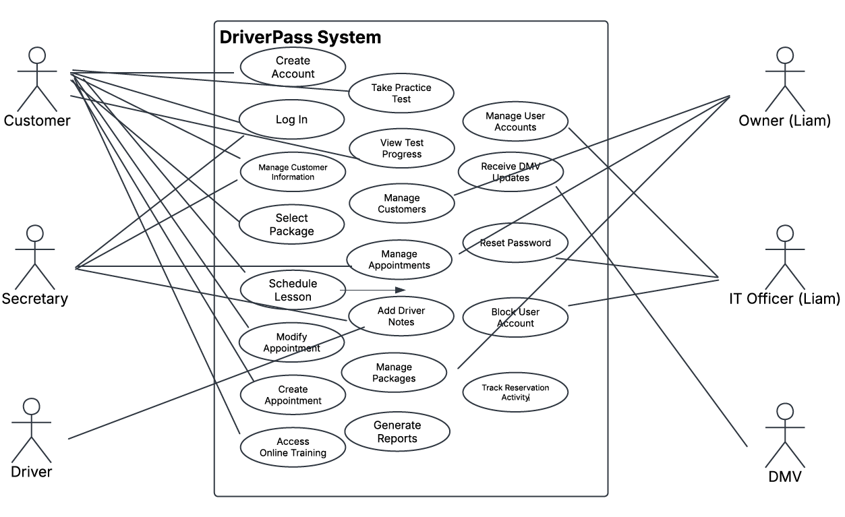

UML Activity Diagrams
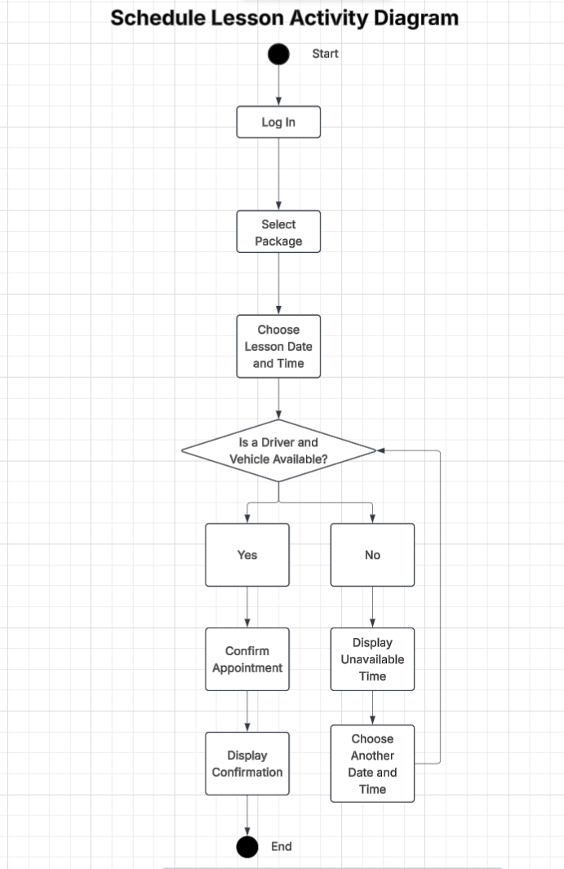
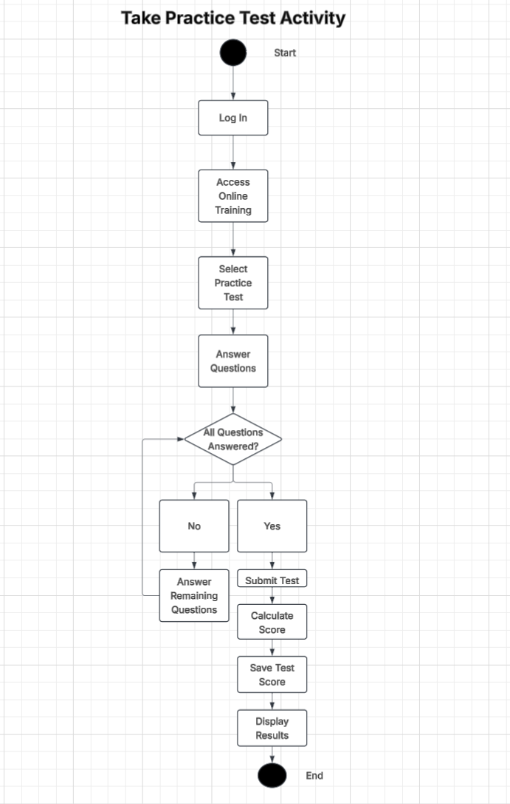

UML Sequence Diagram
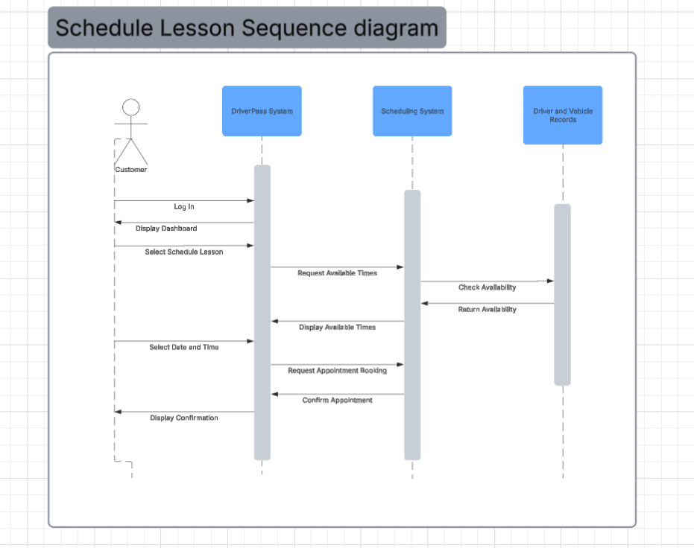

UML Class Diagram
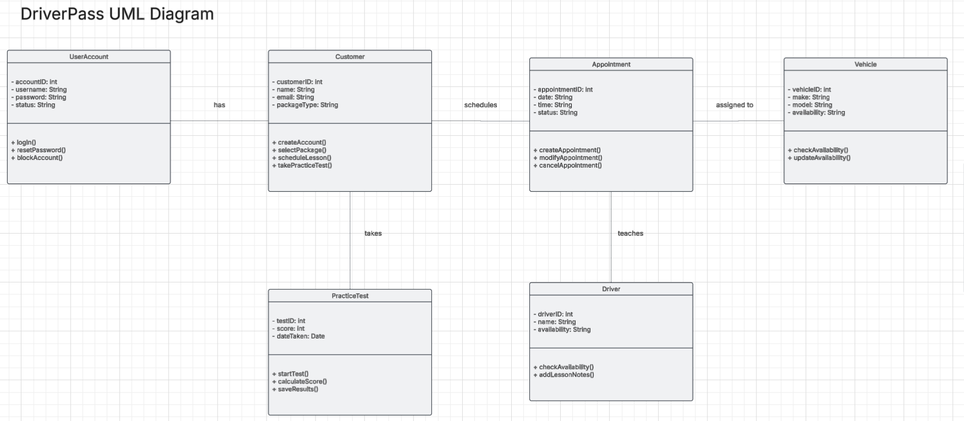

Technical Requirements
Hardware Requirements:

DriverPass will need a reliable server or cloud service to run the system and store its information. Customers and employees will need a computer, tablet, or phone with internet access to use the website. A stable internet connection will help users schedule lessons, take practice tests, and manage appointments without issues.
Software Requirements:
DriverPass will be accessed through a web browser, so users will not need to download a separate application. The system will need a database to keep track of customer information, appointments, driver and vehicle availability, practice test scores, and lesson notes. It should work with common, up-to-date web browsers.

Development Tools:
Lucidchart can be used to create the UML diagrams and show how the system will work. Developers will also need tools to build and test the website and database before the system is ready to use.
Security Requirements:
Users will need to log in to access their accounts. What they can view or change will depend on their role in the system. Passwords and customer information need to be protected. The system should also keep track of appointment changes. The IT officer should be able to reset passwords and block accounts when needed.
Infrastructure and Maintenance:
DriverPass will use cloud hosting so customers and employees can access the system online. Regular backups, updates, and testing will help keep the system running properly and protect its information. The system also needs to check driver and vehicle availability before confirming a lesson so the same driver or vehicle is not scheduled for two lessons at the same time.

