Design Document for SmartBesik project

EN3_A03
Sarzhanova Aygerim
Murzakhmetov Asylbek
Ongarov Aibol
Nazarbek Daryn

Version | Date | Author | Change
0.1 | 10/08/04 | SM | Initial Document

Table of Contents
1 Introduction 3
1.1 Purpose 3
1.2 Scope 3
1.3 Definitions, Acronyms, Abbreviations 3
1.4 Design Goals 3
2 References 4
3 Decomposition Description 5
3.1 Module Decomposition 5
3.2 Concurrent Process 5
3.3 Data Decomposition 5
3.4 STATES 5
4 Dependency Description 6
4.1 Intermodule Dependencies 6
4.2 InterProcess Dependencies 6
4.3 Data Dependencies 6
5 Interface Description 7
5.1 Module Interface 7
5.2 Process Interface 7
6 Detailed Design 8
7 Design Rationale 9
7.1 Design Issues 9
7.2 <Issue 1> 9
7.3 <Issue 1> 9
8 Traceability 11

Introduction

Purpose
The purpose of this document is to explain the design and achitecture of the Pawukon
Application.

Scope
This document covers system decomposition, interfaces, and dependencies, as well as design rationale.

Definitions, Acronyms, Abbreviations
Term | Description
State information | Information taken from harware, SmartBesik mashine. It is information about temperature in room, humidity in the room, and so on.
Administrator | Person which provides customer service by answering to question of users.

Design Goals
- Reliability: The system should protect any user’s data and all user’s information should not be lost.
- Maintainability: The code in project must be well organized and should have god sintax.
- Response Time: Pages which are shows information must be loaded and opened in 15 seconds.

References
(If any)

Decomposition Description

Module Decomposition

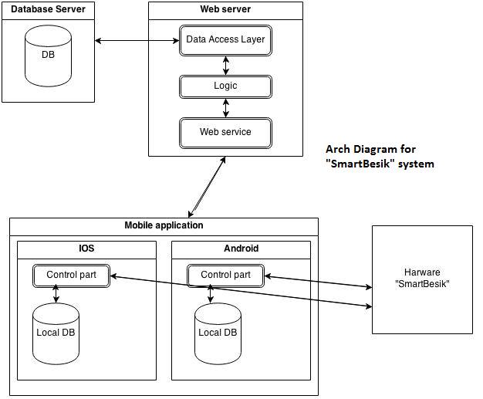

The system is devided into 4 subsystems: hardware, mobile applications, web server and

data base subsystem. Subsystems like web server and mobile application will be builded

in MVC(model, view, controller) architecture.

Web server

Contains itself 3 layers: data acces layer(model part), logic(controller) and view. Data acces layer will provide access to data base. Logic is connects data acces layer with view. It provides how data will be represented, builds some graphics, performs some computings. View part is visible interface to user.

Mobile application

This system is to provide cotroll of the hardware and to allow to user track state of child. Also control part of system will send to web server all data in local db. This system has local db to save in it information which has been received from hardware.

Data base

Data base will store itself tables of data about hardware’s state which were received from web service and also contains itself all question of user to administration.

3.2.4 Hardware

Hardware is mashine that performs all physical actions and gets state’s information about child.

Concurrent Process

Web main page process

This process has one main thread which has 3 events: ask question, and see more, see answer. When user presses button to see more information, for example, presses temperature box, process takes from data base all data temperature statistics information and shows some grafics that show changes of temperature relative to time. If user presses ask question button process will show to user ask question page. Then user can fill fields there and press send button after what process makes request to insert question into database. If user presses see answer button, process will show to user answer to his/her questions.

Mobile application process
Mobile application has two threads: main thread, and refreshing thread. Main thread is session thread which shows to user state information. Main thread also has see more event, when it happens(user pressed see more button) it will show to user statistics information relative to time. Refreshing thread is for refreshing state information which is shown to user. This thread recieves data from harware and stores it in data base and then refreshes state information.

Admin’s page process

This process consists of only one main thread. The process will show to administrator all question has been received. There answer to question event. It happens when admin presses button answer, after it administrator fills necessary fields and sends answer after what process makes request to insert data into database.

