Software Requirements Document for ?????

Author: SmartBesik
Sarzhanova Aygerim
Murzakhmetov Asylbek
Ongarov Aibol
Nazarbek Daryn

Version | Date | Author | Change
0.1 | 09/13/07 | SM | Initial Document

Table of Contents
1 Introduction 3
1.1 Purpose 3
1.2 Scope 3
1.3 Definitions, acronymns, abbreviations 3
1.4 References 3
1.5 Overview 3
2 Overall Description 4
2.1 Product Perspective 4
2.2 Product functions 5
2.3 User characteristics 5
2.4 Constraints 5
2.5 Assumptions and Dependencies 5
3 Specific Requirements 6
3.1 External Interface Requirements 6
3.2 FEATURES 6
3.3 Performance requirements 6
3.4 Design Constraints 6
3.5 Software System Attributes 6
3.6 Other Requirements 7

Introduction

Purpose
The purpose of this document is to provide detailed requirements information about the SmartBesik project

Scope
This document will describe the use cases and features of the SmartBesik project.

Definitions, acronymns, abbreviations
// alphabetical list of terms and their descriptions
// This is part of analysis and you must make sure you describe terms used in this document
Term | Description
SmartBesik | The name of the project which is described in this document. Besik is the Kazakh national cradle.
Baby | Child lying in the cradle.
Parent | Owner of the device which is going to tend baby, control the SmartBesik and know about the state of baby by using our system.
Operator | Person who has access to admin side of our system and answers to questions of parents and engaged in customer service.
Besik | Cradle with our installed device.
State info | All information about state of child in cradle taken by device.

References
// list of references for the reader of this document (if any)

Overview
[OMIT]

Overall Description

The SmartBesik project consists of device which can cradle besik and collect some information about state of baby and system by which parent knows about child’s state and control the besik.

Product Perspective
In foreign countries exists similar auto swing cradle, automatic cradle devices. But in Kazakhstan these products are not popular, so we will do for Kazakh market place. And also our SmartBesik will have good interface and controlling system, which will be helpful for parents.

Concept of Operations
Our mobile application system will connect with besik by wi-fi connection. And all state information will be saved in data base. So web, and mobile application system will take state information from there.

Major User Interfaces
See A2, Screen flow diagram

Example Screenshot and description
See A2, Screenshots

Hardware Interfaces
To see state information: any device with internet connection.
To control the besik: mobile phone with android or IOS operating system.

Software Interfaces
// example: CGI-URL or function signatures etc (OMIT for now).

Communication Interfaces
// example: modem etc (OMIT for now)

Memory Constraints
// RAM, and other storage constraints (OMIT for now)

Operations
// special operations (if any) (OMIT for now)

Site Adaptation Requirements
Content will be in kazakh, english, russian languages

Product functions
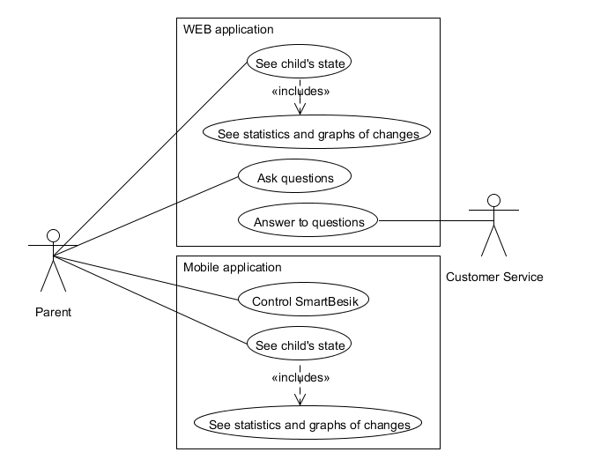

See child’s state
Description: Parent goes into system and knows about baby’s state.
Actor: Parent
2.2.1.1 Parent opens WEB or mobile application system.
2.2.1.2 Client sends to server request to get state’s information
2.2.1.3 Server runs SQL request and selects from database necessary state information.
2.2.1.3 After getting information server sends to client all state information.
2.2.1.4 Parent sees state information
Pre-conditions: Parent logged into the system.
Post-conditions: Parent also will be able to see some graphic information.
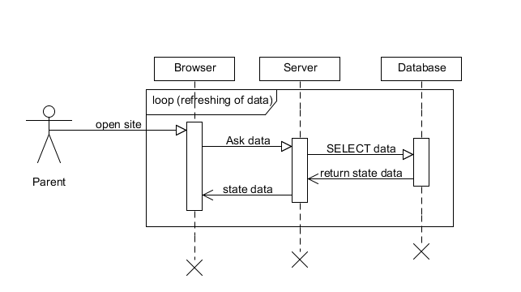

Ask questions
Description: Parent will be able to send questions to Customer Service and then receive answers
Actor: Parent
2.2.2.1 Parent types question and presses send button.
2.2.2.2 Server takes message and makes SQL request to insert into database new message.
2.2.2.3 Parent goes into Customer Service Answers
2.2.2.4 Server makes request from database and takes answer to the questions of parent
2.2.2.5 Taken data will be shown to the user
Pre-condition: Parent logged to system.
Post-condition: Parent will see all history of conversation.
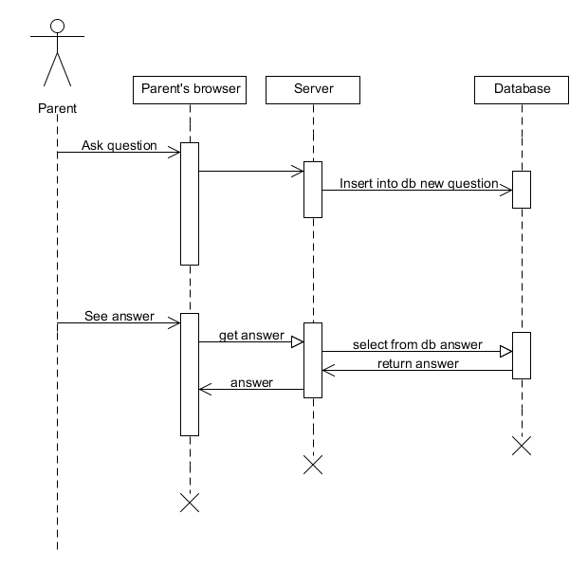

Answer to question

Description: Customer Service will take questions from parents and answer them

Actors: Operator

2.2.3.1 Operator opens the admin site

2.2.3.2 System makes request to server get questions

2.2.3.3 Server makes SQL request from database and takes new questions

2.2.3.4 Server sends new questions to system and system shows it to operator

2.2.3.5 Operator types answer to question presses send

2.2.3.6 System makes request to server to insert answer to database

2.2.3.7 Server insert answers to database

Pre-conditions: Operator logged into the system

Post-conditions: System will refreshed periodically and show questions

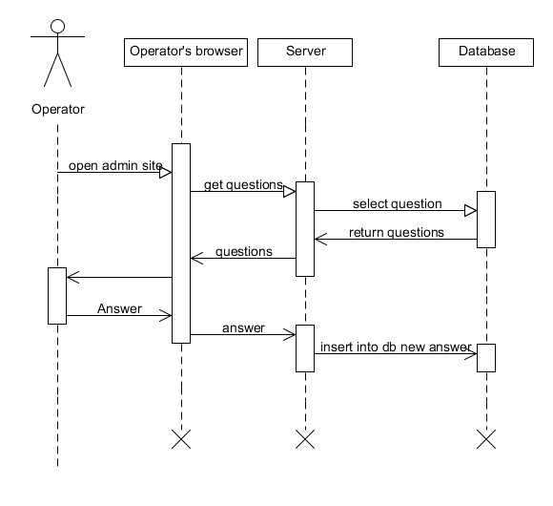

Control besik

Description: Parent will be able to change some configurations in besik like music-playing, cradling.

Actors: Parent

2.2.4.1 Parent changes configurations and presses change button

2.2.4.2 System sends data about changes to besik

2.2.4.3 Besik mashine changes his configurations

2.2.4.4 If changed successfully besik send message about success

2.2.4.5 Parent sees the message

Pre-conditions: System connected by Wi-Fi with besik

Post-conditions: If configurations is not changed successfully parent receives description of problem.

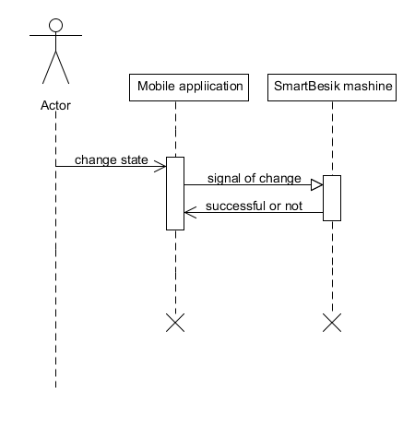

User characteristics
Parent: owner of the SmartBesik and have access to state information and can control besik, and also can ask questions.
Operator: worker of Customer Service who has access to admin side of WEB application and who answers parent’s questions.

Constraints
This project will be used by family man or woman who have little child. So, mainly users can be aged people.

Assumptions and Dependencies
System of project depends of Wi-Fi connection quality.

Specific Requirements

// Here you need to put in details (if any). Mark items [None] if you do not have any information.

External Interface Requirements

User Interfaces

Hardware Interfaces

Software Interfaces

Communications Interfaces

FEATURES

FEATURE-1 ….

…

…..

Performance requirements

Design Constraints

Software System Attributes

Reliability

Availability

Security

Maintainability

Portability

Other Requirements

// ADD Appendices (if any)
// Regenerate Table of Contents

