**Operating Systems**

**Exercise 2**

**Processes and Threads**

**Assignment #1**

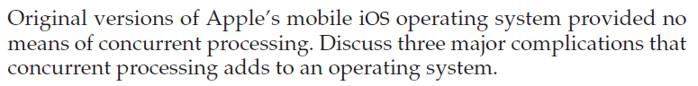

**Assignment #2**

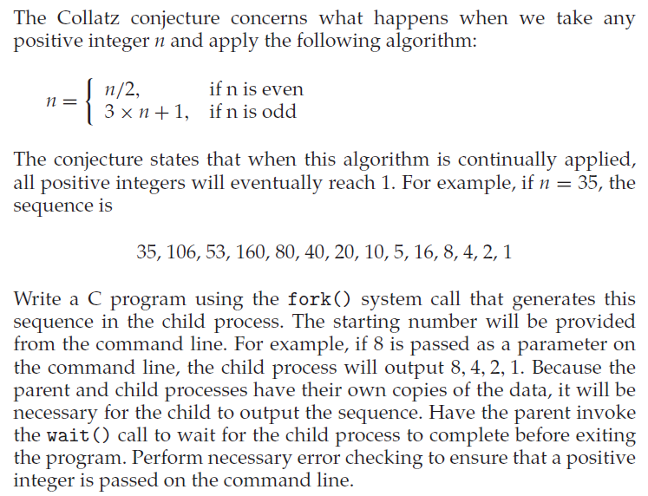

**Assignment #3**

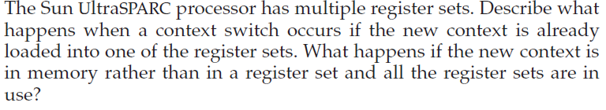

**Assignment #4**

