

**DEAKIN University**

**Reece Max Voice Project**

**Handover Review**

**Version 1.0**

**Trimester 2 2018**

**Project Contact Person**

Name: Alush Selimi

Email: [aselim@deakin.edu.au](mailto:aselim@deakin.edu.au)

**Project Client**Reece Max   
Name: Shane Laffin and Gabi Currin

Email:   
[Shane.Laffin@reece.com.au](mailto:Shane.Laffin@reece.com.au)  
[Gabi.Currin@reece.com.au](mailto:Gabi.Currin@reece.com.au)

**Project Mentor**Dr Nick Patterson

nick.patterson@deakin.edu.au

**Project Team**

**Carryover Members (Team members continuing in T2 2018 from T1 2018)**

|  |  |  |
| --- | --- | --- |
| **Student Name** | **Student Email** | **Role** |
| Wey Hong | [weyh@deakin.edu.au](mailto:weyh@deakin.edu.au) | Developer |
| Weiqi Zhang | [zhangwei@deakin.edu.au](mailto:zhangwei@deakin.edu.au) | Developer |
| Vasu Batra | [vbatr@deakin.edu.au](mailto:vbatr@deakin.edu.au) | Security/Web |
| Alush Selimi | [aselim@deakin.edu.au](mailto:aselim@deakin.edu.au) | Developer/Leader/Web |
| Abdulrahman Baali | [abaali@deakin.edu.au](mailto:abaali@deakin.edu.au) | Database/BA |
| Xueting Jiang | jiangxu@deakin.edu.au | Developer |

**Off boarding members (members no longer continuing)**

|  |  |  |
| --- | --- | --- |
| **Student Name** | **Student Email** | **Role** |
| Mahedi Raz | [mmraz@deakin.edu.au](mailto:mmraz@deakin.edu.au) | UX/UI |

**On boarding members (new members)**

To date, there have been no new additions to the team.

**Reiteration of Project Aims**

Our client wants to offer an application that helps their customers make their busy lives significantly less demanding. They feel that their clients are baffled endeavoring to explore between their 580+ stores in the country. The innumerable number of stores are making it troublesome for clients to discover the stores and subsequently the items they require. Thus, the customer has contrived an idea for a versatile application that would be collating with its site to help the client in discovering Reece branches and leading their clients to them. This will mostly help plumbers as Reece they are the majority of Reece’s clients.   
  
The application will be processing the requests of the user through voice commands and will provide a legitimate answer. If the users says, “Take me to the Burwood store”, the app will direct the user to the Burwood store. It will also be intelligent enough to gain the user’s location and start the navigation from there. It also provides other information such as the contact information of each store, and even has the capacity to make phone calls.

**Document Purpose**

The objective of this document is to review upon the Project handover and review findings, actions and justify any necessary changes. It will also incorporate connections to the project proposal, meeting minutes, GitHub repositories and the tasks on the Trello board.

The project handover can be found here  
https://github.com/vasubatra/Reece-max/blob/master/Project-Handover_ReeceMaxTeam25%20(1).docx

**Business Features**

Max Voice – Voice Recognition

**Findings:** Users were only able to use a few voice commands as the voice recognition code was limited in functionality.

**Actions:** We were able to improve the voice recognition code to allow it to understand more voice commands.

**Justifications:** With newly updated voice recognition code, users are now able to ask for useful Reece store information. However, the information is limited to certain stores. Another functionality we’ve added allows the user to use voice command to call a Reece store branch.

**Planned Features**

**GPS Functionality  
Findings:** For now, the app is able to show the current location of the user.

**Actions:** We are working on further improving the GPS functionality by researching on more codes and how to implement them properly into the app.

**Justifications:** With the updated code, users should be able to use the app to find out either where the nearest store’s location is, or find the specific store the user has asked for, then it should navigate the user to that store.

**Bug Fixes and Improvements to User Experience**  
**Findings:** Currently, the app has limited information from Reece to populate the database. The app also understands voice commands and sometimes it makes mistakes such as generating the wrong text.

**Actions:** We will gather more information from Reece and find out what is causing the voice recognition software to make wrong voice-to-text translations.

**Justifications:** Fixing these bugs is crucial as it could potentially direct the user to the wrong store or not do what the user asks, it will also make improvements to the user experience and reduce frustration.

**Open Issues**

**Findings**: The client is not engaged. The client has missed meetings, shortened meetings at the last minute, and has refused to respond to some emails.

**Actions:**  
Escalate to the project supervisor.   
Contact the client and clarify our communication dependencies.   
  
**Justification:**The client engagement information from the client (store information_ and the feedback on the work being produced is necessary (we feel) to ensure a healthy development cycle.

**Findings:** The team members do not have the skills for mobile application development  
  
**Actions:** seek expressions of interest from other students who are competent with mobile application development knowledge to join the team, alternatively, get those members who do not know how to develop mobile apps to seek online tutorials.

**Justification:** The goal of the project is to develop a mobile application. The skill of mobile application development is important for the project team in being successful in deliverables.

**Lessons Learned**

**Findings:**  The team members have different methods of working. Some do their work early, others start quite late.

**Action:** The team have weekly meetings to clarify tasks, dependencies, and when tasks should be completed by.

**Justification:** The team members will complete work on time and there will be time left to sort out any potential issues.

**Findings:** The project team lacks technical skills relating to mobile application development.

**Justification:** Same as from open issues, seek expressions of interest from other students who are competent in application development or nominate team members to research and present ways of developing mobile applications (tools or IDEs)

**High Level Architecture**

After reviewing our system architecture, we have found that no new system architecture requirements have been identified, as our existing architecture meets all requirements.

**Source Code**No changes to the source code repository or location are required, the current repository (GitHub) will suffice.

**User Manual   
Findings:** The user manual is rather general, and covers all functionality expected from the program  
**Actions:** Make any necessary changes as development continues.   
**Justification:** The user manual is a valuable tool for support, as it teaches the user how to use the application.

**Other Documents**There are no other documents to review

**Summary of Findings and Actions**

|  |  |  |
| --- | --- | --- |
| **Findings and Actions** | **Who** | **When** |
| **Improve Voice Recognition Code** | **Developers** | **Done** |
| **GPS Functionality** | **Developers** | **Sprint 3** |
| **Bug Fixes and UX Improvements** | **Developers** | **Sprint 3** |
| **Engage with Client** | **Team + Client** | **Sprint 3 & 4** |
| **Team Meetings** | **Team** | **Sprint 3 & 4** |

**Team Reflection**

Our Sprint 3 plan closely reflects the findings of this document as well as what we have in our product backlog.

We have realized that more engagement may be required between the team and the client, as well as more team meetings to sort out any issues and keep all team members informed. Our current goals for the next sprint include:   
Global Positioning Code: From current location to specific store.

Improvements to User experience: UI is quite bland, needs to be more appealing to the eyes.   
Bug Fixes: improve transcriptions to reduce incorrect text being displayed.

Our team needs to find a healthy way to work together, there is still instances were people break off from the group to work alone instead of working as a team.   
our actions for this include scheduling a regular team meeting to discuss any issues team mates have as well as changing any roles if team mates feel the need.

Through reviewing the handover, we feel that the progress we have made up until this point is sufficient and that we will be able to deliver all features. We have carefully reviewed the handover and believe we have what it takes to complete the development cycle.

**New Member Reflection**

Our team remains unchanged from last semester and as such, a new member reflection is not applicable.

**Sprint 3 Plan**

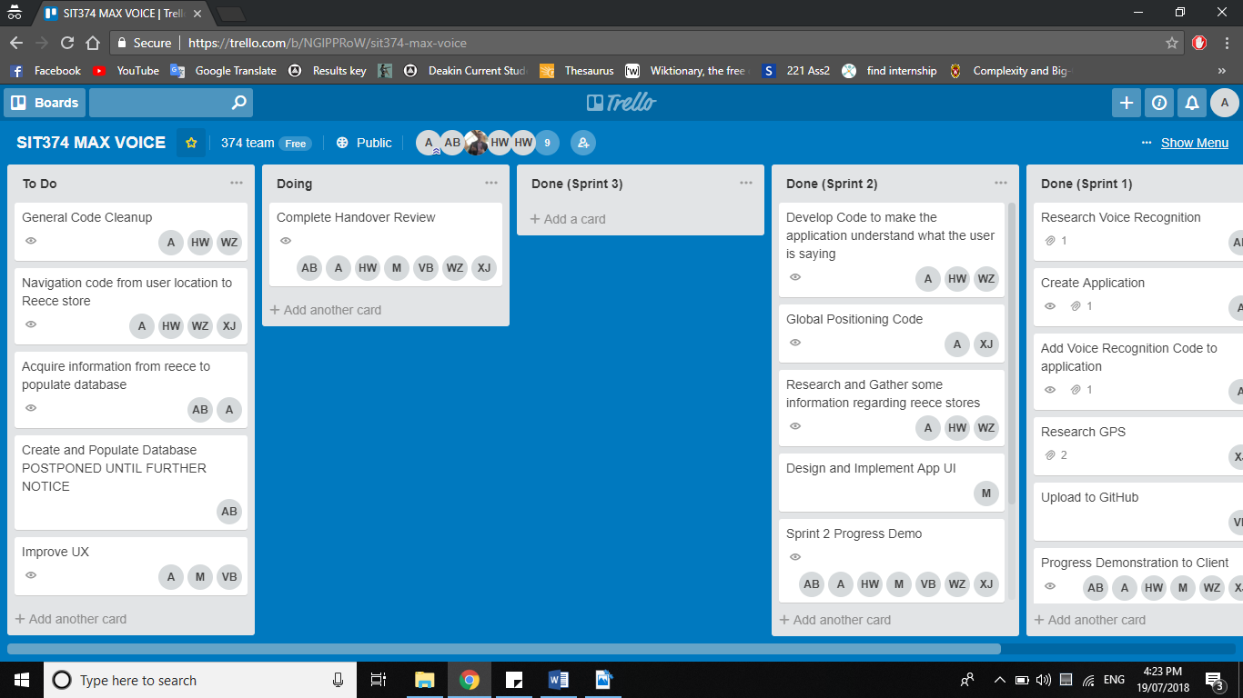

**Sprint 3 Task Allocation**

|  |  |
| --- | --- |
| **Task** | **Who** |
| Global Positioning Code | Alush, Hong, Weiqi, Xueting |
| Database Word | Alush, Abdulrahman |
| Improvements to User Interface/User Experience | Alush, Vasu, Hong, |
| Code Cleanup/Bug Testing | Alush, Hong, Wei |

**Supervisor Sign-off**

Our supervisor, Dr Nick Patterson was provided with this assignment on Sunday July 22nd 2018.

This is his approval confirmation:

// This is the sample

The content included and revisions to the report present a good account of the progress made. There’s a clear plan on the teams immediate next steps and the member roles to further develop the solution to present on the Trello board. This review document should now allow both current and new team members to reflect on the previous sprints and to commence development with minimal delays” // End of sample