**Balancing AI-assisted projects and traditional assessment: The FACT assessment in environmental data science education**

Ahmed S. Elshall1,2,3* and Ashraf Badir1

1 Department of Bioengineering, Civil Engineering, and Environmental Engineering, U.A. Whitaker College of Engineering, Florida Gulf Coast University, Fort Myers, Florida

2 The Water School, Florida Gulf Coast University, Fort Myers, Florida

3 DENDRITIC: A Human-Centered Artificial Intelligence and Data Science Institute, Florida Gulf Coast University, Fort Myers, Florida

*Corresponding author (aelshall@fgcu.edu)

**Abstract**

As artificial intelligence (AI) tools evolve, a growing challenge faced by educators is how to leverage the invaluable AI-assisted learning, while maintaining rigorous assessment. AI tools, such as ChatGPT and Jupyter AI coding assistant, enable students to tackle advanced tasks and real-world applications but risk over-reliance, which can diminish intellectual and skill development and complicate assessment design. To address these challenges, the Fundamental, Applied, Conceptual, critical Thinking (FACT) assessment was implemented in an Environmental Data Science course offered to upper-undergraduate and graduate students from civil and environmental engineering, and Earth sciences. By balancing traditional and AI-assisted assessments, the FACT assessment includes: (1) Fundamental skills assessment (F) through assignments without AI assistance to build a strong coding foundation, (2)applied project assessment (A) through AI-assisted assignments and term projects to engage students in complex tasks, (3) conceptual-understanding assessment (C) through a traditional paper-based exam to independently evaluate comprehension; and (4) critical-thinking assessment (T) through a take-home exam with multi-step case study using AI to assess problem-solving and decision-making. Analysis of students’ performance shows that both AI tools and AI guidance improved student performance and permitted them to tackle complex tasks and real-world applications versus AI tools alone without guidance. Survey results show that many students found AI tools beneficial for problem-solving, yet some students expressed concerns about over-reliance on AI tools. By integrating assessments with and without AI tools, FACT assessment promotes AI-enhanced learning while maintaining rigorous assessment, preparing students for their future careers as industries increasingly integrate AI into their activities.

**Impact Statement**

The FACT assessment framework addresses the challenge of balancing AI-assisted learning with skill development in higher education. By integrating foundational, applied, conceptual, and critical-thinking assessments, FACT mitigates over-reliance on AI while enhancing student engagement and performance. The paper offers educators a scalable approach to promote AI-enhanced learning while ensuring students develop independent problem-solving skills. This framework provides a practical pathway for integrating AI into education, fostering workforce readiness across disciplines.

# 1. Introduction

The integration of artificial intelligence (AI) into environmental data science education and engineering education in general is transforming traditional teaching and assessment paradigms, offering both significant opportunities and challenges (Oliver et al. 2024). AI tools, such as generative AI and coding assistants, enable students to obtain tutoring during learning, and engage in complex tasks. By providing real-time feedback, these tools can make learning more dynamic and effective, as evidenced by applications in environmental data science and engineering education (Baalsrud Hauge and Jeong 2024; Ballen et al. 2024). AI advancements have the potential to provide students with the skills that help their careers (Mosly 2024; Oliver et al. 2024), especially as industries increasingly integrate AI tools to their activities (Aladağ et al. 2024). Additionally, as Google reports that 25% of its new code is AI-generated, this underscores the need for computer science and engineering education to shift focus toward higher-order skills such as quality assurance and collaborative workflows(Talagala 2024). While AI tools have demonstrated the ability to support student learning in programming and computational courses, careful integration of AI tools in engineering education is necessary to avoid diminishing student development, and for maintaining academic rigor.

The increasing sophistication of AI tools raises concerns about over-reliance, the challenge of assessing learning outcomes, and ethical implications. With respect to over-reliance, Frankford et al. (2024) indicate that the use of AI tutoring systems has improved accessibility and personalized feedback, yet there is a need to balance AI use with independent skill development. For example, in data science education, students' dependency on AI tools has the potential to diminish the development of basic coding and problem-solving skills necessary for their professional growth (Camarillo et al. 2024; Wilson and Nishimoto 2024). With respect to challenge of assessing learning outcomes, the misuse of AI in academic settings raises concerns about difficulties in plagiarism detection and learning outcome assessment (Baalsrud Hauge and Jeong 2024). For example, widespread misuse of AI tools has led to significant increases in plagiarism and honor code violations, with some educators spending substantial time detecting AI-driven misconduct (McMurtrie 2024). In addition, large language models like ChatGPT and Gemini have been shown to propagate biases, homogenize knowledge, and occasionally produce misleading information (Oliver et al. 2024).These practical and ethical considerations necessitate structured pedagogical approaches to mitigate these risks and to ensure alignment with academic and industry standards (Lanning et al. 2024). For example, Oliver et al. (2024) highlight the importance of teaching students how to critically assess AI outputs and address ethical considerations, particularly in environmental data science, where generative AI is increasingly employed to synthesize data and design workflows. Thus, there is a need for assessment frameworks that can effectively leverage AI opportunities and mitigate AI risks.

Given the need to develop hybrid assessment frameworks to balance AI-assisted learning with rigorous academic standards (Pham et al 2023), we propose the FACT (**F**undamental, **A**pplied, **C**onceptual, critical **T**hinking) assessment. We show how FACT assessment integrates traditional assessment with pencil and paper with assessment for AI-assisted projects to holistically assess students' skills and achievement of learning outcomes. By leveraging AI tools for applied projects and critical thinking, while maintaining traditional assessments for foundational and conceptual understanding, the FACT assessment ensures that students develop both technical proficiency and higher-order cognitive skills. Such approaches have been shown to enhance student engagement and application of theoretical knowledge to real-world scenarios (Baalsrud Hauge and Jeong 2024; Ballen et al. 2024). This paper contributes to the growing literature on AI in science, technology, engineering and mathematics (STEM) education by showcasing the implementation of the FACT assessment in an Environmental Data Science course. By preparing students for the complexities of AI-integrated professions while maintaining rigorous academic standards, this paper addresses the dual objectives of advancement and integrity in STEM education under the AI paradigm.

# 2. Method

AI coding assistance is integrated into Environmental Data Science. The course was designed to balance the opportunities and challenges associated with AI tools while maintaining rigorous academic standards through applying the FACT assessment. This section describes the course design, FACT assessment, and data collection from student surveys to evaluate the impact of AI integration. By examining these components, the study aims to evaluate the effectiveness of the FACT assessment in addressing the dual objectives of leveraging AI tools, while maintaining rigorous academic standards and avoiding AI overdependence.

## Course design and structure

The Environmental Data Science course is offered to upper-undergraduate and graduate students from civil and environmental engineering, as well as Earth, ocean, and environmental sciences. According to the course syllabus (link to be provided) ), this course introduces students to water and environmental data analysis using Python, a versatile programming language equipped with powerful libraries for data science and scientific computing. Key libraries include Pandas for spreadsheet-like data manipulation, Matplotlib for visualization, NumPy for scientific computing, Xarray for multi-dimensional geospatial data analysis, and CartoPy for geospatial visualization. Students learn to use Python to analyze and visualize water and environmental datasets, working with data from sources such as NOAA, NASA, Copernicus, USGS, and Data.Gov, in formats like CSV, shapefiles, and NetCDF. Additionally, the course is project-based and offers self-directed learning opportunities. The course requires no prior programming experience and prepares students to perform data analysis and visualization to address real-world challenges in water resources and environmental management. Past students have explored and utilized specialized resources tailored to their interests, such as:

* Climate Data Store API for accessing CMIP6 datasets for climate projections and remote sensing data
* sciencebasepy for programmatic interaction with the USGS ScienceBase platform
* Geemap for using Google Earth Engine catalog of satellite imagery and geospatial datasets
* Python in ArcGIS Pro to extend and customize GIS functionality
* statsmodels for statistical analysis
* Scikit-learn and TensorFlow for machine learning analysis of water and environmental datasets
* FloPy for groundwater modeling using this MODFLOW Python API

For detail, check the list of student projects: <https://aselshall.github.io/eds/HW/project#4-student-projects> . Accordingly, hands-on learning and practical applications are key criteria for assessing and evaluating your progress in this course.

The course follows a structured syllabus with distinct stages of assessment as shown in Table 1. Each lesson is 75 minutes. Details about these modules are shown in Appendix 1. All these lessons are available online via the Jupyter book of the course: <https://thaliavch.github.io/Environmental-Data-Science-Book/intro.html> .

Table 1. Course modules and assessment stages with and without AI assistance

|  |  |  |  |
| --- | --- | --- | --- |
| Module | Lessons | Assessment | AI-permitted |
| 1. Introduction to Environmental Data Science with Python | 1-2 (2) | Installing Python and Survey | NA |
| 2. Python Basics | 3-5 (3) | Homework 1 | No |
| 3. Python Programming | 6-9 (4) | Homework 2 | No |
| 4. Pandas for Tabular Data | 10-14 (5) | Homework 3 | Yes |
| 5. AI Coding Assistance | 15 (1) | Homework 4 | Yes |
| 6. Data Science Workflow | 16 -17 (2) | Homework 4 | Yes |
| 7. NumPy for Scientific Computing | 18-19 (2) | Homework 4 | Yes |
| 8. Matplotlib for Visualization | 20-22 (3) | Homework 4 | Yes |
| 9. Xarray and CartoPy for Labeled and Gridded N-dimensional Arrays | 23-27 (5) | Homework 5 (optional) | Yes |
| 10. Google Earth Engine and GeeMap | 28 (1) – Optional | NA | NA |

## FACT assessment

The FACT (Fundamental, Applied, Conceptual, critical Thinking) assessment is a structured approach that combines traditional and AI-assisted learning techniques to assess fundamental skills, applied project performance, conceptual understanding, and critical thinking as summarized in Figure 1. The FACT assessment aims to leverage AI tools, while avoiding overdependence and maintaining academic standards.

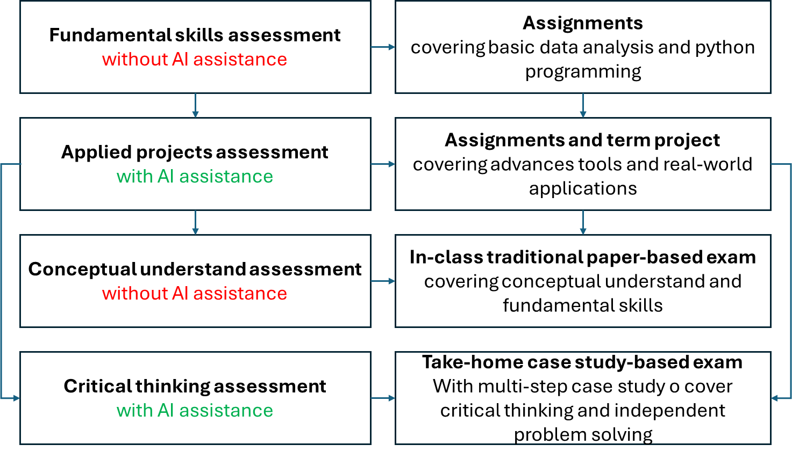

Figure 1. Summary of FACT assessment showing assessment instruments with and without AI assistance

**F**undamental-skills assessment (F) ensures that students build a solid foundation before progressing to more advanced concepts and tools. In the first nine lessons (75 minutes each), students focus on mastering basic Python programming and data analysis techniques without AI assistance. Through two assignments, they learn foundational skills without the aid of AI tools. Homework 1 (<https://aselshall.github.io/eds/HW/HW3> ) covers Pythons basics including variables, formulas, data structures and formatting. Homework 2 covers Python programming including loops, conditional statements, function, scripts, and modules. Assignments are designed to assess these fundamental skills, before progressing to advanced tools like pandas, NumPy, Xarray, CartoPy, scikit-learn, and Geemap.

**A**pplied-project assessment (A) ensures that students engage in advanced tasks and real-world applications. Starting in lesson 10, students work on advanced, project-based assignments that incorporate AI coding assistance using AI-tools such as Jupyter AI, and ChatGPT. Homework 3 (<https://aselshall.github.io/eds/HW/HW3>), which focuses on programmable spreadsheet for analysis of big data using pandas, emphasize practical applications. The students are instructed to repeat the steps in these lessons using a dataset of interest to them and present information and insights uncovered from their data exploration. Graduate students have an additional problem of analyzing water quality due to harmful algae blooms. The students are also instructed to document their use of AI-tools such as large language models (LLMs) in improving their learning and productivity. Box 1 shows the learning objectives of Homework 3.

Box 1. Learning objectives of the first homework where students are permitted to use AI.

As outlined in the syllabus, this course emphasizes project-based learning and self-directed study opportunities. This problem provides you with the chance to explore a dataset of personal interest. The objectives of this problem are to:

* Facilitate your learning of Pandas by engaging with a dataset that aligns with your interests
* Enhance your proficiency in accessing, wrangling, analyzing, and visualizing large csv datasets
* Provide hands-on practice to strengthen your ability to analyze tabular data with mixed data types
* Engage in critical thinking to extract useful information from raw data
* Practice articulating your findings clearly and concisely using visualizations or narrative explanations
* Improve your skills in using AI-LLM for independent and self-directed learning

While in Homework 3 students are permitted to use AI-tools without guidance, lesson 15 introduces AI tools to ensure students can effectively use these tools for work on real-world applications of interest to them. The integration of AI tools was guided by principles of responsible AI usage. Students were encouraged to balance AI assistance with independent problem-solving, and class discussions addressed ethical concerns, including over-reliance and potential biases and errors in AI-generated outputs. The lesson also emphasized the importance of prompt engineering to effectively use these tools.

Leveraging these skills and tools, Module 6. Data Science Workflow in lessons 16 and 17 show detailed examples of effective prompt engineering (<https://thaliavch.github.io/Environmental-Data-Science-Book/Chapters/6.%20Data%20Science%20Workflow/Exercise6.html>). For the rest of the semester, there was a continuous demonstration and discussion about the use of AI in coding and learning new topics and packages not covered in class including statistical analysis methods. These assignments and term projects allowed students to focus on real-world problem-solving, while managing the complexities of advanced coding and data analysis techniques through AI assistance.

**C**onceptual-understanding assessment (C) ensures independent evaluation of student understanding without the use of AI-tools. The course culminates in a traditional, paper-based final exam designed to test students’ understanding of core concepts without the assistance of AI tools. This is a comprehensive exam, consisting of 60 multiple-choice questions in 75 minutes, primarily assesses students' grasp of key concepts, offering less emphasis on critical thinking and independent problem-solving skills. The exam focuses on basic materials from the 10 course modules, with an emphasis on assessing general knowledge discussed in class and class participation. This is a paper-based open book exam that prohibits the use of AI tools and internet resources. Academic honesty is strictly enforced, and violations will result in a grade of zero. The exam study guide (<https://aselshall.github.io/eds/exam/study_guide>) provides sample exam questions and exam instructions.

Critical-**T**hinking assessment (T) ensures the assessment of independent problem-solving through a multi-step case study. While this exam format allows students to demonstrate their conceptual understanding, there is an additional need to assess students’ individual critical thinking and independent problem-solving abilities in real-world contexts.​ To address this gap, a recommended future addition is an additional take-home exam based on a multi-step case study. AI tools would assist with tasks like data cleaning or analysis, but students would need to make independent decisions and apply critical thinking to connect the steps, develop a complete solution, independently interpret results, draw conclusions, and connect insights into a cohesive solution. While this approach would effectively assess students’ independent problem-solving abilities and ensure they can navigate complex environmental science data challenges, designing such exams will become increasingly challenging as AI tools advance. Another concern is that this exam can be time consuming constituting an extra load on students. In this course, students were given the choice of splitting the final exam into two parts, where the first part would be the traditional paper-based in-class exam as described above, and the second part would be a take-home exam covering a case study as described. They chose to do the in-class exam only.

## Student survey for data collection

At the end of the course, an anonymous survey (<https://forms.gle/eXjFo9Lf4GkKDDFe6>) was distributed to gather feedback on students’ experiences with AI coding assistance and the course structure. Clear instructions were given that this survey is not to evaluate the instructor, but rather the learning experience irrespective of their like or dislike of the instructor. Also, clear instructions were given that this survey is for research purposes. Questions focused on students’ perceptions of how AI impacted their learning, problem-solving abilities, and reliance on technology (Survey Questions 6–9). These survey questions included three quantitative questions:

* AI Coding Assistance: When I solve an environmental data science problem, I heavily rely on AI?
* AI Coding Assistance: After I study a topic in this course and feel that I understand it, I have difficulty solving problems on the same topic.
* AI Coding Assistance: When I get stuck on an environmental data science problem, rank how you seek help in order: Seek help from classmates, Consult online resources, Review lecture notes, Experiment on my own, Reach out instructor for guidance, Reach out AI for guidance.

and one qualitative question:

* AI Coding Assistance:  How has the integration of AI coding assistance, such as Jupyter AI or ChatGPT, impacted your learning experience in the course, both positively and negatively?

The purpose of these survey questions is to learn the positive and negative impacts of AI from the students’ perception including ethical considerations and pedagogical implications. Survey results were collected from all 12 of the students who took this course, 9 undergraduate students and 3 graduate students.

## Data analysis and AI-assisted research

To analyze student performance with and without AI assistance using the FACT assessment we used boxplot. Histogram charts were used to analyze quantitative survey questions. Semantic analysis to analyze qualitative survey questions to summarize the main themes from student responses were implemented. In addition, to avoid cognitive biases such as confirmation bias, anchoring bias, and overconfidence effect, semantic analysis with AI assistance from GPT4-o were conducted. Results were verified and confirmed for accuracy. Data analysis and plotting was conducted using standard Python packages including pandas and matplotlib with assistance from GTP-4o and GPT3.5 Turbo via Jupyter AI. In addition to data analysis and plotting, AI assistance from GPT-4o was utilized for providing review comments, refining text for succinctness and clarity, restructuring paragraphs to improve logic flow, and performing semantic analysis of qualitative survey responses.

# 3. Results and discussion

## 3.1 Student performance with and without AI assistance

The boxplot analysis of normalized homework grades without bonus points shows differences in student performance under varying levels of AI assistance and task complexity from homework 1 to homework 4 (Figure 2). For homework 1 and homework 2, where AI tools were not permitted, students demonstrated consistent performance with relatively narrow interquartile ranges (IQRs) and high average scores of 95.3 and 93.4, respectively. These assignments, which focused on foundational skills like basic data analysis and Python programming, provided a solid baseline for students to build their technical competence. However, the presence of a few outliers in homework 1 suggests that some students faced challenges completing these tasks independently, likely due to differences in their prior experience with coding.

Figure 2. Student performance in homework 1 and homework 2 without AI assistance and in homework 3 and homework 4 without AI assistance.

In contrast, homework 3 and homework 4, which incorporated more advanced, real-world tasks and permitted AI assistance, generally exhibit greater variability in performance. Homework 3, with a wider IQR and a lower mean score of 88.4, highlights the adjustment period as students learned to integrate AI tools effectively. This variability might suggest that AI enabled some students to tackle complex tasks. Then students received AI guidance in lesson 15 after homework 3. By homework 4, the mean increased to 95.8, and the IQR narrowed, indicating that students became more adept at leveraging AI for practical applications after receiving AI guidance in lesson 15. These findings suggest that while AI assistance supports engagement with challenging tasks, it requires careful scaffolding and guidance to ensure it complements independent problem-solving skills.

## 3.2 Tackling real-world applications with AI assistance

AI tools and AI guidance improved student performance and permitted them to tackle complex tasks and real-world applications. AI tools and guidance helped students to tackle and excel in Homework 4 and the term project. Homework 4 is a pre-defined project focusing on comparing air quality improvement in selected major cites due to the pandemic lockdown order. Students were encouraged to leverage AI-tools to learn about statistical analysis and develop code to conduct analysis using Python packages such as statsmodels and SciPy that were not covered in class. This is to prepare students to work on their term projects. These projects focus on location-based real-world applications including plasma proteomics of loggerhead sea turtles in the Gulf of Mexico, nutrient analysis in the Sanibel Slough in Sanibel Island, upwelling events and red tides blooms in the west Florda shelf, impact of hurricanes on surface water-groundwater salinity levels in southwest Florida, Naples Botanical Garden plant biodiversity alignment with global databases, machine learning models for red tide prediction in Charlotte Harbor in southwest Florida, and groundwater modeling with FloPy. More details about student projects can be found in the student project page (<https://aselshall.github.io/eds/HW/projct#4-student-projects>).

## 3.3 Student reliance on AI assistance

In homework 3, homework 4, and final project, while AI tools are utilized to handle complex tasks efficiently, students are advised to balance AI assistance and their own problem-solving skills. However, there is no guarantee that students will not over depend on AI, diminishing their technical proficiency and independent thinking. The course final survey results indicated that students appreciated the efficient AI tools provided in managing complex coding tasks but recognized the importance of not becoming overly reliant on AI.

Figure 3. Responses to survey questions: a) “AI Coding Assistance: When I solve an environmental data science problem, I heavily rely on AI?” b) “AI Coding Assistance: After I study a topic in this course and feel that I understand it, I have difficulty solving problems on the same topic.”

While AI tools allowed students to efficiently manage complex tasks, survey results indicate varying degrees of reliance on these tools. Figure 3a shows that 50% of students either strongly agreed or agreed that they heavily rely on AI for solving environmental data science problems, while 33.3% were neutral and 16.7% disagreed, indicating that some students maintain a balance between AI use and their own problem-solving abilities. Despite the widespread use of AI, the survey also showed that 50% of students disagreed or strongly disagreed with the statement that they have difficulty solving problems independently after studying a topic (Figure 3b). This suggests that while AI tools were widely used, many students retained their ability to think critically and solve problems independently. This is confirmed by Figure 4 that shows that students primarily sought help through online resources and lecture notes when stuck on a problem, with some seeking assistance from classmates as well. However, the risk of dependency on AI tools for routine tasks can be also a concern, as noted in other studies (Ballen et al. 2024; Camarillo et al. 2024). Yet the definition of “routine tasks” is contextual. For example, generating a boxplot for upper-level undergraduate students and graduate students is a routine task, yet for lower-level courses on computational tools for undergraduate students is a learning objective.

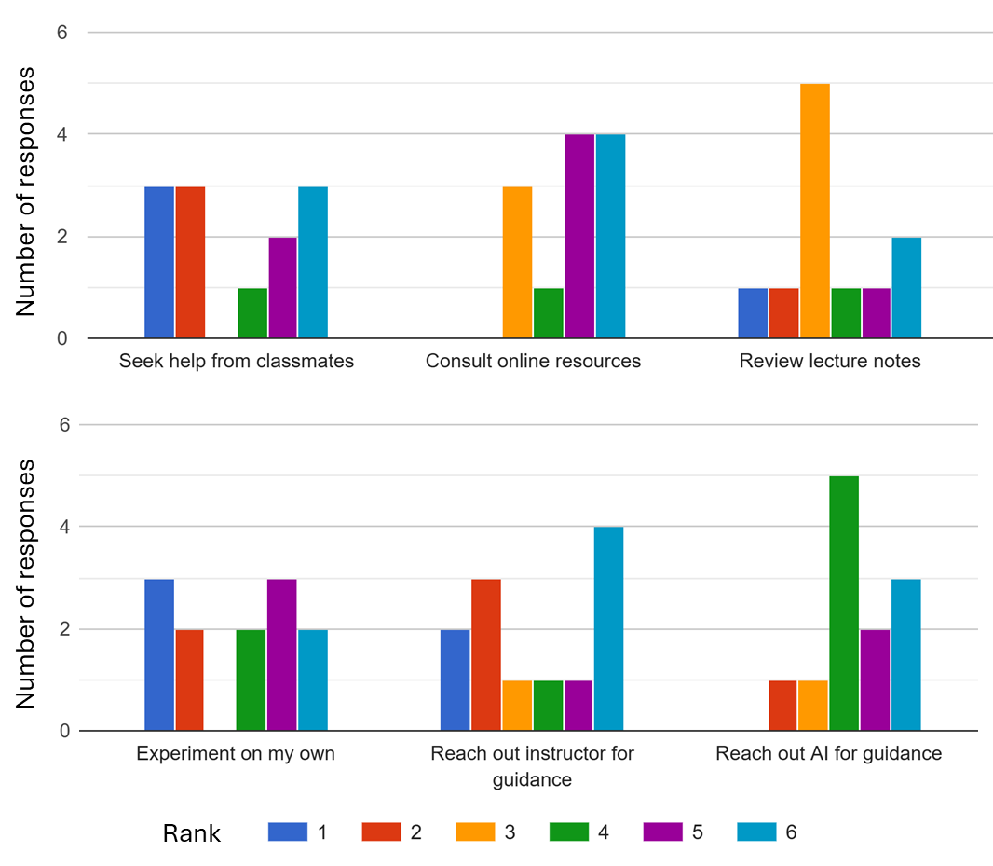

Figure 4. Responses to survey question: “AI Coding Assistance: When I get stuck on an environmental data science problem, rank how you seek help in order.”

## 3.4 Student perception of AI assistance

To gain further insights about students’ expereince of AI-assisted learning from students’ perspectives, semantic analysis was conducted to analyize student responses to the survey question: *"How has the integration of AI coding assistance, such as Jupyter AI or ChatGPT, impacted your learning experience in the course, both positively and negatively?"* We conducted semantic analysis with and without AI assitance. For semantic analysis with AI-assistance, Figure 5 summarizes student responses by semantically analyzing and categorizing responses into nine distinct themes, divided into positive and negative perceptions. Positive themes include support in problem solving, error diagnosis and debugging, efficiency and time management, building project structures, and independence in learning. These highlight how AI tools facilitated learning, with problem solving being the most frequently mentioned benefit. Negative themes, such as over-reliance on AI, inconsistency in performance, complexity of AI responses, and gaps in addressing learning needs, reflect challenges students encountered, particularly in maintaining foundational understanding and addressing advanced or nuanced tasks. AI analysis of data in Figure 5 is “The balanced representation of positive and negative aspects underscores the dual role of AI: a valuable learning tool with limitations that require careful integration into the curriculum. This visualization provides actionable insights to refine AI-assisted education by leveraging its strengths and mitigating potential drawbacks” (AI-generated text).

Figure 5. Semantic analysis of student responses to the survey question: "How has the integration of AI coding assistance, such as Jupyter AI or ChatGPT, impacted your learning experience in the course, both positively and negatively?"

For semantic analysis without AI-assistance, responses show that while AI coding tools were generally appreciated for making complex tasks more manageable, there was concern that over-reliance on AI might hinder deeper learning and diminish technical proficiency. For example, one student noted, "AI coding assistance has helped me build the skeleton of my project and assisted me during homework problems," while another appreciated its ability to "diagnose errors when other resources, such as Stack Exchange, are unclear."

On the other hand, some students expressed concerns about over-reliance on AI tools. Some students felt that relying too much on AI could prevent them from building a strong foundation in coding and problem-solving, with one student explicitly wishing for less dependency on AI tools. For example, one student stated, " I feel like while I am using ChatGPT I am not learning as much as I could, so I wish I had a stronger foundation without it instead of heavily relying on it.” These survey results align with existing literature highlighting the need to balance AI-assisted learning with independent problem-solving to avoid reducing students' fundamental skills and impeding long-term professional development (Oliver et al. 2024; Wilson and Nishimoto 2024). One student explicitly stated the fear of over-reliance stating “chatgpt was slightly helpful but it would be bad if i became too reliant on it.” Over-reliance on AI tools can lead to shallow learning, as students may prioritize completing tasks over understanding underlying concepts. These findings are consistent with concerns raised by Oliver et al. (2024) about the potential homogenization of knowledge and biases introduced by large language models.

## 3.5 Efficacy of the FACT assessment

The FACT (Fundamental, Applied, Conceptual, critical Thinking) assessment combines traditional and AI-assisted assessments to address the challenges of AI integration in education. With respect to fundamental skills assessment (F), by requiring students to complete foundational assignments without AI tools, this component ensured the development of basic Python programming and data analysis skills. Student grade analysis and survey responses suggest that these initial exercises were critical for building confidence before advancing to more complex tasks. With respect to applied project assessment (A), AI-assisted projects allowed students to focus on real-world applications, such as predictive modeling, remote sensing analysis, phenology analysis, data services to local stakeholders, among others. This part of the course included discussions on the ethical implications of AI and provided training to students on prompt engineering to effectively use AI tools. While students appreciated the efficiency of AI tools in managing complex tasks, survey feedback revealed concerns about balancing AI use with independent problem-solving. This highlights the importance of a more structured scaffolding of AI usage with clear expectations for independent contributions.

Regarding the conceptual understanding assessment (C), the traditional, paper-based final exam effectively tested students’ understanding of key concepts without AI assistance. However, this format had limited capacity to assess higher-order skills like critical thinking and problem-solving in real-world contexts. This highlights the need for a case study-based take-home exam to independently assess this component versus group project. Yet with respect to critical thinking assessment (T), all students opted out from taking the optional take-home exam and preferred the in-class paper exam only. Students justified this choice by stating that higher-order skills were already assessed by homework 4 and the term project, and the preference to reduce the course load. Although not implemented, the proposed take-home exam based on multi-step case study can be employed to individual problem-solving skills and critical thinking in general.

However, the above evaluation of the FACT assessment is subject to several limitations. The main drawback of this study is the small sample size of only 12 students, which limits the generalizability of the findings. However, one advantage is the diversity of student cohort from both engineering and geoscience with both graduate and undergraduate students. Additionally, while the survey responses provided valuable qualitative insights, the results may be influenced by self-reporting biases, such as students overestimating or underestimating the role of AI in their learning. Although the survey is anonymous, and clear instructions were given that this is for research purposes, there is a possibility that students under reported their AI use fearing that it might impact evaluation and grade. Another limitation is the variability in students' prior coding experience, which may have impacted their ability to engage with both AI-assisted and non-AI-assisted assignments. However, this might not be a concern because the top four scoring students in this class had no prior coding experience. In addition, not conducting a critical thinking assessment, due to student preference, suggests the need to re-evaluate the component in future iterations of the course. Despite these limitations, the study offers general guidance on integration of AI-assisted learning and highlights the potential of the FACT assessment as a balanced approach to assess foundational skills, applied learning, conceptual understanding, and critical thinking in environmental data science education. Future studies with larger sample sizes, and additional iterations of the FACT assessment can further validate and refine these findings. Also, while guidance was provided to students on prompt engineering to effectively use AI tools, more explicit and structured guidance on critical assessment of AI outputs is needed as suggested by Oliver et al. (2024).

# 4. Conclusions

The fundamental, applied, conceptual, critical thinking (FACT) assessment demonstrates a balanced approach to integrating AI coding assistance in environmental data science education. First, while some students appreciated the use of AI tools in projects involving real-world environmental data science applications, some students have expressed concerns about how these tools can diminish their intellectual and skill development and create over-reliance. These findings emphasize the need for structured and longitudinal studies to understand the impact of these tools on the development of critical thinking and problem-solving skills. Second, a key finding from integrating AI tools into the course is that providing guidance on the use of AI-tools such as prompt engineering considerably improves student performance. This suggests that structured integration of AI tools with clear ethical and pedagogical guidelines can help balance AI benefits with independent skill development. Third, FACT assessment addresses a practical concern that is growing among educators. As AI tool continues to evolve, designing assessments that ensure both technical proficiency and critical thinking will remain a pressing challenge for educators across disciplines and levels. The FACT assessment addresses this challenge by balancing AI-assisted projects with traditional assessments that test conceptual understanding and fundamental skills. The FACT assessment and similar assessment frameworks will keep emerging as educators continue to adapt their teaching and assessment strategies to prepare students for emerging AI-integrated professions.

# Data availability statement

Data and codes that support this study are accessible from: <https://github.com/aselshall/fact>

# Funding statement

This work is funded by U.S. Environmental Protection Agency (EPA) Award Number AWD-03D09024.

**Competing interests**

None

# AI assistance statement

Data analysis and plotting was conducted using standard Python packages including pandas and matplotlib with code generation assistance from GTP-4o and GPT3.5 Turbo via Jupyter AI. AI assistance from GPT-4o was utilized for providing review comments, refining text for succinctness and clarity, providing suggestions for restructuring paragraphs to improve logic flow, and performing semantic analysis of qualitative survey responses. AI contributions were verified and contextualized to ensure accuracy and relevance to the study's objectives.

**Ethical standards**

The research meets all ethical guidelines, including adherence to the legal requirements of the study country including Institutional Review Board (IRB) of Florida Gulf Coast University.

**Author contributions**

Conceptualization: A.E., A.B. Methodology: A.E, A.B. Data curation: A.E, A.B. Data visualisation: A.E. Writing original draft: A.E. All authors approved the final submitted draft.

**Acknowledgements**

We are grateful to students for completing the course surveys and insightful discussions on AI tools in environmental data science education throughout the semester.

# References

Aladağ, H., İ. Güven, and O. Balli. 2024. “Contribution of artificial intelligence (AI) to construction project management processes: State of the art with scoping review method.” *Sigma Journal of Engineering and Natural Sciences*, 42 (5): 1654. https://doi.org/10.14744/sigma.2024.00125.

Baalsrud Hauge, J., and Y. Jeong. 2024. “Does the Improvement in AI Tools Necessitate a Different Approach to Engineering Education?” *SUSTAINABLE PRODUCTION THROUGH ADVANCED MANUFACTURING, INTELLIGENT AUTOMATION AND WORK INTEGRATED LEARNING, SPS 2024*, Advances in Transdisciplinary Engineering, J. Andersson, S. Joshi, L. Malmskold, and F. Hanning, eds., 709–718. Amsterdam: Ios Press.

Ballen, S. D., D. E. Abril, and M. A. Guerra. 2024. “Board 40: Work in Progress: Generative AI to Support Critical Thinking in Water Resources Students.”

Camarillo, M. K., L. S. Lee, and C. Swan. 2024. “Student Perceptions of Artificial Intelligence and Relevance for Professional Preparation in Civil Engineering.”

Frankford, E., C. Sauerwein, P. Bassner, S. Krusche, and R. Breu. 2024. “AI-Tutoring in Software Engineering Education Experiences with Large Language Models in Programming Assessments.” *2024 ACM/IEEE 44TH INTERNATIONAL CONFERENCE ON SOFTWARE ENGINEERING: SOFTWARE ENGINEERING EDUCATION AND TRAINING, ICSE-SEET 2024*, 309–319. New York: Assoc Computing Machinery.

Lanning, J., M. W. Roberts, and B. K. Wiggins. 2024. “Exploring Educational Needs and Practices in Structural Analysis.”

Mosly, I. 2024. “Artificial Intelligence’s Opportunities and Challenges in Engineering Curricular Design: A Combined Review and Focus Group Study.” *Societies*, 14 (6): 89. Basel: MDPI. https://doi.org/10.3390/soc14060089.

Oliver, R. Y., M. Chapman, N. Emery, L. Gillespie, N. Gownaris, S. Leiker, A. C. Nisi, D. Ayers, I. Breckheimer, H. Blondin, A. Hoffman, C. M. L. S. Pagniello, M. Raisle, N. Zimmerman, M. Chapman, N. Emery, L. Gillespie, N. Gownaris, S. Leiker, A. C. Nisi, D. Ayers, I. Breckheimer, H. Blondin, A. Hoffman, C. M. L. S. Pagniello, M. Raisle, and N. Zimmerman. 2024. “Opening a conversation on responsible environmental data science in the age of large language models.” *Environmental Data Science*, 3: e14. https://doi.org/10.1017/eds.2024.12.

Pham, T., B. Nguyen, S. Ha, and T. N. Ngoc. 2023. “Digital transformation in engineering education: Exploring the potential of AI-assisted learning.” *Australas. J. Educ. Technol.*, 39 (5): 1–19. Tugun: Australasian Soc Computers Learning Tertiary Education-Ascilite. https://doi.org/10.14742/ajet.8825.

Talagala, N. 2024. “How AI Will (or Should) Change Computer Science Education.” *Forbes*, 2024.

Wilson, S. E., and M. Nishimoto. 2024. “Assessing Learning of Computer Programing Skills in the Age of Generative Artificial Intelligence.” *J. Biomech. Eng.-Trans. ASME*, 146 (5): 051003. New York: Asme. https://doi.org/10.1115/1.4064364.

# Appendix: Course Schedule

1. **Good Coding Practices**

* GCP1 - Selecting “good” variable names
* Formatting “good” variable names
* Describing Code Readable
* Code Writing Scripts Assertions

1. **Introduction to Environmental Data Science with Python**

* Lesson 1 - Introduction to Environmental Data Science with Python
* Lesson 2 Getting Started

1. **Python Basics**

* Lesson 3 - Python Basics 1
* Lesson 4 - Python Basics 2 - Lists
* Lesson 5 - Python Basics 3 - Formatting

1. **Python Programming**

* Lesson 6 - Loops
* Lesson 7 - Conditional Statements
* Lesson 8 - Functions
* Lesson 9 - Script Files and Modules
* Exercise 3 - Python Programming

1. **Pandas for Tabular Data**

* Lessons 10 - 14 - Pandas Primer
* Exercise 4 - Pandas

1. **Artificial intelligence (AI) Coding Assistance**

* Lesson 15 AI coding assistance
* Exercise 5 - API-Key Module (Optional)

1. **Data Science Workflow**

* Lessons 16 – 17 Data Science Workflow
* Exercise 6 - AQI Data Preparation

1. **NumPy for Scientific Computing**

* Lessons 18-19 - NumPy Basics
* Exercise 7 - NumPy - Air quality data analysis

1. **Matplotlib for Visualization**

* Lesson 20 - 22 - Matplotlib Basics
* Exercise 8 Matplotlib - Air quality data visualization

1. **Xarray and CartoPy for Labeled and Gridded N-dimensional Arrays**

* Lesson 23 - Climate Data - CMIP6 and Remote Sensing Data
* Lesson 24-26 - Xarray basics
* Lesson 27 - CartoPy basics
* Exercise 9 - Sea surface height and red tides (Optional, Advanced)

1. **Introduction to Google Earth Engine (optional)**

* Lesson 28 - Intro to Google Earth Engine
* Exercise 10 - GeeMap, GEE, and Sentinel-2 Data