Alyssa Semerdjian

Stat 510

5 Feb 2018

Homework 3

1.

a)

> area.f=function(r){

+ area=pi\*r^2

+ return(round(area,digits=2))

+ }

> area.f(c(2,4,6))

[1] 12.57 50.27 113.10

b)

> f.to.c=function(f){

+ conversion=(5/9)\*(f-32)

+ return(round(conversion,digits = 2))

+ }

> f.to.c(c(32,60,90,110,212))

[1] 0.00 15.56 32.22 43.33 100.00

2.

a) a is the limit of growth. For example, when a is 3, the growth line will approach 3 but will not cross it.

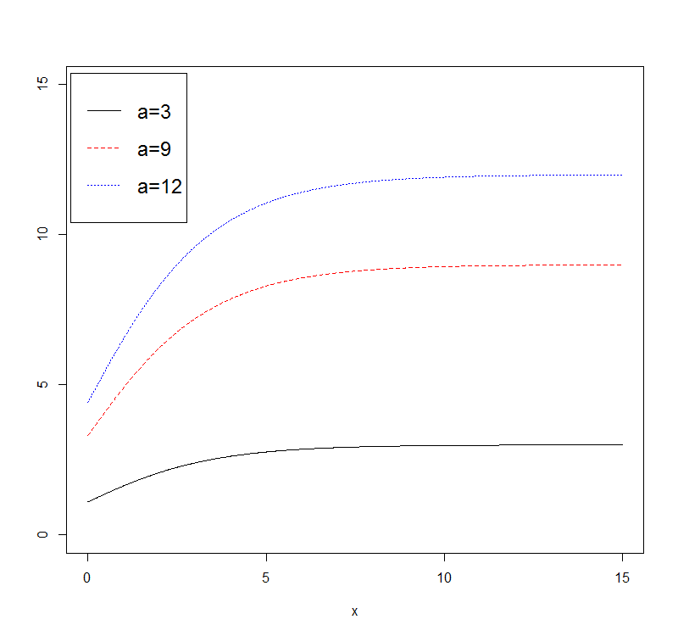

b) Parameter k controls how fast the growth curve approaches the limit.

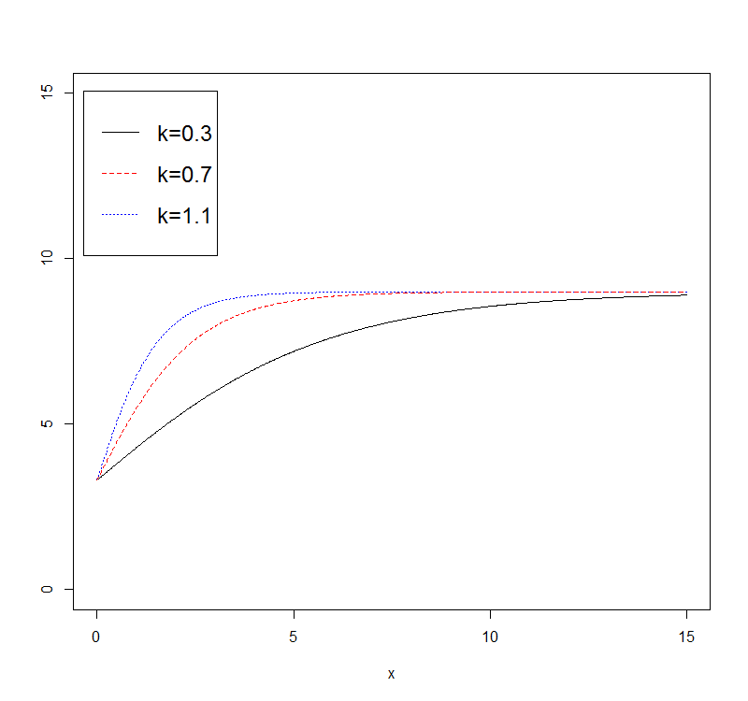

c)Parameter x0 controls where the plot lies horizontally.

