 | CONFIDENTIAL

Proposal For IT Project
Web-based course registration system
Submit to: IT Project Committee, International College

Student Name : Asem Mohammed Abdulziz Farhan.
Matric No. : 108522.
Project Title : Web-based course registration system.
Supervisor Name : MR-Ismail Al-Hadi.

PROJECT TITLE
Web-based course registration system:
It's a web-based system used to allow the registrar and the students to register available courses according to their program in every semester correctly and efficiently that for both branch (Boys, Girls).

ABSTRACT
Course Registration System is a web-based program aimed to make easier and more convenient the registration process that covers all the aspects of the registration process to be satisfying, effective, & efficient as possible by analyzing the current system, and to generate very important reports.

The programs offered by OUM require the students to register for the courses for each semester. Currently there is a system that allows the students to register for the courses; unfortunately this system has some limitations. They are mentioned in the following lines. First, it doesn’t impose a specific time to add or drop courses which should be in the first week semester only, or withdraw courses which should be until the tenth week of the semester. Second, it doesn’t show the courses offered that the student can take in each semester. Third, it allows the user to register course although this course requires prerequisites,. Forth, after registering the courses, It doesn’t generate reports that are needed by University in Malaysia. Finally, it is using different databases for the girls and the boys' branch requires combining the data from both databases manually when it is needed.

After the analysis part, I will be ready to go through the whole process of designing, developing or coding, and testing the new system. To solve and improve the limitations of the current system, and to enhance the students to register for available courses correctly and efficiently.

PROJECT BACKGROUND
1. The registrar keyed in all the courses details for each program in the current system.
2. The program coordinators decide which courses are offered in each semester.
3. The students select which courses they are willing to study and then fill the course registration form manually and submitted to the registrar.
4. The registrar then enters the information to the system and print out the course registration slip for each student.
5. While entering the information, the registrars check whether the student has taken the prerequisite courses of the selected one because the current system doesn’t prevent the registrar from assigning a course to student whether they have taken it or not (the checking for prerequisite option is disabled). It just alters the registrar that the selected course has a prerequisite while he/she is assigning the course for the student.
6. The current system doesn't check whether the student pass or fail in the course because the students results are not kept in the system. Therefore, the registrar may assign a course to student who failed in the prerequisite course which causes the registrar to do modification later.
7. The current system allows the student to drop or withdraw courses even after the specified duration is finished.
8. The current system doesn't inform the student about the remaining courses that he/she must take in order to graduate. In addition, it doesn't show the courses that are offered in each semester.

PROBLEM STATEMENT
Recently, most major universities have moved from manual registration systems to web-based systems that allow students to search and register for courses. As more universities follow this trend and begin to offer online registration, it will become increasingly important for these systems to be considered usable by all students. In addition to the system being usable, it must also provide the student with convenient access to information that will ease the registration process.
Registration process must covers all the aspects of the registration process to be satisfying, effective, & efficient as possible by analyzing the current system and determine the limitations that faced the current system as listed below:
  - The current system doesn’t show the courses offered that the student can take in each semester.
  - The current system doesn't inform the student about the remaining courses that he/she must take in order to graduate.
  - The current system doesn’t prevent the student from adding and dropping courses after specific period (doesn't impose the due date).
  - The current system doesn’t check the prerequisites courses of each selected course, whether the student passed in all the prerequisite of that course.
  - The current system doesn’t provide the required reports.
  - The current system doesn’t check the credit hours of the courses taken by the student.
  - The current system is using different databases for the girls' and the boys' branch.
  - The database of the current system is not connected that have separate database for each semester. That leading to difficulties in searching, updating, reporting, integrating, and consistency of data.

PROJECT OBJECTIVE
- Manage the courses information.
  - To automate the registration process.
- Identify the offered courses in each semester.
- Allow the student to register courses only if has passed in all the prerequisite courses of those courses.
  - To ensure the accuracy, integrity & consistency of the updated information.
- Allow the student to add and drop the courses within specific period.
- To show the taken, registered and remind courses of each student.
  - To simplify the reporting process.
- To manage the grades of students.
  - To enhance the system with help facilities.
- Use one database for both girls and boy' branch.
  - To provide a user friendly system interface.
  - To facilitate the searching process.
  - To sufficiently train the users of the new system.
  - Calendar for setting deadlines and examination schedules.
  - Statistical information on student scores.
  - Passwords and security management.

PROJECT SCOPE
The system is intended to be used by three users, the registrar, the student and the Administrator.

The Registrar can:
- Add and manage the courses’ information.
- Specify the offered courses every semester.
- Register courses for students if the student has passed in all the prerequisite courses of those courses.
- Add or drop courses for students according to the courses credit hours within a specific period
- Withdraw courses within a specific period.
- View the courses taken by each student.
- Generate courses registration slip.
- Generate reports i.e. print them or export them to excel.
- Manage & store the grades of students.
- Search for student.
- Manage & store the grades of students.
- Manage, search & store the courses information for each program.
- Set offer course.
- Search, edit and view course information.
- Set offer course.
- Set and delete course prerequisite.

The Administrator:
- Register courses for students with special cases.
- Create a new user or delete an existing one.
- Search for student.
- Add new news
The student can:
- Register courses.
- Add and drop courses within the specific period.
- View taken, registered and remind courses.
- Change password.

Requirements
- Supervisors
- Interview with IT people dealing with registry systems.
- HTML code includes (font, link, header, CSS code).
- PHP code.
- Mysql_query.
- Books
- Computers
- Internet connection
- Similar projects

LITERATURE REVIEW
Web technologies have become essential in the computing curricula. However, teaching a Web development course to computing students is challenging because of large bodies of knowledge, rapidly changing technologies, demanding support infrastructures and diverse background of audiences.

Through my search from different recourses (internet, books, previous project, interview who work within course registration system). I found a litter literature review have been written about my system that for some reason (1) because it needs to be one member of that system to able to enter to the login page (haven't privileges) and for (2) security issues.

Sana'a University:
The system in Sana'a University is block system for course registration not hour's system (what applied in our collage) that mean the student's in each semester will take group of subjects (block) that mandatory for all the student's to take all subjects for each semesters.

Open Arabic university:
Having a similar scenario of registration process that applied in our collage, that list in background.

Bahrain University:
Is a WAP-based course registration system designed and implemented to facilitating the process of student's registration. The framework will support many opportunities for applying WAP based technology to many services such as wireless commerce, cashless payment... and location-based services. It shows also how the request will be issued, received, processed, formulated, and how the reply is sent back to the student for display.
Department of MIS, College of Information Technology, University of Bahrain, Kingdom of Bahrain.

University of Houston-Clear Lake (UHCL):
In the University of Houston-Clear Lake (UHCL), a Web application development has successfully been taught for seven years. The course was first introduced in fall 1996 as “Software Tools” and has then been renamed to “Internet Application Development” (IAD).

The course began in the fall semester of 1996 with the title “Software Tools” to cover emerging and leading practical tools and techniques for computing students. As the Web was becoming very popular, more than 60% of the topics of the first offering were already devoted to Web techniques, including HTML, CGI-Perl, JavaScript and Java applets.

The course has then evolved quickly to a serious Web programming course with the title changed to “Internet Application Development” in 2000. This emphasis in programming is similar to that of Lee A. A Manageable Web Software Architecture: Searching for Simplicity. Computer science education, February 2003. But in contrast with other courses that include significant Web architecture topics such as compression, Web security, Web administrations and intellectual properties.

ITICSE’04, June 28–30, 2004, Leeds, United Kingdom. 9/04/0006…

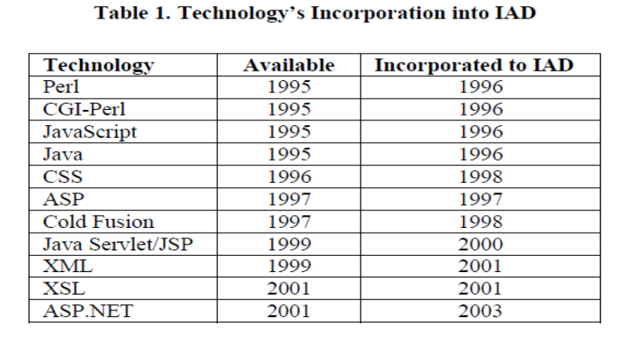

Indiana University of Pennsylvania:
HCI has been taught in universities and colleges as an elective for computer science majors. An inter-disciplinary synthesis course was developed in the Department of Computer Science at Indiana University of Pennsylvania. The course was first offered in the fall of 2004. Objectives, content, and pedagogy of this course are outlined. The paper is concluded by citing challenges and issues regarding the development and launching of such a course.

Course Description
This course provides an overview of interaction design. Interaction design means designing interactive products to support people in their everyday and working lives. The basis of the course is the interaction design process given in Preece, J., Rogers, Y., and Sharp, H., Interaction Design: Beyond Human Computer Interaction, John Wiley, 2002.

The design process consists of the following activities:
1) Identifying the needs and establishing requirements through user interface evaluation.
2) Developing alternative designs that meet the requirements.
3) Building interactive prototype versions of the design so that they can be communicated and evaluated.
4) Re-evaluating what is being built throughout the process.

Some of the issues addressed by the course are:
a) What should interactive products look like?
b) What should one expect from interactive products? c) How can interactive products be used efficiently?
d) When should an interactive product be accepted, rejected or modified?

Rose Shumba
Department of Computer Science
Indiana University of Pennsylvania

PROJECT METHODOLOGY
The methodology that will be use to develop this system is the Rapid Application Development (RAD) methodology. Rapid Application Development (RAD), introduced by James Martin, is a software development methodology that focuses on building applications in a very short amount of time by compressing the analysis, design, build, and test phases into a series of short, iterative development cycles. The RAD methodology uses computerized tools and human techniques in a tightly interwoven fashion to achieve the goals of high-speed and high-quality system. It uses prototypes, iterative customization, and CASE tools.
RAD methodology is a very flexible methodology. It incorporates prototyping and user feedback as it's main mechanisms. RAD will involve the user in all the phase of the system creation. Deliveries of the system are broken into several milestones. The first delivery is usually a prototype of the complete system to include system flow from form to form and from form to report, etc. The end users have a chance to review each delivery before work commences on the remainder of the system.
Figure 1 below described by Michael Cordova (1993) illustrates a typical chain of RAD process events. Note that the left side dotted line from 'Object Creation' through 'Return to Brainstorm, Requirements, Analysis' is optional. If the system designers are well versed on the system requirements then the first RAD deliveries may not have to be redesigned.

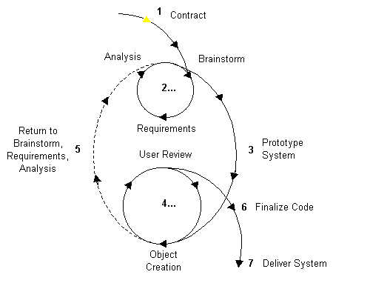
- Figure 1:Rapid Application Development (RAD) Methodology

The following further describes the RAD Methodology as described by Michael Cordova (1993):
- It is important that a contract that is agreeable and beneficial to both sides is signed before any work begins. If the project does not present a 'win - win' situation for both parties, then it is not in the best interests of at least one party to proceed further. I am going to sign the contract, which is the proposal, with my supervisor. It acts as an agreement of requirement specifications of the system that will be developed.
- Once the contract is signed, the Brainstorm, Requirements, and Analysis steps may be repeated until enough information is known to create a prototype. It requires the involvement of the knowledgeable end-users in order to determine what the functions of the system should be. It should be a structured discussion of the problems that need to be solved or the limitations that need to be improve. It can often be done quickly when the right users and executives are involved. I hold several meeting with registrar who has deal several semesters with the current system to detect the bugs in the current system. Also I am going to hold several meetings with the university director who knows about the real flow of the course registration process to determine the system specifications and what the system should include. In the analysis part, I am going to develop all the use cases diagrams, the use case specification and the sequence diagram of the system.
- The next step is to create prototypes of the new system. Prototyping is used to aid in requirements specification and design to help the end-user visualize adjustments to the system. The prototypes may change after receiving user feedback.
- The Object Creation and User Review steps can be repeated multiple times until the system is correct and accepted. Objects might include data entry forms, reports, etc. In this methodology, the project schedule is often driven by the time taken by the end-user (registrar) and supervisor to review deliveries.
- Optionally, if the User Review step results in fundamental changes in the direction of the system, the Brainstorm, Requirements, and Analysis steps can be repeated as depicted in Figure 1.
- Once all of the above steps are completed to the acceptance of the supervisor and end-user, the system code is finalized in preparation for final delivery.
- The system will be tested several times to ensure that the all system's functions are working well and it met all the requirements.
- The system is delivered (with all documentation), installed, and configured. Users are trained, and the system moves into maintenance stage.

LIMITATION

The students’ information is assumed to be keyed in previously in the system.

The limitation of internet access since the system is going to be web-based.

This system is not connected to other departments such as financial or accounting department.

REFERENCES
Mohammed Shma'a , The current OUM course registration system.

Cotterall, S. (2001). Writing a literature review. Postgraduate seminar 2001. Student Learning Support Services and PGSA: Victoria University.

Cordova M. (2008). RAD Methodology. Retrieved April 24, 2008, from 21stsoft website:
http://www.21stsoft.com

___________________________
( )

Date: ______________________

For Office Use Only
Result:
Pass
Fail
Pass with Condition(s)

Conditions:

Comments:

___________________________
( )

Date: ______________________

