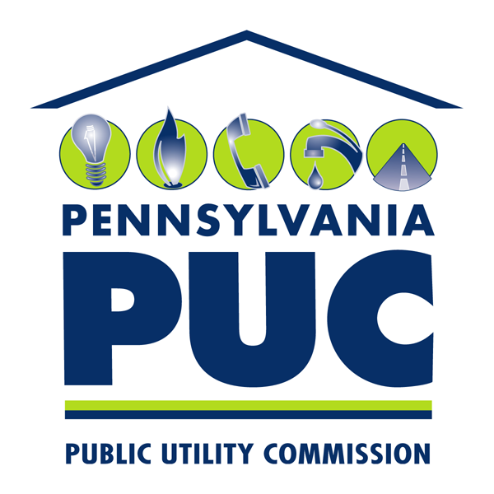 | COMMONWEALTH OF PENNSYLVANIA  PENNSYLVANIA PUBLIC UTILITY COMMISSION  P.O. BOX 3265, HARRISBURG, PA 17105-3265 | IN REPLY PLEASE REFER TO OUR FILE

April 5, 2013

MARK CHAPPELL PE CHIEF
ROW & UTILITY DIVISION
PENNDOT BUREAU OF DESIGN
PO BOX 3362
HARRISBURG PA 17105-3362

A-2013-2351463-Application of Southeastern Pennsylvania Transportation Authority for approval of the alteration of the crossing AAR#592-942-K, where Indian Queen Lane crosses at-grade the tracks of SEPTA, located in the City of Philadelphia, County of Philadelphia, Pennsylvania.

A-2013-2351464-Application of Southeastern Pennsylvania Transportation Authority for approval of the alteration of the crossing AAR#592-940-W, where Scotts Lane crosses at-grade the tracks of SEPTA, located in the City of Philadelphia, County of Philadelphia, Pennsylvania.

Dear Mr. Chappell:

This is to advise that a field investigation and conference will be held on Tuesday, April 30, 2013 for both of the above-captioned applications. The parties will meet at the site of the Indian Queen Lane crossing (DOT No. 592 942 K) at 10:30 am, and proceed directly to the Scotts Lane Crossing (DOT No. 592 940 W) at the conclusion of the meeting at Indian Queen Lane.

Kindly arrange to have a representative present.

Very truly yours,

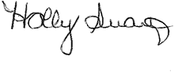
Holly Swartz
Rail Section
Bureau of Technical Utilities
Phone (717) 787-5936
Fax (717) 772-1931
Email hoswartz@state.pa.us

Similar letter list
A-2013-2351463 & A-2013-2351464

MARK CHAPPELL PE CHIEF
ROW & UTILITY DIVISION
PENNDOT BUREAU OF DESIGN
PO BOX 3362
HARRISBURG PA 17105-3362

GINA M D’ALFONSO
DEPARTMENT OF TRANSPORTATION
OFFICE OF CHIEF COUNSEL 9TH FL
P O BOX 8212
HARRISBURG PA 17105

PENNDOT DISTRICT 6-0
MARY ANN LANG
7000 GEERDES BLVD.
KING O FPRUSSIA, PA 19406

MS. NANCY SEN
PHILADELPHIA DEPARTMENT OF STREETS
1401 JOHN F. KENNEDY BLVD.
940 MUNICIPAL SERVICES BLDG.
PHILDELPHIA, PA 19102

MR. PATRICK ODONNELL
PHILDELPHIA DEPARTMENT OF STREETS
1401 JOHN F. KENNEDY BLVD.
940 MUNICIPAL SERVICES BLDG.
PHILDELPHIA, PA 19102

SUSAN VAN ALLEN
COMCAST CABLE COMMUNICATIONS
1401 JOHN F. KENNEDY BLVD.
ONE COMCAST CENTER
PHILADELPHIA, PA 19103

JACK CLAYTON
COMCAST
4400 WAYNE AVENUE
PHILADELPHIA, PA 19140

JOHN LENNON
PHILADELPHIA GAS WORKS
800 WEST MONTGOMERY AVENUE
2ND FLOOR
PHILADELPHIA, PA 19122

BRIAN MAGEE
VERIZON
900 RACE STREET
6TH FLOOR
PHILADELPHIA, PA 19107

LOUIS ROBINSON
PECO ENERGY
830 S. SCHUYLKILL AVENUE
PHILADELPHIA, PA 19146

NIKUNJ KARUMSI
PHILADELPHIA WATER DEPARTMENT
1101 MARKET STREET
ARAMARK TOWER, 2ND FLOOR
PHILADELPHIA, PA 19107

RICHARD WALIGORA
PHILADELPHIA UNIVERSITY
DIRECTOR OF PHYSICAL PLANT
4201 HENRY AVENUE
PHILADELPHIA, PA 19144

DAVID MACKEY
SEPTA
EM&C TRACK ENGINEERING
1234 MARKET STREET
12TH FLOOR
PHILADELPHIA, PA 19107

