# Exercise: HTML Forms

This document defines an in-class exercise from the [Web Fundamentals (HTML & CSS)](https://softuni.bg/courses/web-fundamentals).

## Simple form

Your task is to create a registration form using HTML and CSS. The form should look like the screenshots below. 100% accuracy is **not** required

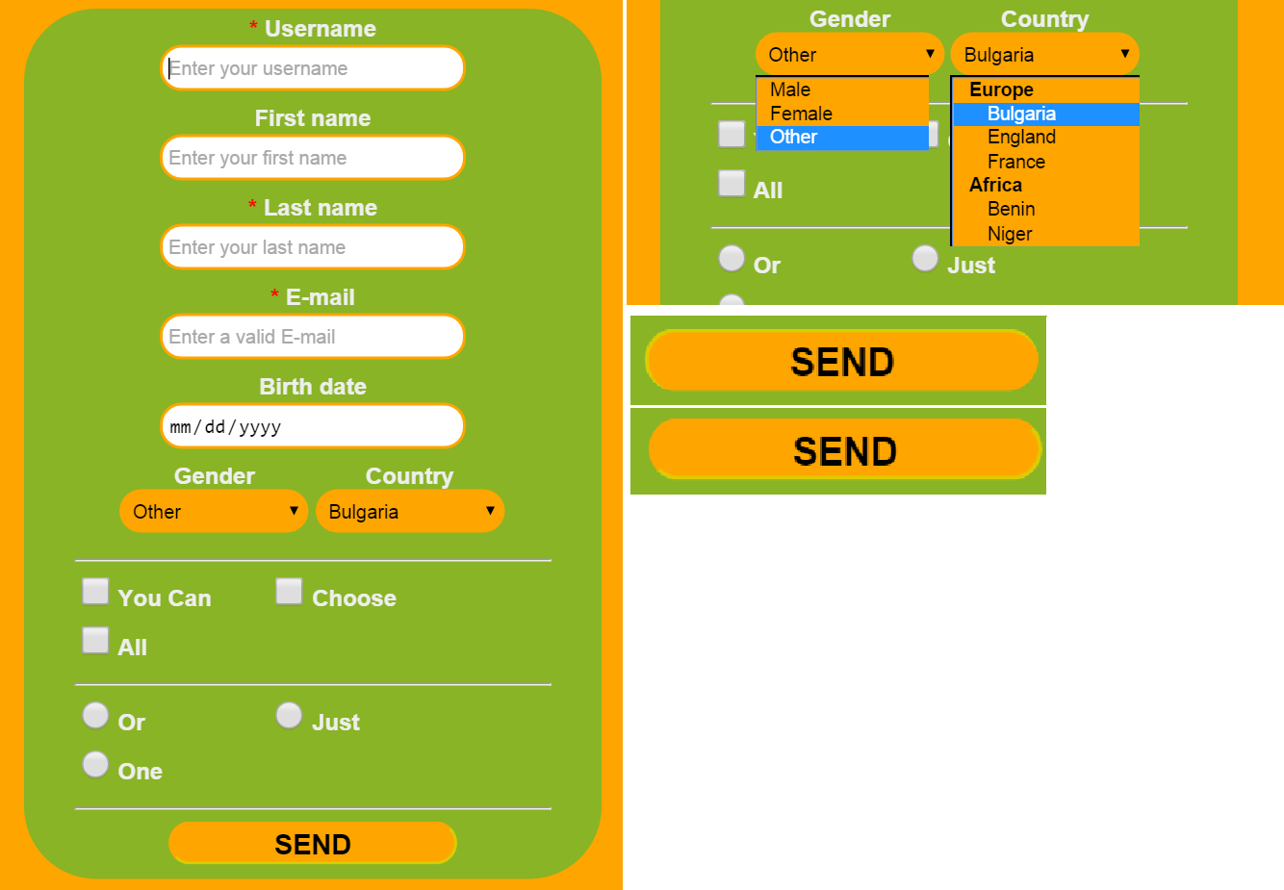

* Wrapper – width: **400px**, background color: **#FFA500**
* Form – width: **330px**, background color: **#89B426**
* Input fields – width: **200px**, border color: **#FFA500**
* Labels should be **centered** above their respective inputs