Have your say

30 September 2019

12:57

1. there must be a button in the the area where add on buttons usually appear. (I am only familiar with firefox(so top right to the right of the url) , but the other browsers must have a reasonable placement of the button as well(standard placement is ok)

2. this add on should work on all major browsers.

3 when you press the button, a box appears (white or translucent or black with red border in night mode ) with a list of previous comments on that website (What to do when the url changes for the website?) the bottom right of the box has the dots indicating you can resize the box.

--one can scroll through the comments

-- each comment is separated by a horisontal thin line

In night mode text is red and background is black. There will be a medium button with black backround and grey text

In the red and black mode, the logo text in the box changes to red. same with the text

in night mode the add on button turns the white areas into red. the indicator number turns red as well.

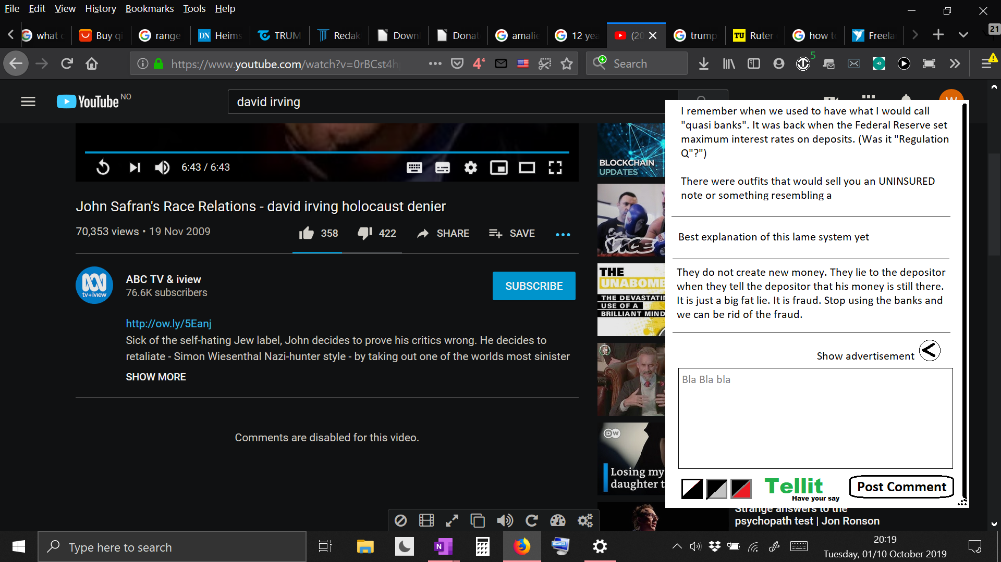

4 in that box, beneath the comments, there is a text input field with a submit box

5 Between the comments and the input box there is a small arrow in a round button with the text "show ad(vertisement)" next to it. When clicked, the arrow turns 90 degrees pointing up and the hidden small add banner appears in the space below the comments and above the text input area. The text next to the button changes to "hide add(vertisement)" For now the hidden advertisement can be this:



its is the banner from sens.org.

But there must be a way for me to implement new advertisements and for me to outsource that job to a third party so someone else can change what adds appear. the ad banner can also be a link. In this case to www.SENS.org

6 the comment box can preferrably be moved around and stretched like a window, but should not be a separate window (only way to remove the comment box is to hit the add on button again. (the add on logo can change to have an x in th top of the logo to signify that you can x out the comment box., but if not, top right corner of page is ok. (See add-on ublock origin, night light and dashlane etc.) the comments always have space in the window. So block of text changes shape. (If this is impossible that is ok.

7 Same font as youtube text

8 share add on function that allows the invited person to install the addon with almost no button clicks. How to take into account different browseren in the share link. To where does it link?

9 the add on must be on the various add on download pages of the different browsers with hosting ready. we discuss this. Also published on the add on page without my name attached for now.

10 the add on logo must have an indicator telling you how many comments are on the current website.

11. I want to improve more in the future. Perhaps a quoting system (with quote collapsed /hidden partially for long comments and quotation marks in a button as a quote button placed behind or below each comment) for the comments and perhaps numbering for the comments.

As this is a work in progress there should be too much uncommented spaghetti code so further work is possible.

Objects of fuemrther discussion and study after user testing.

--Comments point to area of text

-- Classification of comments based on type of comment (spam, offensive etc. ) with death threats and spam hidden and offensive behind a pluss button with the spam and threats hidden behind the offensive/controversial. The best comments as judged by upvotes get bigger font and the downvoted ones get smaller font and greyed out colour on text. faded

I will pay you extra for the stuff in 11.

tellit