Descriptive statistic for multiple groups

Automatic report by R-script /asenic

This document summarizes a comparison between **5** independent groups, comparing **example** between the conditions: **PF, OL, DK, ST, NV**. This script can help to facilitate the analysis of data, and the word-output might prevent copy-paste errors when transferring results to a manuscript.

#Checking for outliers, normality, equality of variances.

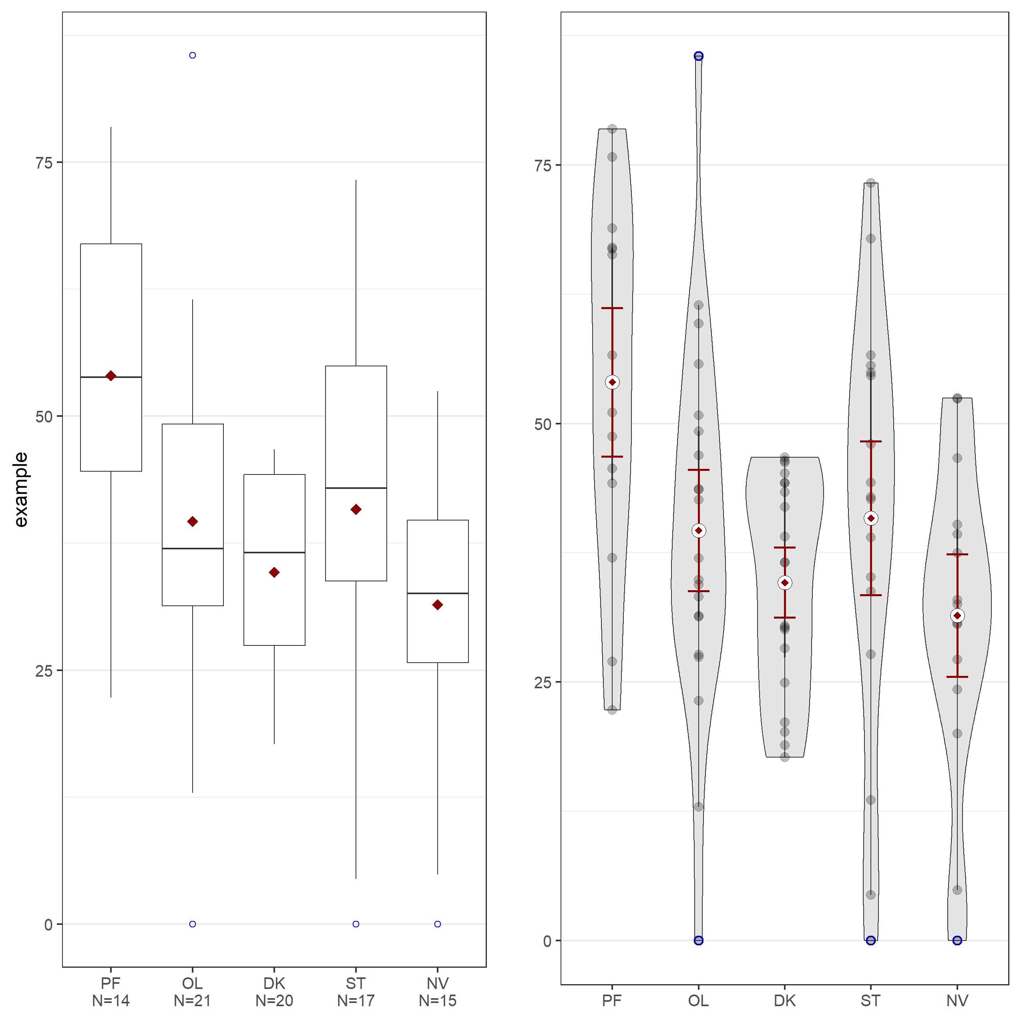

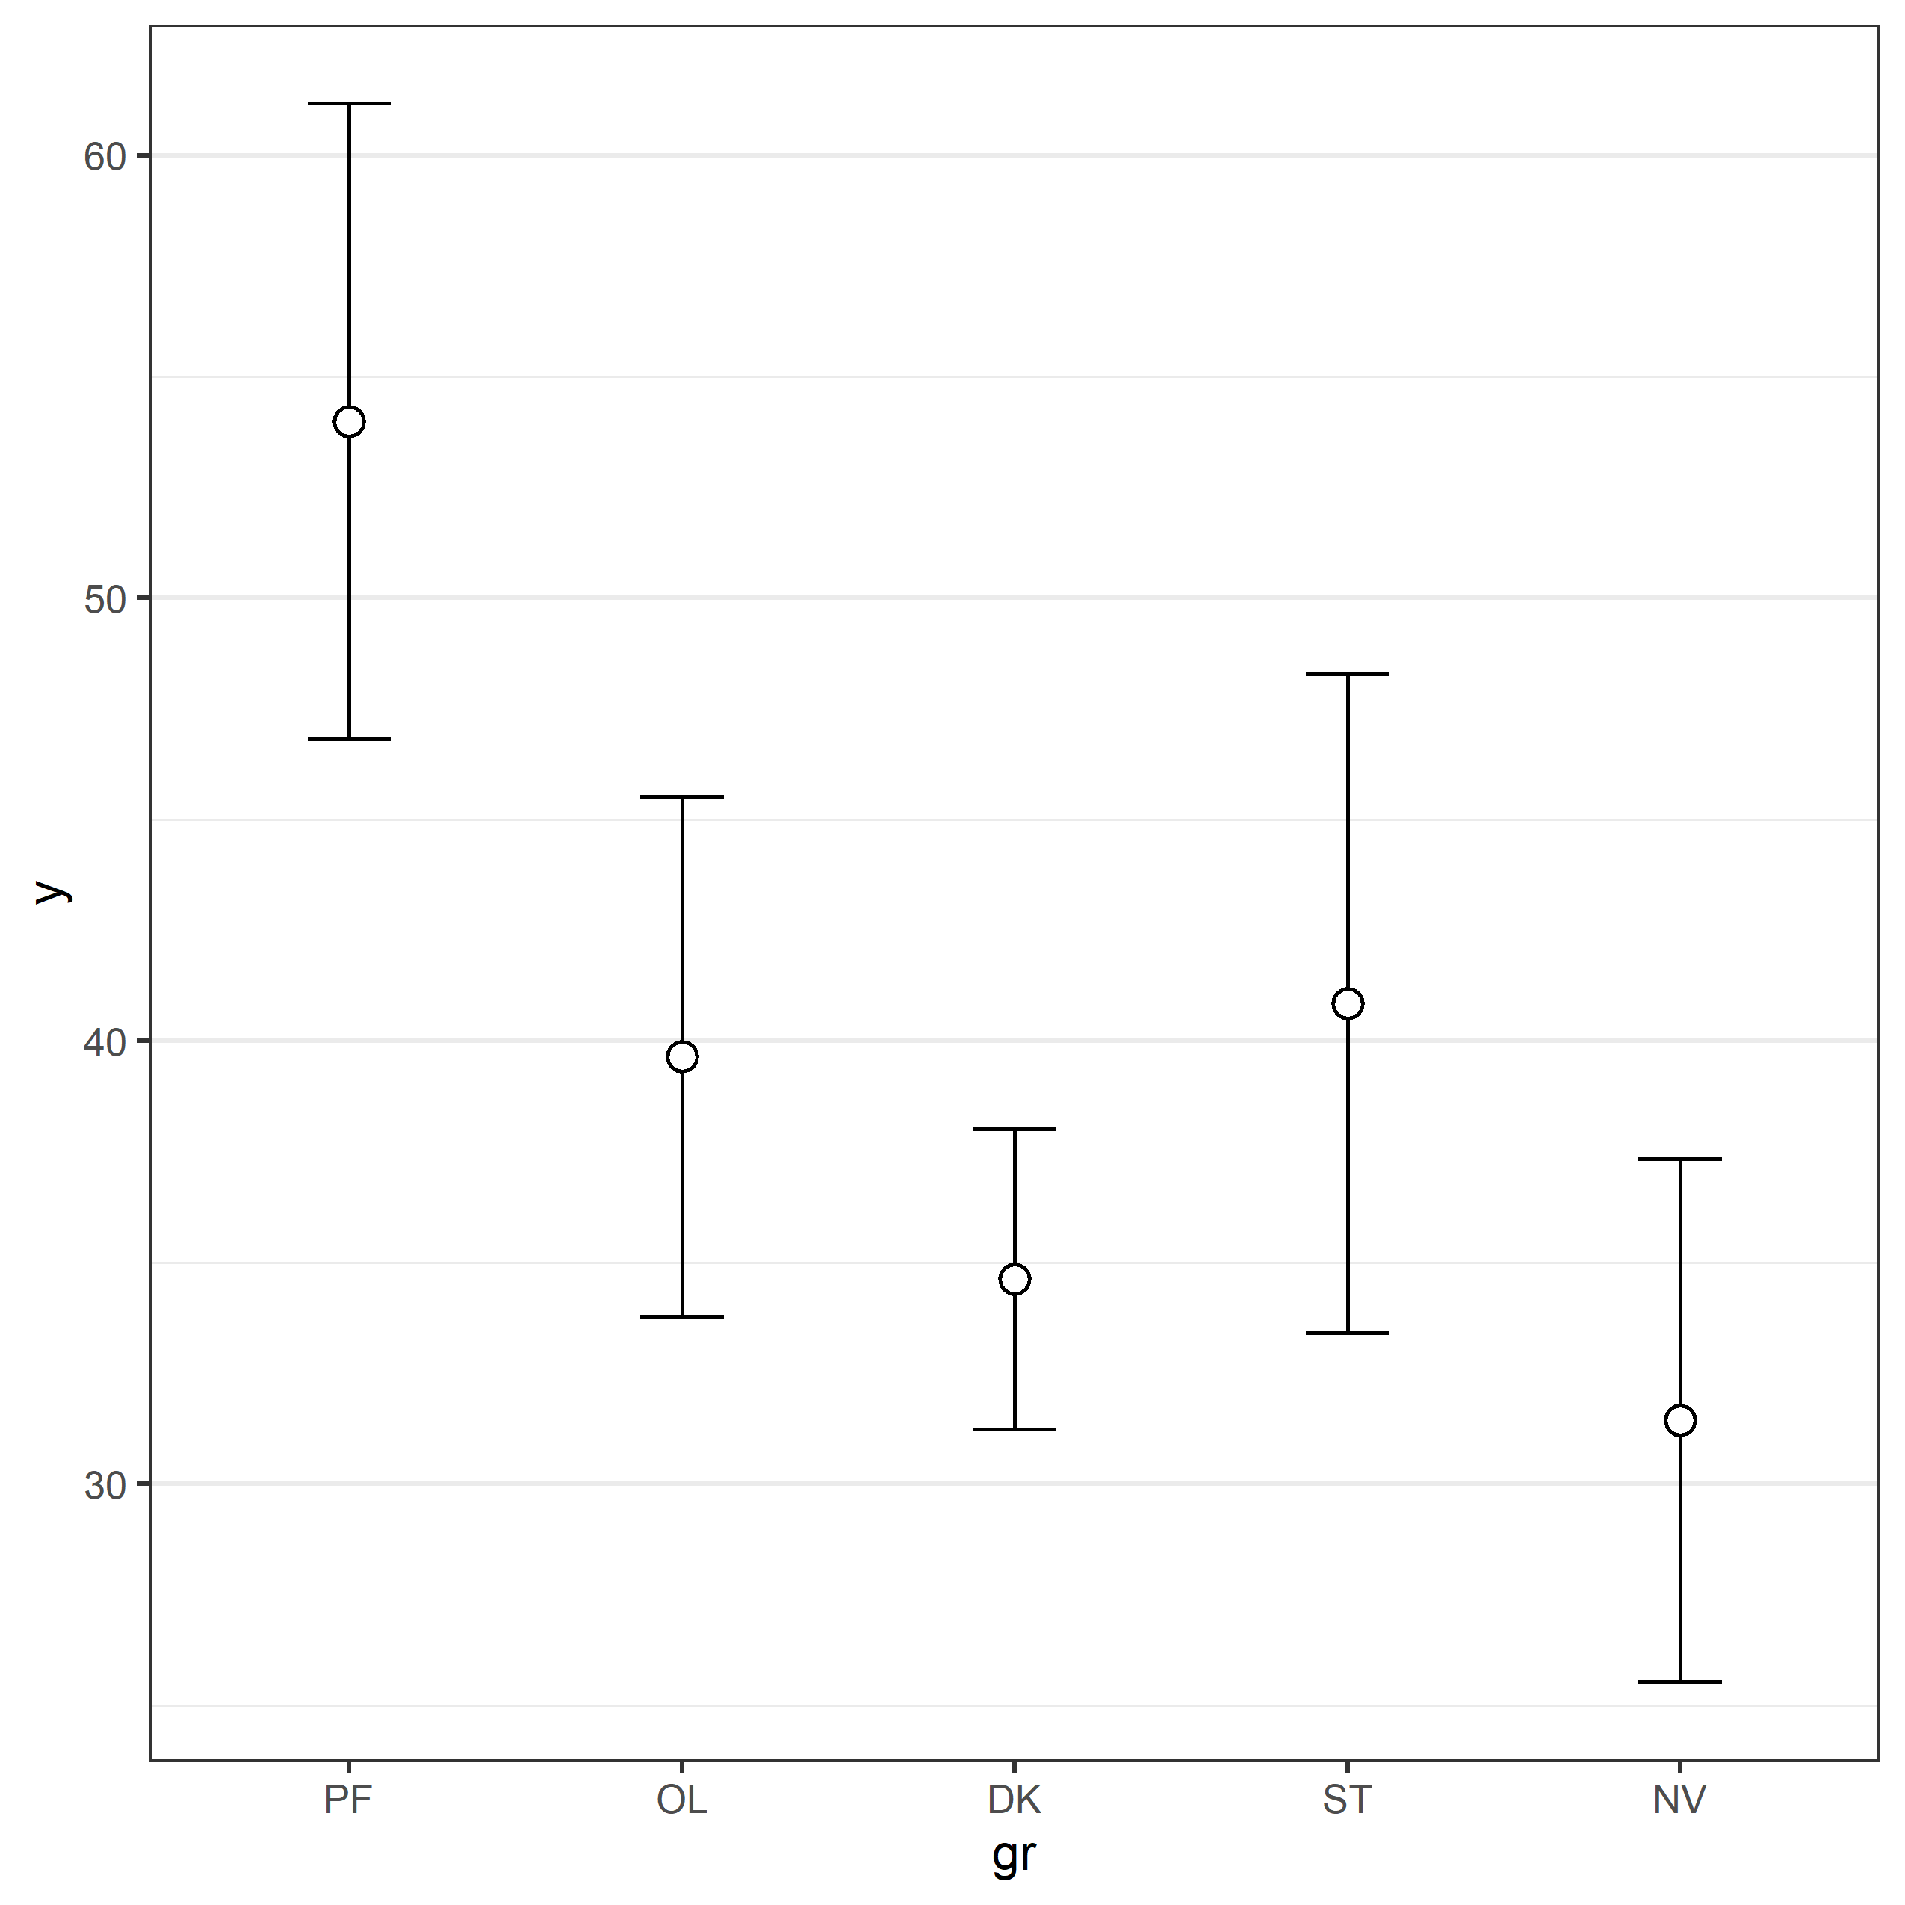

Boxplots can be used to identify outliers (blue open circles). Boxplots give the mean (red rhomboids), the median (thick line), and 25% of the data above and below the median (box). End of whiskers are the maximum and minimum value when excluding outliers. The violin plot on the right shows distributions of all data (grey dots), and means with CI errorbars (difference-adjusted 95% confidence interval, see [Baguely 2012](https://seriousstats.wordpress.com/2012/03/18/cis-for-anova/)).

####Normality assumption

Most frequently used statistical tests assume that scores in all groups are normally distributed. If the normality assumption is violated, the Type 1 error rate of the test is no longer controlled, and can substantially increase beyond the chosen significance level. Formally, a normality test based on the data is incorrect, and the normality assumption should be tested on additional (e.g., pilot) data. Nevertheless, a two-step procedure (testing the data for normality, and using alternatives if normality is violated, seems to work well (see [Rochon, Gondan, & Kieser, 2012](http://www.biomedcentral.com/1471-2288/12/81)).

##Tests for normality

Five tests for normality are reported below for all groups. [Yap and Sim (2011, p. 2153)](http://www.tandfonline.com/doi/pdf/10.1080/00949655.2010.520163) recommend: “If the distribution is symmetric with low kurtosis values (i.e. symmetric short-tailed distribution), then the D’Agostino-Pearson and Shapiro-Wilkes tests have good power. For symmetric distribution with high sample kurtosis (symmetric long-tailed), the researcher can use the JB, Shapiro-Wilkes, or Anderson-Darling test.” The Kolmogorov-Smirnov (K-S) test is often used, but no longer recommended (it highly affected by outliers; K-S test implemented here in two-sided configuration for alternative hypothesis H1, and the result of it changes every run as it uses pseudorandom normally distributed variable with the same sample size, mean and SD).

The normality assumption was **rejected in 1 times out of totally 25 normality tests** for every groups/conditions.

Table of *p*-values:

| **Test Name** | PF | OL | DK | ST | NV |
| --- | --- | --- | --- | --- | --- |
| **Shapiro-Wilk** | 0.52881 | 0.80577 | 0.032471 | 0.43268 | 0.37772 |
| **D’Agostino-Pearson** | 0.61646 | 0.31002 | 0.072332 | 0.51823 | 0.41448 |
| **Anderson-Darling** | 0.54111 | 0.61524 | 0.052869 | 0.37814 | 0.43171 |
| **Jarque-Berra** | 0.66577 | 0.65813 | 0.39559 | 0.62368 | 0.62485 |
| **Kolmogorov-Smirnov** | 0.63548 | 0.85308 | 0.98126 | 0.99994 | 0.18442 |

If a normality test rejects the assumptions that the data is normally distributed (with *p* < .05) non-parametric or robust statistics have to be used. In very large samples (when the test for normality has close to 100% power) tests for normality can result in significant results even when data is normally distributed, based on minor deviations from normality. In very small samples (e.g., n = 10), deviations from normality might not be detected, but this does not mean the data is normally distributed. Always look at a plot of the data in addition to the test results.

###Histogram, kernel density plot (black line) and normal distribution (red line) of difference scores

The density (or proportion of the observations) is plotted on the y-axis. The grey bars are a histogram of the scores in the two groups. Judging whether data is normally distributed on the basis of a histogram depends too much on the number of bins (or bars) in the graph. A kernel density plot (a non-parametric technique for density estimation) provides an easier way to check the normality of the data by comparing the shape of the density plot (the black line) with a normal distribution (the red dotted line, based on the observed mean and standard deviation). For independent *t*-tests, the dependent variables in both conditions should be normally distributed.

## Warning: The dot-dot notation (`..density..`) was deprecated in ggplot2 3.4.0.  
## ℹ Please use `after_stat(density)` instead.

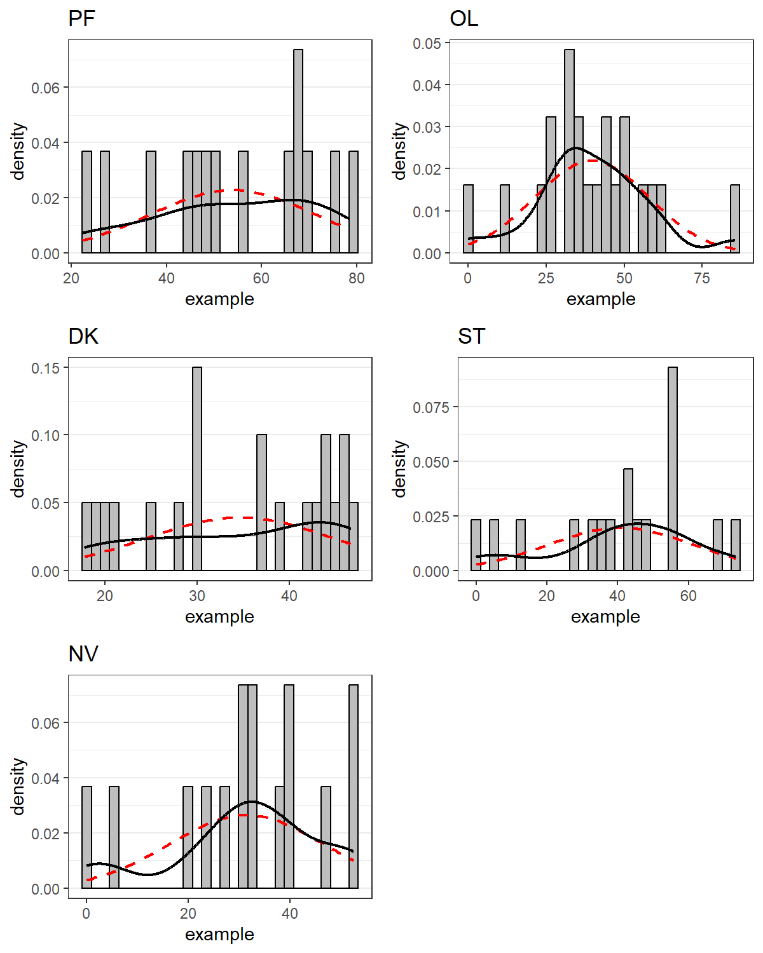

###Q-Q-plot

In the Q-Q plots the points should fall on the line. Deviations from the line in the upper and lower quartiles indicates the tails of the distributions are thicker or thinner than in the normal distribution. An S-shaped curve with a dip in the middle indicates data is left-skewed (more values to the right of the distribution), while a bump in the middle indicates data is right-skewed (more values to the left of the distribution). For interpretation examples, see [here](http://emp.byui.edu/BrownD/Stats-intro/dscrptv/graphs/qq-plot_egs.htm).

## Warning: `qplot()` was deprecated in ggplot2 3.4.0.

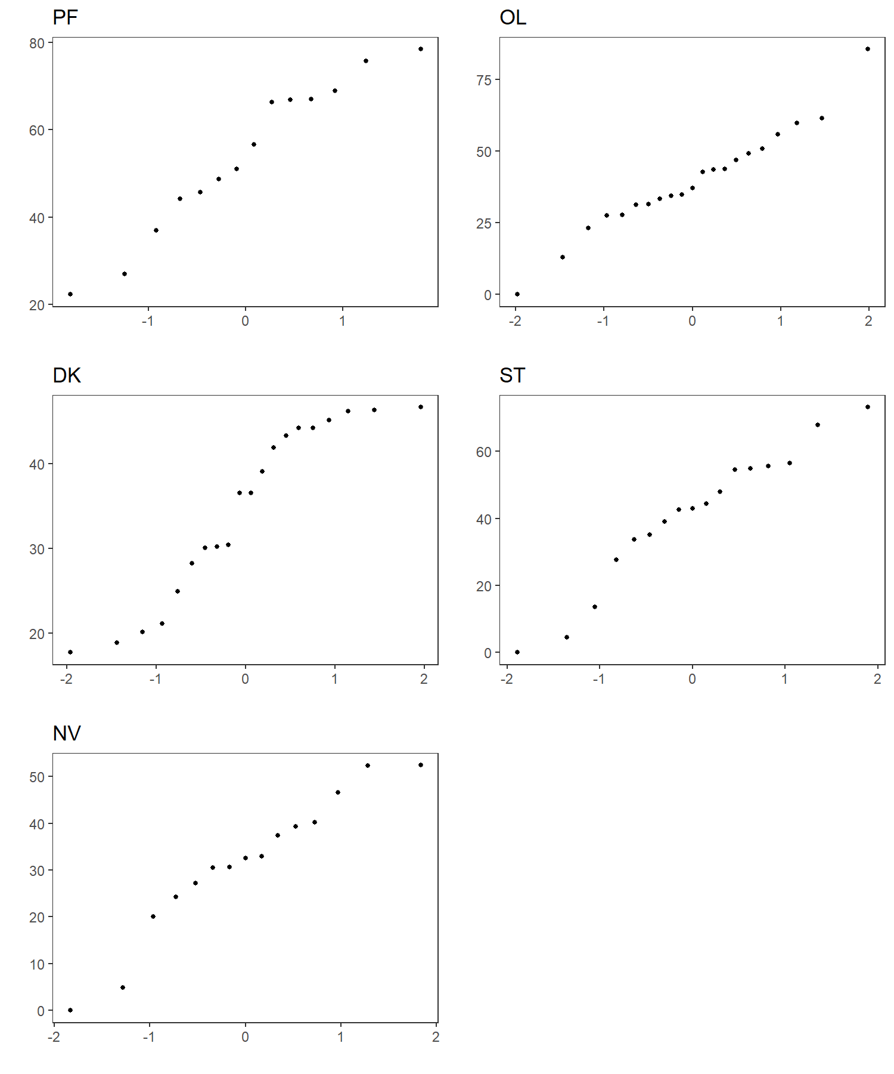

###Equal variances assumption

In addition to the normality assumption, a second assumption used by many tests is that variances in both groups are equal. For two-samples *t-test* [Ruxton (2006)](http://beheco.oxfordjournals.org/content/17/4/688.full) explains: “If you want to compare the central tendency of 2 populations based on samples of unrelated data, then the unequal variance (or Welch’s) *t*-test should always be used in preference to the Student’s *t*-test or Mann-Whitney U test.” This is preferable to the more traditional two-step approach of first testing equality of variances using Levene’s test, and then deciding between Student’s and Welch’s *t*-test. The degrees of freedom for Welch’s *t*-test is typically not a round number.

##Tests for homogeneity of variances (homoscedasticity) There are many tests for equality of variances for any taste. The **Fligner-Killeen** (median) test is recommended for a **rank-based (nonparametric)** k-sample test for homogeneity of variances. The test has been determined in a simulation study as one of the many tests for homogeneity of variances which is most robust against departures from normality, see [Conover, Johnson & Johnson (1981)](A%20comparative%20study%20of%20tests%20for%20homogeneity%20of%20variances,%20with%20applications%20to%20the%20outer%20continental%20shelf%20bidding%20data.%20Technometrics%2023,%20351?361.). **Mood’s** two-sample test for a difference in scale parameters is another rank-based test for a difference in scale parameters [William J. Conover (1971)](Practical%20nonparametric%20statistics.%20New%20York:%20John%20Wiley%20&%20Sons.%20Pages%20234f). Another two-sample test for a difference in scale parameters is **Ansari-Bradley** test. Both two-sample tests are implemented ‘from the box’ here, so please check up the H0 formulation and additional parameters. **Bartlett’s** (K squared) test of the null that the variances in each of the groups (samples) are the same is used **for parametric tests** [Bartlett, M. S. (1937)](Properties%20of%20sufficiency%20and%20statistical%20tests.%20Proceedings%20of%20the%20Royal%20Society%20of%20London%20Series%20A%20160,%20268?282.). For all tests the variances are homogeneous if p-value > 0.05, we accept the null hypothesis H0 (variances homogeneity).

The variances homogeneity assumption was **rejected in 0 times out of 3 homoscedasticity tests** for all 5 groups/conditions. For example, Levene’s test for equality of variances **(*p* = 0.312)** indicates that the assumption that variances in all groups are equal is not rejected.

Table of *p*-values:

| **Test Name** | **Fligner-Killeen** | **Bartlett’s test** | **Levene’s test** |
| --- | --- | --- | --- |
| For 5 groups: | 0.36175 | 0.069372 | 0.31214 |

#One-way analysis of multiple groups Analysis of variance is most used frequentists’ method for comparing multiple independent groups. Usually must be done in protected variant: first test for H0 all groups are equal, and if it return significant *p* for rejecting H0 make all required *post hoc* pairwise tests (with adjustment for multiple comparisons) for revealing which group are different from other. ANOVA on means is standard tool but it assumes normality and homoscedasticity for all groups. If there are no reasons for assuming normality, non-parametric ANOVA on ranks must be used (Kruskal-Wallis test). Welch’s variant of ANOVA help to relax about homoscedasticity. Another way to relax with assumptions is by using robust statistic, like ANOVA on trimmed means (see below). In this script ANOVA on means is implemented with Tukey’s adjusted *post hoc* tests (as in *TukeyHSD* function) for all possible comparisons. For less strict adjustment procedure multiple comparison can be done against one of the group (control). ANOVA on ranks implemented here as Kruskal-Wallis test with Dunn’s method for multiple comparisons with Benjamini-Hochberg (FDR) adjustment (as in *dunnTest* function). Wiliam King [(2016)](http://ww2.coastal.edu/kingw/statistics/R-tutorials/multcomp.html) advertises for using Fisher LSD (Least Significant Difference) test:“The LSD test uses unadjusted p-values, and therefore it makes no attempt to control familywise error rate. If you use it as a protected test (i.e., only after seeing a significant effect in the omnibus ANOVA), it’s good for about three or four comparisons without inflating the error rate. Beyond that, the inflation grows rapidly with increasing numbers of comparisons, if you’re concerned about such a thing. It is among the most powerful of post hoc tests, however, and hey! Type II errors are errors too!”

##Parametric omnibus one-way ANOVA on means:

Analysis of Variance Table

|  | Df | Sum Sq | Mean Sq | F value | Pr(>F) |
| --- | --- | --- | --- | --- | --- |
| **gr** | 4 | 4422 | 1105 | 4.024 | 0.004973 |
| **Residuals** | 82 | 22525 | 274.7 | NA | NA |

###Tukey *post hoc* test for multiple comparisons of means with 95% family-wise confidence level:

|  | diff | lwr | upr | p.adj | sign. |
| --- | --- | --- | --- | --- | --- |
| **OL-PF** | -14.34 | -30.29 | 1.609 | 0.09878 | FALSE |
| **DK-PF** | -19.37 | -35.48 | -3.262 | 0.01033 | TRUE |
| **ST-PF** | -13.15 | -29.84 | 3.535 | 0.1907 | FALSE |
| **NV-PF** | -22.55 | -39.73 | -5.375 | 0.003941 | TRUE |
| **DK-OL** | -5.03 | -19.47 | 9.414 | 0.8672 | FALSE |
| **ST-OL** | 1.192 | -13.89 | 16.27 | 0.9995 | FALSE |
| **NV-OL** | -8.213 | -23.84 | 7.416 | 0.5874 | FALSE |
| **ST-DK** | 6.222 | -9.029 | 21.47 | 0.7859 | FALSE |
| **NV-DK** | -3.183 | -18.97 | 12.61 | 0.9801 | FALSE |
| **NV-ST** | -9.404 | -25.78 | 6.973 | 0.5006 | FALSE |

###Fisher LSD test w/o adjustment:

* **method**: t tests with pooled SD
* **data.name**: unlist(alldata[nn]) and gr
* **p.value**:

|  | * PF | * OL | * DK | * ST |
| --- | --- | --- | --- | --- |
| * **OL** | * 0.01411 | * NA | * NA | * NA |
| * **DK** | * 0.001207 | * 0.3342 | * NA | * NA |
| * **ST** | * 0.03073 | * 0.8261 | * 0.2584 | * NA |
| * **NV** | * 0.0004419 | * 0.1465 | * 0.5755 | * 0.113 |

* **p.adjust.method**: none

###Fisher LSD test with Benjamini-Hochberg (FDR) adjustment:

* **method**: t tests with pooled SD
* **data.name**: unlist(alldata[nn]) and gr
* **p.value**:

|  | * PF | * OL | * DK | * ST |
| --- | --- | --- | --- | --- |
| * **OL** | * 0.04705 | * NA | * NA | * NA |
| * **DK** | * 0.006034 | * 0.4177 | * NA | * NA |
| * **ST** | * 0.07683 | * 0.8261 | * 0.3692 | * NA |
| * **NV** | * 0.004419 | * 0.2442 | * 0.6395 | * 0.2261 |

* **p.adjust.method**: BH

##Non-parametric omnibus one-way ANOVA on ranks (Kruskal-Wallis test):

Kruskal-Wallis rank sum test: unlist(alldata[nn]) by gr

| Test statistic | df | P value |
| --- | --- | --- |
| 13.6 | 4 | 0.008679 * * |

###Dunn’s *post hoc* test with Benjamini-Hochberg (FDR) adjustment: Dunn (1964) Kruskal-Wallis multiple comparison, p-values adjusted with the Benjamini-Hochberg method for all pairwise comparison:

|  | crit.dif | critical.dif | Z | P.unadj | P.adj | sign |
| --- | --- | --- | --- | --- | --- | --- |
| **PF - ST** | 15.27 | 25.12 | 1.635 | 0.1021 | 0.2042 | FALSE |
| **OL - ST** | 14.9 | 25.59 | -0.5335 | 0.5937 | 0.6597 | FALSE |
| **OL - PF** | 19.3 | 24.46 | -2.214 | 0.02681 | 0.08935 | FALSE |
| **NV - ST** | 30.17 | 26.35 | -1.707 | 0.08784 | 0.2196 | FALSE |
| **NV - PF** | 27.56 | 24.71 | -3.215 | 0.001306 | 0.01306 | TRUE |
| **NV - OL** | 4.396 | 23.13 | -1.274 | 0.2028 | 0.2896 | FALSE |
| **DK - ST** | 10.88 | 23.97 | -1.519 | 0.1288 | 0.2146 | FALSE |
| **DK - PF** | 8.26 | 22.15 | -3.131 | 0.001742 | 0.008712 | TRUE |
| **DK - OL** | 12.66 | 23.39 | -1.047 | 0.2953 | 0.3691 | FALSE |
| **DK - NV** | 2.617 | 24.22 | 0.3033 | 0.7617 | 0.7617 | FALSE |

Pairwise KW tests against the first group only, **PF**:

|  | crit.dif | critical.dif | Z | P.unadj | P.adj | sign |
| --- | --- | --- | --- | --- | --- | --- |
| **PF - ST** | 15.27 | 25.12 | 1.635 | 0.1021 | 0.1021 | FALSE |
| **OL - PF** | 19.3 | 24.46 | -2.214 | 0.02681 | 0.03574 | TRUE |
| **NV - PF** | 27.56 | 24.71 | -3.215 | 0.001306 | 0.003485 | TRUE |
| **DK - PF** | 8.26 | 22.15 | -3.131 | 0.001742 | 0.003485 | TRUE |

##One-way PERMANOVA

Permutational methods are modern techniques, which gives much better statistical power then parametrical tests, especially on small and sparse (lot of NA) multiple samples. It widely used in ecology, starting from pioneering work [Anderson 2001](A%20new%20method%20for%20non-parametric%20multivariate%20analysis%20of%20variance.%20Austral%20Ecology,%2026:%2032?46.). Permutational MANOVA can be used in different schemas; here it is implemented in simplest one factor design based on function *adonis {vegan}*. There is not realization of *post hoc* pairwise tests right now (vegan 2.3-3), and author of the package have no plans to do it in future, despite of demand from R community. In this script PERMANOVA calculated statistic for all groups altogether (pretty correct way), and then each of the group **pairwise against the first group (PF)** using additional call of the function. Seems it also correct way of using it, although I didn’t find examples of such analysis done before (people think analysis of permutational residuals may be more correct or computationally efficient way). So, you use these results at your own risk. In the commercial PRIMER software, written by author of the method, pairwise computation arranged by *post hoc* t-tests, as may be guessed from t-statistic in PRIMER’s results tables.

##PERMANOVA with groups as factor:

Permutation: free. Number of permutations: 9999. Method: Euclidean

|  | Df | SumOfSqs | R2 | F | Pr(>F) |
| --- | --- | --- | --- | --- | --- |
| **gr** | 4 | 4422 | 0.1641 | 4.024 | 0.0042 |
| **Residual** | 82 | 22525 | 0.8359 | NA | NA |
| **Total** | 86 | 26946 | 1 | NA | NA |

###Kernel density estimates of permuted values (left, observed value of the statistic marked by vertical line) and QQ-plot of permutations (right, observed value of the statistic marked by horizontal line): 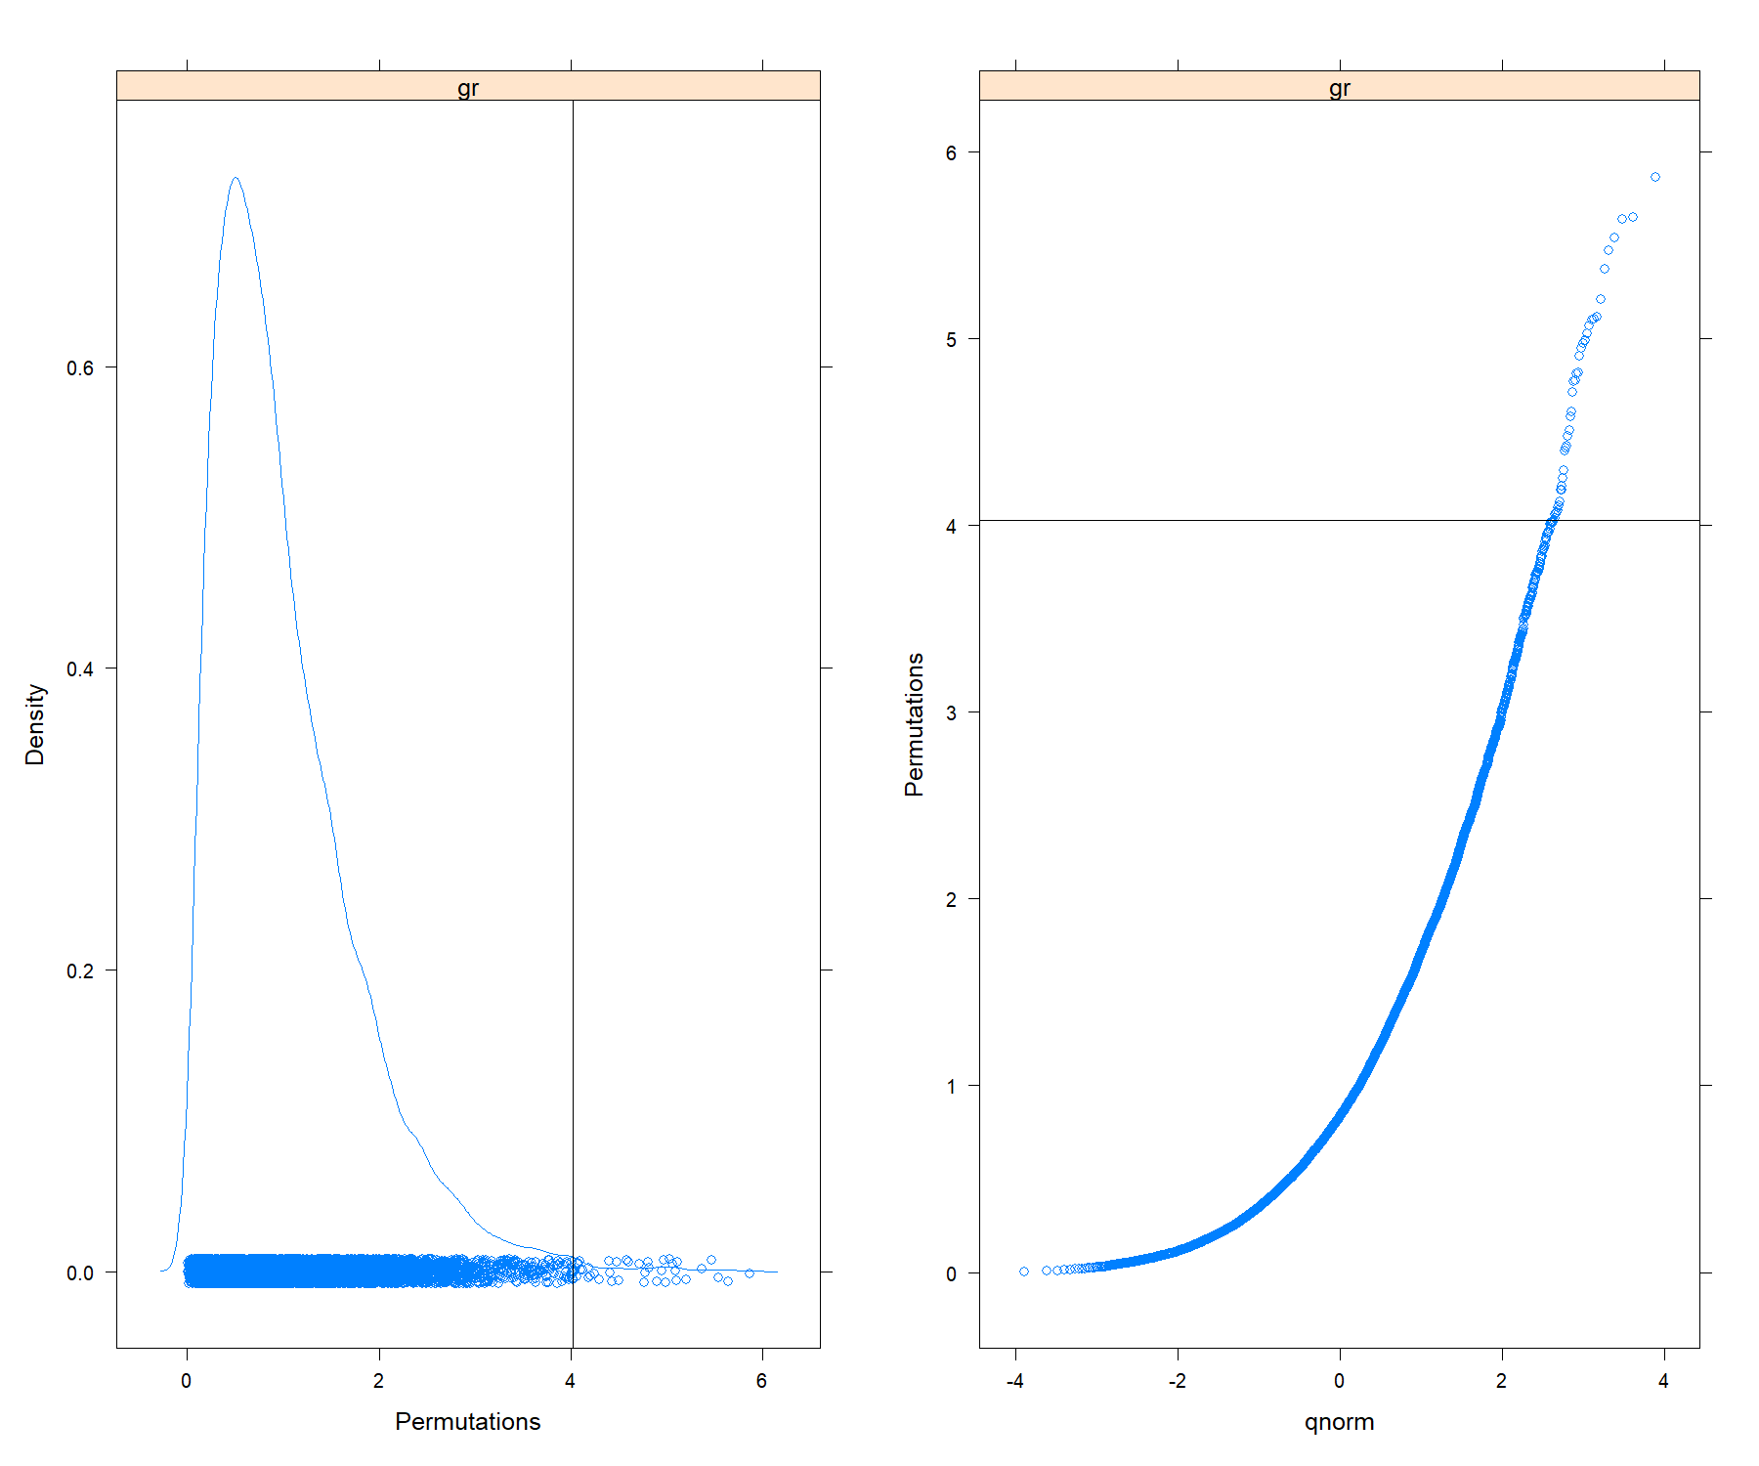

Pairwise tests against the first group, **PF**:

##   
## Group **OL** pairwise test against the 1st group:  
##   
## Df SumsOfSqs MeanSqs F.Model R2 Pr(>F)   
## group 1 1728 1728 5.36 0.14 0.028 *  
## Residuals 33 10647 323 0.86   
## Total 34 12375 1.00   
## ---  
## Signif. codes: 0 '***' 0.001 '**' 0.01 '*' 0.05 '.' 0.1 ' ' 1  
##   
## Group **DK** pairwise test against the 1st group:  
##   
## Df SumsOfSqs MeanSqs F.Model R2 Pr(>F)   
## group 1 3091 3091 16.5 0.34 0.0004 ***  
## Residuals 32 6002 188 0.66   
## Total 33 9092 1.00   
## ---  
## Signif. codes: 0 '***' 0.001 '**' 0.01 '*' 0.05 '.' 0.1 ' ' 1  
##   
## Group **ST** pairwise test against the 1st group:  
##   
## Df SumsOfSqs MeanSqs F.Model R2 Pr(>F)   
## group 1 1328 1328 3.59 0.11 0.067 .  
## Residuals 29 10710 369 0.89   
## Total 30 12038 1.00   
## ---  
## Signif. codes: 0 '***' 0.001 '**' 0.01 '*' 0.05 '.' 0.1 ' ' 1  
##   
## Group **NV** pairwise test against the 1st group:  
##   
## Df SumsOfSqs MeanSqs F.Model R2 Pr(>F)   
## group 1 3684 3684 13.8 0.339 0.0016 **  
## Residuals 27 7197 267 0.661   
## Total 28 10881 1.000   
## ---  
## Signif. codes: 0 '***' 0.001 '**' 0.01 '*' 0.05 '.' 0.1 ' ' 1

Table of *p*-values in pairwise tests against the 1st group.

|  | OL | DK | ST | NV |
| --- | --- | --- | --- | --- |
| **Unadjusted** | 0.0282 | 0.0004 | 0.0672 | 0.0016 |
| **BH adjusted** | 0.0376 | 0.0016 | 0.0672 | 0.0032 |
| **Pseudo-F** | 5.355 | 16.48 | 3.595 | 13.82 |

##Bayesian analysis

One more powerful analysis using randomization techniques, Bayesian MCMC model implemented here as in *JAGS* package. In current configuration the script assuming gamma-distribution and different SD for each group. Summary of results:

##Robust statistics Values in the tails of the distribution can have a strong influence on the mean. If values in the tails differ from a normal distribution, the power of a test is reduced and the effect size estimates are biased, even under slight deviations from normality [Wilcox, R. R. (2012)](Introduction%20to%20robust%20estimation%20and%20hypothesis%20testing.%20Academic%20Press.). One way to deal with this problem is to remove the tails in the analysis by using *trimmed means*. A recommended percentage of trimming is 20% from both tails (Wilcox, 2012), which means inferences are based on the 60% of the data in the middle of the distribution. Useful for the data, where clear outliers are visible on boxplots above.

###Heteroscedastic one-way ANOVA for trimmed means. Implemented here on the base of *WRS2* package. The *t1way* function computes a one-way ANOVA for the medians. Homoscedasticity assumption not required. It uses a generalization of Welch?s method. Corresponding post hoc tests performed using *lincon*. Trimming is 20%.

## Call:  
## t1way(formula = value ~ gr, data = alldata, tr = 0.2)  
##   
## Test statistic: F = 3.9894   
## Degrees of freedom 1: 4   
## Degrees of freedom 2: 24.31   
## p-value: 0.01261   
##   
## Explanatory measure of effect size: 0.6   
## Bootstrap CI: [0.32; 0.81]

| Group | psihat | ci.lower | ci.upper | p.value | sign |
| --- | --- | --- | --- | --- | --- |
| PF vs. OL | 16.26 | -2.795 | 35.31 | 0.1205 | FALSE |
| PF vs. DK | 19.4 | 0.6246 | 38.19 | 0.04107 | TRUE |
| PF vs. ST | 11.73 | -8.933 | 32.39 | 0.498 | FALSE |
| PF vs. NV | 22.44 | 3.736 | 41.14 | 0.01549 | TRUE |
| OL vs. DK | 3.147 | -10.89 | 17.18 | 0.498 | FALSE |
| OL vs. ST | -4.531 | -21.53 | 12.47 | 0.498 | FALSE |
| OL vs. NV | 6.181 | -7.664 | 20.03 | 0.498 | FALSE |
| DK vs. ST | -7.678 | -24.33 | 8.977 | 0.498 | FALSE |
| DK vs. NV | 3.034 | -10.32 | 16.39 | 0.498 | FALSE |
| ST vs. NV | 10.71 | -5.792 | 27.22 | 0.3873 | FALSE |

###One-way ANOVA on means, dataset without outliers (Tukey’s definition):

Analysis of Variance Table

|  | Df | Sum Sq | Mean Sq | F value | Pr(>F) |
| --- | --- | --- | --- | --- | --- |
| **group** | 4 | 4051 | 1013 | 4.933 | 0.001344 |
| **Residuals** | 78 | 16013 | 205.3 | NA | NA |

####Tukey *post hoc* test for multiple comparisons of means with 95% family-wise confidence level:

|  | diff | lwr | upr | p.adj | sign. |
| --- | --- | --- | --- | --- | --- |
| **NV-DK** | -0.9367 | -14.88 | 13.01 | 0.9997 | FALSE |
| **OL-DK** | 4.702 | -8.116 | 17.52 | 0.8433 | FALSE |
| **PF-DK** | 19.37 | 5.429 | 33.32 | 0.001975 | TRUE |
| **ST-DK** | 8.775 | -4.646 | 22.2 | 0.3663 | FALSE |
| **OL-NV** | 5.639 | -8.454 | 19.73 | 0.7969 | FALSE |
| **PF-NV** | 20.31 | 5.185 | 35.43 | 0.003035 | TRUE |
| **ST-NV** | 9.711 | -4.932 | 24.35 | 0.3518 | FALSE |
| **PF-OL** | 14.67 | 0.5765 | 28.76 | 0.03718 | TRUE |
| **ST-OL** | 4.072 | -9.504 | 17.65 | 0.918 | FALSE |
| **ST-PF** | -10.6 | -25.24 | 4.046 | 0.2658 | FALSE |

Used dataset without outliers was saved to file **example_tukeyrobust.txt**

The boxplot and the violin plot for dataset without outliers (new ones may appear): 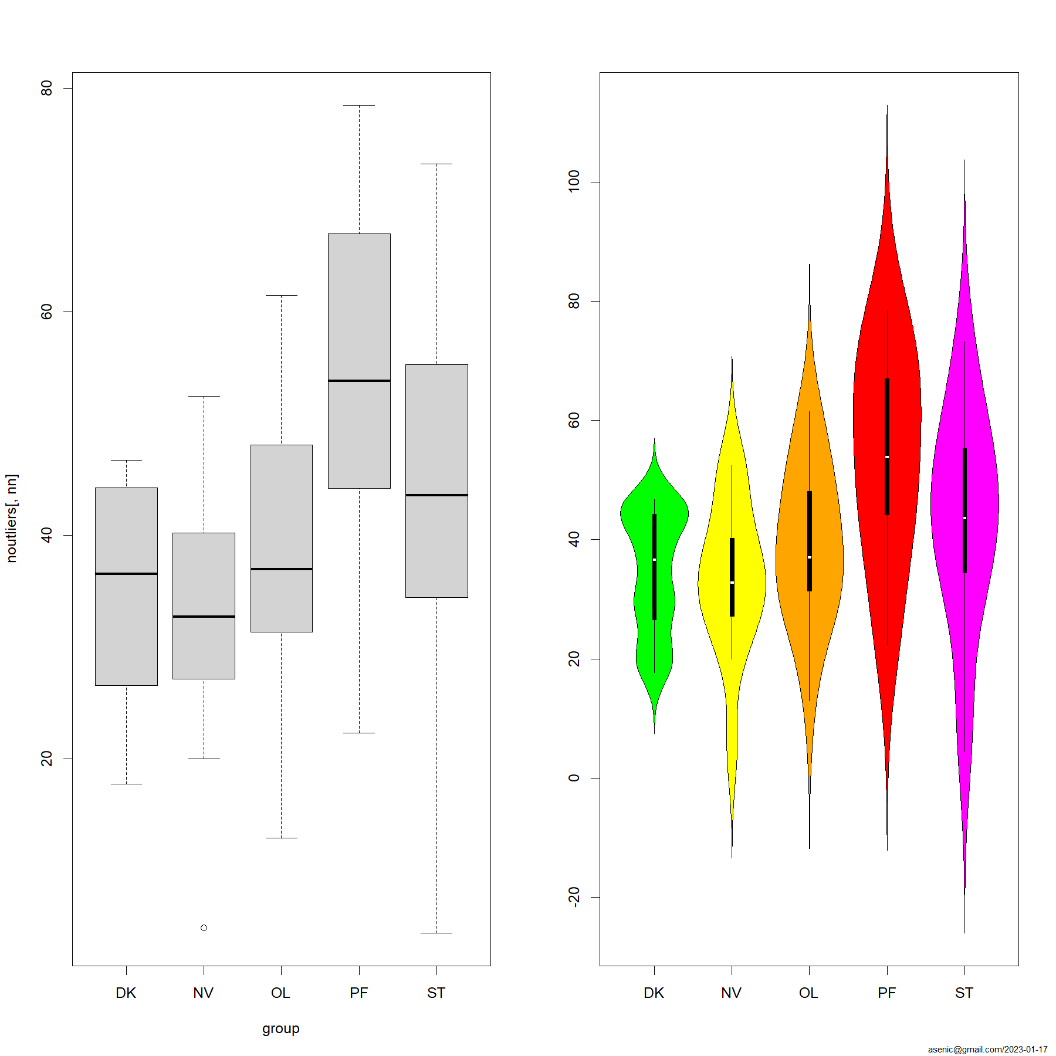

#Descriptive statistic for **example**:

Table continues below

| group | mean | median | N | na | min | max | range | sd | sem | Q25 | Q75 | IQR | ci |
| --- | --- | --- | --- | --- | --- | --- | --- | --- | --- | --- | --- | --- | --- |
| PF | 54 | 53.83 | 14 | 7 | 22.32 | 78.48 | 56.16 | 17.56 | 4.694 | 44.58 | 66.97 | 22.39 | 10.14 |
| OL | 39.65 | 36.97 | 21 | 0 | 0 | 85.54 | 85.54 | 18.22 | 3.975 | 31.33 | 49.23 | 17.9 | 8.292 |
| DK | 34.62 | 36.55 | 20 | 1 | 17.74 | 46.72 | 28.98 | 10.24 | 2.289 | 27.43 | 44.27 | 16.84 | 4.791 |
| ST | 40.85 | 42.9 | 17 | 4 | 0 | 73.25 | 73.25 | 20.46 | 4.963 | 33.76 | 54.93 | 21.17 | 10.52 |
| NV | 31.44 | 32.53 | 15 | 6 | 0 | 52.47 | 52.47 | 15.09 | 3.895 | 25.73 | 39.77 | 14.04 | 8.355 |

| lwr | upr | skew | kurt |
| --- | --- | --- | --- |
| 43.85 | 64.14 | -0.39 | -0.821 |
| 31.36 | 47.95 | 0.282 | 1.414 |
| 29.83 | 39.41 | -0.354 | -1.376 |
| 30.32 | 51.37 | -0.601 | -0.049 |
| 23.09 | 39.8 | -0.68 | 0.361 |

#Raw data:

| PF | OL | DK | ST | NV |
| --- | --- | --- | --- | --- |
| 75.76 | 85.54 | 36.54 | 54.62 | 24.28 |
| 66.87 | 43.68 | 30.26 | 54.93 | 27.17 |
| 51.07 | 0 | 30.44 | 0 | 32.95 |
| 37.01 | 61.46 | 43.37 | 35.14 | 37.46 |
| 45.66 | 59.66 | 39.08 | 4.432 | 30.7 |
| 66.33 | 55.76 | 46.72 | 33.76 | 52.39 |
| 78.48 | 46.92 | 45.2 | 42.9 | 0 |
| 67 | 42.63 | 21.1 | 67.86 | 30.58 |
| 68.88 | 50.8 | 17.74 | 56.59 | 20.01 |
| 26.99 | 34.87 | 46.23 | 44.31 | 52.47 |
| 22.32 | 31.4 | 44.27 | 73.25 | 39.31 |
| 48.76 | 27.41 | 24.95 | 55.6 | 46.66 |
| 44.22 | 34.41 | 20.16 | 38.97 | 4.885 |
| 56.59 | 49.23 | 18.9 | 27.7 | 40.22 |
| NA | 23.21 | 36.57 | 42.68 | 32.53 |
| NA | 31.33 | 30.07 | 48.02 | NA |
| NA | 27.65 | 46.41 | 13.61 | NA |
| NA | 33.25 | 44.27 | NA | NA |
| NA | 43.61 | 28.25 | NA | NA |
| NA | 12.94 | 41.94 | NA | NA |
| NA | 36.97 | NA | NA | NA |

#Session info:

**R version 4.2.2 (2022-10-31 ucrt)**

**Platform:** x86_64-w64-mingw32/x64 (64-bit)

**locale:** *LC_COLLATE=Russian_Russia.utf8*, *LC_CTYPE=Russian_Russia.utf8*, *LC_MONETARY=Russian_Russia.utf8*, *LC_NUMERIC=C* and *LC_TIME=Russian_Russia.utf8*

**attached base packages:** *parallel*, *grid*, *stats*, *graphics*, *grDevices*, *utils*, *datasets*, *methods* and *base*

**other attached packages:** *WRS2(v.1.1-4)*, *runjags(v.2.2.1-7)*, *coda(v.0.19-4)*, *vegan(v.2.6-4)*, *lattice(v.0.20-45)*, *permute(v.0.9-7)*, *car(v.3.1-1)*, *carData(v.3.0-5)*, *PoweR(v.1.0.7)*, *Rcpp(v.1.0.9)*, *FSA(v.0.9.3)*, *DescTools(v.0.99.47)*, *gdata(v.2.18.0.1)*, *gtable(v.0.3.1)*, *gridExtra(v.2.3)*, *HLMdiag(v.0.5.0)*, *ggplot2(v.3.4.0)*, *plyr(v.1.8.8)*, *pgirmess(v.2.0.0)*, *pander(v.0.6.5)* and *reshape2(v.1.4.4)*

**loaded via a namespace (and not attached):** *nlme(v.3.1-160)*, *sf(v.1.0-9)*, *lubridate(v.1.9.0)*, *httr(v.1.4.4)*, *tools(v.4.2.2)*, *utf8(v.1.2.2)*, *R6(v.2.5.1)*, *KernSmooth(v.2.23-20)*, *spData(v.2.2.1)*, *DBI(v.1.1.3)*, *mgcv(v.1.8-41)*, *colorspace(v.2.0-3)*, *withr(v.2.5.0)*, *sp(v.1.5-1)*, *tidyselect(v.1.2.0)*, *Exact(v.3.2)*, *compiler(v.4.2.2)*, *cli(v.3.5.0)*, *expm(v.0.999-6)*, *labeling(v.0.4.2)*, *scales(v.1.2.1)*, *classInt(v.0.4-8)*, *mvtnorm(v.1.1-3)*, *mc2d(v.0.1-22)*, *proxy(v.0.4-27)*, *stringr(v.1.5.0)*, *digest(v.0.6.31)*, *rmarkdown(v.2.19)*, *pkgconfig(v.2.0.3)*, *htmltools(v.0.5.4)*, *dunn.test(v.1.3.5)*, *highr(v.0.10)*, *fastmap(v.1.1.0)*, *rlang(v.1.0.6)*, *readxl(v.1.4.1)*, *rstudioapi(v.0.14)*, *farver(v.2.1.1)*, *generics(v.0.1.3)*, *gtools(v.3.9.4)*, *spdep(v.1.2-7)*, *dplyr(v.1.0.10)*, *magrittr(v.2.0.3)*, *s2(v.1.1.1)*, *Matrix(v.1.5-1)*, *munsell(v.0.5.0)*, *fansi(v.1.0.3)*, *abind(v.1.4-5)*, *lifecycle(v.1.0.3)*, *stringi(v.1.7.8)*, *yaml(v.2.3.6)*, *snakecase(v.0.11.0)*, *MASS(v.7.3-58.1)*, *rootSolve(v.1.8.2.3)*, *lmom(v.2.9)*, *deldir(v.1.0-6)*, *splines(v.4.2.2)*, *knitr(v.1.41)*, *pillar(v.1.8.1)*, *boot(v.1.3-28)*, *gld(v.2.6.6)*, *wk(v.0.7.1)*, *glue(v.1.6.2)*, *evaluate(v.0.19)*, *data.table(v.1.14.6)*, *vctrs(v.0.5.1)*, *cellranger(v.1.1.0)*, *purrr(v.1.0.0)*, *reshape(v.0.8.9)*, *assertthat(v.0.2.1)*, *xfun(v.0.36)*, *janitor(v.2.1.0)*, *e1071(v.1.7-12)*, *class(v.7.3-20)*, *tibble(v.3.1.8)*, *units(v.0.8-1)*, *cluster(v.2.1.4)*, *timechange(v.0.1.1)* and *diagonals(v.6.4.0)*

##References

This script uses the *reshape2*, *plyr* and *gdata* packages for arrange data, the *PoweR* package to perform the normality tests, *HLMdiag* to create the QQplots, *ggplot2* for all plots, *gtable* and *gridExtra* to combine multiple plots into one, *car* to perform Levene’s test, *pander* for nicer table output, *pgirmess* for KW test, *FSA* for Dunn’s test, *DescTools* for some exploratory statistics, *vegan* for PERMANOVA analysis, *rjags* and *runjags* for Bayesian analysis, *WRS2* for robust ANOVA on trimmed means. … may be more - check inside the code!

*refs omitted - click it in text*

The script based on various sources with modifications, including:

Lakens, D. (2015). The perfect *t*-test. Retrieved from <https://github.com/Lakens/perfect-t-test>. <doi:10.5281/zenodo.17603>

Thom Baguley (2012). Independent measures (between-subjects) ANOVA and displaying confidence intervals for differences in means. <https://seriousstats.wordpress.com/2012/03/18/cis-for-anova/>

Wiliam King (2016). R-tutorials. (last updated 2016 February 22) <http://ww2.coastal.edu/kingw/statistics/R-tutorials/multcomp.html>

“Todos Logos” (2009). Analysis of variance: ANOVA, for multiple comparisons <http://statistic-on-air.blogspot.com/2009/07/analysis-of-variance-anova-for-multiple.html>

McDonald, J.H. 2014. Handbook of Biological Statistics (3rd ed.). Sparky House Publishing, Baltimore, Maryland. <http://www.biostathandbook.com/index.html>

Mangiafico, S.S. 2015. An R Companion for the Handbook of Biological Statistics, version 1.09. <http://rcompanion.org/rcompanion/> (Pdf version: rcompanion.org/documents/RCompanionBioStatistics.pdf)

Adapted examples from R package help R cookbook <http://www.cookbook-r.com> StackOverflow <http://stackoverflow.com> blogposts aggregated at <http://www.r-bloggers.com/>