Portfolio Optimization: A Monte Carlo Study
Prepared by Ashwin Senthilkumar
October 25, 2026
Problem Description
An investor distributing money among several risky assets must decide what portion to allocate to each one. Different allocations give different mixes of expected return and risk, with risk measured by the standard deviation of the portfolio’s returns. The collection of reachable risk-return combinations is called the opportunity set, and its upper-left boundary, the efficient frontier, holds the portfolios with the most return for a given level of risk. Instead of solving for the best weights with calculus or a quadratic program, this assignment examines the opportunity set using a Monte Carlo study: drawing many random sets of weights, compute the return and risk of each resulting portfolio, and plotting them.
The analysis compares two investment strategies: A long-only and long-short strategy. The long-only strategy keeps every weight positive, which is the more conservative option. A long-and-short strategy permits negative weights, which is more flexible. The study is run twice. The first run uses the four hypothetical assets (A-D) given in the starter code. The second run uses four real assets that I have selected: BND (a bond fund), GLD (gold), SPY (S&P 500 fund), and BTC-USD (Bitcoin). They run from very safe to highly speculative, have long daily price histories on Yahoo Finance, and bitcoin gives a sharp contrast with the starter assets. I kept to four assets because the starter code assigns four weights to each portfolio. The questions are how much extra return short positions open, how much added risk they introduce, and whether these patterns differ when using real assets.
Data Preparation and Pipeline
Collection
The starter run does not require data because its inputs are provided: annual mean returns, standard deviations, and a correlation matrix specifying 0.3 between asset A and each of the others and 0.6 between B, C and D. For run 2, I estimated equivalent inputs from historical data. The script getdata_yfinance.py uses the yfinance package to download daily prices for the four tickers with the yfinance package, from January 2, 2015 through December 31, 2025, and saves one CSV file per ticker. Bitcoin determines the start date because its Yahoo history begins in late 2014. Adjusted closing prices are used so fund dividends are included.
Cleaning and Estimation
The files contain time zones in their date stamps, so I retain only the calendar dates and merge the four-price series by date. Bitcoin trades every day while the other three trade only on market days, so I keep only the dates where all four have a price. That reduces 4,018 bitcoin prices to 2,766 shared dates, producing 2,765 daily simple returns. Annual inputs use the same convention as the starter code, where the mean is the daily mean times 252, the standard deviation is the daily standard deviation multiplied by the square root of 252, and correlations calculated from daily returns. Table 1 compares the inputs used in both runs side by side.
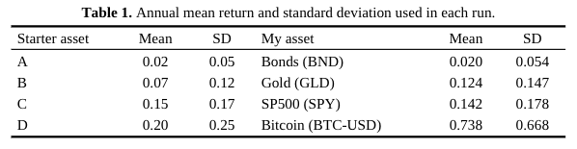
The estimated correlations are generally low across the board. 0.33 between bonds and gold, 0.11 between bonds and stocks, 0.09 between bonds and bitcoin, 0.04 between gold and stocks, 0.09 between gold and bitcoin, and 0.23 between stocks and bitcoin. Bitcoin’s mean of 0.74 and standard deviation of 0.67 are several times larger than anything else in the study, which strongly influences the results that follow.

Research Design
Return Scenarios
Both runs follow the steps in the starter code. I construct the covariance matrix from the standard deviations and correlations as Σ = diag(σ) R diag(σ). I then generate 700 sets of annual returns for the four assets from a multivariate normal distribution with the target means and covariance matrix, using seed 1111. The program prints the sample correlations and covariances alongside the targets as a check, and they come out close.
Weights
For the short-allowed strategy, I randomly selected three weights between -1 and 1 from a uniform distribution and set the fourth to one minus their sum. For the long-only strategy, I drew four weights uniformly between 0 and 1 and divided each by their total. Either way the weights sum to 1. Each strategy uses 700 weight sets (seed 9999 for both). A portfolio is marked as having no short positions when all four weights are positive. IN each run, only 16 of the 700 short-allowed draws met this condition.
Return and Risk
For a weight vector w and return vector r, the portfolio return is calculated as wᵀr. The return shown in the plot is the average over the 700 return scenarios, and the risk plotted is computed from S the sample covariance matrix of the simulated returns:
μp = mean of wᵀr across the 700 scenarios, σp = √(wᵀ S w)
Output and Implementation
The 1400 portfolios per run are plotted with return on the virtical axis and risk on the horizontal axis. Red points represent portfolios with at least one short position, while blue points are portfolios without shorts. The professor’s R started code was translated into Python using numpy, matplotlib, and pandas. Since Python and R use different random number generators, the starter run looks like the professor’s figure but does not match every point exactly.
Results
Starter Assets
Figure 1 presents the starter assets. The long-only portfolios form a tight band of low risk (0.05-0.20) and modest return (0.03 to 0.17), and none have a negative return. Allowing a short position expands the opportunity set to a return of 0.53 at a risk level of 0.76, but also produces portfolios that lose money, with 34/700 having a negative mean return. The highest-return portfolio allowing shorts puts about 371% in asset D and shorts the other three by 88-91% each, making it a leveraged bet on the asset with the highest mean. For each strategy, the left edge of each cloud above zero return is the efficient frontier. This follows the same pattern found in the professor’s report.
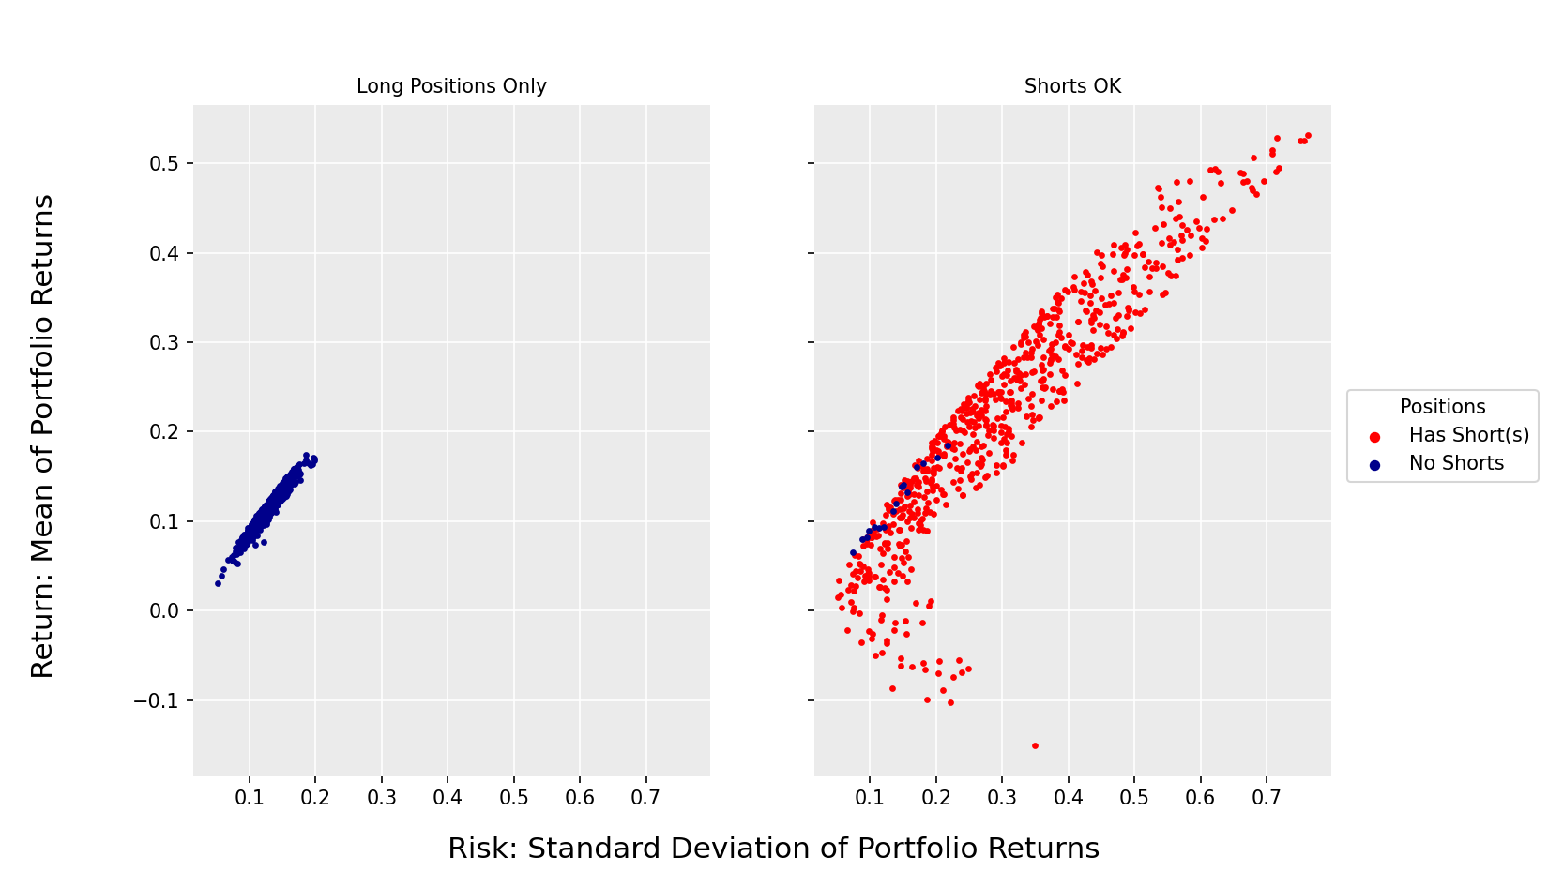
My Assets
Figure 2 shows the same analysis using the real assets, and Table 2 compares the two runs. The shape is the same with a narrow long-only band and a widely spread shorts cloud, but the scale is much larger. Long-only portfolios now range from a return of 0.05 at risk 0.06 to a return of 0.57 at risk 0.47. The lowest-risk long-only portfolio is 93% bonds, while the highest return portfolio holds 73% bitcoin. Across long-only portfolios, the correlation between the bitcoin weight and the portfolio return is 0.985, which is why the band is nearly a straight line. The bitcoin allocation largely determines both the risk and return. When shorting is allowed, returns reach 2.48 at a risk of 2.34 and fall as low as -1.14. 77/700 portfolios have a negative mean return.
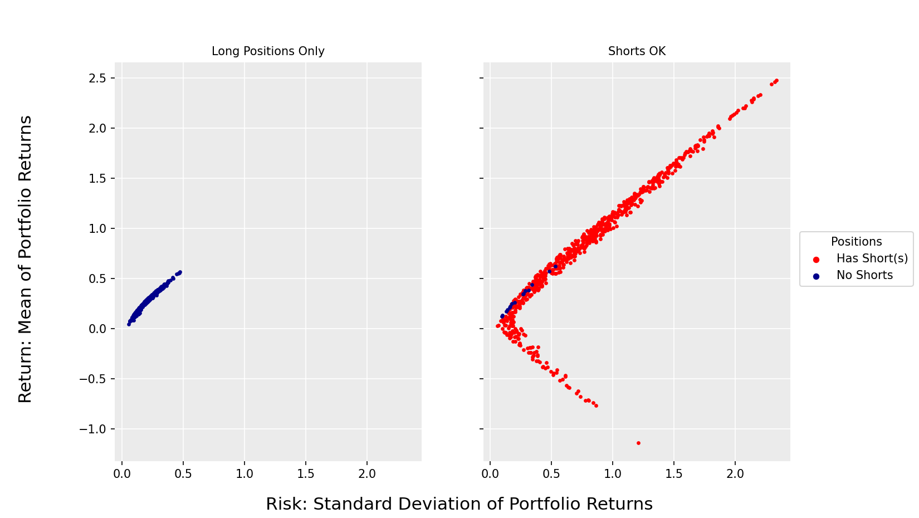
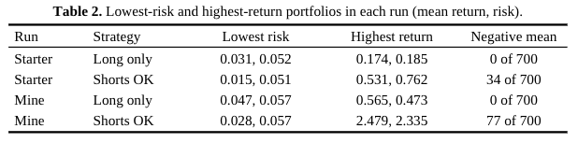
Limitations and Conclusion
Allowing short positions expands the opportunity set in both directions. It reaches returns possible that long-only portfolios cannot reach, but this comes with substantially greater risk, and some of the portfolios lose money. A manager with a moderate to high risk tolerance who wants the highest returns must be open to shorts. An investor who wants to avoid losses is better off staying only long. Using real assets makes these effects more pronounced. Adding bitcoin expands the range of outcomes several times beyond what appears with the starter assets. There are limits to what these results show. Returns are assumed to be normally distributed, but real returns, mainly bitcoins, have fat tails. Two of the 700 simulated bitcoin returns are below -100%, which a long position cannot lose. The inputs also come from one 11-year-old period that was favorable for stocks and bitcoin, and historical averages don’t guarantee future returns. Multiplying a daily mean by 252 gives an arithmetic figure, and bitcoin’s compound growth over the period was closer to 67% than 74%. The 700 random weight combinations only approximate the efficient frontier, and the analysis leaves out shorting costs, margin limits, and trading costs.

Github Repository: https://github.com/asenthilkumar1/MSDS-451-PA2.

