Momentum and Mean Reversion Trading
Prepared by Ashwin Senthilkumar
November 8, 2026
Problem Description
For this programming assignment I built a small automated trading program and backtested it. The backtest replays the rules over past prices one day at a time, charges trading costs, and shows what would have happened. I primarily measure performance with the Sharpe ratio and compare the results with buy-and-hold approaches. The assets are the same four from the previous programming assignment: a bond fund (BND), gold (GLD), an S&P 500 fund (SPY), and bitcoin (BTC-USD).
I tested two simple strategies. The momentum strategy purchases assets that have been rising steadily and sits in cash otherwise. The mean reversion strategy buys assets after they fall well below their recent average and sells once the price comes back. I also tested a combined portfolio that allocates half of its capital to each strategy. My main objective was to determine whether either strategy beats simply owning SPY after trading costs and after taking the extra risk into account. Since machine learning and market regime detection were optional, I skipped them and put my time into testing the simple strategies properly.
Data Preparation and Pipeline
The data comes from the same dataset as Programming Assignment 2: daily adjusted closing prices from Yahoo Finance, January 2015 to December 2025. Each ticker was downloaded with yfinance and stored in its own CSV file. I also reused the data-loading code from PA2. The pipeline keeps the calendar date, aligns the four assets on dates when all four have available prices, and calculates daily returns from the adjusted prices. This gave 2,765 daily returns with nothing missing. The momentum signal needs a few months of history before it produces a useful signal, so I reserved the first 260 trading days as a warm-up. Everything is then scored over the same period, January 15, 2016 to December 31, 2025, which is 2,505 trading days.
Research Design
Momentum
Every five trading days, the program fits a linear regression to each asset's log prices from the previous 90 days. The momentum score is the annualized slope of that line times its R squared, so a smoother upward trend gets a higher score than a more inconsistent trend with a similar overall gain. An asset is held only when its score is positive. Each position is sized to contribute about 5% annualized volatility to the portfolio. This gives bitcoin a small position and bonds a large one. If the positions combined exceed 100% of the portfolio, they are scaled down proportionally, with any remaining capital held in cash. The score is based on the momentum measure in Clenow (2019). I selected the specific parameters, including the 90-day regression window and the 5% volatility target, before reviewing the results and did not optimize them afterwards.
Mean Reversion and Combined Strategy
For each asset, the program computes a z-score that measures how many standard deviations the current price is above or below its 20-day average. It buys when the z-score drops below −1.5 and sells when the price goes back to the average. Each asset gets a quarter of the portfolio, and that allocation remains in cash whenever the asset is not held. The combined strategy divides the portfolio equally between momentum and mean reversion.
Benchmarks
The main benchmark is SPY held continuously without trading. I also show the four assets in equal weights, rebalanced once a month, which is the same portfolio with no trading rules. BND held on its own is included as an additional benchmark.
Backtest Rules and Measures
All trading signals use closing prices. If a rule says to trade at the close on day t, the trade happens at the close on day t + 1. This ensures a trade never uses a price that went into its own signal. Each purchase or sale costs 10 basis points of the amount traded. The portfolio does not use short positions or borrowed money, cash earns nothing, and the risk-free rate is zero, so the Sharpe ratio is the average daily return divided by its standard deviation, scaled up by the square root of 252 to make it annual. For each strategy, I report total return, compound annual growth rate (CAGR), volatility, the Sharpe and Sortino ratios, maximum drawdown, the Calmar ratio, average market exposure, and turnover, along with beta and alpha against SPY. To see how much luck could matter, I also resampled the daily returns in 21-day blocks across 2,000 simulations and recalculated the Sharpe ratio for each strategy.
Programming
The implementation is one Python file, pa3.py. The data loading comes from PA2, and I wrote the rest for this assignment. Running the program generates all the tables used here and saves the figures and CSV files. There is also a test file containing 20 tests. Several tests check the signals and measures on small examples that can be worked out by hand. One test verifies that signals computed from the first part of the data match the same part of the signals computed from everything, which rules out the use of future information. Another test compares the main backtest against a separately implemented version that tracks dollars instead of fund shares, and both implementations produced matching results. The README explains how to set up the environment, run the program, and run the tests.
Results
Table 1 shows the main performance metrics after transaction costs, and Figure 1 shows the growth of $1 invested and the drawdowns of each strategy and benchmark.
Table 1. Backtest results, January 15, 2016 to December 31, 2025, after trading costs.
 | Momentum | Mean Rev. | Combined | SPY | Equal Wt. | BND
CAGR | 9.4% | 2.6% | 6.1% | 15.5% | 29.7% | 2.0%
Volatility | 7.0% | 10.5% | 7.5% | 18.0% | 19.6% | 5.5%
Sharpe ratio | 1.32 | 0.30 | 0.82 | 0.89 | 1.42 | 0.39
Sortino ratio | 1.84 | 0.41 | 1.13 | 1.26 | 2.13 | 0.54
Max drawdown | −11.6% | −24.3% | −14.3% | −33.7% | −35.2% | −18.6%
Calmar ratio | 0.81 | 0.11 | 0.42 | 0.46 | 0.84 | 0.11
Avg. exposure | 80% | 25% | 53% | 100% | 100% | 100%
Annual turnover | 4.9x | 10.4x | 7.7x | 0 | 0.8x | 0

Momentum outperformed mean reversion by a wide margin. Its Sharpe ratio of 1.32 beats SPY's 0.89, and it got there with roughly a third of SPY's volatility and a worst drawdown of −11.6%, compared with −33.7% for SPY. The cost was lower growth: momentum returned 9.4% annually compared with 15.5% for SPY, partly because it sat in cash about 20% of the time. The difference is also visible in individual years. In 2022, momentum lost 4.9% while SPY lost 18.2%, but in strong stock years like 2019 and 2021 it fell well behind. Its beta relative to SPY was only 0.17, and its alpha was 6.5% a year.
However, I would be careful about drawing strong conclusions from the Sharpe ratio gap itself. The bootstrap analysis produced a 95% confidence interval of −0.16 to 0.99 for momentum's Sharpe ratio minus SPY's, and zero is within this range. So the lower risk and smaller drawdowns are the main takeaway here, while the higher Sharpe ratio could partly be due to chance.
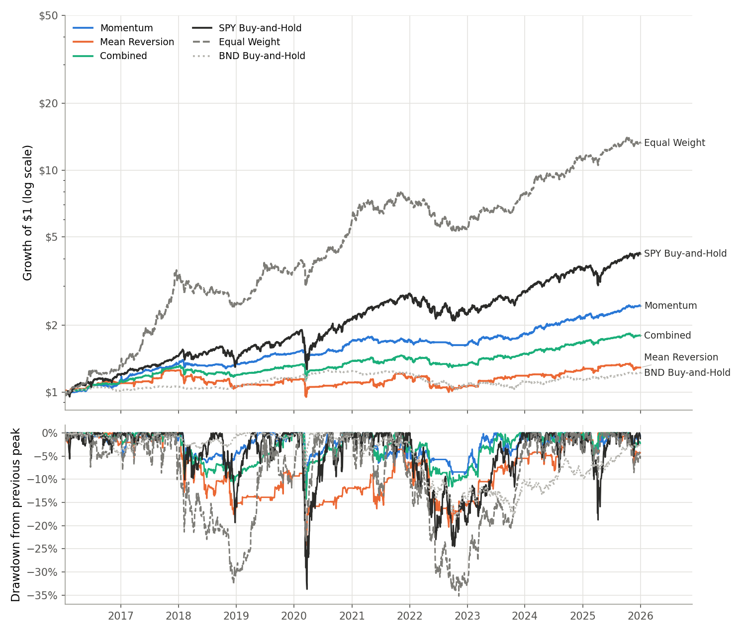
Figure 1. Growth of $1 (log scale) and drawdowns for every strategy and benchmark.
Mean reversion did not perform well on these assets. Its Sharpe ratio of 0.30 is below both SPY's and the bond fund's. Its two worst years were 2018 (−15.6%) and 2022 (−9.7%). In both periods it repeatedly purchased dips in assets that kept falling. Bitcoin accounted for most of these losses, about 8% of the portfolio in 2018 and 10% in 2022. The strategy also trades much more than the others, so costs weigh on it: at 50 basis points per trade, its Sharpe ratio turns negative. The combined portfolio ended up in the middle with a Sharpe ratio of 0.82, close to SPY's but with considerably smaller drawdowns.
The equal-weight portfolio had the highest Sharpe ratio, 1.42, and by far the highest return. Most of the return comes from bitcoin's strong years in 2017 and 2020. The same equal-weight mix without bitcoin grew about 11% a year compared with about 29% with it. Its Sharpe ratio stays high without bitcoin (about 1.3) because bonds, gold, and stocks also performed well in this period. It also had the deepest drawdown, at −35.2%. Neither trading strategy outperformed the equal-weight portfolio on Sharpe ratio, so over this period the trading rules lowered risk but did not add return compared with simply holding the assets.
Since I chose the strategy parameters myself, I also tested alternative settings to see whether the results were sensitive to those choices. I varied the regression window from 40 to 250 days and tried both weekly and monthly trading. Momentum's Sharpe ratio remained between 1.16 and 1.41, always higher than SPY's 0.89. Mean reversion stayed weak, with Sharpe ratios ranging from 0.20 to 0.45 for every window and entry level. Holding trades back by one or two additional days had very little effect on the results. I also split the test period into two halves. Momentum's Sharpe ratio was 1.57 in the first half and 1.06 in the second, beating SPY in both halves.
Limitations and Conclusions
Overall, momentum gave a more consistent experience than holding SPY, with much smaller losses but lower returns. I cannot say it beat the market. Mean reversion, on the other hand, was not worth using on the four assets included in this analysis.
There are several limitations to keep in mind. The assets come from PA2, where bitcoin was included for contrast, and the past ten years were unusually strong for bitcoin, so the equal-weight result should not be treated as typical. The backtest also covers a single stretch of history with no separate holdout period, and the bootstrap results indicate that some of the Sharpe ratio gaps could be due to chance. Another limitation is that cash earns nothing in this simulation, which slightly hurts momentum because it held cash at times while interest rates were higher from 2023 to 2025. Transaction costs are also modeled with a flat 10 basis points, and I left out taxes and the price impact of placing larger orders. If I continued working on this, I would try the market regime approach discussed in class, which would use market conditions to decide whether to favor momentum or mean reversion.
The code, outputs, and data are available at https://github.com/asenthilkumar1/MSDS-451-PA3.
References
Clenow, A. F. (2019). Trading Evolved: Anyone Can Build Killer Trading Strategies in Python. Independently published. ISBN 978-1091983786.

