Group project report

Project AURORA
University of Southern Denmark (SDU)
Faculty of Engineering (TEK)
Sønderborg Campus
Program: BSc. Software Engineering (1st Semester)
Course Code: SI1S-PRO

SUPERVISOR & GROUP INFORMATION
Supervisor: Rebekka Elinor Reithinger

Project Group: 5
PROJECT AUTHORS:
Andreea Micliuc - amicl25@student.sdu.dk
Vlad Garbuz - vlgar25@student.sdu.dk
Asen Tsarev - astsa25@student.sdu.dk
Barna Botond Hutás - bahut25@student.sdu.dk
Table of contents

Abstract 1
Introduction 2
Problem analysis 3
Problem Statement 4
Methods 6
Timeline 7
Requirements 8
Iteration #1 8
Iteration #2 8
System requirements 8
Design 9
Implementation 10
Evaluation 11
Conclusion 12
Process evaluation 13
References 14
Appendix 15

Abstract

For our semester project we are given the task of developing a text-based game, playable on any operating system (e.g. Windows, macOS, Linux), following the principles of the United Nations’ Sustainable Development Goals. We focused on ensuring access to affordable, reliable, sustainable and modern energy for all, and making cities and human settlements inclusive, safe, resilient and sustainable.
Our game portrays a futuristic world, where the overuse of fossil fuels has led to global energy collapse. Through various tasks, the player will learn about the importance of renewable energy and the impact of their decisions on the environment. The goal of our project is to educate players on the importance and the role of green energy sources and its impact on the environment. We made a game that shows players real world scenarios of where renewable energy technologies might go wrong. We made sure the player understands its role in making sure there is an equilibrium in the environment. The player gains new practical knowledge by applying principles learnt in physics, mathematics and science in the game.
We used the C# programming language and Visual Studio Code as our integrated development environment (IDE). To keep track of the code and to ensure equal contribution to the project we used GitHub, as well as WhatsApp and Discord as means of communication.
Over the duration of the project, we discovered the importance of teamwork, communication, as well as utilizing the strengths of each of the members of the group. Moreover, we managed to work on improving our coding skills and learn to apply our knowledge in practical scenarios. We feel that we fulfilled all of our goals in regards to our project, and hope that the future players of our game will benefit from our hard work.

Introduction

Project Aurora explores the importance of renewable energy through a futuristic narrative. It is a text-based game written in C# that is based on the United Nations’ Sustainable Development Goals numbers 7 and 11:
Goal number 7: Ensure access to affordable, reliable, sustainable and modern energy for all
Goal number 11: Make cities and human settlements inclusive, safe, resilient and sustainable
Main storyline:
Set in the year 2075, Project Aurora shows a world where the overuse of fossil fuels has led to global energy collapse. The player acts as a young energy engineer and their task is to restore power to darkened regions by repairing and reactivating renewable energy systems across the planet. Along the journey, they meet expert scientists specializing in solar, wind, hydro, and geothermal energy. They will guide the player through challenges and solutions that mirror real-world energy concepts.
In the game, the user can explore, interact with the world around them, travel between regions, collect items, repair power generators such as solar panels or wind turbines, and talk to different characters who serve as guides for the tasks the player has to complete. As they progress through the story they will learn technical recipes, interesting information about sustainable energy and you will be guided towards repairing power plants and restoring energy back to the planet in a fun but educational way.

Problem analysis

Energy is the foundation of modern civilization, it powers our homes, industries, and technologies. However, for over a century, humanity has relied heavily on fossil fuels such as coal, oil, and natural gas. These unsustainable resources have caused harmful effects on the environment, such as air pollution, climate change, and habitat destruction. In recent years, the focus has shifted to renewable energy sources such as solar, wind, hydro, and geothermal power. These technologies enable us to reduce global carbon emissions and help us craft a cleaner future. In 2021, 71.9% of Denmark’s electricity was from renewables (Danish Energy Agency) and by 2024, this share had reached 88.4% (Invest in Denmark 2025). Yet, achieving a fully renewable world requires innovation, cooperation, and rethinking how we produce and consume energy.
Power plants can be categorized by their energy source, such as fossil fuels (coal, natural gas, oil), nuclear, and various renewables hydroelectric, wind, solar, geothermal biomass.
Solar panels or photovoltaic (PV) cells capture sunlight and convert it into electricity. Since sunlight reaches almost every corner of the planet, it is one of the most widely available renewable sources. But its efficiency depends on the weather and daylight hours. This type of energy is used to power homes, street lighting, and satellites.
Turbines produce wind energy by converting the kinetic energy of moving air. It is efficient, clean, and capable of generating large amounts of energy in windy areas. Different wind patterns, space and noise issues, are the biggest challenges. This type of energy is produced by both onshore and offshore wind farms.
Hydropower uses the movement of water, usually from rivers or dams, to run turbines to generate electricity. It is a very old and stable energy source that generates energy constantly. However, large dams can disrupt ecosystems and displace communities from their home areas. This type of energy is produced by river turbines and small-scale dams, which supply electricity to the entire region.
Geothermal energy is produced by using the natural heat stored beneath the Earth's surface. Wells and turbines capture steam or hot water from underground reserves to generate electricity. However, it is only consistent and efficient in areas with geothermal activity, such as volcanic areas.

Limitations
The nature of the project itself imposes some clear limitations on the extent of impact we can have on the user and its learning path. The work and knowledge required for repairing and maintaining renewable energy technologies would far exceed the capabilities of the player. In a real world scenario, this would mean entire teams that would be responsible for specific technologies. Through our game, we are trying to offer the players a small preview into the real work of experienced engineers and scientists, and we are totally aware that we are limited by the game environment in that aspect.

Methods

Tools used for the project, poster and report so far:
Programming:
Github - sharing and merging the code
VS Code - writing the code
Communication:
Discord - sharing ideas, communicating, organising meetings
Whatsapp - communication, setting up meeting times
Visuals:
Canva - designing the poster and game map
Report writing:
Google - researching ideas, topics and gathering information
Perplexity AI - researching studies, references, statistics
Microsoft Word - keeping track of the logs, writing the agreements
Google docs - collaborating simultaneously on the report writing

Timeline

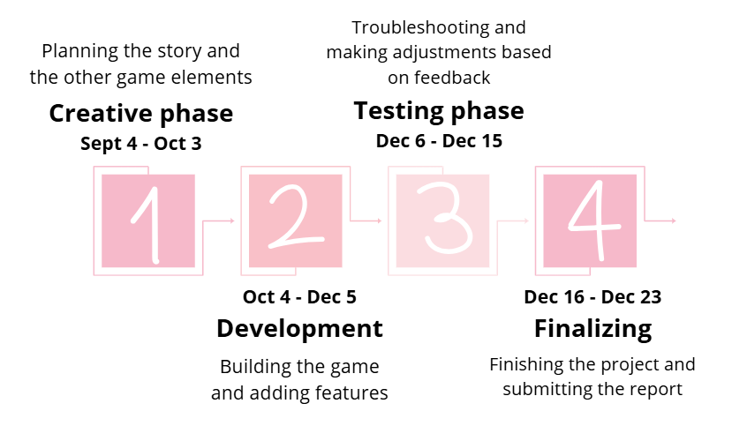

Problem statement

Nowadays, energy is made primarily from fossil fuels like oil, gas and coal, at global scale it accounted for approximately 82% of the world’s primary energy mix in 2023 (Igini, 2024). This type of fuel damages the environment with the release of greenhouse gases like CO₂ when burned, also causing air and water pollution.
In our game, we aim to draw attention to the negative aspects of fossil fuels, and to promote renewable and more environmentally-friendly ways to generate energy. We do this by giving our player the possibility of fixing sustainable generators, restoring the energy back to the planet. Throughout the game, the user learns about the importance of renewable energy, being rewarded for choosing the eco-friendly way to restore it instead of the damaging and short lasting one.

Requirements

Iteration #1

The player starts off in a room called Aurora Control Hub, which serves as a lobby, where the controls and commands of the game are presented along with the main task that needs to be completed. There are several other rooms inside the main regions of the game the player can travel to and explore, some of them containing items that can be picked up and stored in a basic inventory system. A few non-player characters (NPCs) can also be found, but are not yet fully developed.

Name | Description
Navigation between rooms | The player must be able to choose between different directions to navigate.
Interaction with NPCs | The player must be able to interact with NPCs.
Collect items | The user must be able to collect items scattered across the rooms
Answer quizzes | The user must be able to respond to quizzes in order to win a prize
Time management | The user must be able to see the time remaining for completing the quiz

a. Non-Functional Requirements
Name | Description
Terminal interactivity | The entire game user interface and interaction should be implemented in a terminal.
Follow OOP principles | The code structure should follow main OOP principles.
Flexible for future expansion | The code should be clearly written with comments to ensure adaptability for new features later on.

b. User Requirements
Name | Description
Complete storyline | The player should be able to expect to play a full storyline game with clear logic and interesting gameplays
Terminal commands | The game should support entering commands from the terminal interface and printing output to the terminal.
Basic terminal | The game code should only rely on basic terminal features like getting and printing text, clearing terminal, basic colored text
Graceful shutdown | The player should be able to exit the game at any time with a simple command

c. System Requirements
Name | Description
Basic terminal support | The player's hardware should support running the basic terminal prompt and enter input through it.
.NET runtime | The player's computer should support running .NET Runtime 8.0 or newer.
Uninterrupted gameplay | The player's computer should not turn off or close unexpectedly.

Iteration #2

UML graph

Design
Iteration #1
- System Architecture
The system is a text-based console game with a straightforward architecture made up of front-end and back-end parts. All interactions take place in the terminal window because the game is console-based.
- Component and Module Design
Game Engine: Handles the core game logic, including player movement, inventory, and progression.
Input Handler: Manages commands entered by the player in the terminal.
- Data Design
The main data elements in this game include:
Game State: Information about the player’s current position, rooms that they can access, items they can interact with, and an inventory they can store those items in.
- User Interface (UI) Design
Users interact with the game solely through the console. By entering certain commands, they can move around, interact with objects, talk to NPCs, and progress through the game.
- Security Measures
No specific security measures are planned since the game does not handle sensitive data or require user authentication.
- Integration Strategies
The game uses the Threading Console library to add timers for some of the minigames.
- Performance Considerations
As a text-based game, performance is expected to be efficient, with no high resource demands. The console-based nature and limited graphics ensure low memory and CPU usage.
- Scalability and Extensibility
In order to enable future extensions, such as the addition of additional game features, levels, or database integration, the game is built with modular components. Maintaining and updating the game effectively is another benefit of a modular approach.
- Error Handling
Errors are mostly expected to result from user input errors or code problems. Error messages will be shown in the console to alert users, and error handling will be integrated into the code to identify frequent problems and stop crashes.
- Monitoring
No monitoring tools are necessary, as the game is lightweight and runs locally.
- Documentation
The creation of documentation will be included in the report. The main goals of this first documentation will be to describe the game's basic layout, functionality, and gameplay.
- Compliance with Standards
No specific standards or regulations apply to this project.

Iteration #2

Implementation

The "WorldOfZuul" framework is where the project's implementation begins. It is written in C#, and we use Visual Studio Code as our IDE. The navigation system included in the project is a conventional grid-based directional room navigation system.
Every area has a distinct description, NPCs, and most of them feature one or more jobs and quests. We use fundamental OOP concepts like encapsulation, abstraction, and inheritance to make the commands, items, NPCs, rooms, and many other crucial classes modular and simple to grow and extend.
Each member uses Git to submit the code, and we use GitHub to share and store it so that everyone in the group may review it. Several people test the code locally for faults and undetected mistakes following each commission.
Several new commands have been added, each of which performs a distinct function. For instance, an inventory that displays all the items the user currently has at any given time and a ‘talk’ command that allows the player to interact with NPCs.
The code itself is straightforward, organised, adheres to OOP concepts, and makes no use of outside dependencies. We haven't added any security precautions to our code because of this plus the fact that we don't communicate with any sensitive APIs. Additionally, we don't intend to add any external cloud storage.
Thanks to thorough quality assurance on each commit by several team members, there are currently no significant errors or bugs found, and the game functions as intended.
This project is not subject to any particular rules or regulations.

Evaluation

Our project's evaluation identifies a number of areas where we met our objectives and others where we may do better. In terms of meeting requirements, the game effectively incorporates a room-based navigation system and fundamental gameplay elements that revolve around fixing power plants and restoring energy back to the planet. Players work on a variety of tasks in different rooms.
The majority of accomplishments compared to expectations were favourable. Within the constraints of a text-based interface, the team manages to produce a useful and interactive console game that leads the player through genuine reactor maintenance duties. However, time restrictions and the limitations of a console-based interface made it difficult to implement some of the earlier ideas, such as intricate multi-step chores within each area.
In terms of the project's advantages and disadvantages, the user-friendly room navigation and the well-defined tasks that aid players in comprehending reactor operations are among its main advantages. In contrast to a graphical interface, the text-based interface might feel constrictive and restrict the richness of interactions, yet be functional. Furthermore, the depth of gameplay is somewhat constrained by the absence of sophisticated features like dynamic feedback on player actions.
Players may be able to make more strategic choices thanks to these enhancements, which would boost realism and interest.

Conclusion

Process evaluation

In the beginning, we got to know that all of our members had some
experience with programming, which made planning a lot easier and straightforward. Communication was relatively easy, each member completing each of their tasks in the set amount of time.
While we have coded before, not all of us knew the C# programming language, therefore working on this project also proved to be a learning experience. Moreover, even though OOP is taught in class, the semester project has done a great job of providing us all with a clear understanding of how this kind of programming structure should be created.
With only four members in our group, dividing the workload was straightforward. We established two teams of two, easily rotating the roles of report writing and game coding.
The cooperation between the group and our supervisor went smoothly. We met up weekly to discuss developments and we were able to talk to her whenever we had concerns.
The tools we used proved to be sufficient, both for communication between team members and for keeping our code together.
The area in which we still need to improve is time management. We often found ourselves completing our tasks too close to the deadline. Coming up with ideas for the game was also tough.

Appendix

Appendix A: Collaboration agreement
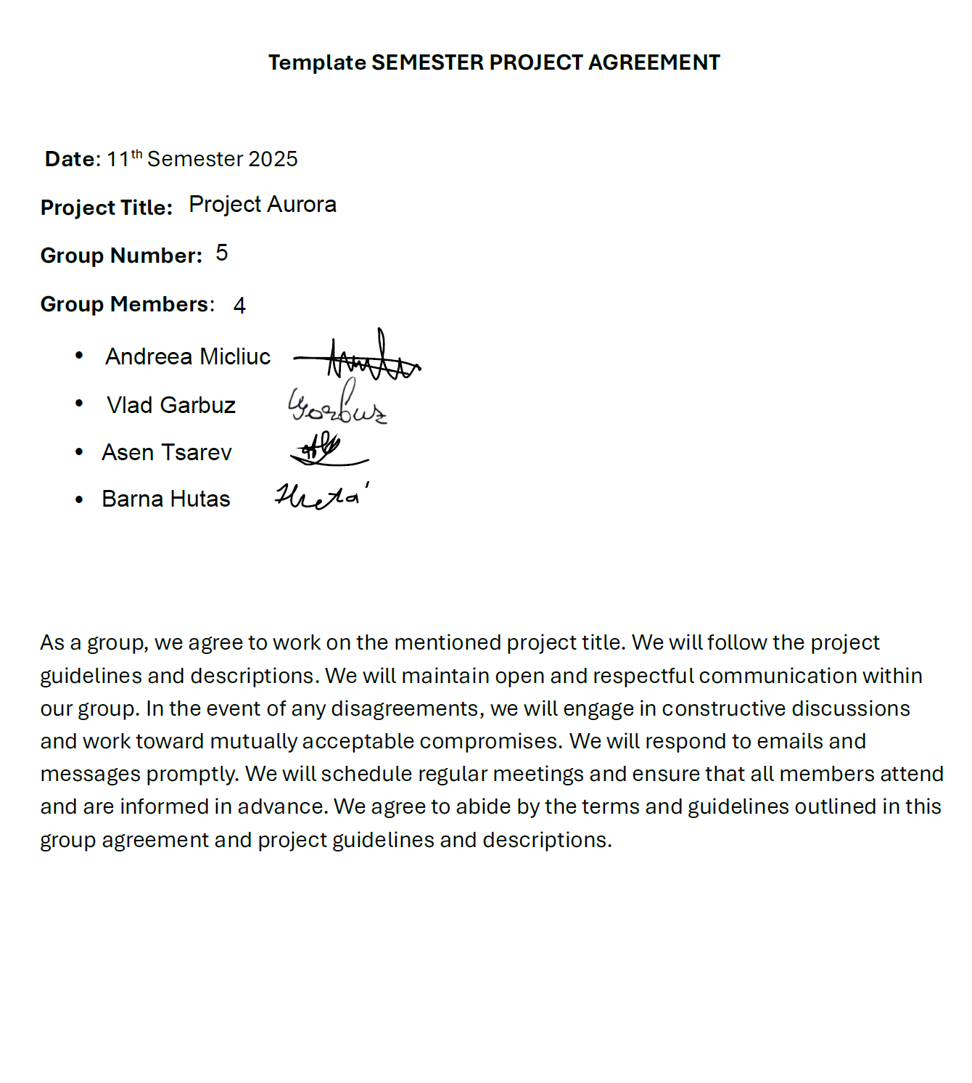

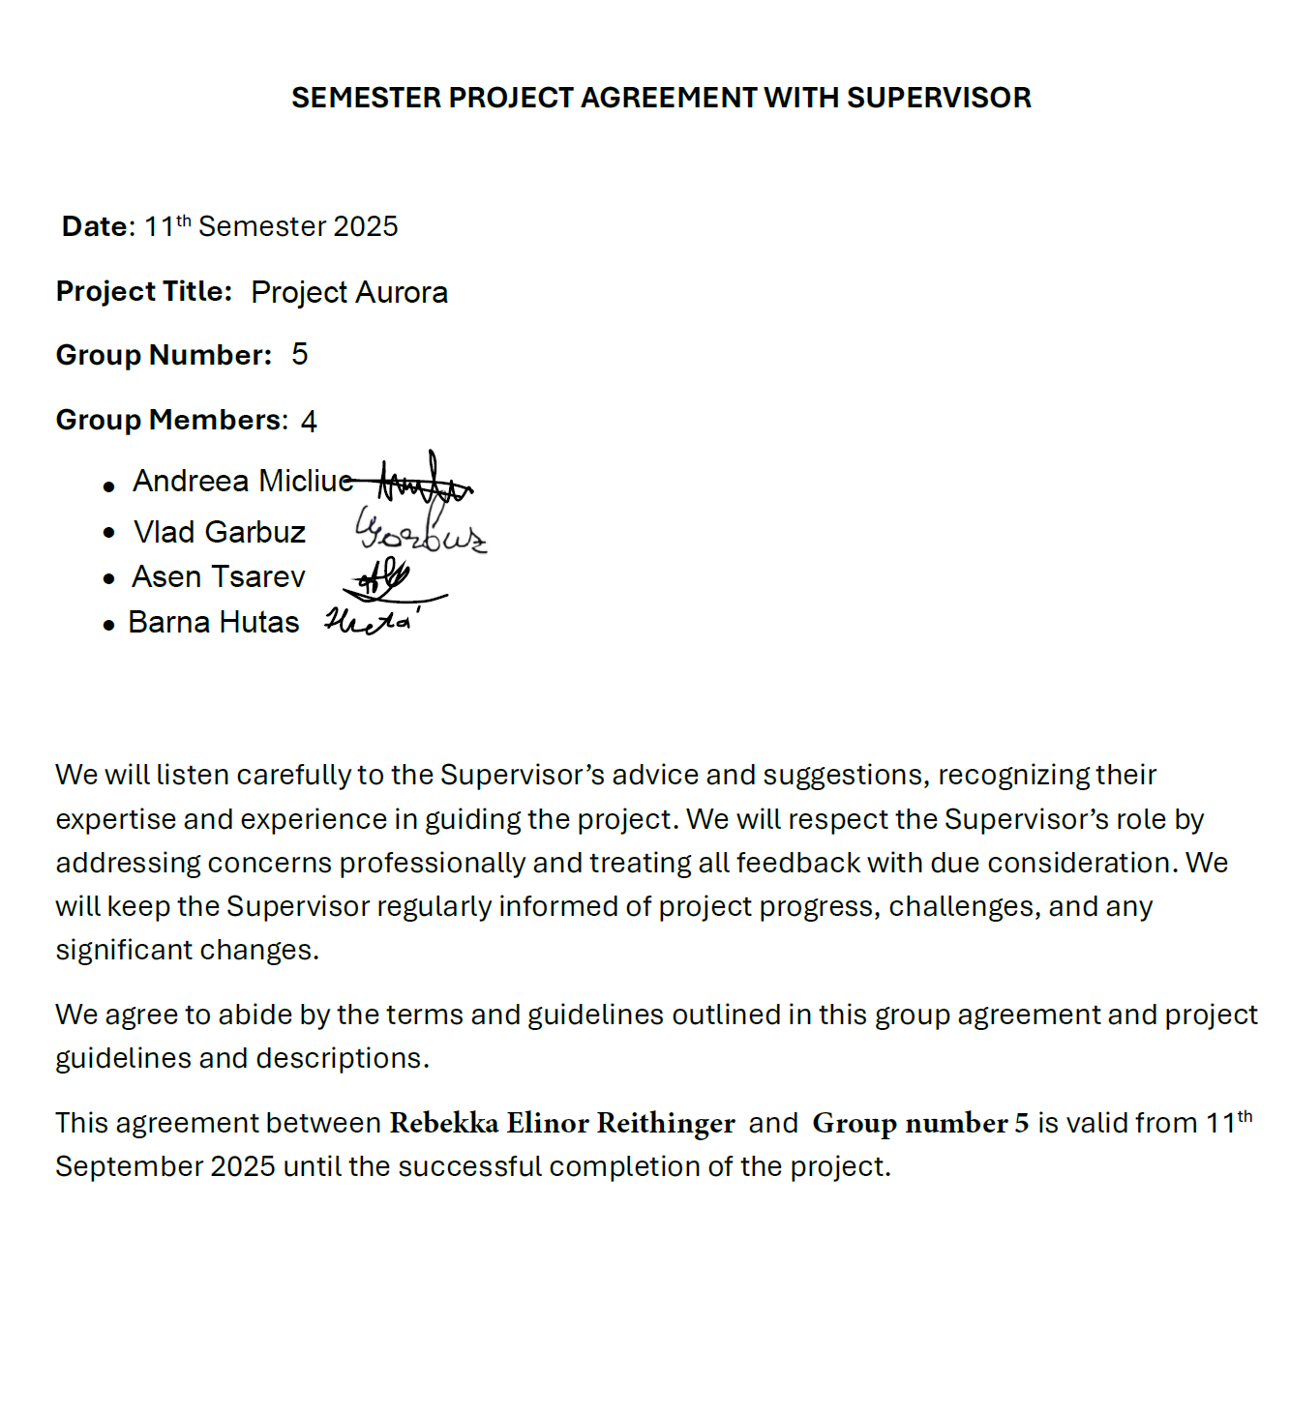
Appendix B: Supervisor agreement
Appendix C: Project log
Group 5 meeting log
Appendix D: Portfolio checklist
References

Danish Energy Agency. (2023). Energy Statistics 2022. https://ens.dk/sites/ens.dk/files/Statistik/energy_statistic_2022.pdf
Igini, M. (2024, June 26). Fossil Fuel Comprised 82% of Global Energy Mix in 2023. Earth.Org. https://earth.org/fossil-fuel-accounted-for-82-of-global-energy-mix-in-2023-amid-record-consumption-report/
Invest in Denmark. (2025, 07 02). Denmark #1 in share of renewables in net electricity generation for 2024 in the EU. https://investindk.com/insights/denmark-1-in-share-of-renewables-in-net-electricity-generation-for-2024-in-the-eu

