|  |  |
| --- | --- |
|  | Nama : Asep Dwi Saputra  NIM : STI202102126  **Mobile Programming Lanjut** |

**UTS**

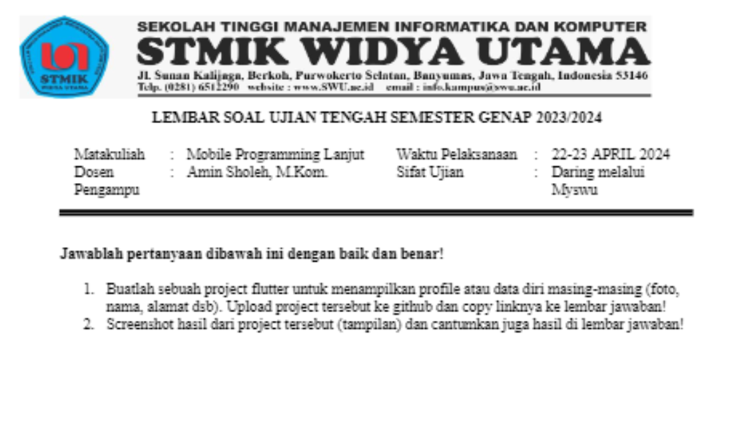

**Hasil Tugas**

1. GitHub:

<https://github.com/asepdwisaputra/MPL-Flutter-SWU/tree/main/Jobsheet-UTS>

1. Tampilan:

