Supplementary Information

Growth-based monolithic 3D integration of single-crystal 2D semiconductors
Ki Seok Kim^{1,4†}, Seunghwan Seo^{1,4†}, Junyoung Kwon^{2,3†}, Doyoon Lee^{4,8†}, Changhyun Kim^{2,3†}, Jung-El Ryu^{1,4}, Jekyung Kim^{1,4}, Jun Min Suh^{1,4}, Hang-Gyo Jung⁵, Youhwan Jo⁶, June-Chul Shin^{1,4}, Min-Kyu Song^{1,4}, Jin Feng^{1,4}, Hogeun Ahn⁵, Sangho Lee^{1,4}, Kyeongjae Cho⁶, Jongwook Jeon⁵, Minsu Seol^{2,3}*, Jin-Hong Park^{5,7}*, Sang Won Kim^{2,3}*, and Jeehwan Kim^{1,2,3,4,8}*
¹Department of Mechanical Engineering, Massachusetts Institute of Technology, Cambridge, MA 02139, USA
²2D Device Laboratory, Samsung Advanced Institute of Technology, Suwon, Korea
³Device Research Center, Samsung Advanced Institute of Technology, Suwon, Korea
⁴Research Laboratory of Electronics, Massachusetts Institute of Technology, Cambridge, MA 02139, USA
⁵Department of Electrical and Computer Engineering Sungkyunkwan University, Suwon-si, South Korea
⁶Department of Materials Science and Engineering, The University of Texas at Dallas, Richardson, TX 75080, USA
⁷SKKU Advanced Institute of Nano Technology (SAINT), Sungkyunkwan University, Suwon-si, South Korea.
⁸Department of Materials Science and Engineering, Massachusetts Institute of Technology, Cambridge, MA 02139, USA
†Equally contributed / *Correspondence to minsu.seol@samsung.com, jhpark9@skku.edu, swon80.kim@samsung.com, jeehwan@mit.edu

1. Supplementary Notes
We have calculated the critical size of flakes based on the classical nucleation theory. The free energy of a nucleus is defined below, where n is the total number of atoms, 𝜇₀ is the bulk chemical potential of WSe₂, A is the basal surface area of the flake, and C is the circumference of the flake. For 𝜇₀, a reported experimental value is used¹. To determine 𝛾_{surface} and 𝛾_{edge} , DFT calculations are done with slab and nanowire models of WSe₂ (Supplementary Fig. 1). The calculated critical nucleus size as a flake length is 1 nm approximately (Supplementary Fig. 2), based on that, flakes created by gas phase reactions likely be longer than 1 nm in the flake length. Those flakes bond weakly to a-HfO₂, therefore can be easily diffused. Meanwhile, the effect of the extra binding energy with a-SiO₂ at the trench edge is more substantial on a-HfO₂ (20 % increase) than c-HfO₂ (10 % increase), therefore the potential well effect can be more significant on a-HfO₂.
(1)
The weak binding energy on a-HfO₂ is originated from two reasons: the flake size effect on bonding characteristics and the effect of amorphous structure on the vdW bonding strength. Supplementary Fig. 3 and Supplementary Fig. 4 show the binding energy contributions from vdW and non-vdW on a-HfO₂ and c-HfO₂, respectively. On both a-HfO₂ and c-HfO₂, the strength of non-vdW bonds decreases after 0.9 nm, unlike the strength of vdW bonds monotonically increasing. In flakes, edge and corner atoms are reactive because of dangling bonds and likely form chemical bonds with a substrate, and those chemical bonds contribute to the non-vdW binding energy. In small flakes, the non-vdW bonds would be dominated by edge and corner atoms. However, as the flake size increases, the portion of edge and corner atoms compared to other atoms decreases therefore the effect of edge and corner atoms diminishes. Meanwhile, other atoms like Se on the bottom face of a flake would experience electrostatic repulsion from O on the surface of a substrate so that the non-vdW binding energy begins to decrease when a flake becomes large sufficiently. On the other hand, the vdW binding energy keeps on increasing because of the non-directional nature of vdW bonds. The vdW strength is likely proportional to a contact area, and the contact area is proportional to the flake size. Eventually, the dominant type of bonds is shifted from non-vdW to vdW as the size of a flake increases (Supplementary Fig. 3 and Supplementary Fig. 4). However, the strength of the vdW bonds is different on a-HfO₂ and c-HfO₂, in general, the vdW binding energy is weaker on a-HfO₂. Because of that, on a-HfO₂, the vdW bonds are not strong enough to compensate for the diminishing non-vdW bonds, therefore the binding energy plateau around 1.2 nm happens (Extended Data Fig. 2).

2. Supplementary Figures
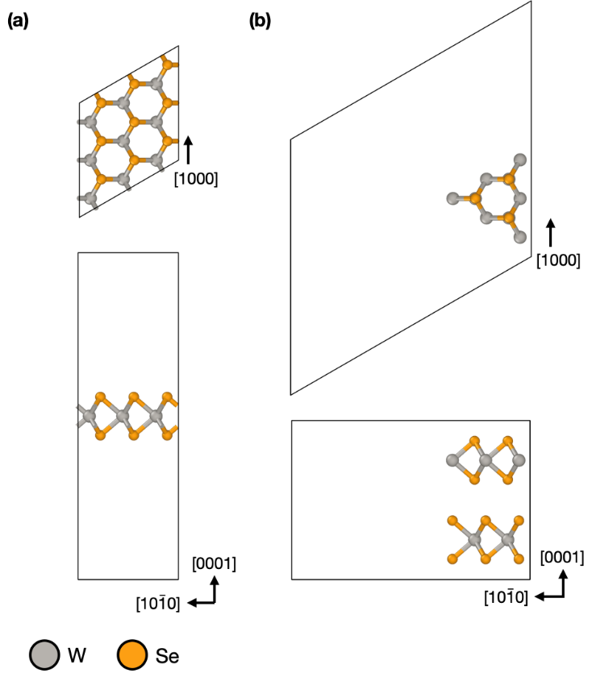
Supplementary Fig. 1 | Atomic models to calculate surface and edge energies of WSe_{2.} a, The slab model of ML WSe₂ to calculate the surface energy. b, The nanowire model of 2H WSe₂ to calculate the edge energy.

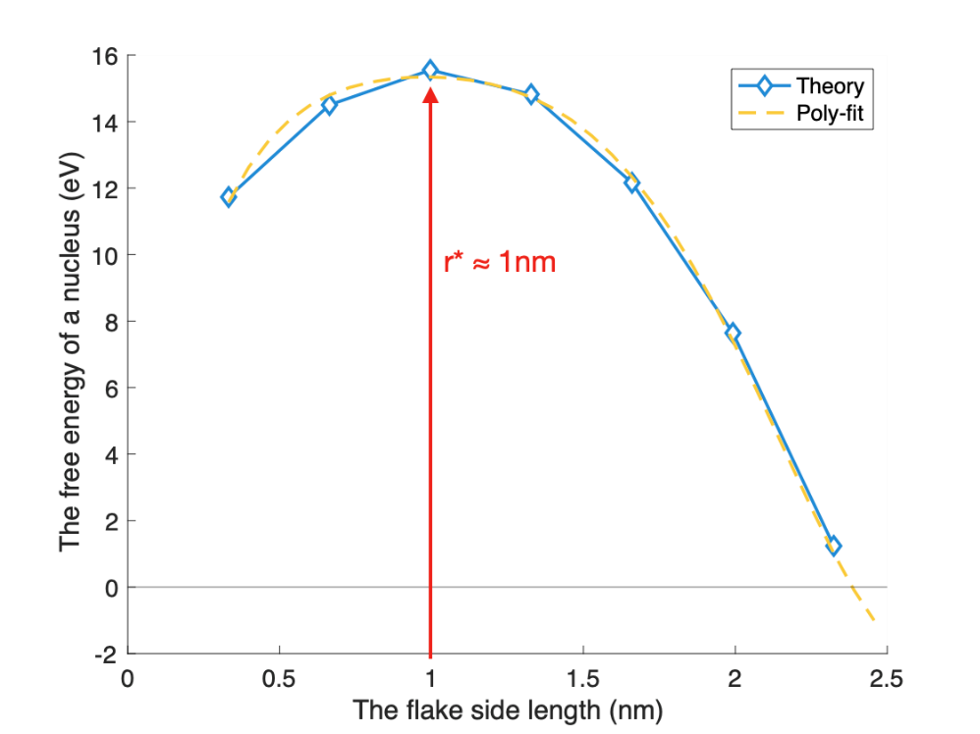

Supplementary Fig. 2 | The free energy of a WSe₂ nucleus (flake) as a function of the flake side length. The 5th order polynomial is used to fit the calculated data points.

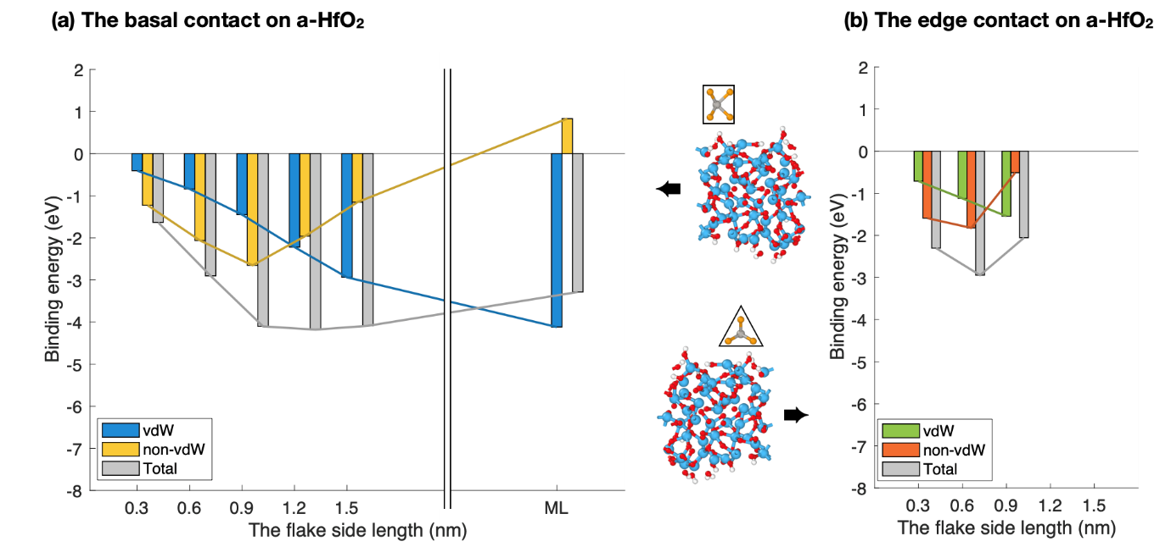
Supplementary Fig. 3 | The binding energy of the WSe₂ on a-HfO₂. vdW and non-vdW contributions on the binding energy are plotted by individual bars.

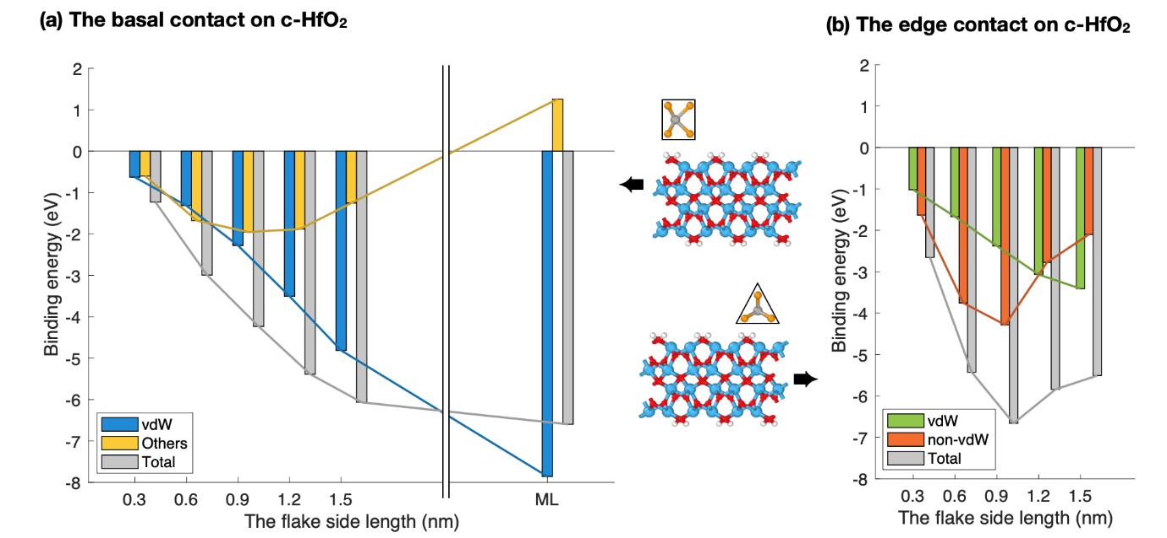
Supplementary Fig. 4 | The binding energy of the WSe₂ on c-HfO₂. vdW and non-vdW contributions on the binding energy are plotted by individual bars.

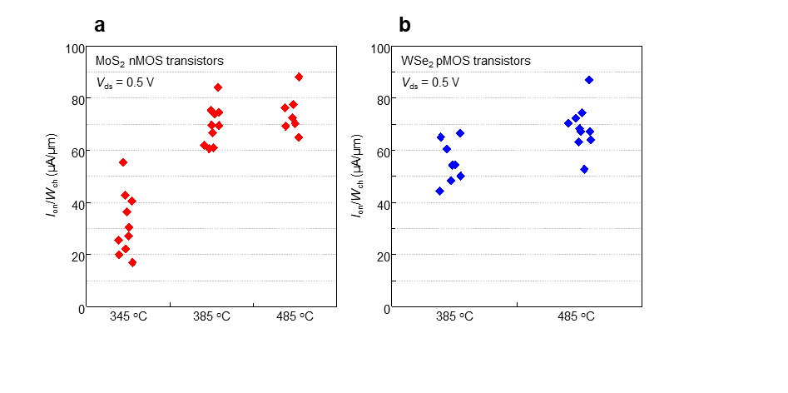
Supplementary Fig. 5 | Electrical characteristics of MoS₂ and WSe₂ grown at low temperature. a–b, Statistical analysis on I_{on}/W_{ch} of MoS₂ and WSe₂-based nMOS (a) and pMOS (b) transistors with respect to growth temperatures ranging from 345 °C to 485 °C for nMOS transistors and from 385 °C to 485 °C for pMOS transistors, respectively.

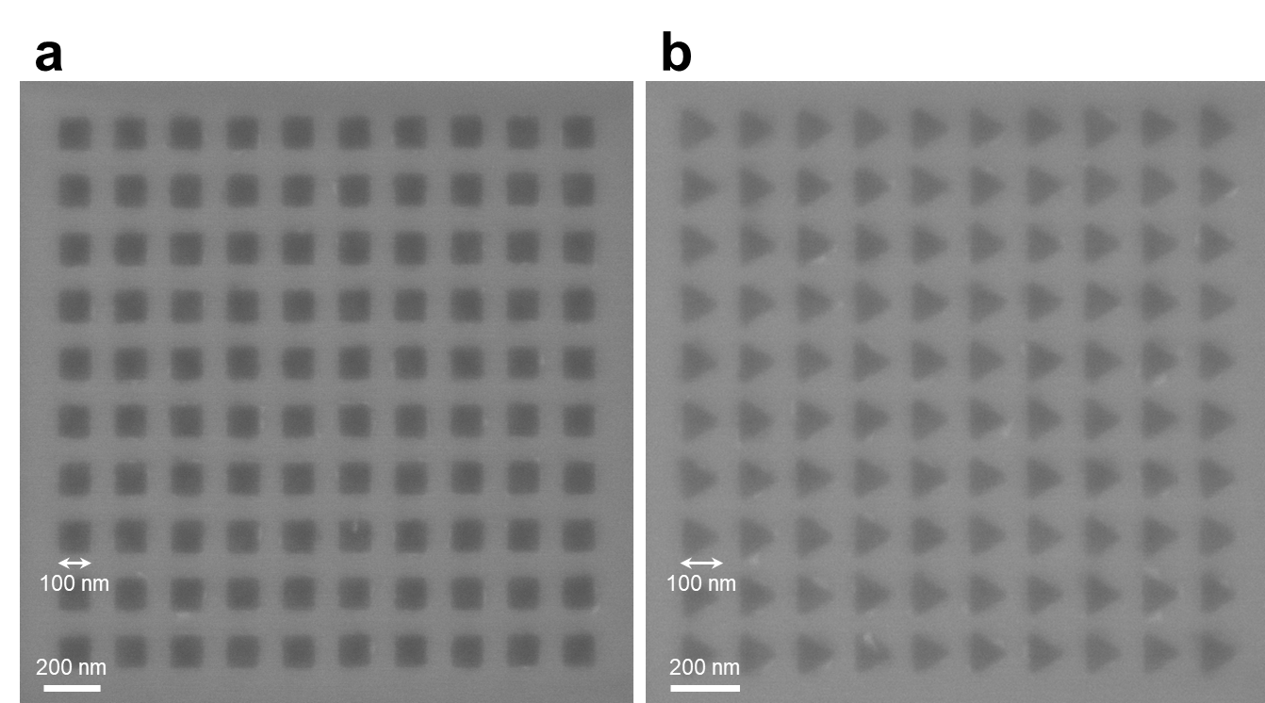
Supplementary Fig. 6 | High-density single-crystalline WSe₂ array. The shapes of the pockets are defined as squares (a) and equilateral triangles (b), each pocket with a width of 100 nm and a spacing of 50 nm between pockets.

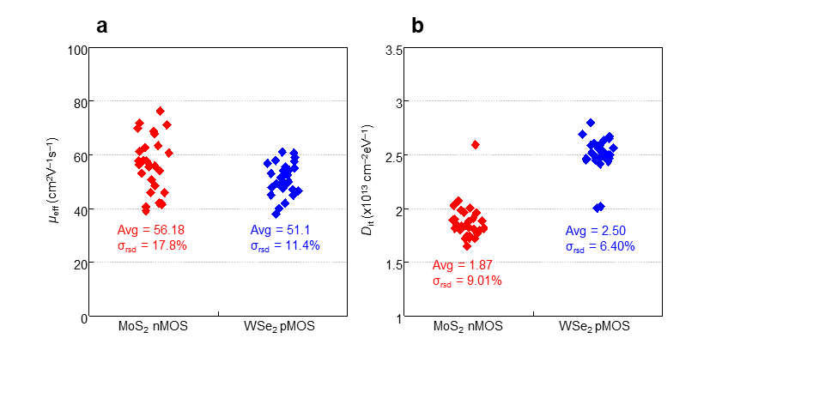
Supplementary Fig. 7 | Characterization of μ_{eff}, and D_{it} of vertical CMOS. a–b, Estimated field effect mobility (μ_{eff}) and interface trap density (D_{it}) values from fabricated 30 vertical CMOS devices.

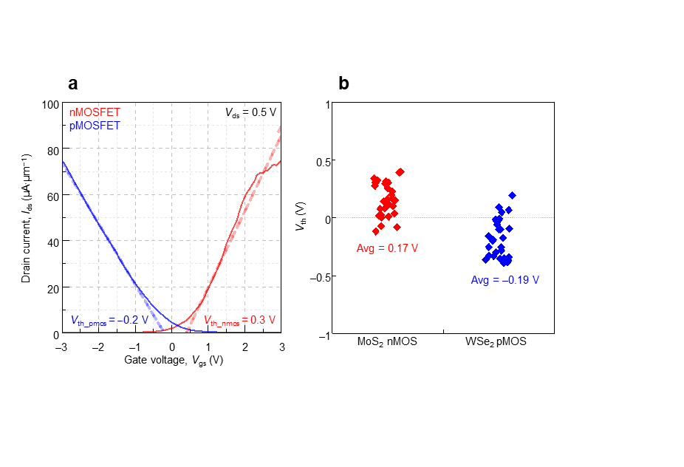
Supplementary Fig. 8 | Characterization of V_{th} of vertical CMOS. a, Transfer characteristic curves of nMOS and pMOS transistors showing the threshold voltage (V_{th}) extraction process with trend lines. b, Estimated V_{th} values from fabricated 30 vertical CMOS devices.

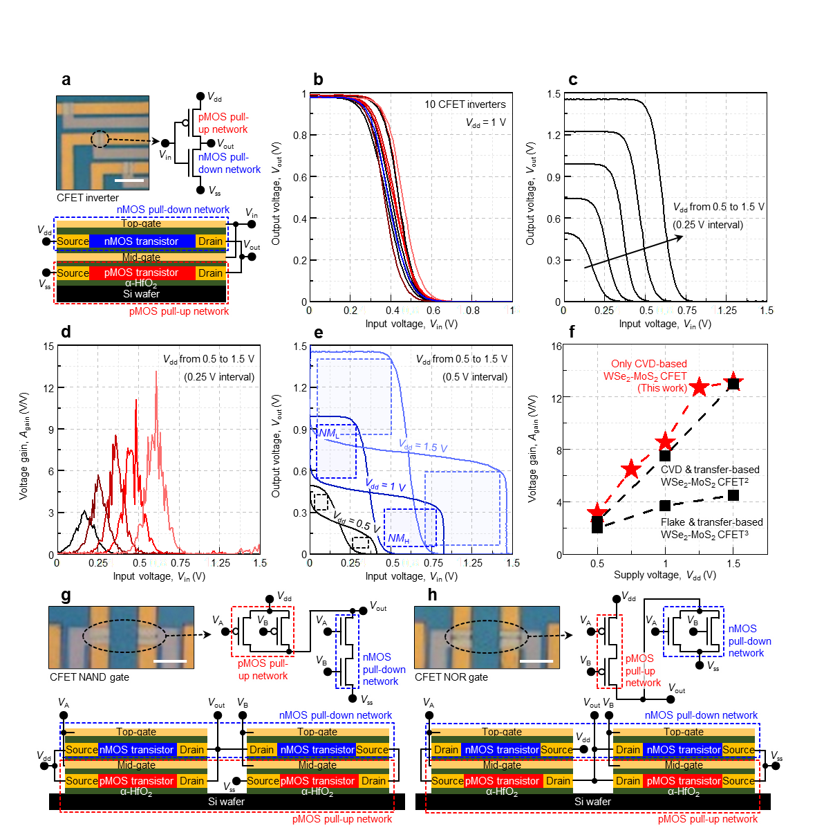
Supplementary Fig. 9 | Characterization of vertical CMOS-based logic circuits. a, OM image of fabricated vertical CMOS inverter array (left top panel) and circuit diagram (right top panel) and structural schematic (bottom panel) of vertical CMOS inverter. Scale bar denotes 8 μm. b, Multiple voltage transfer characteristics verified from 10 vertical CMOS inverters. c, Voltage transfer characteristics verified under various V_{dd} conditions, ranging from 0.5 to 0.75, 1, 1.25, and 1.5 V. d, Extracted voltage gain from voltage transfer characteristics. e, Voltage transfer characteristics denoted with noise margin (NM_{L} and NM_{H}). f, Comparison of voltage gain between our vertical CMOS inverter and WSe₂-MoS₂-based vertical CMOS inverter reported thus far^{2,3}. g–h, OM image of fabricated vertical NAND (g) and NOR (h) gates (left top panel) and circuit diagram (right top panel) and structural schematic (bottom panel) of vertical NAND and NOR gates. Scale bars denote 2 μm.

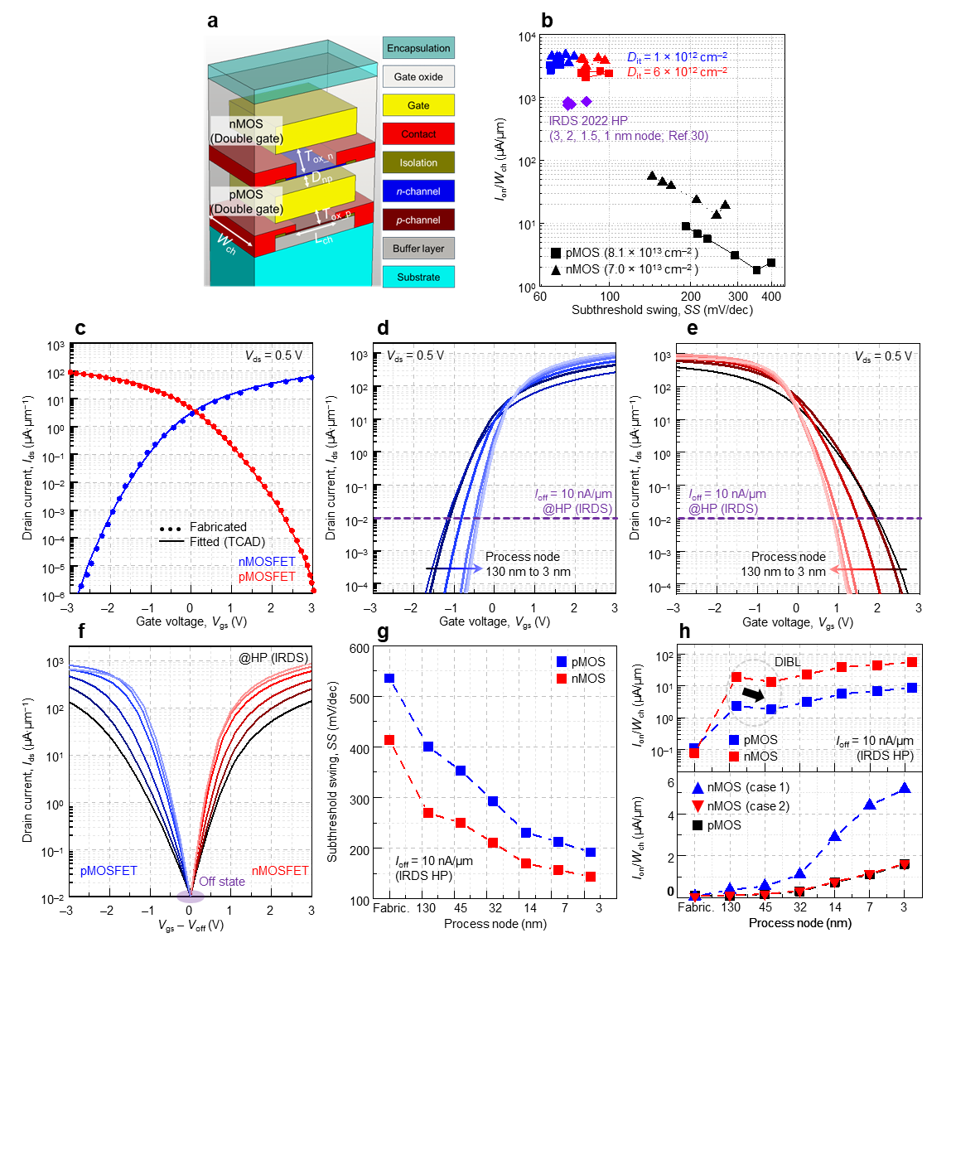
Supplementary Fig. 10 | Advanced CMOS process node-based vertical CMOS. a, Structural schematic of M3D integrated CMOS used in 3D FEM simulation. b, I_{on}/W_{ch} with respect to SS of fabricated vertical CMOS (black-colored plots) and vertical CMOS when D_{it} is assumed to be less than 6 × 10¹² cm^{–2} (red- and blue-colored plots). Targeted high-performance metrics including I_{on}/W_{ch} and SS at 3, 2, 1.5, and 1 nm process nodes that is provided in IRDS 2022⁴ (purple-colored plots). c, Transfer characteristics of nMOS and pMOS transistors of vertical CMOS, where dotted and line profiles denote transfer characteristic of experimentally obtained and TCAD-based fitted results, respectively. d–e, Predicted transfer characteristics of nMOS (d) and pMOS (e) transistors of vertical CMOS with respect to CMOS process node ranging from 130 to 45, 32, 14, 7, and 3 nm. f, Transfer characteristic of nMOS nad pMOS transistors of vertical CMOS with respect to CMOS process node with fixed with I_{off} of 10 nA/μm. g, Predicted I_{on}/W_{ch} values of vertical CMOS with respect to CMOS process nodes ranging from 130 to 45, 32, 14, 7, and 3 nm, respectively, where fixed off current is set to 10 nA/μm. h, Predicted I_{on}/W_{ch} value of vertical CMOS with respect to CMOS process node ranging from 130 to 45, 32, 14, 7, and 3 nm, respectively, where fixed off current is set to 10 nA/μm (top panel), and predicted I_{on}/W_{ch} values of pMOS and nMOS transistors with respect to CMOS process node (bottom panel), without (blue-colored plots) and with (red-colored plots) optimization of D_{np}.

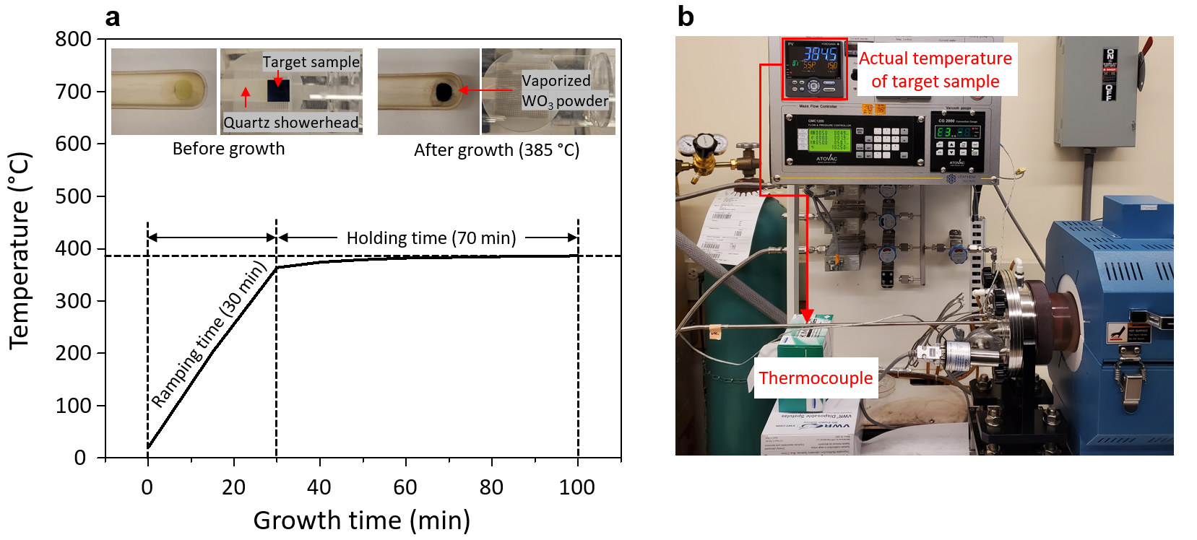
Supplementary Fig. 11 | WO₃ powder vaporized at 385 °C. a, Measured temperature at the target sample location using a thermocouple as a function of growth time (inset images show WO₃ vaporized after growth at 385 °C). b, Image of the actual temperature of the target substrate measured by the inserted thermocouple.

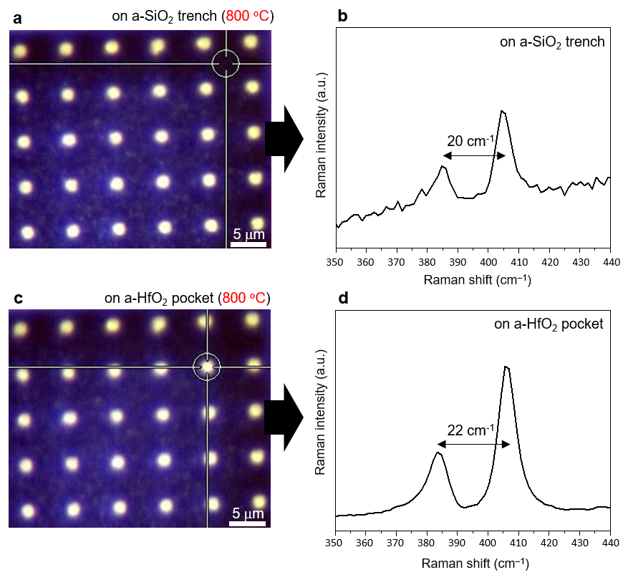
Supplementary Fig. 12 | Confined MoS₂ grown at high temperature (800 °C). OM images and Raman spectra measured in a, b, SiO₂ trench and c, d, HfO₂ pocket. Nucleation also occurs in SiO₂ trench at high temperature.

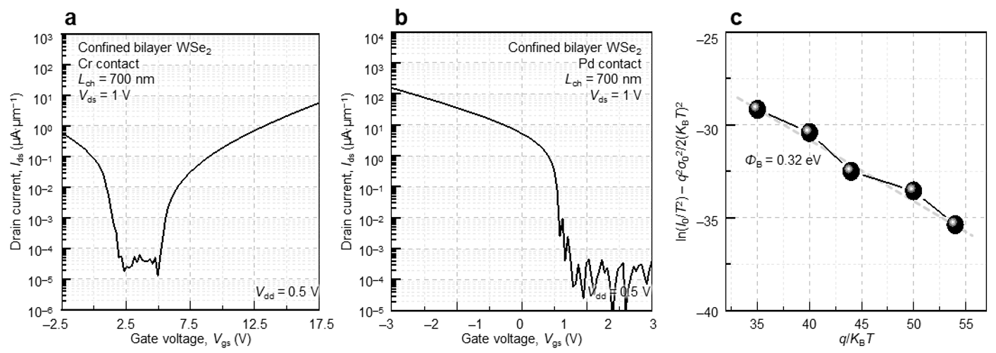
Supplementary Fig. 13 | Characterization of bilayer WSe₂ transistors with Cr and Pd contacts. a, b, Transfer curves of confined WSe₂-based transistors, where Cr and Pd were used as a S/D contact metal. c, Modified Richardson plot method for extracting hole barrier height of WSe₂ transistors with Pd contact as contact metal.

Materials | Growth |  |  | Device
 | Crystallinity | Thermal Budget  (< 400 °C) | Template | Manufacturability | Low power | Immunity to short channel effect
2D | Single  (This work) | O | Arbitrary | O | O^{7,8}  (<1 V) | O^{9,10}  (L_{g} ~ 1nm,  L_{ch} ~20nm)
 | Single^{1,5} | X | Crystal
 | Poly⁶ | O | Arbitrary
Si | Single¹¹ | X | Crystal | X | O  (<1 V) | O
CNT | Single^{12,13}  (CNT network) | O | Arbitrary  (Transfer) | X¹⁴  (Alignment) | O¹⁵  (<1 V) | O¹⁶  (L_{ch} ~10nm)
Organic | Poly | O | Arbitrary | X^{17,18}  (instability & unreliability) | X¹⁹ | X
Ge | Single²⁰ | X | Crystal | X²⁰  (No native oxide,  susceptible to heat) | O²¹  (<1 V) | X

Supplementary Table 1 | Benchmark table of current and future semiconductor channels of the transistor in terms of the requirement for M3D integration.^{1,4-21}

Materials | Crystallinity | Growth |  |  | Device |  |  |  |  |  | Ref
 |  | Type | Temper-ature | Substrate | Gate stack | Contact | Channel  dimension | Operational  voltage | I_{on}/W_{ch} | Current  on/off ratio
WSe₂ | Single | CVD | 485 °C | a-HfO₂ | 10 nm HfO₂ | Pt | 400 nm (L_{ch})/  700 nm (W_{ch}) | 0.5 V | 75.3 μA/μm  RSD = 16.95% | ~10⁶ | This  work
MoS₂ | Single | CVD | 385 °C | a-HfO₂ | 10 nm HfO₂ (bottom)/  20 nm HfO₂ (top) | Cr | 400 nm (L_{ch})/  700 nm (W_{ch}) | 0.5 V | 67.2 μA/μm  RSD = 12.86% | ~10⁷
WSe₂ | Single | CVD | 890 °C | Sapphire | 10 nm HfO₂/  100 nm SiO₂ | Pd | 700 nm (L_{ch})/  2 μm (W_{ch}) | 1 V | 89.9 μA/μm | ~10⁸ | 1
WSe₂ | Poly | CVD | 1180 °C | SiN_{x}/SiO₂ | HfO₂ | Sb | 100 nm (L_{ch}) | 0.5 V | ~ 35 μA/μm | Not verified (-) | 10
WSe₂ | Poly | CVD | 900 °C | SiO₂ | 100 nm SiN_{x} | Bi | 1 μm (L_{ch}) | 1 V | 14 μA/μm | ~10⁸ | 23
WSe₂ | Poly | MOCVD | 537 °C | Sapphire | - | - | - | - | - | - | 24
WSe₂ | Single | MBE | 200~400  °C | Au/Sapphire | - | - | - | - | - | - | 25
MoS₂ | Single | CVD | 750 °C | a-HfO₂ | 10 nm HfO₂/  100 nm SiO₂ | Ni | 700 nm (L_{ch})/  2 μm (W_{ch}) | 1 V | 86.7 μA/μm | ~10⁷ | 1
MoS₂ | Poly | CVD | 1000 °C | Sapphire | HfO₂ | Sb  (110) | 200 nm (L_{ch}) | 1 V | 1440 μA/μm | ~10⁸ | 10
MoS₂ | Poly | CVD | 625 °C | SiO₂ | 100 nm SiN_{x} | Bi | 35 nm (L_{ch}) | 1.5 V | 1135 μA/μm | 10⁶ | 23
MoS₂ | Poly | MOCVD | 320 °C | SiO₂ | 100 nm SiN_{x} | Bi | 120 nm (L_{ch}) | 1.5 V | 560 μA/μm | 10⁷ | 23
MoS₂ | Single | MOCVD | 320 °C | SiO₂,  Sapphire | 300 nm SiO₂ | - | - | 1 V | ~200 μA/μm | ~10⁵ | 26
MoS₂ | Poly | MOCVD | 580 °C | GaN/Si | 30 nm Al₂O₃ | Cr | 45 nm (L_{ch})/  10 μm (W_{ch}) | 1 V | 2.2 μA/μm | 10⁹ | 27
MoS₂ | Poly | MOCVD | 275 °C | SiO₂ | 20 nm Al₂O₃ | Au | 200 nm (L_{ch}) | 0.7 V | 40 μA/μm | 10⁵ | 6

Supplementary Table 2 | Comparison table of synthesized TMD-based transistors in terms of growth temperature of TMD and performance of device.^{1,10,23–27} RSD denotes relative standard deviation.

Type | Material | Parameter | Value
Channel | WSe₂ | Dielectric constant of in-plane (ε∥) | 15.7
 |  | Dielectric constant of out-of-plane (ε⊥) | 7.6
 |  | Energy band gap (E_{g}) | 1.15 [eV]
 |  | Electron affinity (χ) | 4.15 [eV]
 |  | Intrinsic Fermi level (E_{Fi}) | 4.78 [eV]
 |  | Effective mass of electron (m_{e}*/m₀) | 0.33
 |  | Effective mass of hole (m_{h}*/m₀) | 0.46
 | MoS₂ | Dielectric constant of in-plane (ε∥) | 15.7
 |  | Dielectric constant of out-of-plane (ε⊥) | 6.6
 |  | Energy band gap (E) | 1.27 [eV]
 |  | Electron affinity (χ) | 4.52 [eV]
 |  | Intrinsic Fermi level (E_{Fi}) | 5.16 [eV]
 |  | Effective mass of electron (m_{e}*/m₀) | 0.56
 |  | Effective mass of hole (m_{h}*/m₀) | 0.62
Metal | Pt | Fermi level (E_{F}) | 5.15 [eV]
 | Cr | Fermi level (E_{F}) | 4.66 [eV]
 | Pd | Fermi level (E_{F}) | 5.22 [eV]

Supplementary Table 3 | Electrical parameter for TCAD simulation.^{28–31}

 | Fabric. | 130 nm | 45 nm | 32 nm | 14 nm | 7 nm | 3 nm
EOT (nm) | 1.56 | 1.45 | 1.26 | 1.0 | 0.73 | 0.64 | 0.54
Lg (nm) | 400 | 65 | 27 | 24 | 24 | 20 | 16
V_{dd} (V) | 0.5 | 1.2 | 0.97 | 0.9 | 0.8 | 0.75 | 0.7

Supplementary Table 4 | Ground rules roadmap for logic devices.^{32,33}

Case 1 | Fabric. | 130 nm | 45 nm | 32 nm | 14 nm | 7 nm | 3 nm
Tox_p | 20 | 9.3 | 8.1 | 6.4 | 4.7 | 4.1 | 3.5
Tox_n | 10 | 9.3 | 8.1 | 6.4 | 4.7 | 4.1 | 3.5
Dnp | 10 | 9.3 | 8.1 | 6.4 | 4.7 | 4.1 | 3.5
Case 2 | Fabric. | 130 nm | 45 nm | 32 nm | 14 nm | 7 nm | 3 nm
Tox_p | 20 | 9.3 | 9.1 | 6.4 | 4.7 | 4.1 | 3.5
T_{ox_n} | 10 | 9.3 | 9.1 | 6.4 | 4.7 | 4.1 | 3.5
D_{np} | 10 | 28.8 | 21.2 | 16.0 | 12.2 | 9.6 | 8.0

Supplementary Table 5 | Geometric parameter values for Case 1 and Case 2.

Supplementary References

- Kim, K. S., et al. Non-epitaxial single-crystal 2D material growth by geometric confinement. Nature 614, 88-94 (2023)
- Xiong, X., et al. Top-Gate WSe₂ pFETs with Record-High I_{d}~ 594 μA/μm, G_{m}~ 244 μS/μm and WSe₂/MoS₂ CFET based Half-adder Circuit Using Monolithic 3D Integration. 2022 International Electron Devices Meeting (IEDM). IEEE, 2022.
- Sachid, A. B., et al. Monolithic 3D CMOS using layered semiconductors. Advanced Materials 28, 2547–2554 (2016).
- International Roadmap for Devices and Systems; https://irds.ieee.org/editions/2022
- Wang, J., et al. Dual-coupling-guided epitaxial growth of wafer-scale single-crystal WS₂ monolayer on vicinal a-plane sapphire. Nature Nanotechnology, 17, 33-38 (2022)
- Zhu, J., et al. Low-thermal-budget synthesis of monolayer molybdenum disulfide for silicon backend-of-line integration on a 200 mm platform. Nature Nanotechnology 18, 456-463 (2023)
- Shen, P., et al. Ultralow contact resistance between semimetal and monolayer semiconductors. Nature, 593, 211-217 (2021)
- Li, W., et al. Approaching the quantum limit in two-dimensional semiconductor contacts. Nature, 613, 274-279 (2023)
- Desai, S. B., et al MoS₂ transistors with 1-nanometer gate lengths. Science 354, 6308, 99-102 (2016)
- Li, W., et al Uniform and ultrathin high-κ gate dielectrics for two-dimensional electronic devices. Nature Electronics 2, 563-571 (2019)
- Liao, S., et al. Complementary field-effect transistor (CFET) demonstration at 48nm gate pitch for future logic technology scaling. 2023 International Electron Devices Meeting (IEDM), San Francisco, CA, USA, 1-4 (2023)
- Bishop, M. D., et al. Fabrication of carbon nanotube field-effect transistors in commercial silicon manufacturing facilities. Nature Electronics 3, 492-501 (2020)
- Hills, G., et al. Modern microprocessor built from complementary carbon nanotube transistors. Nature 572, 595-602 (2019)
- Zhang, J., et al. Characterization and design of logic circuits in the presence of carbon nanotube density variations. IEEE Transactions on Computer-Aided Design of Integrated Circuits and Systems 30, 1103-1113 (2011)
- Ding, L., et al. CMOS-based carbon nanotube pass-transistor logic integrated circuits. Nature Communications 3, 677 (2012)
- Franklin, A. D. et al. Sub-10 nm carbon nanotube transistor. Nano Letters 12, 2, 758-762 (2012)
- Park, S., et al. Recent advances in the bias stress stability of organic transistors. Advanced Functional Materials 30, 1904590 (2020)
- Sirringhaus, H., Reliability of organic field‐effect transistors. Advanced Materials 21, 3859-3873 (2009)
- Klauk, H., et al. Ultralow-power organic complementary circuits. Nature 445, 745–748 (2007)
- Saraswat, K. C., Germanium: back to the future. 75th Anniversary of the Transistor 415-429 (2023)
- Ye, Peide., Switching channels. IEEE Spectrum 53, 40-45 (2016)
- Cao, W., et al. The future transistors. Nature 620, 501–515 (2023)
- Shen, P.-C., et al. Ultralow contact resistance between semimetal and monolayer semiconductors. Nature 593, 211-217 (2021)
- Grundmann, A., et al. Impact of synthesis temperature and precursor ratio on the crystal quality of MOCVD WSe₂ monolayers. Nanotechnology 34, 205602 (2023)
- Xia, Y., et al. Wafer‐scale single‐crystalline MoSe₂ and WSe₂ monolayers grown by molecular‐beam epitaxy at low‐temperature—the role of island‐substrate interaction and surface steps. Natural Sciences 3, 20220059 (2023)
- Park, J.‐H., et al. Synthesis of high‐performance monolayer molybdenum disulfide at low temperature. Small Methods 5, 200720 (2021)
- Hwangbo, S., et al. Wafer-scale monolithic integration of full-colour micro-LED display using MoS₂ transistor. Nature Nanotechnology 17, 500-506 (2022)
- Laturia, A., Maarten L. Van de Put, and William G. V. Dielectric properties of hexagonal boron nitride and transition metal dichalcogenides: from monolayer to bulk. npj 2D Materials and Applications 2, 6 (2018)
- Liu, W., et al. High-performance field-effect-transistors on monolayer-WSe₂. ECS Transactions 58, 281 (2013)
- Szabó, Á., Reto R., and Mathieu L. Ab initio simulation of single-and few-layer MoS₂ transistors: Effect of electron-phonon scattering. Physical Review B 92, 035435 (2015)
- Yoshida, M., et al. ATR-SEIRAS investigation of the fermi level of Pt cocatalyst on a GaN photocatalyst for hydrogen evolution under irradiation. Journal of the American Chemical Society 131, 13218-13219 (2009)
- International technology roadmap for semiconductors (ITRS). Semiconductor Industry Association (2001-2013)
- International Roadmap for Devices and Systems (IRDSTM). IEEE (2017-2022)

