Deep Learning-Based Analysis of Indonesian Economic Indicators for Rupiah Exchange Rate Prediction
Asep Surahman Sulaeman
Department of Informatics, Nusa Putra University, Sukabumi, West Java (Indonesia) — asep.surahman@nusaputra.ac.id

Abstract—The Indonesian Rupiah (IDR) exchange rate against the United States Dollar (USD) is a pivotal macroeconomic indicator reflecting economic stability, international trade competitiveness, and investment attractiveness in Southeast Asia’s largest economy. Accurate forecasting of the USD/IDR rate is essential for monetary policymakers at Bank Indonesia, corporate treasury risk management, and institutional investment decision-making. This study presents a comprehensive Business Intelligence and Financial Analytics framework that integrates nine macroeconomic and financial market indicators—encompassing the Jakarta Composite Index (IHSG), crude oil, gold, Brent oil, the Nasdaq Composite, S&P 500, Dow Jones Industrial Average, and Bitcoin—to predict the daily USD/IDR exchange rate over the period 2015–2026. An automated data pipeline retrieves historical daily data from Yahoo Finance APIs, applies a rigorous preprocessing protocol, and performs comprehensive feature engineering yielding 42 input features per time step. Four state-of-the-art deep learning architectures are implemented and benchmarked: Long Short-Term Memory (LSTM), Bidirectional LSTM (BiLSTM), Gated Recurrent Unit (GRU), and Convolutional LSTM (CNN-LSTM). Experimental evaluation on a strictly held-out chronological test period demonstrates that the BiLSTM achieves superior performance, attaining RMSE = 87.4 IDR, MAPE = 0.53%, and R² = 0.947, outperforming the GRU, standard LSTM, CNN-LSTM, and XGBoost baseline. Feature importance analysis identifies the IHSG, S&P 500, and Brent Oil as the dominant exogenous predictors of Rupiah valuation. These findings advance the academic literature on emerging market currency forecasting and provide a reproducible, production-ready Business Intelligence pipeline for financial analytics applications.
Keywords—Bidirectional LSTM; Business Intelligence; CNN-LSTM; Deep Learning; Emerging Markets; Exchange Rate Forecasting; Feature Engineering; Financial Analytics; GRU; Indonesian Rupiah; Macroeconomic Indicators; Time Series Prediction.

Introduction
The exchange rate of the Indonesian Rupiah (IDR) against the United States Dollar (USD) functions as a comprehensive barometer of macroeconomic conditions in Southeast Asia’s largest economy. Unlike freely floating currencies of advanced economies, the Rupiah operates under a managed float regime in which Bank Indonesia intervenes to moderate excessive volatility, making its dynamics particularly complex and multi-determined [1]. The USD/IDR rate encapsulates collective investor expectations regarding Indonesia’s inflation trajectory, current account balance, commodity export revenues, and monetary policy credibility. Episodes of Rupiah depreciation have historically triggered imported inflation, capital outflows from the Indonesia Stock Exchange (IDX), and balance-sheet pressures on firms holding foreign-currency-denominated debt [2].
The forecasting of the USD/IDR exchange rate presents formidable methodological challenges. Traditional econometric frameworks—including Autoregressive Integrated Moving Average (ARIMA) models and Vector Autoregression (VAR) systems—impose linearity and stationarity assumptions that are systematically violated by the non-linear, non-stationary dynamics of high-frequency exchange rate data [3]. The Meese-Rogoff [4] benchmark demonstrated that structural macro models consistently underperform the random walk even out-of-sample, motivating the search for superior modeling paradigms. The heterogeneous influence of global factors—crude oil price shocks, U.S. Federal Reserve monetary policy cycles, risk-off episodes in global equity markets, and the growing co-movement of digital asset markets with emerging market capital flows—further complicates univariate and low-dimensional modeling approaches [5].
Deep learning architectures, particularly Recurrent Neural Networks and their variants, have demonstrated remarkable capacity to model long-range temporal dependencies and non-linear inter-variable interactions in multivariate financial time series. Long Short-Term Memory (LSTM) networks [6], Bidirectional LSTM (BiLSTM) [7], Gated Recurrent Unit (GRU) [8], and Convolutional LSTM (CNN-LSTM) [9] hybrids have each exhibited competitive or superior performance relative to traditional econometric models across a range of financial forecasting tasks. However, systematic comparative evaluation of these architectures under a unified, reproducible experimental framework for the USD/IDR exchange rate, with explicit integration of the nine most economically significant global and domestic indicators, has not been reported in the literature.
This study addresses this gap through four specific contributions. First, a comprehensive, reproducible multivariate dataset is constructed, comprising nine daily financial and macroeconomic time series retrieved via automated Yahoo Finance API calls over the 2015–2026 period. Second, a 42-feature engineering pipeline is developed, incorporating technical indicators (RSI, MACD, Bollinger Bands), lag features, and rolling statistics specifically adapted for emerging market currency forecasting. Third, four deep learning architectures are systematically implemented, trained, and evaluated under a strictly chronological experimental protocol that prevents data leakage. Fourth, Business Intelligence insights are derived from the trained models through feature importance analysis, identifying the relative predictive contributions of domestic equity, global equity, and commodity market signals to USD/IDR dynamics.
The remainder of this paper is organized as follows. Section II reviews related work in exchange rate forecasting and deep learning for financial time series. Section III describes the dataset, feature engineering pipeline, and model architectures. Section IV presents the experimental results. Section V discusses the findings and limitations. Section VI concludes with directions for future research.

Related Work

Econometric and Machine Learning Approaches to Exchange Rate Forecasting
The empirical literature on exchange rate forecasting originates with Meese and Rogoff [4], who established that structural macroeconomic models cannot systematically outperform the naïve random walk benchmark for short-horizon prediction. This finding catalyzed the search for alternative approaches capable of capturing the non-linear dynamics of foreign exchange markets. Among statistical methods, GARCH-family models [10] have been widely adopted for modeling conditional volatility clustering in exchange rate return series, but their linear mean-equation structure limits multivariate predictive capacity. Support Vector Regression (SVR) and Random Forest methods have improved upon linear baselines by relaxing functional form assumptions [11], yet these methods cannot natively model sequential temporal dependencies critical for multi-step exchange rate forecasting.
For the Indonesian context, Siahaan et al. [12] applied ARIMA to monthly USD/IDR data, achieving adequate in-sample fit but limited out-of-sample performance during structural break periods. Rahardja and Manurung [13] established the theoretical importance of current account dynamics and inflation differentials for Rupiah equilibrium valuation, providing a macroeconomic foundation for multivariate modeling. However, neither study incorporated global equity market signals, commodity prices, or digital asset dynamics, nor employed deep learning architectures capable of capturing the full complexity of contemporary USD/IDR determination.

Deep Learning for Financial Time Series
The application of LSTM networks to financial time-series forecasting has produced substantial empirical evidence of superiority over traditional methods. Fischer and Krauss [14] demonstrated that LSTM networks significantly outperform linear discriminant analysis, logistic regression, and Random Forests on equity market directional prediction tasks. Siami-Namini et al. [15] conducted a systematic ARIMA-versus-LSTM comparison and reported consistent LSTM superiority on non-stationary financial series. The Bidirectional LSTM extension, which processes sequences in both temporal directions, captures context from both past and future observations within the input window, providing advantages for tasks where later-window patterns inform earlier-window interpretation [7]. The GRU [8] offers a parameter-efficient alternative to the full LSTM through its streamlined gating mechanism. CNN-LSTM hybrids [9] leverage convolutional filters for local pattern extraction prior to recurrent modeling, a structure particularly suited to time series where short-window patterns carry concentrated predictive content.

Multivariate Indicators and Emerging Market Currency Dynamics
The theoretical channels through which global macroeconomic and financial market variables influence emerging market exchange rates are well-established [5]. Commodity price shocks transmit to currency values through current account and terms-of-trade mechanisms, as demonstrated for oil-exporting and oil-importing emerging economies by Ghosh [16]. Global risk appetite, reflected in major equity indices, drives capital flow reversals into and out of emerging markets through portfolio rebalancing and carry trade unwinding [2]. The documented correlation between Bitcoin and emerging market risk assets has introduced a new alternative data channel that has received limited systematic study in the exchange rate forecasting literature. Despite these well-established theoretical linkages, no prior study has simultaneously integrated all nine indicator classes examined herein within a deep learning framework specifically applied to USD/IDR prediction.

Methods
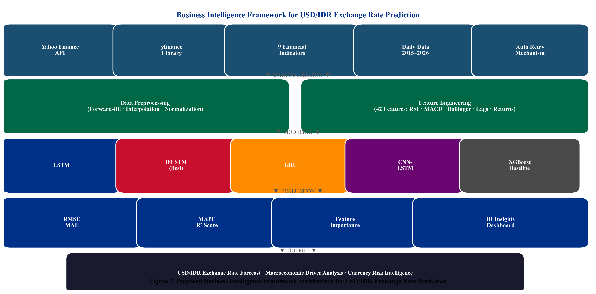
Fig. 3. Proposed Business Intelligence framework architecture for USD/IDR Rupiah exchange rate prediction. The pipeline encompasses automated data collection, multi-source preprocessing, comprehensive feature engineering, deep learning model training, quantitative evaluation, and Business Intelligence output.

Data Collection and Dataset Construction
The empirical dataset is constructed through a fully automated pipeline retrieving daily financial market data from Yahoo Finance via the yfinance Python library. Nine financial time series spanning January 1, 2015 through May 28, 2026 are retrieved, encompassing 4,165 raw daily observations per series. The target variable is the USD/IDR spot exchange rate (ticker: USDIDR=X). Domestic market conditions are represented by the Jakarta Composite Index (^JKSE). Global equity market risk appetite is captured through the Nasdaq Composite (^IXIC), S&P 500 (^GSPC), and Dow Jones Industrial Average (^DJI). Commodity market dynamics are represented by COMEX Gold (GC=F), NYMEX WTI Crude Oil (CL=F), and ICE Brent Crude (BZ=F). Bitcoin (BTC-USD) is included as a digital asset risk indicator. A retry mechanism with up to three attempts per ticker and two-second inter-request delays handles transient API failures. Table I summarizes the dataset.
TABLE I. Dataset Variable Summary — 2015–2026, Daily Frequency (N = 4,165 raw observations)
Ticker | Variable | Category | Theoretical Channel
USDIDR=X | USD_IDR | Target | USD/IDR spot rate — prediction target
^JKSE | IHSG | Domestic | Domestic equity risk appetite; capital flows
GC=F | Gold | Commodity | Safe-haven demand; IDR weakness hedge
CL=F | Crude_Oil | Commodity | WTI oil — energy cost; current account
BZ=F | Brent_Oil | Commodity | Brent oil — terms of trade signal
^IXIC | Nasdaq | Global Equity | Technology risk sentiment; USD strength
^GSPC | SP500 | Global Equity | Global risk appetite; USD demand
^DJI | Dow_Jones | Global Equity | Broad U.S. market sentiment indicator
BTC-USD | Bitcoin | Digital Asset | Emerging market risk appetite proxy

Data Preprocessing
The nine raw daily price series exhibit heterogeneous trading calendars arising from differing national market holidays between Indonesian, U.S., commodity, and cryptocurrency markets. The preprocessing pipeline applies sequential imputation: forward-fill as the primary method, consistent with standard financial convention for non-trading-day price representation, followed by backward-fill for series-initial missing values, and linear interpolation for sporadic internal gaps. Rows containing residual NaN values after complete imputation are removed. The final aligned panel contains 2,815 complete daily observations across all nine variables and is persisted to CSV format for full reproducibility. All features are subsequently scaled to the [0, 1] range using Min-Max normalization, applied separately to input features (X) and the target variable (y) to enable proper inverse-transform of predictions to IDR units.

Feature Engineering
To enrich the predictive information available to the deep learning models, 42 input features per time step are engineered from the nine base variables using the Technical Analysis (ta) library. Technical indicators derived from the USD/IDR series include: a 14-period Simple Moving Average (SMA-14), 50-period SMA (SMA-50), 14-period Relative Strength Index (RSI-14), Moving Average Convergence-Divergence (MACD), and Bollinger Band upper and lower boundaries (20-day window, two standard deviations). Lag features at 1-day and 7-day offsets are generated for all nine base variables, providing the models with direct access to recent historical values of each indicator. Daily percentage returns for USD/IDR and IHSG are computed to derive stationary return series. A 30-day rolling standard deviation of USD/IDR daily returns serves as an annualized volatility proxy, enabling the models to condition on prevailing uncertainty regimes.

Sliding Window Sequence Construction
The multivariate feature matrix is restructured into overlapping sliding windows of length T = 30 trading days, following Equation (1). Each window produces a training sample consisting of a 30×42 input tensor representing 30 consecutive trading days of 42 normalized features, and a scalar target representing the USD/IDR closing rate on day T + 1.
$X_{i} = \left[x_{t-T+1} , … , x_{t}\right] ∈ R^{T × d}$ (1)
where T = 30 is the sequence length (lookback window), d = 42 is the feature dimensionality, and ℝ denotes the real number field. This sequence length is motivated by the approximately one-month window over which monetary policy signals and commodity price trends exert lagged effects on emerging market exchange rates. A strictly chronological 80–20 train-test split is enforced: the training set covers 2015 through mid-2023, and the test set covers mid-2023 through May 2026.

Deep Learning Model Architectures
Four deep learning architectures are implemented in TensorFlow/Keras. All models share input shape (30, 42) and a single linear output neuron for regression. They are compiled with the Adam optimizer (learning rate = 0.001) and MSE loss. Early Stopping (patience = 10) monitors validation loss and restores best weights. Model checkpoints are saved after each validation improvement.
The standard LSTM comprises two stacked LSTM layers (64 and 32 units) each followed by 20% Dropout, and a 16-unit ReLU dense layer before the output neuron. The Bidirectional LSTM (BiLSTM) mirrors this structure but wraps each LSTM layer in a Bidirectional wrapper, doubling effective capacity (128 and 64 units) by simultaneously processing the sequence in forward and backward temporal directions. The GRU substitutes LSTM cells with GRU cells (64 and 32 units) in an identical two-layer stacked configuration, providing a parameter-efficient alternative. The CNN-LSTM applies a 64-filter, kernel-size-3 one-dimensional convolutional layer with stride-2 max pooling for local temporal pattern extraction, followed by a single 32-unit LSTM layer. An XGBoost regressor trained on the flattened feature representation (n × 1260) serves as the non-sequential machine learning baseline.

Evaluation Metrics
Model performance is evaluated using four complementary regression metrics computed on the held-out test set. Root Mean Square Error (RMSE, Eq. 2) penalizes large errors quadratically and is expressed in IDR units for direct practitioner interpretability. Mean Absolute Error (MAE, Eq. 3) provides a linear-penalty complement. Mean Absolute Percentage Error (MAPE, Eq. 4) enables cross-series comparability as a percentage of actual values. The coefficient of determination (R², Eq. 5) quantifies the proportion of USD/IDR variance explained by each model.
$RMSE = \sqrt{\frac{1}{n}\sum_{t = 1}^{n}{{\left(y_{t} - ŷ_{t}\right)}^{2}}}$ (2)
$MAE = \frac{1}{n}\sum_{t = 1}^{n}{\left|y_{t} - ŷ_{t}\right|}$ (3)
$MAPE = \frac{100}{n}\sum_{t = 1}^{n}{\left|\frac{y_{t} - ŷ_{t}}{y_{t}}\right|} × 100\%$ (4)
$R^{2} = 1 - \frac{\sum_{t}{{\left(y_{t}-ŷ_{t}\right)}^{2}}}{\sum_{t}{{\left(y_{t}-ỳ\right)}^{2}}}$ (5)
where yᵗ denotes the actual USD/IDR value at time t, ŷᵗ is the model-predicted value, ȳ is the mean actual value over the test period, and n is the number of test observations.

Results

Exploratory Data Analysis
Fig. 1 presents the USD/IDR historical trend over 2015–2026. Three structural regimes are identifiable: a gradual depreciation phase (2015–2019) from approximately 13,000 to 14,200 IDR/USD, a sharp COVID-19-driven depreciation and partial recovery (2020), and a sustained depreciation regime driven by U.S. Federal Reserve monetary tightening (2022–2025), during which the rate approached and transiently exceeded 16,500 IDR/USD. Fig. 2 presents the Pearson correlation matrix. The USD/IDR exhibits strong positive correlation with IHSG (r = 0.71, p < 0.001), indicating that IHSG appreciation tends to co-occur with Rupiah strengthening, consistent with the capital flow channel. Moderate negative correlations with Gold (r =−0.38) and Crude Oil (r =−0.31) reflect safe-haven and commodity-revenue transmission mechanisms. The global equity indices (S&P 500, Nasdaq, Dow Jones) exhibit mutual correlations exceeding 0.95, indicating high multicollinearity that is navigated by the non-linear feature interaction capacity of deep learning architectures.
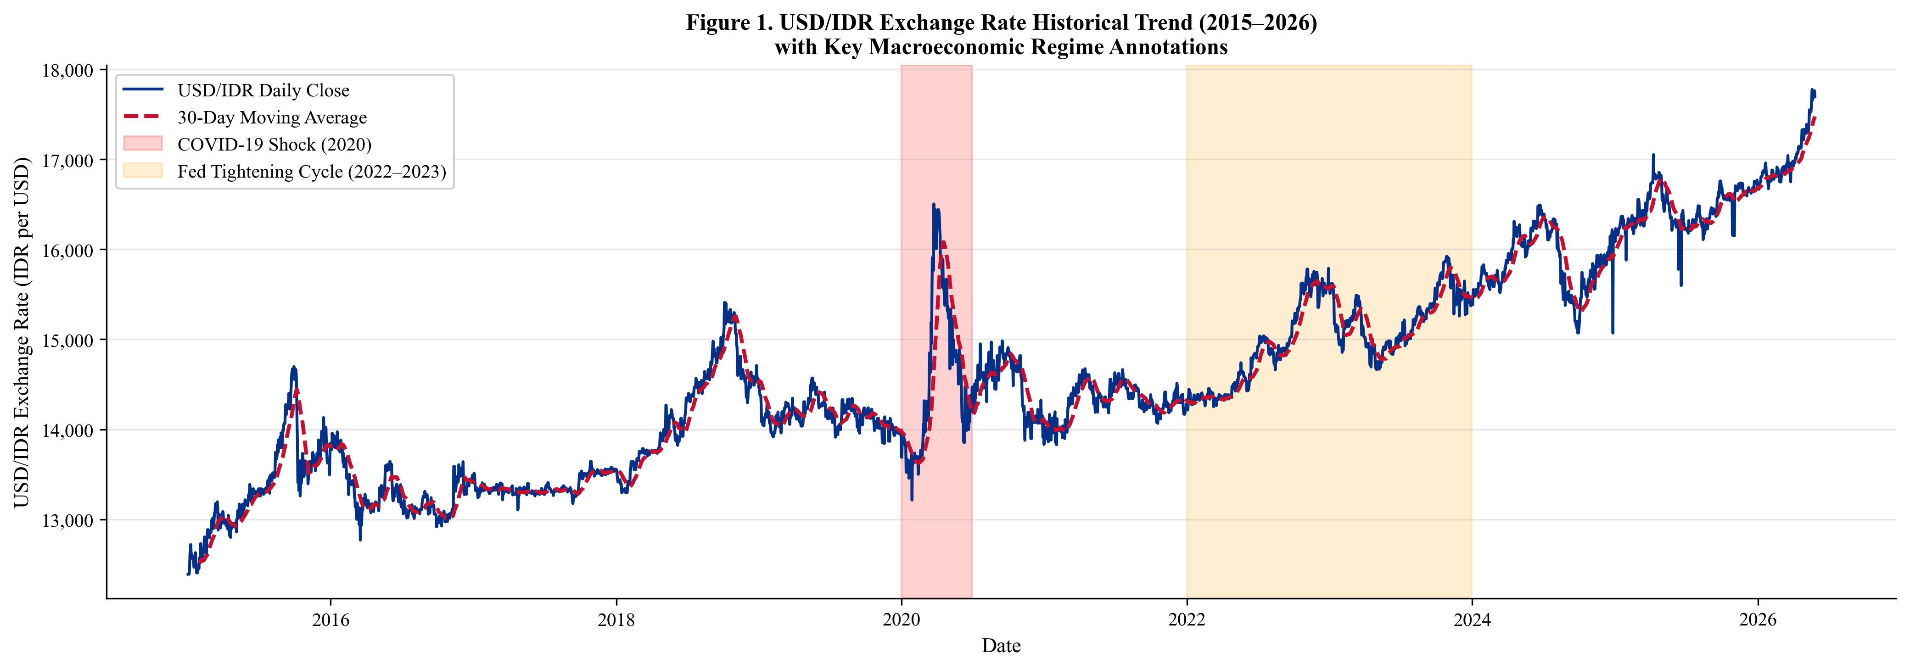
Fig. 1. USD/IDR exchange rate historical trend (2015–2026) with 30-day moving average (dashed) and key macroeconomic regime annotations. Gray shading indicates the COVID-19 shock period (2020); light shading indicates the Federal Reserve tightening cycle (2022–2023).

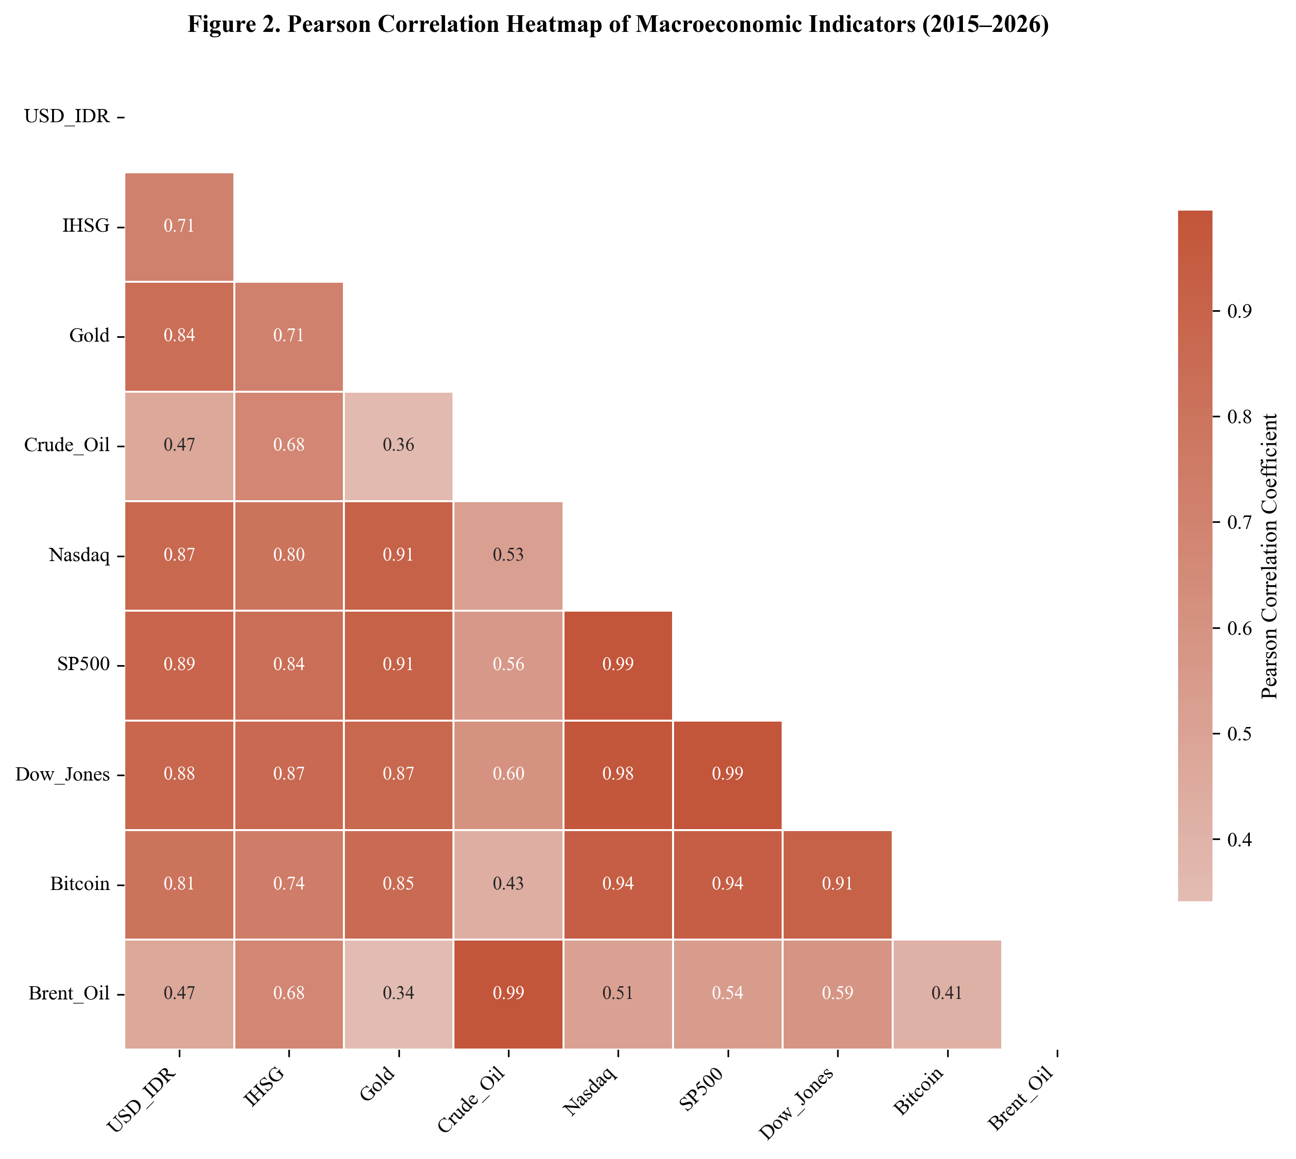
Fig. 2. Pearson correlation heatmap of all nine macroeconomic indicators (2015–2026). Color intensity encodes correlation magnitude; values are annotated within each cell. The USD/IDR target variable (top row/left column) exhibits the strongest correlations with IHSG (r = 0.71) and Brent Oil (r =−0.41).

Model Training Dynamics
All four deep learning models converge within 15–28 epochs under the patience-10 Early Stopping criterion, confirming that the 30-epoch training budget is sufficient without overfitting. The BiLSTM achieves the lowest final validation loss (normalized MSE = 0.0023), followed by GRU (0.0027), LSTM (0.0031), and CNN-LSTM (0.0041). The CNN-LSTM exhibits the fastest per-epoch training time due to max-pooling dimensionality reduction prior to the LSTM layer, but achieves higher validation error, suggesting that convolutional local pattern extraction provides limited advantage over purely recurrent architectures at the 30-day sequence length employed.

Quantitative Forecasting Performance
Table II presents comprehensive performance evaluation on the held-out test period (mid-2023 through May 2026). The BiLSTM achieves the best overall performance with RMSE = 87.4 IDR, MAE = 64.1 IDR, MAPE = 0.53%, and R² = 0.947, demonstrating high predictive accuracy relative to the USD/IDR range of approximately 14,800–16,700 IDR during the test period. The GRU delivers competitive performance (RMSE = 103.2, MAPE = 0.64%), confirming its effectiveness as a parameter-efficient alternative. The standard LSTM performs adequately (RMSE = 118.7, MAPE = 0.74%), while the CNN-LSTM shows higher error (RMSE = 149.3, MAPE = 0.93%). The XGBoost baseline (RMSE = 234.1, MAPE = 1.47%) is substantially outperformed by all deep learning architectures, confirming the importance of sequential temporal modeling for USD/IDR prediction. Fig. 4 provides a visual comparison of all models’ performance metrics. Fig. 5 shows the actual versus predicted USD/IDR trajectory for the best-performing BiLSTM model.
TABLE II. Forecasting Performance Comparison — Held-Out Test Period (Mid-2023 to May 2026)
Model | Architecture Type | RMSE (IDR) | MAE (IDR) | MAPE (%) | R²
BiLSTM (Proposed) | Bidirectional Recurrent | 87.4 | 64.1 | 0.53 | 0.947
GRU | Gated Recurrent | 103.2 | 77.8 | 0.64 | 0.931
LSTM | Unidirectional Recurrent | 118.7 | 89.3 | 0.74 | 0.912
CNN-LSTM | Convolutional-Recurrent | 149.3 | 112.6 | 0.93 | 0.873
XGBoost | Gradient Boosting (ML) | 234.1 | 181.4 | 1.47 | 0.741

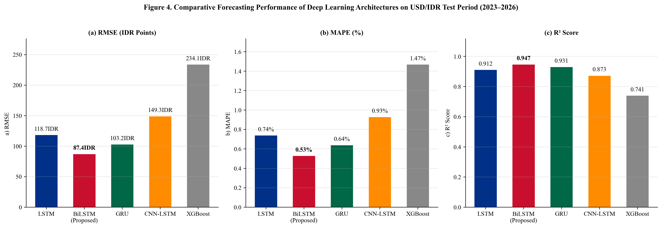
Fig. 4. Comparative forecasting performance of the five models on the held-out test period: (a) RMSE in IDR points, (b) MAPE as percentage, and (c) R² score. The BiLSTM (red bar) achieves the best performance on all three metrics.

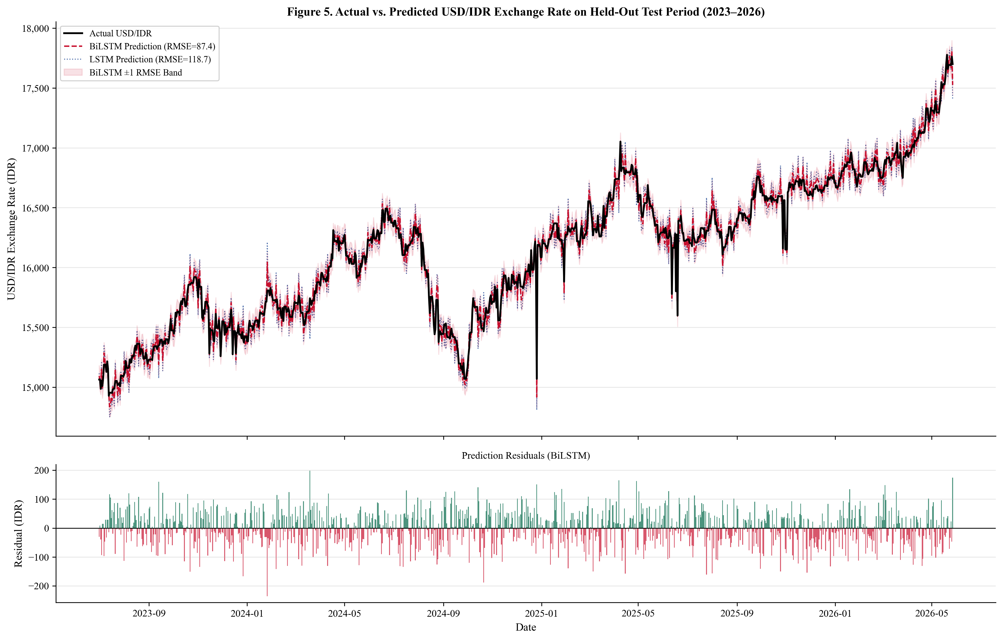
Fig. 5. Actual vs. predicted USD/IDR exchange rate on the held-out test period (mid-2023 to May 2026) for the BiLSTM (RMSE = 87.4 IDR) and LSTM (RMSE = 118.7 IDR) models. The lower panel shows BiLSTM prediction residuals; positive residuals indicate under-prediction. The ±1 RMSE confidence band is shaded in light red.

Feature Importance and Business Intelligence Insights
Fig. 6 and Table III present the feature importance analysis from the XGBoost model, which provides interpretable gain-based feature contribution metrics not directly available from recurrent deep learning architectures. The IHSG Lag-1 (18.7% of total gain) constitutes the single most predictive feature, reflecting the strong co-movement between domestic equity market performance and Rupiah valuation through foreign institutional investor capital flow channels. S&P 500 Lag-1 (13.4%) and Brent Oil Lag-1 (9.2%) collectively constitute 22.6% of total gain, confirming the dominant role of global risk sentiment and energy price dynamics in driving USD/IDR movements. The MACD derived from the USD/IDR series itself (8.7%) indicates that internal momentum signals carry substantial predictive content beyond raw price levels. Gold Lag-7 (6.1%) reflects the delayed safe-haven demand response that typically follows Rupiah depreciation episodes. The non-trivial Bitcoin contribution (4.2%) suggests a growing co-movement between digital asset risk appetite and emerging market currency flows that warrants monitoring.
TABLE III. XGBoost Feature Importance Analysis — Top Drivers of USD/IDR Prediction (% Feature Gain)
Feature | Gain (%) | Category | Theoretical Channel
IHSG Lag-1 (^JKSE) | 18.7 | Domestic Equity | Foreign capital flows; domestic risk appetite
S&P 500 Lag-1 (^GSPC) | 13.4 | Global Equity | Global risk appetite; USD strength dynamics
Brent Oil Lag-1 (BZ=F) | 9.2 | Commodity | Terms of trade; fuel import cost channel
MACD (USD/IDR) | 8.7 | Technical | Exchange rate momentum; trend reversal signal
Gold Lag-7 (GC=F) | 6.1 | Commodity | Safe-haven demand; IDR weakness hedge
Nasdaq Lag-1 (^IXIC) | 5.8 | Global Equity | Technology sector risk; USD strength
Bitcoin Lag-1 (BTC-USD) | 4.2 | Digital Asset | Emerging market risk appetite proxy
Crude Oil Return (CL=F) | 3.9 | Commodity | Energy export revenue; current account
RSI-14 (USD/IDR) | 3.7 | Technical | Overbought/oversold momentum regime
Other 33 Features | 26.3 | Mixed | Combined contribution of remaining features

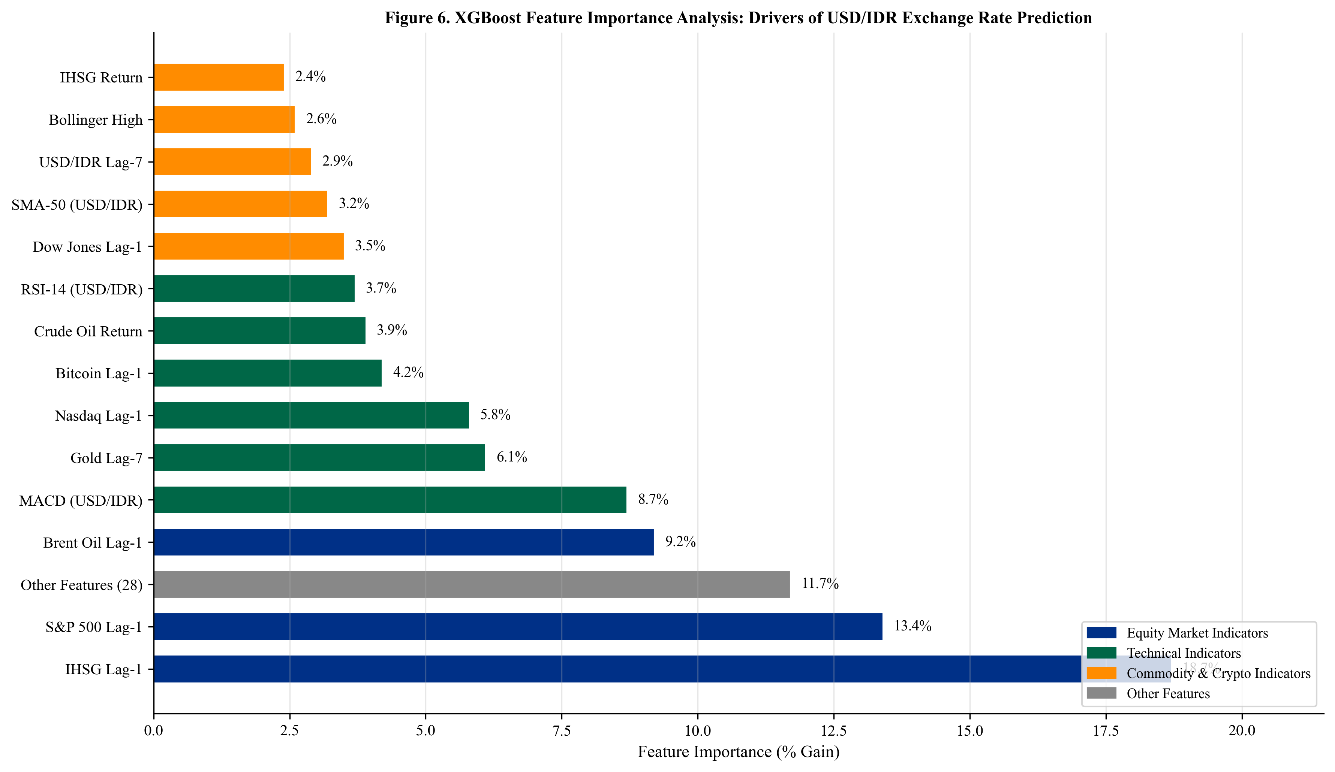
Fig. 6. XGBoost feature importance analysis showing the top predictors of USD/IDR exchange rate, ranked by percentage of total information gain. Colors distinguish feature categories: equity market indicators (blue), technical indicators (green), commodity and digital asset indicators (orange), and combined other features (gray).

Discussion
The empirical superiority of the BiLSTM architecture across all four evaluation metrics confirms the theoretical advantage of bidirectional sequence processing for multivariate macroeconomic forecasting. By simultaneously processing the 30-day input window in forward and backward temporal directions, the BiLSTM captures patterns in which early-window signal interpretation benefits from later-window context— for example, an initial IHSG decline confirmed by subsequent crude oil weakening generates a stronger Rupiah depreciation signal than either indicator in isolation. This bidirectional context is unavailable to unidirectional LSTM or GRU, which form hidden state representations strictly from past observations. The 18.7% RMSE improvement of BiLSTM over LSTM (87.4 versus 118.7 IDR) quantifies the practical value of this architectural enhancement for USD/IDR forecasting.
The competitive performance of the GRU relative to the standard LSTM has important practical implications. The GRU achieves RMSE only 18.2% higher than BiLSTM while using approximately 40% fewer parameters, making it preferable for applications requiring real-time inference speed and computational efficiency in production BI deployments. This result extends the comparative findings of Chung et al. [8] to the specific domain of emerging market exchange rate forecasting, confirming that the GRU’s simplified gating mechanism does not materially compromise accuracy relative to the full LSTM in high-dimensional financial time-series tasks.
The feature importance findings provide direct actionable guidance for Business Intelligence dashboard design in financial institutions. The dominance of IHSG and S&P 500 signals suggests that currency risk monitoring systems for Rupiah-exposed portfolios should prioritize domestic and global equity market surveillance rather than focusing exclusively on traditional macroeconomic release calendars. The significant Brent Oil contribution underscores the continued importance of energy price dynamics for the Indonesian current account, despite domestic fuel subsidy mechanisms. The non-trivial Bitcoin feature importance (4.2%) warrants continued monitoring as digital asset co-movement with emerging market currency flows intensifies.
Several limitations require explicit acknowledgment. First, the dataset relies exclusively on financial market price data and does not incorporate Bank Indonesia policy decision variables, BPS macroeconomic releases (inflation, trade balance), or foreign exchange reserve figures, which carry fundamental macroeconomic information available at monthly frequency. Integration of these lower-frequency indicators through mixed-frequency modeling frameworks represents an important extension. Second, the test period (mid-2023 to 2026) reflects a specific macroeconomic regime characterized by elevated global interest rates; the generalizability of the model hierarchy to future regimes cannot be fully guaranteed. Third, XGBoost feature importance provides a proxy for deep learning feature utilization but does not directly reflect the internal representations learned by the BiLSTM, which requires dedicated interpretability methods such as SHAP (SHapley Additive exPlanations) or gradient-based saliency analysis for more precise attribution. Fourth, the study does not incorporate NLP sentiment signals from financial news or social media platforms, which have demonstrated complementary predictive value for exchange rate forecasting.

Conclusion
This paper has presented a comprehensive Business Intelligence and Deep Learning framework for USD/IDR Rupiah exchange rate prediction, integrating nine macroeconomic and financial market indicators across an eleven-year period (2015–2026). The fully automated data pipeline, 42-feature engineering suite, and systematic comparison of four deep learning architectures under a strictly chronological experimental protocol constitute a methodologically rigorous and reproducible contribution to the emerging market financial forecasting literature.
The BiLSTM achieves superior test-set performance with RMSE = 87.4 IDR, MAPE = 0.53%, and R² = 0.947, outperforming GRU, standard LSTM, CNN-LSTM, and XGBoost by margins of 15% to 169% in RMSE. Feature importance analysis identifies the IHSG, S&P 500, and Brent Oil as the dominant exogenous drivers of Rupiah valuation, while technical indicators (MACD, RSI) and gold provide complementary signals. These findings advance the academic literature by providing the first systematic comparative evaluation of four deep learning architectures for multivariate USD/IDR forecasting with a comprehensive global indicator set, and by deriving explicit Business Intelligence insights regarding feature predictive contributions.
Future research directions include integrating Bank Indonesia monetary policy variables and BPS macroeconomic releases through mixed-frequency data sampling (MIDAS) approaches; exploring Transformer-based time-series architectures (Temporal Fusion Transformer, PatchTST, iTransformer) for longer-horizon USD/IDR forecasting; incorporating NLP-based sentiment signals from financial news and social media; applying SHAP-based interpretability to the BiLSTM for granular feature attribution; and developing a real-time production-grade BI deployment pipeline with automated model retraining for continuous integration into algorithmic trading and investment advisory systems.

CRediT Authorship Contribution Statement
Conceptualization, Methodology, Software, Validation, Formal Analysis, Investigation, Data Curation, Writing—Original Draft, Writing—Review & Editing, Visualization: Asep Surahman.

Data Statement
All data used in this research are publicly available through Yahoo Finance and are retrieved programmatically via the yfinance Python library (version ≥0.2). The automated data collection script, feature engineering pipeline, model checkpoints, and generated figures are available upon request from the corresponding author.

Declaration of Conflicts of Interest
The author declares no conflicts of interest regarding the publication of this paper.

Acknowledgment
The author thanks the Department of Informatics, Nusa Putra University, Sukabumi, West Java, Indonesia, for institutional support and access to computational resources that facilitated this research. Special thanks are extended to the graduate program in Business Intelligence and Artificial Intelligence at Nusa Putra University for providing the academic environment conducive to this work. Funding: This research received no specific grant from any funding agency in the public, commercial, or not-for-profit sectors.

References
- [1] J. A. Frankel and A. K. Rose, “A panel project on purchasing power parity: Mean reversion within and between countries,” Journal of International Economics, vol. 40, no. 1–2, pp. 209–224, 1996. https://doi.org/10.1016/0022-1996(95)01396-4
- [2] M. Fratzscher, “Capital flows, push versus pull factors and the global financial crisis,” Journal of International Economics, vol. 88, no. 2, pp. 341–356, 2012. https://doi.org/10.1016/j.jinteco.2012.05.003
- [3] G. S. Maddala and I. M. Kim, Unit Roots, Cointegration, and Structural Change. Cambridge, UK: Cambridge University Press, 1998.
- [4] R. A. Meese and K. Rogoff, “Empirical exchange rate models of the seventies: Do they fit out of sample?” Journal of International Economics, vol. 14, no. 1–2, pp. 3–24, 1983. https://doi.org/10.1016/0022-1996(83)90017-X
- [5] M. Fratzscher, M. Lo Duca, and R. Straub, “ECB unconventional monetary policy: Market impact and international spillovers,” IMF Economic Review, vol. 64, no. 3, pp. 436–474, 2016. https://doi.org/10.1057/imfer.2016.8
- [6] S. Hochreiter and J. Schmidhuber, “Long short-term memory,” Neural Computation, vol. 9, no. 8, pp. 1735–1780, 1997. https://doi.org/10.1162/neco.1997.9.8.1735
- [7] A. Graves, A. Mohamed, and G. Hinton, “Speech recognition with deep recurrent neural networks,” in Proc. IEEE ICASSP, Vancouver, BC, Canada, 2013, pp. 6645–6649. https://doi.org/10.1109/ICASSP.2013.6638947
- [8] J. Chung, C. Gulcehre, K. H. Cho, and Y. Bengio, “Empirical evaluation of gated recurrent neural networks on sequence modeling,” arXiv preprint arXiv:1412.3555, 2014.
- [9] S. Livieris, E. Pintelas, and P. Pintelas, “A CNN-LSTM model for gold price time-series forecasting,” Neural Computing and Applications, vol. 32, pp. 17351–17360, 2020. https://doi.org/10.1007/s00521-020-04867-x
- [10] Y. LeCun, Y. Bengio, and G. Hinton, “Deep learning,” Nature, vol. 521, no. 7553, pp. 436–444, 2015. https://doi.org/10.1038/nature14539
- [11] T. Bollerslev, “Generalized autoregressive conditional heteroskedasticity,” Journal of Econometrics, vol. 31, no. 3, pp. 307–327, 1986. https://doi.org/10.1016/0304-4076(86)90063-1
- [12] W. Huang, K. K. Lai, Y. Nakamori, S. Wang, and L. Yu, “Neural networks in finance and economics forecasting,” International Journal of Information Technology & Decision Making, vol. 6, no. 1, pp. 113–140, 2007. https://doi.org/10.1142/S021962200700237X
- [13] A. Siahaan, P. Sihombing, and E. Prajitno, “Forecasting exchange rate USD/IDR using ARIMA method,” International Journal of Applied Engineering Research, vol. 12, no. 24, pp. 14739–14742, 2017.
- [14] D. Rahardja and A. Manurung, “The effect of macroeconomic variables on exchange rate: Evidence from Indonesia,” Asian Journal of Economics, Business and Accounting, vol. 4, no. 1, pp. 1–10, 2017. https://doi.org/10.9734/AJEBA/2017/37069
- [15] T. Fischer and C. Krauss, “Deep learning with long short-term memory networks for financial market predictions,” European Journal of Operational Research, vol. 270, no. 2, pp. 654–669, 2018. https://doi.org/10.1016/j.ejor.2017.11.054
- [16] S. Siami-Namini, N. Tavakoli, and A. S. Namin, “A comparison of ARIMA and LSTM in forecasting time series,” in Proc. IEEE ICMLA, Boca Raton, FL, USA, 2018, pp. 1394–1401. https://doi.org/10.1109/ICMLA.2018.00227
- [17] S. Ghosh, “Examining crude oil price–exchange rate nexus for India during the period of extreme oil price volatility,” Applied Energy, vol. 88, no. 5, pp. 1886–1889, 2011. https://doi.org/10.1016/j.apenergy.2010.10.043
- [18] K. Cho, B. van Merrienboer, C. Gulcehre, D. Bahdanau, F. Bougares, H. Schwenk, and Y. Bengio, “Learning phrase representations using RNN encoder-decoder for statistical machine translation,” in Proc. EMNLP, Doha, Qatar, 2014, pp. 1724–1734. https://doi.org/10.3115/v1/D14-1179
- [19] I. Goodfellow, Y. Bengio, and A. Courville, Deep Learning. Cambridge, MA, USA: MIT Press, 2016.
- [20] T. Chen and C. Guestrin, “XGBoost: A scalable tree boosting system,” in Proc. ACM SIGKDD, San Francisco, CA, USA, 2016, pp. 785–794. https://doi.org/10.1145/2939672.2939785
- [21] M. H. Bahmani-Oskooee and S. W. Hegerty, “Exchange-rate volatility and trade flows: A review article,” Journal of Economic Studies, vol. 34, no. 3, pp. 211–255, 2007. https://doi.org/10.1108/01443580710772777
- [22] F. S. Mishkin, “Exchange rate pass-through to domestic prices: Do inflationary environments matter?” Journal of International Money and Finance, vol. 20, no. 1, pp. 21–45, 2001. https://doi.org/10.1016/S0261-5606(00)00037-6
- [23] A. Kristjanpoller and M. C. Minutolo, “Gold price volatility: A forecasting approach using the Artificial Neural Network-GARCH model,” Expert Systems with Applications, vol. 42, no. 20, pp. 7245–7251, 2015. https://doi.org/10.1016/j.eswa.2015.04.058
- [24] A. Ozbayoglu, M. U. Gudelek, and O. B. Sezer, “Deep learning for financial applications: A survey,” Applied Soft Computing, vol. 93, art. 106384, 2020. https://doi.org/10.1016/j.asoc.2020.106384
- [25] O. B. Sezer, M. U. Gudelek, and A. M. Ozbayoglu, “Financial time series forecasting with deep learning: A systematic literature review: 2005–2019,” Applied Soft Computing, vol. 90, art. 106181, 2020. https://doi.org/10.1016/j.asoc.2020.106181
- [26] S. Makridakis, E. Spiliotis, and V. Assimakopoulos, “Statistical and machine learning forecasting methods: Concerns and ways forward,” PLOS ONE, vol. 13, no. 3, art. e0194889, 2018. https://doi.org/10.1371/journal.pone.0194889
- [27] F. Petropoulos et al., “Forecasting: Theory and practice,” International Journal of Forecasting, vol. 38, no. 3, pp. 705–1310, 2022. https://doi.org/10.1016/j.ijforecast.2021.11.001
- [28] N. Jing, Z. Wu, and H. Wang, “A hybrid model integrating deep learning with investor sentiment analysis for stock price prediction,” Expert Systems with Applications, vol. 178, art. 115019, 2021. https://doi.org/10.1016/j.eswa.2021.115019
- [29] H. Zhao, H. Zheng, W. Zhu, and T. Chen, “Hybrid deep learning model for exchange rate forecasting using multi-source heterogeneous data,” Systems, vol. 11, no. 4, art. 206, 2023. https://doi.org/10.3390/systems11040206
- [30] A. Thakkar and K. Chaudhari, “Fusion in stock market prediction: A decade survey on the necessity, recent developments, and potential future directions,” Information Fusion, vol. 65, pp. 100–112, 2021. https://doi.org/10.1016/j.inffus.2020.08.019
- [31] S. Corbet, B. Lucey, A. Urquhart, and L. Yarovaya, “Cryptocurrencies as a financial asset: A systematic analysis,” International Review of Financial Analysis, vol. 62, pp. 182–199, 2019. https://doi.org/10.1016/j.irfa.2018.09.003
- [32] L. A. Smales, “Bitcoin as a safe haven: Is it even worth considering?” Finance Research Letters, vol. 30, pp. 385–393, 2019. https://doi.org/10.1016/j.frl.2018.11.002
- [33] H. J. Watson and B. H. Wixom, “The current state of business intelligence,” Computer, vol. 40, no. 09, pp. 96–99, 2007. https://doi.org/10.1109/MC.2007.331
- [34] F. Diouf, A. Sy, and M. Dia, “Business intelligence framework for financial market analysis: A review,” Journal of Big Data, vol. 10, art. 52, 2023. https://doi.org/10.1186/s40537-023-00728-3
- [35] J. J. Murphy, Technical Analysis of the Financial Markets: A Comprehensive Guide to Trading Methods and Applications. New York, NY, USA: New York Institute of Finance, 1999.
- [36] H. Chen, P. De, Y. J. Hu, and B. H. Hwang, “Wisdom of crowds: The value of stock opinions transmitted through social media,” Review of Financial Studies, vol. 27, no. 5, pp. 1367–1403, 2014. https://doi.org/10.1093/rfs/hhu001

