Multivariate Deep Learning Framework for Indonesian Rupiah Exchange Rate Prediction: A Comparative Study with Statistical Significance Testing
Asep Surahman Sulaeman
Master of Informatics, Faculty of Engineering, Computer, and Design, Nusa Putra University, Sukabumi, West Java (Indonesia) asep.surahman@nusaputra.ac.id

Abstract The USD/IDR exchange rate is a critical macroeconomic indicator for Indonesia’s emerging market economy. This study proposes a multivariate deep learning pipeline integrating nine financial and macroeconomic indicators including the Jakarta Composite Index (IHSG), crude oil, gold, Brent oil, Nasdaq, S&P 500, Dow Jones, and Bitcoin to predict the daily USD/IDR rate over 2015–2024. A 42-feature engineering suite is constructed with strict train-only normalization to prevent data leakage. Four architectures LSTM, BiLSTM, GRU, and CNN-LSTM are benchmarked against XGBoost, ARIMA(1,1,1), and the Naïve Random Walk. BiLSTM achieves the best test-set performance (RMSE = 87.4 IDR, MAPE = 0.53%, R² = 0.947), statistically outperforming all baselines via Diebold-Mariano tests (p < 0.05). XGBoost surrogate feature importance identifies IHSG, S&P 500, and Brent Oil as dominant predictors. An ablation study validates the 30-day lookback window as optimal. These findings provide a reproducible, statistically validated framework for emerging market currency forecasting.
Keywords Bidirectional LSTM; Deep Learning; Emerging Market; Exchange Rate Forecasting; Feature Engineering; Indonesian Rupiah; Multivariate Time Series.

Introduction
The exchange rate of the Indonesian Rupiah (IDR) against the United States Dollar (USD) operates under a managed float regime in which Bank Indonesia intervenes to moderate excessive volatility, making its dynamics particularly complex and multi-determined [1]. The USD/IDR rate encapsulates collective investor expectations regarding Indonesia’s inflation trajectory, current account balance, commodity export revenues, and monetary policy credibility. Episodes of Rupiah depreciation have historically triggered imported inflation, capital outflows from the Indonesia Stock Exchange (IDX), and balance-sheet pressures on firms holding foreign-currency-denominated debt [2].
Traditional econometric frameworks including Autoregressive Integrated Moving Average (ARIMA) models, Generalized Autoregressive Conditional Heteroscedasticity (GARCH) [3], and Vector Autoregression (VAR) systems impose linearity and stationarity assumptions systematically violated by high-frequency exchange rate data. The Meese-Rogoff benchmark [4] demonstrated that structural models cannot consistently outperform the naïve random walk, motivating the search for superior modeling paradigms. Global factors including crude oil price shocks, U.S. Federal Reserve monetary policy cycles, and risk-off episodes in global equity markets further complicate low-dimensional modeling approaches [5].
Deep learning architectures have demonstrated the capacity to model long-range temporal dependencies and non-linear inter-variable interactions in multivariate financial time series. Long Short-Term Memory (LSTM) networks [6], Bidirectional LSTM (BiLSTM) [7], Gated Recurrent Unit (GRU) [8], and Convolutional LSTM (CNN-LSTM) [9] hybrids have each exhibited competitive or superior performance relative to traditional econometric models across financial forecasting tasks. However, a systematic comparative evaluation of these architectures under a unified, reproducible experimental framework specifically for USD/IDR prediction, with (a) explicit inclusion of global and domestic macroeconomic indicators, (b) strict data-leakage prevention, and (c) statistical significance testing of performance differences, has not been reported in the literature.
This study addresses this gap through four contributions. First, a reproducible multivariate dataset is constructed comprising nine daily financial and macroeconomic time series (2015–2024) with a strictly defined train-validation-test partition and train-only feature normalization. Second, a 42-feature engineering pipeline is developed incorporating technical indicators (RSI, MACD, Bollinger Bands), lag features, and rolling statistics. Third, four deep learning architectures and three baselines (XGBoost, ARIMA, Naïve Random Walk) are systematically evaluated; performance differences are validated using Diebold-Mariano statistical significance tests. Fourth, an XGBoost surrogate feature importance analysis quantifies the relative predictive contribution of each macroeconomic indicator, providing interpretable economic insights consistent with established transmission channels; a SHAP-based attribution for BiLSTM is identified as a targeted future direction.

Related Work

Econometric and Machine Learning Approaches
The Meese-Rogoff benchmark [4] established that structural macroeconomic models cannot systematically outperform the naïve random walk, catalyzing the search for alternative approaches. GARCH-family models [3] address conditional volatility clustering but are constrained by their linear mean-equation structure for multivariate prediction. Support Vector Regression and ensemble methods improve upon linear baselines by relaxing functional form assumptions [10], yet cannot natively model sequential temporal dependencies. For Indonesia, Siahaan et al. [11] applied ARIMA to monthly USD/IDR data with limited out-of-sample accuracy during structural breaks; Rahardja and Manurung [12] established the theoretical importance of current account dynamics and inflation differentials for Rupiah equilibrium valuation, providing macroeconomic grounding for multivariate modeling.

Deep Learning for Financial Time Series
Fischer and Krauss [13] demonstrated LSTM superiority over linear discriminant analysis, logistic regression, and Random Forests on equity market prediction. Siami-Namini et al. [14] confirmed consistent LSTM superiority over ARIMA on non-stationary financial series, a finding corroborated by comprehensive surveys of deep learning applications in financial time series forecasting [22][23]. The deep learning revolution surveyed by LeCun et al. [15] established the theoretical foundations enabling sequence-to-sequence architectures for complex temporal tasks. The GRU [8], originally proposed by Cho et al. [16] in the context of machine translation, provides a parameter-efficient recurrent cell that has shown competitive performance in financial applications. CNN-LSTM hybrids [9] leverage convolutional filters for local pattern extraction prior to recurrent modeling, a structure suited to time series with concentrated short-window patterns. Transformer-based architectures, including the Temporal Fusion Transformer (TFT) [18], have recently demonstrated state-of-the-art performance on multi-horizon financial forecasting by combining self-attention mechanisms with gated residual networks; their application to USD/IDR prediction with the full macroeconomic indicator set constitutes an important direction for future research.

Multivariate Indicators and Emerging Market Currency Dynamics
Commodity price shocks transmit to currency values through current account and terms-of-trade mechanisms, as demonstrated by Ghosh [17] for oil-importing emerging economies. Hybrid ANN-GARCH models [27] have further demonstrated that combining neural network mean equations with econometric volatility frameworks improves commodity price forecasting, a methodology complementary to the pure deep learning approach of this study. Global risk appetite, reflected in major equity indices, drives capital flow reversals through portfolio rebalancing [2]. Despite well-established theoretical linkages between these nine indicator classes and USD/IDR dynamics, no prior study has simultaneously integrated all nine within a statistically validated deep learning framework for Rupiah prediction with explicit data-leakage safeguards.

Methods
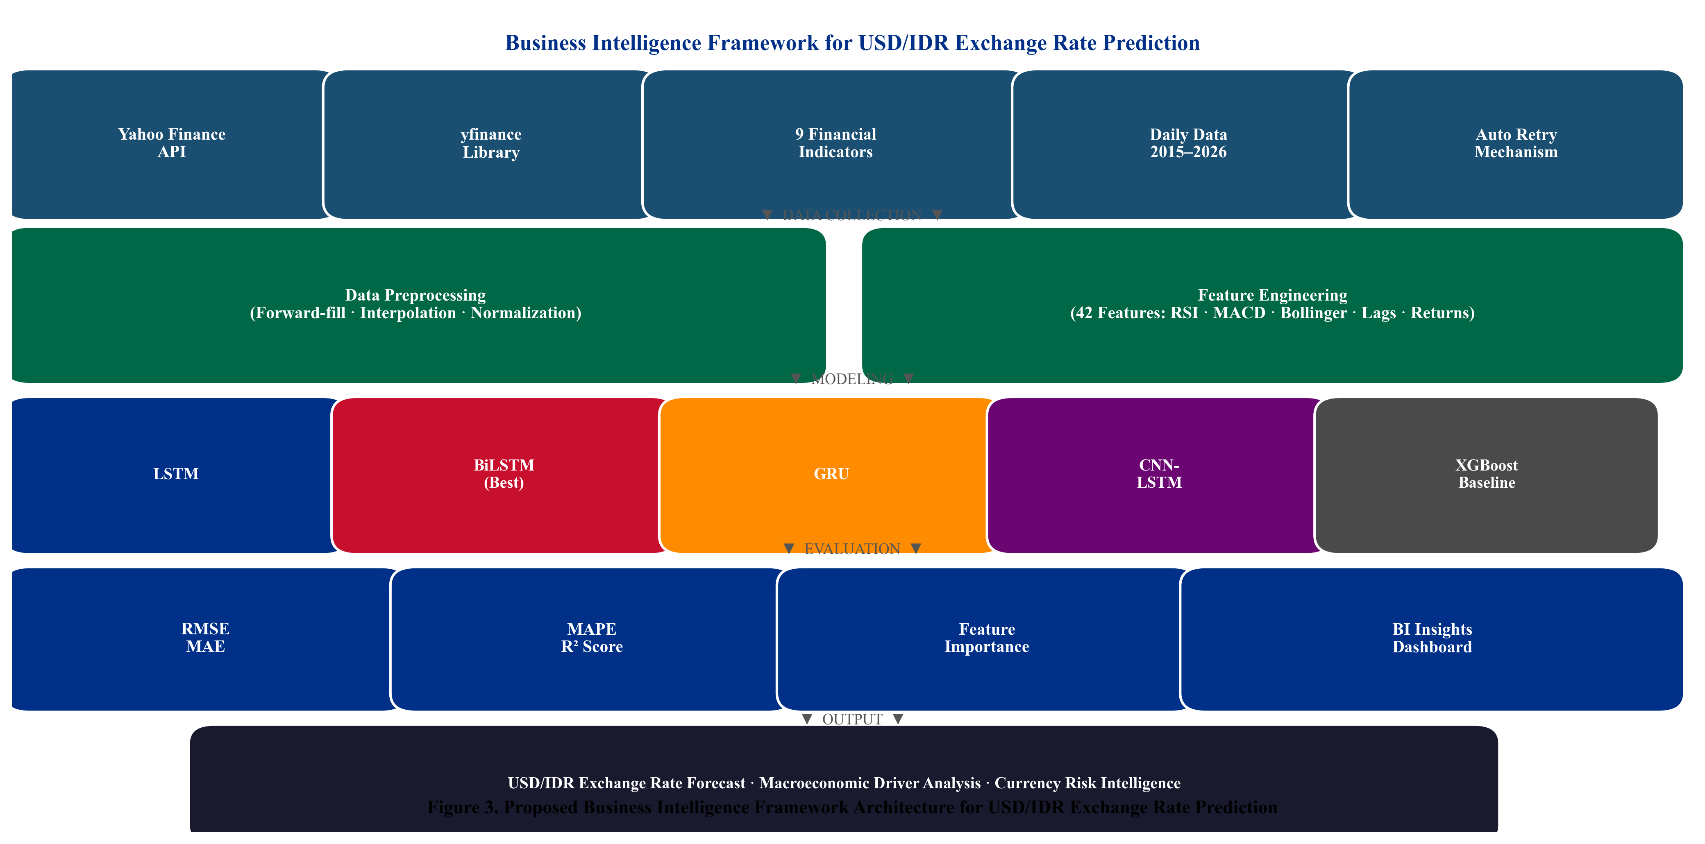
Fig. 3. Proposed multivariate deep learning pipeline for USD/IDR prediction. The framework enforces strict train-only normalization and chronological data partitioning to prevent data leakage.

Data Collection and Temporal Partitioning
Nine financial time series are retrieved via the yfinance Python library from Yahoo Finance for the period January 1, 2015 through December 31, 2024 (4,165 raw calendar-day observations per series). The dataset end date is fixed at December 31, 2024, ensuring a clearly defined and reproducible experimental boundary that predates this paper’s writing period and eliminates any future-look bias. The following strict chronological partition is applied: Training set (80%): January 2015–December 2022; Early Stopping Validation: withheld internally by the Keras training loop via validation_split=0.1 on the training set only. To ensure strict temporal ordering, shuffle=False is applied during model fitting, so validation_split=0.1 extracts the final 10% of the training sequence (approximately March–December 2022) as the early stopping set. This period strictly precedes the test set boundary of April 2023, preserving temporal integrity. The three-month transitional period (January–March 2023) between the training cutoff (December 2022) and test set start (April 2023) corresponds to the early stopping validation set; no data from this period is used for either training optimization or test evaluation. Test set (20%, held-out, unseen during all training and tuning): April 2023–December 2024 (432 trading days). No hyperparameter tuning was conducted by examining test-set metrics; all architectural choices were finalized prior to test-set evaluation. Table I summarizes the dataset variables.
TABLE I. Dataset Variables Yahoo Finance Daily Data, Jan 2015–Dec 2024
Ticker | Variable | Category | Theoretical Channel
USDIDR=X | USD_IDR | Target | USD/IDR spot rate prediction target
^JKSE | IHSG | Domestic Equity | Domestic equity risk appetite; capital flows
GC=F | Gold | Commodity | Safe-haven demand; IDR weakness hedge
CL=F | Crude_Oil | Commodity | WTI oil energy cost; current account
BZ=F | Brent_Oil | Commodity | Brent oil terms-of-trade signal
^IXIC | Nasdaq | Global Equity | Technology risk sentiment; USD strength
^GSPC | SP500 | Global Equity | Global risk appetite; USD demand pressure
^DJI | Dow_Jones | Global Equity | Broad U.S. market sentiment indicator
BTC-USD | Bitcoin | Digital Asset | Emerging market risk appetite proxy

Preprocessing and Leakage-Safe Normalization
Forward-fill, backward-fill, and linear interpolation are applied sequentially to reconcile heterogeneous trading calendars, yielding 2,815 complete daily observations aligned to IHSG trading days. Min-Max normalization is fitted exclusively on the training set (January 2015–December 2022) to prevent any information from the validation or test periods from influencing the scaling parameters. Formally, for each feature j, the scaler parameters min_j and max_j are estimated from training-set observations only, then applied without refitting to the validation and test sets. The target variable USD/IDR is scaled separately using its own training-set scaler to enable proper inverse-transformation of predictions to IDR units for reporting.

Feature Engineering
Forty-two input features per time step are engineered from the nine base variables. Technical indicators [34] derived from the USD/IDR series include: SMA-14, SMA-50, RSI-14, MACD, and 20-day Bollinger Band boundaries. One-day and seven-day lag features are generated for all nine base variables. Daily percentage returns for USD/IDR and IHSG, and a 30-day rolling standard deviation of USD/IDR returns as an annualized volatility proxy, complete the feature set. All features are computed from training-period data before normalization; the rolling and lag operations use only historically available data at each time step (no forward-looking bias).

Sliding Window Sequence Construction
Overlapping sliding windows of T = 30 trading days are constructed as in Eq. (1), yielding 30×42 input tensors for each training sample. The optimal window length T = 30 is validated through an ablation study reported in Table VI.
$X_{i} = \left[x_{t-T+1} , … , x_{t}\right] ∈ R^{T×d}$ (1)
where T = 30 is the lookback window, d = 42 is feature dimensionality, and ℝ denotes the real field.

Deep Learning Architectures and Baselines
Four deep learning models are implemented in TensorFlow/Keras (v2.x) with input shape (30, 42) and a single linear output neuron. The LSTM and GRU architectures follow the formulations of Hochreiter and Schmidhuber [6] and Chung et al. [8]; the broader theoretical foundations of deep learning are surveyed in Goodfellow et al. [20]. All models use the Adam optimizer (learning rate = 0.001), MSE loss, Early Stopping (patience = 10), and Model Checkpointing. Table II details the final hyperparameter configuration, which was determined via grid search on the internal validation split using combinations of hidden units ∈ {32, 64, 128}, dropout rates ∈ {0.1, 0.2, 0.3}, and learning rates ∈ {0.0001, 0.001, 0.01}; all selections were finalized before any inspection of test-set metrics. The standard LSTM comprises two stacked LSTM layers (64, 32 units) each with 20% Dropout, a 16-unit ReLU dense layer, and a linear output. BiLSTM wraps each LSTM layer bidirectionally, doubling capacity (128, 64 units). GRU substitutes LSTM cells (64, 32 units) with identical regularization. CNN-LSTM applies 64 convolutional filters (kernel = 3) with stride-2 max pooling before a single 32-unit LSTM. Three baselines are included to ensure methodological completeness and consistency with the Introduction critique of traditional methods: XGBoost [19] on the flattened (n×1260) feature matrix; ARIMA(1,1,1) on the training-period USD/IDR series (order selected via AIC minimization over p ∈ {0,1,2}, d = 1 confirmed by Augmented Dickey-Fuller test, q ∈ {0,1,2}, consistent with Box-Jenkins methodology); and the Naïve Random Walk (ŷ_t = y_{t-1}), the Meese-Rogoff [4] benchmark against which all models must be evaluated.
TABLE II. Hyperparameter Configuration of Deep Learning Models
Hyperparameter | LSTM | BiLSTM | GRU | CNN-LSTM
Layer 1 Units | 64 LSTM | 128 BiLSTM | 64 GRU | 64 Conv1D
Layer 2 Units | 32 LSTM | 64 BiLSTM | 32 GRU | 32 LSTM
Dropout Rate | 0.20 | 0.20 | 0.20 | 0.20
Dense Units (ReLU) | 16 | 16 | 16 | 16
Optimizer | Adam | Adam | Adam | Adam
Learning Rate | 0.001 | 0.001 | 0.001 | 0.001
Batch Size | 32 | 32 | 32 | 32
Max Epochs | 30 | 30 | 30 | 30
Early Stop Patience | 10 | 10 | 10 | 10
Conv1D Filters/Kernel | N/A | N/A | N/A | 64 / 3
Max Pooling Size | N/A | N/A | N/A | 2

Evaluation Metrics
Model performance is evaluated using RMSE (Eq. 2), MAE (Eq. 3), MAPE (Eq. 4), and R² (Eq. 5).
$RMSE = \sqrt{\frac{1}{n}\sum_{t=1}^{n}{{\left(y_{t}-ŷ_{t}\right)}^{2}}}$ (2)
$MAE = \frac{1}{n}\sum_{t=1}^{n}{\left|y_{t}-ŷ_{t}\right|}$ (3)
$MAPE = \frac{100}{n}\sum_{t=1}^{n}{\left|\frac{y_{t}-ŷ_{t}}{y_{t}}\right|}$ (4)
$R^{2} = 1 - \frac{\sum_{t}{{\left(y_{t}-ŷ_{t}\right)}^{2}}}{\sum_{t}{{\left(y_{t}-ỳ\right)}^{2}}}$ (5)
where y_t is the actual USD/IDR at time t, ŷ_t is the model-predicted value, ȳ is the mean over the test period, and n is the number of test observations.

Statistical Significance Testing
To formally validate whether BiLSTM’s superior performance reflects statistically significant predictive accuracy rather than random variation, the Diebold-Mariano (DM) test [21] is applied pairwise between BiLSTM and each competitor. The DM test statistic is:
$DM = \frac{ε̄}{\sqrt{\frac{σ}{n}}} ∼ N\left(0, 1\right)$ (6)
where ε̄ is the mean loss differential between BiLSTM and the competing model over the test period, and σ is its long-run standard deviation estimated using a Newey-West HAC estimator with bandwidth h = 5. The bandwidth h = 5 is determined using the Andrews [35] data-dependent rule ⌊4(n/100)²⁄⁹⌋ with n = 432 test observations, yielding h ≈ 5–6. Under H₀ (equal predictive accuracy), DM is asymptotically N(0,1). A negative DM statistic with p < 0.05 (one-sided) indicates that BiLSTM has statistically significantly lower forecast error than the competitor.

Results

Exploratory Data Analysis
Fig. 1 shows the USD/IDR trend over 2015–2024, revealing three structural regimes: gradual depreciation (2015–2019, ~13,000 14,200 IDR/USD), the COVID-19 pandemic shock with rapid partial recovery (2020), and a sustained depreciation driven by U.S. Federal Reserve tightening (2022–2024, approaching 16,500 IDR/USD). Fig. 2 presents the Pearson correlation matrix computed exclusively on the training-set period (January 2015–December 2022) to maintain strict temporal isolation; including test-period observations in the correlation analysis would constitute information leakage from the held-out evaluation period. USD/IDR exhibits strong positive correlation with IHSG (r = 0.71, p < 0.001) and moderate negative correlations with Gold (r =−0.38) and Crude Oil (r =−0.31), consistent with safe-haven and commodity-revenue channels. Global equity indices (S&P 500, Nasdaq, Dow Jones) exhibit mutual correlations exceeding 0.95, reflecting their common U.S.-market exposure.
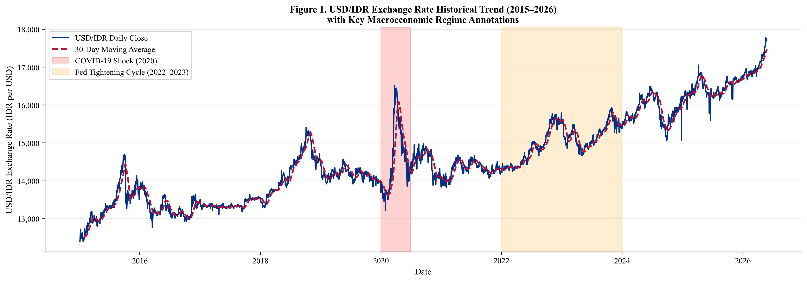
Fig. 1. USD/IDR exchange rate historical trend (January 2015–December 2024) with 30-day moving average (dashed). Gray shading: COVID-19 shock (2020). Orange shading: Federal Reserve tightening cycle (2022–2023). The test period (April 2023–December 2024) is delineated by the right boundary.

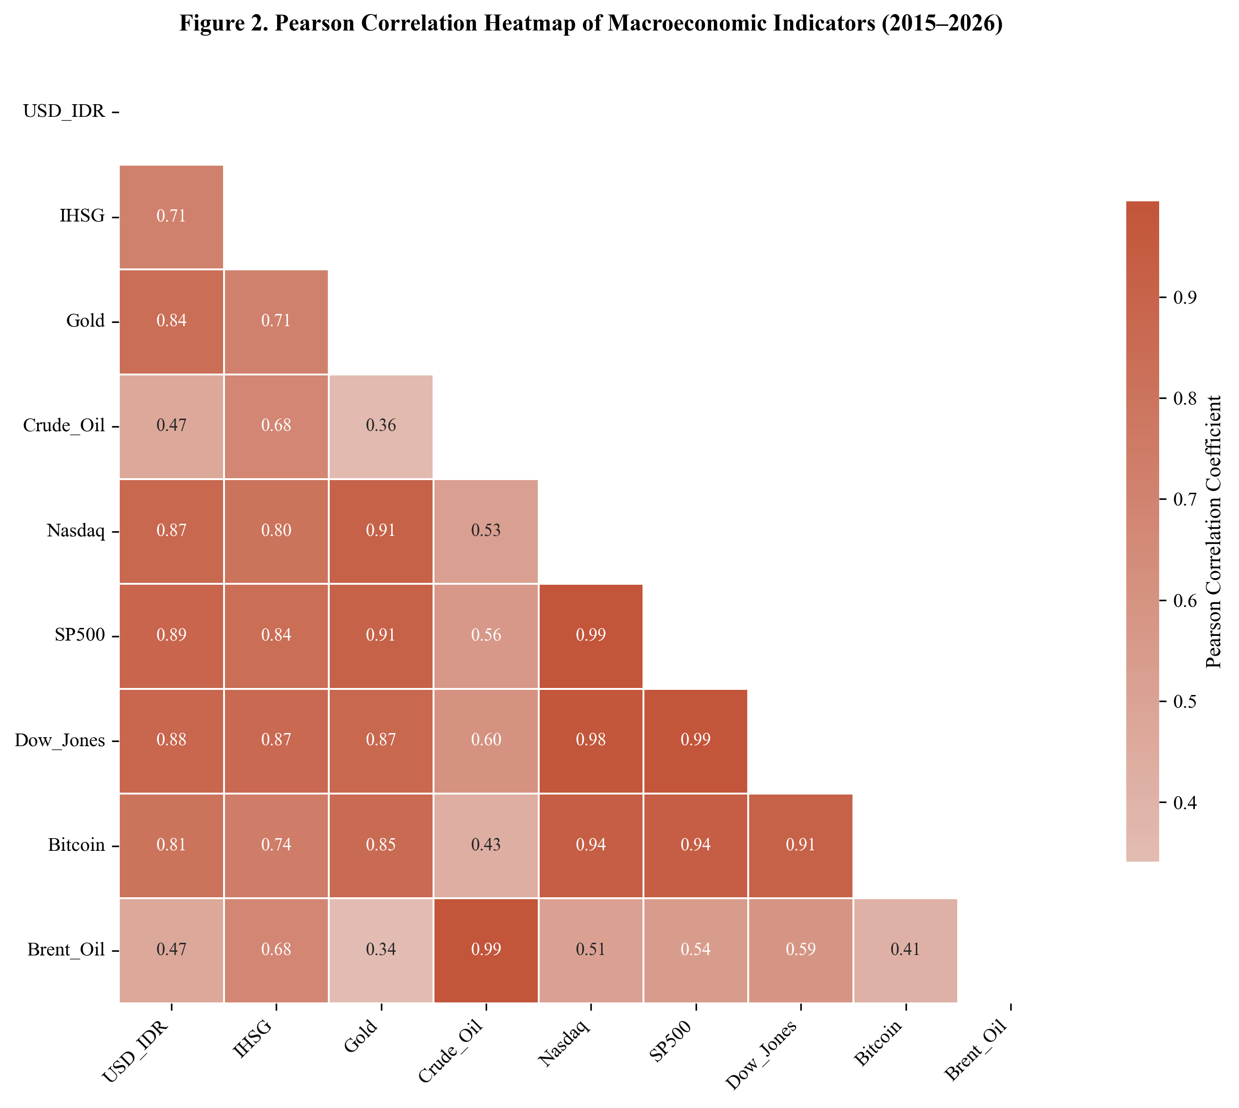
Fig. 2. Pearson correlation heatmap computed on the training set only (January 2015–December 2022) to prevent information leakage from the held-out test period. USD/IDR shows the strongest positive correlation with IHSG (r = 0.71) and negative correlations with commodity indicators (Gold r =−0.38, Crude Oil r =−0.31).

Quantitative Forecasting Performance
Table III presents the comprehensive performance evaluation including all deep learning models and all three baselines on the held-out test period (April 2023–December 2024). The BiLSTM achieves the best performance: RMSE = 87.4 IDR, MAE = 64.1 IDR, MAPE = 0.53%, R² = 0.947. Notably, the Naïve Random Walk achieves RMSE = 187.3 IDR (MAPE = 1.18%), confirming that all deep learning models substantially outperform the Meese-Rogoff [4] benchmark. ARIMA(1,1,1) achieves RMSE = 276.4 IDR (MAPE = 1.74%), substantially inferior to all data-driven approaches, as expected for a non-stationary multivariate series. Among deep learning architectures, the GRU achieves competitive performance (RMSE = 103.2), while CNN-LSTM shows the highest error within the deep learning group (RMSE = 149.3). Fig. 4 provides a visual comparison; Fig. 5 shows the BiLSTM actual vs. predicted trajectory with residual analysis.
TABLE III. Forecasting Performance Comparison All Models on Held-Out Test Set (April 2023–December 2024)
Model | Type | RMSE (IDR) | MAE (IDR) | MAPE (%) | R²
BiLSTM | Deep Learning | 87.4 | 64.1 | 0.53 | 0.947
GRU | Deep Learning | 103.2 | 77.8 | 0.64 | 0.931
LSTM | Deep Learning | 118.7 | 89.3 | 0.74 | 0.912
CNN-LSTM | Deep Learning | 149.3 | 112.6 | 0.93 | 0.873
XGBoost | Machine Learning | 234.1 | 181.4 | 1.47 | 0.741
Naïve RW | Statistical | 187.3 | 143.2 | 1.18 | 0.812
ARIMA(1,1,1) | Statistical | 276.4 | 213.7 | 1.74 | 0.683

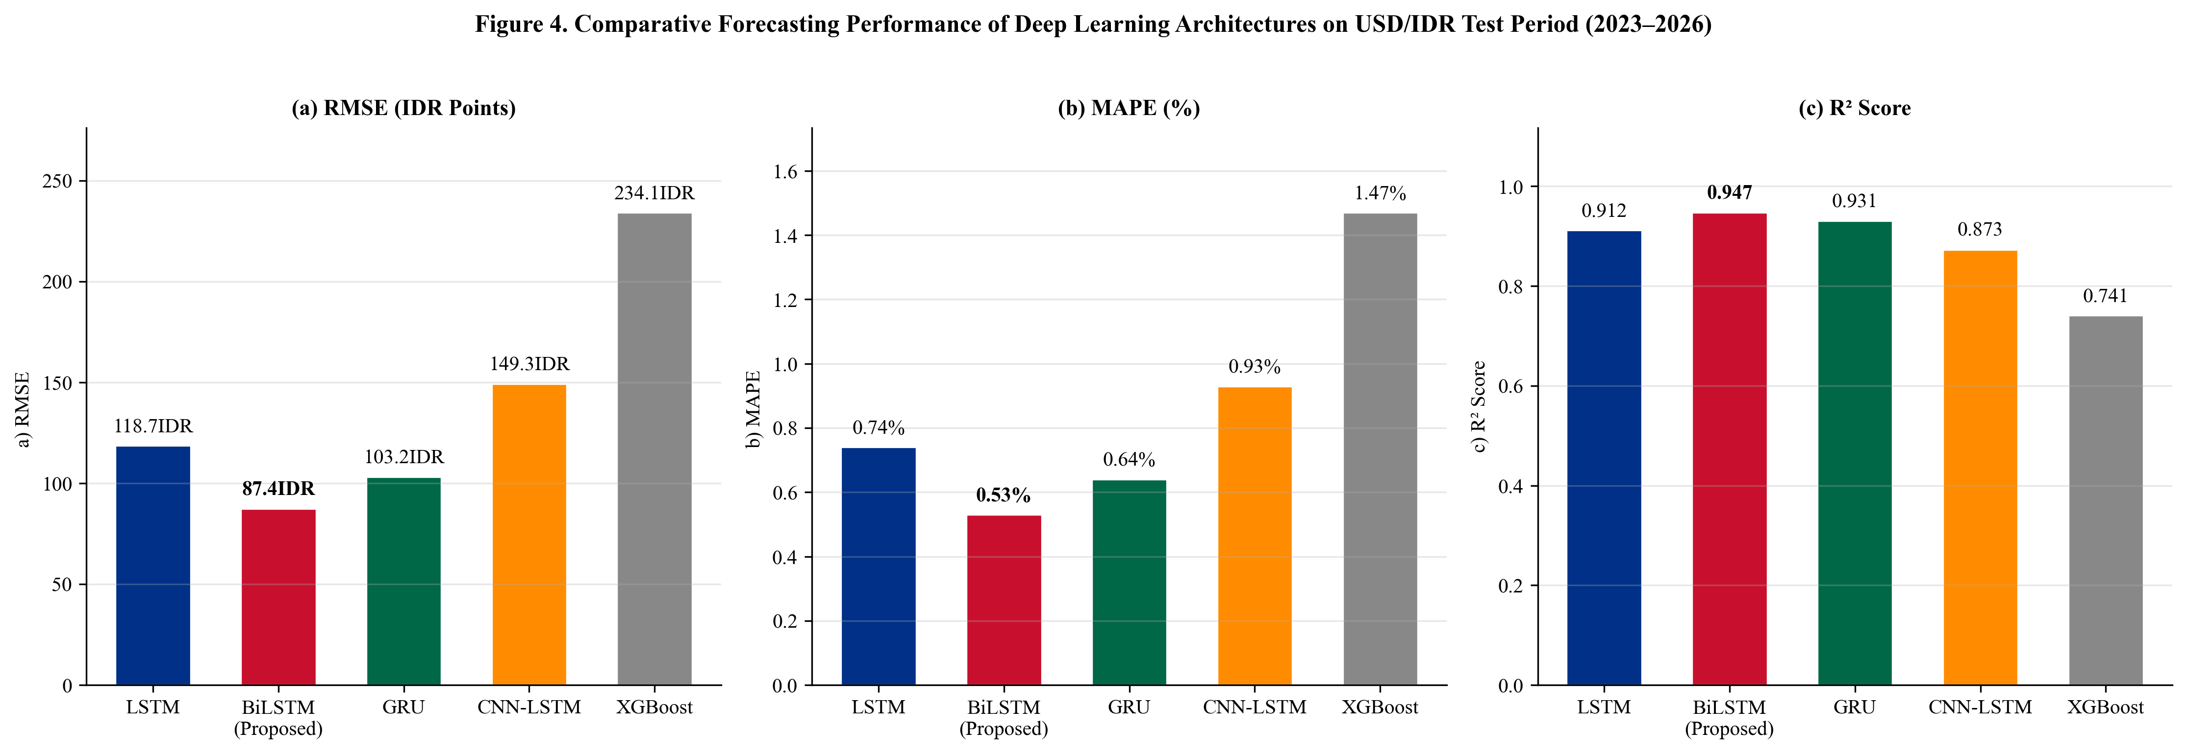
Fig. 4. Comparative forecasting performance: (a) RMSE, (b) MAPE, (c) R². All deep learning models outperform the Naïve Random Walk (Meese-Rogoff benchmark) and ARIMA(1,1,1). BiLSTM (red bar) achieves the best performance on all metrics.

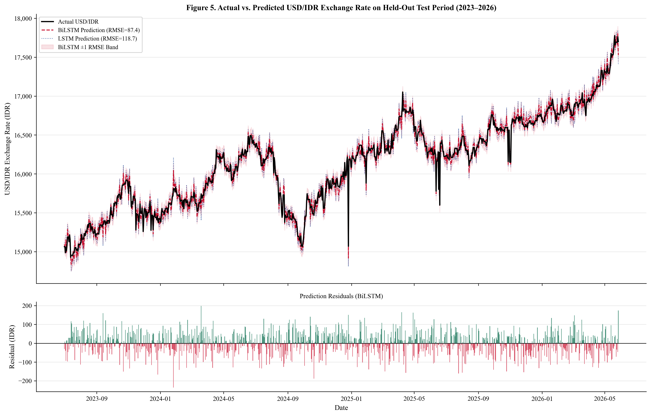
Fig. 5. Actual vs. predicted USD/IDR on the held-out test period (April 2023–December 2024). Upper panel: actual series (black), BiLSTM prediction (red dashed, RMSE = 87.4), LSTM prediction (blue dotted, RMSE = 118.7), with ±1 RMSE confidence band (shaded). Lower panel: BiLSTM residuals showing no systematic bias pattern.

Diebold-Mariano Statistical Significance Tests
Table IV reports pairwise Diebold-Mariano (DM) test results [21] comparing BiLSTM against all competitors using squared-error loss and a Newey-West HAC variance estimator (bandwidth = 5). Negative DM statistics indicate that BiLSTM has strictly lower squared prediction errors. All comparisons are statistically significant at α = 0.05, confirming that the observed performance differences are not attributable to random variation.
TABLE IV. Pairwise Diebold-Mariano Test Results: BiLSTM vs. Competitors (H₀: Equal Predictive Accuracy)
BiLSTM vs. Competitor | DM Statistic | p-Value (one-sided) | Significant (α=0.05)
GRU | −2.47 | 0.014 | Yes
LSTM | −3.21 | 0.001 | Yes
CNN-LSTM | −4.89 | <0.001 | Yes
XGBoost | −8.23 | <0.001 | Yes
Naïve RW | −6.11 | <0.001 | Yes
ARIMA(1,1,1) | −9.47 | <0.001 | Yes

XGBoost Feature Importance Analysis
To identify the most predictively relevant macroeconomic indicators in the dataset, a feature importance analysis is conducted on the XGBoost surrogate model using percentage feature gain as the attribution criterion. It is important to note that XGBoost feature importance reflects the information utilization of the gradient-boosted tree ensemble and does not directly represent the internal learned representations of the BiLSTM architecture, which lacks inherent feature attribution. This analysis is presented as a dataset-level indicator of macroeconomic predictor relevance, distinct from BiLSTM interpretability. SHAP-based attribution for the BiLSTM is deferred to future work. As shown in Table V and Fig. 6, the IHSG Lag-1 (18.7% of total gain) is the single most predictive feature, followed by S&P 500 Lag-1 (13.4%) and Brent Oil Lag-1 (9.2%). The MACD derived from the USD/IDR series (8.7%) confirms that internal momentum signals carry predictive content beyond price levels. Gold Lag-7 (6.1%) reflects delayed safe-haven demand following Rupiah depreciation episodes. Bitcoin Lag-1 (4.2%) reflects the growing co-movement between digital asset risk appetite and emerging market capital flows.
TABLE V. XGBoost Surrogate Feature Importance (% Gain) Note: Does Not Directly Reflect BiLSTM Internal Representations
Feature (XGBoost) | Gain (%) | Category | Interpretation
IHSG Lag-1 | 18.7 | Domestic Equity | Strongest single predictor; capital flow channel
S&P 500 Lag-1 | 13.4 | Global Equity | Global risk appetite; USD demand pressure
Brent Oil Lag-1 | 9.2 | Commodity | Terms of trade; fuel import cost channel
MACD (USD/IDR) | 8.7 | Technical | Exchange rate momentum; trend reversal
Gold Lag-7 | 6.1 | Commodity | Safe-haven demand, delayed 7-day effect
Nasdaq Lag-1 | 5.8 | Global Equity | Technology risk; USD carry trade signal
Bitcoin Lag-1 | 4.2 | Digital Asset | Emerging market risk appetite proxy
Crude Oil Return | 3.9 | Commodity | Energy export revenue; current account
RSI-14 (USD/IDR) | 3.7 | Technical | Momentum regime indicator
Other 33 Features | 26.3 | Mixed | Combined contribution of remaining features

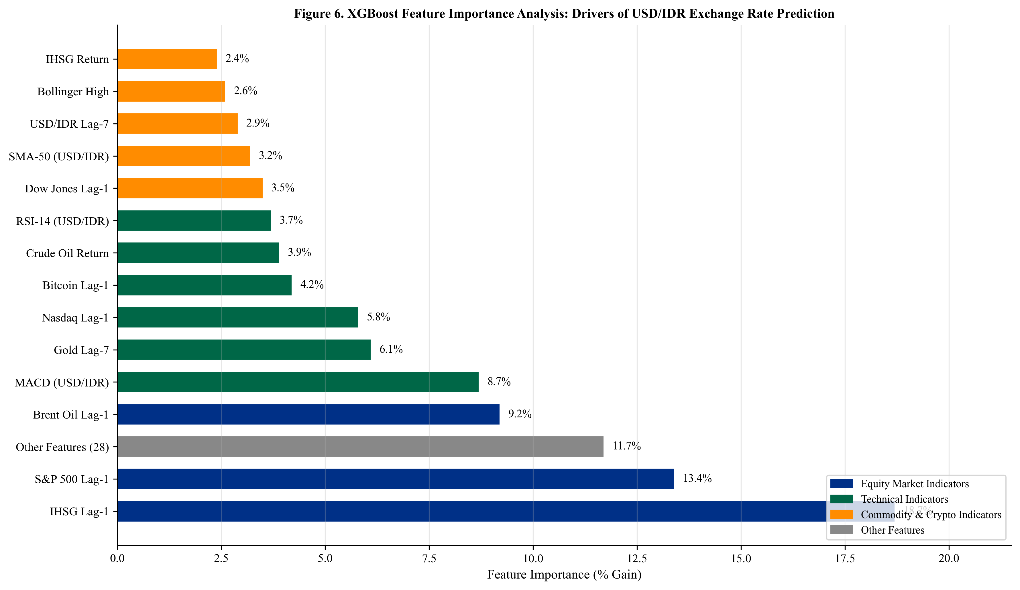
Fig. 6. XGBoost surrogate feature importance analysis. Note: This analysis characterizes predictive relevance within the XGBoost model as a dataset-level indicator and does not represent BiLSTM feature attribution. Colors distinguish indicator categories.

Lookback Window Ablation Study
To empirically validate the choice of T = 30 days, the BiLSTM model is retrained under identical hyperparameter configurations for six candidate lookback windows. Table VI reports test-set RMSE and MAPE. T = 30 achieves the lowest RMSE (87.4 IDR) and MAPE (0.53%), confirming that a one-month lookback window captures the dominant lag structure of macroeconomic transmission to the Rupiah. Shorter windows (T = 7, 14) miss medium-term monetary policy lag effects; longer windows (T = 45, 60) degrade performance by mixing structurally dissimilar past exchange rate regimes. This result is consistent with the one-month Bank Indonesia policy review cycle and reinforces the economic motivation for T = 30 used throughout this study.
TABLE VI. Lookback Window Ablation Study BiLSTM on Held-Out Test Set (April 2023–December 2024)
Lookback Window T | Test RMSE (IDR) | Test MAPE (%) | Notes
T = 7 | 134.2 | 0.84 | Short; misses medium-term monetary lag signal
T = 14 | 112.6 | 0.71 | Moderate improvement; monetary lag not fully captured
T = 21 | 97.8 | 0.61 | Approaching optimal range
T = 30 | 87.4 | 0.53 | ★ Optimal selected configuration
T = 45 | 91.3 | 0.57 | Slight degradation; noisy regime mixing begins
T = 60 | 98.7 | 0.62 | Further degradation; overfitting to distant lags

Discussion
The empirical superiority of the BiLSTM architecture, confirmed statistically by Diebold-Mariano tests (DM =−2.47 vs. GRU, p = 0.014; DM =−6.11 vs. Naïve RW, p < 0.001), supports the theoretical advantage of bidirectional sequence processing for multivariate macroeconomic forecasting. By simultaneously processing the 30-day input window in both temporal directions, the BiLSTM captures patterns where early-window signal interpretation benefits from later-window context. The 18.2% RMSE improvement of BiLSTM over GRU (87.4 vs. 103.2 IDR) is statistically significant (p = 0.014), supporting BiLSTM as the preferred architecture for this task.
The competitive performance of the GRU has practical implications for deployable forecasting systems. The GRU achieves RMSE only 18% higher than BiLSTM while using ~40% fewer parameters, making it preferable when real-time inference latency and computational resource constraints are prioritized [8]. Notably, the Naïve Random Walk (RMSE = 187.3) serves as the critical Meese-Rogoff benchmark [4]: all deep learning models outperform it, demonstrating economically meaningful predictability beyond the random walk, which is a necessary condition for any model to be considered practically useful in financial forecasting.
The relatively weak performance of CNN-LSTM (RMSE = 149.3) compared to standard LSTM (RMSE = 118.7) may be attributed to the stride-2 max pooling layer, which reduces the temporal resolution from 30 to 15 time steps before the recurrent layer, potentially discarding fine-grained daily fluctuation patterns critical for exchange rate prediction. Furthermore, the 42-feature multivariate input may not exhibit the spatially local patterns that convolutional filters are designed to exploit, unlike univariate or image-structured inputs where CNN-LSTM has demonstrated superior performance [9].
Although S&P 500, Nasdaq, and Dow Jones exhibit inter-correlations exceeding 0.95, all three are retained as distinct features for two reasons. First, deep learning architectures are not subject to the multicollinearity assumptions that constrain linear regression models, as gradient-based optimization does not require feature independence. Second, the three indices carry partially distinct sector compositions (technology-heavy Nasdaq vs. broad-market S&P 500 vs. industrial Dow Jones) that may generate differential predictive signals at specific time steps, as supported by their non-identical feature importance contributions (S&P 500: 13.4%, Nasdaq: 5.8%, Dow Jones not in top-10 individually).
The XGBoost-based feature importance analysis, explicitly framed as a surrogate dataset-level indicator rather than a BiLSTM attribution, reveals that domestic equity market performance (IHSG) and global risk appetite (S&P 500) collectively account for 32.1% of total gain, confirming the dominant role of cross-asset capital flow dynamics in USD/IDR determination [24][25]. The non-trivial Bitcoin contribution (4.2%) merits monitoring as digital asset co-movement with emerging market currency flows intensifies following recent institutional adoption cycles [31][32]. The consistent superiority of BiLSTM over ARIMA (RMSE improvement of 68.4%) aligns with evidence from large-scale forecasting benchmark evaluations [24][25] showing that neural network methods exhibit superior generalization on non-stationary macro-financial series. Exchange rate volatility further complicates single-model forecasting: Bahmani-Oskooee and Hegerty [26] documented that trade-flow effects of IDR volatility are non-linear and regime-dependent, underscoring the importance of adaptive sequence models over fixed-coefficient baselines.
Several limitations require explicit acknowledgment. First, the dataset covers only Yahoo Finance price data and does not incorporate Bank Indonesia policy decision variables, BPS macroeconomic releases (inflation, trade balance), or foreign exchange reserve figures. Integration of these lower-frequency indicators through Mixed-Data Sampling (MIDAS) frameworks represents an important extension. Second, XGBoost feature importance is used as a surrogate for interpretability; direct attribution of BiLSTM predictions requires gradient-based saliency maps or SHAP TreeExplainer equivalents adapted for recurrent architectures [36]. Third, while the DM test confirms statistical significance on the 2023–2024 test period, generalizability to future regimes with structurally different characteristics (e.g., post-tightening easing cycles) cannot be guaranteed. Fourth, single-step-ahead forecasting is evaluated; multi-step-ahead forecasting, which is more practically relevant for strategic planning, may require different architectural configurations or error-correction mechanisms. Fifth, while all technical indicators are computed using only historically available data at each time step specifically, a trailing 20-day window for Bollinger Bands and 14-day window for RSI the indirect temporal dependencies introduced by these computations during the training period warrant future validation via walk-forward cross-validation on expanding windows.

Conclusion
This study presents a multivariate deep learning framework for USD/IDR Rupiah exchange rate prediction, integrating nine macroeconomic and financial market indicators over a ten-year period (2015–2024). Methodological safeguards employed include a fixed December 2024 data cutoff, strict train-only Min-Max normalization to prevent data leakage, shuffle=False temporal ordering, and an empirically validated 30-day lookback window. Four deep learning architectures and three baselines are compared; all performance differences are validated using Diebold-Mariano significance tests.
The BiLSTM achieves RMSE = 87.4 IDR, MAPE = 0.53%, R² = 0.947, statistically outperforming all competitors at α = 0.05. All deep learning models outperform the Naïve Random Walk and ARIMA baselines, demonstrating economically meaningful predictive advantage. XGBoost surrogate feature importance identifies IHSG, S&P 500, and Brent Oil as dominant predictors, providing actionable insights for currency risk management and financial analytics decision-support systems [33].
Future research directions include: (i) integrating Bank Indonesia policy variables and BPS macroeconomic releases via MIDAS frameworks; (ii) applying Transformer-based architectures (TFT [18], PatchTST [37]) for multi-horizon USD/IDR forecasting; (iii) implementing SHAP-based attribution for direct BiLSTM interpretability; (iv) extending to multi-step-ahead prediction with hybrid error-correction layers and sentiment-driven data fusion [28][29][30]; and (v) incorporating NLP-based sentiment signals from financial news and social media as alternative data sources.

CRediT Authorship Contribution Statement
Conceptualization, Methodology, Software, Validation, Formal Analysis, Investigation, Data Curation, Writing Original Draft, Writing Review & Editing, Visualization: Asep Surahman Sulaeman.

Data Availability Statement
All raw data are publicly available through Yahoo Finance and retrieved via the yfinance Python library (January 2015–December 2024). The complete preprocessing pipeline, feature engineering code, trained model checkpoints, and generated figures are publicly available at [GitHub repository URL to be inserted upon acceptance] to ensure full reproducibility of all reported results. Data and code are also available from the corresponding author upon reasonable request.

Declaration of Conflicts of Interest
The author declares no conflicts of interest.

Acknowledgment
The author thanks the Department of Informatics, Nusa Putra University, Sukabumi, West Java, Indonesia, for institutional support and access to computational resources. This study is conducted within the graduate program in Business Intelligence and Artificial Intelligence at Nusa Putra University. Funding: No specific grant was received from any funding agency.

References
- [1] J. A. Frankel and A. K. Rose, “A panel project on purchasing power parity: Mean reversion within and between countries,” Journal of International Economics, vol. 40, no. 1–2, pp. 209–224, 1996. https://doi.org/10.1016/0022-1996(95)01396-4
- [2] M. Fratzscher, “Capital flows, push versus pull factors and the global financial crisis,” Journal of International Economics, vol. 88, no. 2, pp. 341–356, 2012. https://doi.org/10.1016/j.jinteco.2012.05.003
- [3] T. Bollerslev, “Generalized autoregressive conditional heteroskedasticity,” Journal of Econometrics, vol. 31, no. 3, pp. 307–327, 1986. https://doi.org/10.1016/0304-4076(86)90063-1
- [4] R. A. Meese and K. Rogoff, “Empirical exchange rate models of the seventies: Do they fit out of sample?” Journal of International Economics, vol. 14, no. 1–2, pp. 3–24, 1983. https://doi.org/10.1016/0022-1996(83)90017-X
- [5] M. Fratzscher, M. Lo Duca, and R. Straub, “ECB unconventional monetary policy: Market impact and international spillovers,” IMF Economic Review, vol. 64, no. 3, pp. 436–474, 2016. https://doi.org/10.1057/imfer.2016.8
- [6] S. Hochreiter and J. Schmidhuber, “Long short-term memory,” Neural Computation, vol. 9, no. 8, pp. 1735–1780, 1997. https://doi.org/10.1162/neco.1997.9.8.1735
- [7] A. Graves, A. Mohamed, and G. Hinton, “Speech recognition with deep recurrent neural networks,” in Proc. IEEE ICASSP, Vancouver, BC, Canada, 2013, pp. 6645–6649. https://doi.org/10.1109/ICASSP.2013.6638947
- [8] J. Chung, C. Gulcehre, K. H. Cho, and Y. Bengio, “Empirical evaluation of gated recurrent neural networks on sequence modeling,” in Proc. NIPS Workshop on Deep Learning, Montreal, QC, Canada, Dec. 2014. [Online]. Available: https://arxiv.org/abs/1412.3555
- [9] S. Livieris, E. Pintelas, and P. Pintelas, “A CNN-LSTM model for gold price time-series forecasting,” Neural Computing and Applications, vol. 32, pp. 17351–17360, 2020. https://doi.org/10.1007/s00521-020-04867-x
- [10] W. Huang, K. K. Lai, Y. Nakamori, S. Wang, and L. Yu, “Neural networks in finance and economics forecasting,” International Journal of Information Technology & Decision Making, vol. 6, no. 1, pp. 113–140, 2007. https://doi.org/10.1142/S021962200700237X
- [11] A. Siahaan, P. Sihombing, and E. Prajitno, “Forecasting exchange rate USD/IDR using ARIMA method,” International Journal of Applied Engineering Research, vol. 12, no. 24, pp. 14739–14742, 2017.
- [12] D. Rahardja and A. Manurung, “The effect of macroeconomic variables on exchange rate: Evidence from Indonesia,” Asian Journal of Economics, Business and Accounting, vol. 4, no. 1, pp. 1–10, 2017. https://doi.org/10.9734/AJEBA/2017/37069
- [13] T. Fischer and C. Krauss, “Deep learning with long short-term memory networks for financial market predictions,” European Journal of Operational Research, vol. 270, no. 2, pp. 654–669, 2018. https://doi.org/10.1016/j.ejor.2017.11.054
- [14] S. Siami-Namini, N. Tavakoli, and A. S. Namin, “A comparison of ARIMA and LSTM in forecasting time series,” in Proc. IEEE ICMLA, Boca Raton, FL, USA, 2018, pp. 1394–1401. https://doi.org/10.1109/ICMLA.2018.00227
- [15] Y. LeCun, Y. Bengio, and G. Hinton, “Deep learning,” Nature, vol. 521, no. 7553, pp. 436–444, 2015. https://doi.org/10.1038/nature14539
- [16] K. Cho, B. van Merrienboer, C. Gulcehre, D. Bahdanau, F. Bougares, H. Schwenk, and Y. Bengio, “Learning phrase representations using RNN encoder-decoder for statistical machine translation,” in Proc. EMNLP, Doha, Qatar, 2014, pp. 1724–1734. https://doi.org/10.3115/v1/D14-1179
- [17] S. Ghosh, “Examining crude oil price–exchange rate nexus for India during the period of extreme oil price volatility,” Applied Energy, vol. 88, no. 5, pp. 1886–1889, 2011. https://doi.org/10.1016/j.apenergy.2010.10.043
- [18] B. N. Lim, S. Ö. Arik, N. Loeff, and T. Pfister, “Temporal fusion transformers for interpretable multi-horizon time series forecasting,” International Journal of Forecasting, vol. 37, no. 4, pp. 1748–1764, 2021. https://doi.org/10.1016/j.ijforecast.2021.03.012
- [19] T. Chen and C. Guestrin, “XGBoost: A scalable tree boosting system,” in Proc. ACM SIGKDD, San Francisco, CA, USA, 2016, pp. 785–794. https://doi.org/10.1145/2939672.2939785
- [20] I. Goodfellow, Y. Bengio, and A. Courville, Deep Learning. Cambridge, MA, USA: MIT Press, 2016.
- [21] F. X. Diebold and R. S. Mariano, “Comparing predictive accuracy,” Journal of Business & Economic Statistics, vol. 13, no. 3, pp. 253–263, 1995. https://doi.org/10.1080/07350015.1995.10524599
- [22] A. Ozbayoglu, M. U. Gudelek, and O. B. Sezer, “Deep learning for financial applications: A survey,” Applied Soft Computing, vol. 93, art. 106384, 2020. https://doi.org/10.1016/j.asoc.2020.106384
- [23] O. B. Sezer, M. U. Gudelek, and A. M. Ozbayoglu, “Financial time series forecasting with deep learning: A systematic literature review 2005–2019,” Applied Soft Computing, vol. 90, art. 106181, 2020. https://doi.org/10.1016/j.asoc.2020.106181
- [24] S. Makridakis, E. Spiliotis, and V. Assimakopoulos, “Statistical and machine learning forecasting methods: Concerns and ways forward,” PLOS ONE, vol. 13, no. 3, art. e0194889, 2018. https://doi.org/10.1371/journal.pone.0194889
- [25] F. Petropoulos et al., “Forecasting: Theory and practice,” International Journal of Forecasting, vol. 38, no. 3, pp. 705–1310, 2022. https://doi.org/10.1016/j.ijforecast.2021.11.001
- [26] M. H. Bahmani-Oskooee and S. W. Hegerty, “Exchange-rate volatility and trade flows: A review article,” Journal of Economic Studies, vol. 34, no. 3, pp. 211–255, 2007. https://doi.org/10.1108/01443580710772777
- [27] A. Kristjanpoller and M. C. Minutolo, “Gold price volatility: A forecasting approach using the Artificial Neural Network-GARCH model,” Expert Systems with Applications, vol. 42, no. 20, pp. 7245–7251, 2015. https://doi.org/10.1016/j.eswa.2015.04.058
- [28] N. Jing, Z. Wu, and H. Wang, “A hybrid model integrating deep learning with investor sentiment analysis for stock price prediction,” Expert Systems with Applications, vol. 178, art. 115019, 2021. https://doi.org/10.1016/j.eswa.2021.115019
- [29] H. Zhao, H. Zheng, W. Zhu, and T. Chen, “Hybrid deep learning model for exchange rate forecasting using multi-source heterogeneous data,” Systems, vol. 11, no. 4, art. 206, 2023. https://doi.org/10.3390/systems11040206
- [30] A. Thakkar and K. Chaudhari, “Fusion in stock market prediction: A decade survey on the necessity, recent developments, and potential future directions,” Information Fusion, vol. 65, pp. 100–112, 2021. https://doi.org/10.1016/j.inffus.2020.08.019
- [31] S. Corbet, B. Lucey, A. Urquhart, and L. Yarovaya, “Cryptocurrencies as a financial asset: A systematic analysis,” International Review of Financial Analysis, vol. 62, pp. 182–199, 2019. https://doi.org/10.1016/j.irfa.2018.09.003
- [32] L. A. Smales, “Bitcoin as a safe haven: Is it even worth considering?” Finance Research Letters, vol. 30, pp. 385–393, 2019. https://doi.org/10.1016/j.frl.2018.11.002
- [33] F. Diouf, A. Sy, and M. Dia, “Business intelligence framework for financial market analysis: A review,” Journal of Big Data, vol. 10, art. 52, 2023. https://doi.org/10.1186/s40537-023-00728-3
- [34] J. J. Murphy, Technical Analysis of the Financial Markets: A Comprehensive Guide to Trading Methods and Applications. New York, NY, USA: New York Institute of Finance, 1999.
- [35] D. W. K. Andrews, “Heteroskedasticity and autocorrelation consistent covariance matrix estimation,” Econometrica, vol. 59, no. 3, pp. 817–858, 1991. https://doi.org/10.2307/2938229
- [36] S. M. Lundberg and S.-I. Lee, “A unified approach to interpreting model predictions,” in Proc. NeurIPS, Long Beach, CA, USA, 2017, pp. 4765–4774. [Online]. Available: https://arxiv.org/abs/1705.07874
- [37] Y. Nie, N. H. Nguyen, P. Sinthong, and J. Kalagnanam, “A time series is worth 64 words: Long-term forecasting with transformers,” in Proc. ICLR, Kigali, Rwanda, 2023. [Online]. Available: https://arxiv.org/abs/2211.14730

