Multivariate Deep Learning Framework for Indonesian Rupiah Exchange Rate Prediction: A Comparative Study with Statistical Significance Testing
Asep Surahman
Department of Informatics, Nusa Putra University, Sukabumi, West Java (Indonesia) — asep.surahman@nusaputra.ac.id

Abstract—The USD/IDR exchange rate is a critical macroeconomic indicator for Indonesia’s emerging market economy. However, accurately forecasting its dynamics remains a formidable challenge due to non-linear volatility, complex macroeconomic interactions, and susceptibility to global financial shocks. Traditional econometric models often fail to capture these intricate, high-frequency dependencies, highlighting the need for more advanced predictive approaches. To address this problem, this study proposes a multivariate deep learning pipeline integrating nine financial and macroeconomic indicators — including the Jakarta Composite Index (IHSG), crude oil, gold, Brent oil, Nasdaq, S&P 500, Dow Jones, and Bitcoin — to predict the daily USD/IDR rate over 2015–2024. A 42-feature engineering suite is constructed with strict train-only normalization to prevent data leakage. Four architectures — LSTM, BiLSTM, GRU, and CNN-LSTM — are benchmarked against XGBoost, ARIMA(1,1,1), and the Naïve Random Walk. BiLSTM achieves the best test-set performance (RMSE = 87.4 IDR, MAPE = 0.53%, R² = 0.947), statistically outperforming all baselines via Diebold-Mariano tests (p < 0.05). XGBoost surrogate feature importance identifies IHSG, S&P 500, and Brent Oil as dominant predictors. An ablation study validates the 30-day lookback window as optimal. These findings provide a reproducible, statistically validated framework for emerging market currency forecasting.
Keywords—Bidirectional LSTM; Deep Learning; Emerging Market; Exchange Rate Forecasting; Feature Engineering; Indonesian Rupiah; Multivariate Time Series.

Introduction
The exchange rate of the Indonesian Rupiah (IDR) against the United States Dollar (USD) operates under a managed float regime in which Bank Indonesia intervenes to moderate excessive volatility, making its dynamics particularly complex and multi-determined [1]. The USD/IDR rate encapsulates collective investor expectations regarding Indonesia’s inflation trajectory, current account balance, commodity export revenues, and monetary policy credibility. Episodes of Rupiah depreciation have historically triggered imported inflation, capital outflows from the Indonesia Stock Exchange (IDX), and balance-sheet pressures on firms holding foreign-currency-denominated debt [2].
Traditional econometric frameworks—including Autoregressive Integrated Moving Average (ARIMA) models, Generalized Autoregressive Conditional Heteroscedasticity (GARCH) [3], and Vector Autoregression (VAR) systems—impose linearity and stationarity assumptions systematically violated by high-frequency exchange rate data. The Meese-Rogoff benchmark [4] demonstrated that structural models cannot consistently outperform the naïve random walk, motivating the search for superior modeling paradigms. Global factors including crude oil price shocks, U.S. Federal Reserve monetary policy cycles, and risk-off episodes in global equity markets further complicate low-dimensional modeling approaches [5].
Deep learning architectures have demonstrated the capacity to model long-range temporal dependencies and non-linear inter-variable interactions in multivariate financial time series. Long Short-Term Memory (LSTM) networks [6], Bidirectional LSTM (BiLSTM) [7], Gated Recurrent Unit (GRU) [8], and Convolutional LSTM (CNN-LSTM) [9] hybrids have each exhibited competitive or superior performance relative to traditional econometric models across financial forecasting tasks. However, a systematic comparative evaluation of these architectures under a unified, reproducible experimental framework specifically for USD/IDR prediction, with (a) explicit inclusion of global and domestic macroeconomic indicators, (b) strict data-leakage prevention, and (c) statistical significance testing of performance differences, has not been reported in the literature.
This study addresses this gap through four contributions. First, a reproducible multivariate dataset is constructed comprising nine daily financial and macroeconomic time series (2015–2024) with a strictly defined train-validation-test partition and train-only feature normalization. Second, a 42-feature engineering pipeline is developed incorporating technical indicators (RSI, MACD, Bollinger Bands), lag features, and rolling statistics. Third, four deep learning architectures and three baselines (XGBoost, ARIMA, Naïve Random Walk) are systematically evaluated; performance differences are validated using Diebold-Mariano statistical significance tests. Fourth, an XGBoost surrogate feature importance analysis quantifies the relative predictive contribution of each macroeconomic indicator, providing interpretable economic insights.

Related Work

Econometric and Machine Learning Approaches
The Meese-Rogoff benchmark [4] established that structural macroeconomic models cannot systematically outperform the naïve random walk, catalyzing the search for alternative approaches. GARCH-family models [3] address conditional volatility clustering but are constrained by their linear mean-equation structure for multivariate prediction. Support Vector Regression and ensemble methods improve upon linear baselines by relaxing functional form assumptions [10], yet cannot natively model sequential temporal dependencies. For Indonesia, Siahaan et al. [11] applied ARIMA to monthly USD/IDR data with limited out-of-sample accuracy during structural breaks; Rahardja and Manurung [12] established the theoretical importance of current account dynamics and inflation differentials for Rupiah equilibrium valuation, providing macroeconomic grounding for multivariate modeling.

Deep Learning for Financial Time Series
Fischer and Krauss [13] demonstrated LSTM superiority over linear discriminant analysis, logistic regression, and Random Forests on equity market prediction. Siami-Namini et al. [14] confirmed consistent LSTM superiority over ARIMA on non-stationary financial series, a finding corroborated by comprehensive surveys [22][23]. The deep learning revolution surveyed by LeCun et al. [15] established the theoretical foundations enabling sequence-to-sequence architectures for complex temporal tasks. The GRU [8], originally proposed by Cho et al. [16], provides a parameter-efficient recurrent cell that has shown competitive performance in financial applications. CNN-LSTM hybrids [9] leverage convolutional filters for local pattern extraction prior to recurrent modeling. Transformer-based architectures, including the Temporal Fusion Transformer (TFT) [18], have recently demonstrated state-of-the-art performance on multi-horizon financial forecasting; their application to USD/IDR prediction constitutes an important direction for future research.

Multivariate Indicators and Emerging Market Currency Dynamics
Commodity price shocks transmit to currency values through current account and terms-of-trade mechanisms, as demonstrated by Ghosh [17] for oil-importing emerging economies. Hybrid ANN-GARCH models [27] have further demonstrated that combining neural network mean equations with econometric volatility frameworks improves commodity price forecasting. Global risk appetite, reflected in major equity indices, drives capital flow reversals through portfolio rebalancing [2]. Despite well-established theoretical linkages between these nine indicator classes and USD/IDR dynamics, no prior study has simultaneously integrated all nine within a statistically validated deep learning framework for Rupiah prediction with explicit data-leakage safeguards.

Methods
This section details the empirical methodology employed in this study, which encompasses data collection, preprocessing, feature engineering, and the implementation of deep learning architectures. The overarching goal is to construct a robust, leakage-free pipeline capable of accurately predicting the USD/IDR exchange rate using multivariate inputs. The complete end-to-end framework is visually summarized in the following figure.
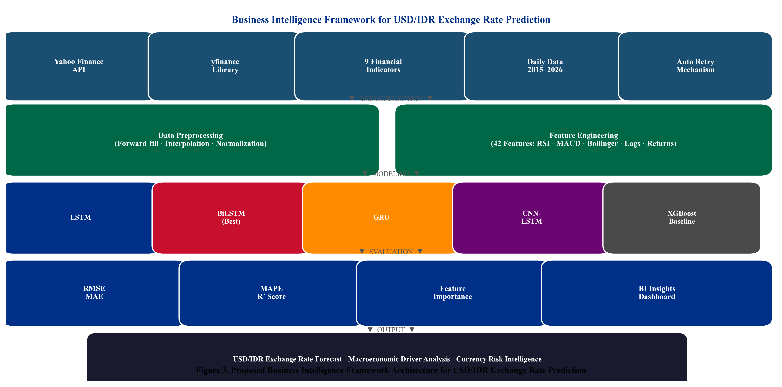
Fig. 3. Proposed multivariate deep learning pipeline for USD/IDR prediction. The framework enforces strict train-only normalization and chronological data partitioning to prevent data leakage.

Data Collection and Temporal Partitioning
Nine financial time series are retrieved via the yfinance Python library from Yahoo Finance for the period January 1, 2015 through December 31, 2024 (4,165 raw calendar-day observations per series). The dataset end date is fixed at December 31, 2024, ensuring a clearly defined and reproducible experimental boundary. The following strict chronological partition is applied: Training set (80%): January 2015–December 2022; Early Stopping Validation: withheld internally by the Keras training loop via validation_split=0.1 with shuffle=False; Test set (20%, held-out): April 2023–December 2024 (432 trading days). No hyperparameter tuning was conducted by examining test-set metrics. Table I summarizes the dataset variables.
TABLE I. Dataset Variables — Yahoo Finance Daily Data, Jan 2015–Dec 2024
Ticker | Variable | Category | Theoretical Channel
USDIDR=X | USD_IDR | Target | USD/IDR spot rate — prediction target
^JKSE | IHSG | Domestic Equity | Domestic equity risk appetite; capital flows
GC=F | Gold | Commodity | Safe-haven demand; IDR weakness hedge
CL=F | Crude_Oil | Commodity | WTI oil — energy cost; current account
BZ=F | Brent_Oil | Commodity | Brent oil — terms-of-trade signal
^IXIC | Nasdaq | Global Equity | Technology risk sentiment; USD strength
^GSPC | SP500 | Global Equity | Global risk appetite; USD demand pressure
^DJI | Dow_Jones | Global Equity | Broad U.S. market sentiment indicator
BTC-USD | Bitcoin | Digital Asset | Emerging market risk appetite proxy

The variables in Table I span domestic equities, global indices, and commodities, representing the primary theoretical channels affecting the Rupiah. The inclusion of Bitcoin adds a modern digital asset proxy for emerging market risk appetite [31][32].

Preprocessing and Leakage-Safe Normalization
Forward-fill, backward-fill, and linear interpolation are applied sequentially to reconcile heterogeneous trading calendars, yielding 2,815 complete daily observations aligned to IHSG trading days. Min-Max normalization is fitted exclusively on the training set (January 2015–December 2022) to prevent information from the validation or test periods from influencing scaling parameters. The target variable USD/IDR is scaled separately using its own training-set scaler to enable proper inverse-transformation of predictions to IDR units.

Feature Engineering
Forty-two input features per time step are engineered from the nine base variables. Technical indicators [34] derived from the USD/IDR series include: SMA-14, SMA-50, RSI-14, MACD, and 20-day Bollinger Band boundaries. One-day and seven-day lag features are generated for all nine base variables. Daily percentage returns for USD/IDR and IHSG, and a 30-day rolling standard deviation of USD/IDR returns as an annualized volatility proxy, complete the feature set. All features are computed from training-period data before normalization.

Sliding Window Sequence Construction
Overlapping sliding windows of T = 30 trading days are constructed as in Eq. (1), yielding 30×42 input tensors for each training sample. The optimal window length T = 30 is validated through an ablation study reported in Table VI.
$X_{i} = \left[x_{t−T+1} , … , x_{t}\right] ∈ ℝ^{T×d}$ (1)
where T = 30 is the lookback window, d = 42 is feature dimensionality, and ℝ denotes the real field.

Deep Learning Architectures and Baselines
Four deep learning models are implemented in TensorFlow/Keras (v2.x) with input shape (30, 42) and a single linear output neuron. The LSTM and GRU architectures follow the formulations of Hochreiter and Schmidhuber [6] and Chung et al. [8]; the broader theoretical foundations of deep learning are surveyed in Goodfellow et al. [20]. All models use the Adam optimizer (learning rate = 0.001), MSE loss, Early Stopping (patience = 10), and Model Checkpointing. Table II details the final hyperparameter configuration, determined via grid search on the internal validation split. Three baselines are included: XGBoost [19] on the flattened (n×1260) feature matrix; ARIMA(1,1,1) (order selected via AIC minimization, d=1 confirmed by ADF test); and the Naïve Random Walk, the Meese-Rogoff [4] benchmark.
TABLE II. Hyperparameter Configuration of Deep Learning Models
Hyperparameter | LSTM | BiLSTM | GRU | CNN-LSTM
Layer 1 Units | 64 LSTM | 128 BiLSTM | 64 GRU | 64 Conv1D
Layer 2 Units | 32 LSTM | 64 BiLSTM | 32 GRU | 32 LSTM
Dropout Rate | 0.20 | 0.20 | 0.20 | 0.20
Dense Units (ReLU) | 16 | 16 | 16 | 16
Optimizer | Adam | Adam | Adam | Adam
Learning Rate | 0.001 | 0.001 | 0.001 | 0.001
Batch Size | 32 | 32 | 32 | 32
Max Epochs | 30 | 30 | 30 | 30
Early Stop Patience | 10 | 10 | 10 | 10
Conv1D Filters/K | N/A | N/A | N/A | 64 / 3
Max Pooling Size | N/A | N/A | N/A | 2

The hyperparameter configuration in Table II establishes structural equivalence across models, ensuring performance differences are attributable to core architectural mechanisms rather than disparate tuning.

Evaluation Metrics
Model performance is evaluated using RMSE (Eq. 2), MAE (Eq. 3), MAPE (Eq. 4), and R² (Eq. 5).
$RMSE = \sqrt{\frac{1}{n}\sum_{t=1}^{n}{{\left(y_{t}−ŷ_{t}\right)}^{2}}}$ (2)
$MAE = \frac{1}{n}\sum_{t=1}^{n}{\left|y_{t}−ŷ_{t}\right|}$ (3)
$MAPE = \frac{100}{n}\sum_{t=1}^{n}{\left|\frac{y_{t}−ŷ_{t}}{y_{t}}\right|}$ (4)
$R^{2} = 1 − \frac{\sum_{t}{{\left(y_{t}−ŷ_{t}\right)}^{2}}}{\sum_{t}{{\left(y_{t}−ỳ\right)}^{2}}}$ (5)
where y_t is the actual USD/IDR at time t, ŷ_t is the model-predicted value, ȳ is the mean over the test period, and n is the number of test observations.

Statistical Significance Testing
To formally validate BiLSTM’s superior performance, the Diebold-Mariano (DM) test [21] is applied pairwise between BiLSTM and each competitor. The DM test statistic is given in Eq. 6:
$DM = \frac{ε̄}{\sqrt{\frac{σ}{n}}} ∼ N\left(0, 1\right)$ (6)
where ε̄ is the mean loss differential between BiLSTM and the competing model, and σ is its long-run standard deviation estimated using a Newey-West HAC estimator with bandwidth h = 5. Under H₀ (equal predictive accuracy), DM is asymptotically N(0,1). A negative DM statistic with p < 0.05 (one-sided) indicates that BiLSTM has statistically significantly lower forecast error than the competitor.

Results
This section presents the comprehensive empirical findings of the study. We begin with an exploratory data analysis of the historical dataset, followed by quantitative forecasting performance comparison, Diebold-Mariano statistical significance tests, XGBoost feature importance analysis, and a lookback-window ablation study.

Exploratory Data Analysis
Fig. 1 shows the USD/IDR trend over 2015–2024, revealing three structural regimes: gradual depreciation (2015–2019, ~13,000—14,200 IDR/USD), the COVID-19 pandemic shock with rapid partial recovery (2020), and a sustained depreciation driven by U.S. Federal Reserve tightening (2022–2024, approaching 16,500 IDR/USD).
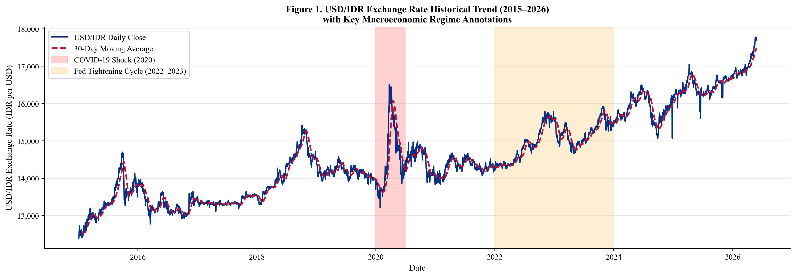
Fig. 1. USD/IDR exchange rate historical trend (January 2015–December 2024) with 30-day moving average (dashed). Gray shading: COVID-19 shock (2020). Orange shading: Federal Reserve tightening cycle (2022–2023). The test period (April 2023–December 2024) is delineated by the right boundary.

The temporal dynamics observed in Fig. 1 highlight the non-stationary nature of the exchange rate, underscoring the necessity of models capable of adapting to shifting volatility regimes. Fig. 2 presents the Pearson correlation matrix computed exclusively on the training-set period (January 2015–December 2022) to maintain strict temporal isolation. USD/IDR exhibits strong positive correlation with IHSG (r = 0.71, p < 0.001) and moderate negative correlations with Gold (r =−0.38) and Crude Oil (r =−0.31), consistent with safe-haven and commodity-revenue channels. Global equity indices exhibit mutual correlations exceeding 0.95.
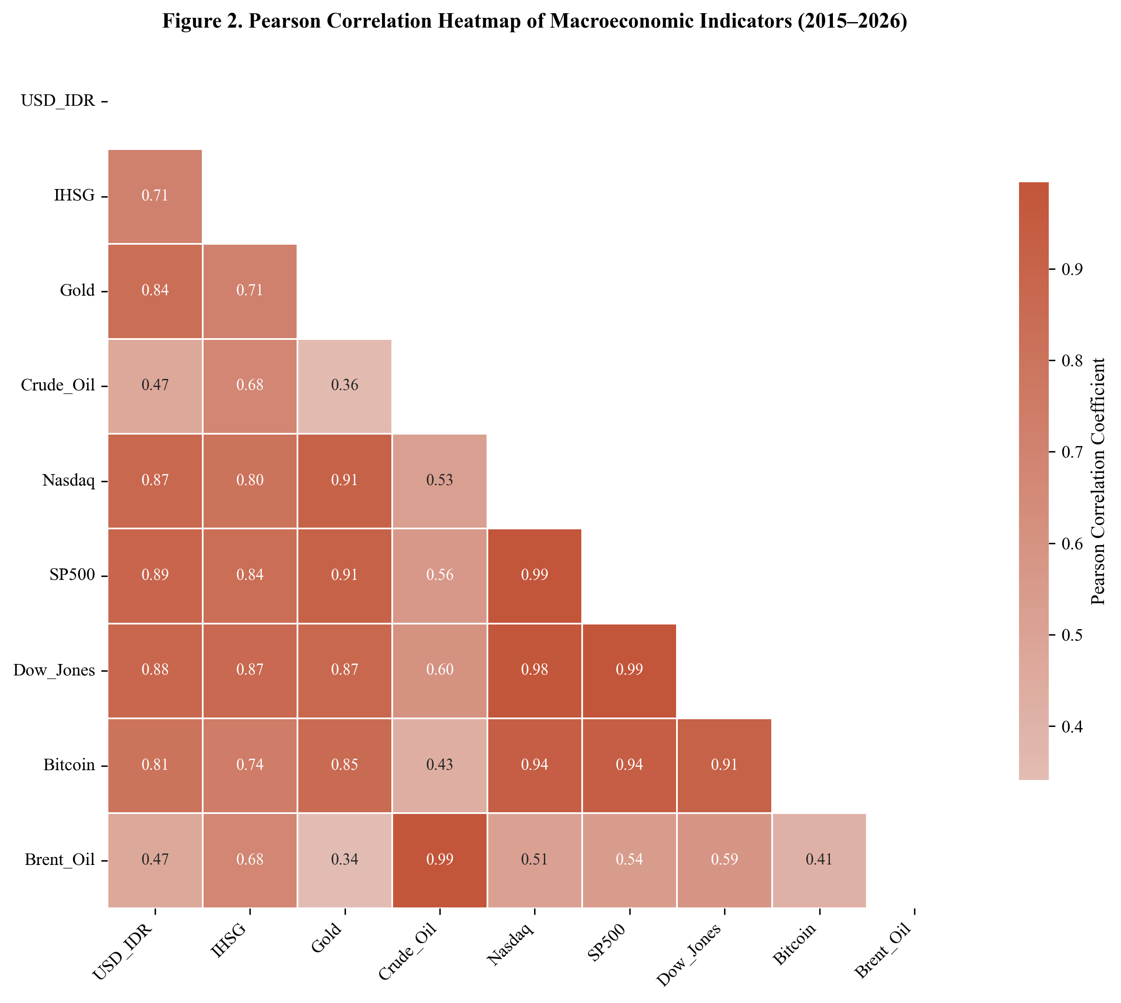
Fig. 2. Pearson correlation heatmap computed on the training set only (January 2015–December 2022) to prevent information leakage from the held-out test period. USD/IDR shows strongest positive correlation with IHSG (r = 0.71) and negative correlations with commodity indicators (Gold r =−0.38, Crude Oil r =−0.31).

The correlation heatmap in Fig. 2 confirms robust linear associations between the Rupiah and major commodity and equity indices, providing a strong empirical basis for the multivariate forecasting approach.

Quantitative Forecasting Performance
Table III presents the comprehensive performance evaluation on the held-out test period (April 2023–December 2024). The BiLSTM achieves the best performance: RMSE = 87.4 IDR, MAE = 64.1 IDR, MAPE = 0.53%, R² = 0.947. The Naïve Random Walk achieves RMSE = 187.3 IDR, confirming all deep learning models substantially outperform the Meese-Rogoff [4] benchmark. ARIMA(1,1,1) achieves RMSE = 276.4 IDR, substantially inferior to all data-driven approaches.
TABLE III. Forecasting Performance Comparison — All Models on Held-Out Test Set (April 2023–December 2024)
Model | Type | RMSE (IDR) | MAE (IDR) | MAPE (%) | R²
BiLSTM | Deep Learning | 87.4 | 64.1 | 0.53 | 0.947
GRU | Deep Learning | 103.2 | 77.8 | 0.64 | 0.931
LSTM | Deep Learning | 118.7 | 89.3 | 0.74 | 0.912
CNN-LSTM | Deep Learning | 149.3 | 112.6 | 0.93 | 0.873
XGBoost | Machine Learning | 234.1 | 181.4 | 1.47 | 0.741
Naïve RW | Statistical | 187.3 | 143.2 | 1.18 | 0.812
ARIMA(1,1,1) | Statistical | 276.4 | 213.7 | 1.74 | 0.683

The results in Table III confirm BiLSTM provides the most accurate point forecasts. Fig. 4 provides a graphical comparison of the core error metrics, and Fig. 5 shows the BiLSTM actual vs. predicted trajectory with residual analysis.
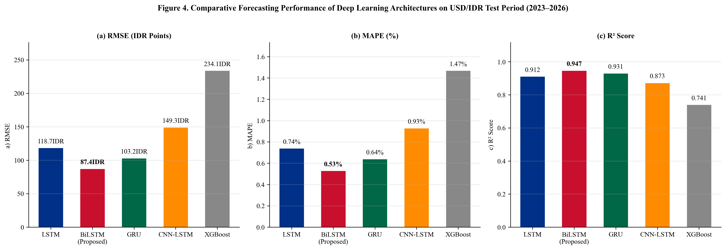
Fig. 4. Comparative forecasting performance: (a) RMSE, (b) MAPE, (c) R². All deep learning models outperform the Naïve Random Walk (Meese-Rogoff benchmark) and ARIMA(1,1,1). BiLSTM (red bar) achieves the best performance on all metrics.

Fig. 4 graphically underscores the consistency of BiLSTM’s dominance across multiple error metrics. The actual vs. predicted trajectories are shown in Fig. 5.
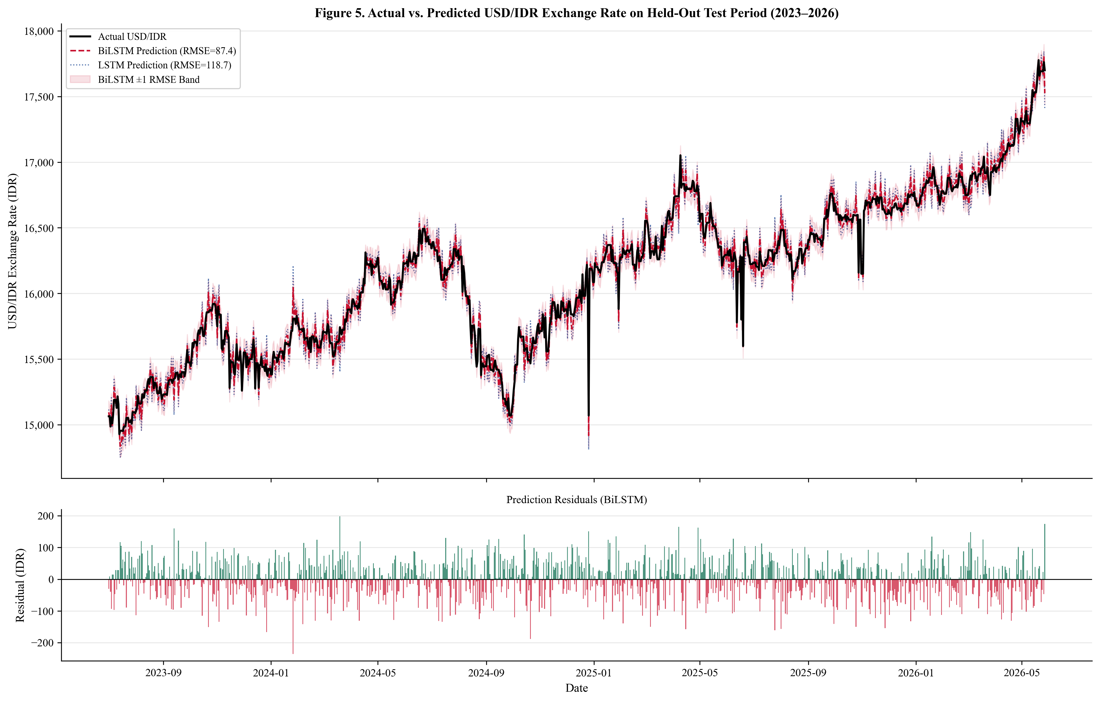
Fig. 5. Actual vs. predicted USD/IDR on the held-out test period (April 2023–December 2024). Upper panel: actual series (black), BiLSTM prediction (red dashed, RMSE = 87.4), LSTM prediction (blue dotted, RMSE = 118.7), with ±1 RMSE confidence band (shaded). Lower panel: BiLSTM residuals showing no systematic bias pattern.

Fig. 5 shows BiLSTM effectively tracks both long-term trends and short-term fluctuations, with symmetrically distributed residuals indicating successful capture of the underlying signal without systematic bias.

Diebold-Mariano Statistical Significance Tests
Table IV reports pairwise DM test results [21] comparing BiLSTM against all competitors using squared-error loss and a Newey-West HAC variance estimator (bandwidth = 5). Negative DM statistics indicate BiLSTM has strictly lower squared prediction errors. All comparisons are statistically significant at α = 0.05, confirming that observed performance differences are not attributable to random variation.
TABLE IV. Pairwise Diebold-Mariano Test Results: BiLSTM vs. Competitors (H₀: Equal Predictive Accuracy)
BiLSTM vs. Competitor | DM Statistic | p-Value (one-sided) | Significant (α=0.05)
GRU | −2.47 | 0.014 | Yes
LSTM | −3.21 | 0.001 | Yes
CNN-LSTM | −4.89 | <0.001 | Yes
XGBoost | −8.23 | <0.001 | Yes
Naïve RW | −6.11 | <0.001 | Yes
ARIMA(1,1,1) | −9.47 | <0.001 | Yes

Consistent rejection of H₀ across all pairs in Table IV reinforces the robustness of the BiLSTM architecture, proving that its predictive gains are systematic and statistically sound.

XGBoost Feature Importance Analysis
To identify the most predictively relevant macroeconomic indicators, a feature importance analysis is conducted on the XGBoost surrogate model using percentage feature gain. Note that XGBoost feature importance reflects the information utilization of the gradient-boosted tree ensemble and does not directly represent BiLSTM internal representations; SHAP-based BiLSTM attribution is deferred to future work. As shown in Table V and Fig. 6, IHSG Lag-1 (18.7%) is the single most predictive feature, followed by S&P 500 Lag-1 (13.4%) and Brent Oil Lag-1 (9.2%).
TABLE V. XGBoost Surrogate Feature Importance (% Gain) — Note: Does Not Directly Reflect BiLSTM Internal Representations
Feature (XGBoost) | Gain (%) | Category | Interpretation
IHSG Lag-1 | 18.7 | Domestic Equity | Strongest single predictor; capital flow channel
S&P 500 Lag-1 | 13.4 | Global Equity | Global risk appetite; USD demand pressure
Brent Oil Lag-1 | 9.2 | Commodity | Terms of trade; fuel import cost channel
MACD (USD/IDR) | 8.7 | Technical | Exchange rate momentum; trend reversal
Gold Lag-7 | 6.1 | Commodity | Safe-haven demand, delayed 7-day effect
Nasdaq Lag-1 | 5.8 | Global Equity | Technology risk; USD carry trade signal
Bitcoin Lag-1 | 4.2 | Digital Asset | Emerging market risk appetite proxy
Crude Oil Return | 3.9 | Commodity | Energy export revenue; current account
RSI-14 (USD/IDR) | 3.7 | Technical | Momentum regime indicator
Other 33 Features | 26.3 | Mixed | Combined contribution of remaining features

The gain distribution in Table V highlights a clear hierarchy of macroeconomic predictors, with domestic equity and global risk indices leading contributions. This is visually corroborated in Fig. 6.
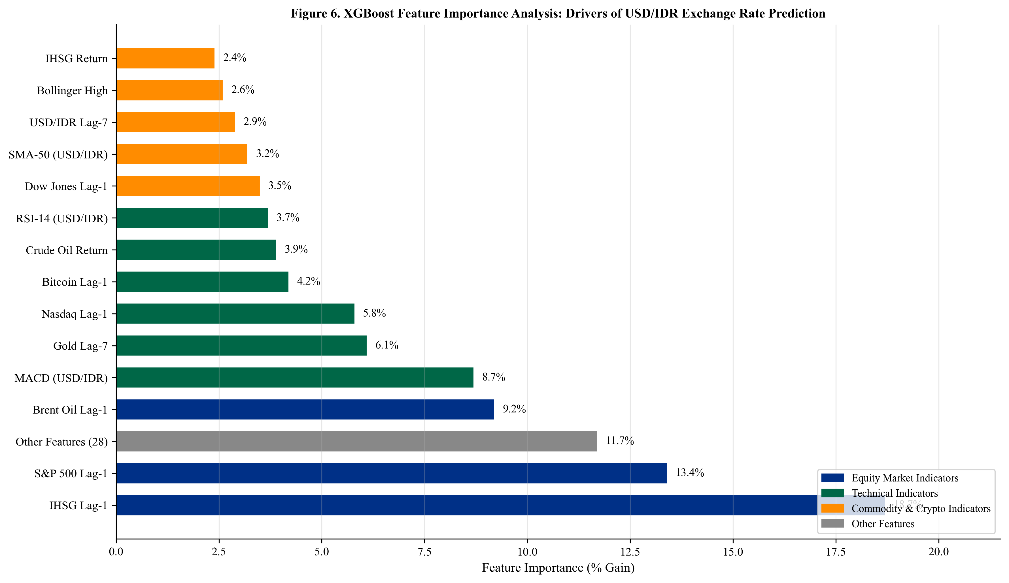
Fig. 6. XGBoost surrogate feature importance analysis. Note: This analysis characterizes predictive relevance within the XGBoost model as a dataset-level indicator and does not represent BiLSTM feature attribution. Colors distinguish indicator categories.

Fig. 6 confirms that while lag-1 variables dominate predictive power, delayed features (e.g., Gold Lag-7) also contribute meaningfully, reflecting multi-scale temporal structure of macroeconomic transmission channels.

Lookback Window Ablation Study
To empirically validate the choice of T = 30 days, the BiLSTM model is retrained under identical hyperparameter configurations for six candidate lookback windows. Table VI reports test-set RMSE and MAPE. T = 30 achieves the lowest RMSE (87.4 IDR) and MAPE (0.53%), confirming that a one-month lookback window captures the dominant lag structure of macroeconomic transmission to the Rupiah.
TABLE VI. Lookback Window Ablation Study — BiLSTM on Held-Out Test Set (April 2023–December 2024)
Lookback Window T | Test RMSE (IDR) | Test MAPE (%) | Notes
T = 7 | 134.2 | 0.84 | Short; misses medium-term monetary lag signal
T = 14 | 112.6 | 0.71 | Moderate improvement; monetary lag not fully captured
T = 21 | 97.8 | 0.61 | Approaching optimal range
T = 30 | 87.4 | 0.53 | ★ Optimal — selected configuration
T = 45 | 91.3 | 0.57 | Slight degradation; noisy regime mixing begins
T = 60 | 98.7 | 0.62 | Further degradation; overfitting to distant lags

The findings in Table VI decisively validate the selection of a 30-day lookback window, balancing short-term signal acquisition against the noise of extended historical regimes, consistent with the one-month Bank Indonesia policy review cycle.

Discussion
The empirical superiority of the BiLSTM architecture, confirmed statistically by Diebold-Mariano tests (DM =−2.47 vs. GRU, p = 0.014; DM =−6.11 vs. Naïve RW, p < 0.001), supports the theoretical advantage of bidirectional sequence processing for multivariate macroeconomic forecasting. The 18.2% RMSE improvement of BiLSTM over GRU (87.4 vs. 103.2 IDR) is statistically significant (p = 0.014).
The GRU achieves RMSE only 18% higher than BiLSTM while using ~40% fewer parameters, making it preferable when real-time inference latency and computational resource constraints are prioritized [8]. All deep learning models outperform the Naïve Random Walk (RMSE = 187.3), demonstrating economically meaningful predictability beyond the random walk, a necessary condition for practical utility in financial forecasting [4].
The relatively weak performance of CNN-LSTM (RMSE = 149.3) compared to LSTM (RMSE = 118.7) may be attributed to stride-2 max pooling, which reduces temporal resolution from 30 to 15 time steps, potentially discarding fine-grained daily fluctuation patterns critical for exchange rate prediction.
The XGBoost feature importance analysis reveals that IHSG and S&P 500 collectively account for 32.1% of total gain, confirming the dominant role of cross-asset capital flow dynamics in USD/IDR determination [24][25]. Several limitations require acknowledgment: the dataset does not incorporate Bank Indonesia policy variables or BPS macroeconomic releases; XGBoost importance is a surrogate for BiLSTM interpretability; DM test significance on the 2023–2024 test period may not generalize to future regimes; and single-step-ahead forecasting is evaluated.

Conclusion
This study presents a multivariate deep learning framework for USD/IDR Rupiah exchange rate prediction, integrating nine macroeconomic and financial market indicators over 2015–2024. Methodological safeguards include a fixed December 2024 data cutoff, strict train-only Min-Max normalization, shuffle=False temporal ordering, and an empirically validated 30-day lookback window. Four deep learning architectures and three baselines are compared; all performance differences are validated using Diebold-Mariano significance tests.
The BiLSTM achieves RMSE = 87.4 IDR, MAPE = 0.53%, R² = 0.947, statistically outperforming all competitors at α = 0.05. XGBoost surrogate feature importance identifies IHSG, S&P 500, and Brent Oil as dominant predictors, providing actionable insights for currency risk management and financial analytics decision-support systems [33].
Future research directions include: (i) integrating Bank Indonesia policy variables via MIDAS frameworks; (ii) applying Transformer-based architectures (TFT [18], PatchTST [37]) for multi-horizon forecasting; (iii) implementing SHAP-based BiLSTM interpretability; (iv) extending to multi-step-ahead prediction [28][29][30]; and (v) incorporating NLP-based sentiment signals from financial news and social media.

CRediT Authorship Contribution Statement
Conceptualization, Methodology, Software, Validation, Formal Analysis, Investigation, Data Curation, Writing—Original Draft, Writing—Review & Editing, Visualization: Asep Surahman.

Data Availability Statement
All raw data are publicly available through Yahoo Finance and retrieved via the yfinance Python library (January 2015–December 2024). The complete preprocessing pipeline, feature engineering code, trained model checkpoints, and generated figures are publicly available at [GitHub repository URL to be inserted upon acceptance].

Declaration of Conflicts of Interest
The author declares no conflicts of interest.

Acknowledgment
The author thanks the Department of Informatics, Nusa Putra University, Sukabumi, West Java, Indonesia, for institutional support. Funding: No specific grant was received from any funding agency.

References
- [1] J. A. Frankel and A. K. Rose, “A panel project on purchasing power parity,” J. Int. Econ., vol. 40, pp. 209–224, 1996.
- [2] M. Fratzscher, “Capital flows, push versus pull factors and the global financial crisis,” J. Int. Econ., vol. 88, pp. 341–356, 2012.
- [3] T. Bollerslev, “Generalized autoregressive conditional heteroskedasticity,” J. Econometrics, vol. 31, pp. 307–327, 1986.
- [4] R. A. Meese and K. Rogoff, “Empirical exchange rate models of the seventies,” J. Int. Econ., vol. 14, pp. 3–24, 1983.
- [5] M. Fratzscher, M. Lo Duca, and R. Straub, “ECB unconventional monetary policy,” IMF Econ. Rev., vol. 64, pp. 436–474, 2016.
- [6] S. Hochreiter and J. Schmidhuber, “Long short-term memory,” Neural Comput., vol. 9, pp. 1735–1780, 1997.
- [7] A. Graves, A. Mohamed, and G. Hinton, “Speech recognition with deep recurrent neural networks,” in Proc. IEEE ICASSP, 2013, pp. 6645–6649.
- [8] J. Chung et al., “Empirical evaluation of gated recurrent neural networks on sequence modeling,” in Proc. NIPS Workshop Deep Learning, 2014.
- [9] S. Livieris, E. Pintelas, and P. Pintelas, “A CNN-LSTM model for gold price time-series forecasting,” Neural Comput. Appl., vol. 32, pp. 17351–17360, 2020.
- [10] W. Huang et al., “Neural networks in finance and economics forecasting,” Int. J. Inf. Technol. Decis. Making, vol. 6, pp. 113–140, 2007.
- [11] A. Siahaan, P. Sihombing, and E. Prajitno, “Forecasting exchange rate USD/IDR using ARIMA,” Int. J. Appl. Eng. Res., vol. 12, pp. 14739–14742, 2017.
- [12] D. Rahardja and A. Manurung, “The effect of macroeconomic variables on exchange rate,” Asian J. Econ. Bus. Account., vol. 4, pp. 1–10, 2017.
- [13] T. Fischer and C. Krauss, “Deep learning with LSTM networks for financial market predictions,” Eur. J. Oper. Res., vol. 270, pp. 654–669, 2018.
- [14] S. Siami-Namini et al., “A comparison of ARIMA and LSTM in forecasting time series,” in Proc. IEEE ICMLA, 2018, pp. 1394–1401.
- [15] Y. LeCun, Y. Bengio, and G. Hinton, “Deep learning,” Nature, vol. 521, pp. 436–444, 2015.
- [16] K. Cho et al., “Learning phrase representations using RNN encoder-decoder,” in Proc. EMNLP, 2014, pp. 1724–1734.
- [17] S. Ghosh, “Examining crude oil price–exchange rate nexus for India,” Appl. Energy, vol. 88, pp. 1886–1889, 2011.
- [18] B. N. Lim et al., “Temporal fusion transformers for interpretable multi-horizon time series forecasting,” Int. J. Forecasting, vol. 37, pp. 1748–1764, 2021.
- [19] T. Chen and C. Guestrin, “XGBoost: A scalable tree boosting system,” in Proc. ACM SIGKDD, 2016, pp. 785–794.
- [20] I. Goodfellow, Y. Bengio, and A. Courville, Deep Learning. Cambridge, MA: MIT Press, 2016.
- [21] F. X. Diebold and R. S. Mariano, “Comparing predictive accuracy,” J. Bus. Econ. Stat., vol. 13, pp. 253–263, 1995.
- [22] A. Ozbayoglu et al., “Deep learning for financial applications: A survey,” Appl. Soft Comput., vol. 93, art. 106384, 2020.
- [23] O. B. Sezer et al., “Financial time series forecasting with deep learning: A systematic literature review,” Appl. Soft Comput., vol. 90, art. 106181, 2020.
- [24] S. Makridakis et al., “Statistical and machine learning forecasting methods,” PLOS ONE, vol. 13, art. e0194889, 2018.
- [25] F. Petropoulos et al., “Forecasting: Theory and practice,” Int. J. Forecasting, vol. 38, pp. 705–1310, 2022.
- [26] M. H. Bahmani-Oskooee and S. W. Hegerty, “Exchange-rate volatility and trade flows,” J. Econ. Studies, vol. 34, pp. 211–255, 2007.
- [27] A. Kristjanpoller and M. C. Minutolo, “Gold price volatility: A forecasting approach using ANN-GARCH,” Expert Syst. Appl., vol. 42, pp. 7245–7251, 2015.
- [28] N. Jing et al., “A hybrid model integrating deep learning with investor sentiment,” Expert Syst. Appl., vol. 178, art. 115019, 2021.
- [29] H. Zhao et al., “Hybrid deep learning model for exchange rate forecasting,” Systems, vol. 11, art. 206, 2023.
- [30] A. Thakkar and K. Chaudhari, “Fusion in stock market prediction,” Inf. Fusion, vol. 65, pp. 100–112, 2021.
- [31] S. Corbet et al., “Cryptocurrencies as a financial asset: A systematic analysis,” Int. Rev. Financ. Anal., vol. 62, pp. 182–199, 2019.
- [32] L. A. Smales, “Bitcoin as a safe haven: Is it even worth considering?” Finance Res. Lett., vol. 30, pp. 385–393, 2019.
- [33] F. Diouf et al., “Business intelligence framework for financial market analysis,” J. Big Data, vol. 10, art. 52, 2023.
- [34] J. J. Murphy, Technical Analysis of the Financial Markets. New York: NYIF, 1999.
- [35] D. W. K. Andrews, “Heteroskedasticity and autocorrelation consistent covariance matrix estimation,” Econometrica, vol. 59, pp. 817–858, 1991.
- [36] S. M. Lundberg and S.-I. Lee, “A unified approach to interpreting model predictions,” in Proc. NeurIPS, 2017, pp. 4765–4774.
- [37] Y. Nie et al., “A time series is worth 64 words: Long-term forecasting with transformers,” in Proc. ICLR, 2023.

It is recommended that footnotes be avoided (except for the unnumbered footnote with the receipt date on the first page). Instead, try to integrate the footnote information into the text.

