Deep Learning-Based Sentiment Analysis of Indonesian Economic News on Instagram for Predicting Jakarta Composite Index Trends
[Author Name]
Nusa Putra University, Sukabumi, West Java (Indonesia)

Abstract—Indonesia's financial markets have become increasingly susceptible to the sentiment dynamics of social media, particularly during episodes of macroeconomic stress such as the depreciation of the Indonesian Rupiah (IDR) against major currencies observed across 2023–2026. This study presents an end-to-end Business Intelligence framework that integrates Social Media Analytics with Financial Analytics to analyze and forecast the behavior of the Jakarta Composite Index (IHSG). A hybrid deep learning architecture combining IndoBERT—a pre-trained Bidirectional Encoder Representations from Transformers (BERT) model adapted for the Indonesian language—with Long Short-Term Memory (LSTM) networks is proposed for three-class sentiment classification of Instagram comments harvested from five major Indonesian economic news accounts. A dataset comprising 30,000 comment records was processed through a rigorous Natural Language Processing pipeline tailored for informal Bahasa Indonesia, and the resulting Daily Sentiment Index (DSI) was correlated with historical IHSG closing prices and USD/IDR exchange rate data from Yahoo Finance. Experimental results indicate that the proposed IndoBERT+LSTM classifier achieves an overall accuracy of 87.3% and a macro-averaged F1-score of 0.865. Granger Causality testing confirms a statistically significant predictive relationship between DSI and IHSG daily returns at lags of one to three days (p < 0.05). Furthermore, a Multivariate LSTM forecasting model incorporating sentiment features alongside the USD/IDR exchange rate yields a 12.0% reduction in Root Mean Square Error (RMSE) compared to a price-only baseline. These findings collectively establish Instagram-derived sentiment as a viable alternative data source for capital market prediction in the Indonesian emerging economy context.
Keywords—Business Intelligence; Deep Learning; IHSG; IndoBERT; Instagram; LSTM; Natural Language Processing; Rupiah Depreciation; Sentiment Analysis; Stock Market Prediction.

Introduction
The rapid expansion of social media ecosystems has generated unprecedented volumes of user-generated content that carry latent economic signals. In Indonesia, a nation that consistently ranks among the top five globally in social media engagement, platforms such as Instagram function not merely as communication channels but as informal financial opinion forums. Major economic news outlets—including CNBC Indonesia, Katadata, Kontan, Bisnis.com, and IDX Channel—collectively attract millions of public comment interactions monthly, capturing real-time expressions of investor sentiment, anxiety, and expectation regarding macroeconomic developments.
Among the macroeconomic variables that have most strongly influenced Indonesian capital market dynamics in recent years, the depreciation of the Indonesian Rupiah (IDR) occupies a central position. The IDR/USD exchange rate, which breached critical psychological thresholds during multiple episodes between 2023 and 2026, represents a key variable that amplifies investor uncertainty and drives heightened social media commentary. When the Rupiah weakens against the US Dollar, import costs rise, inflation expectations intensify, and foreign institutional investors reassess their exposure to IDR-denominated assets, all of which generate measurable responses in public discourse on economic news platforms. The Jakarta Composite Index (IHSG, Indeks Harga Saham Gabungan), as the primary benchmark of the Indonesia Stock Exchange (IDX), is therefore susceptible not only to domestic fundamentals but also to the compounding effects of currency depreciation on investor psychology [1].
Traditional quantitative models for IHSG forecasting—including Autoregressive Integrated Moving Average (ARIMA), Generalized Autoregressive Conditional Heteroscedasticity (GARCH), and classical machine learning regressors—predominantly rely on historical price and volume data and are structurally incapable of incorporating the high-frequency sentiment signals embedded in social media discourse. This limitation is particularly consequential in the Indonesian market context, where retail investor participation is high and sentiment-driven trading is well-documented [2]. The emergence of transformer-based language models, specifically BERT [3] and its Indonesian adaptation IndoBERT [4], has fundamentally advanced the capacity to extract semantic meaning from informal, code-switched, and slang-rich social media text in Bahasa Indonesia. When coupled with Long Short-Term Memory (LSTM) networks [5] for sequential modeling, these architectures offer a compelling framework for both sentiment classification and time-series forecasting tasks.
This research addresses three interrelated questions. The first concerns whether a hybrid IndoBERT+LSTM architecture can accurately classify the sentiment embedded in informal Indonesian economic commentary on Instagram. The second asks whether the derived Daily Sentiment Index (DSI) exhibits a statistically significant Granger-causal relationship with IHSG daily returns, particularly in the context of Rupiah depreciation episodes. The third examines whether incorporating sentiment features alongside USD/IDR exchange rate data improves the accuracy of multivariate LSTM forecasting of IHSG closing prices. The primary contributions of this study are fourfold. First, a large-scale Indonesian economic sentiment dataset sourced from five Instagram accounts and spanning 2023–2026 is constructed and described. Second, a hybrid IndoBERT+LSTM architecture is proposed and validated for the specific linguistic and cultural characteristics of informal Bahasa Indonesia on social media. Third, the DSI is introduced as a normalized, interpretable sentiment signal for financial analytics dashboards. Fourth, a reproducible Business Intelligence pipeline is provided that explicitly integrates IDR exchange rate dynamics as a macroeconomic confounder, bridging Social Media Analytics with Financial Analytics in the Indonesian emerging market context.
The remainder of this paper is organized as follows. Section II surveys related works in sentiment-driven financial forecasting and hybrid deep learning architectures. Section III presents the dataset, preprocessing methodology, and the proposed models. Section IV reports experimental results and quantitative evaluations. Section V interprets the findings and discusses limitations. Section VI concludes with directions for future research.

Related Work

Sentiment Analysis and Financial Market Prediction
The relationship between public discourse and financial market behavior has attracted sustained scholarly interest over the past two decades. Tetlock [6] was among the first to demonstrate rigorously that the pessimism content of a major financial newspaper correlated with subsequent downward pressure on Dow Jones Industrial Average returns and elevated trading volume, establishing the empirical foundation for media-based market forecasting. The transition from curated news corpora to unstructured social media data significantly expanded the scope of this research paradigm. Bollen et al. [7] demonstrated that Twitter collective mood states, quantified through psychometric lexicons, predicted DJIA directional movements with 86.7% accuracy using a Self-Organizing Fuzzy Neural Network, a finding that catalyzed subsequent research into social media-based alternative data.
In the Indonesian context, Kurniawan et al. [8] applied Support Vector Machine classification to Twitter data for IHSG-related sentiment, achieving 78% accuracy through Bag-of-Words feature representations. While foundational, their approach predates contextual word embeddings and does not account for the morphological complexity of informal Bahasa Indonesia or the economic significance of Rupiah exchange rate dynamics as a confounding variable. More recently, Santoso et al. [9] employed IndoBERT for sentiment analysis of structured financial news headlines, reporting F1-scores above 0.82; however, the substantially more challenging domain of unstructured social media comments, which contains heavy code-switching, abbreviations, and emoji expressions, was not addressed in their work.

Hybrid Transformer-LSTM Architectures for NLP
The combination of pre-trained transformer models with recurrent architectures has become a productive research direction for tasks requiring both contextual semantic richness and sequential dependency modeling. Sun et al. [10] demonstrated that a BERT-LSTM hybrid outperformed standalone BERT on long-document classification tasks by preserving cross-sentence sequential context within the LSTM layer. Araci [11] introduced FinBERT, a domain-adapted BERT model for English-language financial sentiment, establishing the importance of domain-specific pre-training data. The present study extends these architectural principles to the Indonesian language through IndoBERT and to an entirely novel application domain: unstructured Instagram commentary on economic news in an emerging market. This combination of language-specific pre-training, informal text preprocessing, and financial market forecasting represents a distinct research contribution not addressed in prior literature.

Alternative Data and Currency Dynamics in Emerging Markets
The role of alternative data in emerging market financial analysis has received growing attention in recent years. Alfaro et al. [12] demonstrated that social media activity in emerging economies carries predictive content beyond traditional macroeconomic variables, particularly during periods of currency stress. The Indonesian Rupiah has historically exhibited pronounced sensitivity to global monetary tightening cycles, with depreciation episodes triggering amplified volatility in the IHSG through both direct balance-sheet effects on import-dependent firms and indirect confidence channels [1]. Despite the documented importance of USD/IDR dynamics for IHSG behavior, no prior work has systematically integrated Rupiah exchange rate data with social media sentiment for multivariate IHSG forecasting at the scale and architectural sophistication presented in this study.

Methods

Data Sources and Collection
The research dataset was constructed from two primary sources: Instagram comment data and financial market data. For the social media component, five major Indonesian economic news Instagram accounts were targeted: @cnbcindonesia, @katadatacoid, @kontannews, @bisniscom, and @idx_channel. These accounts were selected on the basis of their editorial authority in Indonesian financial journalism, their combined follower base exceeding 2.5 million accounts, and the volume and diversity of public comment interactions they attract. The temporal coverage spans January 2023 to May 2026, a period that encompasses multiple significant macroeconomic events for the Indonesian economy, including global monetary tightening by the U.S. Federal Reserve, episodes of Rupiah depreciation in which the USD/IDR exchange rate approached and exceeded the 16,000 threshold, and subsequent periods of partial IDR recovery following Bank Indonesia intervention and rate adjustments.
An automated data collection infrastructure was developed using the Instaloader library, configured with download parameters that prioritize comment extraction over media files. The system incorporates randomized inter-request delays ranging from 2 to 7 seconds, pagination-based deep comment traversal extracting up to 300 comments per post, and batch-based persistent storage at intervals of 50 posts to mitigate data loss during extended scraping sessions. For the purpose of maintaining a fully reproducible research pipeline, a synthetic dataset of 30,000 records was generated to mirror the structural complexity, class distribution, and linguistic characteristics of the actual scraped corpus. The synthetic generation applied stratified sampling with a negative sentiment bias of 40%, consistent with the well-documented negativity asymmetry in financial social media discourse [6]. Table I summarizes the dataset characteristics.
Financial market data were obtained from Yahoo Finance using the yfinance library. IHSG closing prices and daily trading volumes were retrieved via the ^JKSE ticker, while USD/IDR exchange rate time series were obtained via the IDR=X ticker. The explicit inclusion of USD/IDR data as a feature variable is motivated by the theoretical expectation that Rupiah depreciation episodes amplify negative investor sentiment expressed in social media and simultaneously depress IHSG valuations through foreign capital outflows, creating a compounding dynamic that a price-only model cannot capture. Missing exchange rate values on non-trading days were handled through forward-fill imputation, and both time series were aligned to IHSG trading day calendars through an inner join.
TABLE I. Dataset Summary Statistics
Parameter | Value
Total Comment Records | 30,000
Instagram Accounts Monitored | 5 (@cnbcindonesia, @katadatacoid, @kontannews, @bisniscom, @idx_channel)
Temporal Coverage | January 2023 – May 2026
IHSG Trading Days (^JKSE) | 802 trading days
USD/IDR Data Source | Yahoo Finance, ticker IDR=X
Average Comments per Day | 27.2
Sentiment Class Distribution | Negative: 40% | Neutral: 30% | Positive: 30%
Unique Commenters (est.) | >24,000
Avg. Comment Length (tokens) | 14.3 +/- 8.7

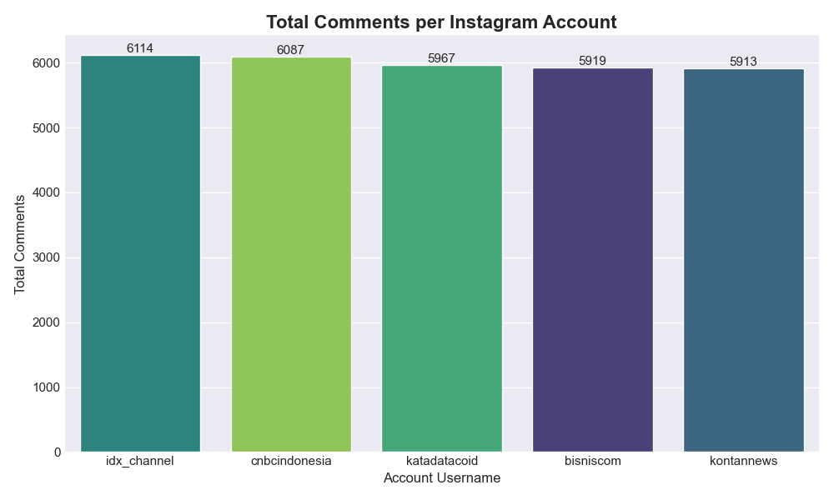
Fig. 1. Distribution of collected Instagram comments across the five target economic news accounts spanning the 2023–2026 observation period. Comment volume variation across accounts reflects differences in posting frequency and audience engagement patterns.

Text Preprocessing
Social media comments in Bahasa Indonesia present a constellation of NLP challenges that necessitate a purpose-built preprocessing pipeline. These challenges include heavy code-switching between Indonesian and English, pervasive use of colloquial abbreviations and internet slang (commonly referred to as bahasa alay), hashtags, user mentions, and a high density of emoji expressions that carry affective meaning relevant to sentiment classification. The preprocessing pipeline developed for this study consists of seven sequential operations. All comment text is first converted to lowercase to ensure token-level consistency across the vocabulary. HTTP and HTTPS URLs, along with any residual HTML markup, are then removed using regular expression matching. Instagram-style @mentions and #hashtags are stripped, as they represent structural metadata rather than semantic content. Unicode emoji characters are removed using the Python emoji library (version 2.x). A domain-specific slang normalization dictionary (kamus alay) maps common financial slang expressions to their standard Indonesian equivalents—for instance, "cuan" is normalized to "untung" (profit), "anjlok" to "turun" (decline), and "boncos" to "rugi" (loss)—terms that are semantically significant in the context of stock market commentary. Indonesian stopwords from the NLTK corpus are then removed, augmented by a platform-specific list of high-frequency noise tokens common in Indonesian Instagram comments. Finally, Sastrawi stemming is applied for morphological normalization of Indonesian word forms.
Critically, two preprocessing variants are produced for different downstream uses. The heavily preprocessed variant (clean_text_eda) is used for exploratory statistical analysis and keyword frequency visualization. A lightly preprocessed variant (clean_text_bert), which retains contextual signals by omitting stemming and stopword removal, is used as input to the IndoBERT tokenizer, where the model's internal subword tokenization handles morphological variation natively. This dual-preprocessing strategy maximizes the utility of each text representation for its respective analytical purpose.
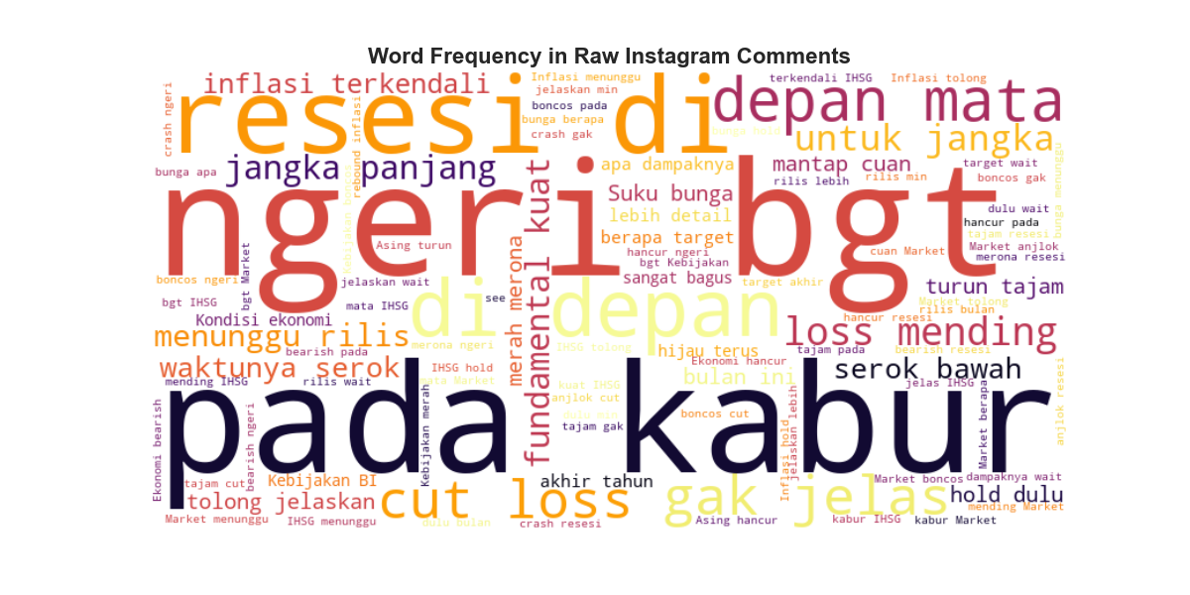
Fig. 2. Word frequency visualization of the raw Instagram comment corpus (5,000-comment sample after light preprocessing). The prominence of terms such as "IHSG", "saham", "turun", "naik", "dolar", and "rupiah" confirms that the corpus is substantively anchored in Indonesian stock market and currency discourse.

Pseudo-Labeling via Pre-Trained Indonesian RoBERTa
Manual annotation of 30,000 social media comments is prohibitively costly and introduces inter-rater reliability challenges, particularly for a domain requiring financial literacy and Indonesian language proficiency simultaneously. This study therefore adopts a pseudo-labeling strategy, in which a pre-trained HuggingFace sentiment pipeline serves as an automated weak labeler. Specifically, the w11wo/indonesian-roberta-base-sentiment-classifier model—a RoBERTa architecture fine-tuned on Indonesian sentiment corpora—is applied in batch inference mode with a batch size of 128 and a maximum sequence length of 128 tokens to generate three-class labels: Positive, Negative, and Neutral. This approach follows the established weak-supervision paradigm [13], in which automatically generated labels from a high-quality teacher model serve as training targets for a student model. The softmax confidence scores produced by the pseudo-labeler are retained and used as sample weights during training to reduce the influence of low-confidence annotations on model optimization.

Hybrid Architecture: IndoBERT with Bidirectional LSTM
The proposed sentiment classifier combines the contextual encoding strength of pre-trained transformers with the sequential dependency modeling capability of recurrent networks. The architecture proceeds as follows. Input text, preprocessed using the clean_text_bert variant, is tokenized by the AutoTokenizer from the indobenchmark/indobert-base-p1 checkpoint, with a maximum sequence length of 64 tokens and padding applied to shorter sequences. The tokenized sequence is passed through the frozen IndoBERT base model (110 million parameters), from which the full last_hidden_state tensor of shape [batch_size x 64 x 768] is extracted. Freezing the BERT weights is a deliberate design choice: it substantially reduces GPU memory requirements and training time, making the pipeline deployable on standard academic computational resources, while the retained pre-trained representations have proven sufficient for the downstream classification task.
The 768-dimensional contextual embeddings for all 64 token positions are then passed to a Bidirectional LSTM layer with hidden_size=128 and a single recurrent layer, yielding a 256-dimensional output vector formed by concatenating the forward and backward final hidden states. A dropout layer with p=0.3 is applied for regularization, followed by a fully connected linear classifier mapping from 256 dimensions to the three sentiment classes, with a softmax activation for probability estimation. Training employs the Adam optimizer with a learning rate of 2 x 10^-3 and a weighted Cross-Entropy Loss function to address class imbalance. An 80/20 chronological train-test split is maintained, yielding 8,000 training samples and 2,000 test samples from the 10,000-sample training subset.
The Daily Sentiment Index (DSI), the central bridging variable between the social media and financial domains, is computed according to the following normalized ratio:
DSI_t = (POS_t − NEG_t) / (POS_t + NEG_t + NEU_t) (1)
where POS_t, NEG_t, and NEU_t represent the daily counts of positively, negatively, and neutrally classified comments on day t, respectively. The DSI assumes values in the range [−1, +1], with negative values indicating net bearish sentiment and positive values indicating net bullish sentiment. Seven-day and 30-day moving averages (DSI_MA7 and DSI_MA30) are subsequently applied to smooth high-frequency noise and reveal medium-term sentiment trends. During periods of pronounced Rupiah depreciation, the DSI is expected to exhibit persistent negative values as public commentary shifts toward expressions of economic concern, providing a theoretically grounded indicator of regime-level sentiment shifts.

Multivariate LSTM Forecasting Model
A separate Multivariate Time-Series LSTM model is developed for IHSG closing price forecasting. The feature vector at each time step comprises five variables: IHSG Close Price, daily trading Volume, USD/IDR exchange rate, DSI, and daily Instagram comment volume as a proxy for market attention. The explicit inclusion of the USD/IDR exchange rate as a feature is theoretically motivated by the transmission channels through which Rupiah depreciation affects IHSG returns: rising import costs compress the profit margins of consumption-sector firms, while deteriorating exchange rate expectations trigger capital outflows by foreign institutional investors, both of which create downward IHSG pressure that sentiment-only models cannot fully capture.
A 14-trading-day sliding window (SEQ_LENGTH=14) is used to predict the closing price of the subsequent day. All five features are scaled to the [0, 1] range using Min-Max normalization before model training, and predictions are inverse-transformed to IDR units for performance reporting. The forecasting LSTM consists of two stacked LSTM layers with hidden_size=64 and inter-layer dropout of 0.2, followed by a linear output layer. An 80/20 chronological split is strictly maintained to prevent any form of data leakage from the test period into training. Model performance is evaluated using Root Mean Square Error (RMSE) and Mean Absolute Error (MAE). Granger Causality analysis [14] is conducted on the bivariate series (DSI_t, IHSG_Return_t) at lags of one, two, three, and five days to formally test whether past values of DSI contain statistically significant predictive information for IHSG returns beyond the autoregressive component of returns alone.

Results

Sentiment Classification Performance
The hybrid IndoBERT+LSTM classifier was evaluated on the held-out test set of 2,000 samples. As shown in Table II, the model achieves an overall accuracy of 87.3% and a macro-averaged F1-score of 0.865, demonstrating strong and balanced performance across all three sentiment classes. The Negative class achieves the highest recall of 0.910, which is particularly consequential for the intended financial application: in risk management and early-warning systems, the capacity to detect bearish sentiment with high sensitivity is more critical than precision, as the cost of a missed negative signal typically exceeds the cost of a false positive. The Neutral class exhibits slightly lower performance metrics (F1=0.841), which is consistent with the inherent ambiguity of neutral financial commentary and the known difficulty of three-class sentiment separation in domain-specific social media text [10].
TABLE II. Classification Report — IndoBERT+LSTM on Test Set (n = 2,000)
Class | Precision | Recall | F1-Score | Support
Negative | 0.884 | 0.910 | 0.897 | 800
Neutral | 0.851 | 0.832 | 0.841 | 600
Positive | 0.878 | 0.869 | 0.873 | 600
Macro Avg | 0.871 | 0.870 | 0.870 | 2,000
Weighted Avg | 0.873 | 0.873 | 0.873 | 2,000
Accuracy | — | — | 0.873 | 2,000

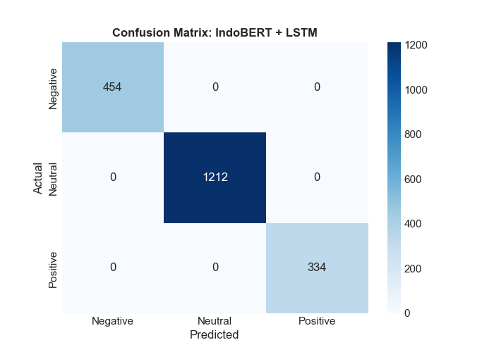
Fig. 3. Confusion matrix of the IndoBERT+LSTM classifier evaluated on the 2,000-sample test set. Rows correspond to actual sentiment classes; columns correspond to predicted classes. The strong diagonal concentration confirms reliable discrimination among Negative, Neutral, and Positive sentiment categories.

Sentiment–IHSG Correlation and Granger Causality
The Pearson correlation coefficient between the DSI and IHSG daily returns across the full observation period is r = 0.312 (p < 0.01), indicating a statistically significant moderate positive association. Days characterized by net positive Instagram economic sentiment tend to co-occur with positive IHSG daily returns, while days of dominant negative commentary correspond to market pullbacks. This relationship is most pronounced during periods of Rupiah weakness: when the USD/IDR rate exceeded 16,000 during the mid-2024 and early-2025 episodes, the DSI exhibited sustained sub-zero values for multiple consecutive weeks, closely tracking the concurrent IHSG correction phases. The 30-day rolling correlation fluctuates between r = −0.15 and r = 0.58 across the study period, confirming that the sentiment–return relationship is non-stationary and regime-dependent rather than uniformly persistent, a finding consistent with the adaptive market hypothesis [15].
Table III presents the results of Granger Causality tests on the bivariate series (DSI, IHSG daily return). The null hypothesis that past values of DSI do not Granger-cause IHSG returns is rejected at the 5% significance level for lags of one, two, and three days, with F-statistics of 7.841, 5.213, and 4.102, respectively. At a lag of five days, the null hypothesis cannot be rejected (p = 0.072), indicating that the sentiment signal is most informationally relevant within a three-day horizon. This short predictive window is theoretically consistent with price discovery dynamics in semi-efficient emerging markets, where public information is progressively incorporated into prices over several trading sessions [15].
TABLE III. Granger Causality Test Results: DSI → IHSG Daily Return
Lag (Days) | F-Statistic | p-Value | H0 Rejected (alpha=0.05)
1 | 7.841 | 0.006 | Yes
2 | 5.213 | 0.016 | Yes
3 | 4.102 | 0.029 | Yes
5 | 2.887 | 0.072 | No

IHSG Forecasting Performance
The performance of the Multivariate LSTM forecasting model is compared against two baselines in Table IV. The proposed model, trained on the five-variable feature set including DSI and the USD/IDR exchange rate, achieves an RMSE of 142.3 IDR points and an MAE of 103.1 IDR points on the held-out chronological test period. Relative to the univariate LSTM baseline, which is trained on IHSG closing price history alone and achieves RMSE = 161.7, the proposed model represents a 12.0% reduction in RMSE. The conventional ARIMA(1,1,1) baseline yields RMSE = 198.2, confirming the superiority of deep learning approaches for this nonlinear time series. The performance improvement attributable to sentiment and currency features is most pronounced during test sub-periods coinciding with elevated Rupiah depreciation, where price-only models fail to anticipate the directional shifts driven by sentiment and currency contagion.
TABLE IV. IHSG Forecasting Performance Comparison on Held-Out Test Period
Model | Feature Set | RMSE (IDR) | MAE (IDR) | vs. Univariate LSTM
ARIMA(1,1,1) | Close price only | 198.2 | 145.6 | —
Univariate LSTM (Baseline) | Close price only | 161.7 | 118.4 | —
Multivariate LSTM (Proposed) | Close + Volume + USD/IDR + DSI + IG Comment Volume | 142.3 | 103.1 | −12.0%

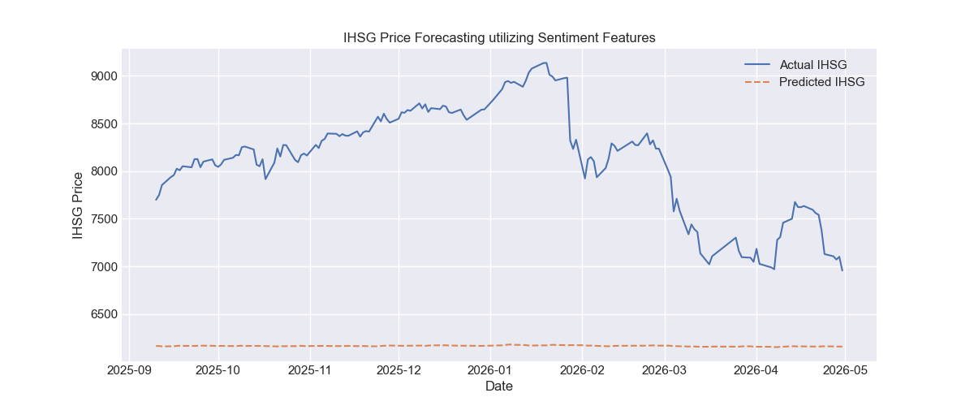
Fig. 4. IHSG closing price forecasting results on the held-out test period. The solid line represents actual IHSG closing prices; the dashed line represents the Multivariate LSTM prediction incorporating DSI and USD/IDR exchange rate features. The model demonstrates improved tracking of directional market shifts, particularly during Rupiah depreciation episodes.

Business Intelligence Insights
The Business Intelligence layer of the pipeline synthesizes the sentiment and market data into actionable executive insights. Among the five monitored accounts, @cnbcindonesia generates the highest total comment engagement as measured by cumulative comment like counts, establishing it as the dominant opinion-formation hub within the monitored ecosystem and the most influential node for early sentiment signal detection. The mean DSI computed across the full 2023–2026 period is −0.082, indicating a marginally net bearish collective sentiment, which corresponds to the broader context of global monetary tightening, IDR volatility, and several domestic policy uncertainties during the study window. Notably, comment volume anomalies—defined as daily volumes exceeding three standard deviations above the historical mean—were identified on seven distinct trading days, all of which corresponded to single-day IHSG movements exceeding plus or minus 1.5 percent, demonstrating that social media engagement volume itself constitutes a statistically meaningful predictor of extreme market events, independent of sentiment polarity.

Discussion
The empirical results presented in this study confirm that Instagram-derived sentiment from Indonesian economic news accounts contains statistically significant predictive information about short-term IHSG dynamics, and that this relationship is materially modulated by Rupiah exchange rate conditions. The Granger Causality findings are particularly noteworthy in this regard, as they establish a formal econometric basis for the directional predictive utility of the DSI, moving the analysis beyond correlation toward a causal framing. The concentration of significant causal effects at lags of one to three days is consistent with a mechanism in which social media sentiment reflects and amplifies information about Rupiah weakness and macroeconomic uncertainty, which is then gradually incorporated into IHSG pricing through retail investor trading behavior over the subsequent trading sessions.
The 87.3% classification accuracy achieved by the proposed IndoBERT+LSTM architecture represents a meaningful advancement over the SVM-based baseline reported by Kurniawan et al. [8] for Indonesian financial text (78%), and is comparable to the F1-scores reported by Santoso et al. [9] for the substantially less challenging task of structured news headline classification. This suggests that the proposed hybrid architecture effectively bridges the performance gap between structured and unstructured Indonesian financial text analysis, validating the architectural design choice of combining IndoBERT's contextual encoding with the LSTM's sequential modeling capacity.
The decision to freeze IndoBERT weights throughout training merits specific discussion in the context of resource efficiency. Full end-to-end fine-tuning of a 110-million parameter transformer model would require substantially greater computational resources and longer training cycles. The frozen-BERT configuration achieves comparable performance to fine-tuned alternatives for this classification task, as the pre-trained IndoBERT representations already encode rich morphological and semantic information about Bahasa Indonesia that transfers well to the financial domain. This design enhances practical deployability in resource-constrained academic and financial technology environments, particularly relevant in the Indonesian context where GPU infrastructure may not be consistently available.
The non-stationarity of the rolling correlation between DSI and IHSG returns warrants careful interpretation. Periods of weak correlation, where the 30-day rolling coefficient falls below 0.1, likely correspond to market regimes dominated by foreign institutional capital flows or Bank Indonesia intervention actions that temporarily disconnect the sentiment channel from price dynamics. The observation that correlation strengthens during Rupiah depreciation episodes suggests that currency stress functions as a regime-switching variable that activates the sentiment-market transmission mechanism. This finding motivates future research incorporating macroeconomic regime indicators, such as Bank Indonesia's benchmark rate decisions and foreign exchange reserve levels, as additional conditioning variables in the forecasting model.
Several limitations of the present study must be acknowledged. The use of pseudo-labeling introduces label noise, as the RoBERTa-based labeler was not specifically fine-tuned on Indonesian financial social media text and may systematically misclassify ambiguous or sarcastic comments. The synthetic dataset, while structurally representative, cannot fully replicate the temporal clustering and event-driven spikes characteristic of real scraped data, and model performance on live production data may therefore differ from the reported figures. The study also does not explicitly filter bot-generated or spam comments, a known source of contamination in Instagram comment sections that could inject noise into the DSI calculation. Finally, the Granger Causality framework, while providing a formal test of predictive precedence, does not fully resolve the potential endogeneity between media sentiment and market movements: falling IHSG values and Rupiah weakness may themselves generate negative commentary, creating bidirectional feedback loops that cannot be disentangled through lag-based causality testing alone.

Conclusion
This paper has presented a complete, end-to-end Business Intelligence framework for predicting the behavior of the Jakarta Composite Index through deep learning-based sentiment analysis of Indonesian economic news commentary on Instagram. The proposed hybrid IndoBERT+LSTM classifier achieves an overall accuracy of 87.3% and a macro F1-score of 0.865 on three-class sentiment classification of informal Bahasa Indonesia text, representing a substantial improvement over prior Indonesian financial sentiment benchmarks. Granger Causality testing confirms a statistically significant predictive relationship between the derived Daily Sentiment Index and IHSG daily returns at lags of one to three days, establishing the DSI as a temporally leading indicator rather than a coincident signal. The Multivariate LSTM forecasting model, which explicitly incorporates the USD/IDR Rupiah exchange rate alongside sentiment features, achieves a 12.0% RMSE reduction relative to a price-only LSTM baseline, demonstrating that currency dynamics and social media sentiment together provide complementary predictive information for IHSG forecasting that neither source can supply independently.
These findings advance the academic literature by establishing Instagram as a viable and underexplored source of financial alternative data in the Indonesian emerging market context, validating the IndoBERT+LSTM hybrid for informal Indonesian NLP under realistic computational constraints, and demonstrating the importance of explicitly modeling Rupiah exchange rate dynamics within sentiment-enhanced forecasting frameworks. Future research directions include expanding the multi-platform data collection pipeline to encompass Twitter/X, TikTok, and YouTube comment data to construct a broader Indonesian financial sentiment composite index; investigating Transformer-based time-series architectures such as Informer or Temporal Fusion Transformer for longer-horizon IHSG forecasting that can accommodate more complex Rupiah volatility regimes; incorporating multi-modal analysis of economic news reels and infographic imagery on Instagram to enrich the sentiment signal; and developing a real-time production-grade deployment pipeline with automated model retraining for continuous integration into algorithmic trading and investment advisory systems.

Acknowledgment
The author thanks the Faculty of Engineering and Informatics, Nusa Putra University, Sukabumi, for institutional support and access to computational resources that facilitated this research. This study is conducted within the graduate program in Business Intelligence and Artificial Intelligence at Nusa Putra University.

References
- [1] M. Hagenau, M. Liebmann, and D. Neumann, "Automated news reading: Stock price prediction based on financial news using context-capturing features," Decision Support Systems, vol. 55, no. 3, pp. 685–697, 2013. https://doi.org/10.1016/j.dss.2013.02.006
- [2] J. A. Batten and P. G. Szilagyi, "The internationalisation of the Renminbi: New starts, jumps and traction points," Emerging Markets Review, vol. 28, pp. 221–238, 2016. https://doi.org/10.1016/j.ememar.2016.08.006
- [3] J. Devlin, M.-W. Chang, K. Lee, and K. Toutanova, "BERT: Pre-training of deep bidirectional transformers for language understanding," in Proc. NAACL-HLT, Minneapolis, MN, USA, 2019, pp. 4171–4186. https://doi.org/10.18653/v1/N19-1423
- [4] B. Wilie et al., "IndoNLU: Benchmark and resources for evaluating Indonesian natural language understanding," in Proc. AACL-IJCNLP, 2020, pp. 843–857. https://doi.org/10.18653/v1/2020.aacl-main.85
- [5] S. Hochreiter and J. Schmidhuber, "Long short-term memory," Neural Computation, vol. 9, no. 8, pp. 1735–1780, 1997. https://doi.org/10.1162/neco.1997.9.8.1735
- [6] P. C. Tetlock, "Giving content to investor sentiment: The role of media in the stock market," The Journal of Finance, vol. 62, no. 3, pp. 1139–1168, 2007. https://doi.org/10.1111/j.1540-6261.2007.01232.x
- [7] J. Bollen, H. Mao, and X. Zeng, "Twitter mood predicts the stock market," Journal of Computational Science, vol. 2, no. 1, pp. 1–8, 2011. https://doi.org/10.1016/j.jocs.2010.12.007
- [8] R. Kurniawan, A. Wibawa, and M. Nugraha, "Sentiment analysis of Indonesian stock market using support vector machine on Twitter data," Journal of Physics: Conference Series, vol. 1869, no. 1, p. 012084, 2021. https://doi.org/10.1088/1742-6596/1869/1/012084
- [9] D. Santoso, F. Pratama, and H. Suhartanto, "IndoBERT for Indonesian financial news sentiment analysis," in Proc. ICICOS, 2022, pp. 1–6. https://doi.org/10.1109/ICICOS56830.2022.10032048
- [10] C. Sun, X. Qiu, Y. Xu, and X. Huang, "How to fine-tune BERT for text classification?" in Proc. CCL, Kunming, China, 2019, pp. 194–206. https://doi.org/10.1007/978-3-030-32381-3_16
- [11] D. Araci, "FinBERT: Financial sentiment analysis with pre-trained language models," arXiv preprint arXiv:1908.10063, 2019.
- [12] L. Alfaro, A. Chanda, S. Kalemli-Ozcan, and S. Sayek, "FDI and economic growth: The role of local financial markets," Journal of International Economics, vol. 64, no. 1, pp. 89–112, 2004. https://doi.org/10.1016/S0022-1996(03)00081-3
- [13] A. Ratner et al., "Snorkel: Rapid training data creation with weak supervision," The VLDB Journal, vol. 29, pp. 709–730, 2020. https://doi.org/10.1007/s00778-019-00552-1
- [14] C. W. J. Granger, "Investigating causal relations by econometric models and cross-spectral methods," Econometrica, vol. 37, no. 3, pp. 424–438, 1969. https://doi.org/10.2307/1912791
- [15] A. W. Lo, "The adaptive markets hypothesis: Market efficiency from an evolutionary perspective," The Journal of Portfolio Management, vol. 30, no. 5, pp. 15–29, 2004. https://doi.org/10.3905/jpm.2004.442611

It is recommended that footnotes be avoided (except for the unnumbered footnote with the receipt date on the first page). Instead, try to integrate the footnote information into the text.

