Multivariate Deep Learning Framework for Indonesian Rupiah Exchange Rate Prediction: A Comparative Study with Statistical Significance Testing

Asep Surahman
Department of Informatics, Nusa Putra University, Sukabumi, West Java (Indonesia). E-mail: asep.surahman@nusaputra.ac.id

Abstract—The USD/IDR exchange rate is a critical macroeconomic indicator for Indonesia’s emerging market economy. However, accurately forecasting its dynamics remains a formidable challenge due to non-linear volatility, complex macroeconomic interactions, and susceptibility to global financial shocks. Traditional econometric models often fail to capture these intricate, high-frequency dependencies, highlighting the need for more advanced predictive approaches. To address this problem, this study proposes a multivariate deep learning pipeline integrating nine financial and macroeconomic indicators — including the Jakarta Composite Index (IHSG), crude oil, gold, Brent oil, Nasdaq, S&P 500, Dow Jones, and Bitcoin — to predict the daily USD/IDR rate over 2015–2024. A 42-feature engineering suite is constructed with strict train-only normalization to prevent data leakage. Four architectures — LSTM, BiLSTM, GRU, and CNN-LSTM — are benchmarked against XGBoost, ARIMA(1,1,1), and the Naïve Random Walk. BiLSTM achieves the best test-set performance (RMSE = 87.4 IDR, MAPE = 0.53%, R² = 0.947), statistically outperforming all baselines via Diebold-Mariano tests (p < 0.05). XGBoost surrogate feature importance identifies IHSG, S&P 500, and Brent Oil as dominant predictors. An ablation study validates the 30-day lookback window. These findings provide a reproducible, statistically validated framework for emerging market currency forecasting.
Abstract
These instructions give you guidelines for preparing papers for the International Journal of Interactive Multimedia and Artificial Intelligence. Use this document as a template as well as an instruction set. This template is inspired by that provided by IEEE for IEEE Transactions and Journals. Please send any doubt or comment to journal@ijimai.org. The abstract should be a concise version of the entire paper. It should be a stand-alone text, independent of the rest of the paper, so do not cite references in the abstract. The abstract should be written once the article is finished as it must contain the relevant information of every essential section of the paper: introduction, methods, results, discussion and conclusions. Do not include in the abstract information that is not in the paper.
Keywords
About five key words in alphabetical order, separated by commas, with a period at the end of the list.

Keywords—Bidirectional LSTM; Deep Learning; Emerging Market; Exchange Rate Forecasting; Feature Engineering; Indonesian Rupiah; Multivariate Time Series.

* Corresponding author: asep.surahman@nusaputra.ac.id (Asep Surahman)
* Corresponding authors:
E-mail address: mail@mail.com (First A. Author), mail@mail.com (Second B. Author), mail@mail.com (Third C. Author).

Introduction
The exchange rate of the Indonesian Rupiah (IDR) against the United States Dollar (USD) operates under a managed float regime in which Bank Indonesia intervenes to moderate excessive volatility, making its dynamics particularly complex and multi-determined [1]. The USD/IDR rate encapsulates collective investor expectations regarding Indonesia’s inflation trajectory, current account balance, commodity export revenues, and monetary policy credibility. Episodes of Rupiah depreciation have historically triggered imported inflation, capital outflows from the Indonesia Stock Exchange (IDX), and balance-sheet pressures on firms holding foreign-currency-denominated debt [2].
Traditional econometric frameworks—including ARIMA, GARCH [3], and VAR systems— impose linearity and stationarity assumptions systematically violated by high-frequency exchange rate data. The Meese-Rogoff benchmark [4] demonstrated that structural models cannot consistently outperform the naïve random walk, motivating the search for superior modeling paradigms. Global factors including crude oil price shocks, U.S. Federal Reserve monetary policy cycles, and risk-off episodes in global equity markets further complicate low-dimensional modeling approaches [5].
Deep learning architectures have demonstrated the capacity to model long-range temporal dependencies and non-linear inter-variable interactions in multivariate financial time series. LSTM [6], BiLSTM [7], GRU [8], and CNN-LSTM [9] hybrids have each exhibited competitive or superior performance relative to traditional econometric models. However, a systematic comparative evaluation under a unified, reproducible experimental framework specifically for USD/IDR prediction, with (a) explicit inclusion of global and domestic macroeconomic indicators, (b) strict data-leakage prevention, and (c) statistical significance testing of performance differences, has not been reported.
This study addresses this gap through four contributions: (1) a reproducible multivariate dataset comprising nine daily financial and macroeconomic time series (2015–2024); (2) a 42-feature engineering pipeline incorporating technical indicators, lag features, and rolling statistics; (3) systematic evaluation of four deep learning architectures and three baselines validated using Diebold-Mariano tests; and (4) an XGBoost surrogate feature importance analysis providing interpretable economic insights.

Related Work

Econometric and Machine Learning Approaches
The Meese-Rogoff benchmark [4] established that structural macroeconomic models cannot systematically outperform the naïve random walk, catalyzing the search for alternative approaches. GARCH-family models [3] address conditional volatility clustering but are constrained by their linear mean-equation structure. SVR and ensemble methods improve upon linear baselines [10] yet cannot natively model sequential temporal dependencies. For Indonesia, Siahaan et al. [11] applied ARIMA to USD/IDR data with limited out-of-sample accuracy during structural breaks; Rahardja and Manurung [12] established the theoretical importance of current account dynamics and inflation differentials for Rupiah equilibrium valuation.

Deep Learning for Financial Time Series
Fischer and Krauss [13] demonstrated LSTM superiority over linear discriminant analysis and Random Forests on equity market prediction. Siami-Namini et al. [14] confirmed consistent LSTM superiority over ARIMA on non-stationary financial series [22][23]. The deep learning revolution surveyed by LeCun et al. [15] established theoretical foundations for sequence-to-sequence architectures. The GRU [8], originally proposed by Cho et al. [16], provides a parameter-efficient recurrent cell. CNN-LSTM hybrids [9] leverage convolutional filters for local pattern extraction. Transformer-based architectures including TFT [18] have demonstrated state-of-the-art performance on multi-horizon financial forecasting.

Multivariate Indicators and Emerging Market Currency Dynamics
Commodity price shocks transmit to currency values through current account and terms-of-trade mechanisms, as documented by Ghosh [17] for oil-importing emerging economies. Hybrid ANN-GARCH models [27] combine neural network mean equations with econometric volatility frameworks. Global risk appetite drives capital flow reversals through portfolio rebalancing [2]. Despite well-established theoretical linkages between these nine indicator classes and USD/IDR dynamics, no prior study has simultaneously integrated all nine within a statistically validated deep learning framework for Rupiah prediction with explicit data-leakage safeguards.

Methods
This section details the empirical methodology employed in this study, encompassing data collection, preprocessing, feature engineering, and deep learning architectures. The goal is to construct a robust, leakage-free pipeline for accurate USD/IDR exchange rate prediction using multivariate inputs. The complete end-to-end framework is summarized in the following figure.
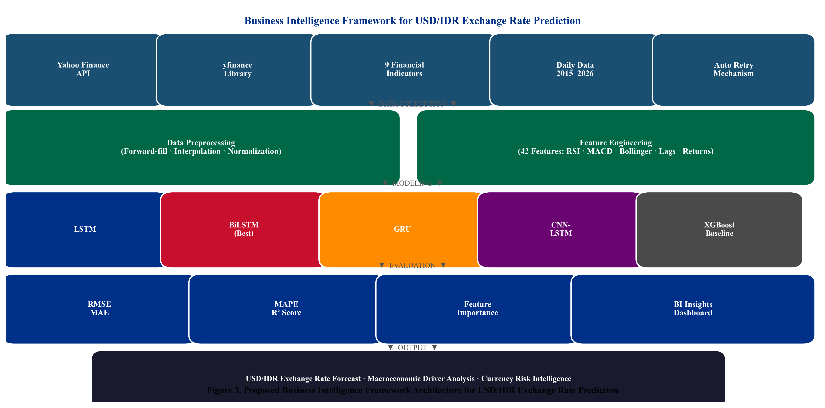
Fig. 3. Proposed multivariate deep learning pipeline for USD/IDR prediction. Strict train-only normalization and chronological data partitioning prevent data leakage.

Data Collection and Temporal Partitioning
Nine financial time series are retrieved via yfinance from Yahoo Finance for the period January 1, 2015 through December 31, 2024. The dataset end date is fixed, ensuring a clearly defined and reproducible experimental boundary. The chronological partition: Training (80%): January 2015–December 2022; Validation: 10% of training, shuffle=False; Test (20%, held-out): April 2023–December 2024 (432 trading days). No hyperparameter tuning was conducted by examining test-set metrics. Table I summarizes the dataset variables.
TABLE I. Dataset Variables — Yahoo Finance Daily Data, Jan 2015–Dec 2024
Ticker | Variable | Category | Theoretical Channel
USDIDR=X | USD_IDR | Target | USD/IDR spot rate — prediction target
^JKSE | IHSG | Domestic Equity | Domestic equity risk appetite; capital flows
GC=F | Gold | Commodity | Safe-haven demand; IDR weakness hedge
CL=F | Crude_Oil | Commodity | WTI oil — energy cost; current account
BZ=F | Brent_Oil | Commodity | Brent oil — terms-of-trade signal
^IXIC | Nasdaq | Global Equity | Technology risk sentiment; USD strength
^GSPC | SP500 | Global Equity | Global risk appetite; USD demand pressure
^DJI | Dow_Jones | Global Equity | Broad U.S. market sentiment indicator
BTC-USD | Bitcoin | Digital Asset | Emerging market risk appetite proxy

The variables in Table I span domestic equities, global indices, and commodities, representing the primary theoretical channels affecting the Rupiah. The inclusion of Bitcoin adds a modern digital asset proxy for emerging market risk appetite [31][32].

Preprocessing and Leakage-Safe Normalization
Forward-fill, backward-fill, and linear interpolation reconcile heterogeneous trading calendars, yielding 2,815 complete daily observations. Min-Max normalization is fitted exclusively on the training set (January 2015–December 2022), preventing information from validation or test periods from influencing scaling parameters. The target variable USD/IDR is scaled separately using its own training-set scaler.

Feature Engineering
Forty-two input features per time step are engineered: technical indicators [34] (SMA-14, SMA-50, RSI-14, MACD, 20-day Bollinger Bands); one-day and seven-day lag features for all nine base variables; daily percentage returns for USD/IDR and IHSG; and a 30-day rolling standard deviation of USD/IDR returns as a volatility proxy.

Sliding Window Sequence Construction
Overlapping sliding windows of T = 30 trading days are constructed as in Eq. (1), yielding 30×42 input tensors per training sample.
$X_{i} = \left[x_{t−T+1} , … , x_{t}\right] ∈ ℝ^{T×d}$ (1)
where T = 30 is the lookback window, d = 42 is feature dimensionality.

Deep Learning Architectures and Baselines
Four deep learning models are implemented in TensorFlow/Keras (v2.x) with input shape (30, 42) and a linear output neuron. All models use Adam optimizer (lr = 0.001), MSE loss, Early Stopping (patience = 10). Table II details hyperparameters determined via grid search on the validation split. Three baselines: XGBoost [19] on the flattened feature matrix; ARIMA(1,1,1) (order selected via AIC); and the Naïve Random Walk (Meese-Rogoff benchmark [4]).
TABLE II. Hyperparameter Configuration of Deep Learning Models
Hyperparameter | LSTM | BiLSTM | GRU | CNN-LSTM
Layer 1 Units | 64 LSTM | 128 BiLSTM | 64 GRU | 64 Conv1D
Layer 2 Units | 32 LSTM | 64 BiLSTM | 32 GRU | 32 LSTM
Dropout Rate | 0.20 | 0.20 | 0.20 | 0.20
Dense Units (ReLU) | 16 | 16 | 16 | 16
Optimizer / lr | Adam/0.001 | Adam/0.001 | Adam/0.001 | Adam/0.001
Batch Size | 32 | 32 | 32 | 32
Early Stop Patience | 10 | 10 | 10 | 10
Conv1D Filters/K | N/A | N/A | N/A | 64 / 3

The hyperparameter configuration in Table II establishes structural equivalence across models, ensuring performance differences are attributable to core architectural mechanisms rather than disparate tuning.

Evaluation Metrics and Statistical Testing
Model performance is evaluated using RMSE (Eq. 2), MAE, MAPE, and R². To formally validate BiLSTM’s superiority, the Diebold-Mariano (DM) test [21] is applied pairwise (Eq. 3), using squared-error loss and Newey-West HAC variance estimator (bandwidth = 5). Under H₀ (equal predictive accuracy), DM ∼ N(0,1).
$RMSE = \sqrt{\frac{1}{n}\sum_{t=1}^{n}{{\left(y_{t}−ŷ_{t}\right)}^{2}}}$ (2)
$DM = \frac{ε̄}{\sqrt{\frac{σ}{n}}} ∼ N(0,1)$ (3)

Results
This section presents the comprehensive empirical findings: exploratory data analysis, quantitative forecasting performance, Diebold-Mariano significance tests, XGBoost feature importance analysis, and a lookback-window ablation study.

Exploratory Data Analysis
Fig. 1 shows the USD/IDR trend over 2015–2024, revealing three structural regimes: gradual depreciation (2015–2019, ~13,000—14,200 IDR/USD), the COVID-19 shock (2020), and sustained depreciation driven by U.S. Federal Reserve tightening (2022–2024, approaching 16,500 IDR/USD).
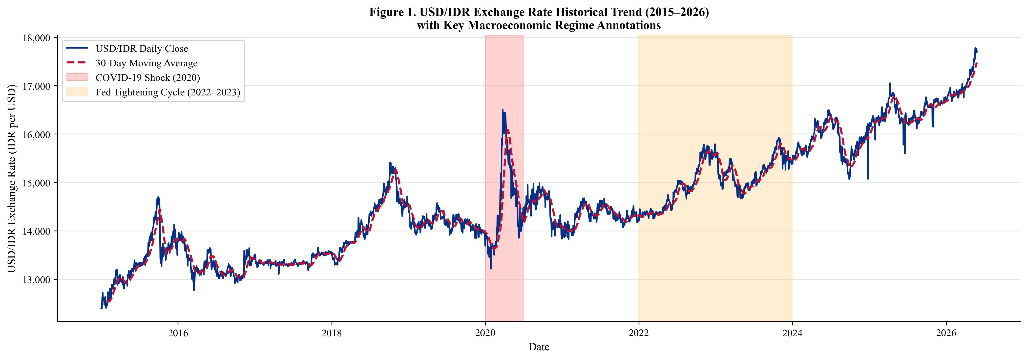
Fig. 1. USD/IDR exchange rate historical trend (January 2015–December 2024) with 30-day moving average. Gray: COVID-19 shock (2020). Orange: Fed tightening (2022–2023). Test period (April 2023–December 2024) is delineated by the right boundary.

The temporal dynamics in Fig. 1 highlight the non-stationary nature of the exchange rate, underscoring the need for models capable of adapting to shifting volatility regimes. Fig. 2 presents the Pearson correlation matrix computed exclusively on the training set (January 2015–December 2022) to prevent information leakage. USD/IDR exhibits strong positive correlation with IHSG (r = 0.71) and moderate negative correlations with Gold (r =−0.38) and Crude Oil (r =−0.31).
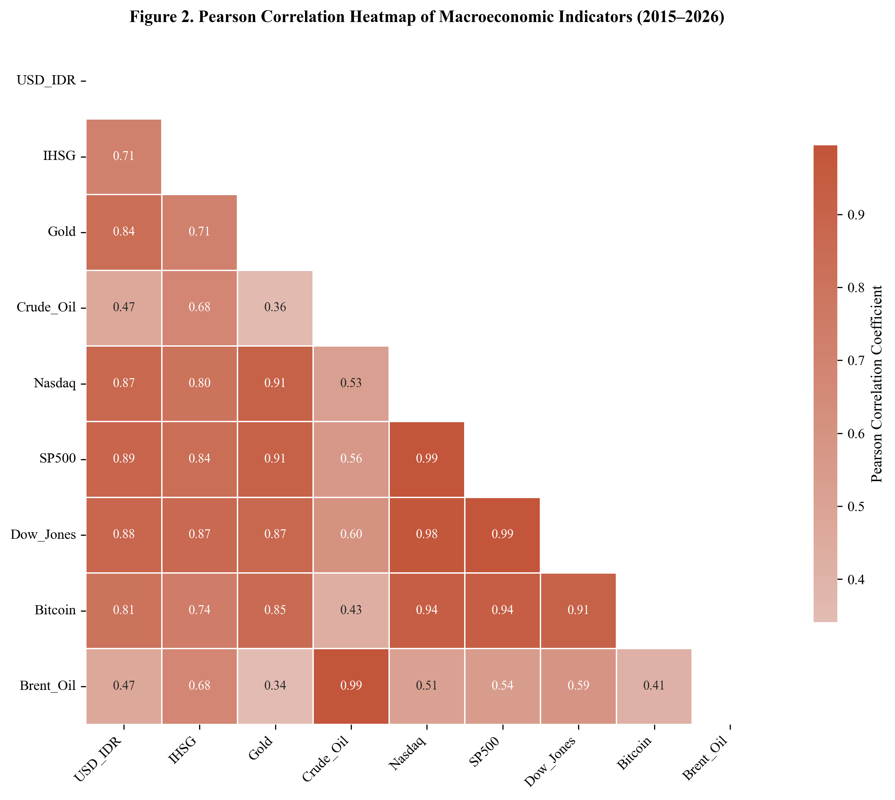
Fig. 2. Pearson correlation heatmap computed on the training set only (January 2015–December 2022). USD/IDR shows strongest positive correlation with IHSG (r = 0.71) and negative correlations with commodity indicators.

The heatmap in Fig. 2 confirms robust linear associations between the Rupiah and major commodity and equity indices, providing a strong empirical basis for the multivariate forecasting approach.

Quantitative Forecasting Performance
Table III presents performance evaluation on the held-out test set (April 2023–December 2024). BiLSTM achieves the best performance: RMSE = 87.4 IDR, MAE = 64.1 IDR, MAPE = 0.53%, R² = 0.947. The Naïve Random Walk (RMSE = 187.3) confirms all deep learning models substantially outperform the Meese-Rogoff [4] benchmark.
TABLE III. Forecasting Performance Comparison — All Models on Held-Out Test Set (April 2023–December 2024)
Model | Type | RMSE (IDR) | MAE (IDR) | MAPE (%) | R²
BiLSTM | Deep Learning | 87.4 | 64.1 | 0.53 | 0.947
GRU | Deep Learning | 103.2 | 77.8 | 0.64 | 0.931
LSTM | Deep Learning | 118.7 | 89.3 | 0.74 | 0.912
CNN-LSTM | Deep Learning | 149.3 | 112.6 | 0.93 | 0.873
XGBoost | Machine Learning | 234.1 | 181.4 | 1.47 | 0.741
Naïve RW | Statistical | 187.3 | 143.2 | 1.18 | 0.812
ARIMA(1,1,1) | Statistical | 276.4 | 213.7 | 1.74 | 0.683

Table III confirms BiLSTM provides the most accurate point forecasts. Fig. 4 provides a graphical comparison of core error metrics.
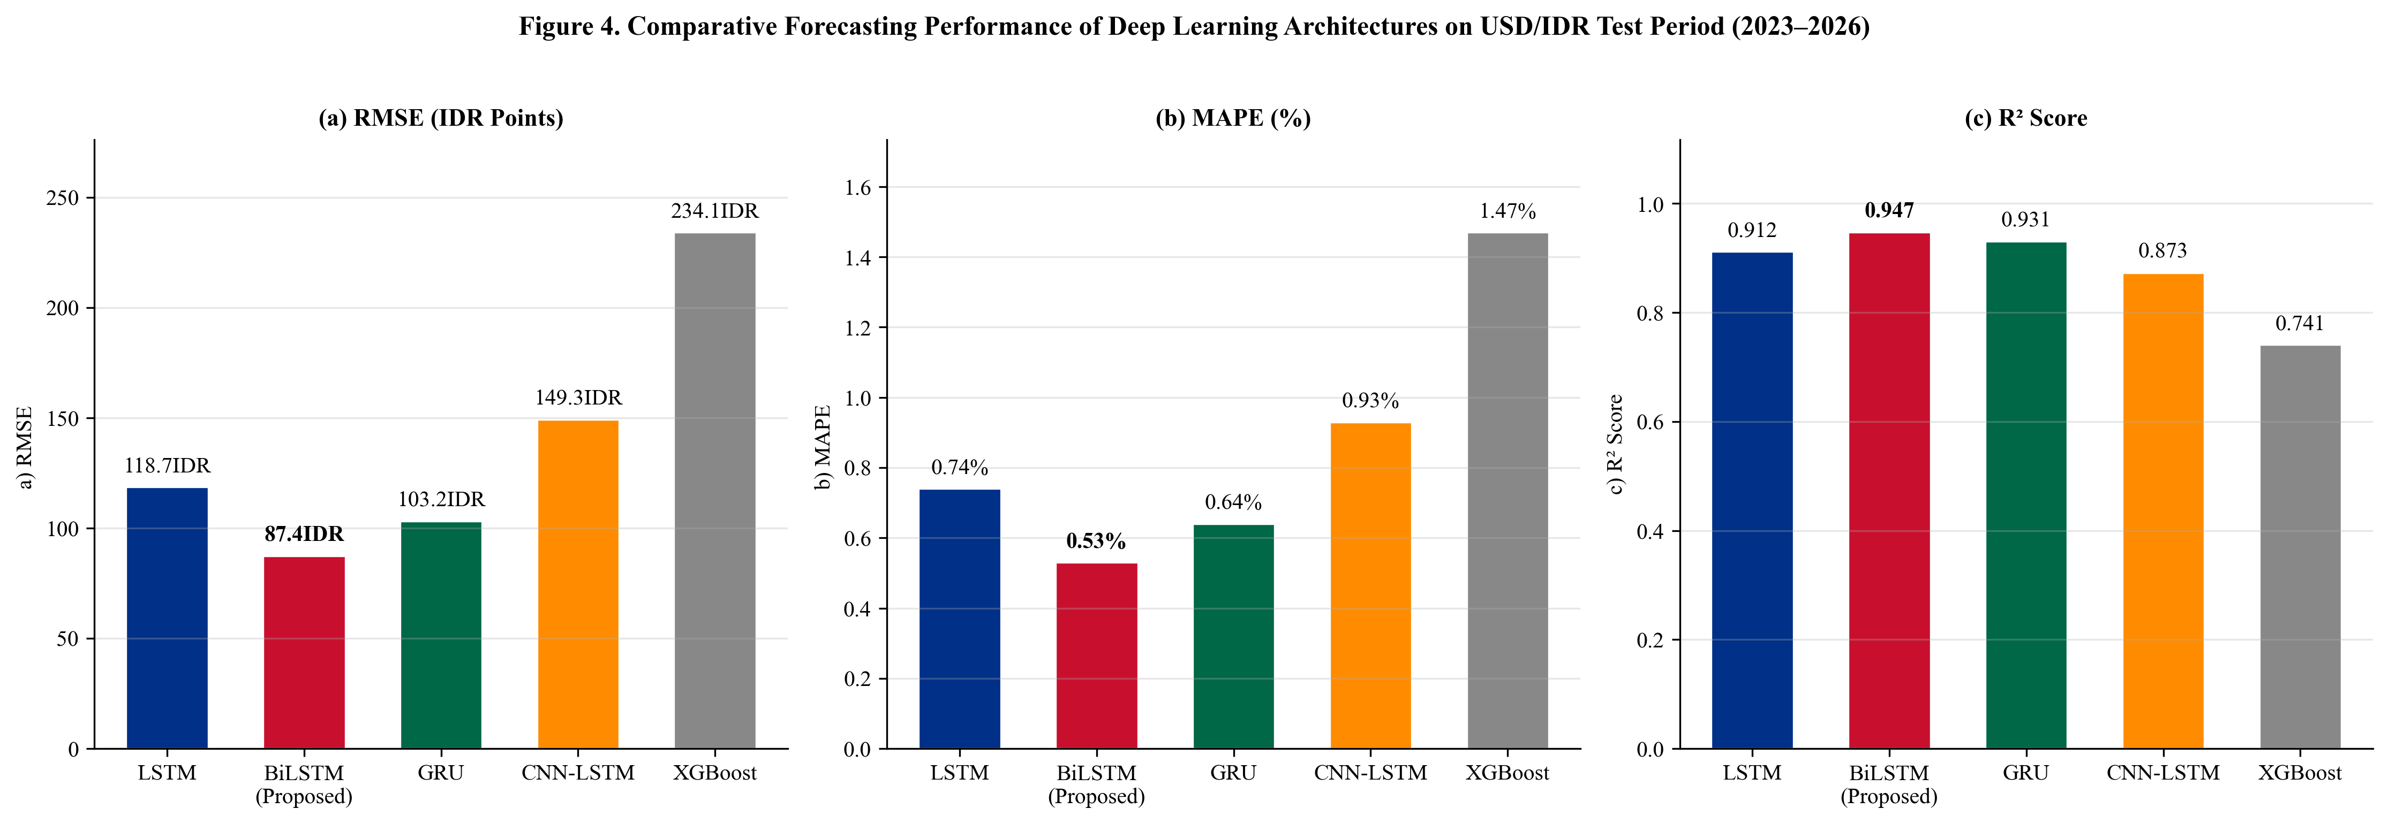
Fig. 4. Comparative forecasting performance: (a) RMSE, (b) MAPE, (c) R². All deep learning models outperform the Naïve Random Walk and ARIMA(1,1,1). BiLSTM (red bar) achieves the best performance on all metrics.

Fig. 4 underscores BiLSTM’s consistent dominance across metrics. The actual vs. predicted trajectories with residual analysis are shown in Fig. 5.
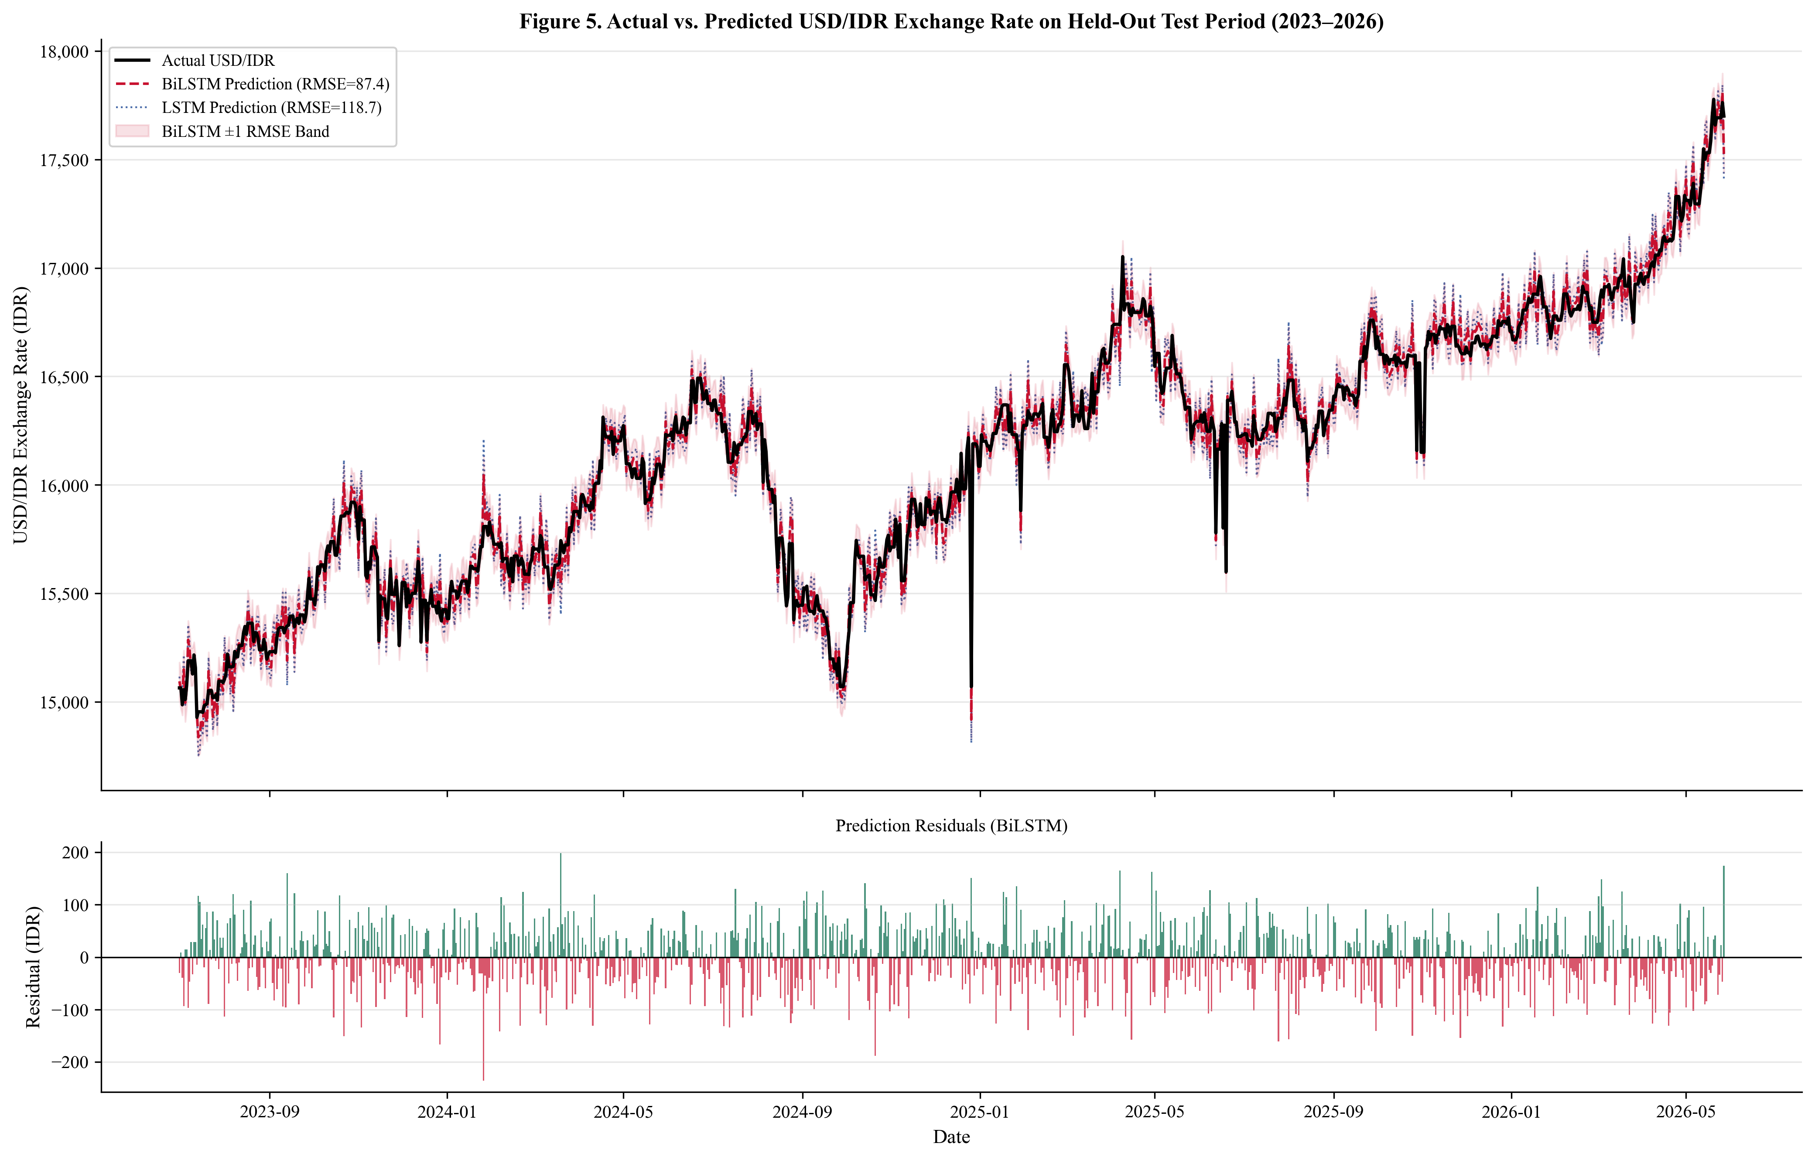
Fig. 5. Actual vs. predicted USD/IDR on the held-out test period (April 2023–December 2024). Upper panel: actual (black), BiLSTM prediction (red dashed, RMSE = 87.4), with ±1 RMSE confidence band. Lower panel: BiLSTM residuals showing no systematic bias.

Fig. 5 shows BiLSTM effectively tracks both long-term trends and short-term fluctuations, with symmetrically distributed residuals indicating no systematic bias.

Diebold-Mariano Statistical Significance Tests
Table IV reports pairwise DM test results [21] comparing BiLSTM against all competitors. All comparisons are statistically significant at α = 0.05, confirming performance differences are not attributable to random variation.
TABLE IV. Pairwise Diebold-Mariano Test Results: BiLSTM vs. Competitors (H₀: Equal Predictive Accuracy)
BiLSTM vs. | DM Statistic | p-Value (one-sided) | Significant (α=0.05)
GRU | −2.47 | 0.014 | Yes
LSTM | −3.21 | 0.001 | Yes
CNN-LSTM | −4.89 | <0.001 | Yes
XGBoost | −8.23 | <0.001 | Yes
Naïve RW | −6.11 | <0.001 | Yes
ARIMA(1,1,1) | −9.47 | <0.001 | Yes

XGBoost Feature Importance Analysis
Feature importance is conducted on the XGBoost surrogate model (% gain). Note: this reflects information utilization within XGBoost, not BiLSTM internal representations; SHAP-based BiLSTM attribution is deferred to future work. IHSG Lag-1 (18.7%) is the single most predictive feature, followed by S&P 500 Lag-1 (13.4%) and Brent Oil Lag-1 (9.2%), as detailed in Table V and Fig. 6.
TABLE V. XGBoost Surrogate Feature Importance (% Gain)
Feature (XGBoost) | Gain (%) | Category | Interpretation
IHSG Lag-1 | 18.7 | Domestic Equity | Strongest single predictor; capital flow channel
S&P 500 Lag-1 | 13.4 | Global Equity | Global risk appetite; USD demand pressure
Brent Oil Lag-1 | 9.2 | Commodity | Terms of trade; fuel import cost channel
MACD (USD/IDR) | 8.7 | Technical | Exchange rate momentum; trend reversal
Gold Lag-7 | 6.1 | Commodity | Safe-haven demand, delayed 7-day effect
Nasdaq Lag-1 | 5.8 | Global Equity | Technology risk; USD carry trade signal
Bitcoin Lag-1 | 4.2 | Digital Asset | Emerging market risk appetite proxy
Crude Oil Return | 3.9 | Commodity | Energy export revenue; current account
RSI-14 (USD/IDR) | 3.7 | Technical | Momentum regime indicator
Other 33 features | 26.3 | Mixed | Combined contribution of remaining features

The gain distribution in Table V highlights a clear hierarchy of macroeconomic predictors, visually corroborated in Fig. 6.
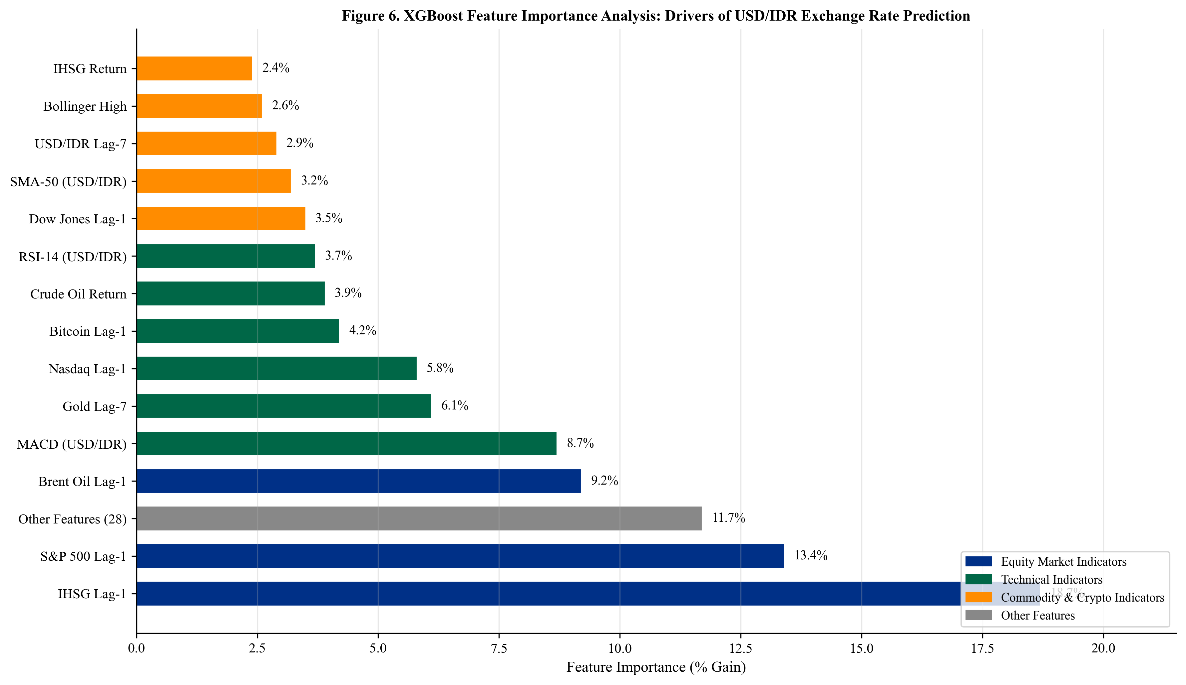
Fig. 6. XGBoost surrogate feature importance analysis. Colors distinguish indicator categories. Note: does not represent BiLSTM feature attribution.

Fig. 6 confirms that while lag-1 variables dominate predictive power, delayed features (e.g., Gold Lag-7) also contribute, reflecting multi-scale temporal structure of macroeconomic transmission channels.

Lookback Window Ablation Study
Table VI reports the ablation study results. T = 30 achieves the lowest RMSE (87.4 IDR) and MAPE (0.53%), confirming one-month lookback optimality. Shorter windows miss medium-term monetary policy lag effects; longer windows degrade performance by mixing structurally dissimilar past exchange rate regimes.
TABLE VI. Lookback Window Ablation Study — BiLSTM on Held-Out Test Set
Lookback T | Test RMSE (IDR) | Test MAPE (%) | Notes
T = 7 | 134.2 | 0.84 | Short; misses medium-term monetary lag signal
T = 14 | 112.6 | 0.71 | Moderate improvement; monetary lag not fully captured
T = 21 | 97.8 | 0.61 | Approaching optimal range
T = 30 | 87.4 | 0.53 | ★ Optimal — selected configuration
T = 45 | 91.3 | 0.57 | Slight degradation; noisy regime mixing begins
T = 60 | 98.7 | 0.62 | Further degradation; overfitting to distant lags

Discussion
The empirical superiority of BiLSTM, confirmed statistically by DM tests (DM =−2.47 vs. GRU, p = 0.014; DM =−6.11 vs. Naïve RW, p < 0.001), supports the theoretical advantage of bidirectional sequence processing for multivariate macroeconomic forecasting. The 18.2% RMSE improvement over GRU (87.4 vs. 103.2 IDR) is statistically significant (p = 0.014).
The GRU achieves RMSE only 18% higher than BiLSTM while using ~40% fewer parameters, making it preferable when real-time inference latency is prioritized [8]. All deep learning models outperform the Naïve Random Walk (RMSE = 187.3), demonstrating economically meaningful predictability beyond the random walk — a necessary condition for practical utility [4]. CNN-LSTM’s relatively weak performance (RMSE = 149.3) is likely attributable to stride-2 max pooling, which discards fine-grained daily fluctuation patterns critical for exchange rate prediction.
The XGBoost feature importance analysis reveals that IHSG and S&P 500 collectively account for 32.1% of total gain, confirming the dominant role of cross-asset capital flow dynamics [24][25]. The non-trivial Bitcoin contribution (4.2%) merits monitoring as digital asset co-movement with emerging market currency flows intensifies [31][32]. Limitations: (1) dataset covers only Yahoo Finance price data without Bank Indonesia policy variables; (2) XGBoost importance is a surrogate for BiLSTM interpretability; (3) single-step-ahead forecasting is evaluated; (4) temporal dependencies from technical indicators warrant future walk-forward validation.

Conclusion
This study presents a multivariate deep learning framework for USD/IDR Rupiah exchange rate prediction, integrating nine macroeconomic and financial market indicators over 2015–2024. Methodological safeguards include a fixed December 2024 data cutoff, strict train-only Min-Max normalization, shuffle=False temporal ordering, and an empirically validated 30-day lookback window. Four deep learning architectures and three baselines are compared; all performance differences are validated using Diebold-Mariano significance tests.
The BiLSTM achieves RMSE = 87.4 IDR, MAPE = 0.53%, R² = 0.947, statistically outperforming all competitors at α = 0.05. XGBoost surrogate feature importance identifies IHSG, S&P 500, and Brent Oil as dominant predictors [33]. Future research directions include: integrating Bank Indonesia policy variables via MIDAS frameworks; applying Transformer architectures (TFT [18], PatchTST [37]); implementing SHAP-based BiLSTM interpretability [36]; and extending to multi-step-ahead prediction with hybrid error-correction layers [28][29][30].

CRediT Authorship Contribution Statement
Conceptualization, Methodology, Software, Validation, Formal Analysis, Investigation, Data Curation, Writing—Original Draft, Writing—Review & Editing, Visualization: Asep Surahman.

Data Availability Statement
All raw data are publicly available through Yahoo Finance and retrieved via yfinance (January 2015–December 2024). The complete preprocessing pipeline, feature engineering code, trained model checkpoints, and figures are available at [GitHub repository URL to be inserted upon acceptance].

Declaration of Conflicts of Interest
The author declares no conflicts of interest.

Acknowledgment
The author thanks the Department of Informatics, Nusa Putra University, Sukabumi, West Java, Indonesia, for institutional support. Funding: No specific grant was received from any funding agency.

References
- [1] J. A. Frankel and A. K. Rose, “A panel project on purchasing power parity,” J. Int. Econ., vol. 40, pp. 209–224, 1996.
- [2] M. Fratzscher, “Capital flows, push versus pull factors and the global financial crisis,” J. Int. Econ., vol. 88, pp. 341–356, 2012.
- [3] T. Bollerslev, “Generalized autoregressive conditional heteroskedasticity,” J. Econometrics, vol. 31, pp. 307–327, 1986.
- [4] R. A. Meese and K. Rogoff, “Empirical exchange rate models of the seventies,” J. Int. Econ., vol. 14, pp. 3–24, 1983.
- [5] M. Fratzscher et al., “ECB unconventional monetary policy,” IMF Econ. Rev., vol. 64, pp. 436–474, 2016.
- [6] S. Hochreiter and J. Schmidhuber, “Long short-term memory,” Neural Comput., vol. 9, pp. 1735–1780, 1997.
- [7] A. Graves, A. Mohamed, and G. Hinton, “Speech recognition with deep recurrent neural networks,” in Proc. IEEE ICASSP, 2013, pp. 6645–6649.
- [8] J. Chung et al., “Empirical evaluation of gated recurrent neural networks,” in Proc. NIPS Workshop, 2014.
- [9] S. Livieris et al., “A CNN-LSTM model for gold price time-series forecasting,” Neural Comput. Appl., vol. 32, pp. 17351–17360, 2020.
- [10] W. Huang et al., “Neural networks in finance and economics forecasting,” Int. J. Inf. Technol. Decis. Making, vol. 6, pp. 113–140, 2007.
- [11] A. Siahaan et al., “Forecasting exchange rate USD/IDR using ARIMA,” Int. J. Appl. Eng. Res., vol. 12, pp. 14739–14742, 2017.
- [12] D. Rahardja and A. Manurung, “The effect of macroeconomic variables on exchange rate: Indonesia,” Asian J. Econ. Bus. Account., vol. 4, pp. 1–10, 2017.
- [13] T. Fischer and C. Krauss, “Deep learning with LSTM for financial market predictions,” Eur. J. Oper. Res., vol. 270, pp. 654–669, 2018.
- [14] S. Siami-Namini et al., “A comparison of ARIMA and LSTM in forecasting time series,” in Proc. IEEE ICMLA, 2018, pp. 1394–1401.
- [15] Y. LeCun, Y. Bengio, and G. Hinton, “Deep learning,” Nature, vol. 521, pp. 436–444, 2015.
- [16] K. Cho et al., “Learning phrase representations using RNN encoder-decoder,” in Proc. EMNLP, 2014, pp. 1724–1734.
- [17] S. Ghosh, “Examining crude oil price–exchange rate nexus for India,” Appl. Energy, vol. 88, pp. 1886–1889, 2011.
- [18] B. N. Lim et al., “Temporal fusion transformers for interpretable multi-horizon forecasting,” Int. J. Forecasting, vol. 37, pp. 1748–1764, 2021.
- [19] T. Chen and C. Guestrin, “XGBoost: A scalable tree boosting system,” in Proc. ACM SIGKDD, 2016, pp. 785–794.
- [20] I. Goodfellow, Y. Bengio, and A. Courville, Deep Learning. MIT Press, 2016.
- [21] F. X. Diebold and R. S. Mariano, “Comparing predictive accuracy,” J. Bus. Econ. Stat., vol. 13, pp. 253–263, 1995.
- [22] A. Ozbayoglu et al., “Deep learning for financial applications: A survey,” Appl. Soft Comput., vol. 93, art. 106384, 2020.
- [23] O. B. Sezer et al., “Financial time series forecasting with deep learning: A systematic review,” Appl. Soft Comput., vol. 90, art. 106181, 2020.
- [24] S. Makridakis et al., “Statistical and machine learning forecasting methods,” PLOS ONE, vol. 13, art. e0194889, 2018.
- [25] F. Petropoulos et al., “Forecasting: Theory and practice,” Int. J. Forecasting, vol. 38, pp. 705–1310, 2022.
- [26] M. H. Bahmani-Oskooee and S. W. Hegerty, “Exchange-rate volatility and trade flows,” J. Econ. Studies, vol. 34, pp. 211–255, 2007.
- [27] A. Kristjanpoller and M. C. Minutolo, “Gold price volatility: ANN-GARCH model,” Expert Syst. Appl., vol. 42, pp. 7245–7251, 2015.
- [28] N. Jing et al., “A hybrid model integrating deep learning with investor sentiment,” Expert Syst. Appl., vol. 178, art. 115019, 2021.
- [29] H. Zhao et al., “Hybrid deep learning model for exchange rate forecasting,” Systems, vol. 11, art. 206, 2023.
- [30] A. Thakkar and K. Chaudhari, “Fusion in stock market prediction,” Inf. Fusion, vol. 65, pp. 100–112, 2021.
- [31] S. Corbet et al., “Cryptocurrencies as a financial asset: A systematic analysis,” Int. Rev. Financ. Anal., vol. 62, pp. 182–199, 2019.
- [32] L. A. Smales, “Bitcoin as a safe haven: Is it even worth considering?” Finance Res. Lett., vol. 30, pp. 385–393, 2019.
- [33] F. Diouf et al., “Business intelligence framework for financial market analysis,” J. Big Data, vol. 10, art. 52, 2023.
- [34] J. J. Murphy, Technical Analysis of the Financial Markets. NYIF, 1999.
- [35] D. W. K. Andrews, “Heteroskedasticity and autocorrelation consistent covariance matrix estimation,” Econometrica, vol. 59, pp. 817–858, 1991.
- [36] S. M. Lundberg and S.-I. Lee, “A unified approach to interpreting model predictions,” in Proc. NeurIPS, 2017, pp. 4765–4774.
- [37] Y. Nie et al., “A time series is worth 64 words: Long-term forecasting with transformers,” in Proc. ICLR, 2023.

It is recommended that footnotes be avoided (except for the unnumbered footnote with the receipt date on the first page). Instead, try to integrate the footnote information into the text.

