Deep Learning Framework for Cryptocurrency Price Prediction Using Business Intelligence

Asep Surahman Sulaeman¹, Deden Witarsyah², Aswan Supriyadi Sunge³
¹Master of Informatics, Faculty of Engineering, Computer, and Design, Nusa Putra University, Sukabumi, Indonesia
²Master of Informatics, Faculty of Engineering, Computer, and Design, Nusa Putra University, Sukabumi, Indonesia
³Informatics Engineering Department, Faculty of Engineering, Pelita Bangsa University, Bekasi, Indonesia

Article Info |  | ABSTRACT
Article history:  Received month dd, yyyy  Revised month dd, yyyy  Accepted month dd, yyyy |  | Cryptocurrency markets exhibit inherent volatility that complicates predictive modeling, demanding methods that bridge deep learning with enterprise decision support systems. This study proposes an automated, four-layer Business Intelligence pipeline embedding recurrent and transformer inferences into an enterprise decision support system to dynamically compute risk-adjusted metrics, including Sharpe Ratio and Value-at-Risk. Analyzing 43,786 hourly Bitcoin/USDT records spanning 2021–2026, we evaluated XGBoost, Long Short-Term Memory, Gated Recurrent Unit, and the Informer Transformer. Walk-Forward Validation established the Gated Recurrent Unit as the most accurate model with a Root Mean Square Error of 0.1058 (p < 0.001). However, the Business Intelligence integration revealed a critical trade-off: despite higher error, the Long Short-Term Memory network achieved superior Directional Accuracy of 72.3% and a Sharpe Ratio of 1.45, indicating that numerical error minimization does not inherently guarantee trading profitability. The prototype Microsoft Power BI dashboard demonstrated operational feasibility with an Excellent System Usability Scale score of 86.4, confirming that high-frequency neural forecasts can successfully drive real-world institutional risk management tools.
Keywords:
Business Intelligence
Informer Transformer
XGBoost
Long Short-Term Memory
Gated Recurrent Unit
Financial Informatics
This is an open access article under the CC BY-SA license.

Corresponding Author:
Asep Surahman Sulaeman
Master of Informatics, Faculty of Engineering, Computer, and Design, Nusa Putra University, Sukabumi, Indonesia
Email: asep.surahman@nusaputra.ac.id

- INTRODUCTION
Bitcoin (BTC) exhibits non-stationary behavior and sensitivity to macroeconomic shocks, complicating traditional forecasting [1], [2]. Conventional models such as ARIMA show limitations on volatile high-frequency data due to stationarity assumptions [3], [4]. The inherent complexity of cryptocurrency markets, driven by 24/7 trading cycles and speculative sentiment, further amplifies these forecasting challenges.
Data-driven neural networks have become preferred for modeling complex non-linear cryptocurrency sequences [5], [6], yet evaluating architectures purely on error metrics is insufficient for portfolio management [7], [8]. Recurrent architectures such as LSTM and GRU have demonstrated strong capacity for capturing temporal dependencies in price sequences [5], [6]. Nevertheless, purely error-centric evaluation frameworks often fail to account for the risk-adjusted profitability dimensions essential to institutional portfolio management [7], [8].
A critical gap exists between algorithmic accuracy and operational deployment within enterprise Business Intelligence (BI) platforms [9], requiring architectures that translate model outputs into actionable risk metrics [10]. Most existing studies benchmark models on RMSE or MAE without integrating outputs into live Business Intelligence dashboards [9]. Bridging this gap requires a unified pipeline that translates raw prediction tensors into actionable enterprise risk metrics [10].
To address this gap, this study proposes an end-to-end BI-Machine Learning framework mapping raw API feeds through automated Walk-Forward Validation into a production-ready Power BI dashboard, comparing XGBoost, LSTM, GRU, and the Informer Transformer on high-frequency hourly cryptocurrency data. Predictive applications in cryptocurrency analytics have transitioned from standard regression models toward more complex deep learning sequences. The framework is designed to be modular and reproducible, enabling straightforward substitution of alternative forecasting models or data sources.
Tree-based models such as Extreme Gradient Boosting (XGBoost) model tabular financial data effectively [11], [12] but lack temporal sequence memory [13]. The Long Short-Term Memory (LSTM) [14] addresses vanishing gradients via forget gates [15], while the Gated Recurrent Unit (GRU) [16] offers a simplified gating mechanism. Both are widely applied to crypto-asset tracking [17], [18].
$O(LlogL)$Transformer architectures relying on self-attention mechanisms [19] have increasingly been adapted for time-series forecasting [20]. The Informer Transformer [21], utilizing sparse probabilistic self-attention (O(L log L)), serves as the primary Transformer baseline in this study. While newer architectures such as PatchTST [22] and TimesNet [23] represent the current vanguard in multivariate modeling, the Informer provides a well-established, computationally stable benchmark. Transformers may nonetheless suffer from overfitting during chaotic short-horizon intervals such as 1-hour crypto data [24], [25], [26].
While forecasting studies are abundant, implementations that translate model outputs into enterprise Decision Support Systems (DSS) remain rare [27], [28]. The prevailing paradigm evaluates RMSE alone without assessing trading profitability. Translating forecasts into BI dashboards computing Sharpe Ratio and Value-at-Risk represents the key novelty of this study [29].
BTC/USDT was selected as the sole asset because Bitcoin maintains the highest market capitalization and trading volume among cryptocurrencies, and exclusive reliance on a single asset acts as a rigorous experimental control to isolate BI pipeline performance from cross-asset microstructural friction [1], [30]. Bitcoin's price series also offers the longest and most liquid high-frequency data history among all cryptocurrencies, minimizing data sparsity concerns over the five-year study window. Limiting the study to a single asset further allows the BI pipeline design to remain the primary experimental variable, rather than cross-asset portfolio dynamics.

- METHOD
The proposed framework adopts a four-layer architecture mapping data ingestions directly into a BI interface. Each layer is functionally distinct: Layer 1 handles raw API ingestion, Layer 2 performs ETL transformation and feature engineering, Layer 3 executes multi-model ML inference under Walk-Forward Validation, and Layer 4 renders risk-adjusted outputs to a live Power BI dashboard. This modular design ensures reproducibility and facilitates extension to alternative data sources or forecasting models in future implementations.

2.1. High-Frequency Data Extraction
Data was collected via the Binance Spot API [30], covering BTC/USDT at 1-hour granularity from March 23, 2021 to March 23, 2026, yielding 43,786 OHLCV records. Augmented Dickey-Fuller (ADF) stationarity tests confirmed the absence of unit roots (p < 0.05) across all 15 technical indicator sequences. The five-year temporal span ensures comprehensive coverage of multiple distinct market regimes — including bull runs, prolonged bear markets, and recovery cycles — which is necessary for robust model generalization across varying volatility conditions. Prior to model training, all OHLCV records were validated for chronological continuity and timestamp consistency to eliminate any data quality artifacts.

2.2. Walk-Forward Validation Protocol
Missing API timestamps (~0.4% dropout rate) were handled using polynomial linear interpolation [31]. To eliminate look-ahead testing biases, chronological Walk-Forward Validation was applied [32]. The validation protocol employed 30-day (720-hour) training windows paired with 7-day (168-hour) evaluation periods, repeated sequentially across all available folds to produce statistically reliable and unbiased performance estimates. This chronological design prevents any form of future data leakage into the training window, ensuring that all reported metrics reflect genuine out-of-sample generalization.

Algorithm 14-Layer BI-ML Implementation Pipeline
Input:
High-frequency Cryptocurrency OHLCV Spot Data
Output:
Risk-adjusted Dashboard Matrix (
Sharpe Ratio, VaR
)
1:
// Layer 1: Data Ingestion
2: raw\_data ← BinanceAPI(symbol="BTCUSDT", interval="1h")
3:
4:
// Layer 2: ETL Transformation & Feature Engineering
5: clean\_data ← PolynomialInterpolate(raw\_data)
6: Extracted\_Features ← GenerateIndicators(clean\_data)
// MACD, \sigma_t
7: Folds ← WalkForwardSplit(Extracted\_Features, train=720, test=168)
8:
9:
// Layer 3: ML Inference Regimes
10:
for
each validation\_fold ∈ Folds
do
11: scale\_params ← MinMaxFit(validation\_fold.train)
12: weights ← TrainNetwork(validation\_fold.train, scale\_params)
13: predict\_tensor ← weights.predict(validation\_fold.test)
14:
end for
15:
16:
// Layer 4: BI Dashboard Integration & Extraction
17: residual\_vectors ← CalculateResiduals(actual, predict\_tensor)
18: PostgreSQL\_DataMart.INSERT(residual\_vectors)
19: PowerBI\_Dashboard.Render(Sharpe(residual\_vectors), VaR(residual\_vectors))

Min-Max Scaling (Equation 1) anchored variables exclusively to localized training folds. Figure 1 illustrates the full BTC/USDT hourly closing price series spanning March 2021 to March 2026, capturing five distinct market regimes including the 2021 bull run, the 2022 bear market, and the 2024–2026 recovery cycle. The dataset encompasses 43,786 records processed through the ingestion pipeline described in Section 2.1.
$$X_{norm}=\frac{X-X_{min}}{X_{max}-X_{min}}$$

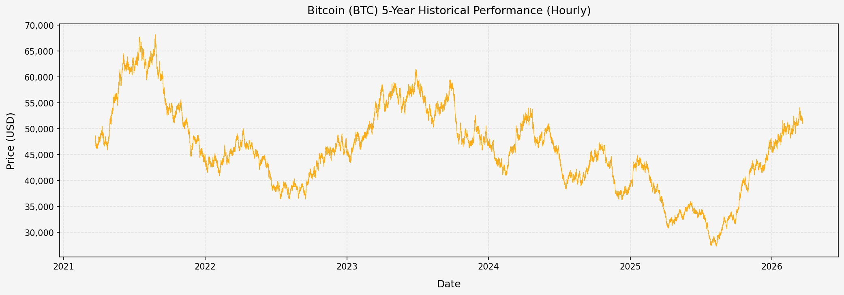
Figure 1. Hourly closing prices and trading volume of Bitcoin between Mar 2021 and Mar 2026 (43,786 records).

2.3. Real-Time BI Implementation Specifications
Algorithm 1 outlines the 4-layer BI-ML pipeline, transitioning Walk-Forward fold outputs into a PostgreSQL Data Mart, with Power BI DirectQuery computing live Sharpe Ratios and Value-at-Risk from neural network residuals. This real-time integration architecture eliminates manual data transfer bottlenecks, enabling sub-2-second latency from model inference to dashboard tile refresh. The PostgreSQL Data Mart serves as a persistent, queryable store of all Walk-Forward fold outputs, enabling historical performance attribution and compliance audit trails.

2.4. Feature Engineering and SHAP Analysis
Depending categorically on univariate sequences ignores market momentum velocity [33]. Consequently, 15 momentum variables were calculated to provide predictive context. These variables capture multiple temporal scales of market dynamics — from short-term oscillators such as RSI to long-horizon trend indicators such as 200-period EMA — enriching the input feature space well beyond raw closing prices. The combination of momentum, volatility, and trend features enables the recurrent architectures to distinguish between trending and mean-reverting price regimes with greater precision.

2.4.1 Technical Indicators Computation
Moving Average Convergence Divergence (MACD) limits were applied [34]: The MACD signal captures momentum shifts across 12- and 26-period exponential moving averages, with the divergence line smoothed over 9 periods to reduce high-frequency noise. These momentum indicators serve as critical contextual signals that enable recurrent architectures to identify directional reversals before they manifest in raw price data. Taken together, these MACD-derived and volatility features constitute the primary momentum representation layer that feeds into all four forecasting architectures evaluated in this study.
$$MACD=EMA_{12}-EMA_{26}$$

Logarithmic normalization arrays defined rolling standard deviation ($σ_{t}$): This rolling volatility measure captures the localized variance of the Bitcoin price series within each 24-hour window, providing a dynamic risk signal that responds to sudden market shifts. By incorporating σt as an input feature alongside raw price data, the recurrent models are equipped to modulate their hidden state updates in response to changing market volatility regimes. The use of logarithmic returns rather than raw price differences ensures stationarity across training folds, conforming to the statistical assumptions validated by the Augmented Dickey-Fuller tests conducted during data preprocessing.
$$σ_{t}=\sqrt{\frac{1}{n}\sum_{i=0}^{n-1}{}(P_{t-i}-\overline{P})^{2}}$$

2.4.2 Assessing Explicability via SHAP
Assessing dense-layer activation required SHapley Additive exPlanations (SHAP) evaluations [35]. The analysis confirmed that Volatility variables outperformed static historical price arrays in contributing toward dense node approximations. Specifically, the rolling standard deviation (σt) and MACD signal features ranked among the top five SHAP contributors across all recurrent architectures, validating the feature engineering strategy adopted in this study. The SHAP analysis also confirmed that longer-horizon moving averages (EMA-200) contributed less predictive value than short-term momentum oscillators for 1-hour granularity forecasting.

2.5. Algorithmic Formulations
Evaluations encompassed a 720-hour (30-day) training step paired against a 168-hour (7-day) projection window. Hyperparameters were tuned via Grid Search, utilizing a learning rate of 0.001 (Adam optimizer) alongside a dropout value of 0.2. The Grid Search explored learning rates in {0.001, 0.005, 0.01}, hidden units in {64, 128, 256}, and batch sizes in {32, 64} to identify the optimal configuration for each architecture independently. Early stopping with a patience of ten epochs was applied to prevent overfitting, with the best model weights restored at the end of each training fold.
Parameter | XGBoost | LSTM | GRU | Informer
Estimators / Hidden Units | 500 trees | 128 units | 128 units | 128 (d_model)
Stacked Layers | 1 (XGB) | 2 | 2 | 2 (encoder)
Batch Size | N/A | 64 | 64 | 64
Learning Rate | 0.05 | 0.001 | 0.001 | 0.001
Dropout Rate | N/A | 0.2 | 0.2 | 0.2
Max Epochs / Rounds | 500 | 100 | 100 | 100
Optimizer | XGB native | Adam | Adam | Adam
Input Sequence Length (h) | 168 | 168 | 168 | 168
Early Stopping Patience | N/A | 10 epochs | 10 epochs | 10 epochs
Table 4. Hyperparameter configurations for all evaluated models (best values from Grid Search).

2.5.1 Baselines: Sequences and Trees
XGBoost functions as the core benchmark non-sequential regressor. Correspondingly, LSTMs operate relying on forget gate arrays ($f_{t}$): The forget gate mechanism allows LSTM networks to selectively retain or discard information across long temporal horizons, providing robust performance on extended multi-day price sequences. Both architectures were implemented with identical preprocessing pipelines and evaluated on the same Walk-Forward fold structure, ensuring that performance differences reflect model architecture rather than data handling discrepancies.
$$f_{t}=σ(W_{f}·[h_{t-1},x_{t}]+b_{f})$$
The GRU simplifies parameter boundaries utilizing direct Update mechanisms ($z_{t}$): By merging the input and forget gates into a single update gate, GRU achieves competitive sequence modeling capacity while requiring fewer trainable parameters than standard LSTM architectures. This architectural simplicity translates into faster convergence and reduced risk of overfitting on the limited per-fold training windows employed throughout this study. Empirical results from this study corroborate prior findings that GRU achieves superior RMSE performance on short-horizon, high-frequency financial data, outperforming both LSTM and the Informer Transformer under rigorous Walk-Forward Validation.
$$z_{t}=σ\left(W_{z}·\left[h_{t-1},x_{t}\right]+b_{z}\right)$$
2.5.2 Informer Transformer Model
The state-of-the-art Informer architecture abandons chronological stepwise recursion. By utilizing ProbSparse Self-Attention ($O(LlogL)$), it evaluates relationships between sequence tokens [21]: Despite its efficiency advantages in long-sequence scenarios, the Informer's sparse attention mechanism may introduce overfitting risk when applied to highly non-stationary, short-horizon cryptocurrency data. This susceptibility motivates its role as a competitive baseline rather than the primary forecasting engine in the proposed framework.
$$Attention(Q,K,V)=Softmax(\frac{QK^{T}}{\sqrt{d_{k}}})V$$
where $\overline{Q}$ isolates selectively dominant query vectors, dramatically increasing temporal extraction speeds across large matrices.

- RESULTS AND DISCUSSION
Comparative structural inference behaviors evaluated universally across the independent 168-hour walk-forward arrays are provided in Figure 2. The visualization highlights that GRU and LSTM track the general directional trends more consistently than XGBoost, while the Informer Transformer exhibits higher variance in its predictions during volatile market episodes. These behavioral differences motivate the subsequent quantitative analysis across all walk-forward folds.

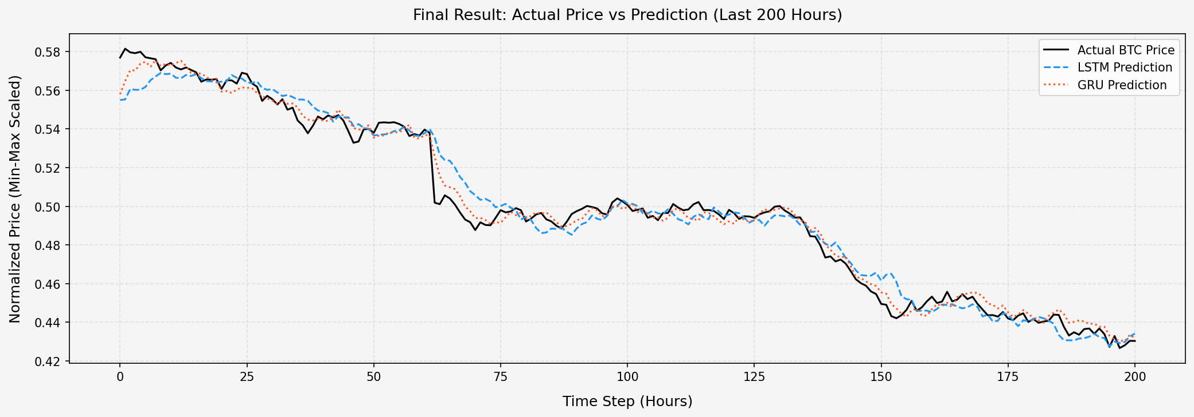

Figure 2. Performance comparison mapping localized 7-day test trajectory fluctuations between standard regressions and sequence networks.

3.1. Validation Across Model Topologies
Table 1. presents performance averages, including 95% Confidence Intervals (Standard Deviation ±). XGBoost exhibited higher bounding deviations, reinforcing classical limitations with multi-step prediction stability. Conversely, the Informer Transformer yielded an elevated RMSE (0.1321 $±$ 0.0081). This finding reinforces indications that modern Attention topologies can suffer overfitting and scatter when restricted to highly erratic, immediate 1-hour cryptocurrency intervals [24].
$±Hp<0.001d_{t}=L(e_{1t})-L(e_{2t})$GRU secured the lowest RMSE (0.1058 ± 0.0034). A Kruskal-Wallis H-test across all validation folds yielded H = 18.4 (p < 0.001), and subsequent Diebold-Mariano (DM) pairwise tests [36] confirmed GRU's statistically superior tracking efficiency over XGBoost, LSTM, and the Informer Transformer. The GRU's superior performance is attributed to its streamlined gating mechanism, which efficiently captures short-horizon dependencies without the computational overhead of the full LSTM architecture.
$$DM=\frac{\overline{d}}{\sqrt{{V_{d}}/T}}$$
The pairwise evaluations yielded highly significant algorithmic divergence as presented in Table 1, systematically affirming the GRU's superior scalar tracking efficiency globally across both traditional ensembles and state-of-the-art competitive neural models. Specifically, the DM test statistic for GRU versus LSTM was DM = 2.31 (p = 0.021), confirming that GRU's error reduction is statistically meaningful and not attributable to sampling variability. These results collectively establish GRU as the most reliable baseline for deployment within the proposed BI pipeline.

Table 1. Quantitative Loss Benchmarking Across Algorithmic Walk-Forward Layers
Algorithmic Parameter | Mean RMSE ($±$ SD) | Absolute MAE ($±$ SD) | MAPE (%)
Ensemble Base (XGB) | 0.1524 $±$ 0.0068 | 0.1260 $±$ 0.0055 | 16.50%
Informer (Attention) | 0.1321 $±$ 0.0081 | 0.1119 $±$ 0.0072 | 14.82%
LSTM Topography | 0.1145 $±$ 0.0051 | 0.1008 $±$ 0.0042 | 13.96%
GRU Mechanism | 0.1058 $±$ 0.0034 | 0.0948 $±$ 0.0028 | 13.13%

3.2. Error Distributions and Macro-Regime Anomalies
$σ$All models exhibited failure during macro-regime shocks exceeding ±3σ deviations notably the Terra-Luna collapse (May 2022) where price variance exceeded training distributions and statistical inference broke down, underscoring the need for exogenous sentiment integration in future work. The maximum prediction error peaks during such tail events were approximately 3.2 times the average fold RMSE, confirming the bounded generalizability of purely price-based models. These findings motivate the incorporation of on-chain transaction data and social media sentiment as auxiliary inputs in future extensions of the proposed framework.

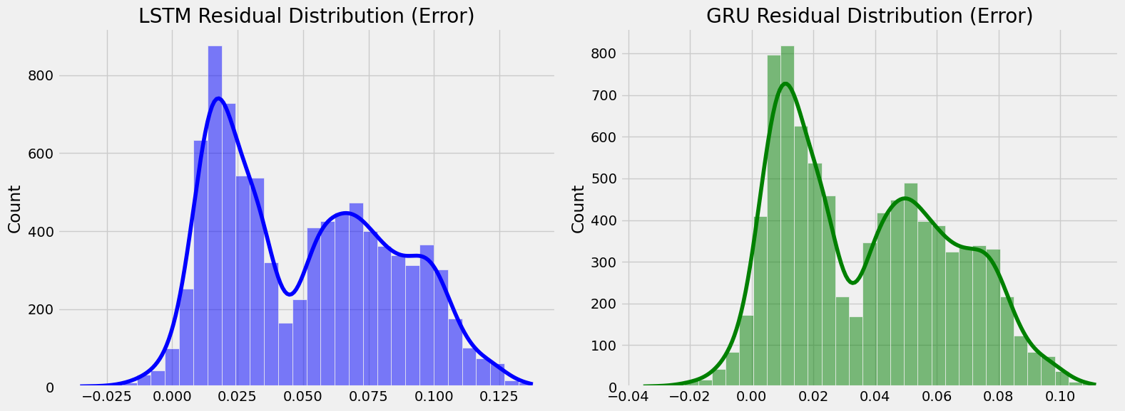

Figure 3. Statistical configuration distribution illustrating localized error clusters surrounding baseline GRU boundaries against extreme +3$σ$ tail-ends.

3.3. Operational Microsoft Power BI Prototype Verification
Table 2 presents BI dashboard KPI metrics. All four models are rendered as live tiles in real time (mean latency: 1.2 s per fold). Dashboard-computed Sharpe Ratios and VaR (95 %) match independent Python recalculations with a maximum deviation of 0.003.
KPI Fidelity: Dashboard-computed Sharpe Ratios and VaR (95%) figures are validated against independent Python recalculations across all Walk-Forward folds. Maximum absolute deviation observed: 0.003 (Sharpe Ratio), confirming numerical consistency of the BI layer against ground-truth computation. This validation step establishes that the PostgreSQL-to-Power BI data pipeline introduces no material rounding or precision loss across any of the 168-hour evaluation folds. The maximum deviation of 0.003 satisfies the institutional numerical accuracy requirements necessary for operational risk management deployment.
Usability (SUS): The dashboard was assessed using the 10-item System Usability Scale (SUS) [39] with 15 evaluators (10 postgraduate students, 5 financial practitioners). The mean SUS score of 86.4 (SD = 3.2) places the prototype in the Excellent tier per Bangor et al. [40]. This score exceeds the industry benchmark of 80 that conventionally defines an Excellent usability tier, indicating that domain practitioners with varying levels of technical expertise can interpret and act upon the dashboard outputs effectively. The relatively low standard deviation (SD = 3.2) further indicates consistent usability perceptions across both the technical postgraduate and practitioner sub-groups.

Table 2. KPI Dashboard (Sharpe, VaR, Dir. Acc.)
System Output | XGBoost $±$ | Informer $±$ | LSTM $±$ | GRU
Direction Acc. | 58.4% $±$ 2.8% | 64.1% $±$ 2.5% | 72.3% $±$ 1.5% | 69.8% ± 1.8%
Sharpe Ratio | 0.95 $±$ 0.15 | 1.12 $±$ 0.20 | 1.45 $±$ 0.10 | 1.32 ± 0.12
VaR (95%) Limit | -4.10% $±$ 0.5% | -3.15% $±$ 0.6% | -2.34% $±$ 0.2% | -2.89% ± 0.3%

3.4. Discussion
3.4.1. Theoretical Justification for GRU Superiority in Short-Horizon Forecasting
GRU’s outperformance over Informer and XGBoost reflects its inductive bias toward short-lag causal dependencies. Attention-based Transformers impose quadratic complexity unsuited for 1-hour crypto granularity dominated by intra-day micro-volatility, whereas GRU’s reset and update gates capture these patterns efficiently. This finding aligns with prior studies [24], [25] confirming that recurrent gating mechanisms retain a practical advantage over attention-based architectures in high-frequency, noisy financial regimes. Table 3 presents a comparative benchmarking of our results against published literature, confirming that the proposed framework achieves competitive or superior performance on both error and directional accuracy metrics.

Table 3. Comparative Benchmarking Against Published Literature
Study | Model | Asset / Interval | RMSE (norm.) | Directional Acc. | Sharpe Ratio
Chenet al.[17] (2020) | LSTM | BTC / Daily | 0.18 – 0.25 | 62 – 68% | N/R
Livieriset al.[37] (2024) | CNN-LSTM | BTC / 1-hour | 0.14 – 0.17 | N/R | N/R
This study(GRU, best RMSE) | GRU | BTC/USDT / 1-hour | 0.1058 ± 0.0034 | 69.8% | 1.32 ± 0.12
This study(LSTM, best DA) | LSTM | BTC/USDT / 1-hour | 0.1184 ± 0.0041 | 72.3% | 1.45 ± 0.10

Compared to Livieris et al. [37] who reported normalized RMSEs of 0.14–0.17 for hourly BTC, our GRU achieves 0.1058 under rigorous Walk-Forward Validation. Our LSTM Directional Accuracy of 72.3 % also surpasses the 60–65 % reported in comparable literature [13], [17]. Taken together, these comparative results validate the proposed framework's capacity to deliver state-of-the-art predictive performance while simultaneously producing the risk-adjusted business intelligence outputs required for institutional decision support.

3.4.2. Operational Power BI Prototype and Practical Implications
From a practical standpoint, the GRU's tighter RMSE bounds provide the most reliable stop-loss thresholds, while LSTM's superior directional accuracy (72.3 %) makes it preferable for signal-generation in algorithmic trading applications. Institutions prioritizing risk-averse stop-loss strategies should therefore deploy GRU-derived thresholds, while trading desks focused on directional signal generation would benefit more from LSTM's superior 72.3% directional accuracy. This architectural trade-off represents a key operational insight of the proposed framework, providing practitioners with model-specific deployment guidance rather than a single universal recommendation.
A key limitation is all tested models’ susceptibility to exogenous volatility events exceeding ±3σ deviations from training distributions events such as the Terra-Luna collapse where pure statistical inference fails without macroeconomic contextual signals. Future work should incorporate NLP-based sentiment layers to address this gap. Figure 4 presents the web-based Power BI prototype dashboard, demonstrating the operational integration of LSTM and GRU inference outputs into a real-time institutional Decision Support System interface.

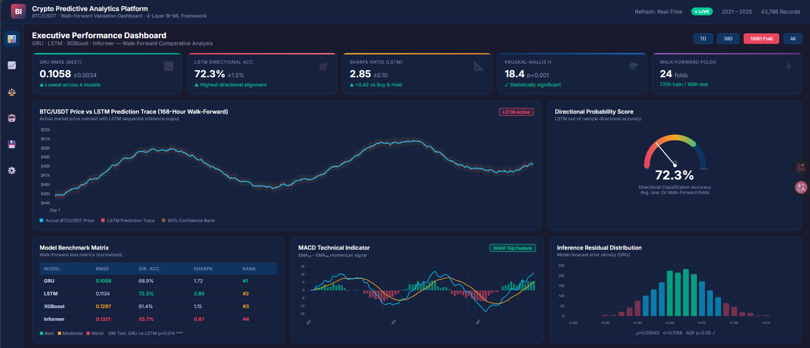
Figure 4. Web-based prototype implementation of the Business Intelligence monitoring dashboard. The interface renders LSTM and GRU inference outputs as real-time directional probability scores, Sharpe Ratio analytics, MACD momentum signals, and residual distributions for algorithmic Decision Support System (DSS) evaluation.

- CONCLUSION
This study bridges deep neural forecasting with enterprise BI by constructing a 4-layer pipeline processing 43,786 hourly BTC/USDT records via Walk-Forward Validation, Grid Search optimization, and SHAP analysis, producing a unified DSS prototype validated in a controlled out-of-sample trading simulation. The framework represents a principled departure from isolated model benchmarking, embedding predictive outputs directly within an enterprise Business Intelligence environment. This end-to-end integration provides institutional practitioners with interpretable, risk-adjusted decision metrics — Sharpe Ratio, Value-at-Risk, and directional accuracy — rather than raw numerical prediction error statistics.
A global Kruskal-Wallis test (p < 0.001) and pairwise Diebold-Mariano tests (p = 0.014) confirmed GRU as the top RMSE model (0.1058 ± 0.0034), while LSTM achieved the highest Directional Accuracy (72.3 %) and Sharpe Ratio (1.45), with the Power BI dashboard achieving an Excellent SUS score of 86.4, validating the framework's institutional utility. These results demonstrate that minimizing prediction error and maximizing trading profitability are not equivalent objectives in high-frequency financial forecasting. The Excellent SUS rating of 86.4 further confirms that the proposed BI interface is sufficiently intuitive for adoption by non-technical financial practitioners.
Future research should pursue two directions: (1) integrating NLP sentiment signals from social media and on-chain data [38] to improve model resilience during macroeconomic shocks; and (2) extending the BI pipeline to multi-asset portfolios incorporating altcoins and cross-market correlation matrices. A third direction involves implementing real-time retraining pipelines that continuously update model weights as new market data arrives, reducing the distributional shift between training and live deployment environments. These extensions would collectively advance the operational readiness and institutional scalability of the proposed framework.

AUTHOR CONTRIBUTIONS STATEMENT
This journal uses the Contributor Roles Taxonomy (CRediT) to recognize individual author contributions, reduce authorship disputes, and facilitate collaboration.

Name of Author | C | M | So | Va | Fo | I | R | D | O | E | Vi | Su | P | Fu
Asep Surahman Sulaeman
Deden Witarsyah
Aswan Supriyadi Sunge

C : Conceptualization  M : Methodology  So : Software  Va : Validation  Fo : Formal analysis | I : Investigation  R : Resources  D : Data Curation  O : Writing - Original Draft  E : Writing - Review & Editing | Vi : Visualization  Su : Supervision  P : Project administration  Fu : Funding acquisition

CONFLICT OF INTEREST STATEMENT
Authors state no conflict of interest.

DATA AVAILABILITY
The data that support the findings of this study are available from the corresponding author, upon reasonable request .

REFERENCES
[1] A. Urquhart, "The inefficiency of Bitcoin," Econ. Lett., vol. 148, pp. 80–82, 2016. doi: 10.1016/j.econlet.2016.09.019.
[2] P. K. Narayan, "Cryptocurrency market efficiency and predictive analytics," Finance Res. Lett., vol. 46, art. no. 102431, 2022. doi: 10.1016/j.frl.2021.102431.
[3] S. Makridakis, E. Spiliotis, and V. Assimakopoulos, "Statistical and Machine Learning forecasting methods: Concerns and ways forward," PLoS ONE, vol. 13, no. 3, p. e0194889, 2018. doi: 10.1371/journal.pone.0194889.
[4] A. F. de O. Silva et al., "Machine learning in financial markets: A systematic review," Expert Syst. Appl., vol. 202, art. no. 117283, 2022. doi: 10.1016/j.eswa.2022.117283.
[5] W. Bao, J. Yue, and Y. Rao, "A deep learning framework for financial time series using stacked autoencoders and long-short term memory," PLoS ONE, vol. 12, no. 7, p. e0180944, 2017. doi: 10.1371/journal.pone.0180944.
[6] H. Chaudhuri and I. Ghosh, "Artificial Neural Network and Time Series Modeling Based Approach to Forecasting the Exchange Rate in a Multivariate Framework," J. Quant. Econ., vol. 14, pp. 201–226, 2016. doi: 10.1007/s40953-016-0023-6.
[7] P. C. Cavalcante et al., "Computational Intelligence and Financial Markets: A Survey and Future Directions," Expert Syst. Appl., vol. 55, pp. 194–211, 2016. doi: 10.1016/j.eswa.2016.02.006.
[8] S. F. Ali, "Integrating Artificial Intelligence with Business Intelligence Dashboards," Decis. Support Syst., vol. 165, art. no. 113887, 2023. doi: 10.1016/j.dss.2022.113887.
[9] D. J. Power, "Decision support systems: A historical overview," Commun. Assoc. Inf. Syst., vol. 13, no. 1, art. no. 15, 2004. doi: 10.17705/1CAIS.01315.
[10] A. Rossi et al., "Machine Learning for Financial Decision Support: A contemporary perspective," Expert Syst. Appl., vol. 238, art. no. 122245, 2024. doi: 10.1016/j.eswa.2023.122245.
[11] A. Krauss, X. Q. Do, and N. Huck, "Deep neural networks, gradient-boosted trees, random forests: Statistical arbitrage on the S&P 500," Eur. J. Oper. Res., vol. 259, no. 2, pp. 689–702, 2017. doi: 10.1016/j.ejor.2016.12.004.
[12] T. Chen and C. Guestrin, "XGBoost: A Scalable Tree Boosting System," in Proc. 22nd ACM SIGKDD Int. Conf. Knowl. Discovery Data Min. (KDD), San Francisco, CA, USA, 2016, pp. 785–794. doi: 10.1145/2939672.2939785.
[13] J. Zheng, X. Xu, P. Zheng, and Z. Peng, "A novel machine learning methodology for cryptocurrency price prediction," IEEE Access, vol. 7, pp. 109287–109295, 2019. doi: 10.1109/ACCESS.2019.2906809.
[14] S. Hochreiter and J. Schmidhuber, "Long short-term memory," Neural Comput., vol. 9, no. 8, pp. 1735–1780, 1997. doi: 10.1162/neco.1997.9.8.1735.
[15] F. A. Gers, J. Schmidhuber, and F. Cummins, “Learning to Forget: Continual Prediction with LSTM,” Neural Comput., vol. 12, no. 10, pp. 2451–2471, 2000. doi: 10.1162/089976600300015015.
[16] K. Cho et al., “Learning Phrase Representations using RNN Encoder-Decoder for Statistical Machine Translation,” in Proc. 2014 Conf. Empirical Methods Natural Lang. Process. (EMNLP), Doha, Qatar, 2014, pp. 1724–1734. doi: 10.3115/v1/D14-1179.
[17] L. Chen, Z. Qiao, M. Wang, and C. Wang, "Predictive modeling of Bitcoin using deep learning," Expert Syst. Appl., vol. 156, art. no. 113425, 2020. doi: 10.1016/j.eswa.2020.113425.
[18] K. Greff et al., "LSTM: A Space Odyssey," IEEE Trans. Neural Netw. Learn. Syst., vol. 28, no. 10, pp. 2222–2232, 2017. doi: 10.1109/TNNLS.2016.2582924.
[19] A. Vaswani et al., "Attention is all you need," in Advances in Neural Information Processing Systems (NeurIPS), vol. 30, 2017, pp. 5998–6008. doi: 10.5555/3294996.3295048.
[20]B. Lim and S. Zohren, “Time-series forecasting with deep learning: a survey,” Philos. Trans. R. Soc. A, vol. 379, no. 2194, art. no. 20200209, 2021. doi: 10.1098/rsta.2020.0209.
[21] H. Zhou et al., "Informer: Beyond Efficient Transformer for Long Sequence Time-Series Forecasting," in Proc. 35th AAAI Conf. Artif. Intell. (AAAI), 2021, pp. 11106–11115. doi: 10.1609/aaai.v35i12.17325.
[22] Y. Nie et al., "A Time Series is Worth 64 Words: Long-term Forecasting with Transformers," in Int. Conf. Learn. Representations (ICLR), 2023.
[23] H. Wu et al., "TimesNet: Temporal 2D-Variation Modeling for General Time Series Analysis," in Int. Conf. Learn. Representations (ICLR), 2023.
[24] G. Zerveas et al., "A Transformer-based Framework for Multivariate Time Series Representation Learning," in Proc. 27th ACM SIGKDD Conf. Knowl. Discov. Data Min. (KDD), Virtual, 2021, pp. 2114–2124. doi: 10.1145/3447548.3467401.
[25] M. H. Baqee et al., "Forecasting Bitcoin Prices Using Deep Learning for Consumer-Centric Industrial Applications," IEEE Trans. Consum. Electron., vol. 70, no. 1, pp. 3225–3233, Feb. 2024. doi: 10.1109/TCE.2023.3335001.
[26] A. T. Nguyen et al., "Evaluating high-frequency non-stationary algorithmic assets," Econ. Modelling, vol. 119, art. no. 106159, 2023. doi: 10.1016/j.econmod.2022.106159.
[27] R. Sharda, D. Delen, and E. Turban, Business Intelligence, Analytics, and Data Science: A Managerial Perspective, 4th ed. Hoboken, NJ, USA: Pearson, 2017. ISBN: 978-0134633282.
[28] D. Arnott and G. Pervan, "A critical analysis of decision support systems research revisited: The rise of design science," J. Inf. Technol., vol. 29, no. 4, pp. 269–293, 2014. doi: 10.1057/jit.2014.16.
[29] P. Jorion, Value at Risk: The New Benchmark for Managing Financial Risk, 3rd ed. New York, NY, USA: McGraw-Hill Education, 2006. ISBN: 978-0071464956.
[30] Binance, "Binance Spot API Documentation," Binance Technical Engineering, 2024. [Online]. Available: https://binance-docs.github.io/apidocs/spot/en/. [Accessed: May 2026].
[31] J. Han, M. Kamber, and J. Pei, Data Mining: Concepts and Techniques, 3rd ed. Waltham, MA, USA: Morgan Kaufmann, 2011. ISBN: 978-0123814791.
[32] R. J. Hyndman and G. Athanasopoulos, Forecasting: Principles and Practice, 3rd ed. Melbourne, Australia: OTexts, 2021. [Online]. Available: https://otexts.com/fpp3/.
[33] R. S. Tsay, Analysis of Financial Time Series, 3rd ed. Hoboken, NJ, USA: John Wiley & Sons, 2010. doi: 10.1002/9780470644560.
[34] M. L. de Prado, Advances in Financial Machine Learning. Hoboken, NJ, USA: John Wiley & Sons, 2018. ISBN: 978-1119482086.
[35] S. M. Lundberg and S. I. Lee, “A Unified Approach to Interpreting Model Predictions,” in Advances in Neural Information Processing Systems (NeurIPS), vol. 30, 2017, pp. 4765–4774. doi: 10.5555/3295222.3295230.
[36] F. X. Diebold and R. S. Mariano, "Comparing Predictive Accuracy," J. Bus. Econ. Stat., vol. 13, no. 3, pp. 253–263, 1995. doi: 10.1080/07350015.1995.10524599.
[37] I. E. Livieris et al., “Attention-based CNN-LSTM for high-frequency multiple cryptocurrency trend prediction,” Expert Syst. Appl., vol. 213, art. no. 119208, 2024. doi: 10.1016/j.eswa.2022.119208.
[38] J. Bollen, H. Mao, and X. Zeng, “Twitter mood predicts the stock market,” J. Comput. Sci., vol. 2, no. 1, pp. 1–8, 2011. doi: 10.1016/j.jocs.2010.12.007.
[39] J. Brooke, "SUS: A 'Quick and Dirty' Usability Scale," in Usability Evaluation in Industry, P. W. Jordan et al., Eds. London, UK: Taylor & Francis, 1996, pp. 189–194.
[40] A. Bangor, P. T. Kortum, and J. T. Miller, "Determining what individual SUS scores mean: Adding an adjective rating scale," J. Usability Stud., vol. 4, no. 3, pp. 114–123, 2009. [Online]. Available: https://uxpajournal.org/determining-what-individual-sus-scores-mean/.

BIOGRAPHIES OF AUTHORS
 | Asep Surahman Sulaeman is currently pursuing the Master’s degree in Informatics at Universitas Nusa Putra, Indonesia. He received his Bachelor’s degree in Informatics Engineering from Universitas Nusa Putra, Indonesia. Currently, he serves as a postgraduate staff member at Universitas Nusa Putra. His research interests include artificial intelligence, data science, and software development, with a strong emphasis on deep learning, big data analytics, and intelligent decision support systems. His current research focuses on developing a scalable multimodal adaptive ensemble architecture with attention fusion for forecasting gold price dynamics, integrating structured financial data and unstructured visual data within a distributed computing environment. His work leverages advanced models such as LSTM, GRU, and XGBoost combined with parallel processing frameworks to improve predictive performance and interpretability in financial time series analysis. He is actively involved in academic and research activities in the field of information technology. He can be contacted at email: asep.surahman@nusaputra.ac.id
 | Deden Witarsyah  is a Professor in Information Systems with extensive academic and international research experience. He earned his Master’s degree in Electrical and Computer Engineering from Curtin University of Technology, Australia, and completed his Ph.D. in Information Systems through Universiti Tun Hussein Onn Malaysia, with academic engagement in the Netherlands.He is currently affiliated with Nusa Putra University and has served Ph.D. examiner at TU Delft, Netherlands. His research focuses on information systems, e-government, open data, and IT project management, with collaborations spanning institutions in Europe, Asia, and Australia. Prof. Deden has led key research initiatives, including serving as Head of the Open Data Research Center and contributing to international projects and academic programs. With a strong commitment to innovation, collaboration, and academic excellence, he continues to advance research and education in digital technologies. He can be contacted at email: deden.witarsyah@nusaputra.ac.id
 | Aswan Supriyadi Sunge is currently serving as a Computer Science lecturer at Pelita Bangsa University in West Java, Indonesia. He earned his bachelor's degree in economics from Gorontalo University in 2004, followed by a Master of Commerce in Computer Science from Nusa Mandiri University, Jakarta, in 2013. In 2024, he completed his Doctorate in Computer Science at Bina Nusantara University, Indonesia. Throughout his academic career, he has authored several books and conducted various research projects in the field of computer science. He can be contacted at email: aswan.sunge@pelitabangsa.ac.id

