Alexandru Seremet
CSC 138
Professor Sun
2/24/2019
TCP/UDP Server-Client
TCP server code
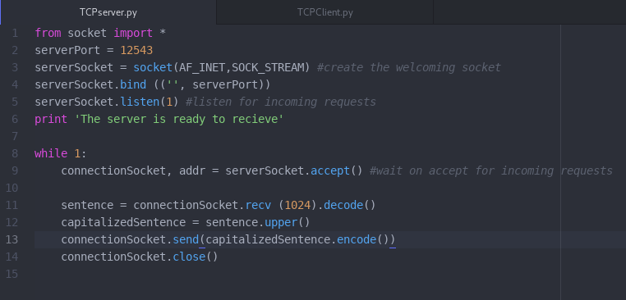

TCP server run
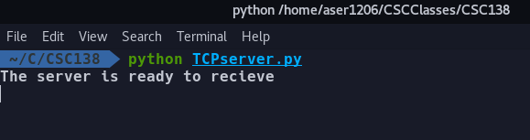

TCP client code
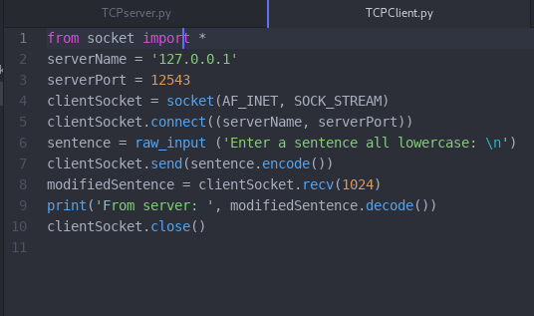

TCP client run
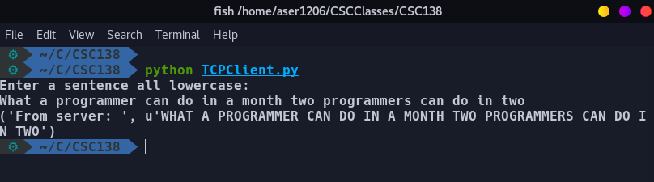

UDP server code
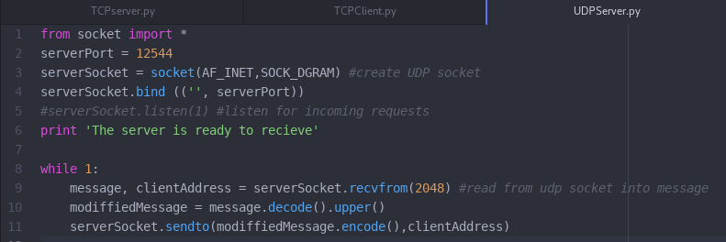

UDP server run
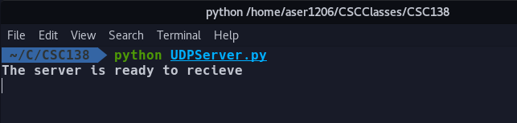

UDP client code
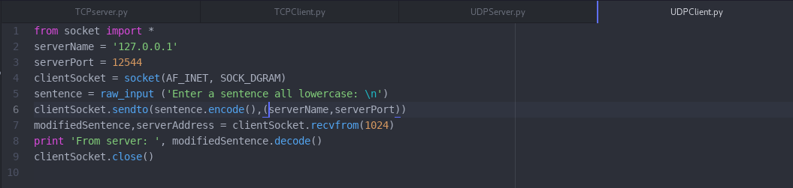

UDP client run
