Manual for Identifying Refactorings between Two Program Versions

If you don’t want to do fact extraction, but simply want to check how the refactoring identification works, we recommend you use any of these- hier3.rub, hierState.rub or niki_sample3.rub as an input tyruba file.

Section 1: Fact Extraction (This section has been borrowed from Alex Loh)

Using the LSDiff plugin

The LSDiff plugin is implemented as a view. It can be found in Show View -> Other -> LSDiff -> LSDiff Rules.

To start, click on the Open Project button.
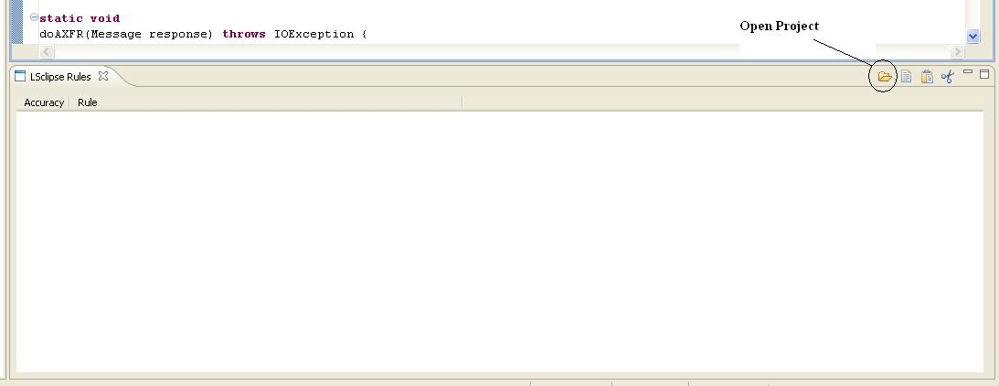

This will launch the File Selection dialog. This dialog selects the project versions to be parsed by LSDiff. There are two ways to do the selection.

1) Select by Workspace Diff
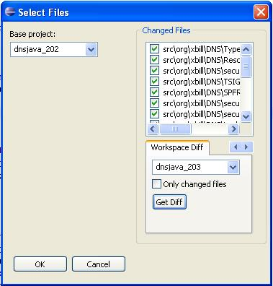
Both versions must be opened in the current workspace for this to work. Select the Base Project and the Changed Project. Click the Get Diff button to find the files which changed between these versions.

2) Select by SVN Log
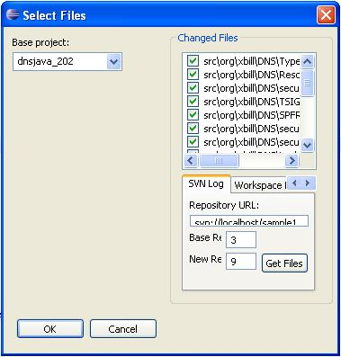
This option will pull the project’s change information from its SVN log. The Base Revision should be the version of the select Base Project in the repository. The New Revision is the revision to compare against. Click the Get Files button to read the changed files from SVN.

After selecting versions to compare, start LSDiff by click the OK button.
This process may take several minutes.
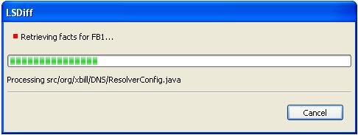

When it is done, the rules found by LSDiff will appear in the view.
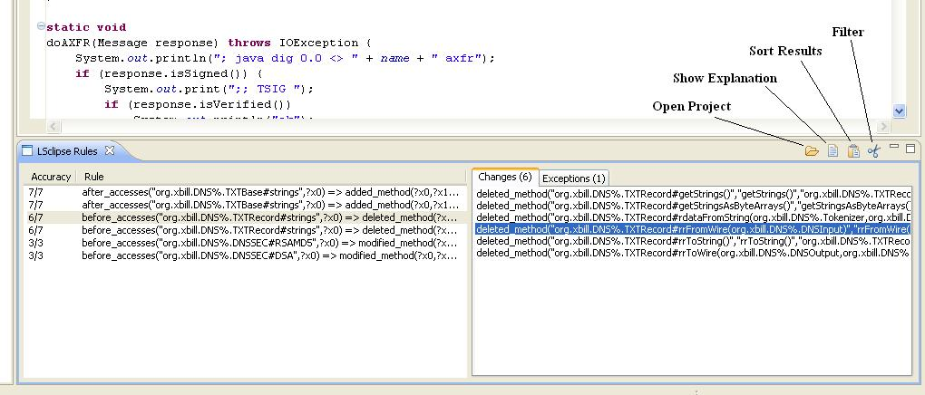
Accuracy refers to how often the consequent of the rule is matched out of the total number of time the antecedent of the rule is matched. Clicking on the Explain button will show the Matches and Exceptions to the rule. Left-clicking will jump the cursor to the next location of this match or exception. Right-clicking will open up a context menu.
___________________
| Jump to code |
| Compare versions |
| Change information |
|__________________|
Selecting Compare Versions will open up the default Eclipse Compare editor on the two versions. Change information is only available via SVN. It will list Revision, Time, Author, and Comments for the change corresponding to the selected matching fact.

Rules can be sorted by Accuracy, Support, Type, or Declaring Class using the Sort button.

The Filter button launches the Filter dialog.
Search/Filter
 |  |  |  | Types
Accuracy: | 0 % - | 100 % |  |  | Before | After
Matches: | 0 - | 999 [MAX] |  | Access | O | O
Exceptions: | 0 - | 999 [MAX] |  | Calls | O | O
Support: | 0 - | 999 [MAX] |  | Subtype | X | O
 |  |  |  | Implements | X | O
Contains String: |  |  |  | ….
_______________________
This dialog filters the rules based on their attributes.

Section 2: Rule Inference

- Go to the directory where the 2KB and deltaKB files have been written to. In my case the directory is C:\Documents and Settings\Nikita\My Documents\download\eclipse-SDK-3.5-win32\eclipse\runtime-EclipseApplication\.metadata\.plugins\LSclipse\input\lsclipse.
- Copy all the rules from both the 2KB_lsclipsePred.rub and deltaKNlsclipsePred.rub to your own input tyruba file. We suggest you don’t copy the rules that have “modified” in them. The refactoring rules we have framed don’t call these and these will only add to overhead. Thus ignore these for now. If you still want to keep them, you will have include the necessary predicates in “preds1.rub”.
- Add the following line to your input tyruba file:
#include “preds1.rub”
- Enter your input tyruba file name for filename in the main method of niki_algorithm2.java. Run Main
- Open your input tyruba file, it should have the found refactorings written to it. That’s it.

The next time you run it, be sure to erase any of the refactorings found, since else tyruba will take them as given.

