RabbitMQ Installation Windows

## Prerequesites

* Install Erlang (version 64 bits)
* Install RabbitMQ (64 bits Windows)

## Introduction

**RabbitMQ** is a message broker: it accepts and forwards messages. You can think about it as a post office: when you put the mail that you want posting in a post box, you can be sure the postman will eventually deliver the mail to your recipient. In this analogy, **RabbitMQ** is a post box, a post office and a postman.

Producing means nothing more than sending. A program that sends messages is a producer.

https://www.rabbitmq.com/img/tutorials/producer.png

A queue is the name for a post box which lives inside **RabbitMQ**. Although messages flow through RabbitMQ and your applications, they can only be stored inside a queue. A queue is only bound by the host's memory & disk limits, it's essentially a large message buffer. Many producers can send messages that go to one queue, and many consumers can try to receive data from one queue. This is how we represent a queue:

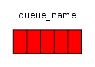

* Consuming has a similar meaning to receiving. A consumer is a program that mostly waits to receive messages:

https://www.rabbitmq.com/img/tutorials/consumer.png

Note that the producer, consumer, and broker do not have to reside on the same host; indeed in most applications they don't.

(P) -> [|||] -> (C)

## Environment configuration

**RabbitMQ** default configuration runs on localhost and standard default port 5672.

* Create 2 new folders: **c:\rabbitmq** and **c:\premuser**
* Set 2 new environment variables: **RABBITMQ_BASE**, **HOMEDRIVE**.

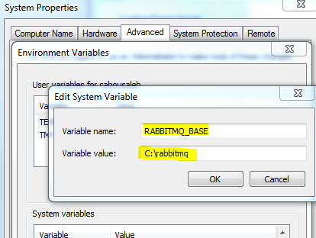

Set the **HOMEDRIVE** variable from the command line (it doesn’t work from the Windows Control Panel for some reason)

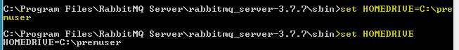

1. Run the terminal command prompt as Administrator.
2. Navigate to the **sbin** directory and uninstall the service. **rabbitmq-service remove**
3. Reinstall the service **rabbitmq-service install**
4. Enable the plugins **rabbitmq-plugins enable rabbitmq_management**
5. Start the service **rabbitmq-service start**

* Check that the **RabbbitMQ** server is running on port **5672:**

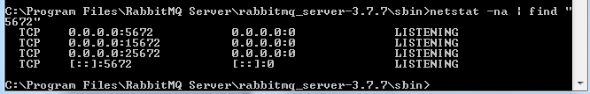

* Check the **RabbbitMQ** service status

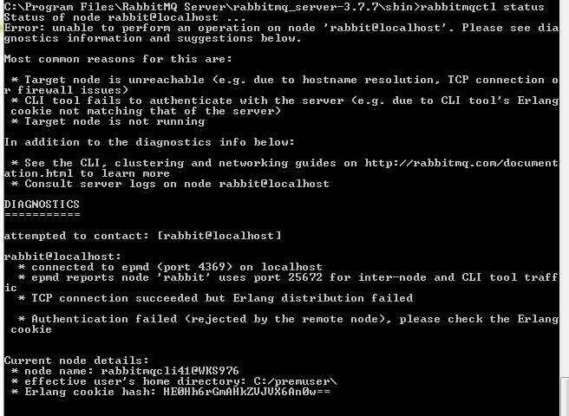

* Check your access to the administration page by visiting the following URL:

http://localhost:15672/

Logon with the default user **guest/guest**

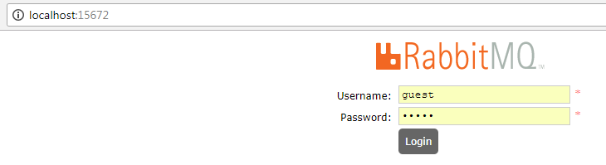

* Create a new admin user (serge/<password>) from the **admin** tab.

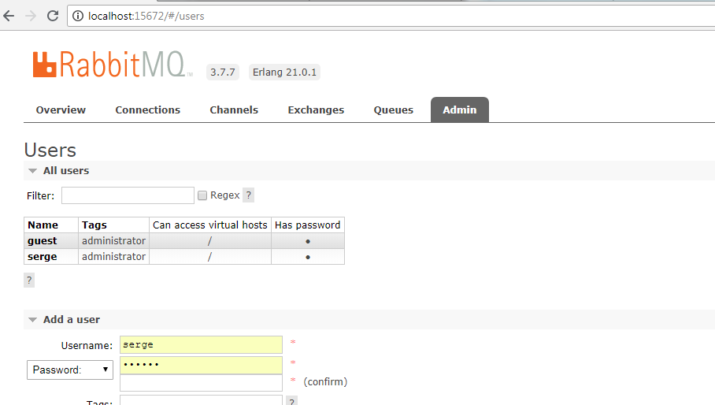

## Java App using the RabbitMQ Client

After setting up the RabbitMQ message broker, We can now test it with a Java client for sending and receiving messages.

**Maven dependency**

<dependency>

<groupId>com.rabbitmq</groupId>

<artifactId>amqp-client</artifactId>

<version>5.2.0</version>

</dependency>

**Sending messages** (on 2 different queues)

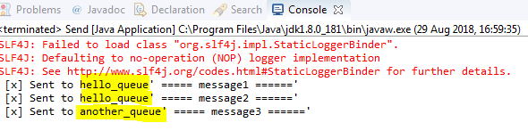

**Receiving messages** (only from the hello_queue)



Check the created queues on the **RabbitMQ** administration Console.

