DB2 Community Edition Installation

Linux Ubuntu 16.04

Contents

a) Prerequisites 2

b) Linux Proxy Settings (On Ubuntu or Debian) 2

Proxy settings for the system 2

Proxy settings for the package manager apt-get 3

c) Shared folder between Windows and the Linux VM 3

d) Docker CE installation 5

Docker repository setup 5

Docker users and groups 5

Docker proxy settings (Ubuntu 16.04+) 6

e) DB2 database installation 7

## Prerequisites

* Install **VirtualBox** or **VMWare** in order to create and run Linux virtual machines on your Windows PC.
* Create a new Linux Ubuntu (16.04 +) Virtual Machine from an iso image (ex: 15GB+ disk, 2GB RAM, enough CPU).
* Add the **VirtualBox** executables to the Path (Control Panel -> System -> environment variables-> user Path). 🡺Add this C:\Program Files\Oracle\VirtualBox
* Check your VDI (Virtual machine file) information with the following command on Windows:

vboxmanage.exe showhdinfo "path_to_your_VDI"

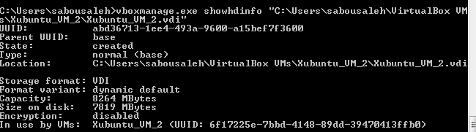

## Linux Proxy Settings (On Ubuntu or Debian)

### Proxy settings for the system

Create a simple user “**devuser**” and use sudo command to execute most of the following commands.

Edit the environment variables file:

devuser:~$ sudo vi /etc/environment

Add the following environment variables:

export http_proxy="http://10.152.1.11:8080"

export HTTP_PROXY=http://10.152.1.11:8080

export https_proxy="http://10.152.1.11:8080"

export HTTPS_PROXY="http://10.152.1.11:8080"

export ftp_proxy="http://10.152.1.11:8080"

export FTP_PROXY="http://10.152.1.11:8080"

export no_proxy="localhost,127.0.0.1,localaddress,.localdomain"

export NO_PROXY="localhost,127.0.0.1,localaddress,.localdomain"

### Proxy settings for the package manager apt-get

Create a new file called **95proxies** under /etc/apt/apt.conf.d/, and include the following:

Acquire::http::proxy "http://10.152.1.11:8080";

Acquire::ftp::proxy "http://10.152.1.11:8080";

Acquire::https::proxy "https://10.152.1.11:8080";

Restart the networking interface:

devuser:~$ sudo /etc/init.d/networking restart

Check the proxy is working well:

devuser:~$ sudo apt-get update

## Shared folder between Windows and the Linux VM

We first need to mount the VirtualBox image (.iso) in order to install the required guest additions. For that, access the **VirtualBox settings**, go to the **storage** tab, Controller: IDE -> select path to the iso image **VBoxGuestAdditions.iso** located on your local Windows machine.

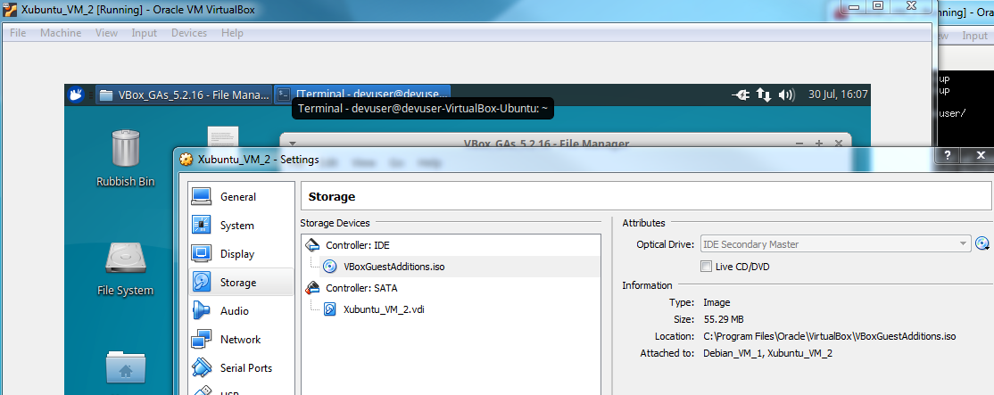

Now configure a shared folder for your Linux VM:

VirtualBox Menu -> Devices -> Shared Folders -> Shared folders Settings…

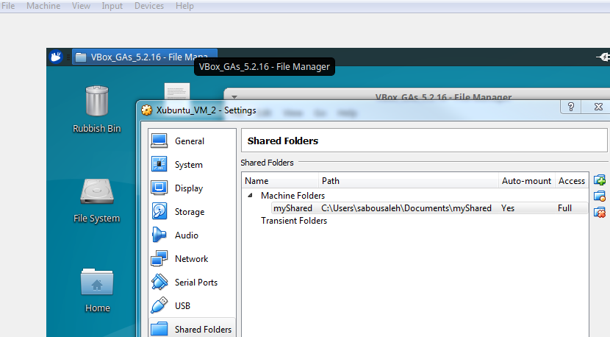

Now we need to configure the Linux VM to be able to access the shared folder.

Access the mounted drive containing the VirtualBox guest additions:

devuser:~$ cd /media/devuser/VBox_GAs_5.2.16/

Run the script to install the VirtualBox guest additions

devuser:~$ sudo ./VBoxLinuxAdditions.run

Locate the newly created group vboxsf:

devuser:~$ cat /etc/group | grep vboxsf

Add current user to the group:

devuser:~$ sudo adduser devuser vboxsf

Check the user was added to the group:

devuser:~$ cat /etc/group | grep vboxsf

Reboot your Linux VM and try accessing the shared folder visible under path /media (or under File Manager).

## Docker CE installation

### Docker repository setup

Install packages to allow apt to use a repository over HTTPS:

devuser:~$ sudo apt-get install apt-transport-https ca-certificates curl software-properties-common

You might need to add username and password to the proxy authentication, before running the command to add Docker’s official GPG key:

devuser:~$ sudo curl -fsSL https://download.docker.com/linux/ubuntu/gpg | sudo apt-key add -

Verify that you now have the key with the fingerprint 9DC8 5822 9FC7 DD38 854A E2D8 8D81 803C 0EBF CD88

devuser:~$ sudo apt-key fingerprint 0EBFCD88

Set up the “stable” repository

devuser:~$ sudo add-apt-repository \

"deb [arch=amd64] https://download.docker.com/linux/ubuntu \

$(lsb_release -cs) \

stable"

Update the apt package repository

devuser:~$ sudo apt-get update

List available Docker CE versions:

devuser:~$ sudo apt-cache madison docker-ce

Install the latest Docker CE version:

devuser:~$ sudo apt-get install docker-ce

Check that Docker was installed successfully:

devuser:~$ docker -v

### Docker users and groups

Add the current user **devuser** to the **docker** group:

devuser:~$ sudo adduser devuser docker

devuser:~$ cat /etc/group | grep docker

### Docker proxy settings (Ubuntu 16.04+)

Create a systemd drop-in directory:

devuser:~$ sudo mkdir /etc/systemd/system/docker.service.d

Create a config file **http-proxy.conf** inside this directory:

devuser:~$ cd /etc/systemd/system/docker.service.d

devuser:~$ sudo touch http-proxy.conf

Edit file **http-proxy.conf** with the following lines:

[Service]

Environment="HTTP_PROXY=http://10.152.1.11:8080/"

Environment="HTTPS_PROXY=http://10.152.1.11:8080/"

Environment="NO_PROXY=localhost,127.0.0.1,localaddress,.localdomain.com"

Flush changes:

devuser:~$ sudo systemctl daemon-reload

Restart Docker:

devuser:~$ sudo systemctl restart docker

Restart the docker service

devuser:~$ sudo service docker restart

Check that docker is running:

devuser:~$ ps -ef | grep docker

Stop / remove all of Docker containers:

devuser:~$ docker stop $(docker ps -a)

devuser:~$ docker rm $(docker ps -a)

## DB2 database installation

Create a free IBM account and download the free “**DB2 developer community edition**”.

Add the downloaded file (ibm-db2-developer_community_edition-1.2.1-x86_64.AppImage) to the shared drive so it can be executed from the Linux VM.

Check you have at least 4GB of free disk space on your Linux VM:

devuser:~$ df-h

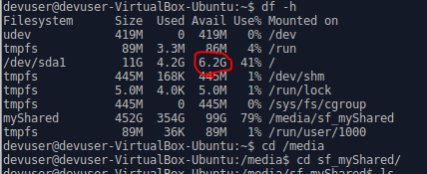

Run the executable installation script accessible on the shared folder:

devuser:~$ sudo ./ibm-db2-developer_community_edition-1.2.1-x86_64.AppImage

Once the script executed, you should reach the following screen. Follow the steps and installation should run fine until the end.

