Maven Setup on Eclipse

Go to Eclipse Windows preferences:

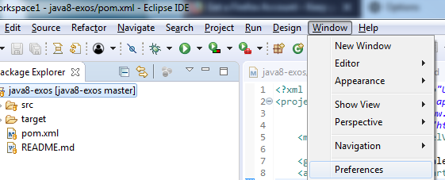

In the Menu: Maven -> Installation (selected should be EMBEDDED)

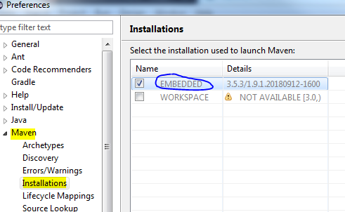

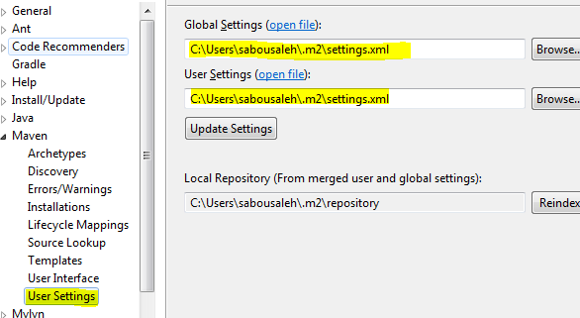

Create the Maven configuration file: **settings.xml**

<settings xmlns="http://maven.apache.org/SETTINGS/1.0.0"

xmlns:xsi="http://www.w3.org/2001/XMLSchema-instance"

xsi:schemaLocation="http://maven.apache.org/SETTINGS/1.0.0

https://maven.apache.org/xsd/settings-1.0.0.xsd">

<proxies>

<proxy>

<id>myproxy</id>

<active>true</active>

<protocol>http</protocol>

<host>10.152.1.11</host>

<port>8080</port>

<nonProxyHosts>localhost|127.0.0.1</nonProxyHosts>

</proxy>

</proxies>

</settings>

Clean the Maven local repository by deleting all existing folders:

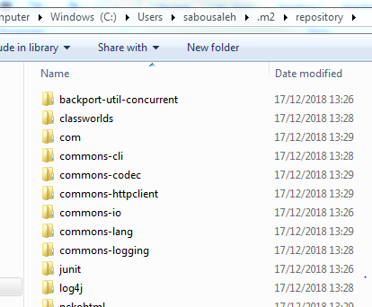

Create a Run configuration for your local project:

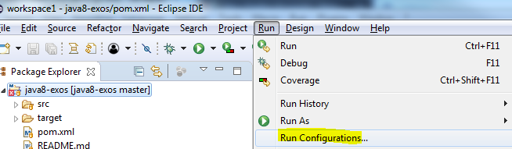

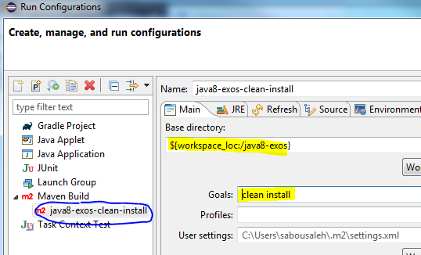

Run this newly added task:

The Maven .m2 repository will receive the downloaded dependencies, the build should be successful:

