**Components**

Maven 3.3.9

SpingBoot 1.5.10.RELEASE

Junit – AssertJ (Integrated in Springboot test)

Rest API for Get, Post and Delete

Dictionary file included in the package

Development done with Eclipse-Oxygen 4.7.3a

**Instructions**

Place the dictionary file inside folder **src/main/resources** and name it as **Words_Tech_Test.txt**

**Front-End**

I only display a jsp page to welcome the user, I haven’t plugged my front-end to the REST API. I aimed to do it with Angular instead of plain JQuery Ajax.

**Build**

maven clean install

**Launch Application**

java -jar target/anagram-0.0.1-SNAPSHOT.jar

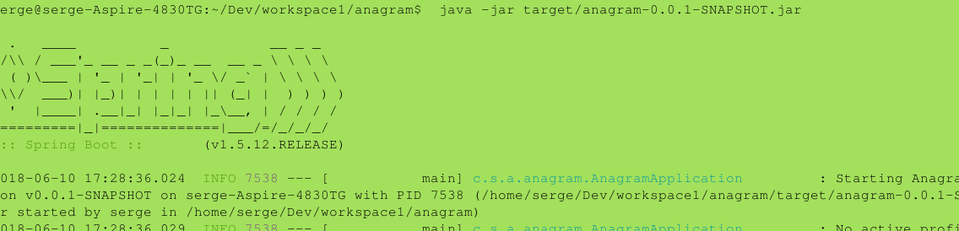

Access the web app at <http://localhost:8080/>

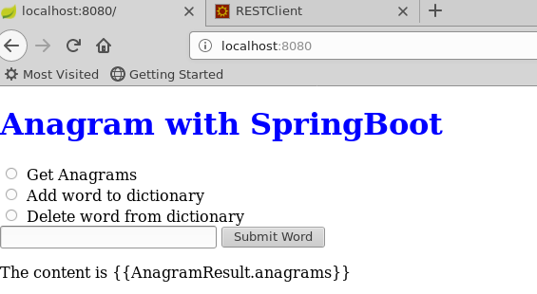

**Examples below Using a Rest client on Firefox**

**Get Anagrams**

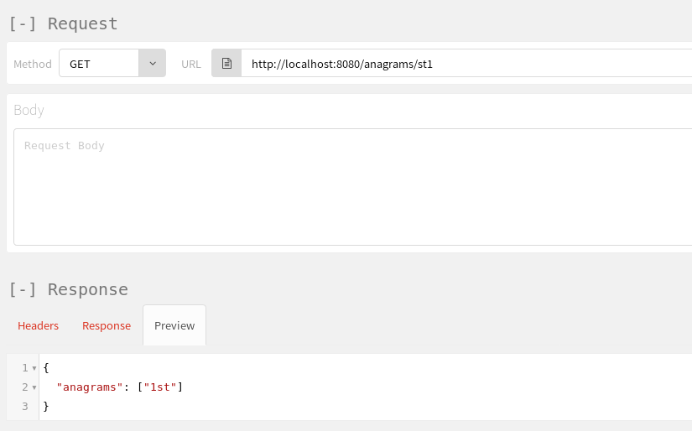

**Add word to dictionary**

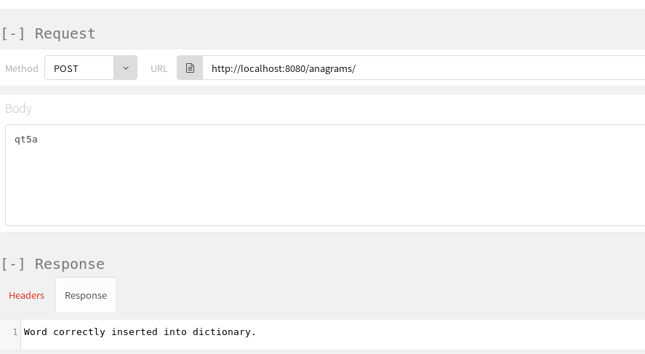

**Delete word from dictionary**

