分类号 学号 I201221254
学校代码10487 密级

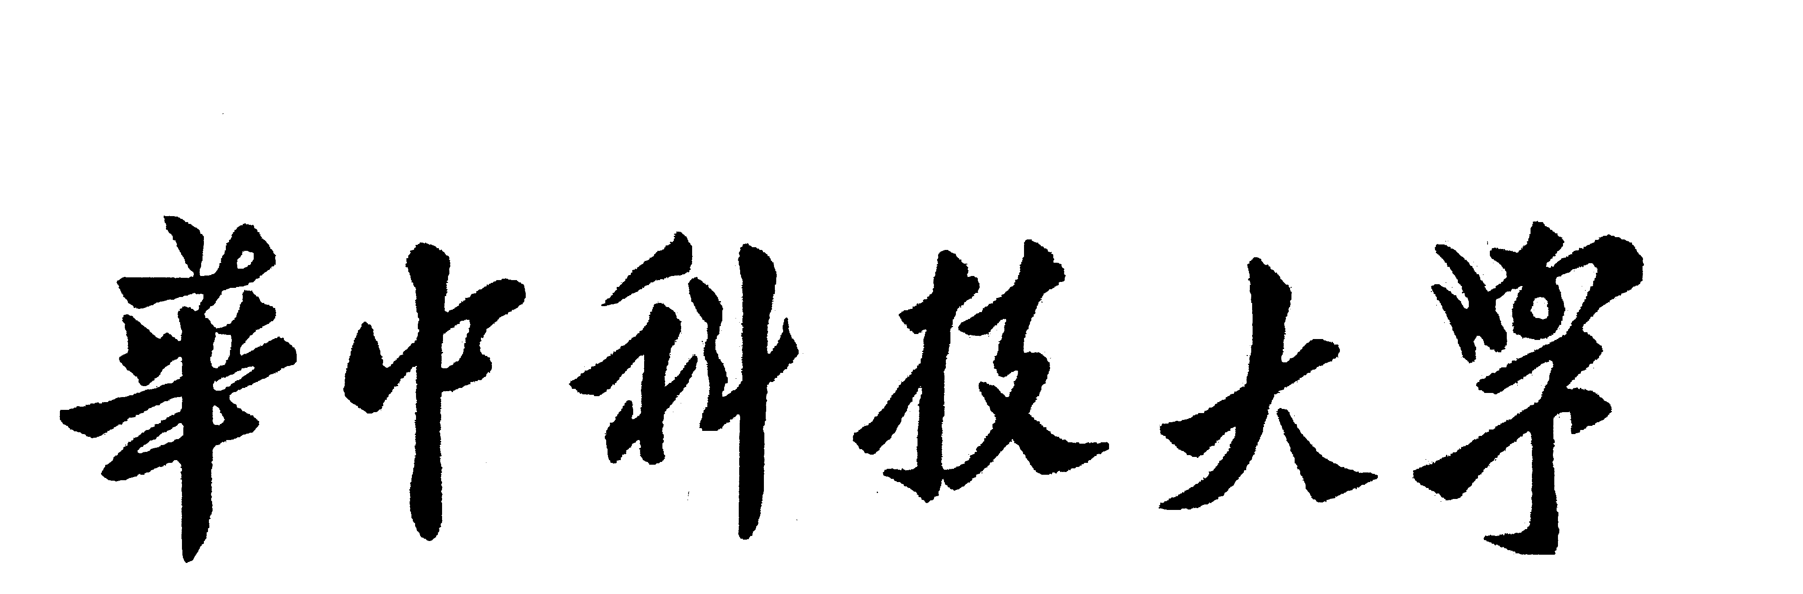

硕士学位论文

k-NN算法的扩展与并行实现

学位申请人 | ： | 杨 喆
学科专业 | ： | 计算机应用技术
指导教师 | ： | 马光志 副教授
答辩日期 | ： | 2014.5.28

A Thesis Submitted in Partial Fulfilled of the Requirements for the Degree of Master of Engineering

Extension and Parallel Implementation of k-NN Algorithm

Candidate : Yahya Abdulhamid Yahya
Major : Computer Applied Technology
Supervisor : Associate Prof. Guang Zhima

Huazhong University of Science and Technology
Wuhan, Hubei 430074, P. R. China
May, 2014
独创性声明

本人声明所呈交的学位论文是我个人在导师指导下进行的研究工作及取得的研究成果。尽我所知，除文中已经标明引用的内容外，本论文不包含任何其他个人或集体已经发表或撰写过的研究成果。对本文的研究做出贡献的个人和集体，均已在文中以明确方式标明。本人完全意识到本声明的法律结果由本人承担。

学位论文作者签名：
日期： 年 月 日

学位论文版权使用授权书

本学位论文作者完全了解学校有关保留、使用学位论文的规定，即：学校有权保留并向国家有关部门或机构送交论文的复印件和电子版，允许论文被查阅和借阅。本人授权华中科技大学可以将本学位论文的全部或部分内容编入有关数据库进行检索，可以采用影印、缩印或扫描等复制手段保存和汇编本学位论文。
保密□， 在 年解密后适用本授权书。
本论文属于
不保密□。
（请在以上方框内打“√”）

学位论文作者签名： 指导教师签名：
日期： 年 月 日 日期： 年 月 日

摘 要
在数据挖掘及其它研究领域，k-近邻算法k-NN是一种广泛用于不同分类用途的算法。然而，k-NN倾向于处理数值类型的数据集，这就限制了它用于科学及工程领域的许多问题。而且，随着其知识库规模的变大，其效率也成为一个瓶颈问题，因为它总是比较所有样本以发现最佳匹配。
为了扩展其应用范围到非数值类型，将编辑距离引入到k-NN算法中，以便它能向数值数据一样发现最佳匹配。因为在k-NN中涉及数值计算，将编辑距离和Levenshtein距离结合以计算两个样本之间的距离。基于上述方法，具有数值和非数值类型的样本可以比较和匹配。
为了提高样本匹配过程的计算速度，将并行计算方法引入到k-NN算法中。考虑到OpenMp框架能够支持网络中的多处理器，并且可以利用处理器中的多核进行并行线程计算，为此，使用Code:: Blocks跨平台的C/C++集成开发环境同OpenMp结合，实现了k-NN算法的线程并行计算。
提出的算法被设计成能够处理数值和非数值列的任何数据集。对线性和并行的k-NN 算法进行了试验，并比较了这些试验所产生的结果。同线性k-NN 算法相比，并行k-NN 在数据集足够大能够弥补并行线程负载的情况下更快。如果数据集非常小则并行算法使用起来不够有效。
在试验中，提出的扩展并行k-NN 算法能够按预期方式工作，这表明该扩展并行化的k-NN 算法能够被广泛及有效地应用于大规模数据集。

关键词：k近邻算法 Levenshtein距离 并行 OpenMp

Abstract
In data mining and other research fields, k-nearest neighbor algorithm k-NN is one of the widely used algorithms for different classification purposes. However, k-NN is supposed to deal with numerical data sets, this limits the application for k-NN for many science and engineering problems. And more, when its knowledge base becomes larger, the efficiency becomes a bottle neck for it tries to compare all examples and find the best match.
To extend its application area to non-numerical data sets, the edit distance is introduced into k-NN so that it can find the best match like numerical data sets. Since the calculation of distance for numerical data are involved in the k-NN algorithm, the edit distance is combined with Levenshtein distance to calculate distance between two examples. Therefore, the examples with numerical and non-numerical data can be compared and matched.
To enhance the speed of matching process, parallel computation is introduced into k-NN algorithm. The OpenMp framework can support multiple processors in a network and can make use of multiple cores for parallel thread computation. In this paper, Code:: Blocks cross-platform C/C++ IDE is used with OpenMp to implement the thread parallelization for k-NN algorithm.
The proposed algorithm is designed to tackle any data sets with numerical and non-numerical columns. Experiments have been done for sequential and parallel computation and the results are compared. Compared to sequential algorithm, the performance of parallelized algorithm is faster under condition that datasets are large enough to compensate the parallel thread overheads. If there is just small amount of data then parallelized algorithm won’t be used effectively.
The proposed algorithm for the mixed type datasets is working as expected in the experiments. This indicates that the extended and parallelized k-NN algorithm can be widely and efficiently used for any large scale data sets.

Key words: k-NN Algorithm Levenshtein Distance Parallelization OpenMp

Abbreviations
k-NN | k- nearest neighbor
MP  API  GUI  3D  CPU | Message passing interface  Application programming interface  Graphical user interface  3 Dimension  Central processing unit
pthread | Parallel thread
OpenMp | Open Multi-Processing

Table of Contents
45)

1 INTRODUCTION

1.1 Parallel computing
A parallel computing is an attempt to speed up your solution of a particular task by doing certain things. One of those things is by dividing task into sub-tasks that are much smaller than their larger task and then be able to execute those sub-tasks simultaneously on multiple cores.
With parallel computing, we can solve our problems fast that are, reducing time-around time of big jobs. If you have large amount of job that takes long time to execute, with parallel computing it will take less time with the same amount of a job. And in case of interactive application, it will increase better responsiveness of interactive apps; you will get better turn-around and interaction with those applications. Also availability of better solution in the same amount of time that is, you may have a case where your data set is too large to fit on the current technology. With parallel computing, you can run that larger model and do it at the same amount of time that will take for a smaller dataset case. This allow you to increase the resolution of models and allow you to make your model more sophisticated, add more processing, physics, add more things to the model where the faster computer can take advantage of. A parallel computing is the one of the method where by a faster computer uses to speed up its operations.
If you are going to be successful dividing a computation and running in parallel, you have to do two things. First you have to understand where parallelism can be most effective and then have the knowledge of how to design good solutions.
Previously, clock speed was the main reason of speeding up your task during computation. According to Herb Sutter, he said “The free lunch is over”, which means the clock speed are no longer going to be increasing exponentially, as seen from the graph on figure 1.1.
Clock speeds have double for every 18 months or two years according to Moore’s law but it is not going to sustain that growth any longer and still it is needed for our applications to run faster.
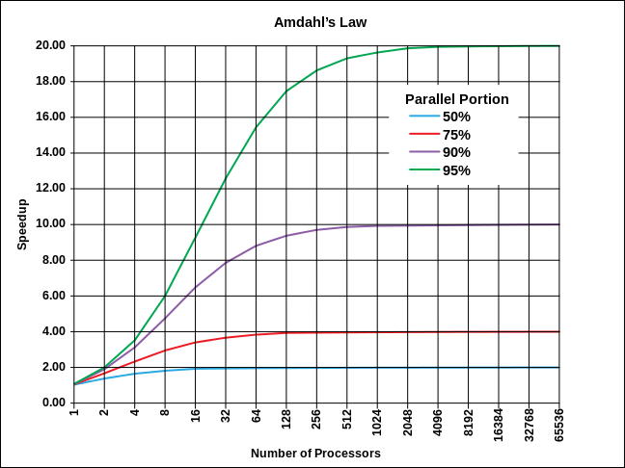
Figure 1.1 Parallel performances for multiple processors
With higher speeds come different problems, one is excessive power consumptions. It takes more power to drive a processor faster and faster. There is also a case of heat dissipation, if you run more current through a processor, you are going to get hotter and hotter and you have to deal with that heat in some way.
When you put more power into a processor, the leakage between wire and a processor increases and so it becomes less efficient in the use of that power. For mobile device like laptop and notebooks, power consumption has become critical factor, it is needed to increase battery life of devices and make sure they last longer on a single charge.

1.2 Execution optimization
There are several ways besides parallelism that can be used to try to optimize or increase performance of applications. The popular ways for optimization are:
- Instruction pre-fetching. If it can be known what are the next instructions are going to be executed, it could make sure that part of our processing is to go out and fetch that instructions before it needs it;
- Instruction reordering. This is done by taking your instructions and put them into different order from what you wrote in serial code. If instructions have operands available and ready, they should be allowed to execute and where instructions don’t have operand available, they should be left behind. This will increase performance in the application;
- Pipelined function unit. This allow to have multiple instructions in flight at the same time that will increase performance;
- Multiple functional units. With this unit it can be done editor operations, memory allocations and other tasks at the same time which will increase performance;
- Hyper threading. It takes advantage of multiple function unit, if one thread or one process is not taking advantage of all of the function unit and there is another process the can use those function unit that are being used then it can be merged those stream together and execute two process at the same time using different functional unit.
All of the above ways can help increase performance but there is not a lot of cases where the programmer can actually directly affect them, they are all devoted to hardware. As addition of sophistications to hardware itself, it is required more and more silicon be devoted to the things that control the hardware.
With multiple hardware, more cores can be added to that hardware. So the strategy behind multiple hardware is to be able to limit the core speed and decrease sophistications so that it can be added multiple core in a single chip. Suppose p.f is the potential performance of the core, s is the speed of the core, p is the number of the core. If the speed of the core is kept constant then
p.f = (1-1)
Now if we could increase the speed of a core a little bit and be able to have a space to increase the number of cores in hardware, then the more number of cores you have, the more performance you get. And likewise goes to the speed of the core.
Back on the old days, not so many people were demanding the best and greatest way to make their parallelism easier and this led parallel programming to be a little difficult. These days parallel programming have become a little bit easier compared to the old days. Nowadays a programmer and compiler can work together to increase the performance. A programmer is given a way to express the parallelism and then it’s up to compiler to take those hints given by the programmer and translate that code and make it into parallel application that can be run into multiple cores. Programmers of modern CPU must take architecture and compiler into account in order to get peak performance.
With this capability of multicore processor; PCs, notebook, laptops are parallel computers. Nowadays anybody can have parallel computers to support these platforms and to learn parallel programming as well ^{[1-5]}.

1.3 Objective of the Research
The main purpose of this research focused on the modification and parallelization of k-NN algorithm. Their demonstration based on the followings:
- To evaluate the performance of k-NN algorithm when non-numerical input data are being used to predict the output;
- To evaluate the precision of the modified algorithm, whether if it is reliable or not;
- To evaluate the execution time performance of the sequential and the parallelized k-NN algorithm.
Generally, the objective is to evaluate the modified k-NN algorithm before and after modification in terms of performance in time and precision.

1.4 Research Contributions
It is already known that the existing k-NN algorithm is used in many aspects on the research. Previously, it is known that k-NN algorithm uses numerical data for computation. What I have tried to contribute in this research is:
- Trying to use the same idea of the k-NN algorithm and combining it with other ideas to produce k-NN algorithm that can accept strings as its data input for computation;
- Showing the effects of using OpenMp for parallelization of k-NN algorithm. Every programmer has different approach to achieve parallelization of their code. Therefore I have tried to use OpenMp as my threading model.

1.5 Background and Related Work

1.5.1 Background
As briefly explained earlier, parallel computation in computer science focus on software architecture and the problems associated with the implementation of the application processing system. For long time it has been a field of active interesting research and applications , the main objective is on high-performance computing which is now have became a widely used computing model.
In the application development in the world, parallel computing has a very active part. Parallel application has not been easier to write. An application that divided into multiple parallel tasks procedure is more difficult to write, because the necessary synchronization and communication between these tasks are needed to be taken. Some standards have been discovered.
For massive parallel processors and cluster brings together a number of software programming interfaces to the mid-1990s, is known as a single standard of MPI ^{[6]}. The same process launched by the two standards and convergence by the mid to late 1990s: pthread and OpenMp for shared memory multi-processor computing. In addition to these, over the years many competing parallel programming models have emerged. These models and languages to parallel programming problems can be a better solution than the above "standard”, all of which are modifications of traditional, non-parallel languages such as C.
With multicore processors bring parallel computing mainstream customers, the key problem in today’s application industry is how to transform them in parallel programming .so far there is no software or a system that can transform all applications everywhere to parallel. Doing so will need extensive collaboration and create a family of technology that work together so as to bring the power of parallel computing to future mainstream applications. The changes required will affect the entire industry, from consumers to hardware manufacturers and from the entire software development infrastructure ^{[7]}.
Future features such as photo-realistic graphics, and machine learning to calculate the true perception relies on highly parallel algorithms ^{[8]}. Enabling these features will drive the next generation experience, expanding the scope and efficiency of the user in their digital lifestyle and workplace implementation. These experiences include more natural, realistic, and more and more, to provide multi-dimensional richness and context-aware multi-sensory interaction. Parallel computing future is bright, but with the new positive chances brought new challenges as well.
Because of existing of parallel computers; concurrent programming languages, libraries, API, and parallel programming model have been created for parallel programming. These can be roughly categorized based on their underlying assumptions made in memory architecture, shared memory, distributed memory or shared distributed memory ^{[9]}. Shared memory programming languages communicate by manipulating shared memory variables. POSIX threads and OpenMp parallel models are the two most widely used shared memory API whereas Message Passing Interface (MPI) is the most widely used message passing system API. One concept used in programming parallel programs is the future concept, where one part of a program promises to deliver a required datum to another part of a program at some future time.

1.5.2 Related works
The difficulty of text mining has gained rising attention in up to date years because of the huge amounts of text data, which are created in a variety of social network, web, and other information-centric applications. Unstructured data is the easiest form of data which can be created in any application scenario. As a result, there has been a tremendous need to design methods and algorithms which can effectively process a wide variety of text applications ^{[18]}.
Data mining is a field which has seen rapid advances in recent years because of the immense advances in hardware and software technology which has lead to the availability of different kinds of data ^{[10]}. This is particularly true for the case of text data, where the development of hardware and software platforms for the web and social networks has enabled the rapid creation of large repositories of different kinds of data. In particular, the web is a technological enabler which encourages the creation of a large amount of text content by different users in a form which is easy to store and process. The increasing amount of text data available from different applications has created a need for advances in algorithmic design which can learn interesting patterns from the data in a dynamic and scalable way.
While structured data is generally managed with a database system, text data is typically managed via a search engine due to the lack of structures ^{[11]}. A search engine enables a user to find useful information from a collection conveniently with a keyword query, and how to improve the effectiveness and efficiency of a search engine has been a central research topic in the field of information retrieval ^{[12-13]}, where many related topics to search such as text clustering, text categorization, summarization, and recommender systems are also studied ^{[14-16]}.
However, research in information retrieval has traditionally focused more on facilitating information access ^{[12]} rather than analyzing information to discover patterns, which is the primary goal of text mining. The goal of information access is to connect the right information with the right users at the right time with less emphasis on processing or transformation of text information. Text mining can be regarded as going beyond information access to further help users analyze and digest information and facilitate decision making. There are also many applications of text mining where the primary goal is to analyze and discover any interesting patterns, including trends and outliers, in text data, and the notion of a query is not essential or even relevant.
Technically, mining techniques focus on the primary models, algorithms and applications about what one can learn from different kinds of text data. Some examples of such questions are as follows:
- What are the primary supervised and unsupervised models for learning from text data?
- How is traditional clustering and classification problems different for text data, as compared to the traditional database literature?
- What are the useful tools and techniques used for mining text data?
- Which are the useful mathematical techniques which one should know, and which are repeatedly used in the context of different kinds of text data?
- What are the key application domains in which such mining techniques are used, and how are they effectively applied?
Recently, there has been rapid growth of text data in the context of different web-based applications such as social media, which often occur in the context of multimedia or other heterogeneous data domains. Therefore, a number of techniques have recently been designed for the joint mining of text data in the context of these different kinds of data domains. For example, the Web contains text and image data which are often intimately connected to each other and these links can be used to improve the learning process from one domain to another. Similarly, cross-lingual linkages between documents of different languages can also be used in order to transfer knowledge from one language domain to another. This is closely related to the problem of transfer learning ^{[17]}.
Unsupervised learning methods for text data: Unsupervised learning methods do not require any training data, thus can be applied to any text data without requiring any manual effort. The two main unsupervised learning methods commonly used in the context of text data are clustering and topic modeling.
Supervised learning methods for text data: Supervised learning methods are general machine learning methods that can exploit training data (i.e., pairs of input data points and the corresponding desired output) to learn a classifier or regression function that can be used to compute predictions on unseen new data. Since a wide range of application problems can be cast as a classification problem (that can be solved using supervised learning), the problem of supervised learning is sometimes also referred to as classification. Most of the traditional methods for text mining in the machine learning literature have been extended to solve problems of text mining. These include methods such as rule based classifier, decision trees, nearest neighbor classifiers, maximum margin classifiers, and probabilistic classifiers. K- Nearest neighbor algorithm is an instant based learning algorithm that uses existing training datasets for classification of the new tested data.
Parallel text mining: In many applications of text mining, the amount of text data is huge and is likely increasing over time, thus it is infeasible to store the data in one machine, making it necessary to develop parallel text mining algorithms that can run on a cluster of computers to perform text mining tasks in parallel. In particular, how to parallelize all kinds of text mining algorithms, including both unsupervised and supervised learning methods is a major future challenge. This direction is clearly related to cloud computing and data-intensive computing, which are growing fields themselves.

1.6 Thesis Organization
The remaining of my thesis is organized as follows.
The second chapter is about the fundamental of parallelization. it introduces the basic concept of parallelization in general and how parallelization works with multicore processor and memory sharing. Introduction of basic concept of OpenMp and its directives that are mostly have been used on my experiment
The third chapter is about introducing the concept about k-NN algorithm and Levenshtein distance algorithm and how they work to process their results. It explains about methods of modification of k-NN algorithm on input strings data and algorithm parallelization.
The fourth chapter is about the experiment conducted and evaluation of the results obtained from the tested methods which were discussed on the previous chapters. Performance of the algorithms was tested with different types of data that is numerical and non numerical.
The fifth chapter is about conclusion and suggestion for future work to be done.

2 Fundamental of Parallelization
In this chapter, I am going to discuss about ways of exploiting parallelism, how to find parallelism in the algorithm, concept of threads and process, OpenMp and its methods on how it works in terms of its pragma directives function and time performance

2.1 Ways of exploiting parallelism
The simple methodology to understand parallelism is to study the problem, sequential program or whatever code segment which are interested at and trying to find the opportunity of parallelism. One of the main goals of doing parallel programming is trying to keep the entire core on the processor busy doing useful work. So I will be looking at some performance techniques and ways of making sure to get the right amount of parallelism for the problem at hand.
The three different ways to take your serial application and divide it up into subtask that can be run into parallel are domain decomposition, task decomposition and pipelining ^{[19]}.
Domain decomposition: The idea behind this decomposition method is you are looking at your problem as a large data set where each element of a data set is going to be operated on and the operation on those elements can be done independently once you decided how data elements should be divided among cores ^{[20]}. Second part is to decide which task each core should be doing. So you divide up your data and assign block of data on to those cores.
One example is vector addition. If there are two vectors eg ai+bj and ci+dj and there is addition of the corresponding elements together, I can divide those vectors into blocks and assign blocks to different cores and have those cores execute their portion independently of any other core that executing different portion of the vector, that is (a+c)i and(b+d)j each with different core. As another example, suppose there is a set of an array and it is required to find the largest array.
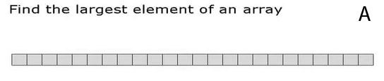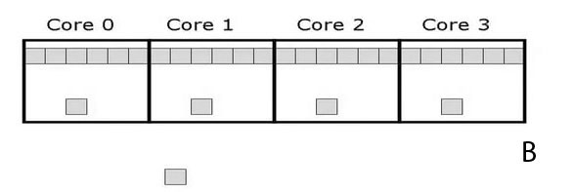
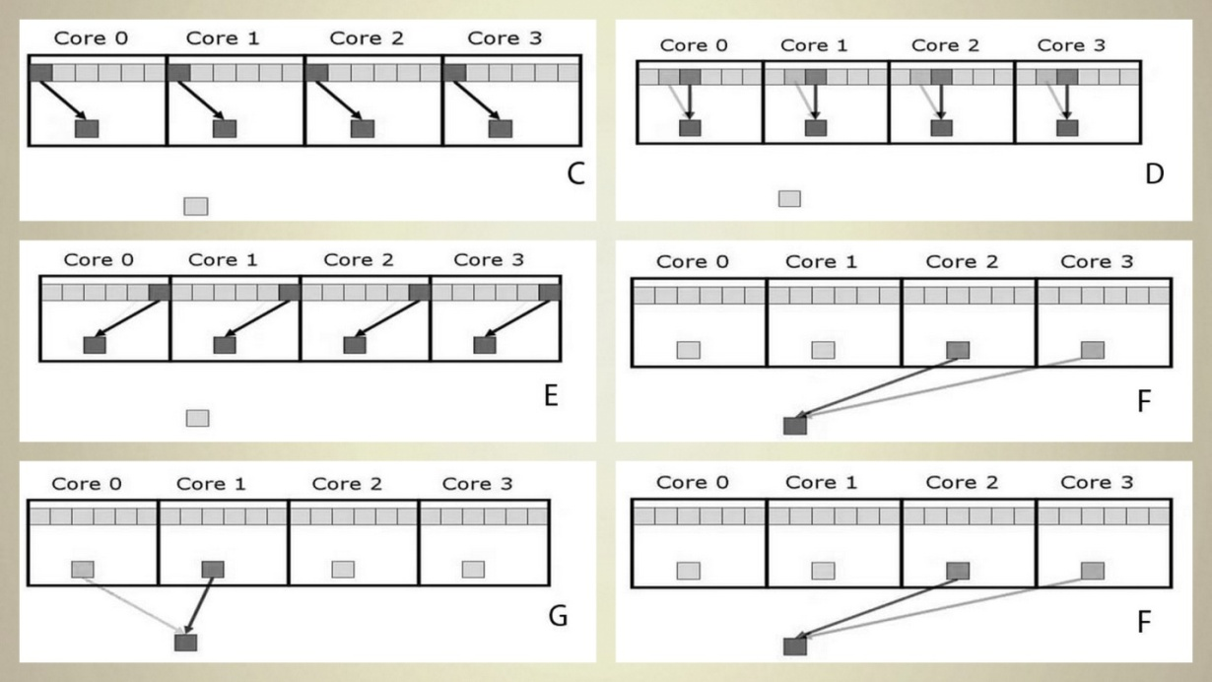
Figure 2.1 domain decomposition methods on parallelization
On the part A of the figure 2.1 above is an array that is required to find the maximum value of. In a domain composition, what is required to do first is divide up an array from A and put it into individual core as shown on part B of a figure 2.1. It can be done this operation on parallel because finding the maximum of the element that are stored or given to the core 0 is going to be independent of finding the maximum value of those elements given to core 2 and other cores. After division for each core, the algorithm will take a subsection for each core and find the maximum value within its local area and store the value as shown on part C, D and E of the figure 2.1. Once completed, again the algorithm will take the four maximum values for each core and compare them to one another so that the maximum array can be found as shown on the part G and F of the figure 2.1.
Task (functional) decomposition: In this case I want to divide a problem into independent tasks. I can look at the actual computations that are being done and look for independent computations that I can assign to different cores. Once I define my independent task, the second part is to find is to find the data that goes along with each of those tasks and make sure the data is accessible by the core which is going to execute those tasks ^{[21]}.
An example of task decomposition is Event-handler for GUI. There are several different events like mouse clicks, screen, keyboard functioning or things that are being processed when you want to update the GUI. Those are all independent to each other to some extent and can be then assign to different core during the parallel implementation of event-handler for your GUI. The figure 2.2 below shows how some tasks like f, g, h, q, r, s can be executed by different cores.
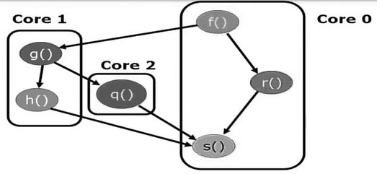
Figure 2.2 Task decomposition method
Pipelining: This is special kind of task decomposition ^{[22]}. It’s an assembly line or stages that are executed or your data flow through so as to do computations. As an example 3D-rendering in computer graphics might be done as pipe line. I can think of rendering of pixels being done in four stage process as illustrated on the figure 2.3.
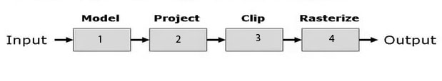
Figure 2.3 Pipelining
With our sequential processor, if there is one core available, each of the stage on that single core should be done one step at a time. Therefore I can say, it is just one dataset in four steps. If there are four cores system and four stage pipeline, I can assign each stage of pipeline to a single core. In that case I can do two datasets almost simultaneously but the restriction is that, the modeling of the first data set has to be done before the modeling of the second datasets can begin. The first dataset after completing its modeling goes to the next core and pipeline can do the projection.
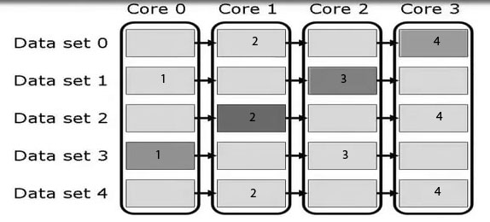
Figure 2.4 Four stage pipeline
If I consider dataset number 3 that has four stages as shaded on the figure 2.4 above. Each stage of dataset 3 is being executed almost simultaneously by different core and different portion of a pipeline, meaning that each core executes only one stage for each data input. With five dataset and four cores, I can execute those five dataset in eight steps. If I had to this in serial, those five datasets would have taken twenty steps. And now I can see the advantages of doing parallel pipelining.

2.2 Finding parallelism
In order to find independent task within an application, first you have to be familiar with application and you should have a good idea on where independent computation can be found. For example ^{[1, 2, 3, 23]}:
- If there is a large dataset involved. Then a domain composition could probably be a good solution;
- If there is a portion of your code that can be executed in different order or independently to each other, then a task composition is a potentially possible solution on that matter;
- If the computations are a set of stages that don’t interact except when the output of one stage is the input of another stage, then pipeline composition could be a better solution.
Now if you are not familiar with an application, you could read the application and try to find those computation intensive parts that can be made parallel.
Shared memory consideration: If you are going to do any parallel computing and you have got multiple processors that are working together to speed up the solution of a single task, then that’s require some kind of cooperation between the thread of the processors^{[24]}. There are two kind of cooperation that can be seen.
- It is needed to share information. There may be some data that one core or one thread had, that another core or thread needs to perform its computations. So it is needed to communicate those data value back and forth between those two threads and two cores.
- Second, the kind of cooperation of just keeping out on each other’s way. If I have shared resources between the threads, I want to make sure that access to those shared resources is done in a nice orderly fashion so that the answers I get in serial code should be the same answer I get in parallel code.
One way I can look at shared memory module of computing system is with diagram shown on the figure 2.5 below.
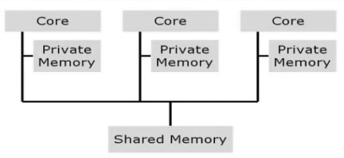
Figure 2.5 Private and shared memory module
Here, there are several different cores, each of those cores have private memory that allocated to only being accessed by core. There are things like registers used by the core, cache that is exclusively only accessible by the core. And also every core has access to shared memory to some kind of bus structure. In a shared memory module like see on the figure 2.5, both memories are going to be accomplished through shared variables. In the case of communications, it has to be set a buffer that known to each of the two threads that need to share data, one thread write data on that buffer and the other thread raise the data out of that buffer. As far as synchronization goes, there are several synchronization objects available depending on what threading module or threading libraries you are using for implementation. Things like semaphore and locks will be useful to make sure that threads are coordinating the access to shared resources in correct order.
Parallelism and threads: To understand threads first it is needed to know what a process is. A process is a program in some state of execution. It has code associated that executed during the course of execution of the process, it uses data that being read in and read out and also it has a logical address space that contain within the memory of the machine that is executing the process^{[25, 3, 26]}.
During execution, the operating system keeps track certain information about process. Things like a process state, where is within the execution it can be done by looking at the program counter to see where in the code the process is currently executing. The value of the cores registers that actually executing the process need to be held especially when the process is swapped out either from the execution or swap from a different core. The memory management also needs to be controlled and kept tracked of. It is needed to know where the memory is the process located, what data is being used out of memory and so on.
On the other hand, a thread is not quite as heavy as a process. The process needs a whole lot of things for the operating system to keep track of, but a thread its jus a part of a process. A thread needs to have program counter. Since it is a part of execution process, it has to know where in the code it is executing currently. A thread also needs a copy of core register. Since it is the one that actually doing the execution and keep tracking the computation and the result, a copy of those values need to be stored whenever a thread move from either a core or just out of the core. The stack also need to be kept with a thread so that it can be figured out where in the process the thread is executing and how it is getting back from a certain function call.
Being on a memory shared module, thread is going to share the process’s data, code, the address space and all the other resources that the process has been assign. The largest difference between a thread and a process is that, a thread has a lower overhead than a process. To create a process you need to create all the different things that go into a process. In the case of a thread, it has a few things like the program counter, register, stack of activation records and a little bit of memory. All the rest of that stuff is going to be shared with a process. so every time you create the new thread, its much faster or easier to do much less overhead than when you have to a create new process. Another overhead is minimized when swapping out a thread from a core and replace it with another thread.
Since thread has such low overhead, this is why it is easier to use them in parallel implementation rather than having multiple processes that are executing on the same task. Threads are fairly flexible enough to implement between the threads all of the three decomposition method that are explained earlier.

2.3 OpenMp
In this section I am going to do some implementation with OpenMp as our threading module. I am also going to explore OpenMp in the pragma and how to add those pragma to code that are suitable for parallel execution. I am going to focus more on the pragma directives that I have used on my experiment.
OpenMp is simply an API for parallel programming ^{[27, 28, 39]}. It was first developed in 1997 and it has become standard for shared memory parallel programming. It is the set of compiler directives, library functions and environment variables that can be added to C/C++ or FORTRAN codes. OpenMp is not its self a separate language but its pragma and directives are added to those languages that are recognized by a compiler and the compiler will then transform your code from a serial implementation into a parallel one. OpenMp its self is based on fork/join module of threads which I am going to explain as follows.
In the fork join module then, the master thread is that thread which executes the sequential portion of your application ^{[27]}. When you come to your parallel portion of your program and when the master thread encounter a parallel portion of your code, it forks off by either creating or awakening additional threads that then execute that parallel portion in parallel. At the end of the parallel section of code, all threads join back together again and the master thread then continue execution of serial portion that follows the parallel region. Below is the figure of fork/join module.
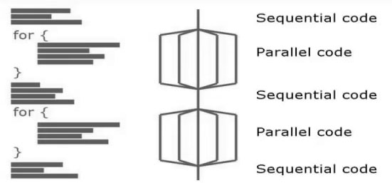
Figure 2.6 Fork/join modules
As seen on the figure 2.6 above. At first there is a little bit of sequential code and then there is may be a for loop whose iteration could be done in parallel, at that point it might required to fork out our thread and have our iteration executed in parallel. At the end of the loop, threads are joined back together and the master thread will then run through the sequential code that follows that for loop. When reaching another parallel region say the next for loop in our code with independent operation, again thread can be fork out and have threads executed in parallel. When they are done with the iteration, the threads are joined and let the master thread to continue as just like the end of for loop in sequential code.
Besides the fork/join model, OpenMp gives us another advantage which is incremental parallelization. In this case I have a sequential program being a special case of a threaded program, as a programmer you can take a sequential code and add parallelism on that part that you think can be made parallel. You add it to one section of your code and then you can profile the program execution, time it and see if you can get a better execution time. If execution time is better then leave that parallelism part and go to the next portion of your code and repeat the process. Therefore you are transforming your sequential code incrementally by stages into corresponding parallel code.
At some point you might may be run out of portion that can be made in parallel or by adding parallelism it will make your performance to be worst, in that case you remove your parallelism and go on to the next portion of your code. Every time you change your code to transform from serial to parallel, you need to make sure it is right. Therefore try to validate your code to make sure you get the right answer as it was in serial code.
In C/C++ OpenMp uses compiler directives that are called pragma. The pragmas are actually handled by the preprocessors and they will transform your code into an equivalent threaded version of each parallel region that you identified. Now all the OpenMp pragmas are going to have the same beginning syntax. It start with pound sign or hash (#) followed by the word pragma and then OpenMp will start every pragma used and then after that the use of whatever construct needed at that particular time within our code. One thing to note is that pragmas are going to appear immediately before the relevant portion of the code they affect and in fact, it is syntaxically incorrect to insert other code between the pragma and the codes that it affects. In most cases the compiler could detect the error and not allowed compilation.
Now this is our first OpenMp compiler directives.
#pragma omp parallel for: This tell the compiler that what follows immediately is going to be a “for loop” and each iteration of the “for loop” can be done or executed independently and in parallel ^{[29]}. Now If it is going to be used a pragma like this, it is must to make sure the number of the loop iteration is computable at run time before the loop execute. All OpenMp pragmas must be followed by a structure of code. In the case of “for loop”, this means the loop cannot contain a break, return or an exit. if you have a “go to” within a loop, “the go loop” cannot actually jump to a label outside of that parallel region. Here is an example of the use for parallel for:
int first, *marked, prime, size ;
#pragma omp parallel for
for (int i=first; i<size; i+=prime)
{
marked[i]= 1 ; }
This is the domain decomposition problem because you can think of the mark array as a large dataset that can be divided into chunks and pieces and assign those pieces to a thread. Things to consider, first the variable “first”, size and prime are not going to be known at compile time when a preprocessor is actually translate this code into a thread equivalent. But OpenMp is going to require that to know the value of the first, size and prime at run time so that when it execute this loop, the run time library for OpenMp could calculate how many iteration there are and then be able to divide those iterations into chunks and assign those chunks into threads for independent and parallel execution. The second thing is there is an implicit barrier at the end of ‘parallel for construct’, that means at the end of for loop, all of the threads must join together as explained in fork/join module.
The nice side effect of using ‘parallel for’ is that the iterator variable in our example “i” is going to be made automatically private for each thread. Every thread has to have private index variable to run iteration of the loop. If they had to share that varible, they will each try to increment or read the shared variable and the whole thing will get confused and each thread could get the wrong value.
#pragma omp parallel: Sometimes you may have code that should be executed in parallel but it is not contained within the “for loop”. In that case, you can write in this form:
#pragma omp parallel
{
Dosomework (res,m);
Dootherwork (res,m);
}
If you want more than one line to be executed in parallel, you need to put in curly braces {}. Therefore the pragma affect anything within curly braces.
Another form that can be used is:
#pragma omp parallel
{
Dosomework(res,m);
#pragma omp for
for (int i=0; i<m; i++){
res[i]= huge( ); }
Dootherwork(res,m);
}
In this case above, only Dosomework(res,m) and Dootherwork(res,m) will be executed by all threads while the code within the for loop will be divided within the threads similarly as the for loop explained earlier in "#pragma omp parallel for": #pragma omp parallel for private(x,y,…,j). Consider the following case:
for (int k=0; i<n; k++)
#paragma omp parallel for
for (int i=0; i<n; i++)
for (int j=0; i<n; j++)
a[i][j] = MIN(a[i][j] , a[i][k] + a[k][j] )
In this case, there is variable k, i and j for their respected loop. Since k was established before the establishment of parallelism, the value k in the parallel region will remain the same for all threads that will be executed. For the case of int i on its respected loop, the i variable will automatically be private variable for each thread due to the use of directive ‘#paragma omp parallel for’ as explained earlier. And for the remaining value j on its respected loop, it will remain as a shared variable for all the threads in the parallel region which might leads wrong computation to a different thread. If each thread call j on its own time for computation , it will be confusing for each thread since each thread might call the value of j on different iteration of j. There for the solution for this problem is to make j private manually since it was not private from the first place. And our directive in this case should be as #paragma omp parallel for private(j). Suppose there is:
float x,y; int i ;
#paragma omp parallel for private(x,y)
for (int i=0; i<n; i++){
x = a[ i ]; y = b[i ] ; c[ i ] = x + y ; }
In this case, the private variables present are x, y and the variable “i” as a default private variable. The values that these variables hold are only recognized by one thread which computed those values. And when threads join together, all private variables are destroyed and the values of private variables will not be recognized by the master thread.

2.4 Reduction in parallel region reduction
If I have associated binary operator a1 + a2 + a3 +…+ a nth is called reduction by taking a large collection of data and compressing it into a single value. some example of associated binary operator that will work in this situation are addition, subtraction, multiplication, some of the logical operator ANDs and ORs and minimum and maximum are some of the operator that can be used in the reduction operation ^{[30]}.
When you add a reduction clause to your pragmas, the value that used to initialize private copy is going to be the identity value for the “op” that listed. So in the case of addition, every private copy will be given a value zero to begin with, since the private copy are going to be updated locally by a thread that executing the region. At the end of the construct all private copy are going to be combined together through the op operation into a single value. And the value that computed will be stored in the original shared variable that was in the list of the reduction clause. Below there is example of the loop of dot product function that has modified to use the reduction clause. I have used + as an op and sum as a variable:
#pragma omp parallel for reduction (+ : sum)
for (int i = 0; i < N; i ++) {
sum += a[i] * b[i] ; }

2.5 Race condition
If I decide to make a loop in parallel without considering private or reduction clause, what is going to happen is the race condition ^{[31]}. A race condition is nondeterministic behavior caused by the order in which two or more threads access a shared variable. In the previous example about reduction, sum is shared variable before parallelization. If we never used reduction and private clause, each thread could try to update sum variable at the same time. If that could happen the value for the sum would be wrong since it might have any value from a different thread with different variable for computation of variable sum.
Programs with race conditions exhibit non deterministic behavior. Sometimes give the correct result and sometimes the wrong ones. Programs often work correctly on trivial datasets and small number of threads. Errors are more likely to occur when number of threads or/and execution time increases. Hence debugging race condition could be difficult.
To avoid race conditions on OpenMp, the followings can be executed:
- Using OpenMp private clause as I have explained earlier;
- Variables are decleared within threaded functions. If declaration of variables is in parallel region then each thread will declare as its own private variable;
- Allocate on thread’s stack (pass as parameter).
These methods only work if you are going to use variables only within the parallel region. If it is must to use calculated value or the last value stored outside the parallel region then you need to use another method which is to control shared access with a “critical region”. And that is done through mutual exclusion and synchronization.
If you put logic into your code that will guarantee in such a way only one thread at a time will access shared resources then race conditions can be prevented. Among the method that can be used is a “critical region”. Critical region is a portion of a code that threads execute in a mutually exclusive way. It only allows one thread a time to access code within the critical region. In another way you can view it as the code in critical region is executed sequentially. In OpenMp, critical pragma is used to create critical region, see the following example.
#pragma omp parallel
{
#pragma omp for
for (int i=0; i<m; i++){
res[i]= huge( ); }
Dootherwork(res,m);
#pragma omp critical
{ Dosomework(res,m); }
}
There is also a simple special construct that can be used called atomic. It only works on one statement at a time within threads. It only updates the memory location that associate the statement. It applies only for simple operation like:
- Pre or post increment ++ and decrement – ;
- Assigning with binary operator (of scalar types) ;
- Works on single statement.
An example is as follows:
#pragma omp atomic
Couter += 5;
Another pragma for OpenMp is #pragma omp single. If there are section of code that is not necessary to be executed in parallel then this pragma is perfect. The code within single pragma will be executed by a single thread only. See the example below.
#pragma omp parallel
{
#pragma omp for
for (int i=0; i<m; i++){
res[i]= huge( ); }
#pragma omp single
{Dootherwork(res,m); }
}
Another pragma for OpenMp is #pragma omp task. Task is independent unit of work. It allows parallelization of irregular problems such as unbounded loop (while loop), recursive algorithm such as quicksort algorithm and producer consumer models between threads. OpenMp only decide to execute tasks if threads are available for execution, if not, then task has to wait until a thread is available. Pragma task works almost similar like domain decomposition for data where each input data is executed by different thread. While in this case each task or function is executed by a different thread as long as it doesn’t affect other task executed by other threads. See the following example .
#pragma omp parallel
{
#pragma omp task
{ Dosomework(res,m);}
#pragma omp task
{ Sample1= inputdata( ); }
#pragma omp task
{ Dootherwork(res,m); }
}

2.6 Prediction of parallel performance
Speed up is the ratio between sequential execution time and parallel execution time ^{[32]}. For example if the sequential program executes in 8 seconds and parallel ones execute in 4 seconds then the speed up is 4x.
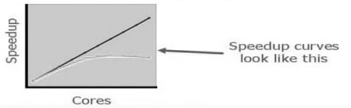
Figure 2.7 the graph of speedup against number of cores
Consider the figure 2.7 above. There is the line that shows linear speed up, that is as cores increase and speedup increases as well. Also there is a curved line that’s practically occurs in the parallel applications. Speedup will increase linearly up to certain point where it will be constant and then decreases.
Efficiency, Ef is the measure of core utilization on the processor when parallel application is executed. Numerically, efficiency is:
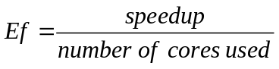 (2-1)
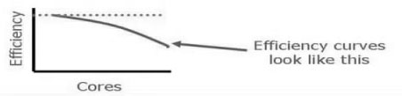
Figure 2.8 Efficiency against number of cores
In most typical cases when trying to increase the number of cores or the number of threads executing, the efficiency will tend to go down. The reason for this is, if there is a fixed amount of work to be done and as trying to increase the number of cores working on the problem, the overhead of the extra cores and threads actually increases and then the efficiency will decrease.
Now suppose s is the fraction of time spent in a program that is sequential and (1 − s) is the fraction of time spent on the code that can be made parallel, then according to Amdahl's law, the maximum speedup SX that can beachieved by using p cores is:
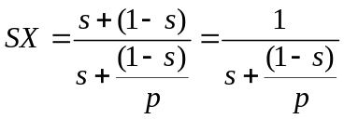. (2-2)
But the Amdahl’s law is too optimistic. It ignores some important factors such as:
- parallel processing overhead, assuming that parallel portions can be divided into p cores and executing without any overhead;
- Load imbalance issues such as function call and others where a core has to wait a little bit so as to work properly.
Besides its optimistic problems, Amdahl’s law is still useful for predicting the speedup performance although it is not an actual value that it can be achieved.
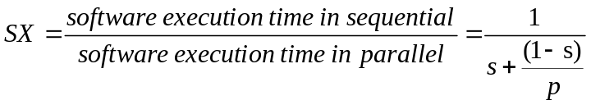 (2-3)

2.7 Chapter summary
In this chapter I have described about the ways of exploring parallelism and three different methods that can be used to parallelize an application. I continued by explaining how to find parallelization by considering the use of shared and private memory access. I have shown how the number of cores, process and threads related to each other. And lastly I have explained about OpenMp and its effects on sequential and parallel application.

3 Formulation of algorithms
In this chapter I am going to explain about the algorithms that I have used in my research which are k-NN algorithm, Levenshtein distance and how they work. Also I am going to explain step by step methods of modification of these algorithms to get the modified one which receive mixed data type.

3.1 k-NN algorithm
k-Nearest Neighbors algorithm (k-NN ) is a non-parametric method used for categorization and regression ^{[33]}. In pattern recognition, the input consists of the k closest training samples in the feature area. The output depends on whether k-NN is used for classification or regression:
In k-NN categorization or classification, the output is a part of class membership. An object is categorized by a majority vote of its closest sample, with the object being assigned to the class most common among its k nearest neighbors (k is a positive integer, typically small). If k = 1, then the object is simply assigned to the class of that single nearest neighbor.
In k-NN regression, the output is the property value for the object. This value is the average of the values of its k nearest neighbors.
k-NN is a type of algorithm that learn trends of data instantly in a lazy or simple way, it works in such a way that the function is only calculated and approximated locally and all computation is deferred until classification. The k-NN algorithm is one among the simplest way of all machine learning algorithms.
Both for classification and regression, it can be advantageous to weight the contributions of the neighbors, so that the neighbors who are closer contribute more to the average than the one who are far. The neighbors are taken from a set of objects for which the class (for k-NN classification) or the object property value (for k-NN regression) is known. This can be thought of as the training set for the algorithm, though no explicit training step is required.
The problem of the k-NN algorithm is that it is sensitive to the local arrangement of the data.
k-NN algorithm works based on minimum distance from the query instance to the training data samples so as to determine its k- nearest neighbors ^{[34]}. After k-NN getting its nearest neighbors, we only take simple majority of the query among the k nearest neighbors as a prediction. Consider the following example on the table where X1 and X2 are training datasets and Y is the remarks or result for the data sets.
Table 3.1 Sample table for k-NN algorithm
X1 | 4 | 1 | 3 | 3 | 7 | 4 | 6 | 5 | 3 | 6 | 4 | 4 | 5 | 7 | 5 | 10 | 7 | 4 | 9 | 5 | 8 | 6 | 7 | 8 | 6
X2 | 3 | 3 | 3 | 7 | 4 | 1 | 5 | 6 | 7 | 2 | 6 | 4 | 8 | 8 | 6 | 5 | 6 | 10 | 7 | 4 | 5 | 6 | 4 | 8 | 5
Y | + | + | + | + | + | + | + | + | + | + | - | - | - | - | - | - | - | - | - | - | - | - | - | - | Prediction
The last column on the table is the one that needs prediction. Therefore I am going to calculate a distance between elements on each column on the table and the last column (6, 5). On the graph, this problem can be shown as follows.
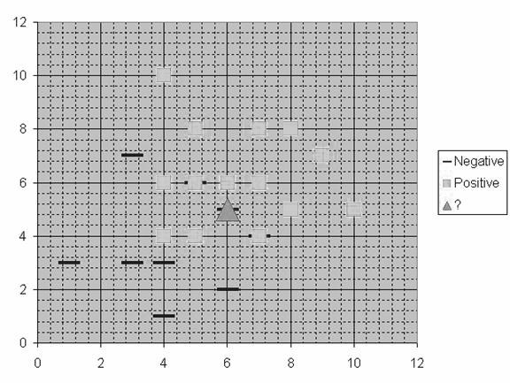
Figure 3.1 Demonstration of the table 3.1
Suppose k = 8, then I am going to consider 8 neighbors with the lowest distance as shown on the table.
Table 3.2 showing how k-NN algorithm works
X1 | 4 | 1 |  | 3 | 3 |  | 7 | 4 |  | 6 |  | 5 | 3 |  | 6 | 4 |  | 4 | 5 |  | 7 |  | 5 | 10 |  | 7 | 4 | 9 |  | 5 | 8 |  |  | 6 |  | 7 | 8 | 6
X2 | 3 | 3 |  | 3 | 7 |  | 4 | 1 |  | 5 |  | 6 | 7 |  | 2 | 6 |  | 4 | 8 |  | 8 |  | 6 | 5 |  | 6 | 10 | 7 |  | 4 | 5 |  |  | 6 |  | 4 | 8 | 5
Y | + | + |  | + | + |  | + | + |  | + |  | + | + |  | + | - |  | - | - |  | - |  | - | - |  | - | - | - |  | - | - |  |  | - |  | - | - | ?
Distance =  ((x1-6)^2+  (x2-5)^2)^0.5 | 8 | 29 |  | 13 | 13 |  | 2 | 20 |  | 0 |  | 2 | 13 |  | 9 | 5 |  | 5 | 10 |  | 10 |  | 2 | 16 |  | 2 | 29 | 13 |  | 2 | 4 |  |  | 1 |  | 2 | 13
The Chosen 8  neghbors |  |  |  |  |  |  | + |  |  | + |  | + |  |  |  |  |  |  |  |  |  |  | - |  |  |  |  |  |  | - | - |  |  | - |  | -
counting majority |  |  |  |  |  |  |  |  |  |  |  |  |  |  |  |  |  |  |  |  |  |  |  |  | number of positive = 3 |  |  |  |  |  |  | number of negative = 5
the prediction for (6,5) is negative - since it is the majority
As shown and demonstrated on the table above, generally the distance is based on Euclidean distance between a test sample and the specified training samples. Suppose xi be an input sample with p features (xi1,xi2, ..,xip) , n be the total number of input samples (i=1,2,…,n) and p the total number of features (j=1,2,…,p) . Then the Euclidean distance between sample xi and xl (l=1,2,…,n) is defined.
The formula for Euclidean distance only works if the training datasets are numbers (numeral), it can show how far between the tested and training data set ^{[35]}.
For the case of non-numerical datasets, Euclidean distance will not work. Instead I am going to use Levenshtein distance which will work on non- numerical data to measure distance between two strings.

3.2 Levenshtein distance
The Levenshtein distance is a string metric for measuring the difference between two sequences ^{[36-37]}. The Levenshtein distance between two words is the minimum number of single-character edits (i.e. insertions, substitutions or deletions) required to change one word into the other.
For example, the Levenshtein distance between "kitten" and "sitting" is 3, since the following three edits change one into the other, and there is no way to do it with fewer than three edits:
(1) kitten → sitten (substitution of "s" for "k");
(2) sitten → sittin (substitution of "i" for "e");
(3) sittin → sitting (insertion of "g" at the end).
The Levenshtein distance has several simple bounds. These include:
(1) It is always at least the difference of the sizes of the two strings;
(2) It is at most the length of the longer string;
(3) It is zero if and only if the strings are equal;
(4) If the strings are the same size, the Hamming distance is an upper bound on the Levenshtein distance;
(5) The Levenshtein distance between two strings is no greater than the sum of their Levenshtein distances from a third string.
Now by using Levenshtein distance, we can convert string input data into levenshtein distance numerical data then after that we can use the ordinary k-NN algorithm procedure as mentioned earlier.

3.3 Modification of the Algorithm
One among the objectives of this research is to modify the k-NN algorithm so that it can work with non numerical sample as well.
Consider the following example, a sample table of customer review DT1, DT2,…, DTn in a week which was discussed and recorded by a committee of staff before I was employed. After joining the employment, a new sample data for customer new DT was presented and it is needed to categorize new customer based on the discussion that a committee did last time. I am going to use my modified k-NN algorithm to predict the result.
Table 3.3 Example of sample of k-NN problem
ITEMS | SAMPLE |  |  |  |  | RESULT
DATA | Shop visit frequency | Types of goods bought | Amount of money spent | Customer manner | - | TASTE
DT1 | 4 | drinks | 1000 | small | - | GOOD
DT2 | 7 | furniture | 654 | high | - | GOOD
DT3 | 3 | fruits | 800 | avrg | - | BAD
DT4 | 2 | fish | 1065 | high | - | BAD
- | - | - | - | - | - | .
- | - | - | - | - | - | .
DTn |  |  |  |  | -
new DT | 5 | birds | 500 | avrg | - | ?
Methods: For my algorithm to process this kind of mixed data, that is numerical and non numerical. I have considered doing the following:
- Inputting all data (numerical and non numerical ) from database to algorithm in the form of string type and in terms of row and column;
- Extracting numerical data from string type data by using ‘atof’ function found in standard library in C++ which returns floats. If the data type is number then the function will return the number. If not, it will return false 0;
- After distinguishing numbers from string type data, I have calculated distance between a training data set DTn and the tested data set new DT, by considering the condition that, if atof function return true (number) for both DTn and newDT then Euclidean distance is used for distance calculation. Otherwise if one of the data is string then Levenshtein distance is used for calculation;
- After calculating the distance. I have arranged calculated distance from low to high value by using bubble sort algorithm but also quicksort algorithm can be used for the same purpose;
- Choosing the value of k so that k data of lowest distance can be taken for the majority counting;
- Lastly, choosing the value with highest majority and its correspondent remarks (result) which will be our prediction for the new DT. Basically k is an odd positive integer. It is set to be k=1 if the result for training datasets is not repetitive. Otherwise the value of k will depend upon the type of training dataset that you are dealing with and other factors as well.
Parallelization of algorithm: Previously, I have already explained on chapter 2 about how to consider parallelizing the algorithm or part of it if it is not possible to parallelize the whole algorithm. On my modified k-NN algorithm, the intensive parts I have considered are:
- Distance calculation. By considering example of table 3.3, calculation of distance for each row on the table is independent of other rows. Since I have used ‘for loop’ to calculate distance for each row therefore I have used “#pragma omp parallel for “to parallelize this part.
- Sorting calculated distance. Since I have used the bubble sort idea for sorting, it is difficult to parallelize this idea since it has dependence in the” for loop” when array value is exchanged by a previous array.
Generally I have used “#pragma omp parallel for “for all outer “for loop” in the algorithm that did not depend on the respective previous iteration value of the “for loop”.
start
Reading string data type from database

Conversion of string data type to float
Levenshtein distance calculation n
NO
YES
Euclidean distance calculation

Sorting calculated distance from low to high

Choosing the k value with lowest distance

Counting the majority for k result

Choosing the prediction

end

Figure 3.2 Flow chart for modified k-NN algorithm.

3.4 Chapter summary
In this chapter I have described about the concept of k-NN algorithm, how it works and its limitations. I explain the concept of edit distance, how it works and its contribution on removing the limitation of k-NN algorithms. I continued by providing modification of the algorithms where it explains about how to modified the algorithm to compute numerical and non numerical data as well as increasing its efficiency performance. Finally I have shown the flow chart of the modified algorithm.

4 Experiment and Result
In this chapter I am going to explain about how I did my experiment, showing the result in the form of tables and graphs as well. And finally I am doing the evaluation of the result.

4.1 Experiment
Tools: The tools required on this experiment is computer that support multicore processor, programming language and a compiler that supports parallel programming models. In my case, I have used:
- A laptop Pentium(R) Dual-core CPU T4300 @ 2.10GHz with 32-bit window 7 ultimate operating system;
- C++ programming language;
- OpenMp as my parallel programming models;
- Code blocks platform IDE.
Usually Codeblocks platform does not come with OpenMp libraries support. Therefore to enable OpenMp in the code blocks platform, you should do the following ^{[38]}.
Update MinGW if using Windows: The streamlined version of MinGW that is included with Code-Blocks needs to be changed to one that has the OpenMp Libraries.
Find the MinGW folder, this will be in Code:: Block’s Program Files.
Delete the “MinGW” folder. Download MinGW from http://www.mingw.org/.
Install it (Make sure you include the C++ option) and remember the location chosen for the binaries, in my case C:\MinGW\.

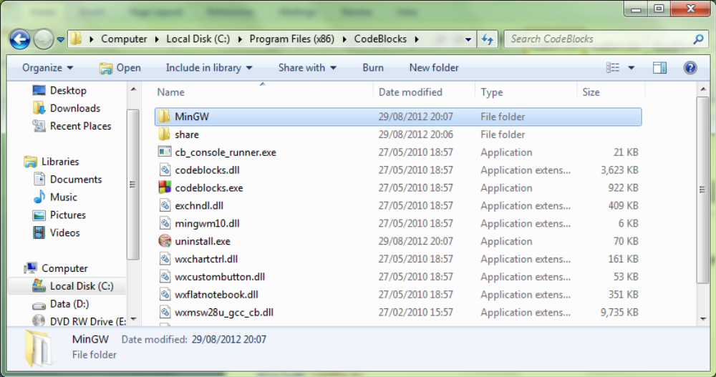
Figure 4.1
Copy C:\MinGW\ to replace the folder you previously deleted in C:\Program Files(x86)\CodeBlocks\.
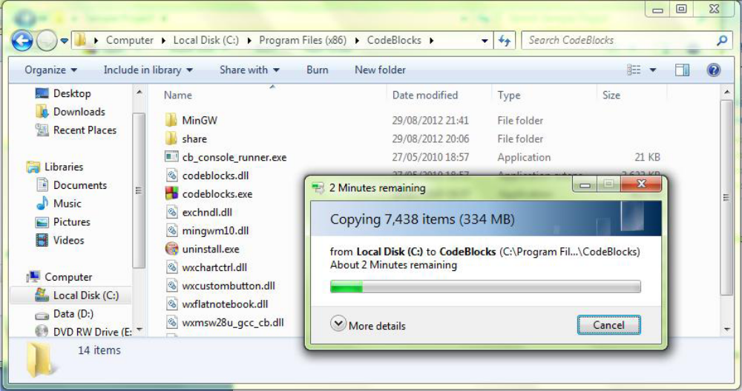
Figure 4.2
After setting up your project, you can build and run your project to make sure it is correct. Then right click on the current Project and select “Build Options...”.
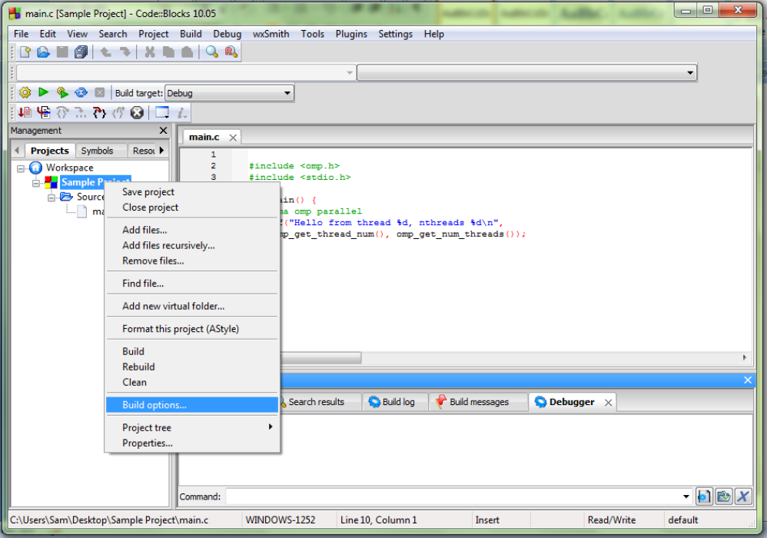
Figure 4.3
Select the Current Project on the left hand side of the dialog, and then the GNU GCC compiler, Compiler settings, Other Options tabs respectively.
Add “-fOpenMp” to the text area and click OK.
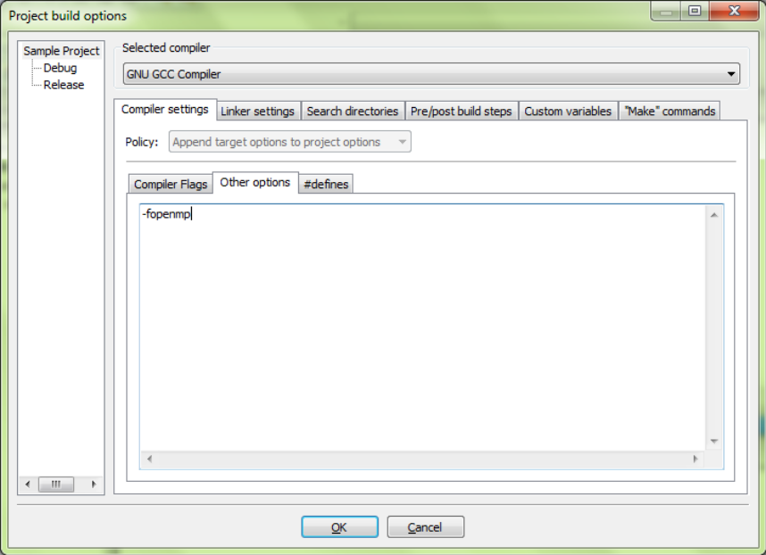
Figure 4.4
Open the “Linker” Tab and go to “Add” a library, browse to find it and change the view to show “All Files (*.*)” .
Select the "C:\Program Files (x86)\CodeBlocks\MinGW\bin\libgomp-1.dll" Library (your path may vary).
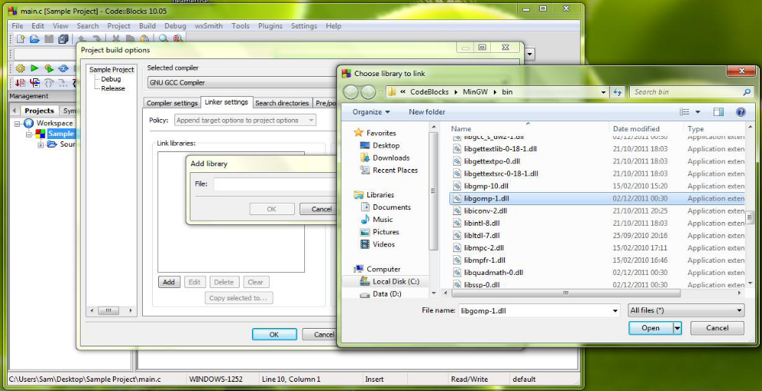
Figure 4.5
Now re-build and run the project and then if your programming is correct then the project will be parallelized.

4.2 Testing mixed input data
Now to understand my experiment, I will have to assume a simple problem that required to be solved. Consider the following table below as problem that needs solution.
Table 4.1 sample of mixed data type
ITEMS | SAMPLE |  |  |  |  | RESULT
DATA | Shop visit frequency | Types of goods bought | Amount of money spent | Customer manner | - | TASTE
DT1 | 4 | drinks | 1000 | small | - | first
DT2 | 7 | furniture | 654 | high | - | second
DT3 | 3 | fruits | 800 | avrg | - | third
DT4 | 2 | fish | 1065 | high | - | fourth
- | - | - | - | - | - | .
- | - | - | - | - | - | .
DTn |  |  |  |  | -
new DT | 5 | birds | 500 | avrg | - | ?
I have taken 10 rows of training datasets with 4 sample categories. Two were strings and two were numbers as shown on the table. I have remarked the result (remark) of the data set as according to the position of row of the data set so that I can understand how my modified algorithm makes its decision more based on strings or numbers. Therefore the remarks were first, second, third and so on.

4.3 Result and evaluation for mixed data algorithm
By varying different strings and different value of numbers, I have analyzed the following:
- Logically, based on the training dataset the algorithm predicts best choice. And when the tested sample is exactly similar to some of the training dataset the algorithm works on its best;
- The “atof” function used to convert strings to float was not the best solution. For example “56molly” was required to be of string type and the “atof” function was supposed to return false. Instead it returns value “56” and discard the part “molly”.
This could lead wrong calculation and result false prediction. To avoid this error, some restrictions and conditions should be set to a user when inputting data to the data base. That is, a string should not start by a number followed by alphabets.

4.4 Testing parallelization
I have taken a record of the execution time as the number of training dataset varies with number of samples. The record of the sequential algorithm and the parallelized algorithm.
Before parallelization method, I have set the number of sample, S (columns) to be constant S = 5 and measuring execution time by varying the number of training dataset (rows). I have measured the execution time 10 times and then calculating the average of it.
Table 4.3 Execution time result for 5 samples
number of dataset | 1000 | 2000 | 3000 | 4000 | 5000 | 6000 | 7000 | 8000 | 9000 | 10000
average time(mms) | 171.7 | 630.2 | 1379 | 2451 | 3724.9 | 5200.1 | 6967 | 8999 | 11177 | 13588.9
I have set the number of sample, S (columns) to be constant S = 100 and measuring execution time by varying the number of training dataset (rows). I have measured the execution time 10 times and then calculating the average of it.
Table 4.3 Execution time result for 100 samples
number of dataset | 250 | 500 | 750 | 1000 | 1250 | 1500 | 1750 | 2000 | 2250 | 2500
average time(mms) | 66 | 149.1 | 239.3 | 352.8 | 574.8 | 821.1 | 1026.5 | 1243.2 | 1457 | 1717
Again I have set the number of dataset, n (row) to be constant n = 1000 and measuring execution time by varying the number of samples (column). I have measured the execution time 10 times and then calculating the average of it, as shown below.
Table 4.4 Execution time result for 1000 datasets
number of samples | 20 | 40 | 60 | 80 | 100 | 120 | 140 | 160 | 180 | 200
average time(mms) | 164.2 | 167.7 | 184 | 183.8 | 181.7 | 136.1 | 100.8 | 77 | 63 | 56.9
After parallelization method, I have set the same conditions just like when it was unparallelized. I have set the number of sample, S (column) to be constant = 5 and measuring execution time by varying the number of data (rows). I have measured the execution time 10 times for each number of data (n)and then calculating the average of it.
Table 4.5 Execution time result for 5 samples
number of data(n) | 1000 | 2000 | 3000 | 4000 | 5000 | 6000 | 7000 | 8000 | 9000 | 10000
average time(mms) | 213 | 730 | 1558 | 2704 | 4353.6 | 6087.2 | 8037.6 | 10766 | 13122 | 16711
I have set the number of sample, S (columns) to be constant S = 100 and measuring execution time by varying the number of training dataset (rows). I have measured the execution time 10 times and then calculating the average of it.
Table 4.3 Execution time result for 100 samples
number of dataset | 250 | 500 | 750 | 1000 | 1250 | 1500 | 1750 | 2000 | 2250 | 2500
average time(mms) | 36.2 | 112 | 180 | 263 | 440.3 | 644.6 | 766.8 | 946.5 | 1028.7 | 1369.6
With the same condition as well, again I have set the number of data, n (row) to be constant = 1000 and measuring execution time by varying the number of samples (column). I have measured the execution time 10 times for each number of samples (S) and then calculating the average of it, as shown below.
Table 4.4 Execution time result for 1000 data sets
Number of samples(s) | 20 | 40 | 60 | 80 | 100 | 120 | 140 | 160 | 180 | 200
average time(mms) | 188.4 | 184 | 177 | 178.6 | 174.8 | 121.6 | 95.6 | 74.9 | 60.5 | 53.1

4.5 Result and evaluation of parallelization
To understand the performance of new algorithm, it is required to compare with the same conditions of sequential and parallelized algorithm. That is everything should be the same, the only difference is parallelism of the algorithm.
execution time in mms
number of samples
Figure 4.6 the performance of algorithm when data set is constant = 1000
By varying the number of samples on the figure 4.1 , the graph for parallelized algorithm is showing to have slower performance at first than then the sequential algorithm .But as the number of samples becomes large enough, then the performance of parallelized algorithm become faster than the sequential algorithm.

Figure 4.7 the performance of algorithm when number of sample is not large enough

Figure 4.8 the performance of algorithm when number of sample is large enough
From these results, it has been discovered that:
- The sequential algorithm performance when varying number of data, rows (n) is faster than the parallelized algorithm;
- The parallelized algorithm performance when varying number of samples, colums (s) is faster than the sequential algorithm;
- When I was varying the number of samples (columns) to a parallelized algorithm the performance was slower at first compared to the sequential algorithm but then it became faster as I increased the number of column.
Reasoning: The behavior of these results could occur due to parallel thread overhead. Parallel overhead is the amount of time required to arrange parallel threads as opposed to doing useful work. Parallel overhead can include the followings:
- Thread start-up time;
- Synchronization;
- Software overhead imposed by parallel compilers, libraries, tools, operating system, etc;
- Thread termination time.
Therefore the parallelized algorithm performance was slower at first because each thread for the data was not doing useful work since the number of samples was few. This led to too much thread star-up time and termination time which contribute delay time for the performance. But when the number of sample was large enough the performance was better than the sequential performance.

5 Conclusion and Future Work

5.1 Conclusion
In this thesis, I provided a deep concept of k-NN algorithm and its limitations associated with inability of processing non numerical data and poor efficiency due to delay time when large dataset is computed. I then started by exploring the concept of parallel computing, its advantages and disadvantages when it is wrongly programmed. I explored the concept of edit distance which also involves Levenshtein distance which I have used to overcome the limitation of non numerical data processing for k-NN algorithm. I explored the concept of OpenMp which I have used to improve the computation delay time problem. Finally, I presented my work on implementation of modified k-NN algorithm. I can summarize my key contribution as follows:
(1) For non-numeric data types such as strings, edit distance method was introduced to k-NN algorithm so that it can calculate the distance the same as the numerical data. Levenshtein distance which uses the concept of edit distance was used to calculate distance between non numerical datasets;
(2) To improve the speed of computation for large datasets, the parallel computing method was introduced to k-NN algorithm. Parallelization improved the speed of computation for large datasets which then increased the efficiency of the algorithm;
(3) Code::Blocks cross-platform C/C++ IDE was used with OpenMp to implement the thread parallelization for k-NN algorithm. When the OpenMp is configured, it can support multiple processors in a network and can make use of multiple cores for parallel thread computation. In this paper;
(4) Experiments were conducted for sequential and parallel computation and the results were compared. Compared to sequential algorithm, the performance of parallelized algorithm is faster under condition that datasets are large enough to compensate the parallel thread overheads. If there is just small amount of data then parallelized algorithm won’t be used effectively.
Note that, when deciding parallelizing any application, it is not necessary to parallelize all the algorithms present in your application because after parallelization, some algorithm in your application may perform faster and some slower which depend on the ways that were used. What you need is to consider the only algorithms that will improve your performance.

5.2 Future works
Besides OpenMp, there are other threading models and other APIs that can be used for parallelization such as POSIX. Programmers could use these opportunity to implement these ideas with different APIs and models so that they can observe better performance for each model.
With OpenMp, there is plenty of flexibility of its pragma directives. I have used my approach of programming where it led me to parallelize some part of the algorithm and leave some part unparallelized. With different approach to code the algorithm, and the use of different pragma could lead the parallelization of the whole algorithm that result better and more performance.
The modified k-NN algorithm can be improved more since the methods which were used to approach the algorithm such as conversion of strings to float, sorting results, distance calculation and other methods can be approached in many different ways.

Acknowledgements
All thanks to God the creator of everything for making me healthy with strength, and protection over the time I spent on my studies in China.
I wish to express my sincere gratitude to the government of China for giving me the opportunity to pursue my studies in China.
Also I express my sincere gratitude to Associate Professor Guang Zhi Ma for accepting me, and for him to be my supervisor who helped me a lot throughout my entire research. I have gained a lot through his directions that he gave me.
I would like to give my thanks to all my teachers, school staffs, my fellow students and friends for their helps and encouragement to go on towards my goals.
I will not forget to thank my entire family and relatives for their support and care they gave me over my time of stay in china.

REFERENCES
- Zhang, Eddy Z., Yunlian Jiang, Xipeng Shen. Does cache sharing on modern CMP matter to the performance of contemporary multithreaded programs?. ACM Sigplan Notices, 2010, 45(5)
- Robert L. Mitchell. Decline of the Desktop. Computerworld, September 26, 2005
- Michael J. Quinn, Parallel Programming in C with MPI and OpenMp, McGraw-Hill, 2004
- Sutter, Herb. The free lunch is over: A fundamental turn toward concurrency in software. Dr. Dobb’s Journal, 2005, 30(3): 202-210
- Thain, Douglas, John Bent, Andrea C. Arpaci-Dusseau, et al. Pipeline and batch sharing in grid workloads." In High Performance Distributed Computing. Proceedings. 12th IEEE International Symposium on, 2003: 152-161
- Asanovic, Krste, et al. The landscape of parallel computing research: A view from Berkeley. Vol. 2. Technical Report UCB/EECS-2006-183, EECS Department, University of California, Berkeley, 2006
- http://en.wikipedia.org/wiki/Parallel_computing
- Cohen-Or D., Rich E., Lerner U., et al. A real-time photo-realistic visual flythrough. Visualization and Computer Graphics, IEEE Transactions on, 1996, 2(3): 255-265
- Arnold J. M. S5: the architecture and development flow of a software configurable processor. In Field-Programmable Technology, 2005. Proceedings. 2005 IEEE International Conference on, 2005: 121-128
- Han J., Kamber M., Pei J. Data mining: concepts and techniques. Morgan kaufmann, 2006
- Croft W. B., Metzler D., Strohman T. Search engines: Information retrieval in practice. Reading: Addison-Wesley, 2010: 283
- Jones K. S. Readings in information retrieval. Morgan Kaufmann, 1997
- R. A. Baeza-Yates, B. A. Ribeiro-Neto. Modern Information Retrieval - the concepts and technology behind search, Second edition, Pearson Education Ltd., Harlow, England, 2011
- G. Salton. An Introduction to Modern Information Retrieval. Mc Graw Hill, 1983
- C. Manning, P. Raghavan, H. Schutze. Introduction to Information Retrieval. Cambridge University Press, 2008
- D. A. Grossman, O. Frieder. Information Retrieval: Algorithms and Heuristics (The Kluwer International Series on Information Retrieval). Springer-Verlag New York, Inc, 2004
- S. J. Pan, Q. Yang. A Survey on Transfer Learning, IEEE Transactions on Knowledge and Data Engineering, 2010, 22(10): 1345-1359
- Aggarwal C. C., Zhai C. Mining text data. Springer, 2012
- Gordon M. I., Thies W., Amarasinghe S. Exploiting coarse-grained task, data, and pipeline parallelism in stream programs. In ACM SIGOPS Operating Systems Review, 2006, 40(5): 151-162
- Bjorstad P., Gropp W. Domain decomposition: parallel multilevel methods for elliptic partial differential equations. Cambridge University Press, 2004
- Geist A. PVM: Parallel virtual machine: a users' guide and tutorial for networked parallel computing. MIT press, 1994
- Wilkinson B., Allen M. Parallel programming. New Jersey: Prentice hall, 1999
- Reinders J. Intel threading building blocks: outfitting C++ for multi-core processor parallelism. O'Reilly Media, Inc., 1997
- Chapman B., Jost G., Van Der Pas R. Using OpenMP: portable shared memory parallel programming. MIT press, 2008
- Gropp W., Lusk E., Skjellum A. Using MPI: portable parallel programming with the message-passing interface. MIT press, 1999
- Garland M., Grand S. L., Nickolls J., et al. Parallel Computing in CUDA. IEEE micro, 2008, 28(4): 13-27
- Dagum L., Menon R. OpenMP: an industry standard API for shared-memory programming. Computational Science & Engineering, IEEE, 1998, 5(1): 46-55
- Chandra R. Parallel programming in OpenMP. Morgan Kaufmann, 2001
- Novillo D. OpenMP and automatic parallelization in GCC. In GCC developers summit, 2006
- Marowka A. Parallel computing on any desktop. Communications of the ACM, 2007, 50(9): 74-78
- Mattson T., Eigenmann R. OpenMP: An API for writing portable SMP application software. In Super Computing 99 Conference, 1999
- Kumar V., Grama A., Gupta A., et al. Introduction to parallel computing. Redwood City: Benjamin/Cummings, 1994
- http://en.wikipedia.org/wiki/K-nearest_neighbors_algorithm
- Zhang M. L., Zhou Z. H. ML-KNN: A lazy learning approach to multi-label learning. Pattern recognition, 2007, 40(7): 2038-2048.
- Weinberger K., Blitzer J., Saul L. Distance metric learning for large margin nearest neighbor classification. Advances in neural information processing systems, 2006, 18: 1473
- Yujian L., Bo L. A normalized Levenshtein distance metric. Pattern Analysis and Machine Intelligence. IEEE Transactions on, 2007, 29(6): 1091-1095.
- http://en.wikipedia.org/wiki/Levenshtein_distance
- http://www2.imperial.ac.uk/~shb104/c/files/other/CbOpenMp
- OpenMp API Specification, www.OpenMp.org
- Jim Beveridge, Robert Wiener. Mutithreading Applications in Win32. Addison-Wesley, 1997

