Openssl + mysql环境搭建

Openssl 自签署证书(Redhat7.5)
- 创建CA证书
在/var/lib/mysql 目录下创建ssl目录：
cd /var/lib/mysql
mkdir ssl
cd ssl
执行如下命令生成CA key：
openssl genrsa 2048 > ca-key.pem
执行如下命令生成证书：
openssl req -new -x509 -nodes -days 365000 -key ca-key.pem -out ca-cert.pem
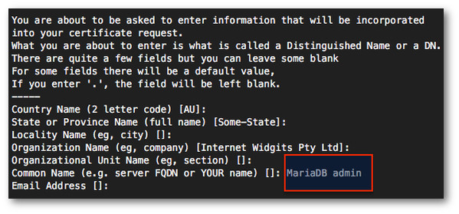
注：用于服务器和客户机证书/密钥的Common Name值必须与用于CA证书的Common Name值不同。为了避免出现任何问题，将其设置如下:
CA common Name : MariaDB admin
Server common Name: MariaDB server
Client common Name: MariaDB client
在/var/lib/mysql下生成了 ca-key.pem 和ca-cert.pem两个文件，下面使用这两个文件生成server和client的证书。
- 创建server证书
创建server key：
openssl req -newkey rsa:2048 -days 365000 -nodes -keyout server-key.pem -out server-req.pem
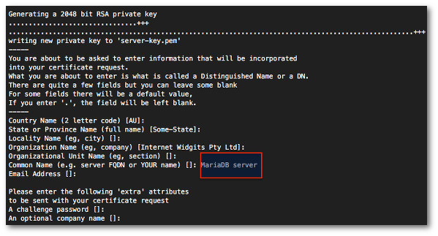
转换成RSA KEY：
openssl rsa -in server-key.pem -out server-key.pem
server证书签名：
openssl x509 -req -in server-req.pem -days 365000 -CA ca-cert.pem -CAkey ca-key.pem -set_serial 01 -out server-cert.pem
生成了如下文件：
server-cert.pem
server-key.pem
- 创建client证书
创建client key:
openssl req -newkey rsa:2048 -days 365000 -nodes -keyout client-key.pem -out client-req.pem
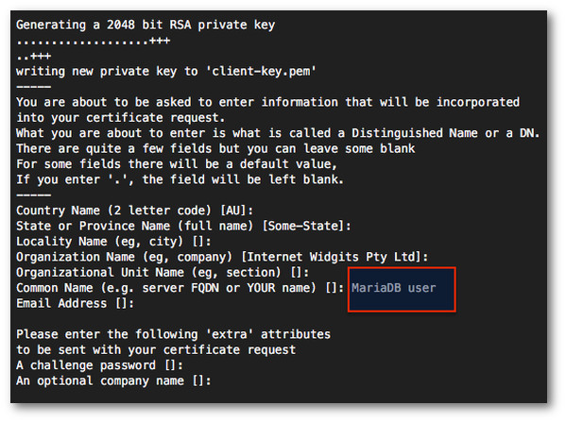
生成client RSA key：
openssl rsa -in client-key.pem -out client-key.pem
client证书签名：
openssl x509 -req -in client-req.pem -days 365000 -CA ca-cert.pem -CAkey ca-key.pem -set_serial 01 -out client-cert.pem
- 验证证书
openssl verify -CAfile ca-cert.pem server-cert.pem client-cert.pem
成功显示如下：
server-cert.pem: OK
client-cert.pem: OK

Mysql 配置支持ssl远程连接（Redhat7.5 mariadb-5.5.60）
- 配置server使用SSL
修改/etc/my.cnf 配置文件，在[mysqld]分区下修改/增加如下配置：
ssl
ssl-ca=/var/lib/mysql/ssl/ca-cert.pem
ssl-cert=/var/lib/mysql/ssl/server-cert.pem
ssl-key=/var/lib/mysql/ssl/server-key.pem
修改完保存，重启mariadb:
service mariadb restart
- 配置client使用SSL
修改/etc/my.cnf文件，新增如下配置：
[client]
ssl-ca=/var/lib/mysql/ssl/ca-cert.pem
ssl-cert=/var/lib/mysql/ssl/client-cert.pem
ssl-key=/var/lib/mysql/ssl/client-key.pem
修改完保存，重启mariadb:
service mariadb restart
- 验证
输入命令进入数据库：
mysql -uroot -p123456
执行如下命令查看SSL功能打开状态：
SHOW VARIABLES LIKE '%ssl%';
或者执行如下命令：
status;
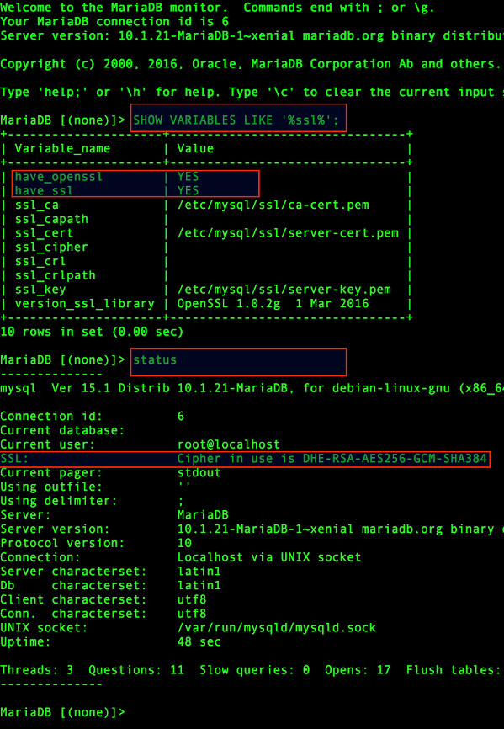
验证SSL或者TLS连接：
验证ssl3
openssl s_client -connect 192.168.80.101:3306 -ssl3
验证TLS v 1/1.1/1.2
openssl s_client -connect 192.168.80.101:3306 -tls1
openssl s_client -connect 192.168.80.101:3306 -tls1_1
openssl s_client -connect 192.168.80.101:3306 -tls1_2
输出示例如下：
[root@localhost ssl]# openssl s_client -connect 192.168.80.101:3306 -tls1
CONNECTED(00000003)
140296459859856:error:1408F10B:SSL routines:SSL3_GET_RECORD:wrong version number:s3_pkt.c:365:
---
no peer certificate available
---
No client certificate CA names sent
---
SSL handshake has read 5 bytes and written 7 bytes
---
New, (NONE), Cipher is (NONE)
Secure Renegotiation IS NOT supported
Compression: NONE
Expansion: NONE
No ALPN negotiated
SSL-Session:
Protocol : TLSv1
Cipher : 0000
Session-ID:
Session-ID-ctx:
Master-Key:
Key-Arg : None
Krb5 Principal: None
PSK identity: None
PSK identity hint: None
Start Time: 1562663819
Timeout : 7200 (sec)
Verify return code: 0 (ok)
---

- 授权用户通过（SSL+密钥）登录
登录root用户:
mysql -uroot -p123456;
创建用户：
grant all on *.* to 'ssl_test'@'%' identified by '123456' require x509;
flush privileges;
查看所有用户：
SELECT DISTINCT CONCAT('User: ''',user,'''@''',host,''';') AS query FROM mysql.user;
- 代码登录示例：
QT5:
db = QSqlDatabase::addDatabase("QMYSQL");
db.setHostName(ip);
db.setDatabaseName(DB_NAME);
db.setPort(DB_PORT);
db.setUserName(USER_NAME);
db.setPassword(USER_PASSWORD);
//设置mysql连接断开时，自动重连
db.setConnectOptions("MYSQL_OPT_RECONNECT=1;\
CLIENT_SSL=1;\
CLIENT_IGNORE_SPACE=1;\
SSL_KEY=./client-key.pem;\
SSL_CERT=./client-cert.pem;\
SSL_CA=./ca-cert.pem");
if (!db.open())
{
qDebug() << "连接数据库失败！";
return 1;
}
db.exec("set NAMES UTF8");
Python:
import mysql.connector
from mysql.connector.constants import ClientFlag
config = {
'user': 'ssl_test',
'password': '123456',
'host': '192.168.80.101',
'client_flags': [ClientFlag.SSL],
'ssl_ca': '',
'ssl_cert': 'C:/Users/hx-yy/Desktop/ca_mysql/client-cert.pem',
'ssl_key': 'C:/Users/hx-yy/Desktop/ca_mysql/client-key.pem',
}
cnx = mysql.connector.connect(**config)
cur = cnx.cursor(buffered=True)
cur.execute("SHOW STATUS LIKE 'Ssl_cipher'")
print(cur.fetchone())
cur.execute("SHOW VARIABLES LIKE '%ssl%'")
print(cur.fetchall())
cur.close()
cnx.close()

参考链接：
https://www.cyberciti.biz/faq/how-to-setup-mariadb-ssl-and-secure-connections-from-clients/

