SmartPark Solutions
Use Case Document: SmartPark Solutions Overall Use Case
CRUD Sets: 1 — Parking Lot Management; 2 — Parking Reservation Management
Use Case ID: UC-SP-00
Use Case Name: Find, Reserve and Manage Parking (Overall System Use Case)
Primary Actors: Driver, Lot Manager
Supporting Actors: Payment Gateway, Maps API, Notification Service, Parking Sensor
Priority: High
1. Description
This overall use case describes how the SmartPark Solutions web application supports its two primary actors from start to finish. Lot Managers keep parking lot information accurate by adding, updating and deleting parking lots, including location, total spots, available spots and hourly rate. Parking sensors or manual entry points keep the number of available spots current in real time.
Drivers register or log in, search for available parking in an area, and reserve a spot in advance. The system validates each reservation, checks availability, calculates the estimated cost and processes payment through a payment gateway. Drivers can then get directions to the lot, receive notifications about their parking time limit, extend their session remotely, and view, edit or cancel their reservations. Lot Managers can view all reservations and usage reports for their lots. Together, these use cases reduce the time drivers spend searching for parking, which lowers traffic congestion, emissions and fuel use.
2. Preconditions
- The SmartPark Solutions web application is available and accessible through a web browser.
- The user has a registered account with an assigned role of Driver or Lot Manager.
- At least one parking lot has been added by a Lot Manager with location, total spots, available spots and hourly rate.
- Parking availability is supplied by sensors or by manual entry at the parking facility.
- The Payment Gateway, Maps API and Notification Service are available to the application.
- The Driver has at least one vehicle registered in their profile before creating a reservation.
3. Trigger
A Driver opens the SmartPark Solutions application to find and reserve parking, or a Lot Manager opens the application to maintain parking lot information.
4. Main Success Scenario
- The Lot Manager logs in and navigates to the Parking Lot Management section.
- The Lot Manager adds a new parking lot or updates an existing one, entering its name, location, total spots, available spots and hourly rate.
- The system validates and saves the parking lot information.
- The Parking Sensor (or a staff member using manual entry) sends the current number of available spots, and the system updates the lot's availability and last-updated time.
- The Driver registers or logs in to the application.
- The Driver adds or confirms a vehicle in their profile (license plate, vehicle type and color).
- The Driver searches for parking in a specified area.
- The system displays matching parking lots with real-time available spots and hourly rates.
- The Driver selects a parking lot and chooses Reserve.
- The Driver enters the reservation date, start time, end time and vehicle.
- The system validates the information, checks parking availability for the requested period and calculates the estimated cost.
- The system displays a reservation summary for the Driver to review.
- The Driver confirms the reservation and selects a payment method (credit card, debit card or mobile wallet).
- The system sends the payment request to the Payment Gateway, which approves the payment.
- The system saves the reservation with a unique reservation ID and a status of Confirmed, records the payment, and reduces the lot's available spots.
- The system displays a confirmation message, and the Notification Service sends a reservation confirmation to the Driver.
- The Driver selects Get Directions; the system requests the best route from the Maps API and displays it.
- Before the reserved time ends, the Notification Service sends the Driver a time-limit alert.
- The Driver may choose to extend the parking session; the system checks availability, processes the additional payment and updates the reservation end time.
- When the parking session ends, the system marks the reservation as Completed and releases the parking spot.
- The Lot Manager views all reservations and usage reports for their parking lots.
5. Alternative and Exception Flows
A1: Invalid Login Credentials
- At Step 1 or Step 5, the system cannot match the email and password entered.
- The system displays an invalid login message.
- The user re-enters their credentials or registers a new account.
- The workflow resumes at the step where login was attempted.
A2: Missing or Invalid Information
- At Step 3 or Step 11, the system identifies missing or invalid required fields.
- The system displays an appropriate validation message.
- The user corrects the information and resubmits.
- The workflow resumes at the validation step.
A3: Invalid Reservation Date or Time
- At Step 11, the system determines that the reservation date or time is in the past, or that the end time is earlier than or equal to the start time.
- The system displays an error explaining the invalid reservation period.
- The Driver enters a valid date and time.
- The workflow resumes at Step 11.
A4: No Parking Availability
- At Step 8 or Step 11, the system determines that the selected lot has no available spaces for the requested period.
- The system displays a message and suggests nearby parking lots with available spots.
- The Driver selects another lot or changes the reservation date or time.
- The workflow resumes at Step 11.
A5: Payment Declined
- At Step 14, the Payment Gateway declines the payment.
- The system displays a payment failure message and does not confirm the reservation.
- The Driver selects another payment method or exits.
- If the Driver exits, no reservation is saved and the parking spot is not held.
A6: Driver Edits a Reservation
- After Step 16, the Driver selects Edit for a Confirmed reservation from the My Reservations page.
- The Driver changes the parking lot, date, start/end times or vehicle.
- The system validates the changes, rechecks availability and recalculates the estimated cost (see UC-RES-03 Edit Parking Reservation).
- The reservation keeps its original reservation ID and Confirmed status.
A7: Driver Cancels a Reservation
- After Step 16, the Driver selects Cancel for a Confirmed reservation.
- The system asks the Driver to confirm the cancellation.
- The system sets the reservation status to Cancelled and releases the parking spot.
- If the reservation was paid, the system requests a refund through the Payment Gateway.
A8: Session Extension Not Possible
- At Step 19, the system determines that the lot has no availability for the extra time requested.
- The system displays a message that the session cannot be extended.
- The original reservation end time remains unchanged.
A9: External Service Unavailable
- At Step 4, 14, 16, 17 or 18, the Parking Sensor, Payment Gateway, Notification Service or Maps API does not respond.
- The system displays a message that the service is temporarily unavailable.
- For availability, the system shows the last known spot count with its last-updated time, and staff may enter counts manually.
- No reservation is confirmed until payment is approved.
A10: Unauthorized Access
- A Driver attempts to open a Lot Manager page, or a user attempts to view another user's reservation.
- The system denies access and displays an appropriate message.
- No information is displayed or modified.
A11: Lot Cannot Be Deleted
- At Step 2, the Lot Manager attempts to delete a parking lot that has upcoming Confirmed reservations.
- The system prevents the deletion and displays a message listing the active reservations.
- The parking lot remains unchanged.
6. Postconditions
Successful Outcome:
- Parking lot information, including available spots and hourly rate, is accurate and current.
- The Driver's reservation is saved with a unique reservation ID, the selected parking lot, date, start/end times, vehicle and estimated cost.
- The payment is recorded and linked to the reservation.
- The reservation status is Confirmed, then Completed when the session ends.
- The lot's available spots are reduced while the reservation is active and released when it ends or is cancelled.
- The Driver receives confirmation, directions and time-limit notifications.
- The Lot Manager can view the reservation and its effect on lot usage.
Unsuccessful Outcome:
- No reservation is created or changed, and no payment is charged.
- Existing parking lot and reservation information remains unchanged.
- The system displays an appropriate error or validation message.
- The user may correct the information, try again or exit.
7. Business Rules
- Users can only access pages and information relevant to their role (Driver or Lot Manager).
- Only Lot Managers can add, update or delete parking lots.
- Each parking lot must have a location, total spots greater than zero, and an hourly rate of zero or more.
- Available spots can never be less than zero or greater than the lot's total spots.
- A reservation must reference an existing parking lot, a registered Driver and one of that Driver's vehicles.
- Reservation dates and times cannot be in the past, and the end time must be after the start time.
- A reservation cannot be confirmed if the selected lot has no available spaces for the requested period.
- The estimated cost equals the lot's hourly rate multiplied by the reservation duration.
- A reservation is Confirmed only after the payment is approved.
- Only reservations with a status of Confirmed may be edited or cancelled; Cancelled and Completed reservations cannot be modified.
- Each reservation keeps its original unique reservation ID for its whole life.
- Cancelling a paid reservation triggers a refund request through the Payment Gateway.
- A parking lot with upcoming Confirmed reservations cannot be deleted.
- Full card numbers are never stored by SmartPark; only the gateway's transaction reference is saved.
- Drivers can view, edit and cancel only their own reservations; Lot Managers can view reservations for the lots they manage.
8. Data Requirements
Field | Entity | Description
User ID | User | Unique identifier of the Driver or Lot Manager
Name / Email / Phone | User | Contact details; email is used to log in
Role | User | Driver or Lot Manager; controls access
Vehicle ID | Vehicle | Unique identifier of a registered vehicle
License Plate | Vehicle | Vehicle license plate number
Vehicle Type / Color | Vehicle | Type and color used to identify the vehicle
Parking Lot ID | Parking Lot | Unique identifier of the parking lot
Parking Lot Name / Location | Parking Lot | Name and address of the parking facility
Total Spots | Parking Lot | Total number of parking spaces in the lot
Available Spots | Parking Lot | Current open spaces, updated by sensor or manual entry
Hourly Rate | Parking Lot | Price per hour of parking at the lot
Reservation ID | Reservation | Unique identifier of the reservation; never changes
Reservation Date | Reservation | Date the Driver intends to park
Start Time / End Time | Reservation | Beginning and end of the parking period
Estimated Cost | Reservation | Hourly rate multiplied by reservation duration
Reservation Status | Reservation | Pending, Confirmed, Completed or Cancelled
Payment ID | Payment | Unique identifier of the payment
Amount / Payment Method | Payment | Amount charged and method (credit card, debit card or mobile wallet)
Payment Status | Payment | Pending, Completed, Failed or Refunded
Notification Type / Message | Notification | Confirmation, time-limit or cancellation alert and its text
9. Use Case Model
The use case model identifies the actors that interact with SmartPark Solutions and the use cases each one performs. Use case IDs follow the team's existing numbering (for example, UC-RES-03 Edit Parking Reservation).
9.1 Actors
Actor | Type | Description
Driver | Primary (human) | Finds, reserves, pays for, edits, cancels and extends parking; gets directions and alerts
Lot Manager (Administrator) | Primary (human) | Adds, updates and deletes parking lots; views all reservations and usage reports
Payment Gateway | Supporting (external system) | Processes credit card, debit card and mobile wallet payments and refunds
Maps API | Supporting (external system) | Calculates the best route to the selected parking lot
Notification Service | Supporting (external system) | Sends confirmations and parking time-limit alerts
Parking Sensor | Supporting (external system) | Reports real-time available spots, or staff enter them manually
9.2 Use Cases
ID | Use Case | Actor(s) | CRUD / Source
UC-ACC-01 | Register / Log In | Driver, Lot Manager | Role-based access
UC-ACC-02 | Manage Profile and Vehicles | Driver | User and Vehicle data
UC-LOT-01 | Add Parking Lot | Lot Manager | CRUD 1 — Create
UC-LOT-02 | Search Available Parking (view lots and real-time availability) | Driver | CRUD 1 — Read; Real-time Parking Availability
UC-LOT-03 | Update Parking Lot | Lot Manager | CRUD 1 — Update
UC-LOT-04 | Delete Parking Lot | Lot Manager | CRUD 1 — Delete
UC-LOT-05 | Update Spot Availability | Parking Sensor | Real-time Parking Availability
UC-RES-01 | Create Reservation | Driver | CRUD 2 — Create; Advance Booking
UC-RES-02 | View Reservations (My Reservations / All Reservations) | Driver, Lot Manager | CRUD 2 — Read
UC-RES-03 | Edit Parking Reservation | Driver | CRUD 2 — Update
UC-RES-04 | Cancel Reservation | Driver | CRUD 2 — Delete
UC-RES-05 | Extend Parking Session | Driver | Notification Services
UC-PAY-01 | Make Payment | Payment Gateway | Mobile Payment
UC-PAY-02 | Process Refund | Payment Gateway | Mobile Payment
UC-NAV-01 | Get Directions to Lot | Driver | Traffic and Navigation
UC-NAV-02 | Calculate Route | Maps API | Traffic and Navigation
UC-NTF-01 | Receive Time-Limit Alerts | Driver, Notification Service | Notification Services
UC-RPT-01 | View Usage Reports | Lot Manager | Data Collection
9.3 Relationships Between Use Cases
- «include»: UC-RES-01 Create Reservation always includes UC-PAY-01 Make Payment.
- «include»: UC-RES-05 Extend Parking Session always includes UC-PAY-01 Make Payment.
- «include»: UC-NAV-01 Get Directions to Lot always includes UC-NAV-02 Calculate Route.
- «extend»: UC-PAY-02 Process Refund extends UC-RES-04 Cancel Reservation when the reservation was already paid.
- Precondition: UC-ACC-01 Register / Log In must be completed before any other Driver or Lot Manager use case.

10. Use Case Diagram
The diagram shows the SmartPark Solutions system boundary, the two primary actors, the four supporting systems, and the include and extend relationships described in Section 9.
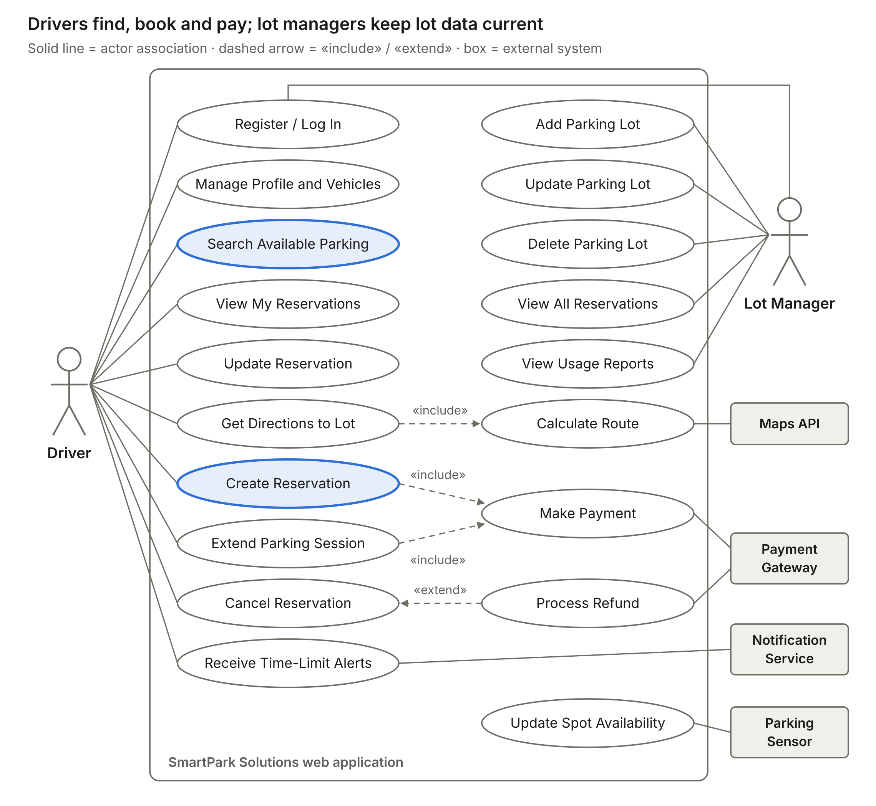
Figure 1. SmartPark Solutions overall use case diagram
- The Driver (left) is associated with ten use cases, and the Lot Manager (right) with five; both share Register / Log In.
- Supporting systems are shown as boxes on the right and connect to the use cases they serve.
- Highlighted use cases (Search Available Parking and Create Reservation) are the core tasks that reduce time spent searching for parking.
11. Midterm Implementation Notes
For the midterm submission, SmartPark Solutions will be developed using HTML, CSS, Bootstrap and PHP, with GitHub used for version control and collaboration.
The midterm will implement the two CRUD sets from the project proposal: Parking Lot Management (UC-LOT-01 to UC-LOT-04) and Parking Reservation Management (UC-RES-01 to UC-RES-04). These pages will use predefined sample data to demonstrate viewing lots and availability, adding, updating and deleting lots, and creating, viewing, editing and cancelling reservations.
The application will demonstrate input validation, availability checks against sample data, estimated cost calculation, review of reservation details and confirmation messages. Create, Update and Delete operations will be simulated using PHP and sample data without permanent database storage.
User accounts and login, payments and refunds, notifications, navigation, live sensor data and usage reports are planned for the final submission and are outside the scope of the midterm implementation.

