|  |  |
| --- | --- |
|  | **Does Shall-Issue Law**  **Reduce Crime?**    **BUAN 6312.001 – Applied Econometrics and Time-series Analysis**  **Submitted by:**  Sameeta Narkar |

**TABLE OF CONTENTS**

1. INTRODUCTION **2**
2. EXPLORATORY DATA ANALYSIS **3**
3. MODELS **6**
4. CONCLUSION **17**
5. APPENDIX 1 **18**
6. APPENDIX 2 **19**

**INTRODUCTION**

Shall-Carry Law

Shall-carry law has been one of the most debated topics in USA. The Shall-carry law allows citizens of USA to carry a concealed handgun. The motto behind this law was to reduce crimes by increased level of self-protection on the part of the citizens. However, many believe that the law leads to increased crimes and thus deviates from its purpose.

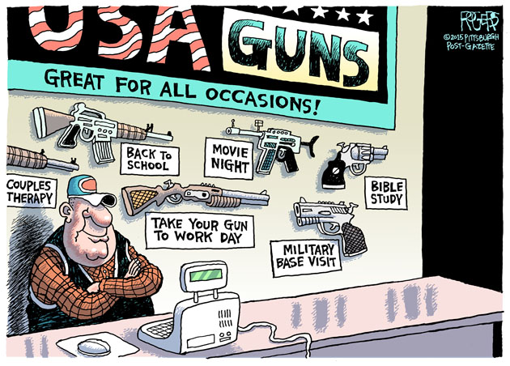

To be eligible to carry a gun a person is required to be mentally stable, should have no past criminal record and successfully complete a course in firearms safety training (if required by law). Irrespective of whether it is a necessity, a person is entitled to carry a gun if these requirements are met. As a result, many across US possess Guns. US has seen several mass shootings because of which there have been initiatives to demolish the shall-carry law.

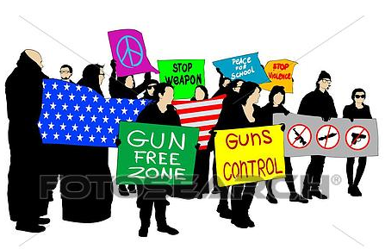

However, the debate is still open, with people for and against the shall-carry law. We will study the violent crimes in US across various variables like murder, population, year, income etc to gain a better insight on the topic. **Is Shall-carry law effective in reducing crime or does it lead to crime?**

**EXPLORATORY DATA ANALYSIS**

We are working with a balanced panel dataset that measures violent crimes across 50 US states and District of Columbia (total of 51 states), from year 1977-1999. Our data has 1173 observations in total representing 51 states across 23 years.

After carrying out a detailed exploratory analysis, following are the list of factors that would potentially influence crime and its descriptive statistics-

|  |  |
| --- | --- |
| Variable | Description |
| year | To capture effects annually (1977-1999) |
| vio | Represents crime incidents per 100000 members in the population. |
| rob | Represents robbery incidents per 100000 members in the population. |
| mur | Represents murder incidents per 100000 members in the population. |
| shall | It is an indicator variable, representing whether shall-carry law is in effect in the given year. |
| incarc_rate | Represents the number of prisoners sentenced per 100000 residents in the previous year (Incarceration rate). As the distribution for incarc_rate is skewed we will be using it in its log form. |
| density | Represents population per square mile of land area (divided by 1000). As the distribution for density is highly skewed we will be using it in its log form. |
| avginc | Represents real per capita personal income in thousands of dollars for the given state. |
| pop | Denotes population in millions |
| pm1029 | Represents percentage of male population, aged 10-29, for the given state |
| pw1064 | Represents percentage of whites aged 10-64 for the given state |
| pb1064 | Represents percentage of black aged 10-64 for the given state |
| stateid | Represents ID number of every state |

**Descriptive Statistics:**

The descriptive statistics for each variable is as follows:

|  |  |  |  |  |  |  |  |  |  |
| --- | --- | --- | --- | --- | --- | --- | --- | --- | --- |
|  |  |  |  |  |  |  |  |  |  |
|  |  |  |  |  |  |  |  |  |  |
|  |  | **Year** |  |  | **Vio** |  |  | **Rob** |  |
|  | Mean | 88 |  | Mean | 503.07 |  | Mean | 161.82 |  |
|  | Median | 88 |  | Median | 443 |  | Median | 124.10 |  |
|  | Mode | 77 |  | Mode | 256.80 |  | Mode | 111.60 |  |
|  | Standard Deviation | 6.64 |  | Standard Deviation | 334.28 |  | Standard Deviation | 170.51 |  |
|  | Skewness | 1.518E-18 |  | Skewness | 2.54 |  | Skewness | 3.89 |  |
|  | Minimum | 77 |  | Minimum | 47 |  | Minimum | 6.400 |  |
|  | Maximum | 99 |  | Maximum | 2922 |  | Maximum | 1635.10 |  |
|  | Count | 1173 |  | Count | 1173 |  | Count | 1173 |  |
|  |  |  |  |  |  |  |  |  |  |
|  |  | **Mur** |  |  | ***Incarc_rate*** |  |  | **Pb1064** |  |
|  | Mean | 7.67 |  | Mean | 226.58 |  | Mean | 5.34 |  |
|  | Median | 6.40 |  | Median | 187 |  | Median | 4.03 |  |
|  | Mode | 3.60 |  | Mode | 98 |  | Mode | #N/A |  |
|  | Standard Deviation | 7.52 |  | Standard Deviation | 178.89 |  | Standard Deviation | 4.89 |  |
|  | Skewness | 5.79 |  | Skewness | 3.89 |  | Skewness | 2.35 |  |
|  | Minimum | 0.20 |  | Minimum | 19 |  | Minimum | 0.25 |  |
|  | Maximum | 80.60 |  | Maximum | 1913 |  | Maximum | 26.98 |  |
|  | Count | 1173 |  | Count | 1173 |  | Count | 1173 |  |
|  |  |  |  |  |  |  |  |  |  |
|  |  | **Pw1064** |  |  | **Pm1029** |  |  | **Pop** |  |
|  | Mean | 62.95 |  | Mean | 16.081 |  | Mean | 4.82 |  |
|  | Median | 65.06 |  | Median | 15.895 |  | Median | 3.27 |  |
|  | Mode | #N/A |  | Mode | #N/A |  | Mode | #N/A |  |
|  | Standard Deviation | 9.76 |  | Standard Deviation | 1.732 |  | Standard Deviation | 5.25 |  |
|  | Skewness | -2.23 |  | Skewness | 0.268 |  | Skewness | 2.43 |  |
|  | Minimum | 21.78 |  | Minimum | 12.214 |  | Minimum | 0.40 |  |
|  | Maximum | 76.53 |  | Maximum | 22.353 |  | Maximum | 33.15 |  |
|  | Count | 1173 |  | Count | 1173 |  | Count | 1173 |  |
|  |  |  |  |  |  |  |  |  |  |

|  |  |  |  |  |  |  |  |  |  |
| --- | --- | --- | --- | --- | --- | --- | --- | --- | --- |
|  |  |  |  |  |  |  |  |  |  |
|  |  | **Avginc** |  |  | **Density** |  |  | **Stateid** |  |
|  | Mean | 13.72 |  | Mean | 0.35 |  | Mean | 28.96 |  |
|  | Median | 13.40 |  | Median | 0.08 |  | Median | 29 |  |
|  | Mode | 11.66 |  | Mode | #N/A |  | Mode | 1 |  |
|  | Standard Deviation | 2.55 |  | Standard Deviation | 1.36 |  | Standard Deviation | 15.68 |  |
|  | Skewness | 0.74 |  | Skewness | 6.70 |  | Skewness | -0.02 |  |
|  | Minimum | 8.55 |  | Minimum | 0.00 |  | Minimum | 1 |  |
|  | Maximum | 23.65 |  | Maximum | 11.10 |  | Maximum | 56 |  |
|  | Count | 1173 |  | Count | 1173 |  | Count | 1173 |  |
|  |  |  |  |  |  |  |  |  |  |
|  |  |  |  |  | **Shall** |  |  |  |  |
|  |  |  |  | Mean | 0.24 |  |  |  |  |
|  |  |  |  | Median | 0 |  |  |  |  |
|  |  |  |  | Mode | 0 |  |  |  |  |
|  |  |  |  | Standard Deviation | 0.43 |  |  |  |  |
|  |  |  |  | Skewness | 1.20 |  |  |  |  |
|  |  |  |  | Minimum | 0 |  |  |  |  |
|  |  |  |  | Maximum | 1 |  |  |  |  |
|  |  |  |  | Count | 1173 |  |  |  |  |
|  |  |  |  |  |  |  |  |  |  |

**Relation between variables:**

* A correlation matrix was generated to understand relations between the explanatory variables.

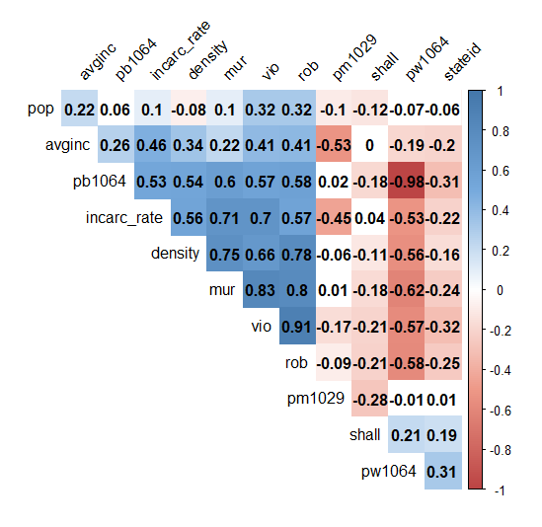

* The variables pb1064 (percentage of state population that is black in age 10–64) and pw1064(percentage of state population that is white in age 10–64) are highly negatively correlated (-0.98). This is because in a given state and time there should be either of them. This might lead to multicollinearity. Hence, we will be using pw1064 in our models for analysis.
* The variables mur, vio and rob are highly positively correlated in our data which is as per the economic theory
* There is moderate correlation between incarc_rate and mur, vio & rob which is justified

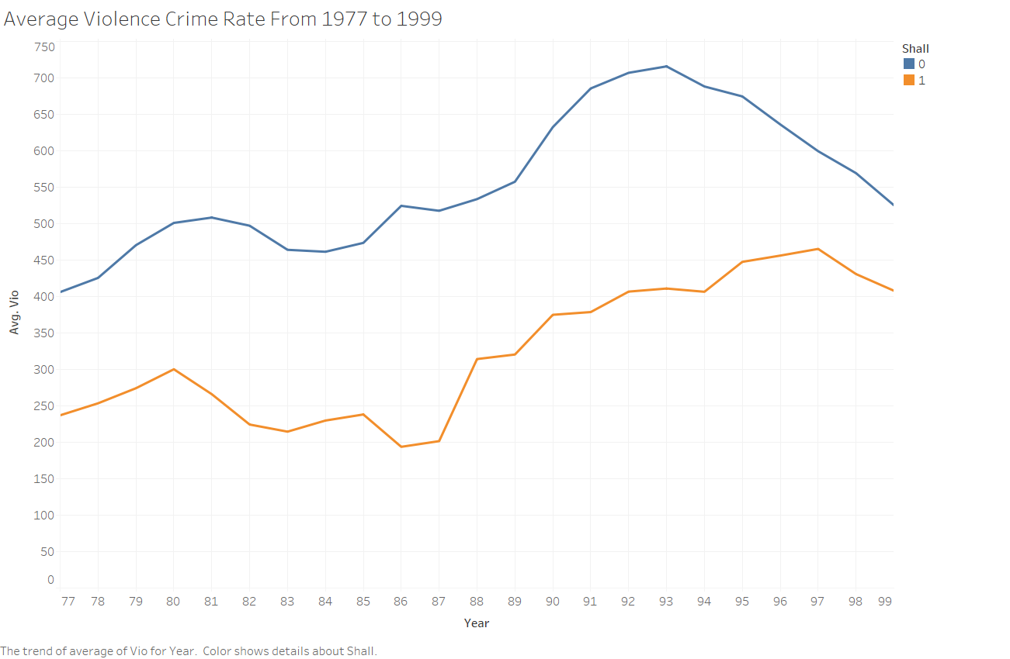

* The above graph shows the average violence rate trends over the years from 1977 to 1999. The blue trend line depicts the average violence rate for all those states where ‘shall-carry’ in not in effect and orange trend line depicts the average violence rate for all those states where ‘shallcarry’ in in effect. As suspected the average violence rate is lower for the states where ‘shallcarry’ in in effect as compared to those where it is not in effect.

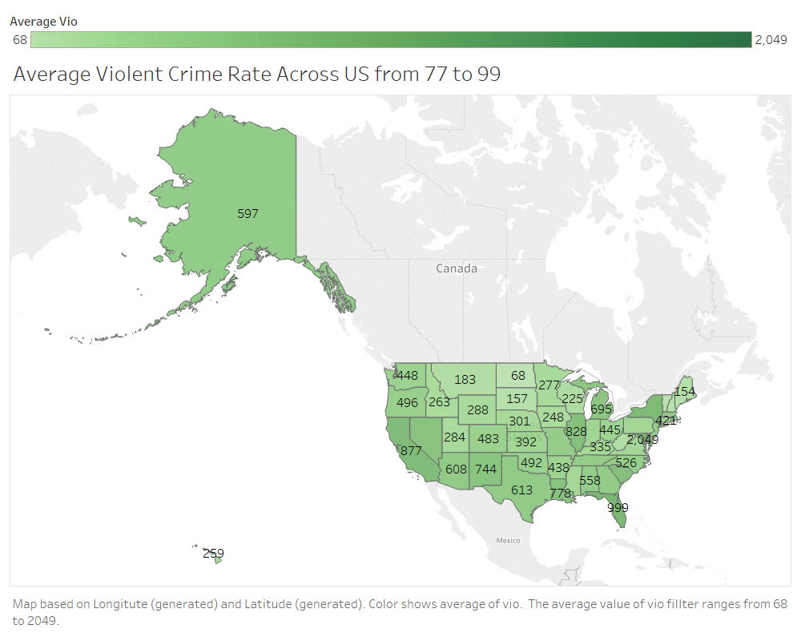

**MODELS**

We ran different models in order to understand the significance and magnitude of various variables affecting the violent crime rate.

In the FBI’s Uniform Crime Reporting (UCR) Program, violent crime is composed of four offenses: murder and nonnegligent manslaughter, rape, robbery, and aggravated assault. Therefore, we are not including murder(mur) and robbery(rob) as the independent variables in the model.

To understand the effect of shall laws, we are running 3 different models: Pooled OLS, Time fixed effects and Entity and Time fixed effects using Violent crime rate(vio) as the dependent variable in the models.

**Expectations :**

We expect shall law measures(shall) and incarceration to be negatively related with the violent crime rate. Shall laws be enforced to minimize the crime rates and therefore should have a negative impact on the crime rate.

On the other hand, one would expect an increased crime rate with an increase in population per square mile of the land area, %black of state population that is black aged 10-64.

So, we ran several models and studied their behaviors.

**Pooled OLS**

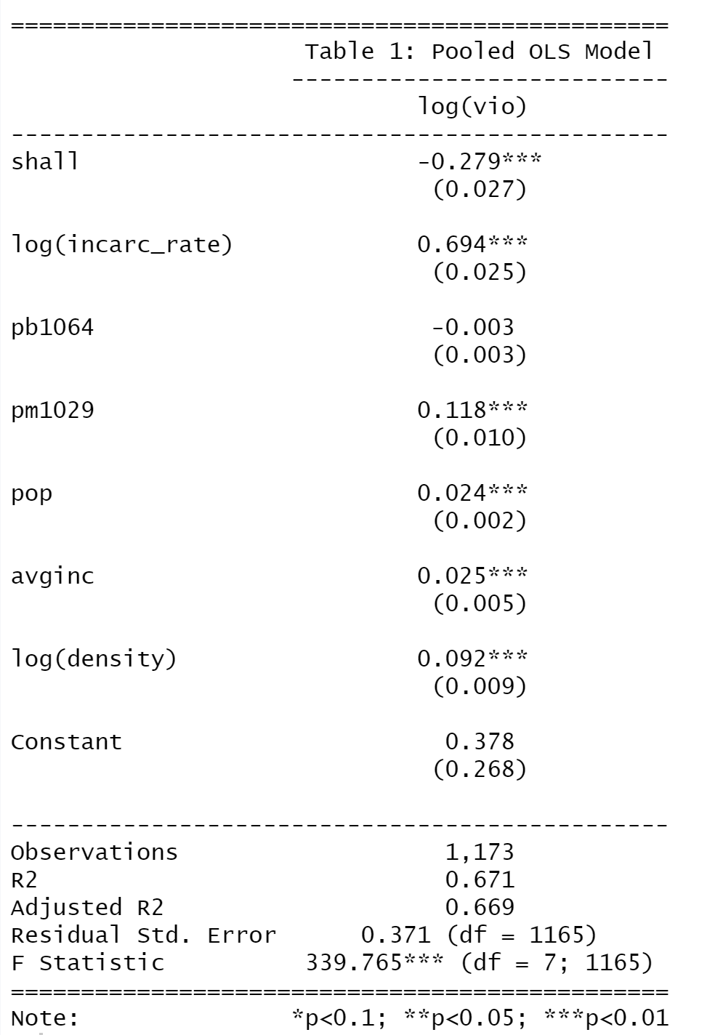

Significant Variables

* shall laws(-ve) at 1% level
* Incarceration rate(+ve) at 1% level
* % male population aged 10-29(+ve) at 1% level
* real per capita personal income in the state (+ve) at 1% level
* population per square mile of land area (+ve) at 1% level

Insignificant Variables

* % of state population that is black

As per the Pooled OLS Model, all the variables except the percentage of state population that is black are significant and affect the violent crime rate. Incarceration rate, real per capita personal income in the state, percentage of male population aged 10-29, population per square mile of land area have a positive significant coefficient and are highly significant.

Although percentage of state population that is black has a negative coefficient but it’s highly insignificant.

At this point, pooled OLS seems unreasonable. Perhaps, we have heteroskedasticity in the model because variance may also be different in different time periods which might be making the estimator inefficient. Hence, we decided to test for heteroskedasticity with below hypotheses:

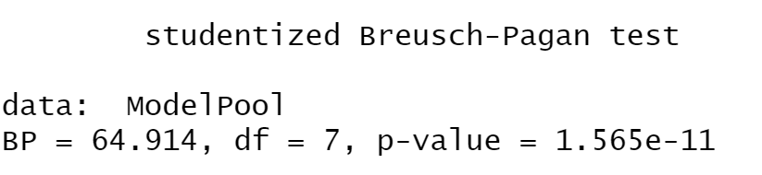

We performed Breusch-Pagan test for Heteroskedasticity and get a p-value that is practically 0.

Therefore, we reject the null hypothesis of Homoskedasticity and conclude that we have heteroskedasticity in the model.

When we have heteroskedasticity present in the model, the OLS estimator is unbiased and consistent but no longer the best. This leads to the formulas for standard errors incorrect and thereby leads to invalid confidence interval estimation and hypothesis tests.

**CLUSTER ROBUST STANDARD ERRORS**

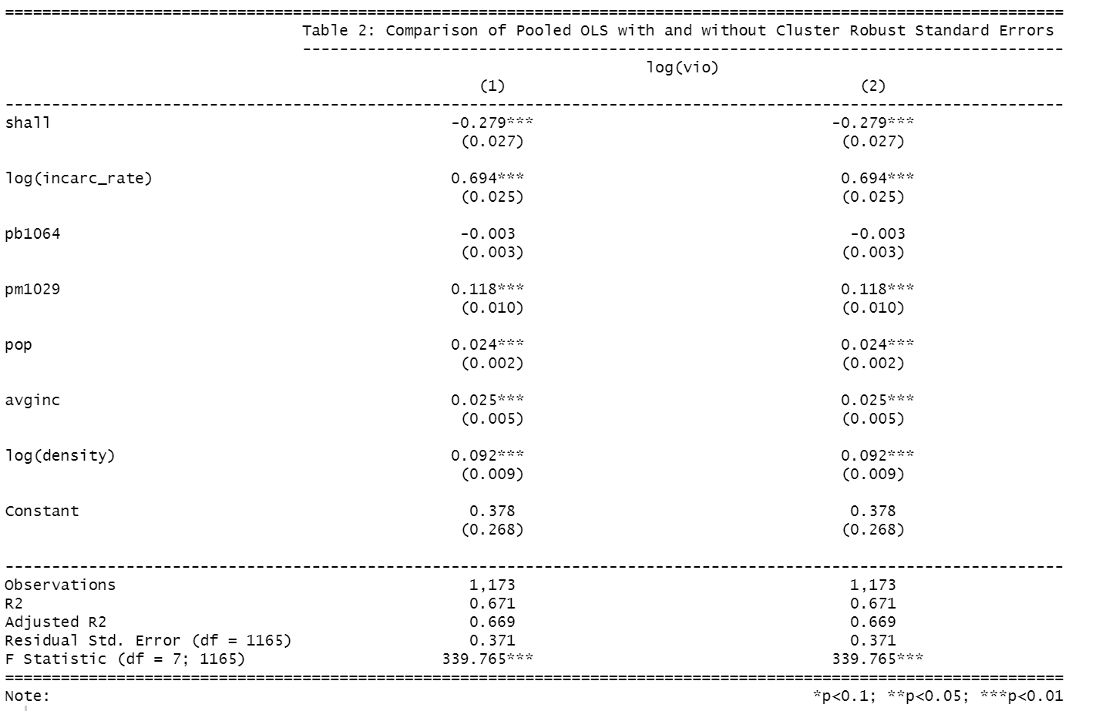We used cluster robust standard errors, but the estimator is still inefficient. The standard errors did not improve and there was no change in the significance in of the variables with the cluster robust standard error. The pooled OLS model does not completely capture the individual characteristics that are correlated over time such as cultural attitude for each of the states. Ignoring the individual characteristics decreases the reliability of the pooled OLS model and the estimates are believed to be overstated.

Hence, we decided to use entity fixed effects estimator which accounts for unobserved heterogeneity that is constant over time but varies between states.

However, in doing so we are making a strong assumption that the individual characteristics of one state is not correlated with other states which is reasonable for our analysis because the US is one of the most culturally diverse countries in the world and the states in here are significantly distinct culturally.

**Entity Fixed Effects Model**

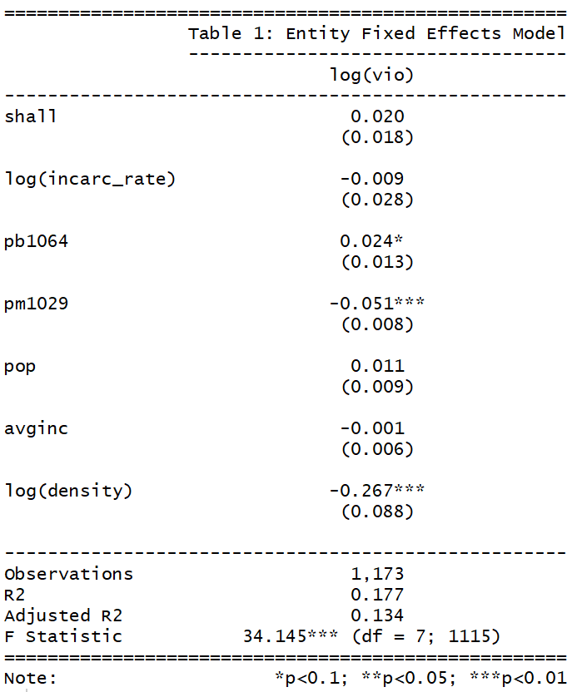

Significant coefficients

Percentage of male population, aged 10-29, for the given state (-ve) at 1%

Percentage of blacks aged 10-64 for the given state (+ve) at 10%

Population per square mile of land area (divided by 1000) (-ve) at 1%

Insignificant coefficients

Whether shall-carry law is in effect in the given year

The number of prisoners sentenced per 100000 residents in the previous year (Incarceration rate)

* + - * + Population in millions

Real per capita personal income in thousands of dollars for the given state. FE model with entity fixed effects states that if shall-carry law is in effect in a state in the given year, it increases the violent crime rate by 2%. This is not consistent with the economic theory.

We can see that the percentage of male population, aged 10-29, for the given state, results in a decrease in violent crime rate. This is not supported by the economic theory as we had expected males in between the age groups of 10 to 29 years to be the most likely demographic groups associated with committing crime. Similarly, the population per square mile of land area (divided by 1000) has a significantly negative impact on violent crime. This is expected, since areas with a sparse population density rate are locations that are more prone to crime. Percentage of blacks aged 10-64 for the given state positively affect crime. However, this result is significant only at the 10% level of significance.

Even though we get satisfactory results from entity fixed FE, there are possibilities of missing out variables that might vary over time but not across these states such as global macroeconomic factors like recession (which may result in an increase in violent crime rate) or federal laws affecting guns and crime like stricter background checks before issuing gun permits, increasing the number of police officers on patrol etc. To capture such time fixed effects, we went ahead and implemented an entity fixed and time fixed effects model.

**Entity and Time Fixed Effect Model**

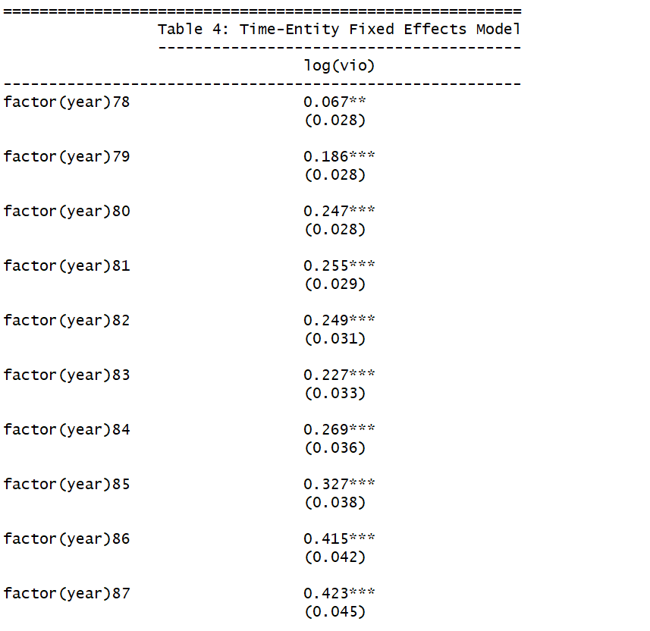Significant Coefficients

* Coefficients on Year 1978 (+ve) is significant at 5 percent level of significance.
* Coefficient of Years 1979, 1980, 1981, 1982, 1983, 1984,1985, 1986, 1987, 1988, 1989, 1990, 1991, 1992, 1993, 1994, 1995, 1996, 1997, 1998, 1999 (all positive)
* Percentage of male population aged 10-29 for given state (+ve) is significant at 1 percent significance level.
* 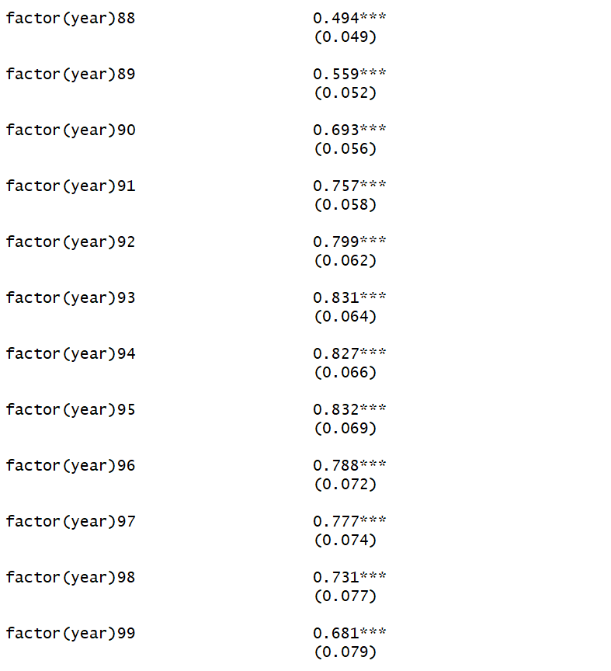The log of Incarceration rate (negative) and log of density are significant at 1 percent level significance level.

Insignificant Coefficients

* Population percentage of blacks aged 10-64.
* Whether shall-carry law is in effect in the given year populations in millions

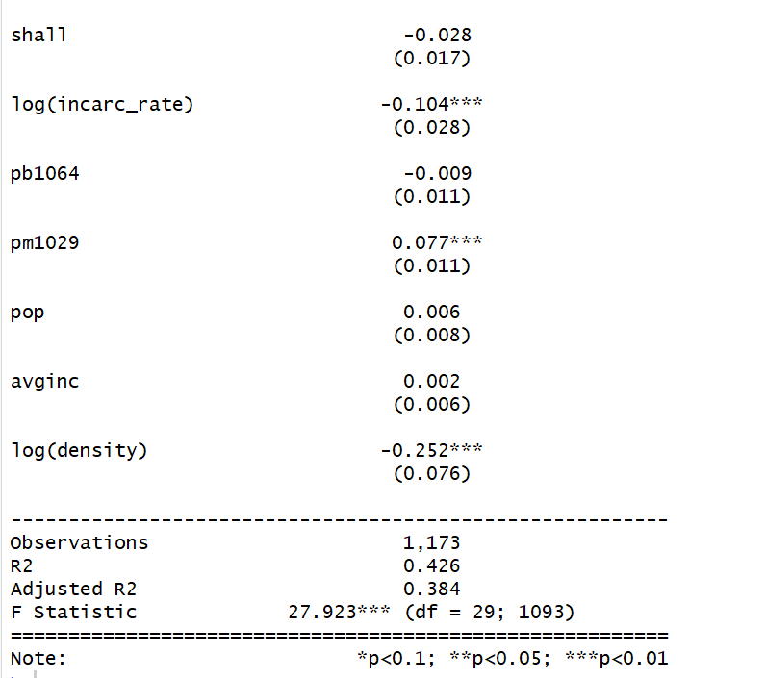

FE model with entity and time fixed effects states that if shall-carry law is in effect in a state in the given year, it reduces the violent crime rate by 2.8%, however this coefficient is not significant at 5 percent significance level.  
We can see that the percentage of male population, aged 10-29, for the given state is positively affects violent crime rate. This is expected as males in between the age group of 10 to 29 years are disproportionately high representation among criminals. Both Incarceration rate and density of population are highly significant and have a negative impact in crime rate. Population density’s relationship is intuitive as sparsely populated regions tend to have higher crime.

All the year coefficients are significant and have positive relation with crime, it means as compared with the base Year 1977, in the subsequent years crime rate increases on average.

In the time – entity fixed effects the factors that may vary over time but are same across entities are taken into account. For instance, variables federal laws that may apply to all states when passed may be part of the omitted variable. The importance of capturing this effect in omitted variable becomes even more profound when this large timeline is taken into account. This is the benefit of using the time and entity fixed effects model.

**Comparison between models**

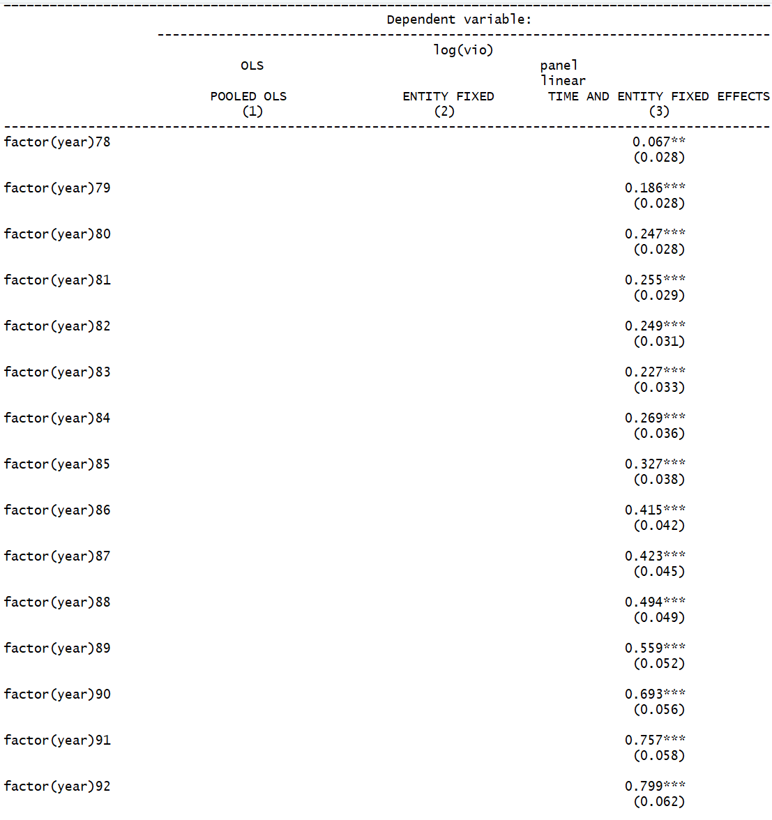

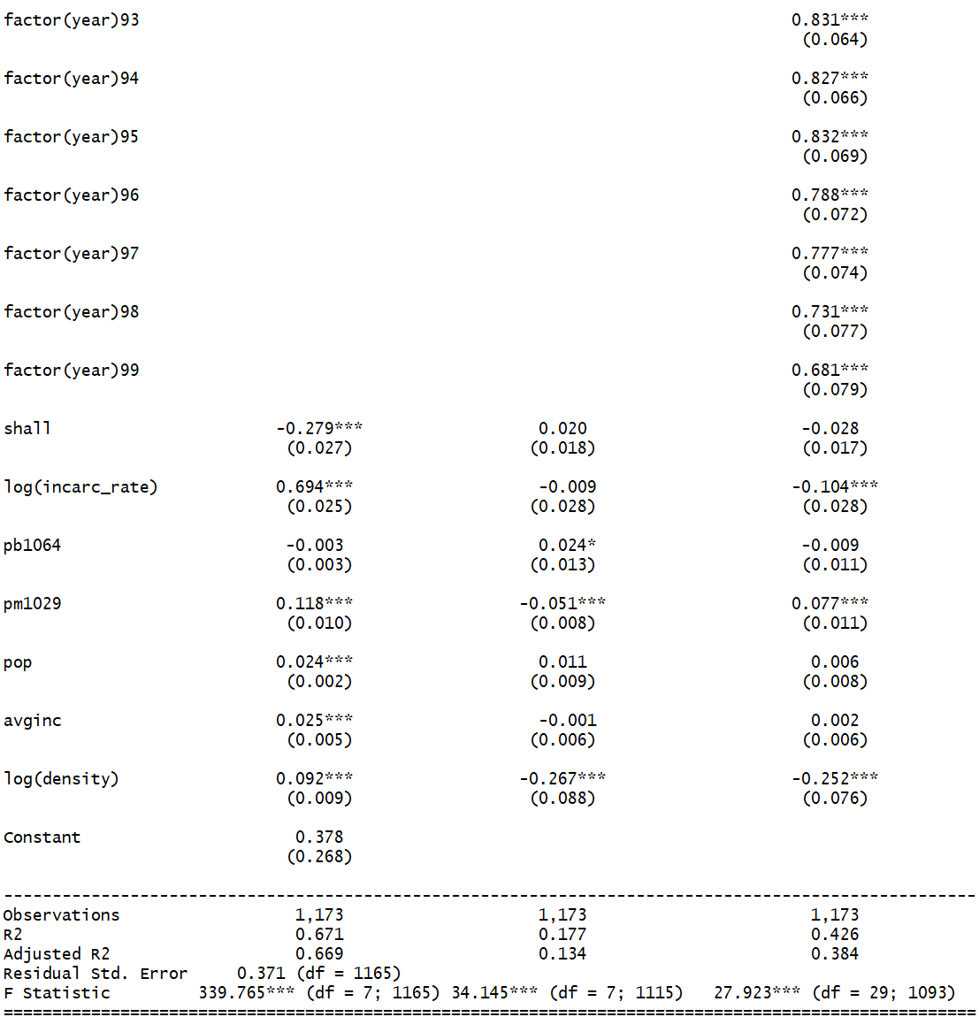

**CONCLUSION**

While working on the data, we came across different issues like heteroskedasticity, collinearity etc. Statistical and visual analysis helped us in understanding the variables closely after which we performed modeling. We are using fixed models as our data is fixed and not randomly selected. All US states are considered and the differences between these states are equal. **‘Time and Entity Fixed Effects’** model is the ideal model for our data as our data varies across time but across entity.

We can infer the following:

* Shall is an insignificant variable in the entity and time fixed model. However, it has a negative coefficient value with states that states with shall laws have more crime as compared to states without shall laws.
* Increase in incarceration rate will decrease the crime rate of the state.
* Increase in percentage of males aged 10-29 will increase the crime rate.

Thus, from the above observations, we can infer that shall laws do not affect the crime rate in different states. There might be different factors like cultural and behavioral attributes of different states contribute in the crime rate.

Evidence for the effect of shall-issue laws on violent crime is inconclusive, therefore we can conclude that the is a limited evidence that shall laws affect in decreasing the crime rate.

**APPENDIX: PART 1**

While working on the project, we used several tools and packages for analysis and coding.

Below is a list of all tools and packages with a link to their documentation:

1. **RStudio:** Our primary platform for analysis and coding – <https://www.rstudio.com/products/rstudio/download/>
2. **Tableau for Students:** We created visualizations in Tableau. We would like to thank them for providing a free student license for 1 year. - <https://www.tableau.com/academic/students>
3. **Overleaf, Online LaTeX Editor:** We used overleaf to compile LaTeX code generated by stargazer library for better formatted tabular outputs. – <https://www.overleaf.com/>
4. **Package ‘foreign’:** Used to read dta file to RStudio Workspace. - <https://cran.r-project.org/web/packages/foreign/foreign.pdf>
5. **Package ‘plm’:** Used to do analysis and modelling on panel data. - <https://cran.r-project.org/web/packages/plm/plm.pdf>
6. **Package ‘dplyr’:** Used to manipulate dataset. - <https://cran.r-project.org/web/packages/dplyr/dplyr.pdf>
7. **Package ‘stargazer’:** Used to generate LaTeX code for tabulated model summary. - <https://cran.r-project.org/web/packages/stargazer/vignettes/stargazer.pdf>
8. **Package ‘ggplot2’:** Used to plot graphs in R. - <https://www.rdocumentation.org/packages/ggplot2/versions/3.1.0>

**APPENDIX: PART 2**

**Code:**

**# Set working Directory as needed**

**# Loading Libraries**

library(readxl)

library(foreign)

library(plm)

library(dplyr)

library(stargazer)

library(ggplot2)

library(corrplot)

library(car)

library(survey)

library(MASS)

library(vars)

library(het.test)

**# Reading data**

data <- read.xlsx("C:/Users/Player1/Downloads/guns.xlsx", sheetIndex = 1, header=TRUE) #Change as needed

**# Converting to Panel Data Frame**

data_pan <- pdata.frame(data,index=c('State','year'))

**# Fixing Missing Data**

data_pan[is.na(data_pan)] <- 0

**#Pooled OLS Model**

ModelPool <- lm (log(vio)~shall+log(incarc_rate)+pb1064+pm1029+pop+avginc+log(density), data=data_pan)

summary(ModelPool)

stargazer(ModelPool, dep.var.caption="Table 1: Pooled OLS Model",type = 'text',align = TRUE)

bptest(ModelPool) **# Testing for Heteroskedasticity**

**# Pooled OLS with Cluster Robust Standard Errors**

ModelPoolRobSE <- lm(log(vio)~shall+log(incarc_rate)+pb1064+pm1029+pop+avginc+log(density), data=data_pan)

summary(ModelPoolRobSE,vcov=vcovHC(ModelPoolRobSE,method="arellano"))

stargazer(ModelPoolRobSE,type='text',align = TRUE)

**# Checking the difference in Standard Errors**

stargazer(ModelPool,ModelPoolRobSE, dep.var.caption = "Table 2: Comparison of Pooled OLS with and without Cluster Robust Standard Errors", type='text',align = TRUE)

**# Entity Fixed Effects Model**

ModelFE <- plm(log(vio)~shall+log(incarc_rate)+pb1064+pm1029+pop+avginc+log(density)

, model="within"

, data = data_pan)

summary(ModelFE)

stargazer(ModelFE, dep.var.caption="Table 3: Entity Fixed Effects Model", type="text", align = TRUE)

**# Entity and Time Fixed Effects Model Code**

ModelTFE3 <- plm(log(vio)~factor(year)+shall+log(incarc_rate)+pb1064+pm1029+pop+avginc+log(density), model="within", data = data_pan)

summary(ModelTFE3)

stargazer(ModelTFE3, type="text",align = TRUE)

waldtest(ModelTFE3, update(ModelTFE3, .~.-factor(year)), vcov=vcovHC)

stargazer(waldtest(ModelTFE3, update(ModelTFE3, .~.-factor(year)), vcov=vcovHC), type = "text")

**# Comparing the 3 models**

stargazer(ModelPoolRobSE,ModelFE,ModelTFE3, column.labels=c("POOLED OLS","ENTITY FIXED","TIME AND ENTITY FIXED EFFECTS"),

type="text",align = TRUE)