LAB PRACTICUM: OpenMP Multi-Core Scaling in Python
Completed Task Sheet
Student Name: | Tolegen Aset | Student ID: | 230103240
Hardware / CPU: | AMD Ryzen 7 5825U (8 cores / 16 threads) | Date & Section: | 02.10.2026

Challenge 1: The Core Speedometer & Amdahl's Law
A. Baseline T₁ (1 thread) = 3.0231 s. Maximum multi-thread runtime T_max (16 threads) = 0.4078 s, giving a speedup of 7.41x and an efficiency of 46.3% (see Table 1).
B. Numba compiles the function to machine code with its JIT compiler the first time the function is called. Compilation takes from hundreds of milliseconds to several seconds. Without the warm-up call, this compile time would be included in the first measurement, so the timing would reflect the compiler rather than the computation. Because the 1-thread run is measured first and is used as the baseline T₁, the error would also distort every speedup value. The warm-up call with 10,000 samples triggers compilation in advance, so all later timings measure only the execution of the already compiled native code.
C. No. Efficiency fell from 100% (1 thread) to 90.2% (2 threads), 73.3% (4 threads) and 46.3% (16 threads). The main reasons are:
- Hyperthreading / SMT: the 16 hardware threads are logical threads, so two of them share one physical core (the same ALUs, caches and execution units). A second thread on a core adds far less than a full core of throughput. The speedup of 7.41x on 16 threads is close to what 8 physical cores would give, which is consistent with this limit.
- Amdahl's Law: the serial part of the program (thread-pool start-up, work distribution and the final reduction) does not scale. The speedup is limited to S = 1 / (s + (1 - s)/N), so efficiency drops as N grows.
- Frequency and thermal limits: when all cores are busy, the CPU lowers its turbo frequency and may throttle because of power and heat limits. On hybrid CPUs, efficiency cores are also slower than performance cores.
- Scheduling overhead: creating threads, splitting the iteration space and combining partial results cost time that a single thread does not pay.
- Memory bus contention is not a major factor here, because the Monte Carlo loop works only on registers and does not read large arrays from memory.
D. Numba recognises the pattern inside prange (x += ... on a scalar) as a reduction and automatically generates the equivalent of an OpenMP reduction(+:inside_circle) clause. Each thread gets its own private copy of the counter, initialised to zero, and increments it without locks or data races. When the parallel loop finishes, the private partial sums are combined into one final value. Since no two threads ever write to the same variable at the same time, the count is not corrupted.

Challenge 2: Load Imbalance & Dynamic Scheduling
A. The column-parallel version was faster: t_cols = 0.770 s versus t_rows = 0.869 s (about 11% faster). The Mandelbrot set is most expensive in the centre of the image. With row decomposition, the block of rows that contains the centre of the set gets much more work than the blocks at the top and bottom, so some threads finish early and wait. The set stretches across most of the image width, so splitting by columns gives neighbouring blocks a more even mix of heavy and light pixels, and the load is better balanced. The memory-access pattern also differs (column decomposition writes to img[r, c] with a large stride), but the run time is dominated by the compute-heavy while loop, so the load balance has a larger effect than the cache effect. Also, the rows version runs first, so start-up effects may contribute to some of the difference.
B. NumPy arrays are C-contiguous (row-major), so img[r, 0], img[r, 1], ... are adjacent in memory. A cache line is 64 bytes and holds 16 int32 values. When the inner loop moves along a row (img[r, c] with c increasing), consecutive writes fall in the same cache line, so one cache-line load serves 16 writes and the hardware prefetcher works well. When the access pattern is img[c, r] (moving down a column), each consecutive write is a whole row (2500 x 4 = 10,000 bytes) away, so every write touches a different cache line and uses only 4 of its 64 bytes. This wastes memory bandwidth and cache capacity. In addition, if different threads write to neighbouring elements of the same cache line, the line bounces between cores (false sharing, via the cache-coherence protocol), which slows the program further.
C. Points inside the Mandelbrot set run all max_iter = 1000 iterations, while points far outside escape after 2-3 iterations. Rows through the centre of the image are very expensive, and rows near the top and bottom are almost free. With static scheduling, the thread that receives the centre 20% of rows has far more work than the thread that receives the top 20%. The light thread finishes quickly and then idles at the barrier at the end of the loop while the heavy thread is still working, and the total time equals the time of the slowest thread. Dynamic scheduling (OpenMP schedule(dynamic)) fixes this by handing out small chunks of iterations on demand: a thread that finishes its chunk immediately takes the next chunk from a shared queue. Fast threads therefore keep working while slow chunks are still in progress, and the load evens out automatically. The cost is a small scheduling overhead for each chunk, which is worth paying for uneven workloads such as this one.
D. The exported image mandelbrot_output.png is attached below.
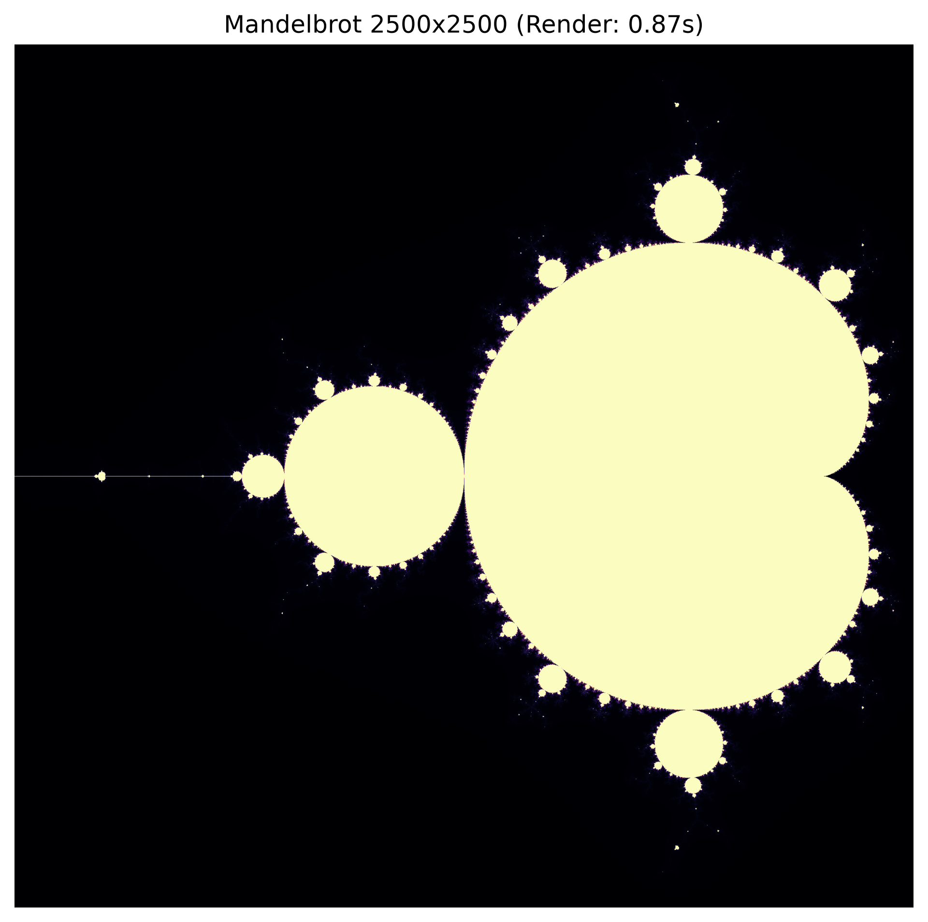

Challenge 3: Stencil Computation & Memory Bandwidth
A. float64 result: 0.541 s total runtime and 1248.17 Megacells/sec throughput (see Table 1).
B. With np.float32 the runtime fell from 0.541 s to 0.118 s, a factor of 4.59 faster (throughput rose from 1248.17 to 5725.64 Megacells/sec). A stencil does very little arithmetic per value it loads (a handful of additions and multiplications per five reads), so it is limited by memory bandwidth, not by compute capability. Halving the element size halves the number of bytes that must be moved per cell, so the same bandwidth delivers twice as many cells. The gain here is larger than 2x because of the cache: with float64 the two 1500 x 1500 arrays take about 36 MB, which probably does not fit in the L3 cache, so the data streams from RAM; with float32 they take about 18 MB, which fits much better in cache, so a large part of the work is served from fast cache instead of main memory. The arithmetic units were mostly idle before the change, which is why reducing the memory footprint improves throughput far more than any compute improvement would.
C. The Roofline model says that attainable performance is min(peak compute, memory bandwidth x arithmetic intensity). A stencil has a low arithmetic intensity (roughly 0.1-0.2 FLOP per byte), so it lies under the sloped memory roof, not the flat compute roof. Memory controllers and the memory bus are shared by all cores. Once a few cores already saturate the available bandwidth (GB/s), additional cores cannot receive data any faster and simply wait for memory. Doubling the number of cores therefore does not double the speed: the speedup curve flattens at a plateau set by the memory bandwidth, not by the number of cores.

Student Result Scorecard (Table 1)
Benchmark Challenge | Active Threads | Array Size / Samples | Time (seconds) | Speedup Factor | Efficiency (%)
Challenge 1: Monte Carlo | 1 Thread (Base) | 120,000,000 | 3.0231 | 1.00x | 100.0%
Challenge 1: Monte Carlo | 2 Threads | 120,000,000 | 1.6749 | 1.80x | 90.2%
Challenge 1: Monte Carlo | 4 Threads | 120,000,000 | 1.0316 | 2.93x | 73.3%
Challenge 1: Monte Carlo | Max Threads (16) | 120,000,000 | 0.4078 | 7.41x | 46.3%
Challenge 2: Mandelbrot (Rows) | Max Threads (16) | 2500 x 2500 | 0.869 | N/A | N/A
Challenge 2: Mandelbrot (Cols) | Max Threads (16) | 2500 x 2500 | 0.770 | N/A | N/A
Challenge 3: Heat Stencil | Max Threads (16) | 1500 x 1500 x 300 | 0.541 | N/A | N/A

Note: the hardware reported 16 threads (numba.config.NUMBA_NUM_THREADS = 16). Challenge 3 with float32: 0.118 s (5725.64 Megacells/sec).

