Lab 5 Report
Adversarial Search: Minimax & Alpha-Beta Pruning
Name | Asfa Ali
Roll No | 126
Course | Artificial Intelligence Lab (CAI601400)
Lab | Lab 5: Adversarial Search: Minimax & Alpha-Beta Pruning

1. Objective
To apply Minimax and Alpha-Beta pruning to a game tree, and to explain how pruning reduces the number of leaves searched while still giving the same Minimax decision.

2. Case Study
A small two-player zero-sum game tree with known terminal scores is used to choose the best move. MAX moves at the root and MIN and MAX alternate at each level below it. The leaf scores used are [3, 5, 2, 9, 3, 5, 2, 9], which gives a complete binary tree of depth 3 (8 leaves).

3. Task 1: Hand Trace of the Tree

3.1 Minimax
Values are computed bottom-up. At a MAX node the larger child value is taken and at a MIN node the smaller one. The left subtree gives max(3, 5) = 5 and max(2, 9) = 9, so the MIN node above them takes min(5, 9) = 5. The root (MAX) therefore receives 5, and the Minimax value of the tree is 5.

3.2 Alpha-Beta Pruning
The same tree is traced again with alpha and beta bounds. After the first MAX branch returns 5, the MIN node has beta = 5. In the second branch, once a value of 9 or higher is seen, alpha >= beta holds and the remaining leaves cannot change the result, so they are pruned (crossed out in the figure). The root value is still 5.
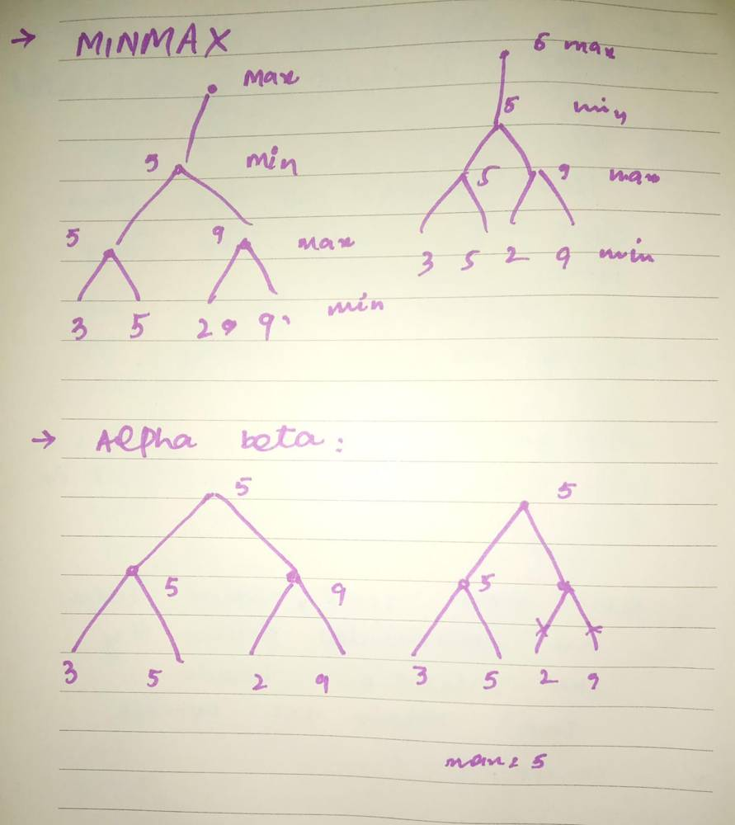
Figure 1: Hand-drawn Minimax tree and Alpha-Beta pruned tree (root value = 5)

4. Task 2: Implementation with Leaf Counter
A leaf-evaluation counter (a one-element list passed by reference) was added to both algorithms. It is incremented whenever the recursion reaches the target depth, so it records how many leaves were actually evaluated.

4.1 Minimax
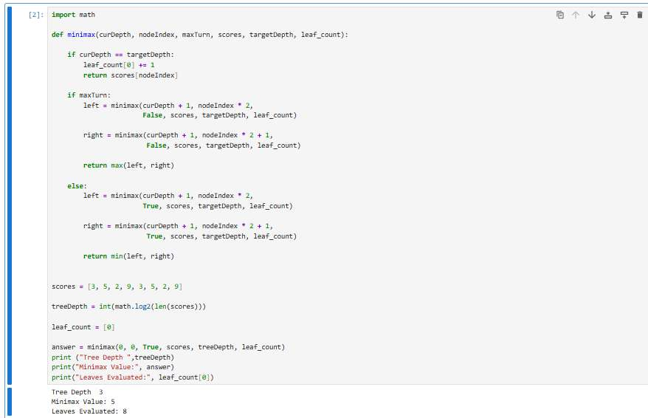
Figure 2: Minimax code with leaf counter and output (Tree Depth 3, Value 5, Leaves 8)

4.2 Alpha-Beta Pruning
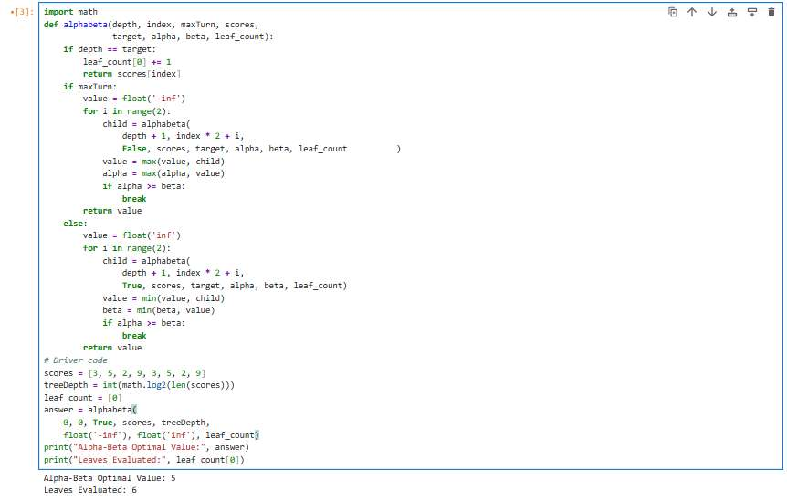
Figure 3: Alpha-Beta code with leaf counter and output (Value 5, Leaves 6)
Result: Both algorithms return the same root value of 5. Minimax evaluates all 8 leaves, while Alpha-Beta evaluates only 6, so 2 leaves were pruned.

5. Task 3: Reordering Branches and Comparison
Both functions were placed in one program and run on the original scores and on a reordered list, to see how pruning changes while the Minimax value stays the same.

5.1 Combined code
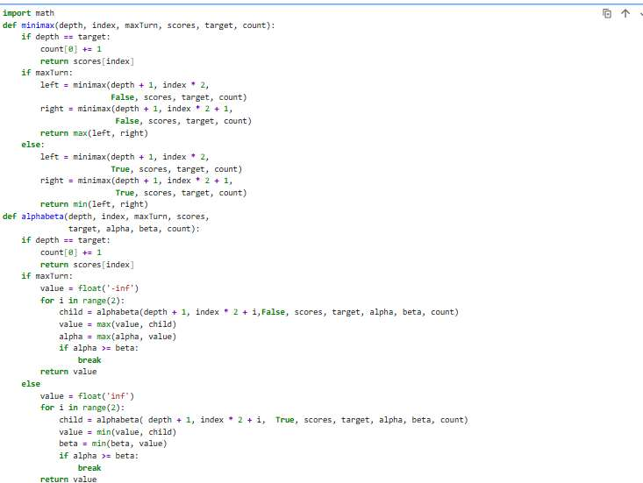
Figure 4: Minimax and Alpha-Beta functions with leaf counters

5.2 Comparison code and output
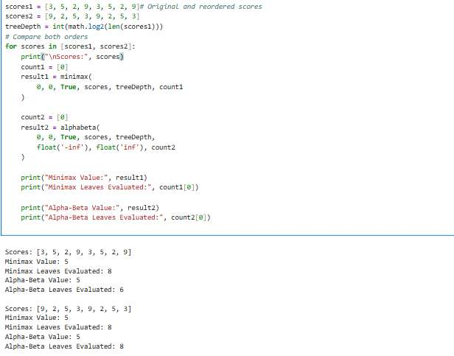
Figure 5: Comparison of original and reordered scores
Observation: For the original order, Alpha-Beta evaluated 6 leaves. After reordering to [9, 2, 5, 3, 9, 2, 5, 3], it evaluated all 8 leaves, the same as Minimax. The value remained 5 in both cases.

6. Test Results Table
The table below records the tests, including an edge case in which all leaf scores are equal.
Test | Scores | Minimax Value | Minimax Leaves | Alpha-Beta Value | Alpha-Beta Leaves
Original | [3, 5, 2, 9, 3, 5, 2, 9] | 5 | 8 | 5 | 6
Reorder 1 | [9, 2, 5, 3, 9, 2, 5, 3] | 5 | 8 | 5 | 8
Reorder 2 | [2, 9, 3, 5, 2, 9, 3, 5] | 5 | 8 | 5 | 8
Edge case (all same) | [5, 5, 5, 5, 5, 5, 5, 5] | 5 | 8 | 5 | 5

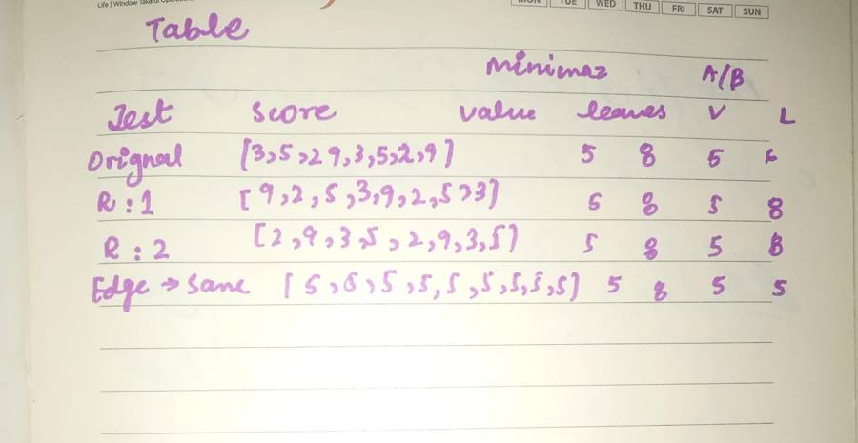
Figure 6: Hand-written table of test results

7. Interpretation of Results
- Minimax and Alpha-Beta gave the same root value (5) in every test, so pruning does not change the optimal decision.
- Minimax always evaluated all 8 leaves because it never skips any branch.
- Alpha-Beta evaluated 6 leaves on the original order, 8 on both reordered lists, and 5 on the all-equal edge case. It never evaluated more leaves than Minimax.
- The amount of pruning depends on move ordering. When a strong move is examined early, a cut-off happens sooner and more leaves are skipped. With a poor ordering, no cut-off occurs and Alpha-Beta does the same work as Minimax.

8. Viva-Ready Answers
Why does MAX assume MIN will choose the worst outcome for MAX? Because the game is zero-sum and the opponent is assumed to play optimally, so MAX plans for the best result it can guarantee against the strongest reply.
What do alpha and beta represent? Alpha is the best value MAX can already guarantee along the current path, and beta is the best (lowest) value MIN can guarantee. When alpha >= beta, the remaining children of that node cannot affect the final decision and are pruned.
Does pruning change the Minimax result? No. Pruning only skips branches that cannot influence the root value, so the result is identical to plain Minimax.
Why does move ordering affect pruning efficiency? Good ordering raises alpha or lowers beta early, which triggers cut-offs sooner. Poor ordering delays or prevents them, as seen in the reordered tests where all 8 leaves were evaluated.

9. Reflection
- What did I learn today? How Minimax values are computed bottom-up, and how alpha-beta bounds let the search skip branches without changing the answer.
- How will I apply this in a real AI system? In game-playing agents such as chess or tic-tac-toe, where searching every position is too expensive and pruning allows deeper search in the same time.
- What surprised me? That reordering the leaves changed the number of pruned leaves from 2 to 0 even though the final value stayed 5.
- What would I do differently next time? Test more orderings, including a best-case ordering, and also return the chosen move along with the value.

10. Conclusion
Minimax and Alpha-Beta pruning were implemented with leaf counters and tested on the given tree, on reordered inputs and on an edge case. Both always returned the same root value of 5, and Alpha-Beta evaluated no more leaves than Minimax, with the saving depending on the ordering of the branches.

