DEMs for terrain correction in the MapReady tool
Rudi Gens

This manual provides a complete overview of the use of digital elevation models (DEMs) for terrain correction in the MapReady tool. The DEM is required to correct SAR images for the distortions caused by the side looking geometry in which the data is acquired.

Sources for digital elevation models
Digital elevation models can be generated in a number of ways and, therefore, the sources for them are manifold. Currently, the most complete coverage on a global scale has been established by the elevation models interferometrically derived from data acquired during the Shuttle Radar Topography Mission (SRTM) in 2000 within eleven days. This data set was converted to digital elevation models spanning the globe between 60° Northern and 58° Southern latitude. It is distributed by the US Geological Survey (USGS) as part of the seamless data distribution system.

SRTM DEMs from USGS
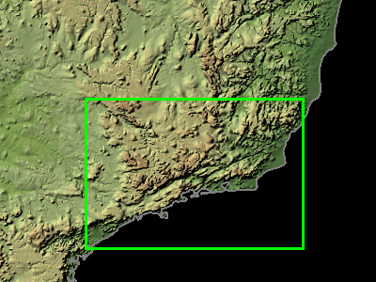
The SRTM data can be selected and downloaded using an interactive map. The size of the data sets that can be downloaded is limited to 250 MB. This is the reason why users need to download several data sets when they are working in larger study areas or with imagery such as Radarsat ScanSAR imagery that might exceed the limits what can be covered with a single SRTM elevation model. The DEMs are distributed in the geographic projection.
Selection of an SRTM DEM from USGS

The SRTM data is available in a variety of formats: ArcGrid, GeoTIFF, BIL and GridFloat. In order to correctly import the SRTM DEMs into the MapReady tool the data should be downloaded in GeoTIFF format. Since the default download format is "ArcGrid" the GeoTIFF format needs to be selected by modifying the data request before downloading the data. Out of the compressed download file only two files are required: the DEM that is stored in a .tif extension file and the accompanying .aux file.

Import of SRTM DEM using asf_import
The asf_import tool is used to convert the data from the GeoTIFF into ASF internal format with the following command line:

asf_import –format geotiff <input file> <output file>

The input and output files do not require their respective extensions.

Geocoding of SRTM DEM using asf_geocode
The asf_geocode tool is used to get the still pseudo projected DEM into a proper cartographic map projection. This can be achieved in two different ways. Since the UTM projection does not require the knowledge of any further map projection parameters but the zone and hemisphere that is automatically determined from the metadata when using the following command line:

asf_geocode –p utm <input file> <output file>

Alternatively, the predefined map projection files, which can be selected within the graphical user interface, can be used for the geocoding.

asf_geocode
–read-proj-file lambert_conformal_conic_south_america.proj
<input file> <output file>

Apart from the projection file name that contains all the relevant map projection parameters there is no prior knowledge required to select any particular map projection file.

In case several SRTM are geocoded that later need to be combined to one large DEM, the pixel size should be specifically be defined using the –pixel-size option. This ensures that the individual DEMs can be correctly combined later.

Combining SRTM DEMs using mosaic
In case several SRTM DEMs need to be combined in order to cover the area of interest, the mosaic tool can be used with the following command line:

mosaic <output file> <input 1> <input 2> … <input n>

The mosaicking tool assumes that all input images have the same map projection and the same pixel spacing. This geocoded DEM mosaic in ASF internal format can be now used for terrain correction with the MapReady tool.

