The use of the asf_convert tool
Rudi Gens

This manual provides a complete overview of the conversion from operationally produced SAR data to a variety of user friendly format. It presents the theoretical background for the formats, corrections and processing steps in the processing flow. The manual describes the functionality of the graphical user interface in detail. The manual contains a description about the command line version of the asf_convert tool. The generation and modification of all parameters in the configuration file that is used to run the asf_convert tool are explained in detail. Examples of completed runs are provided. A number of exercises explain how the asf_convert tool can applied for different applications.

General background

This section provides some background information to allow the user to make the most effective use of the asf_convert tool.

Data formats
After processing the analog SAR signal to binary SAR signal data, the data is called level zero data in SKY telemetry format (STF). The level zero data covers a certain area on the ground in the form of a swath. The length of the swath depends on the amount of data originally collected during the actual acquisition. The size of the files varies but can easily reach some gigabytes. The level zero swaths are then subdivided in frames. For ERS imagery, these frames have a size of 100 · 100 km, which is equivalent to about 26000 lines of radar data. The accompanying leader file is defined in CEOS standard format. This is why these data sets are referred to as CEOS frames.

The CEOS data come in three different flavors. The CEOS level zero data is raw signal data that needs to run through a SAR processor before it can be visualized. The CEOS single look complex (SLC) data is primarily used to SAR interferometry, as it contains amplitude and phase information. Furthermore, the data has not been multilooked, i.e. the pixel size is not square (with the exception of Radarsat fine beam data). To be useful for SAR interferometry, the data is generally deskewed during the SAR processing. The so called zero Doppler geometry ensures that two interferometric data sets can be combined without introducing any further distortions. In order to be visualized the data needs to be first converted from its complex form into an amplitude image. Finally, CEOS level one data is the most commonly used format. It does not require any further processing to be useful for regular use. This is the only format that is currently fully supported by the asf_convert tool.

Apart from SAR data itself, which is stored in a binary form, the majority of the other files is stored in ASCII format and can be viewed with any editor available on the system. There is an important exception. The CEOS leader file is not completely in ASCII format. In order to display the contents of these files, some tools are provided. The program metadata enables the user to read any of the CEOS records and store them in a file for further reference. The ASF metadata viewer mdv provides a graphical user interface to inspect the metadata.

After ingesting the data all files are stored in an internal format. The image files are flat generic binary files without any headers (with the extension .img). The metadata are stored in text files (with the extension .meta).

Calibration
A SAR processor is calibrated when the coefficients required for accurate radiometry have been determined, but an image is calibrated only when those coefficients have been applied.
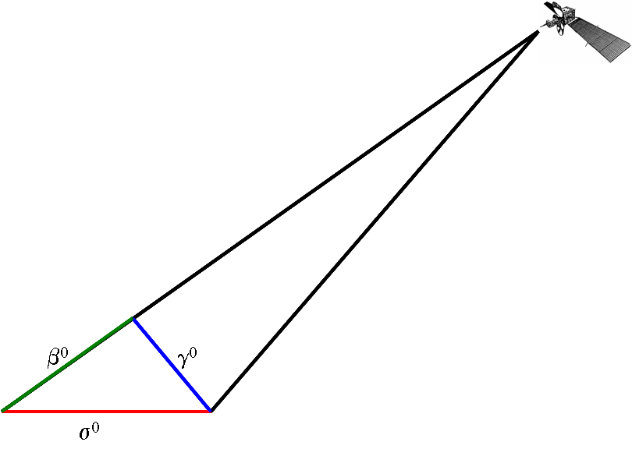
Calibrating a SAR image is the process of converting a linear amplitude image into a radiometrically calibrated power image. The input image is in units of digital numbers (DNs), whereas the output image is in units of β₀, γ₀ or σ₀, which is the ratio of the power that comes back from a patch of ground to the power sent to the patch of ground. The application will determine which of these calibration units to choose. Scientists are generally interested in quantitative measures that are referring to the ground, i.e. they would work with σ₀ values. For calibration purposes γ₀ values are preferred because they are equally spaced. Finally, system design engineers would choose β₀ values, because these values are independent from the terrain covered.

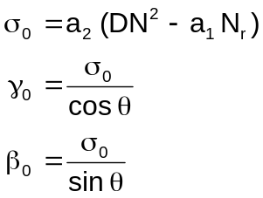

The radar backscatter coefficients σ₀, γ₀ and β₀ are calculated using the above equations. The digital numbers DN are the original pixel values. The noise offset N_{r} is a function of range. The noise scale factor a₁ and linear conversion factor a₂ are determined during the calibration of the processor. The values from the above equation are in power scale. In order to convert them into dB values the following relation is used:

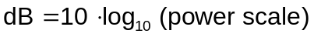

Calibrated images are generally used in the logarithmic dB scale. However, when image statistics are calculated for calibrated imagery, special attention needs to be given to the logarithmic nature of the values. In order to correctly determine the mean value of any part of the image, for example, the calculation has to be based on power scale values. The mean power scale value can then be safely converted into the logarithmic scale to represent dB values.

Terrain correction
SAR images are acquired in a side looking geometry. This leads to a number of distortions in the imagery.

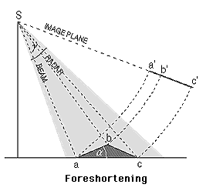
The time difference of two signals backscattered at the bottom and the top of a steep slope is shorter than in a flat area. Therefore, the distance between two points is mapped shorter in the image. This geometric effect called foreshortening compresses the backscattered signal energy, i.e. the affected area on the image appears brighter.

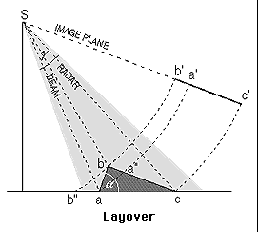

The layover effect represents the extreme case of Foreshortening. The signal backscattered from the top of the mountain is received earlier than the signal from the bottom, i.e. the fore slope is reversed. The pixel information from various objects is superimposed which leads to a brighter appearance on the image.
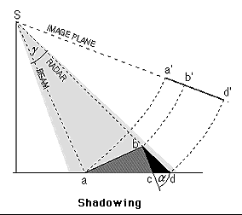

The shadow effect in radar imagery is different from optical imagery. In the case of radar, no information is received from the back slope which appears as black regions on the image. The length of the shadow depends on its position in range direction. Therefore, the shadows in far range are longer than in near range.

The terrain correction removes the geometry induced distortions using the height information from a digital elevation model (DEM). In this process the DEM is mapped into the SAR slant range geometry. Part of this processing step is the refinement of the geolocation of the SAR image by matching the real SAR image with a simulated SAR image derived from the DEM. Then the SAR image can be converted in ground range geometry while correcting for the terrain effects.

Map projections
Maps are a two-dimensional representation of the three-dimensional real world. Projecting three-dimensional coordinates into a two-dimensional space is not possible without distortions of shape, area, distance, or direction. A very practical illustration of this problem is to lay a carefully peeled orange onto a flat table surface without fracturing it. Map projections can preserve some of the above mentioned characteristics. That makes map projections suitable for certain applications and/or geographical regions.

Cylindrical projections work best in equatorial areas. The Universal Transverse Mercator (UTM) projection is most commonly used one from this category of projections. The distortions within the UTM projection are manageable as long as the projected area is not very large.

Conic projections, mostly defined with two standard parallels, are often used in mid-latitude regions. The Albers Conic Equal Area projection preserves the area, while the Lambert Conformal Conic projection preserves the angles.

Azimuthal projections are mostly used in Polar Regions. The Polar Stereographic projection and Lambert Azimuth Equal Area projection are well known representatives of this type of projection.

The convert supports five of the most commonly used map projection:
- Universal Transverse Mercator (UTM)
- Albers Conic Equal Area
- Polar Stereographic
- Lambert Conformal Conic
- Lambert Azimuthal Equal Area

Configuration file
The convert tool has a large number of options and parameters that define the exact processing flow to be run through. In order to keep track of the parameters in an organized fashion, they are stored in a configuration file. This configuration file, which is created by the graphical user interface on the fly, is passed to the actual convert tool that executes all selected processing step.

The command line version of asf_convert is the back end of the asf_convert graphical user interface. For simplicity a configuration file is the one required input to run the tool. For throughput a batch mode is available that allows users to run large quantities of data files through the system. All essential options can be stored in a default values file that is used to process all files on the batch file list with the same parameters.

Temporary directories
The convert tool provides the user with the capability of keeping intermediate results for further analysis. These intermediate files are kept in separate subdirectories for each data set. In order to ensure that intermediate results are not accidentally overwritten by consecutive processing of the same input files, the names of the subdirectories include a date and time stamp. The intermediate files themselves have descriptive names that should make it easy to identify the files for further analysis.

Using the Convert Graphical User Interface

Functionality
The graphical user interface (GUI) of asf_convert provides the user with a convenient and interactive way to convert SAR data from their specific CEOS or STF format, explained in detail in the background section, into more user friendly formats that the majority of software packages dealing with images and their processing and analysis are able to handle. As part of the conversion process, the user can perform a number of modifications that make SAR data more powerful to use. These modifications include

- converting the digital numbers of an image into radiometrically calibrated values;
- converting the image from its SAR geometry into a map projection, i.e. geocoding it;
- correcting the SAR image for its geometric distortions using a digital elevation model, i.e. terrain correcting it.

The GUI consists of five areas that allow the user to set up, monitor and execute the conversion processing flow. The functionality of these five areas is described in this section of the manual in more detail.

Tabs
This area consists of five tabs that define all the parameters used in the conversion process.

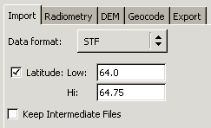
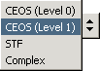
The user can choose from a variety of data formats: CEOS (Level 0), CEOS (Level 1), STF, and Complex.

In the current implementation only the processing of CEOS level one data, which is the default value, is fully supported. Additional tools are required to take full advantage of the level zero data and level one complex data.

The latitude option allows the user to create a subset of level zero swath data (STF) that contains a certain latitude range defined by its low and high latitude values.

The processing flow creates a number of intermediate results for the various processing steps. For troubleshooting purposes or further analysis those intermediate results can be kept.

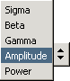
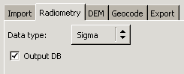
SAR data in its detected form reflects the intensity or amplitude of the reflected backscatter. In order to use SAR data in a quantitative fashion, it is advisable to radiometrically correct the data.

The radiometry default value for the data ingest is 'amplitude', i.e. the pixel values in the image are raw digital numbers. Alternatively, the intensity of the SAR image can be expressed by its power. Certain applications prefer to use the power of an image, rather than the amplitude. As mentioned before, for quantitative measurements the calibration parameters need to be applied. Depending on the type of measurements, the calibrated values (sigma, beta or gamma) refer to the different projections as discussed in the background section. The values are in power scale.

Optionally, the values can be converted from power scale into dB.

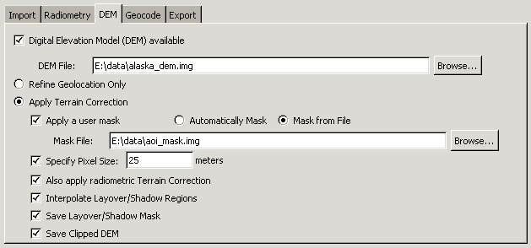

The use of digital elevation models (DEMs) is optional. However, a DEM can be used to improve the SAR data in two different ways. The most important improvement is the correction of distortions caused by the SAR geometry, also referred to as terrain correction. In very flat areas the regular terrain correction procedures might not work very well. In this case, the user might want to consider only refining the geolocation of the image.

The DEM is assumed to be in the ASF internal format. DEMs retrieved in GeoTIFF format from the USGS seamless data distribution can be ingested using the asf_import command line tool. Once a DEM is defined, by default the geolocation is refined by the DEM.

For the terrain correction the user has a number of options.

In case the SAR imagery contains areas that are moving, e.g. water bodies or glaciers, the user can refine the procedure by applying a mask. The automatic mask considers all values in the DEM below a threshold one meter as masked. This approach works well for water bodies at sea level. Alternatively, a user defined mask file, assumed to be internal format, can be used. The description how to generate a mask file within a GIS environment can be found elsewhere.

The terrain correction corrects the distortions in the SAR image using the height information in the DEM. For this process the tool adjusts the pixel size of the SAR image to the pixel size of the reference DEM (usually of lower resolution). This behavior can be overwritten by specifying the otherwise optional pixel size. The pixel size option in the Geocoding tab (described below) is more appropriate if you are attempting to size the final image product, the pixel size value specified here should be chosen based on the pixel size of the DEM.

Apart from the geometric correction performed by the terrain correction, the image can be also corrected for its radiometry. Currently, a very simple model is applied.

By default layover and shadow regions in the terrain corrected image are filled with interpolated values. By deselecting this option, the algorithm fills these data holes with zeros.

The layover/shadow masks as well as the clipped, both generated in the terrain correction process, can be saved for further analysis. These products a very specific to this process and do not fall into the general scheme of keeping intermediate products, if selected.

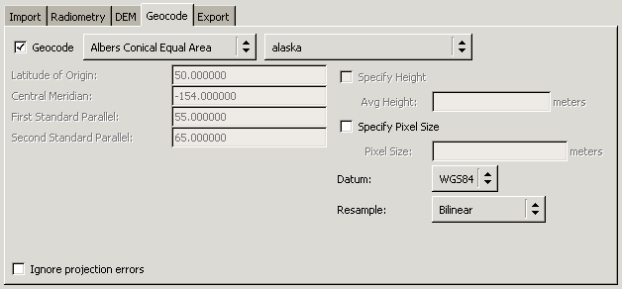

The geocoding step is an essential step to establish the relation from the SAR image geometry to the real world. By transforming the image from the SAR geometry into one of the standard map projections, the user can use the data set outside the ASF software tools. Nevertheless, the geocoding of the data is optional, as users might be interested in visually interpreting the data in different software package.

The geocoding step is invoked by turning on the “Geocode” checkbox, and selecting one of the available map projections.

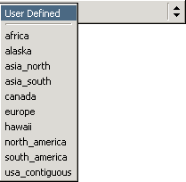
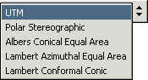
The map projections that are supported by the tool are listed on the right.

For the UTM projection (default) only requires the zone number to define the other map projection parameters. If the user does not specify a zone, the program automatically determines the zone from the center longitude of the respective image. The user can define a different zone, as long as the zone is valid for some part of the image.

For all other map projections the user can choose from a list of geographical regions for which the required map projection parameters are predefined. For the Polar Stereographic projection the choices are limited to the northern or southern hemisphere. The remaining map projection offers definitions for a larger number of areas as indicated on the left. The user can define a map projection by manually entering the required projection parameters. In order to permanently add a user defined map projection, a projection file following the given naming scheme needs to be added to the projections subdirectory of the respective map projection.

The use of map projection parameters outside their regular value range is limited to avoid extreme distortions in the output image. The following tests are performed to detect whether parameters are outside their regular range:
- latitudes need to be larger than -90 degrees and smaller than 90 degrees;
- longitudes need to be larger than -180 degrees and smaller than 180 degrees;
- UTM zones are only defined between 1 and 60;
- UTM zone needs to be covered in some part of the image;
- Polar Stereographic coordinates are only well defined in polar regions, hence limited to areas higher than 60 degrees latitude and lower than -60 degrees latitude;
- latitudes need to within 30 degrees of the latitude range defined by first and second parallel for Albers Equal Area Conic and Lambert Conformal Conic projection.
Even though these restrictions are highly recommended, they can be overwritten by selecting the "Ignore projection errors" option.

An average height can be specified for the geocoding. All pixels at this particular height will have no geometric distortions in the resulting geocoded image. This assumes that no terrain correction is applied to the data --- if terrain correction has been applied, the average height value is ignored. Another option is the definition of a pixel size for the geocoded output image.

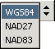
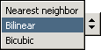
The three datums shown on the left can be selected as reference frame. The most commonly used one is WGS84 which is the default.

As part of the transformation from the SAR geometry into the map projected space, pixels need to be resampled using an interpolation approach. The list on the right offers three different methods. The nearest neighbor approach is the fastest of these techniques but also regularly introduces unwanted artifacts. The bilinear interpolation scheme considers four neighboring pixel values and normally leads to satisfactory results. In the trade off between accuracy and computational effort, the bilinear interpolation scores very high and, therefore, has been selected as the default method. The bicubic interpolation is even more accurate but is also computationally far more intense.

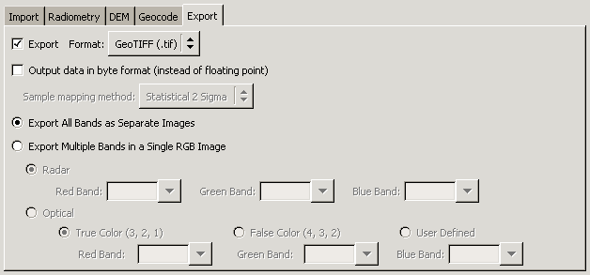
In order to use the data in external software packages, the user might want to convert the images in a more common format. This processing is optional, however selected by default.

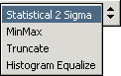
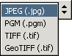
The available output formats are listed on the left. The first three formats (JPEG, PPM and TIFF) are common graphic formats. They are generally used for visualizing the data. Because the JPEG format has the best compression capabilities of these formats, it was chosen as default. All the above mentioned formats require the scaling of the data from floating point to byte values. The GeoTIFF is the most flexible choice. It allows to user to preserve the full dynamic range by keeping the floating point values. Optionally, if no quantitative analysis is required later, the values can be safely converted to byte values. In addition, the GeoTIFF format is able to store projection related information that is essential for any further meaningful analysis.

For the scaling of floating point to byte values, a number of sampling methods are available. They are listed on the right. The default method uses a statistical approach that eliminates any outliers that are outside of two standard deviations around the mean. This approach produces satisfactory results in most cases. Alternatively, the original dynamic range of the image with its minimum and maximum value can be mapped into the byte value range of 0 to 255. In cases of masks, the values can most often simply be truncated without any loss of information. Histogram equalization is a standard method for image processing and can be applied as a fourth option.

Files section
While the tabs section defines the steps, parameters and options of the processing flow, the files section control the data that serve as input to the processing flow. It consists of a number of components describe here in more detail.

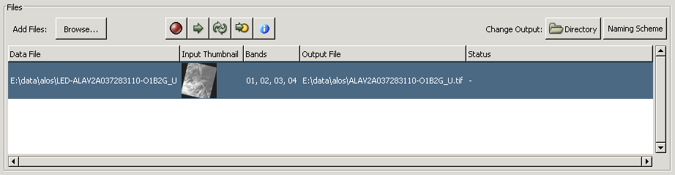

The file browsing menu with its standard functionality handles the selection of individual or groups of files to be processed. Once selected, the files are individually listed and thumbnails are generated for each input image.

A number of buttons help to get the data sets organized for the processing.

The "Remove" button deletes a file from the processing list. This becomes necessary, for example, when the input thumbnails, even though they are small, reveal that the selected image does not contain a certain feature or the area of interest. All selected files are removed.

The "Process" button starts the processing of the selected data set rather than processing the entire list of files (see "Execute" button for details). This feature is particularly useful when a few data sets out of a long list did not successfully process with the current sets of options and parameters. After selecting the appropriate values the data sets can be individually re-run using this feature.

The "Rename" button lets the user individually rename the output images of a run. This feature is mostly used when the same input data set is run with different options and parameters without overwriting any of the previous results. For renaming a large number of files see the details on naming schemes.

The "View log" button allows the user to display the log file once a data set has been processed. The log file contains the feedback from the individual functions called as part of the processing flow. The log file is the single most useful piece of information for troubleshooting problems as it contains the error messages that the tool issues in case the processing needs to be aborted.

The "Display CEOS metadata" button launches the ASF metadata viewer. The viewer reads the CEOS leader file, a partially binary and partially ASCII file that contains the metadata associated with the binary data.

The leader file is defined by a number of so called records. The data set summary record provides general information about the image such as orbit and frame number, acquisition date, image size and sensor characteristics. The platform position data record contains orbital information in form of state vectors that describe the position of the satellite at a given time.

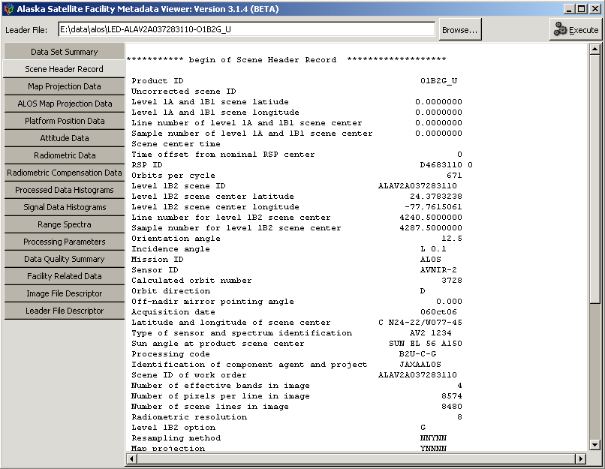

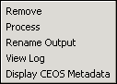
The functionality of the file section menu buttons is also available as a right mouse click menu (as shown on the right). The menu can only be invoked when a file is selected from the file list.
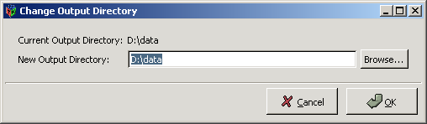
The "Change output directory" button opens a selection menu that lets the user browse for the appropriate output directory where all the results of the current processing run are stored. This option applies to all files in the list. If only individual files in a different output directory are supposed to be stored in a specific directory, then those files need to be renamed using the "Rename" button or via the right mouse click menu as described above.

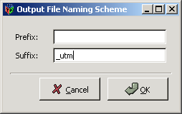
The "Naming scheme" button opens a menu for defining a naming scheme for the output images. These schemes are particularly useful if the user wants to run the same batch of data sets with different processing options for a comparative analysis. To all the files selected in the section a prefix and/or suffix can be added, e.g. to indicate that all files have been geocoded into the UTM projection.

A thumbnail is created for the input image. In case of multi-band imagery, the thumbnail is generated for the first band. For multi-band images all available bands are displayed in the bands field. This simplifies the selection of an appropriate band combination in case the output images are supposed to be exported as an RGB composite. The user can monitor the progress of processing the individual data sets. The status that is updated indicating what processing step is currently performed. In case the error occurs during the processing, a short error message is displayed in the status field.

Once the image is successfully processed it moves into the completed files section.

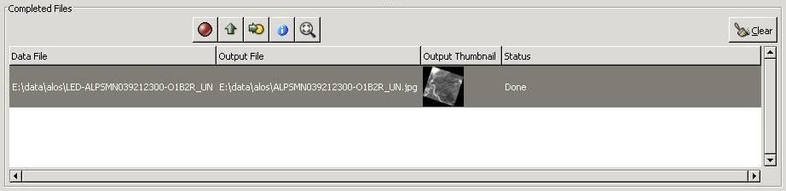

A number of buttons help to analyze the results

The "Remove" button deletes a file from the processing list. This becomes necessary, for example, when the input thumbnails, even though they are small, reveal that the selected image does not contain a certain feature or the area of interest. All selected files are removed.

The "Prepare to Re-Process" button moves the image back into the processing queue. This feature is useful when image had apparently not been processed with the intended processing parameters.

The "View log" button allows the user to display the log file once a data set has been processed. The log file contains the feedback from the individual functions called as part of the processing flow. The log file is the single most useful piece of information for troubleshooting problems as it contains the error messages that the tool issues in case the processing needs to be aborted.

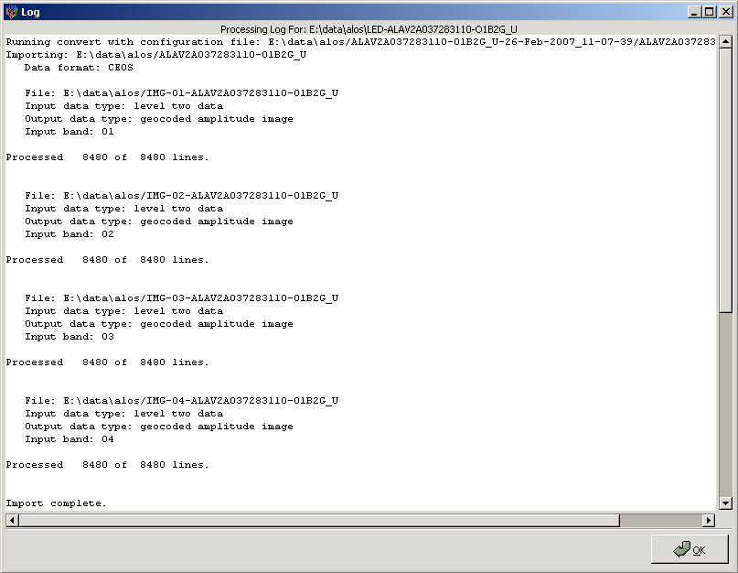
The "Display ASF metadata" button opens a text window with the internal ASF metadata. The metadata contains a number of structures that provide the essential information to identify, describe and process the data. It is a very small subset of parameters that are extracted out of the CEOS metadata.

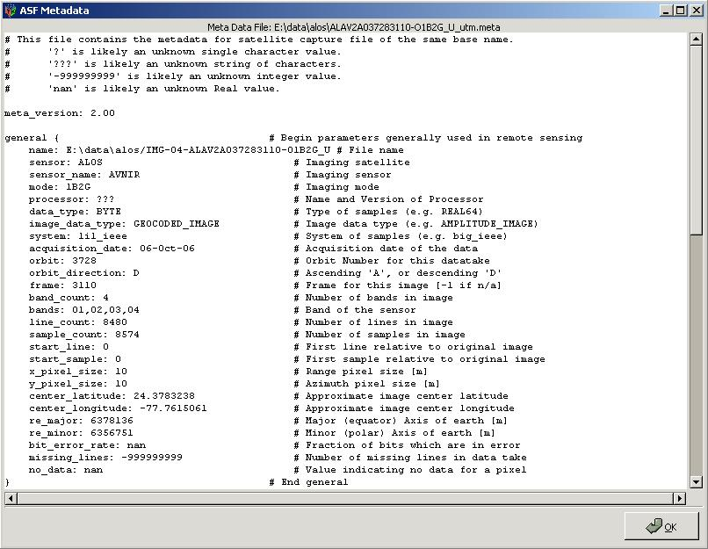
The "View output" button opens the output viewer that allows the user to inspect the output images. It this point it has very limited functionality. Predefined zoom level and scroll bars only allow a cursory inspection of the imagery to visually identify processing problems. This feature of the GUI was never meant to have the full functionality of an image analysis tool.

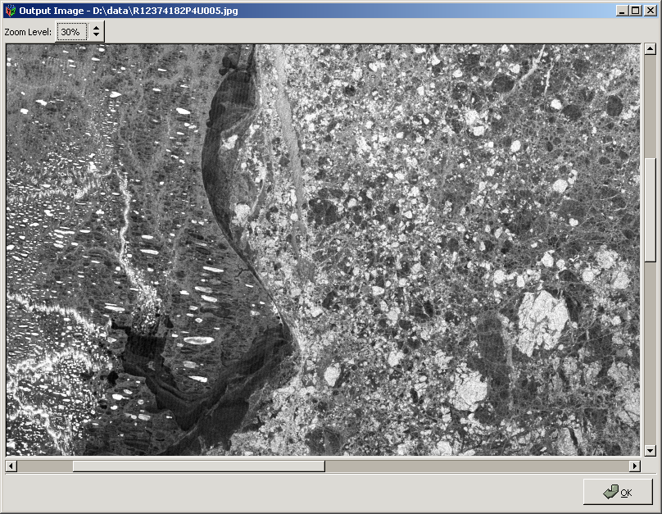

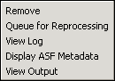
The functionality of the completed files section menu buttons is also available as a right mouse click menu (as shown on the right). The menu can only be invoked when a file is selected from the file list.

The "Clear" button deletes the images from the completed files section.

A thumbnail for the each output image is generated once it is moved into the completed files section. The information about input and output names remains available.

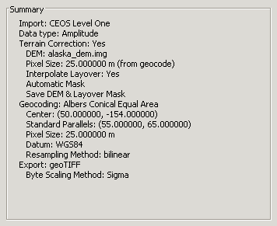
Summary section
The user can find all file names and parameters that are used by the conversion tool in one compact list.

The list is divided into separate entries for each of the tabs. The summary allows the user to verify which of the processing steps are selected and what input values are used for the individual processing steps. It is updated each time make a change in the tab section of the GUI.

Footer menu buttons
The footer consists of five menu buttons that allow the user to manage the processing of all the files loaded in the files section.

The "Execute" button starts the processing of all the files listed in the files section. The files are processed are processed with the output directories and naming schemes defined for the individual data sets. The list of data sets is processed in the order that they were loaded into the files section.

During processing, the terminal window that opens along with Convert will contain the messages generated during the processing. These messages can also be viewed with the “View Log” option, after the file has finished processing.

If an image is successfully processed, it is moved to the “Completed Files” section. If one or more errors occurred during the processing, then it remains in the upper “Files” section, and the Status is set to “Error”, along with a small portion of the actual error message. To get the full error information, use the “View Log” option.

Warning messages generated during processing are also kept in the log – if your image result isn’t satisfactory, check the log to see if any warning messages were generated that might explain why the image didn’t produce the result you were expecting.

The "Stop" button interrupts the processing of the list of data sets. The image that is currently being processed will stop with a “Processing Stopped By User” error. It may take a moment for the processing to stop.

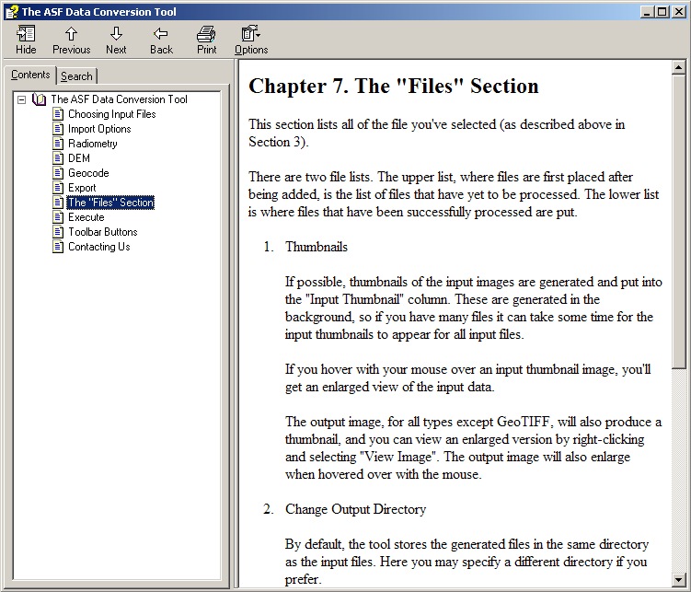
The "Help" button opens the help menu shown on the right. The help menu contains a contents section with information on

- how to obtain and install the tool
- how to get started following some example conversions
- options and settings used for the processing of data sets.

In addition, the help menu also has a function that provides the user with the capability to search for keywords.

Tool tips
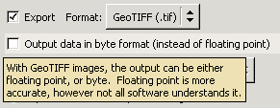
All parts of the GUI, i.e. buttons, check boxes etc, have tool tips attached to them. They provide a brief explanation about the functionality and the options available to the user.

Using the command-line tool, asf_convert

Generating a configuration file
If no configuration file is available that can be modified for processing a data set, the configuration file can be created from scratch using

asf_convert -create <name of configuration file>.

This generates a configuration file with the following content.

asf_convert configuration file

[General]

# This parameter looks for the basename of the input file

input file =

# This parameter looks for the basename of the output file

output file =

# The import flag indicates whether the data needs to be run through
# 'asf_import' (1 for running it, 0 for leaving out the import step).
# For example, setting the import switch to zero assumes that all the data
# is already in the ASF internal format.
# Running asf_convert with the -create option and the import flag
# switched on will generate an [Import] section where you can define further
# parameters.

import = 1

# The terrain correction flag indicates whether the data needs to be run
# through 'asf_terrcorr' (1 for running it, 0 for leaving out the terrain
# correction step).
# Running asf_convert with the -create option and the terrain correction
# flag switched on will generate an [Terrain correction] section where you
# can define further parameters.

terrain correction = 0

# The geocoding flag indicates whether the data needs to be run through
# 'asf_geocode' (1 for running it, 0 for leaving out the geocoding step).
# Running asf_convert with the -create option and the geocoding flag
# switched on will generate a [Geocoding] section where you can define further
# parameters.

geocoding = 1

# The export flag indicates whether the data needs to be run through
# 'asf_export' (1 for running it, 0 for leaving out the export step).
# Running asf_convert with the -create option and the export flag
# switched on will generate an [Export] section where you can define further
# parameters.

export = 1

# The default values file is used to define the user's preferred parameter
# settings. In most cases, you will work on a study where your area of interest is
# geographically well defined. You want the data for the entire project in the same
# projection, with the same pixel spacing and the same output format.
# A sample of a default values file can be located in
# /export/asf_tools/share/asf_tools/asf_convert.

default values =

# The intermediates flag indicates whether the intermediate processing
# `results are kept (1 for keeping them, 0 for deleting them at the end of the
# processing).

intermediates = 0

# The quiet flag determines how much information is reported by the
# individual tools (1 for keeping reporting to a minimum, 0 for maximum reporting

quiet = 1

# The short configuration file flag allows the experienced user to generate
# configuration files without the verbose comments that explain all entries for
# the parameters in the configuration file (1 for a configuration without comments,
# 0 for a configuration file with verbose comments)

short configuration file = 0

# This parameter looks for the location of the batch file
# asf_convert can be used in a batch mode to run a large number of data
# sets through the processing flow with the same processing parameters.

batch file =

# A prefix can be added to the outfile name to avoid overwriting
# files (e.g. when running the same data sets through the processing flow
# with different map projection parameters

prefix =

# A suffix can be added to the outfile name to avoid overwriting
# files (e.g when running the same data sets through the processing flow
# with different map projection parameters

suffix =

This basic configuration file contains all general parameters with a detailed explanation about the respective parameter for the novice user. More experienced users can switch the explanatory part off by setting the short configuration file parameter to 1.

It is obvious that the input and output files need to be known. The next four parameters are basically switches indicating whether this processing step is supposed to be performed or not. For example, setting the import switch to zero assumes that all the data is already in the ASF internal format. The final results are kept in ASF internal format if the export switch is set to zero. The default values file is described in more detail in the next section. Intermediate files are usually deleted but the user can set the flag to keep them. The batch file only needs to be defined if you want to run the asf_convert tool in batch mode. This procedure is explained in a later section.

Filled in with the basic minimum the configuration file would look like this.

asf_convert configuration file

[General]
input file = /data/R153253303G3S007
output file = /data/R153253303G3S007
import = 1
terrain correction = 1
geocoding = 1
export = 1

The configuration file can be extended to include the necessary parameters by using

asf_convert -create <name of configuration file>

again.

A fully initialized configuration file has the following parameters.

asf_convert configuration file

[General]
input file = /data/R153253303G3S007
output file = /data/R153253303G3S007
import = 1
terrain correction = 1
geocoding = 1
export = 1
default values =
intermediates = 0
short configuration file = 1
tmp dir =

[Import]
format = CEOS
radiometry = AMPLITUDE_IMAGE
look up table =
lat begin = -99.00
lat end = -99.00
precise =
output db = 0

[Terrain correction]
pixel spacing = -99.00
digital elevation model = /data/delta_dem.img
mask =
auto mask water = 0
water height cutoff = 1.000000
fill value = 0
refine geolocation only = 0
interpolate = 1
save terrcorr dem = 0
save terrcorr layover mask = 0

[Geocoding]
projection = /export/asf_tools/share/asf_tools/projections/utm/utm.proj
pixel spacing = -99.00
height = 0.0
datum = WGS84
resampling = BILINEAR
background = 0.00
force = 0

[Export]
format = GEOTIFF
byte conversion = SIGMA

In this case all four processing step of importing, terrain correction, geocoding and exporting the data set are performed.

The values for each option are given here in all-capital letters, however the processing is not case sensitive, you may use lower-case values for options if you prefer.

The Convert GUI generates configuration files in order to process each image. If you have turned on the “Keep Intermediate Files” option, the directory where the intermediate files are stored will contain a configuration file based on the settings chosen by the GUI. You may find it convenient to use this file as a template to build your own configuration files.

Import
As import formats ASF, CEOS and STF are recognized. Defining ASF, being the internal format, as the import format is just another way of actually skipping the import step. The only CEOS format that currently makes sense to include in the processing flow is the CEOS level one data. The conversion of single look complex data to amplitude data as well as the processing of any level zero data, CEOS and STF alike, has not been implemented yet. Without SAR processing being part of the processing flow any of the other steps are obsolete at this point.

The radiometry can be one of the following:
- AMPLITUDE_IMAGE
- POWER_IMAGE
- SIGMA_IMAGE
- GAMMA_IMAGE
- BETA_IMAGE
The amplitude image is the regularly processed SAR image. The power image represents the magnitude (square of the amplitude) of the SAR image. The sigma, gamma and beta image are different representations of calibrated SAR images. Their values are in power scale. Alternatively, the values can be stored in dB setting the output db flag. If you plan on terrain correcting, using dB for sigma, gamma and beta is highly recommended, otherwise the co-registration may fail.

The look up table option is primarily used by the Canadian Ice Service (CIS) and scales the amplitude values in range direction. The file parsed in to the import tool is expected to have two columns, the first one indicating the look angle with the corresponding scale factor as the second column. Here is an example of part of the ice look up table that the CIS is using.

...
22.0316 2.063874702
22.2442 2.087184476
22.4568 2.110376734
22.6694 2.133451475
22.882 2.156408699
23.0946 2.179248406
23.3072 2.201970597
23.5198 2.22457527
23.7324 2.247062427
23.945 2.269432068
24.1576 2.291684191
24.3702 2.313818798
24.5828 2.335835887
24.7954 2.35773546
25.008 2.379517517
...

The latitude constraints (lat begin and lat end) can only be used when importing level zero swath data (STF). This is the most convenient way to cut a subset out of a long image swath. Be sure that the lat begin and lat end values both lie within the swath.

The precise option, currently under development, will allow the use of ERS precision state vector from DLR as a replacement of the restituted state vectors that are provided from the European Space Agency. The parameter required here defines the location of the precision state vectors.

Terrain correction
For the terrain correction portion of the processing a digital elevation model is required. If the SAR image and the reference DEM have different pixel spacings, the resolution of terrain corrected SAR image needs to be adjusted. This can be left to the asf_convert tool to handle by setting the pixel spacing to -99. Alternatively, a user defined value can be set.

The digital elevation model parameter defines the location of the reference DEM.

In some cases, parts of the images are known to be moving (e.g. water, glaciers etc.). This can cause severe problems in matching the SAR image with the simulated SAR image derived from the reference. Providing a mask defines the areas that are stable and can be used for the matching process.

Instead of creating a mask, you can have terrain correction automatically generate a mask for you (by setting the auto mask water flag), based on the DEM, which attempts to mask the regions of your scene that are water (these regions provide a poor match). Specifically, all DEM values <1m are masked, unless a different water height cutoff is specified.

When applying a mask during terrain correction, you can choose how the regions covered by the mask are filled in the final terrain corrected result. You can either specify a (non-negative) value. If you would like the SAR data to be kept then use -1 as the fill value.

Applying the terrain correction in homogeneously flat areas does not lead to feasible results at times. In these cases, the reference DEM might still be used to improve the geolocation of the SAR image without performing the actual terrain correction. This can be achieved by setting the refine geolocation only flag. With this option, the image data is not changed at all – only the metadata is affected.

Layover and shadow regions are problem areas in the SAR geometry, since the backscatter information is either heavily condensed or even missing. In the terrain correction process they can either be left black (resulting in better image statistics in the remainder of the image) or they may be interpolated over (resulting in a nicer-looking image). Setting the interpolate parameter to 1 indicates that these regions should be interpolated over.

For a more detailed analysis of the terrain correction results a couple of files used in the process can be saved. Setting the save terrcorr dem parameter keeps the clipped reference DEM in slant range geometry. Setting the save terrcorr layover mask parameter keeps the layover and shadow mask.

Geocoding
The geocoding tool currently supports five different map projections: Universal Transverse Mercator (UTM), Polar Stereographic, Albers Equal Area Conic, Lambert Conformal Conic and Lambert Azimuthal Equal Area. For all these map projections a large number of projection parameter files have been predefined for various parts of the world. The projection parameter in the geocoding block indicates the file name of the predefined projection parameter file. Users can define their projection parameter file using the text editor of their choice. On Unix systems the projection parameter files are located in the asf_tools/share/asf_tools/projections/<projection> directories, while on Windows systems they are located in the projections/<projection> directories in the ASF Tools installation folder, by default this is c:\Program Files\ASF_Tools. The projection parameter file for the UTM projection is a special case. It contains an empty zone parameter, in which case asf_geocode determines the zone from the center longitude of the image. It allows the use of any other zone for the geocoding as long as that zone is covered in the imagery. For these cases the user can define the zone parameter in the generic UTM projection file.

The pixel spacing determines the pixel size used for the resulting geocoded image and, therefore, the size of the output image.

An average height can be defined for the image that is taken into account and adjusted for during the geocoding process.

Furthermore, a vertical datum can be defined for geocoded image. WGS84 is the only currently supported datum. However, NAD27 and NAD83 are planned to be appropriate alternatives.

Three different resampling methods have been implemented as part of the geocoding: NEAREST NEIGHBOR, BILINEAR and BICUBIC. The bilinear resampling method is the default.

After geocoding, a fill value is required for the regions outside the geocoded image. By default this value is 0, but may be set to a different value here.

In order to ensure the proper use of projection parameter files, we have implemented a number of checks that verify whether the map projection parameters are reasonable for the area that is covered by the data. For example, applying a projection parameter file that is defined for South America for a data set that is covering Alaska would lead to huge distortions. These checks can be overridden by setting the force option.

Export
The following format values are considered valid:
- TIFF
- GEOTIFF
- JPEG
- PGM
In the same way as for the import block, ASF as an export option results in skipping the export step entirely. All other formats, with the exception of GeoTIFF, require the scaling of the internal ASF format from floating point to byte. The GeoTIFF supports byte as well as floating point data.

The byte conversion options are SIGMA, MINMAX, TRUNCATE or HISTOGRAM_EQUALIZE. They scale the floating point values to byte values in various ways:
- SIGMA – Determines the mean and standard deviation of an image and applies a buffer of two sigma (i.e., standard deviations) around the mean value, and then maps this buffer to the byte range 0 to 255. This buffer is adjusted if the two sigma buffer is outside the value range.
- MINMAX – Determines the minimum and maximum values of the input image and linearly maps those values to the byte range of 0 to 255.
- TRUNCATE – Values less than 0 are mapped to 0, values greater than 255 are mapped to 255, and values in between are truncated.
- HISTOGRAM_EQUALIZE – Produces an image with equally distributed brightness levels over the entire brightness scale which increases contrast.

Default values file
The default values file is used to define the user's preferred parameter settings. In most cases, you will work on a study where your area of interest is geographically well defined. You want the data for the entire project in the same projection, with the same pixel spacing and the same output format. The default values file is essential part of the batch processing, described in the next section.

Here is an example of a default values file that the Canadian Ice Service (CIS) is using for their automated processing system.

import = 1
sar processing = 0
terrain correction = 0
geocoding =1
export = 1
intermediates = 0
quiet = 0
short configuration file = 0
input format = CEOS
radiometry = AMPLITUDE_IMAGE
look up table = /export/cis/cis_ice.lut
projection = /export/asf_tools/share/projections/lambert_conformal_conic/
lambert_conformal_conic_cis.proj
pixel spacing = 100
height = 0.0
datum = WGS84
resampling = BILINEAR
force = 1
output format = GEOTIFF
byte conversion = SIGMA

Running asf_convert in batch mode
asf_convert can be used in a batch mode to run a large number of data sets through the processing flow with the same processing parameters. This requires a much shorter configuration file that for the regular processing. Most of the configuration options will be specified in a “default values” file.

asf_convert configuration file

[General]
default values = cis.defaults
batch file = cis.batch
prefix = test
suffix = lcc

In this case there are only two parameters that need to be defined, the default values file (as described in the previous section) and the batch file. Optionally, a prefix as well as a suffix can be defined for the output names. With these naming schemes the user can prevent the tool from overwriting results, e.g. when running the same data sets through the processing flow with different map projection parameters. The batch file contains the basenames of all the data sets to be processed, so the file would look like this:

R153253303G3S007
R153253303G4S013
...

Running the individual tools on the command line

The command line tools have a few additional options that are worth pointing out.

asf_import, asf_geocode and asf_export have a -band option that allows the user to apply their respective functionality to a single band if the passed band identifier can be found in the multi-band image.

Command line:
asf_import -band 4 ALAV2A037283110-O1B2G_U bahamas

Importing: ALAV2A037283110-O1B2G_U
Data format: CEOS

File: IMG-04-ALAV2A037283110-O1B2G_U
Input data type: level two data
Output data type: geocoded amplitude image
Input band: 04

Processed 8480 of 8480 lines.

Import complete.

In this example, we are just interested in band 4 of an ALOS AVNIR image and only import this particular band.

For the water masking as part of the terrain correction asf_convert assumes all height values in the digital elevation model below 1 m to be water. In some circumstances, this value is not ideal. asf_terrcorr allows for a more flexible handling of this value by passing a different height value using the -mask-height-cutoff option.

Related to the masking of values during the terrain correction is another option within asf_export. The -lut option applies a look up table to the image while exporting. Some look up table files are in the look_up_tables subdirectory in the asf_tools share directory. For the terrain correction mask there is a layover_mask.lut defined that color codes the terrain correction mask for further analysis.
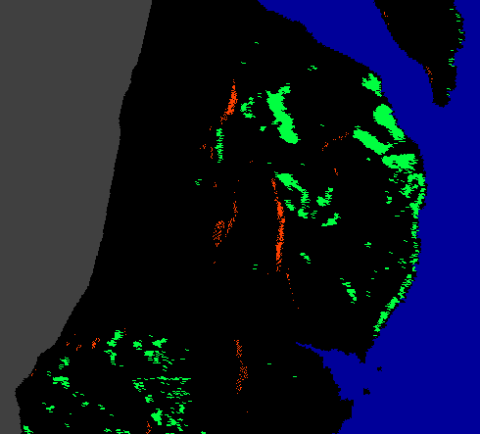
Layover mask of a terrain corrected image

User masked values, in this case water, are coded in blue. Layover regions are depicted in green, regions of shadow are red. Invalid data, which include areas of no data during the terrain correction as well as background fill resulting from geocoding the mask, are displayed in dark grey. All other valid data is indicated in black.

Examples
In this section some of the most common uses of the asf_convert tool are demonstrated.

Converting optical ALOS AVNIR data into GeoTIFF format
The AVNIR instrument on the ALOS satellite is a four-band (visible-and near-infrared) radiometer with a resolution of 10 m, designed for observing land and coastal zones. This multi-band imagery is provided in CEOS format with four individual files for the respective bands and a common leader file.

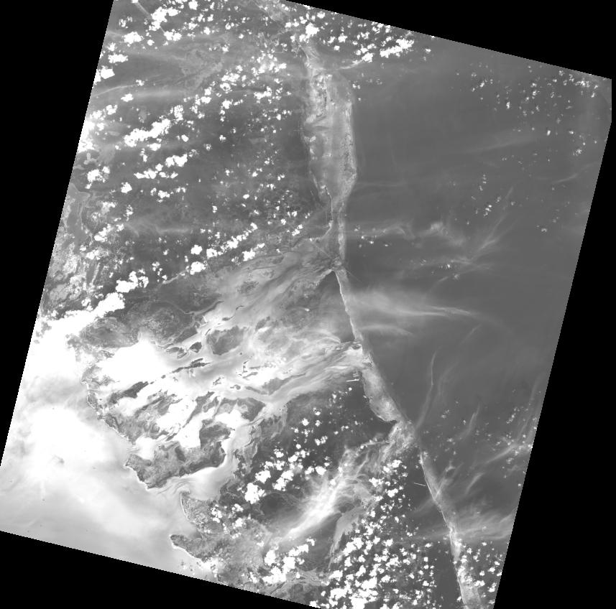  Band 1 | 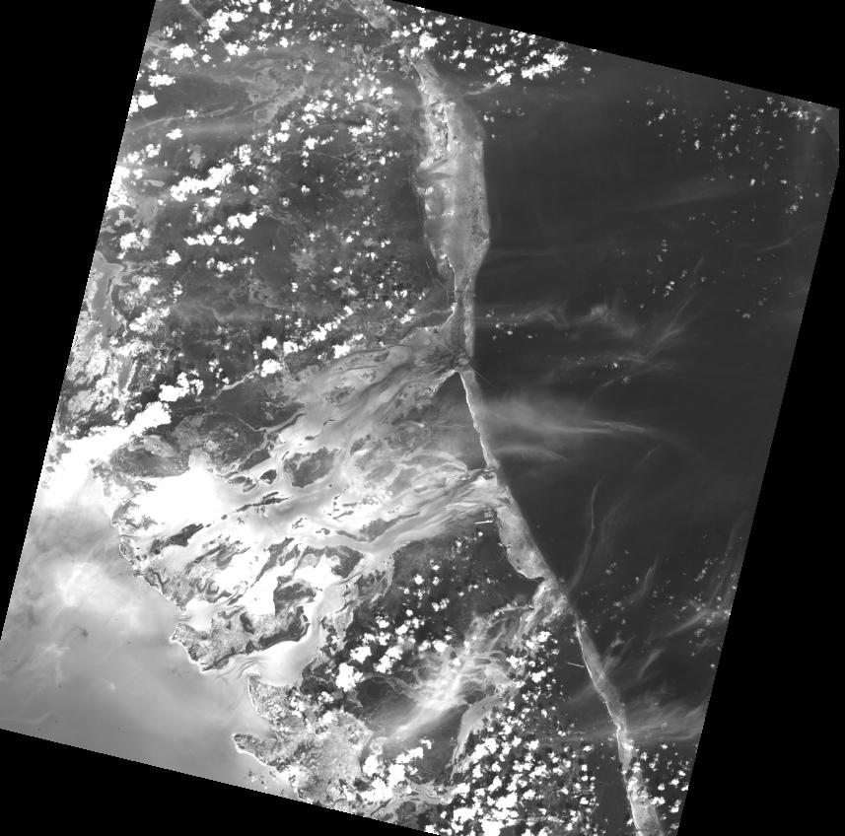  Band 2
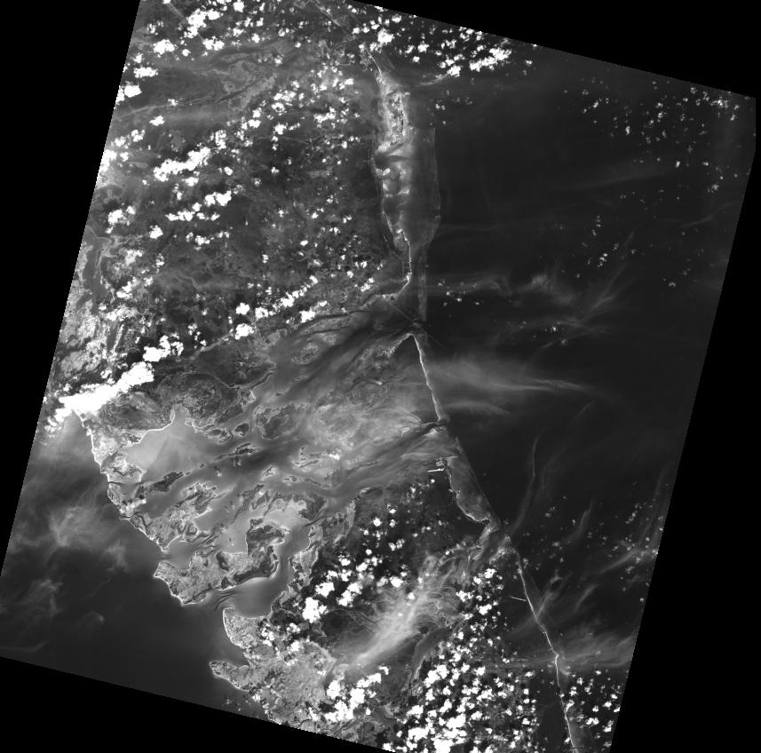  Band 3 | 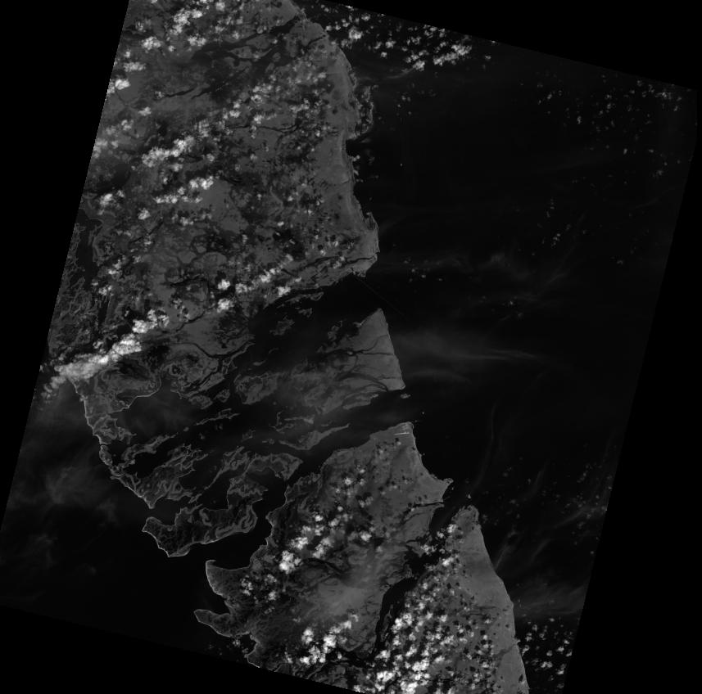  Band 4
By importing the individual image files the bands in the ASF internal format in a band sequential form in a single file. In this example, the image in the Bahamas was ordered in the 1B2G format, i.e. geocoded in this case to UTM.

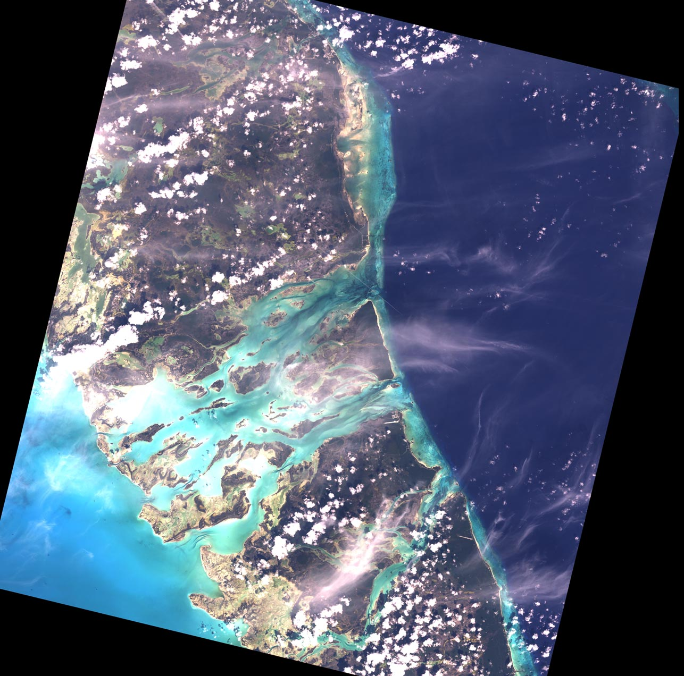True color RGB composite

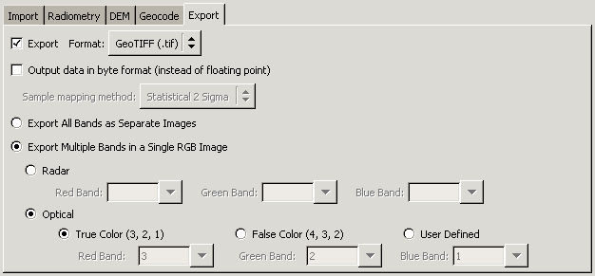
When exporting the data the data to GeoTIFF there are two standard options to consider. The true color option will combine the three visible bands 3,2 and 1 into a true color RGB composite.

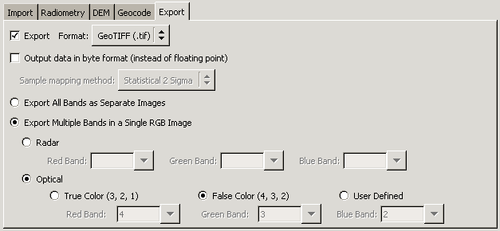
Alternatively, the data can be stored as a standard false color composite with the bands 4,3 and 2. The near-infrared band 4 will characteristically highlight the imaged vegetation in red.
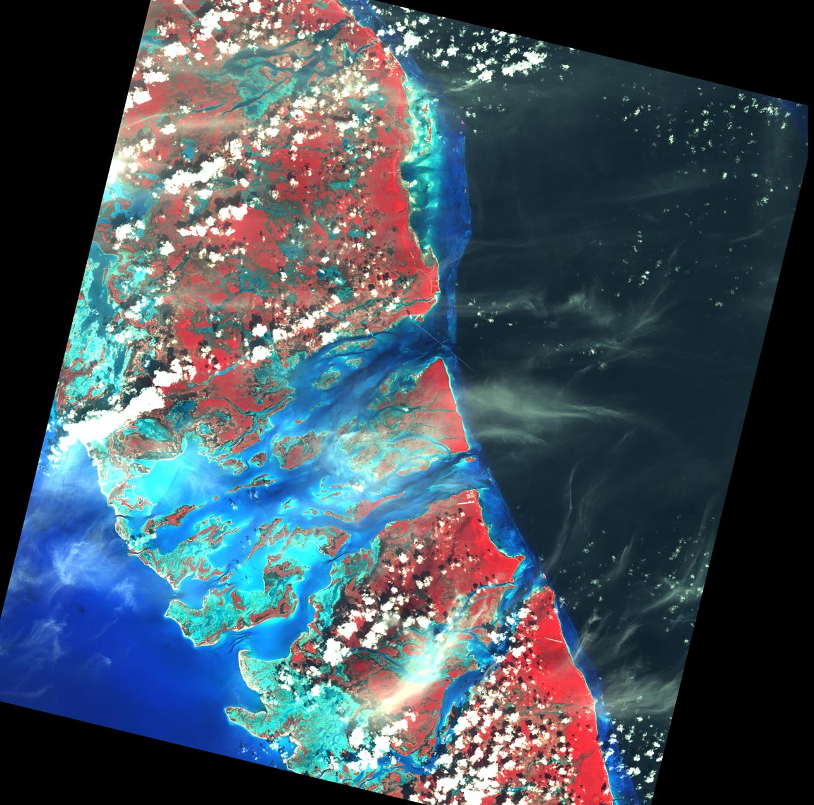Standard False Color Composite (FCC)

Finally, the user can define other band combinations that are suitable for other types of investigations.

Converting optical ALOS PRISM data into GeoTIFF format
The PRISM instrument on ALOS satellite provides high-resolution (2.5 m) panchromatic imagery and used to provide land coverage and land-use classification maps for monitoring regional environments.

For this example, we have chosen georeferenced 1B2R imagery over Delta Junction. Georeferenced images leave the user the choice of map projection for the geocoding. For most remote sensing studies in Alaska the preferred map projection is the Albers Conic Equal Area projection.

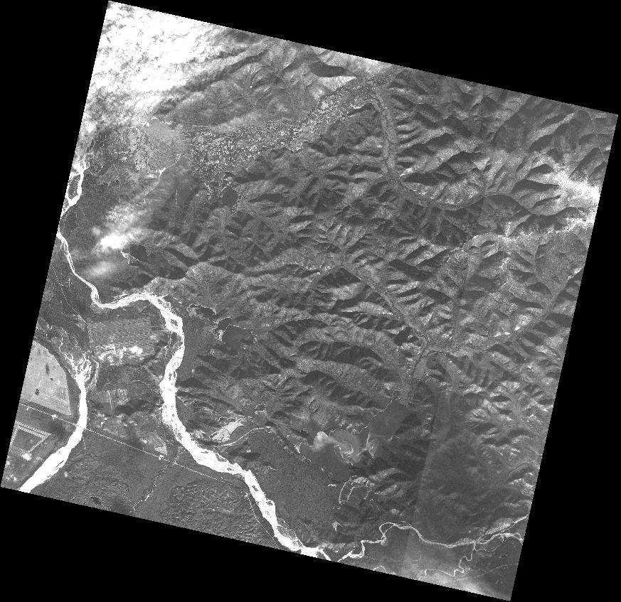
PRISM image geocoded to Albers Conic Equal Area projection
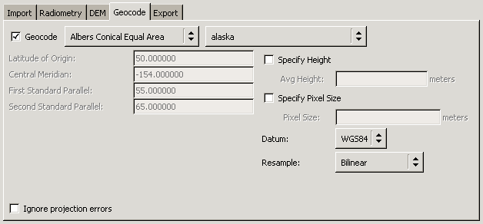
The geocoded image can now be used in any further analysis as the GeoTIFF format can be handled by the majority of image processing software packages.

Converting ALOS PALSAR data into GeoTIFF format

PALSAR is the L-band SAR instrument on board the ALOS satellite. It operates in a variety of modes with different polarizations (single-, dual- and quad-pol) and look angles. For this example, we demonstrate the conversion of a quad-pol image into GeoTIFF format.

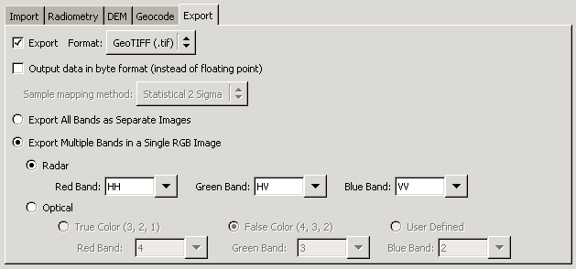
In this case, we chose both horizontal and vertical polarizations as well as one of the cross polarizations for the RGB composite.
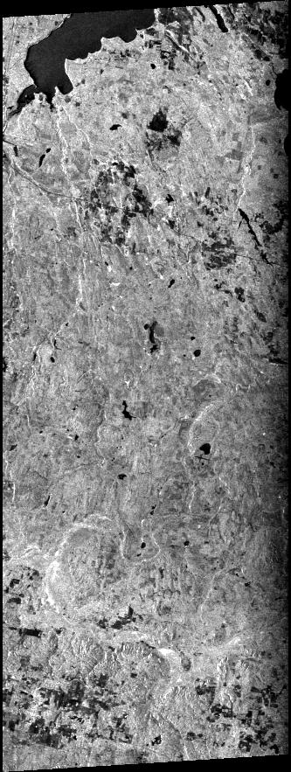  HH band | 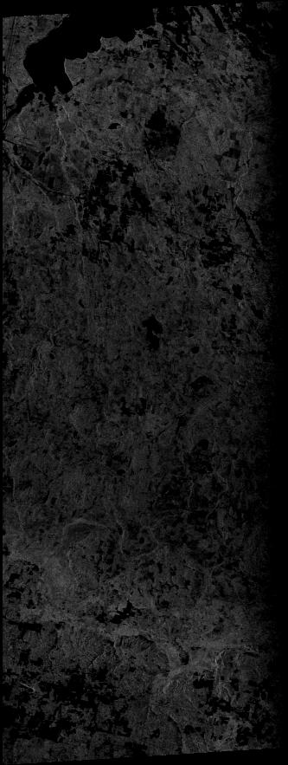  HV band | 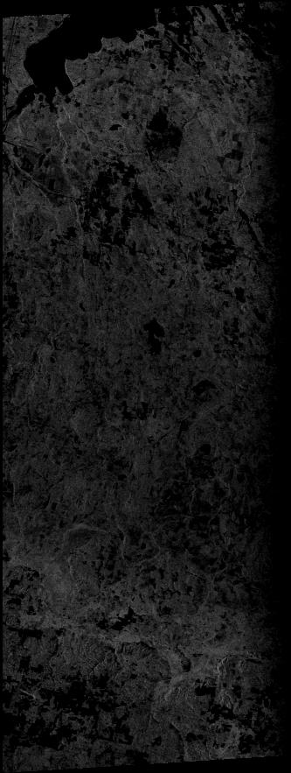  VH band | 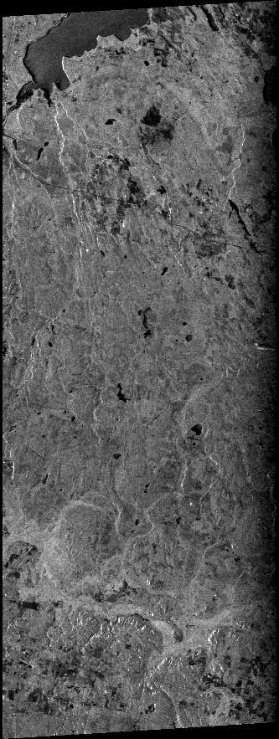  VV band

It is apparent that in this image the HH band provides much more contrast than the VV band. With this kind of difference in the opposite polarizations it is to be expected that the cross-polarized bands show up very dark. Compared to each other, both cross-polarized band look very similar.

Interpreting polarimetric data is not straight forward. There are a few standard decompositions, such as the Paul decomposition and the Sinclair decomposition, used to visualize polarimetric data. However, a more detailed analysis requires an in depth knowledge of the underlying physics and the properties on the ground.

In this example we used a band combination that is very close to a Sinclair decomposition, assuming that the cross-polarized bands HV and VH are close to the same. The water bodies in our example predominantly blue as the HH polarization provides the highest return. The fields in the upper part of the image show different signatures and give an indication why polarimetric data is superior for studying properties on the ground compared to single-polarized images. The combination of the two polarizations including their cross terms carries a wealth of information, especially when the phase information is added to this interpretation.
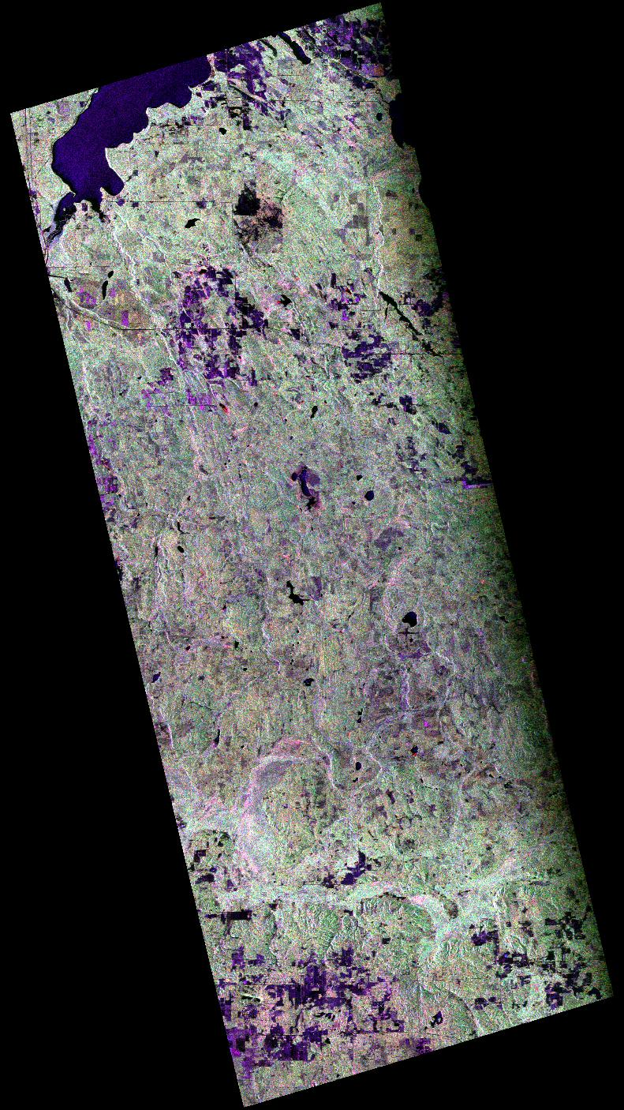
PALSAR RGB composite (HH, HV, VV)

Terrain correcting standard beam RADARSAT imagery
The terrain correction of radar data is a standard procedure before the image can be combined with any other data in a GIS environment.

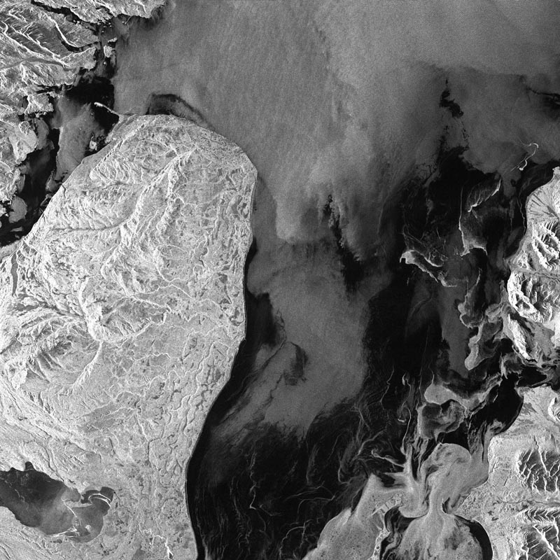
Radarsat Standard Beam image of Cook Inlet

This Radarsat image of the Cook Inlet, Alaska, contains some fairly steep topography that requires terrain correction. A considerable part of the image is covered with water that we want to mask out in the process.

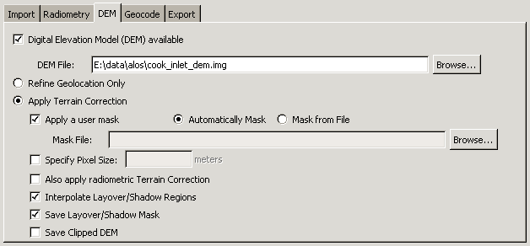
The automatic mask takes a cut out height of 1 m and masks out every pixel below this threshold. This function was designed for imagery near a coastline to mask out large water bodies that would otherwise make the terrain correction impossible.

Alternatively, the mask can be user specified.
After the terrain correction all the distortions that are introduced by the side-looking geometry of the sensor are removed.

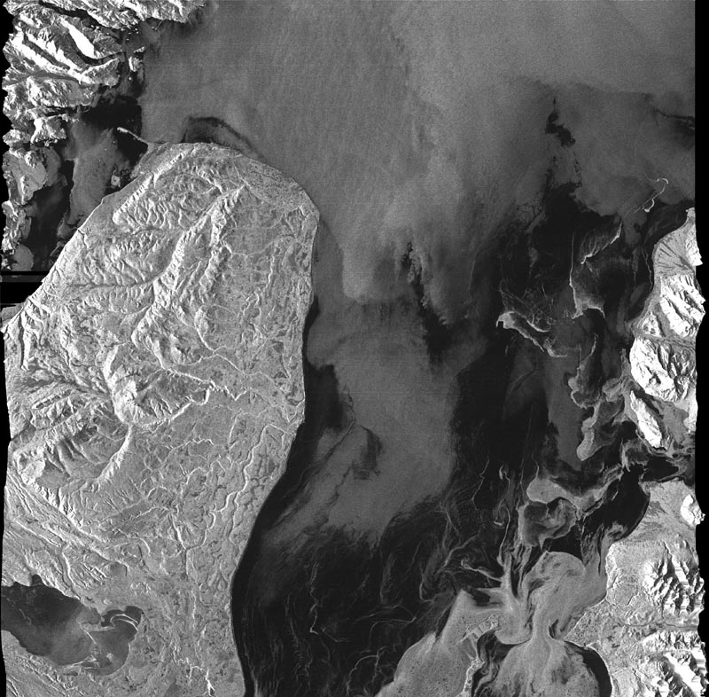
Terrain corrected standard beam image of Cook Inlet
In the next step the terrain corrected image can be geocoded as any other image.

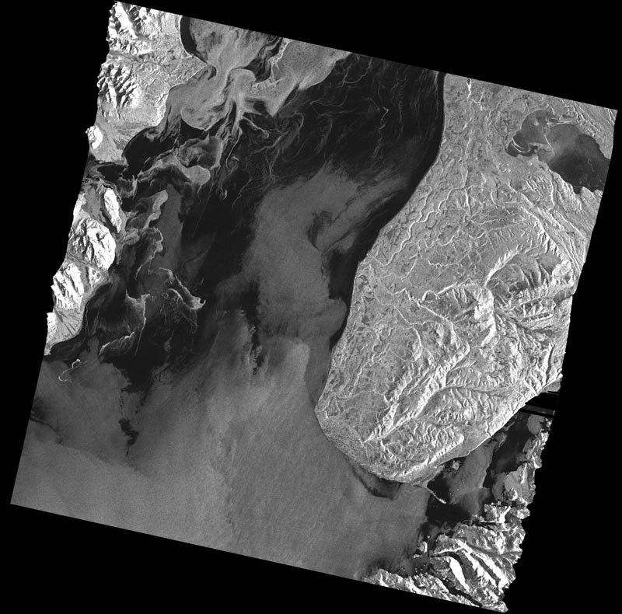
Terrain corrected and geocoded image of Cook Inlet

For further analysis the geocoded layover mask can be used. In this case, we have overlaid the mask on top of the terrain corrected image.

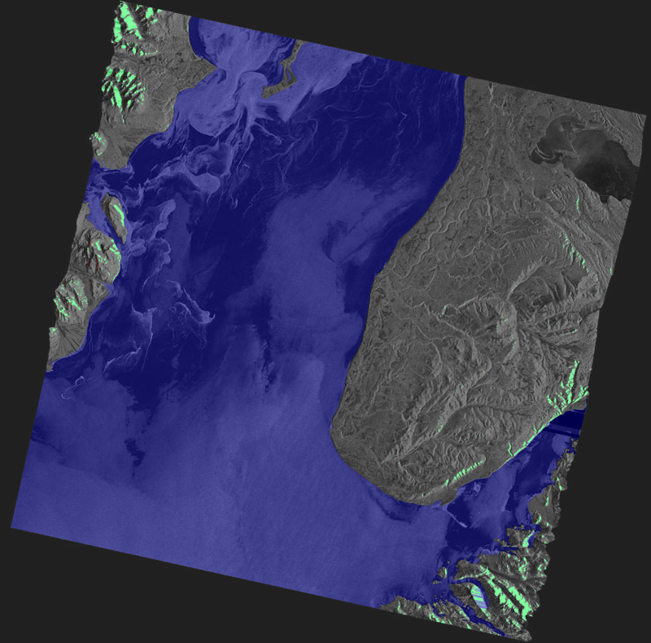
Layover mask overlaid on the terrain corrected image

Appendix
This is an example of a complete configuration with full descriptions of each individual parameter.

asf_convert configuration file

[General]

# This parameter looks for the basename of the input file

input file = e2_3919_290

# This parameter looks for the basename of the output file

output file = e2_3919_290_tc

# The import flag indicates whether the data needs to be run through
# 'asf_import' (1 for running it, 0 for leaving out the import step).
# For example, setting the import switch to zero assumes that all the data
# is already in the ASF internal format.
# Running asf_convert with the -create option and the import flag
# switched on will generate an [Import] section where you can define further
# parameters.

import = 1

# The terrain correction flag indicates whether the data needs be run
# through 'asf_terrcorr' (1 for running it, 0 for leaving out the terrain
# correction step).
# Running asf_convert with the -create option and the terrain correction
# flag switched on will generate an [Terrain correction] section where you
# can define further parameters.

terrain correction = 1

# The geocoding flag indicates whether the data needs to be run through
# 'asf_geocode' (1 for running it, 0 for leaving out the geocoding step).
# Running asf_convert with the -create option and the geocoding flag
# switched on will generate an [Geocoding] section where you can define further
# parameters.

geocoding = 1

# The export flag indicates whether the data needs to be run through
# 'asf_export' (1 for running it, 0 for leaving out the export step).
# Running asf_convert with the -create option and the export flag
# switched on will generate an [Export] section where you can define further
# parameters.

export = 1

# The default values file is used to define the user's preferred parameter
# settings. In most cases, you will work on a study where your area of interest is
# geographically well defined. You want the data for the entire project in the same
# projection, with the same pixel spacing and the same output format.

# A sample of a default values file can be located in
# /export/asf_tools/share/asf_tools/asf_convert.

default values = /data/asf_convert.defaults

# The intermediates flag indicates whether the intermediate processing
# results are kept (1 for keeping them, 0 for deleting them at the end of the
# processing).

intermediates = 0

# The short configuration file flag allows the experienced user to
# generate configuration files without the verbose comments that explain all
# entries for the parameters in the configuration file (1 for a configuration
# without comments, 0 for a configuration file with verbose comments)

short configuration file = 0

# The tmp dir is where temporary files used during processing will
# be kept until processing is completed. Then the entire directory and its
# contents will be deleted.

tmp dir =

[Import]

# The recognized import formats are: ASF, CEOS and STF.
# Defining ASF, being the internal format, as the import format is
# just another way of actually skipping the import step.

format = CEOS

# The radiometry can be one of the following: AMPLITUDE_IMAGE,
# POWER_IMAGE, SIGMA_IMAGE, GAMMA_IMAGE and BETA_IMAGE.
# The amplitude image is the regularly processed SAR image. The power image
# represents the magnitude (square of the amplitude) of the SAR image.
# The sigma, gamma and beta image are different representations of calibrated
# SAR images. Their values are in power scale.

radiometry = AMPLITUDE_IMAGE

# The look up table option is primarily used by the Canadian Ice
# Service (CIS) and scales the amplitude values in range direction. The file
# parsed in to the import tool is expected to have two columns, the first one
# indicating the look angle with the corresponding scale factor as the second
# column.

look up table =

# The latitude constraints (lat begin and lat end) can only be used
# when importing level zero swath data (STF). This is the most convenient way
# to cut a subset out of a long image swath.

lat begin = -99.00
lat end = -99.00

# The precise option, currently under development, will allow the use
# of ERS precision state vector from DLR as a replacement of the restituted
# state vectors that are provided from the European Space Agency. The parameter
# required here defines the location of the precision state vectors.

precise =

# When the output db flag is non-zero, the calibrated image
# is output in decibels. It only applies when the radiometry is sigma,
# gamma or beta.

output db = 0

[Terrain correction]

# This parameter defines the output size of the terrain corrected
# image. If set to -99 this parameter will be ignored and the 'asf_terrcorr' will
# deal with the issues that might occur when using different pixel spacings in
# the SAR image and the reference DEM

pixel spacing = -99.00

# The heights of the reference DEM are used to correct the SAR image
# for terrain effects. The quality and resolution of the reference DEM determines
# the quality of the resulting terrain corrected product

digital elevation model = /data/delta_dem.img

# In some case parts of the images are known to be moving (e.g. water,
# glaciers etc.). This can cause severe problems in matching the SAR image with
# the simulated SAR image derived from the reference. Providing a mask defines the
# areas that are stable and can be used for the matching process.

mask =

# Instead of creating a mask, you can have terrain correction
# automatically generate a mask for you, based on the DEM, which attempts to mask
# the regions of your scene that are water (these regions provide a poor match).
# Specifically, all DEM values <1m are masked, unless a different height cutoff
# is specified with the 'water height cutoff' option, described next.

auto mask water = 0

# When creating a mask automatically with the previous flag,
# you may specify use a value other than 1m as the height cutoff.
# This value is ignored when 'auto mask water' is 0.

water height cutoff = 1.000000

# When applying a mask during terrain correction, you can choose
# how the regions covered by the mask are filled in the final terrain corrected
# result. You can either specify a (non-negative) value of your choosing,or
# if you'd like the SAR data to be kept then use -1 as the fill value.

fill value = 0

# Even if you don't want to change the image via terrain correction,
# you may still wish to use the DEM to refine the geolocation of the SAR image.
# If this flag is set, terrain correction is NOT performed.

refine geolocation only = 0

# Layover/shadow regions can either be left black (resulting in better
# image statistics in the remainder of the image), or they may be interpolated over
# (resulting in a nicer-looking image). Setting this parameter to 1 indicates that
# these regions should be interpolated over.

interpolate = 1

# The DEM that is provided is clipped to match the scene. Normally this
# clipped DEM is removed along with the other temporary files, however if you are
# interested you can turn this option on (set it to 1), which will keep the clipped
# DEM, as well as geocode (if you've elected to geocode) and export it (if you've
# elected to export, though the DEM is always exported as floating point data even
# when you exporting your SAR data as bytes). The clipped DEM will be slightly
# larger than the SAR image, usually, since a larger region must be clipped to
# allow for the height variations.

save terrcorr dem = 0

# This option determines if a file marking the regions of layover and
# shadow should be created along with the output image. It is geocoded using the
# the same parameters as your SAR image, and exported as byte data.

save terrcorr layover mask = 1

[Geocoding]

# The geocoding tool currently supports five different map projections:
# Universal Transverse Mercator (UTM), Polar Stereographic, Albers Equal Area
# Conic, Lambert Conformal Conic and Lambert Azimuthal Equal Area.
# For all these map projections a large number of projection parameter files
# have been predefined for various parts of the world.
# The projection parameter files are located in
# /export/asf_tools/share/asf_tools/projections.

projection = /export/asf_tools/share/asf_tools/projections/utm/utm.proj

# The pixel spacing determines the pixel size used for the resulting
# geocoded image and, therefore, the size of the output image.

pixel spacing = -99.00

# An average height can be defined for the image that is taken into
# account and adjusted for during the geocoding process.

height = 0.0

# A vertical datum can be defined for geocoded image. WGS84 is the
# only currently supported datum. However, NAD27 and NAD83 are planned to be
# appropriate alternatives.

datum = WGS84

# Three different resampling methods have been implemented as part
# of the geocoding: NEAREST NEIGHBOR, BILINEAR and BICUBIC. The bilinear
# resampling method is the default.

resampling = BILINEAR

# After geocoding, a fill value is required for the regions outside
# of the geocoded image. By default this value is 0, but may be set to a
# different value here.

background = 0.00

# In order to ensure the proper use of projection parameter files,
# we have implemented a number of checks that verify whether the map
# projection parameters are reasonable for the area that is covered by the
# data. For example, applying a projection parameter file that is defined for
# South America for a data set that is covering Alaska would lead to huge
# distortions. These checks can be overwritten by setting the force option.

force = 0

[Export]

# The following format are considered valid format: ASF, TIFF, GEOTIFF
# JPEG and PGM.
# In the same way as for the import block, ASF as an export option results in
# skipping the export step entirely. All other formats, with the exception of
# GeoTIFF, require the scaling of the internal ASF format from floating point
# to byte. The GeoTIFF supports byte as well as floating point data.

format = GEOTIFF

# The byte conversion options are SIGMA, MINMAX, TRUNCATE or
# HISTOGRAM_EQUALIZE. They scale the floating point values to byte values.

byte conversion = SIGMA

