Generating a mask for terrain correction
Rudi Gens

This manual describes the procedure how to generate a geocoded mask saved in GeoTIFF format that can be used during the terrain correction as part of the asf_convert tool. It uses functionality provided within the ArcGIS software package.

Area of interest
In a first step, we need to determine our study area by defining the area of interest. This can be achieved in various ways.

If we have a well defined area of interest, e.g. a glacier, the boundary is known in its entirety with some detail. In this case, a shapefile either already exists or can be generated by digitizing the boundary within ArcGIS.

In other cases, e.g. a land/water boundary defined by the coast line, needs to be treated differently. We typically use four corner coordinates for which we have geographic coordinates, i.e. latitude and longitude, to define our area of interest. More points can be used, if so desired, but this is generally not required. The corner coordinates are stored in a tab delimited file with three columns: point ID, latitude, longitude. Any text editor or an Excel spreadsheet can be used for this step.

This polygon file is then converted into a shapefile using the convert2vector tool. The command line would look like this

convert2vector point shape cook_inlet.csv cook_inlet

Generating a vector mask
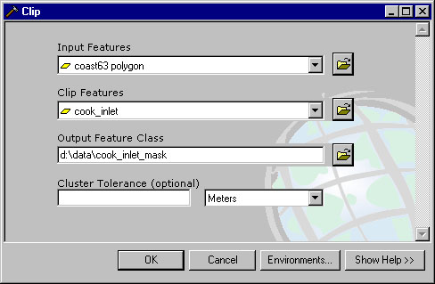
For our water body example we now need to clip the coast line to only cover our previously defined area of interest.

The clipping function is part of the 'Extract' functions of the analysis tool within the ArcToolbox. As shown in the example on the right, a coast line polygon (1:63,360 scale) is the input feature. The previously defined boundary file serves as clip feature.
Note that the resulting vector mask inherits the map projection information from the input feature. If you want to use a different projection during the terrain correction process, reproject the input feature into this projection before clipping the area of interest.

In case of a fully defined boundary, e.g. our glacier example, this step is obviously not required.

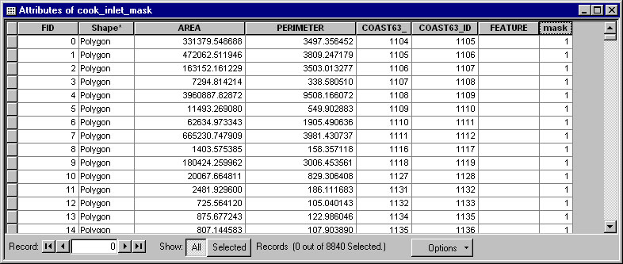

In the next step, add a new mask field to the attribute table (type: short integer) and set the mask attribute to 1. This is effectively done using 'Find and replace' in the options menu, once the table is in editing mode.

Generating a raster mask
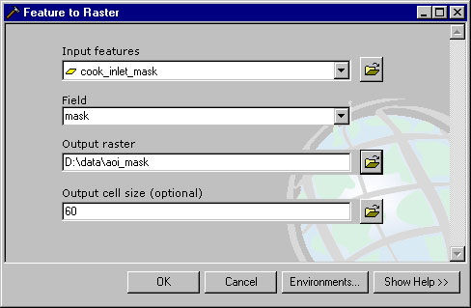
In order to use the vector mask in the terrain correction process, it needs to be converted to a raster format.

For that we convert the vector mask using the newly defined mask field into a raster format. In this step it is important to define the output cell size. The cell size should be same as the pixel size that we intend to use during the terrain correction. In the resulting raster mask image all pixels that are included in the area of interest are set to 1. All other pixels are set to 0.
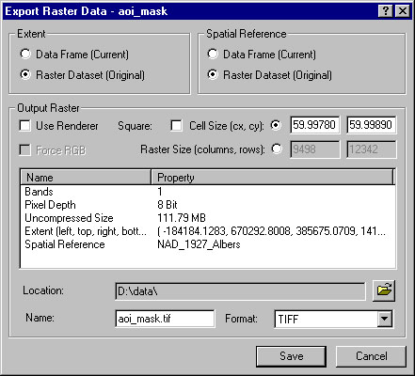
By converting the raster mask image into the GeoTIFF format the mask can be used for the terrain correction of radar images within the asf_convert tool.

Note that this step preserves the map projection information introduced earlier.

