WEEK 1 INTERNSHIP REPORT
Data Acquisition, Cleaning, and Preprocessing
Dataset: Telco Customer Churn Dataset
Submitted By:
Asfina Magi
Program:
B.Tech Computer Science & Engineering – Artificial Intelligence & Machine Learning
Week:
Week 1
Date:
August 2026
Tools Used:
Python, Pandas, NumPy, Google Colab

3. INTRODUCTION
Data preprocessing is an important step in any data analysis or machine learning project. Real-world datasets may contain missing values, duplicate records, inconsistent data types, irrelevant attributes, erroneous values, and outliers. If these issues are not identified and handled properly, they can negatively affect the accuracy and reliability of subsequent analysis.
The objective of this Week 1 task was to acquire a publicly available dataset, investigate its structure and quality, identify data quality issues, and perform appropriate cleaning and preprocessing using Python. The Telco Customer Churn dataset was selected for this task because it contains customer demographic information, service details, billing information, and churn-related attributes.
Python was used as the primary programming language, with Pandas and NumPy used for data manipulation, inspection, cleaning, and preprocessing. Google Colab was used as the development environment.
The major activities performed during this task included dataset acquisition, exploratory data analysis, missing-value detection, duplicate checking, data-type validation, categorical-value analysis, erroneous-value detection, outlier analysis, removal of redundant attributes, categorical encoding, and final validation.
4. OBJECTIVES
The main objectives of this task were:
- To obtain a relevant publicly available dataset.
- To understand the structure and characteristics of the dataset.
- To identify missing and inconsistent values.
- To detect duplicate records.
- To identify and investigate erroneous data entries.
- To detect numerical outliers using statistical methods.
- To correct inappropriate data types.
- To remove irrelevant, redundant, or constant columns.
- To convert categorical variables into a numerical representation.
- To prepare a cleaned and preprocessed dataset for further analysis.
- To document the preprocessing decisions and their potential impact on future analysis.

5. DATASET SELECTION
5.1 Dataset Description
The dataset selected for this task is the Telco Customer Churn dataset. It contains information about telecommunications customers, including demographic characteristics, subscribed services, contract information, billing details, and customer churn information.
The dataset contains 7,043 customer records and originally contains 33 columns. The attributes include customer identification, location information, demographic characteristics, service subscriptions, contract details, monthly charges, total charges, churn information, churn score, customer lifetime value (CLTV), and churn reason.

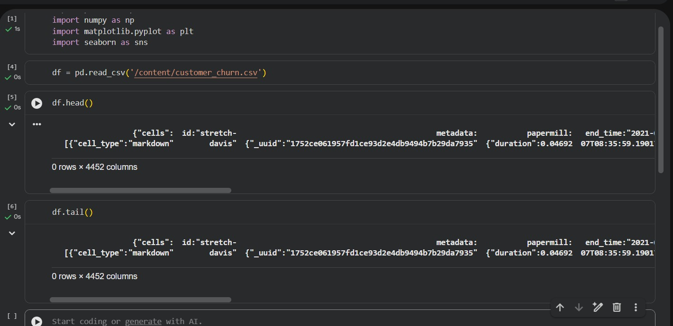
Figure 1: Initial records of the Telco Customer Churn dataset

6. TOOLS AND TECHNOLOGIES USED
Make a table:
Tool | Purpose
Python | Data processing and analysis
Pandas | Data loading, cleaning and manipulation
NumPy | Numerical operations and validation
Google Colab | Development and execution environment
Microsoft Word | Report preparation
7. DATA ACQUISITION
7.1 Dataset Loading
Code:
import pandas as pd
df = pd.read_excel('/content/Telco_customer_churn.xlsx')
Explanation:
The dataset was provided in Excel format and loaded into Python using the Pandas read_excel() function. After loading the dataset, the DataFrame was inspected to verify that the data had been imported correctly.
Then show:
df.head()
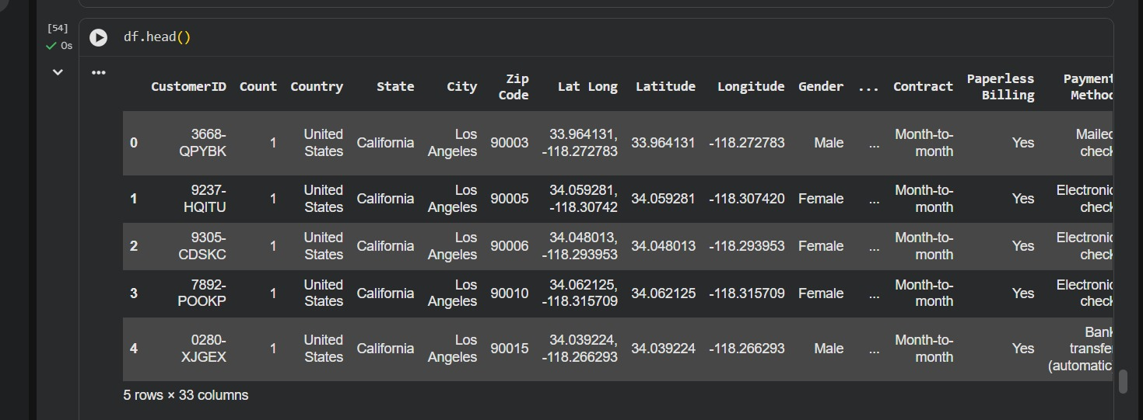
8. INITIAL DATA EXPLORATION
8.1 Dataset Dimensions
Code:
print(df.shape)
Result:
(7043, 33)
Explanation:
The dataset initially contained 7,043 rows and 33 columns. Each row represents a customer and each column represents a customer attribute or business-related variable.
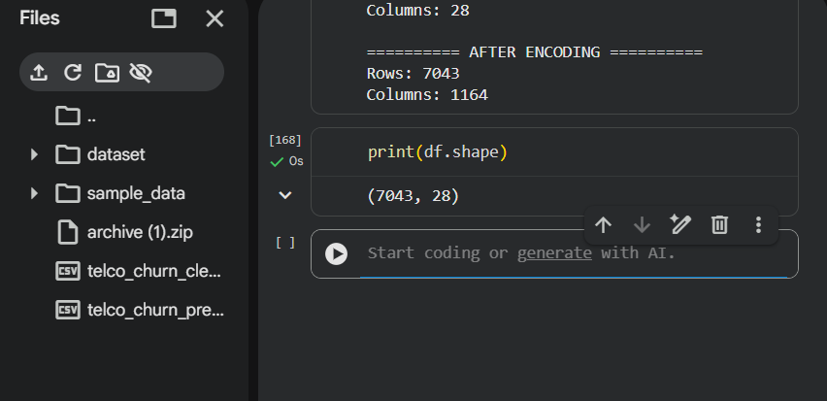

9. DATA STRUCTURE AND DATA TYPES
Code:
df.info()
Explanation:
The info() function was used to examine the structure of the dataset, including the number of records, column names, non-null values, and data types. The dataset contained numerical, categorical, and object-type variables. This step was important for identifying columns that required data-type conversion before further analysis.
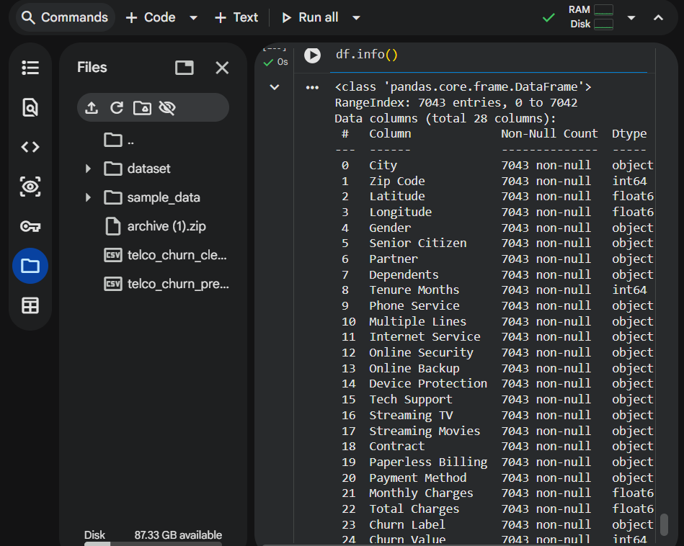

10. NUMERICAL DATA EXPLORATION
Code:
df.describe()
Explanation:
Descriptive statistics were calculated for numerical variables using the describe() function. This provided information such as count, mean, standard deviation, minimum, quartiles, and maximum values. These statistics helped in understanding the distribution and range of variables such as tenure, monthly charges, total charges, churn score, and CLTV.
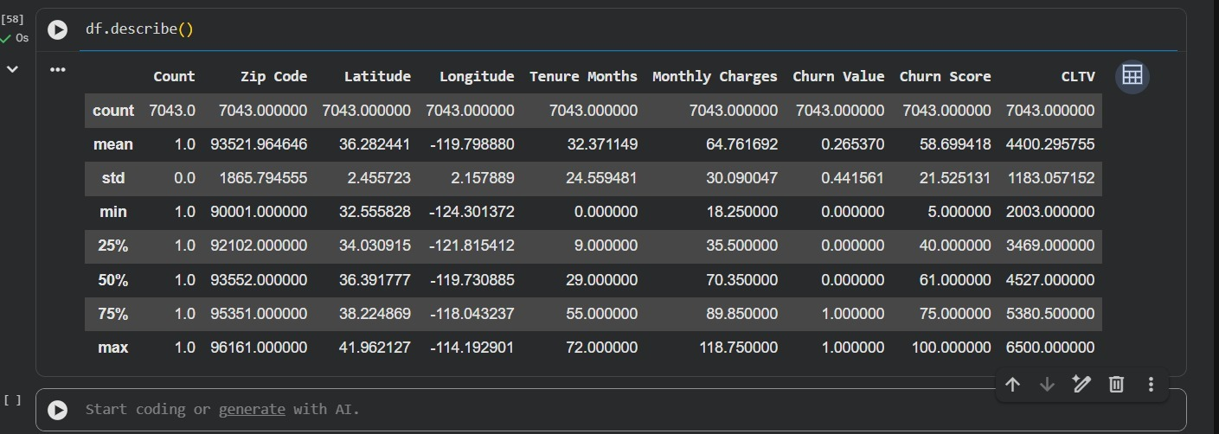

11. MISSING VALUE ANALYSIS
Code:
missing_table = pd.DataFrame({
'Missing Values': df.isnull().sum(),
'Percentage': (df.isnull().sum() / len(df)) * 100
})
missing_table
Result:
Your important result was:
Churn Reason 5174 73.463013
while the other columns had 0 missing values.
Explanation:
The missing-value analysis showed that most columns did not contain missing values. However, the Churn Reason column contained 5,174 missing values, representing approximately 73.46% of the dataset.
These missing values were not treated as ordinary data-entry errors because Churn Reason is applicable primarily to customers who have churned. Customers who did not churn naturally do not have a churn reason. Therefore, replacing these values with arbitrary values could introduce misleading information.
For the modeling/preprocessing dataset, Churn Reason was excluded because it represents information associated with the outcome of churn and could introduce data leakage if used as an input feature.
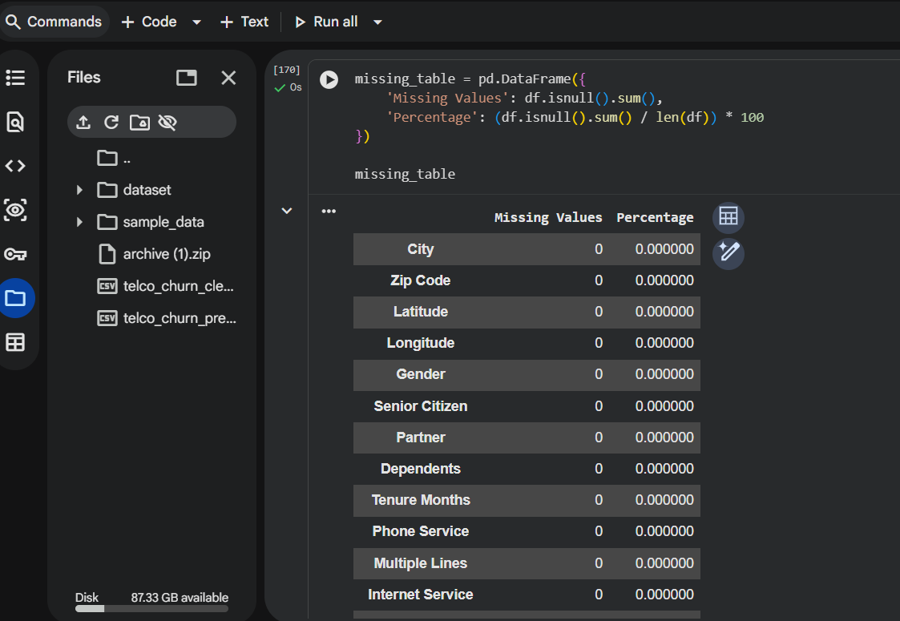
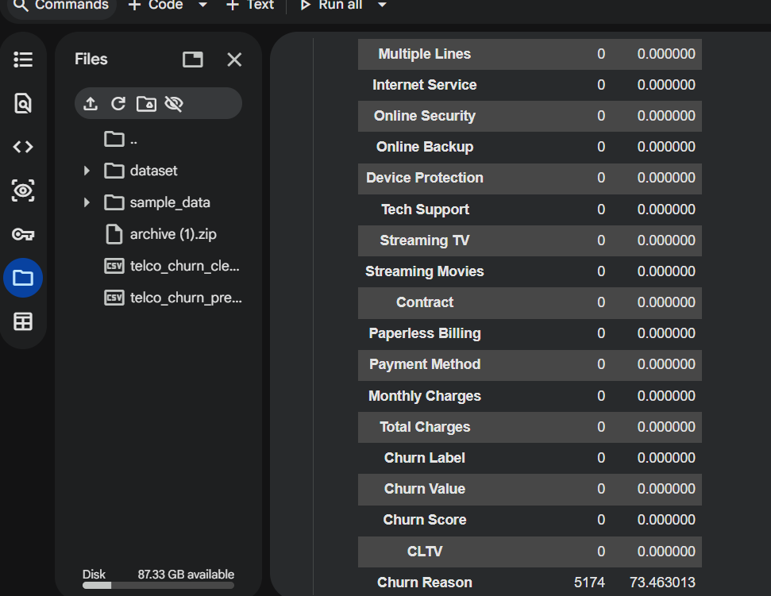

12. DUPLICATE VALUE ANALYSIS
Code:
print("Duplicate rows:", df.duplicated().sum())
Result:
Duplicate rows: 0
Explanation:
Duplicate records were checked using Pandas' duplicated() function. The analysis identified zero duplicate rows. Therefore, no duplicate records needed to be removed.
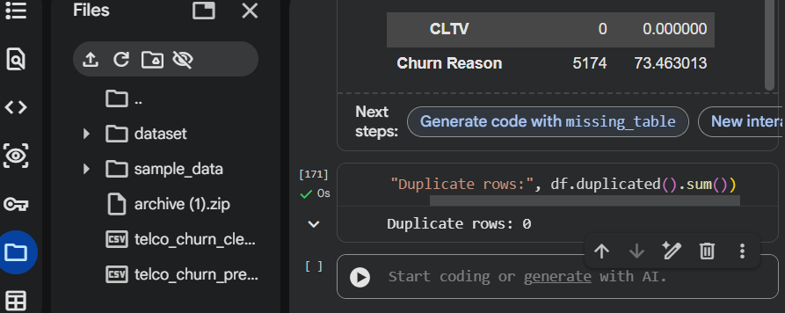

13. CATEGORICAL DATA ANALYSIS
You checked several categorical variables.
For example:
print(df['Gender'].value_counts())
Result:
Male 3555
Female 3488
And:
print(df['Contract'].value_counts())
Result:
Month-to-month 3875
Two year 1695
One year 1473
Explanation:
Frequency analysis was performed on categorical variables to understand their distributions and identify unexpected or inconsistent categories. Variables such as Gender, Contract, Internet Service, Payment Method, and Churn Label were examined.
The observed categories were meaningful and consistent with the expected values. For example, the Contract variable contained three categories: Month-to-month, One year, and Two year.
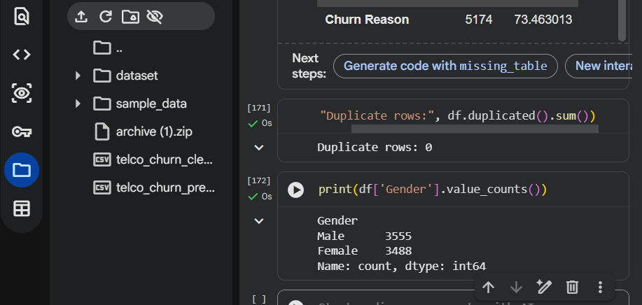
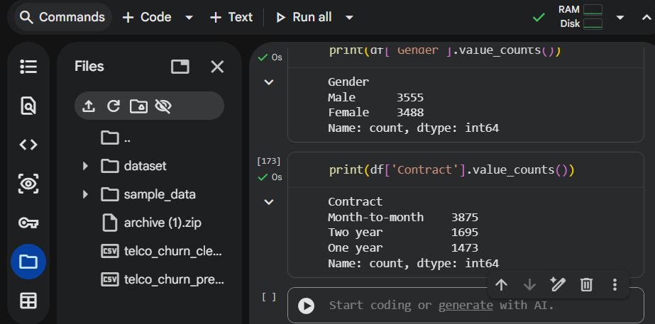

14. CHURN CONSISTENCY CHECK
You performed this:
pd.crosstab(df['Churn Label'], df['Churn Value'])
Result:
Churn Value 0 1
Churn Label
No 5174 0
Yes 0 1869
Explanation:
A consistency check was performed between Churn Label and Churn Value. The results showed that customers labelled "No" had a churn value of 0, while customers labelled "Yes" had a churn value of 1. Therefore, the two columns were logically consistent.
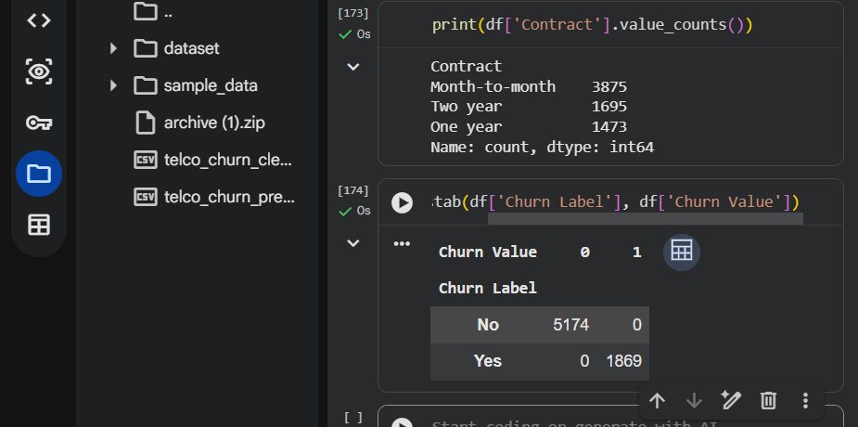

15. DATA TYPE CORRECTION
This is an important part of your report because you encountered the Total Charges problem.
Initially, you encountered:
KeyError: 'TotalCharges'
because the actual column name was:
Total Charges
with a space.
Code:
df['Total Charges'] = pd.to_numeric(
df['Total Charges'],
errors='coerce'
)
Explanation:
During the data-type investigation, the Total Charges column was identified as an object-type column even though it represented numerical billing values. An initial attempt to access TotalCharges resulted in a KeyError because the actual column name contained a space (Total Charges).
The correct column name was identified by inspecting df.columns. The column was then converted into a numerical data type using pd.to_numeric() with errors='coerce'. This conversion ensured that the column could be used correctly for numerical analysis.
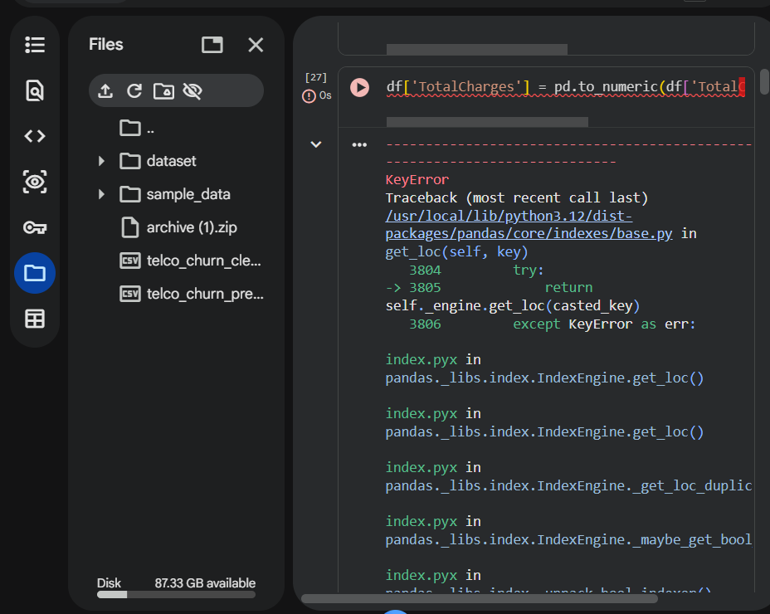

16. IDENTIFICATION OF BLANK VALUES IN TOTAL CHARGES
You found 11 problematic records, all with:
Tenure Months = 0
Churn Label = No
Explanation:
After converting Total Charges to a numeric format, 11 records were identified as missing values. These records corresponded to customers with zero tenure months and zero/initial service duration. Therefore, the missing values were associated with newly joined customers rather than random missing billing information.
These records were retained rather than arbitrarily deleting customers, because removing them would reduce the dataset and could potentially introduce bias.
17. CONSTANT COLUMN ANALYSIS
You found:
Unique values in Count: 1
Standard deviation: 0.0
Code:
print("Unique values in Count:", df['Count'].nunique())
print("Standard deviation:", df['Count'].std())
Then:
df = df.drop(columns=['Count'])
Explanation:
The Count column contained only one unique value, which was 1 for every record. Its standard deviation was 0, indicating no variation. Since a constant column does not provide useful information for analysis or modeling, it was removed.
18. OUTLIER DETECTION
used the IQR method.
Explain:
The Interquartile Range (IQR) method was used to identify potential outliers in numerical variables. The IQR is calculated as the difference between the third quartile (Q3) and first quartile (Q1).
The lower and upper bounds were calculated as:
Lower Bound = Q1 − 1.5 × IQR
Upper Bound = Q3 + 1.5 × IQR
Values outside these boundaries were considered potential outliers.
results:
Variable | Number of Outliers
Tenure Months | 0
Monthly Charges | 0
Total Charges | 0
Churn Score | 0
CLTV | 0
Explanation:
No outliers were detected in the selected numerical variables using the IQR method. Therefore, no outlier removal or transformation was required.
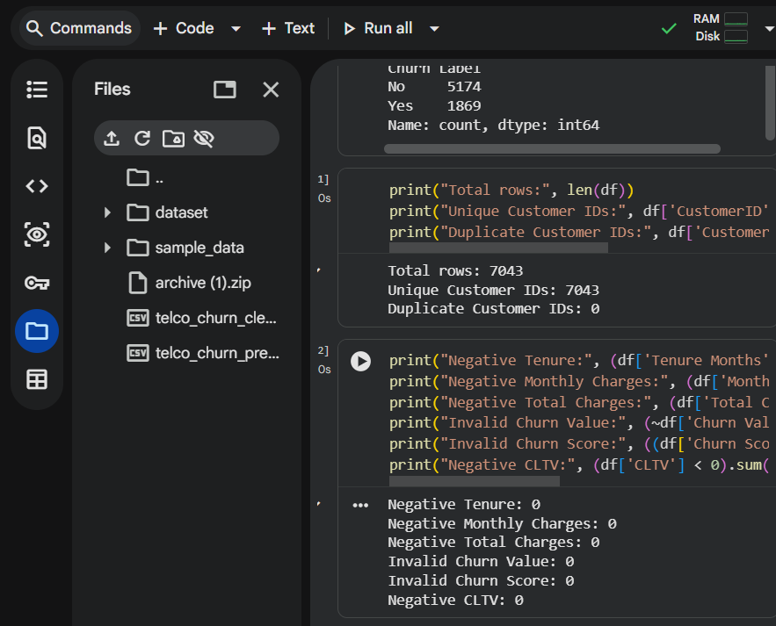

20. REDUNDANT AND IRRELEVANT COLUMN REMOVAL
You removed:
CustomerID
Country
State
Lat Long
Code:
df = df.drop(columns=[
'CustomerID',
'Country',
'State',
'Lat Long'
])
Explanation:
Several columns were removed because they did not provide useful information for the intended preprocessing task. CustomerID was an identifier rather than a behavioral feature. Country and State had no useful variation in the selected dataset. Lat Long was redundant because latitude and longitude were already available as separate columns.
Then:
Cleaned dataset shape: (7043, 28)

21. CREATION OF CLEANED DATASET
Code:
cleaned_df = df.copy()
print("Cleaned dataset shape:", cleaned_df.shape)
Result:
(7043, 28)
Explanation:
After the cleaning procedures, the dataset contained 7,043 records and 28 columns. The number of rows remained unchanged because no duplicate records were found and no rows were removed during the cleaning process.

22. CATEGORICAL ENCODING
Machine learning algorithms generally require numerical input. Therefore, categorical variables were converted into numerical representations using one-hot encoding.
Code:
categorical_cols = model_df.select_dtypes(
include='object'
).columns.tolist()
model_df_encoded = pd.get_dummies(
model_df,
columns=categorical_cols,
drop_first=True
)
model_df_encoded = model_df_encoded.astype(int)
Result:
(7043, 1164)
Explanation:
One-hot encoding increased the number of features from 26 to 1,164. This increase occurred mainly because variables with many unique categories, particularly location-related variables such as City, generated many binary indicator columns.
The drop_first=True parameter was used to remove the first category from each categorical variable and reduce redundant dummy variables.
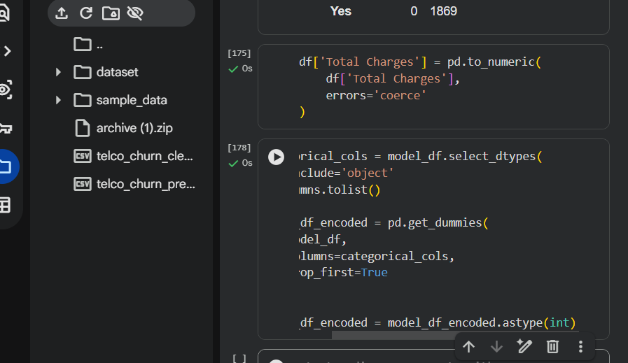

23. TARGET VARIABLE HANDLING
Explain:
Churn Value was retained as the numerical target variable, while Churn Label was excluded from the modeling dataset because it represents the same churn information in categorical form.
Churn Reason was also excluded from the modeling features because it describes the reason associated with churn and contains a large number of values that are not applicable to non-churned customers. Including this variable as an input could result in information leakage.

24. FINAL VALIDATION
Code:
print("Shape:", model_df_encoded.shape)
print(
"Missing values:",
model_df_encoded.isnull().sum().sum()
)
print(
"Duplicate rows:",
model_df_encoded.duplicated().sum()
)
print(
"Object columns:",
model_df_encoded.select_dtypes(
include='object'
).columns.tolist()
)
final checks should show:
Shape: (7043, 1164)
Missing values: 0
Duplicate rows: 0
Object columns: []
Explanation:
Final validation confirmed that the preprocessed dataset contained no missing values, no duplicate rows, and no remaining object-type columns. Therefore, the encoded dataset was successfully converted into a numerical representation suitable for further analysis.
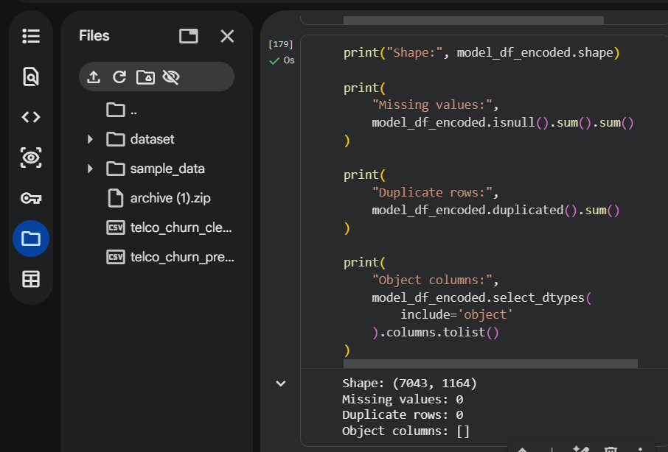

25. BEFORE VS AFTER COMPARISON
Put a table:
Stage | Rows | Columns
Original dataset | 7,043 | 33
After cleaning | 7,043 | 28
After encoding | 7,043 | 1,164
Explanation:
The number of records remained constant throughout preprocessing because no duplicate or invalid records required deletion. The number of columns decreased from 33 to 28 after removing constant and redundant attributes. Following one-hot encoding, the number of features increased substantially to 1,164 because categorical variables were transformed into multiple binary features.

26. CHALLENGES FACED
This section is very important because the assignment specifically asks for challenges.
Write:
Several challenges were encountered during the data preprocessing process.
The first challenge was identifying the correct name of the Total Charges column. An initial attempt to access TotalCharges resulted in a KeyError because the actual column name contained a space. This was resolved by inspecting the DataFrame column names and using the correct column name.
Another challenge involved the missing values in Total Charges. After converting the column to numeric format, 11 missing values were identified. These records corresponded to customers with zero tenure months, so they were investigated rather than automatically deleted.
The Churn Reason column also contained a high proportion of missing values. Rather than treating these values as simple data-entry errors, their relationship with customer churn was considered. Since a churn reason is not applicable to customers who did not churn, the column was excluded from the modeling feature set.
Finally, one-hot encoding significantly increased the number of columns from 26 to 1,164. This was mainly due to high-cardinality categorical variables such as City. This demonstrated the trade-off between preserving categorical information and increasing dataset dimensionality.

27. IMPACT OF PREPROCESSING ON FUTURE ANALYSIS
The preprocessing steps performed in this task are expected to improve the reliability of subsequent analysis. Removing constant and redundant columns reduces unnecessary information and simplifies the dataset. Correcting the data type of Total Charges allows numerical calculations to be performed correctly.
Identifying missing values and investigating their meaning prevents inappropriate imputation or deletion. Similarly, checking for duplicates, invalid values, and outliers helps ensure that unusual records do not negatively influence subsequent analysis.
One-hot encoding makes categorical variables usable by machine learning algorithms that require numerical input. However, the substantial increase in dimensionality from 26 to 1,164 features may increase computational requirements and could potentially require feature selection or dimensionality reduction in future modeling work.
Overall, preprocessing creates a more structured and consistent dataset that can be used for further exploratory analysis and machine learning tasks.

28. LIMITATIONS
Although extensive cleaning and preprocessing were performed, some limitations remain. The dataset is specific to a telecommunications customer base and therefore the findings may not generalize to other industries or populations. Additionally, high-cardinality categorical variables resulted in a large number of encoded features. Future work may investigate feature selection or alternative encoding strategies to reduce dimensionality.
Furthermore, this task focused on data acquisition, cleaning, and preprocessing rather than building and evaluating a predictive model. Therefore, the effect of these preprocessing decisions on actual model performance has not yet been measured.

29. CONCLUSION
This Week 1 task provided practical experience in acquiring, exploring, cleaning, and preprocessing a real-world customer churn dataset using Python. The dataset initially contained 7,043 records and 33 columns.
A systematic data-quality investigation was conducted to identify missing values, duplicates, inconsistent data types, erroneous values, and potential outliers. The Total Charges column was converted to a numerical format, duplicate and invalid records were checked, and no numerical outliers were identified using the IQR method.
Constant and redundant columns were removed, resulting in a cleaned dataset containing 7,043 records and 28 columns. Categorical variables were subsequently converted into numerical representations using one-hot encoding, resulting in a preprocessed dataset with 1,164 features.
The final validation confirmed that the preprocessed dataset contained no missing values, duplicate rows, or remaining object-type columns. The resulting dataset is now prepared for further exploratory analysis and potential machine learning applications.

Report Description
This report presents the complete data acquisition, cleaning, and preprocessing workflow performed on a publicly available Telco Customer Churn dataset. The objective of the work was to understand the structure and quality of the dataset and prepare it for further analysis and machine learning applications.
The dataset was obtained as an Excel file and loaded into Python using Pandas. An initial exploratory analysis was performed to examine the number of rows and columns, column names, data types, statistical summaries, and categorical-value distributions. The dataset contains 7,043 customer records and initially included 33 columns.
Several data-quality checks were performed during the cleaning process. Missing values were identified, particularly in the Total Charges column and the Churn Reason column. The Total Charges column was converted from an object data type into a numeric format, with invalid or blank values handled appropriately. The missing Total Charges values were associated with customers having zero tenure. The Churn Reason column contained a large number of missing values because churn reasons are not applicable to customers who did not churn.
Duplicate records were also checked, and no duplicate rows were found. Numeric columns such as Tenure Months, Monthly Charges, Total Charges, Churn Score, and CLTV were examined for potential outliers using the Interquartile Range (IQR) method. No statistical outliers were identified using the selected IQR boundaries. Logical validation checks were also performed to identify negative or invalid values, and no invalid negative values were found in the checked numerical fields.
The dataset was then cleaned by removing unnecessary columns and preparing relevant numerical and categorical variables for analysis. Categorical variables were transformed using appropriate encoding techniques during preprocessing. The final cleaned dataset contained 7,043 records and 28 columns, while the encoded/preprocessed dataset was prepared for potential future machine learning analysis.
The report also discusses the reasoning behind each preprocessing decision, challenges encountered during the process, and the possible impact of these decisions on future analysis. Overall, the work demonstrates a systematic approach to preparing real-world customer data for reliable analysis and machine learning.

