# 

# 

# **A Computational Approach for Designing novel therapeutics for Osteoarthritis**

**Prepared**

**By**

Asfiya Tehmeen

###### **Abstract**

Osteoarthritis is a progressive joint disease that becomes worse over time and can cause pain and stiffness.[1] The existing treatments or therapies only give symptomatic relief.[2] The aim of this project was to identify potential therapeutic targets for osteoarthritis using a computational approach. Interleukin-17A (IL-17A) was selected for this study. Different structures of this cytokine were analysed based on parameters like resolution, missing residues, presence of heteroatoms, etc, ultimately leading to the selection of 4HSA[3] structure for docking study. Over 120 natural compounds and their analogs, sourced from the ZINC database[4], were screened for their binding potential against IL-17A. This project was able to show the initial steps in identifying the lead compounds, but due to time constraints, a more detailed analysis was not possible. In the future, we will concentrate more on binding analysis.

###### **List of Figures**

Fig.1: Flowchart of Methodology showing all the steps involved in this project

Fig.2: Structure of 4HSA viewed in Pymol [6]. Different chains are given different colors

Fig. 3: Potential IL related treatments for OA. [7]

Fig. 4: List of bioactive natural compounds, the model system of study and their targets [8]

Fig. 5: Command lines given in the Command Prompt to run Virtual Screening

Fig. 6: Interactions of the receptor with 4 ligands - visualized in Pymol [6]

###### 

###### **Table of contents**

Abstract

List of Figures

1. Background

2. Rationale

3. Aim and Objectives

4. Methodology

4.1. Disease & Target Research

4.2. Find the existing therapies

4.3. Selection of target structure of IL-17A

4.4. Receptor Preparation

4.5. Ligand Preparation

4.6. Virtual Screening

5. Observations and Results

6. Future Scope

7. References

**Chapter 1 - Background**

Selected drug target - IL-17:

IL-17 is an important pro-inflammatory cytokine that augments immune mechanisms by causing production of other inflammatory mediators. While this has been extensively studied in autoimmune diseases such as rheumatoid arthritis, its functional aspect with osteoarthritis is still being explored. The increased levels of IL-17 in the synovial fluid of osteoarthritis patients were found to correlate positively with the extent of cartilage damage and joint inflammation.[1] IL-17 further stimulates the production of matrix metalloproteinases (MMPs), which are enzymes that degrade cartilage matrix. Therefore, targeting IL-17 may represent an attractive novel approach to reducing the inflammation and subsequent cartilage loss that occurs in osteoarthritis

**Chapter 2 - Rationale**

Surgical replacement of the joint is the last resort when the situation is severe and NSAIDs, corticosteroids, analgesics, or intra-articular injections of corticosteroids or hyaluronic acid fail to do much apart from offering symptomatic relief. However, none of these therapies alters the disease modification. There is an urgent need for interventions or therapies that can retard the process of cartilage degeneration.[2] These options- do very little and most times nothing to halt progress of osteoarthritis or to repair damage done to the joints structure. Therefore, it is essential to develop medications that can address the underlying molecular basis of the disease. [5]

**Chapter 3 - Aim and objectives**

- To identify or design novel lead molecules targeting IL-17 for treating osteoarthritis using computational tools.

- Computational docking

**Chapter 4 - Methodology**

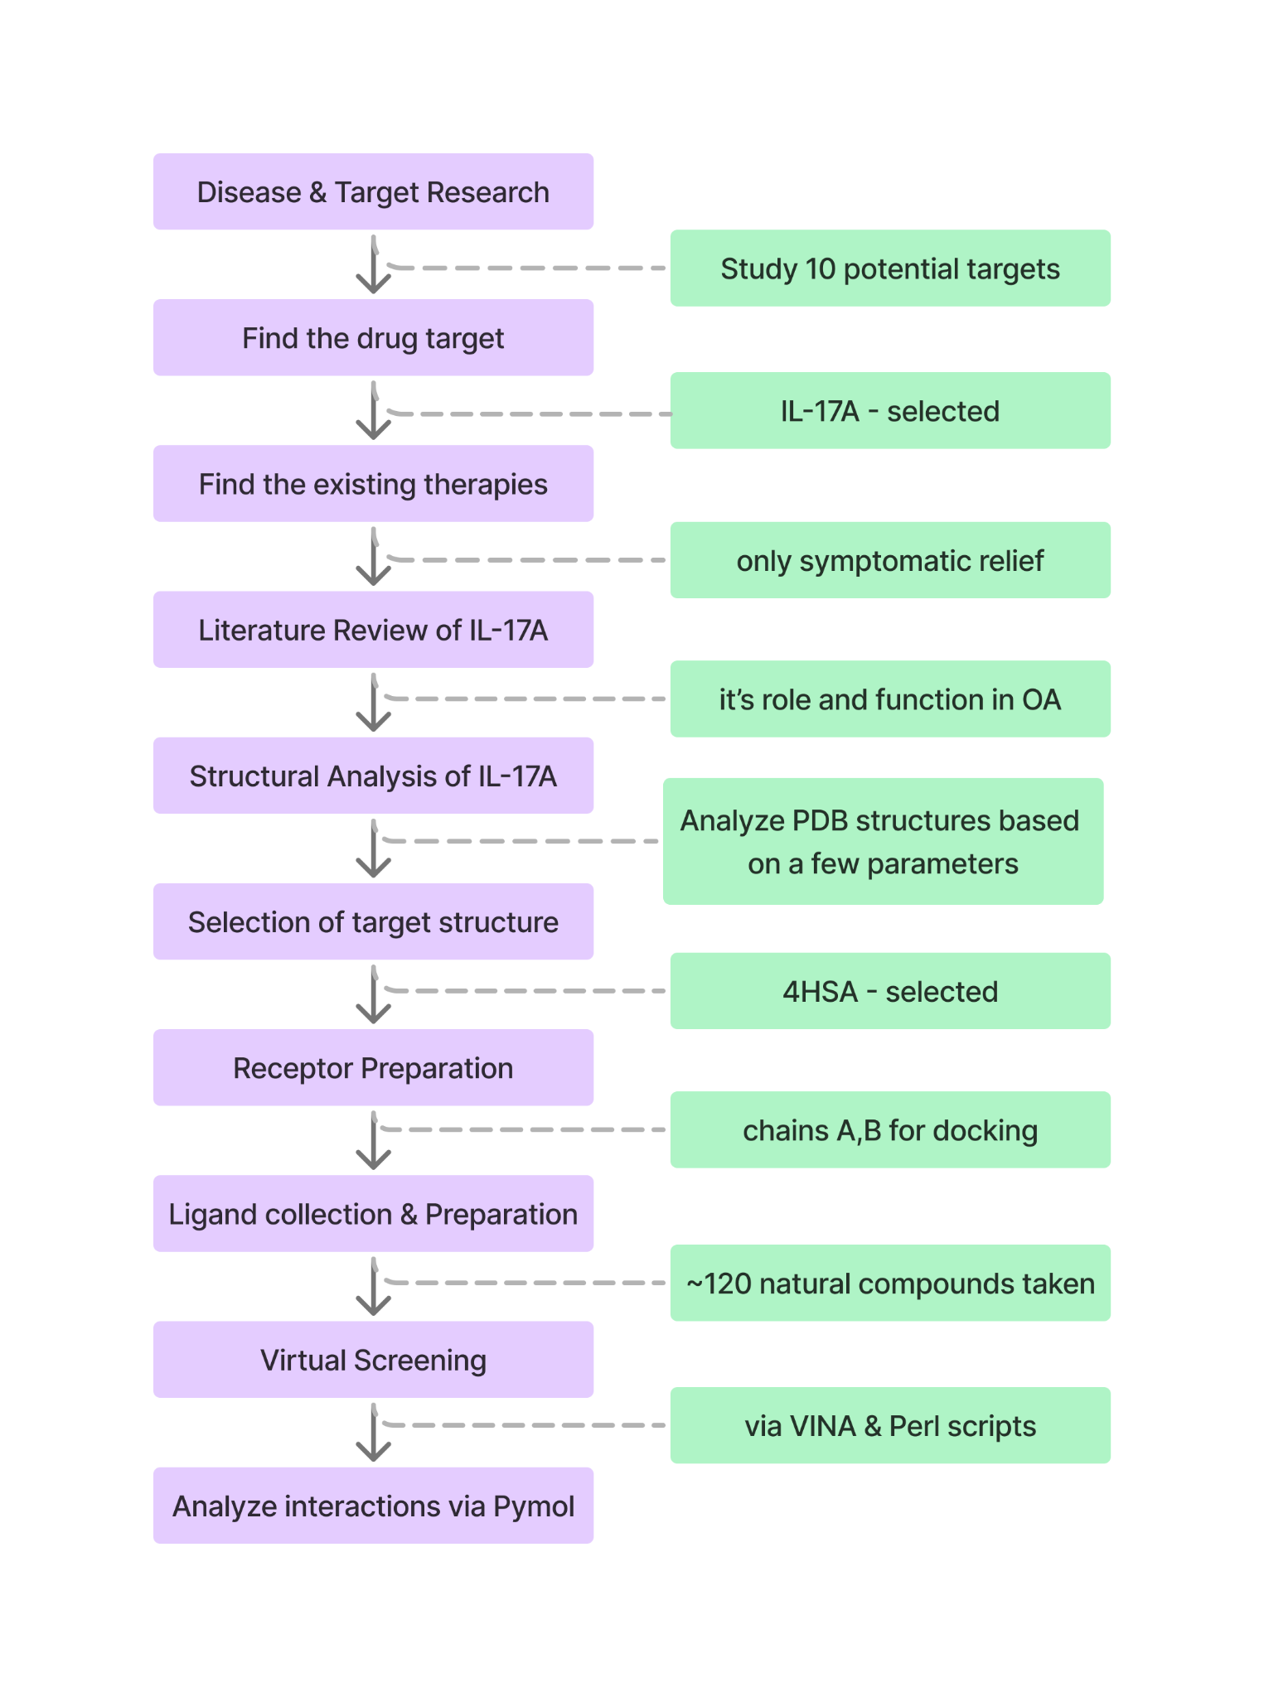

***Fig.1:*** *Flowchart of Methodology showing all the steps involved in this project*

Fig.1 shows all the important steps taken in our research with Osteoarthritis as the disease of focus. Each of these steps is further described below.

4.1. Disease & Target Research

Firstly, we studied about 10 genes that could have been the potential targets for Osteoarthritis -

1. IL-17
2. FAP
3. ADAMTS-5
4. MMP-13
5. SOST
6. Wnt/β-catenin Pathway Inhibitors
7. Leptin
8. TLRs
9. GDF5
10. CXCR4

Each gene was evaluated based on their drug availability, current research status, availability of human protein structure, whether it was membrane bound (we specifically needed a non-membrane bound protein). Finally, IL-17A was chosen as the target.

4.2. Finding the Existing Therapies

We then studied the existing therapies of IL-17A. Like NSAIDs, corticosteroids, analgesics, etc, and found out that these generally offer symptomatic relief only, as discussed in the ‘Rationale’ section of our study. [2]

4.3. Selection of target structure of IL-17A

Following this, we analyzed the available structures of IL-17A from the PDB database [5], focusing on factors like no of missing residues, resolution, sequence length, and the presence of heteroatoms. The following table shows a detailed classification of a few structures of IL-17A.

| **Structures** | **Resolution** | **Sequence length** | **Year deposited** | **Link** | **Image** | **Missing residues** |
| --- | --- | --- | --- | --- | --- | --- |
| 3JVF | 3.30 Å |  | 2009-09-16 | <https://www.rcsb.org/structure/3JVF> |  | in the doc |
| 4HSA | 3.15 Å | 122 | 2012-10-29 | <https://www.rcsb.org/structure/4HSA> |  |  |
| 4NUX | 2.29 Å |  | 2013-12-04 | <https://www.rcsb.org/structure/4NUX> |  | LEAST - MISSING RES |
| 5N9B | 1.90 Å |  | 2017-02-24 | <https://www.rcsb.org/structure/5N9B> |  |  |
| 5NAN | 3.30 Å | 132 | 2017-02-28 | <https://www.rcsb.org/structure/5NAN> |  |  |
| 7UWL | 3.70 Å | 319 | 2022-05-03 | <https://www.rcsb.org/structure/7UWL> |  |  |
| 7UWM | 2.50 Å | 169 | 2022-05-03 | <https://www.rcsb.org/structure/7UWM> |  |  |
| 7UWN | 3.01 Å | 170 | 2022-05-03 | <https://www.rcsb.org/structure/7UWN> |  |  |
| 7ZAN | 5.06 Å | 123 | 2022-03-22 | <https://www.rcsb.org/structure/7ZAN> |  |  |

***Table:*** *Classification of different IL-17A structures based on a few parameters*

4HSA was chosen as it fulfilled most of our requirements. 4HSA is a structure of interleukin 17a in complex with il17ra receptor [3]. Therefore, it had 2 macromolecules - IL-17A and IL-17RA. Upon structural analysis, it was found that chains A, B, D, E corresponded to IL-17A and chains C, F corresponded to IL-17RA. We opened the structure in AutoDock, we kept the chains A and B of IL-17A, and eliminated the other chains.

**Fig.2** shows different chains of the complex 4HSA, to differentiate between chains of IL-17A and IL-17RA.

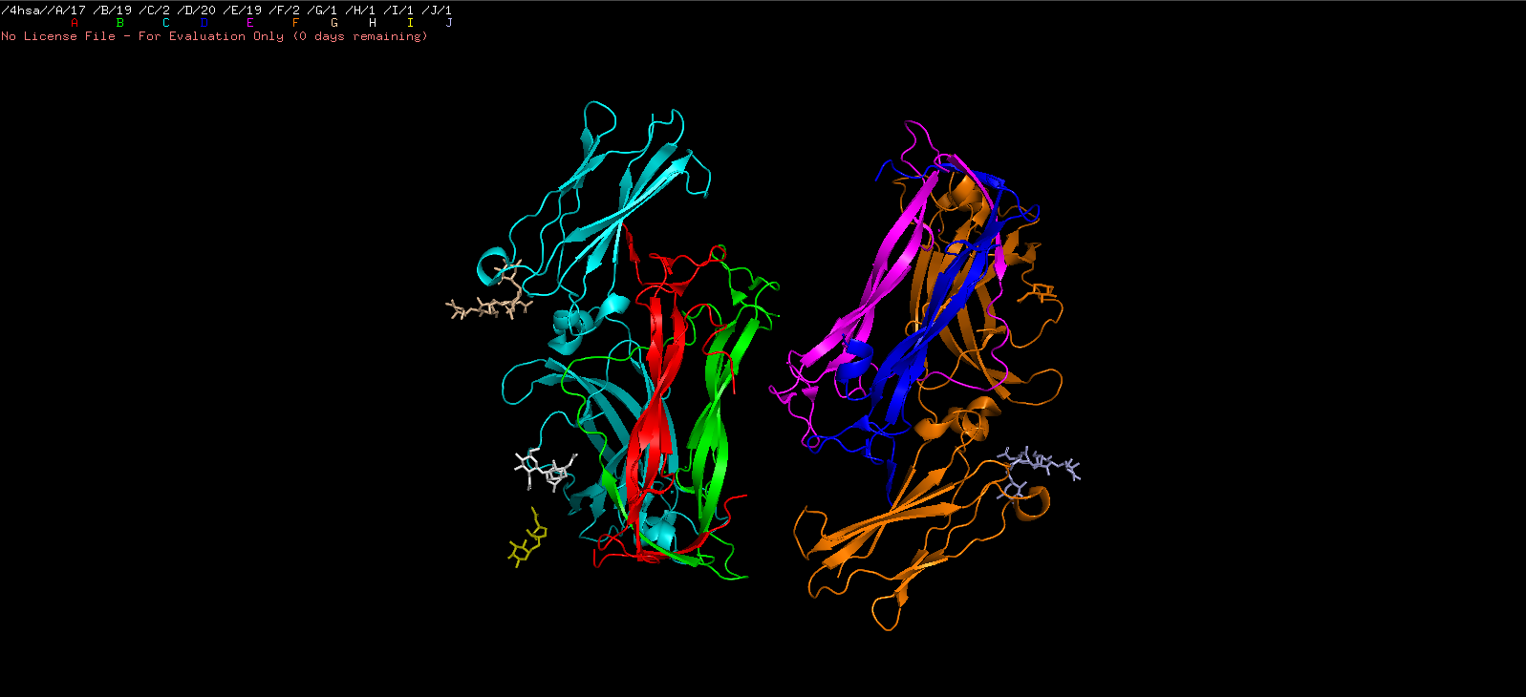

***Fig.2:*** *Structure of 4HSA viewed in Pymol [6]. Different chains are given different colors*

4.4. Receptor Preparation

After the receptor structure was finalised, we then prepared it for docking in AutoDock. [4]

*Steps for Receptor Preparation:*

File >> Preferences >> Set >> Startup Directory (delete & Paste the path of the folder with Autodock Tools)

1. Take the protein structure
2. Delete Water molecules
3. Remove Hete atoms
4. Remove the inhibitor
5. Add Hydrogen atoms
6. Add Kollmann charges

4.4. Ligand Preparation

Around 120+ molecules were downloaded from the ZINC database for ligand interactions. [4] These natural compounds and their analogs were selected based on the research articles and their potential in osteoarthritis treatments.

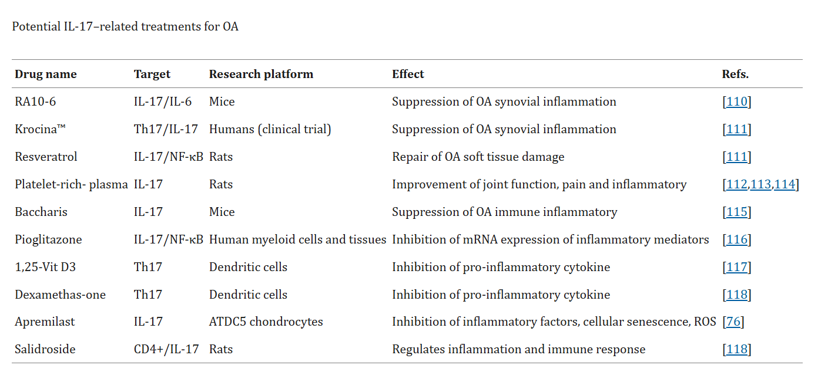

***Fig. 3:*** *Potential IL related treatments for OA. [7]*

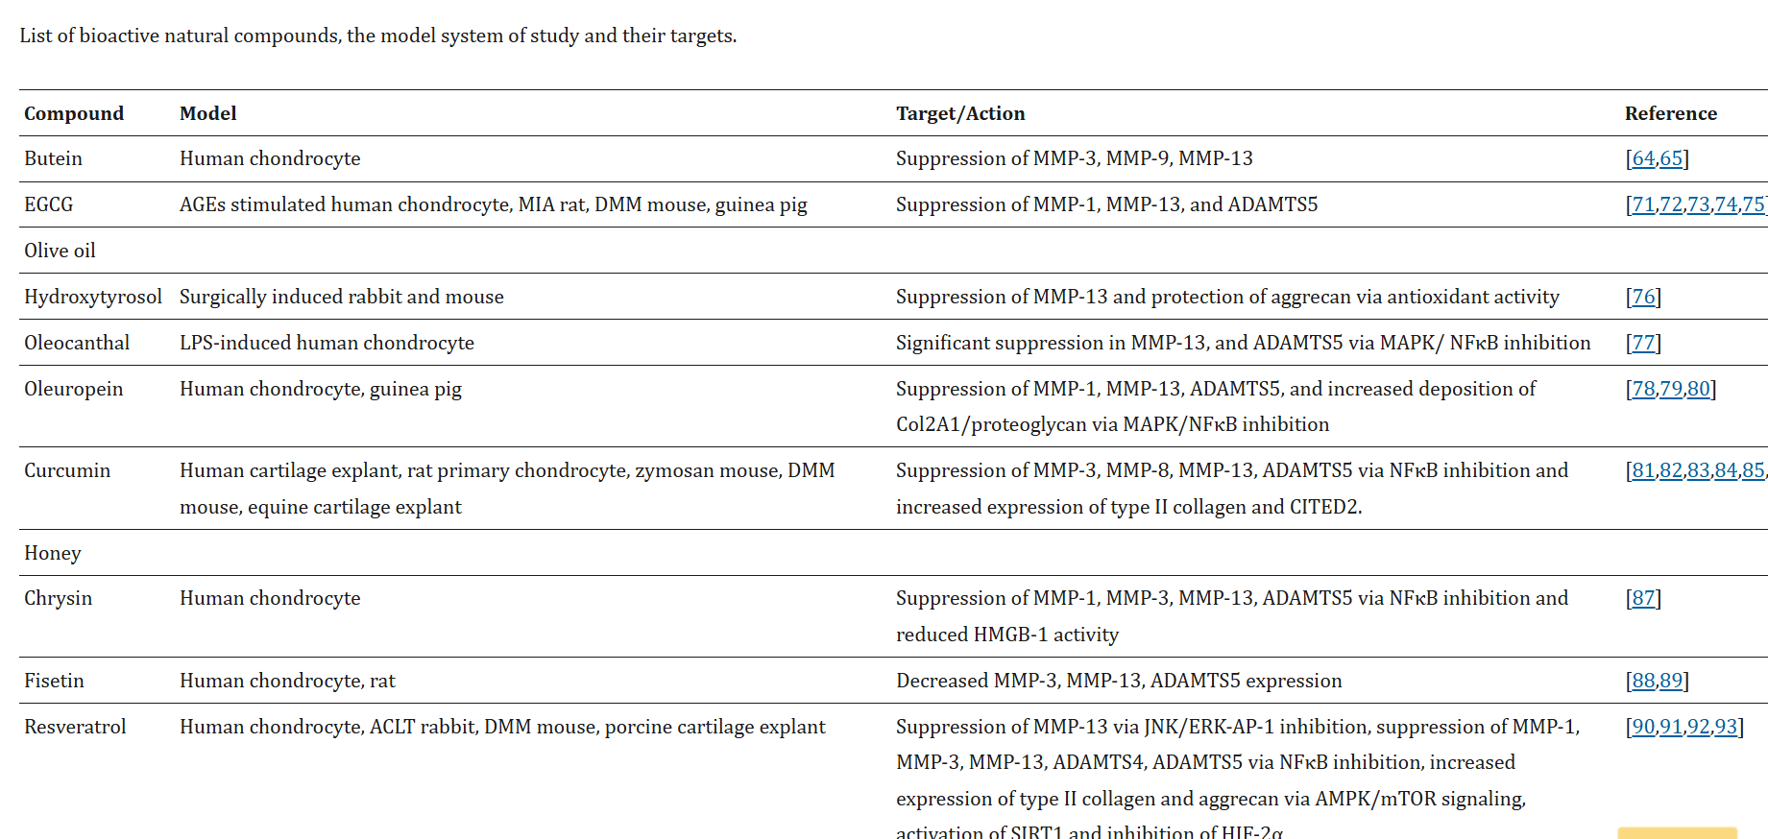

***Fig. 4:*** *List of bioactive natural compounds, the model system of study and their targets [8]*

Here’s a list of natural compounds taken -

| **Natural Compounds** | **Saved as** |
| --- | --- |
| Resveratrol | res-res25 |
| Apremilast | apr |
| Salidroside | sal |
| Pioglitazone | piog-piog1 |
| Curcumin | circ-circ18 |
| ursolic acid | urs-urs11 |
| Gossypol | gos-gos6 |
| Honokiol | hon |
| Indirubin | ind-ind6 |
| Magnolol | mag |
| Amygdalin | amy |
| Baicalein | bai-bai2 |
| Cinchonidine | cin |
| Sclareol | scl-scl4 |
| Butein | but |
| Oleuropein | ole-ole1 |
| Chrysin | chr-chr10 |
| Fisetin | fis-fis4 |
| Zingerone | zing-zing4 |
| Carnosol | car |
| Morin | mor-mor11 |

These molecules were then prepared as ligands for docking with the receptor.

After the receptor and ligand preparation, we created a grid around the receptor with the following

Steps for creating a Grid box:

Grid > Macromolecules > Choose > Receptor

Then, Grid > Grid Box > Set the values > File > Save as txt

“receptor = receptor.pdbqt

center_x = -49.622

center_y = 40.651

center_z = -36.565

size_x = 126

size_y = 126

size_z = 126”

4.5. Virtual Screening

The Perl[9] script that was used was this -

#!/usr/bin/perl

print"Ligand_file:\t";

$ligfile=<STDIN>;

chomp $ligfile;

open (FH,$ligfile)||die "Cannot open file\n";

@arr_file=<FH>;

for($i=0;$i<@arr_file;$i++)

{

print"@arr_file[$i]\n";

@name=split(/\./,@arr_file[$i]);

}

for($i=0;$i<@arr_file;$i++)

{

chomp @arr_file[$i];

print"@arr_file[$i]\n";

system("vina.exe --config conf_vs.txt --ligand @arr_file[$i] --log @arr_file[$i]_log.log");

}

This script was saved as ‘Vina_windows.pl’

Then we created the configuration file with the name ‘conf_vs’ that had the following contents -

“receptor = receptor.pdbqt

ligand = ligand1.pdbqt

center_x = -49.622

center_y = 40.651

center_z = -36.565

size_x = 126

size_y = 126

size_z = 126

energy_range = 4

exhaustiveness = 8”

Then we used the Command Prompt and gave in the following command lines step by step -

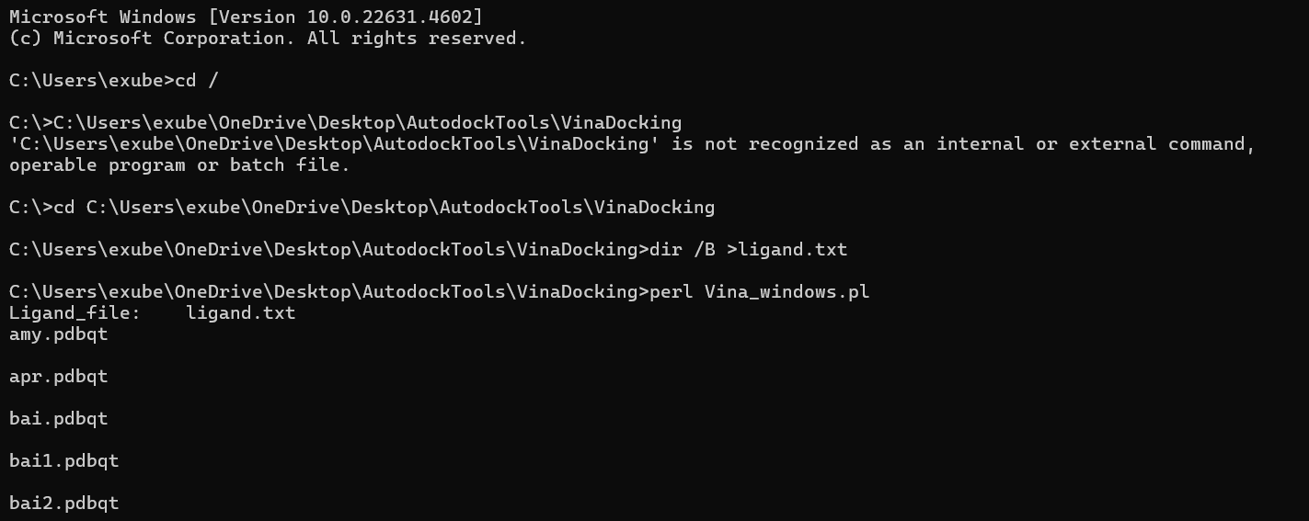

***Fig. 5:*** *Command lines given in the Command Prompt to run Virtual Screening*

The docking process took around 3-4 hours and we got the output and log files for each molecule.

**Chapter 5 - Observations and Results**

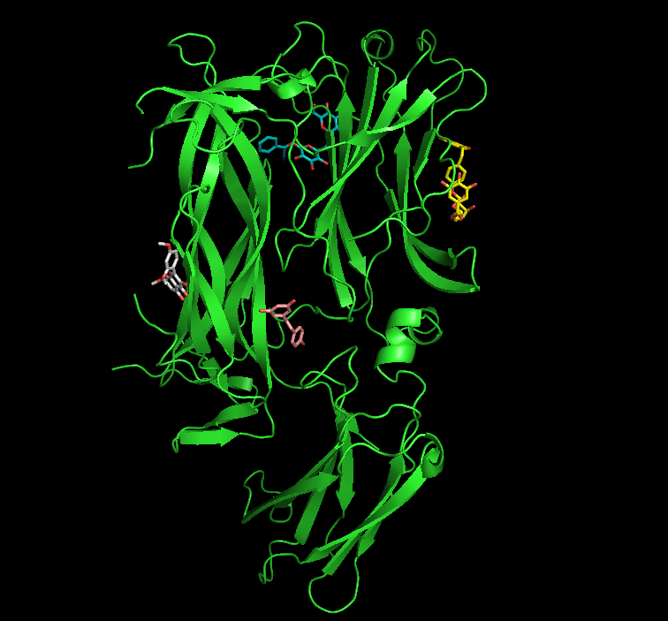

***Fig. 6:*** *Interactions of the receptor with 4 ligands - visualized in Pymol [6]*

The receptor IL-17A was successfully prepared, and ~120 ligands were docked using AutoDock[4], AutoDock Vina[10], and Perl[9]. This process was done without any errors, that means our virtual screening was successful for this receptor.

Through docking, we were able to identify and visualise the interactions between the receptors and ligands. The ligands occupied the receptor’s binding site, forming interactions with important residues. Therefore, it gave us insights into how the ligands bind. However, due to time constraints, we were not able to quantitatively analyze the binding affinities and types of interactions.

**Chapter 6 - Key Takeaways**

- Developed a comprehensive understanding of the molecular mechanisms involved in osteoarthritis, especially the role of pro-inflammatory cytokines, IL-17A in the progression of the disease.

- Learned how to identify and assess drug targets based on various criteria like protein structure, drug availability, etc.

- Gained skills like preparing protein structures and ligands for docking, analyzing PDB files, selecting suitable chains, identifying the binding sites, etc. for docking studies.

- Learned computational tools like AutoDock, Pymol, AutoDock Vina, Perl, etc, and to use various databases like ZINC, PubChem, Drugbank, etc.

**Chapter 7 - Future Scope**

A detailed analysis of the docking scores, binding energy, and specific interactions needs to be done. This will help us find the potential lead molecules for inhibiting IL-17, and also the receptor compatibility.

**5. REFERENCES**

[1] J. Xiao *et al.*, “IL-17 in osteoarthritis: A narrative review,” *Open Life Sciences*, vol. 18, no. 1, Jan. 2023, doi: https://doi.org/10.1515/biol-2022-0747.

[2] L. Yu, R. Luo, G. Qin, Q. Zhang, and W. Liang, “Efficacy and safety of anti-interleukin-1 therapeutics in the treatment of knee osteoarthritis: a systematic review and meta-analysis of randomized controlled trials,” *Journal of Orthopaedic Surgery and Research*, vol. 18, no. 1, Feb. 2023, doi: <https://doi.org/10.1186/s13018-023-03590-2>.

[3]P. Data, “RCSB PDB - 4HSA: Structure of interleukin 17a in complex with il17ra receptor,” *Rcsb.org*, 2020. https://www.rcsb.org/structure/4HSA (accessed Nov. 15, 2024).

[4]“ZINC,” *zinc.docking.org*. https://zinc.docking.org/

[5] Wikipedia Contributors, “Interleukin 17,” *Wikipedia*, Jul. 13, 2024. https://en.wikipedia.org/wiki/Interleukin_17 (accessed Oct. 24, 2024).

[4]mgl-admin, “Homepage,” *AutoDock*. <https://autodock.scripps.edu/>

[5] [“RCSB PDB: Homepage,” *Rcsb.org*. <https://www.rcsb.org/>

[6]“PyMOL | pymol.org,” *Pymol.org*, 2019. https://www.pymol.org/

[7]J. Xiao *et al.*, “IL-17 in osteoarthritis: A narrative review,” *Open Life Sciences*, vol. 18, no. 1, Jan. 2023, doi: https://doi.org/10.1515/biol-2022-0747.

‌[8]O. S. Ashruf and M. Y. Ansari, “Natural Compounds: Potential Therapeutics for the Inhibition of Cartilage Matrix Degradation in Osteoarthritis,” *Life*, vol. 13, no. 1, p. 102, Dec. 2022, doi: https://doi.org/10.3390/life13010102.

‌[9]“The Perl Programming Language - www.perl.org,” *www.perl.org*. https://www.perl.org/

‌[10]mgl-admin, “Homepage,” *AutoDock Vina*. https://vina.scripps.edu/

‌