Twitter Trend Mining

In this project author is using twitter data to identify trending or hot topics as now a days all users are using social media microblogging sites to express their views and opinions and by analysing this data one can identify trending topics and the topic which are discussing more on social media can be consider as hot topics.

So we can take twitter data as input and then count frequency of each words and each hashtag to identify trending topics and we can detect mood of each user by applying sentiment technique on each tweet and to implement this paper author has design following modules

1. Upload Tweets Dataset: Using this module we will upload tweets dataset to application
2. Preprocess Dataset: Tweets contains raw data which often consists of stop words, special symbols and hash tags. To clean tweets we apply preprocessing on each tweet and by removing stop words we can know the real frequency of each word
3. Features Extraction: Each process tweets will be tokenize to extract words and hash tag and then find out frequency of each word and hash tag by applying this module
4. Trend Detection: In this module we will calculate weight of each word and hash tag and then display top 100 trending hash tags and words
5. Mood Prediction: using this module we will detect mood of person who is writing tweet as positive, negative or neutral
6. Top Ten Trending Hashtags Graph: using this module we will plot top 10 highest weight hash tags so user can easily understand which topics are trending most

SCREEN SHOTS

To run project double click on ‘run.bat’ file to get below screen

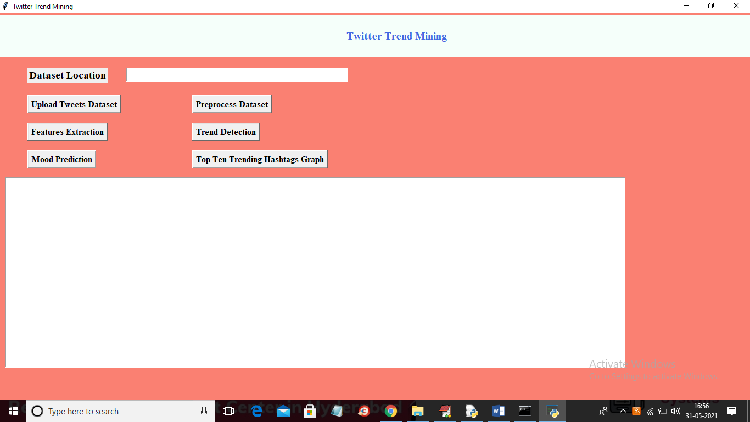

In above screen click on ‘Upload Tweets Dataset’ button to upload tweets

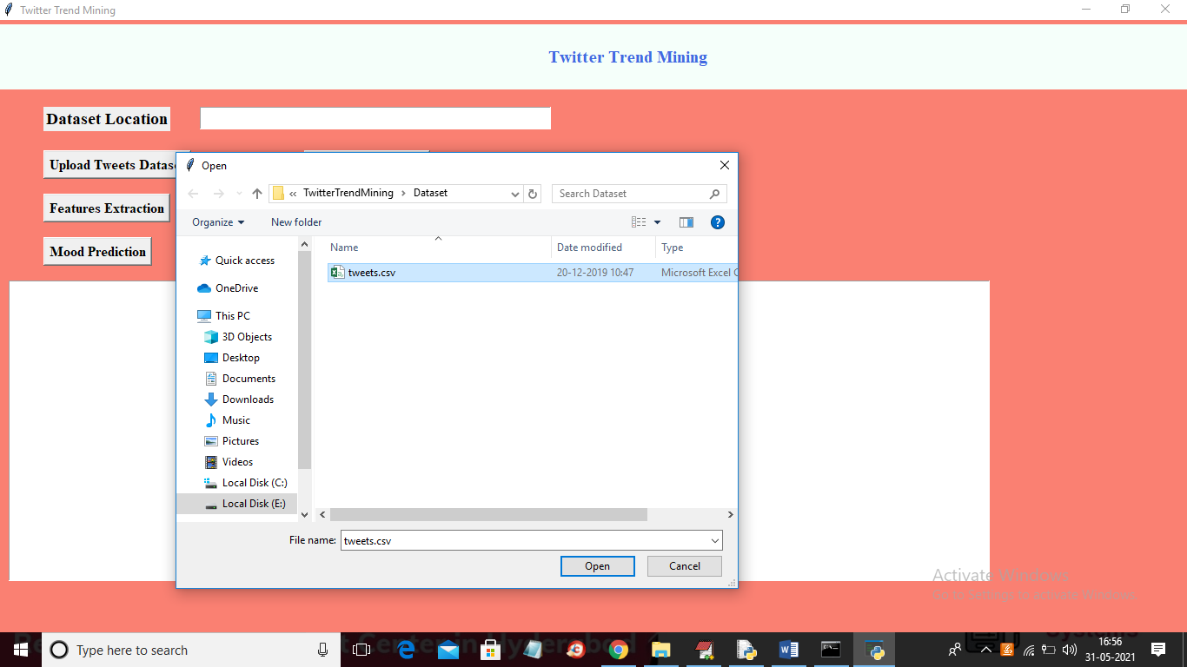

In above screen selecting and uploading ‘tweets.csv’ file and then click on ‘Open’ button to load dataset and to get below screen

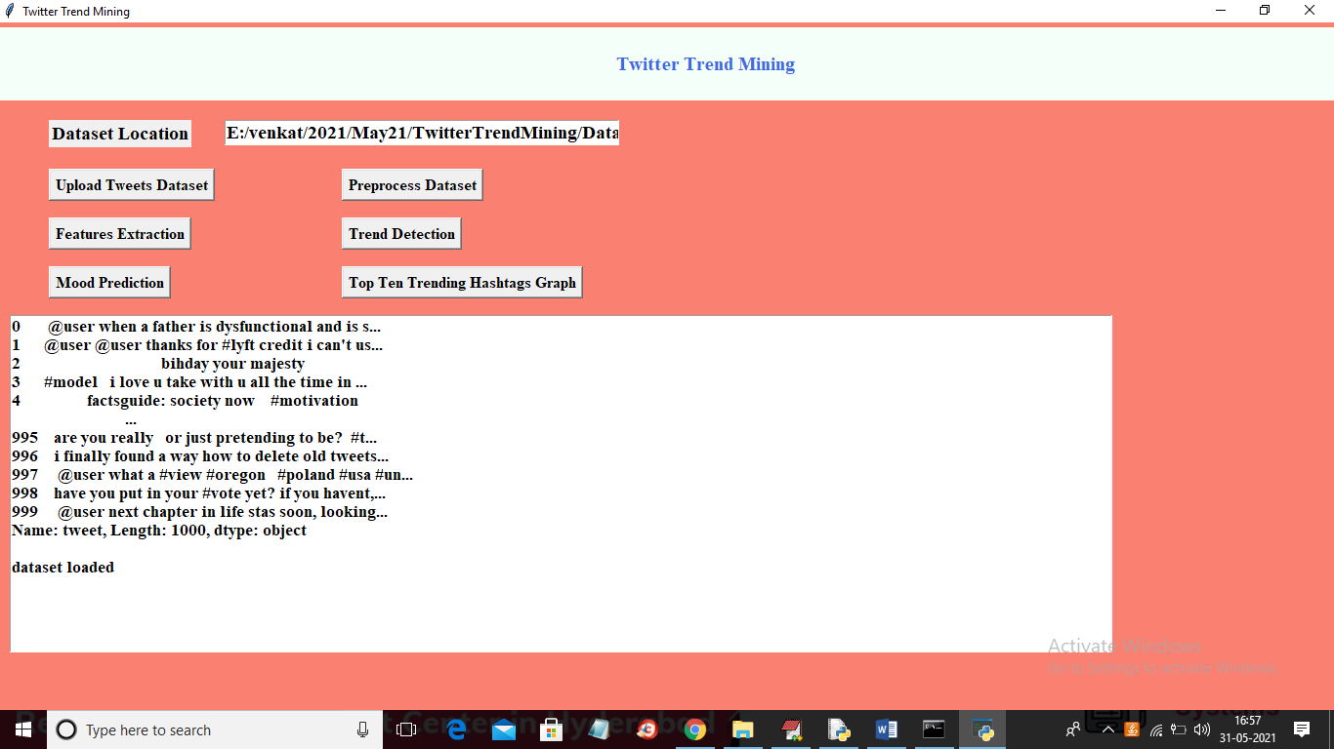

In above screen dataset loaded and I am displaying few tweets and we can see tweets contains special symbols and stop words so click on ‘Preprocess Dataset’ button to clean it

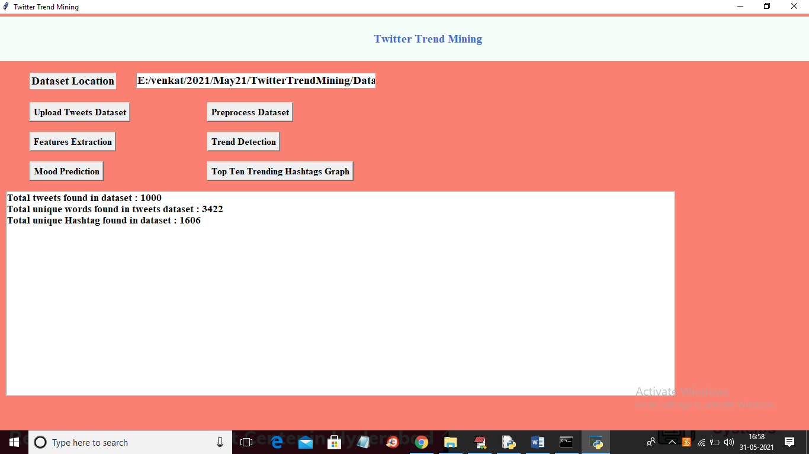

In above screen we can see dataset contains 1000 tweets and total words are 3422 and total hash tags are 1606 and now click on ‘Features Extraction’ button to find frequency of each words and hash tag

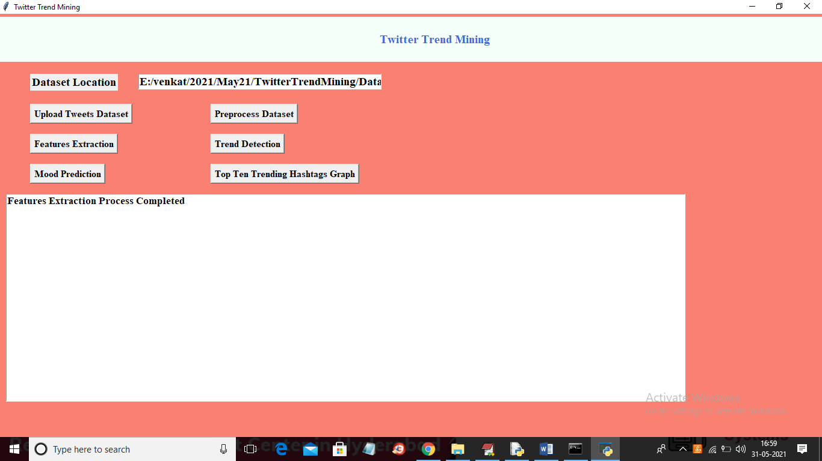

In above screen features extraction process completed and now click on ‘Trend Detection’ button to get weight of each hash tag and words

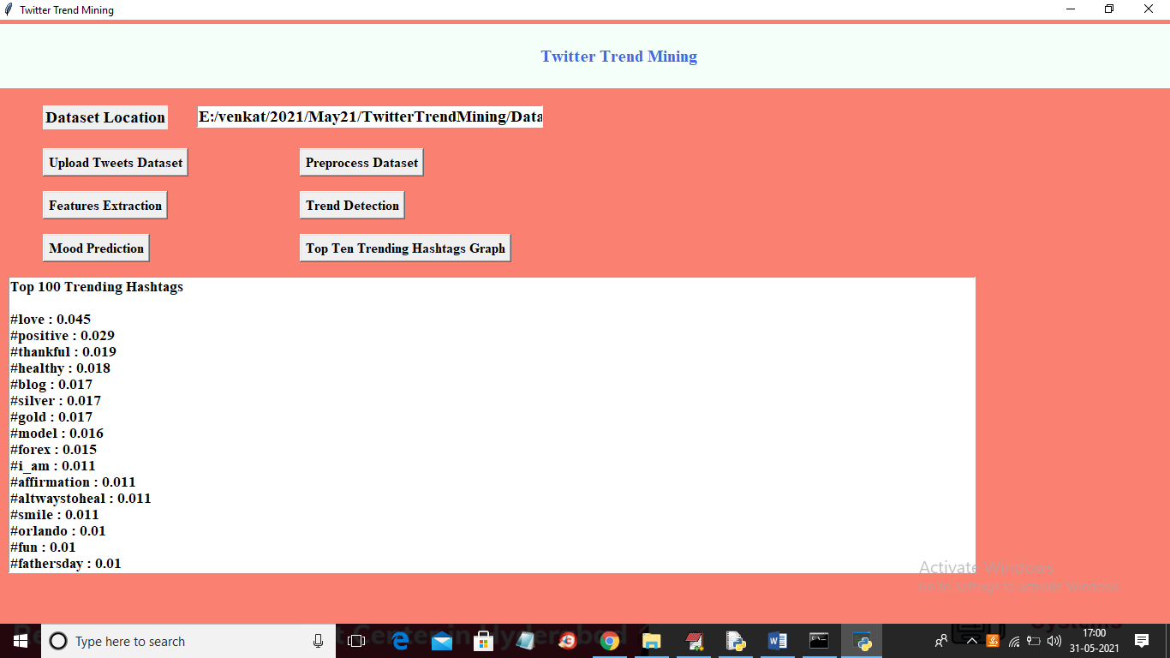

In above screen displaying hash tag from high to low weight and scroll down above text area to see top frequent words

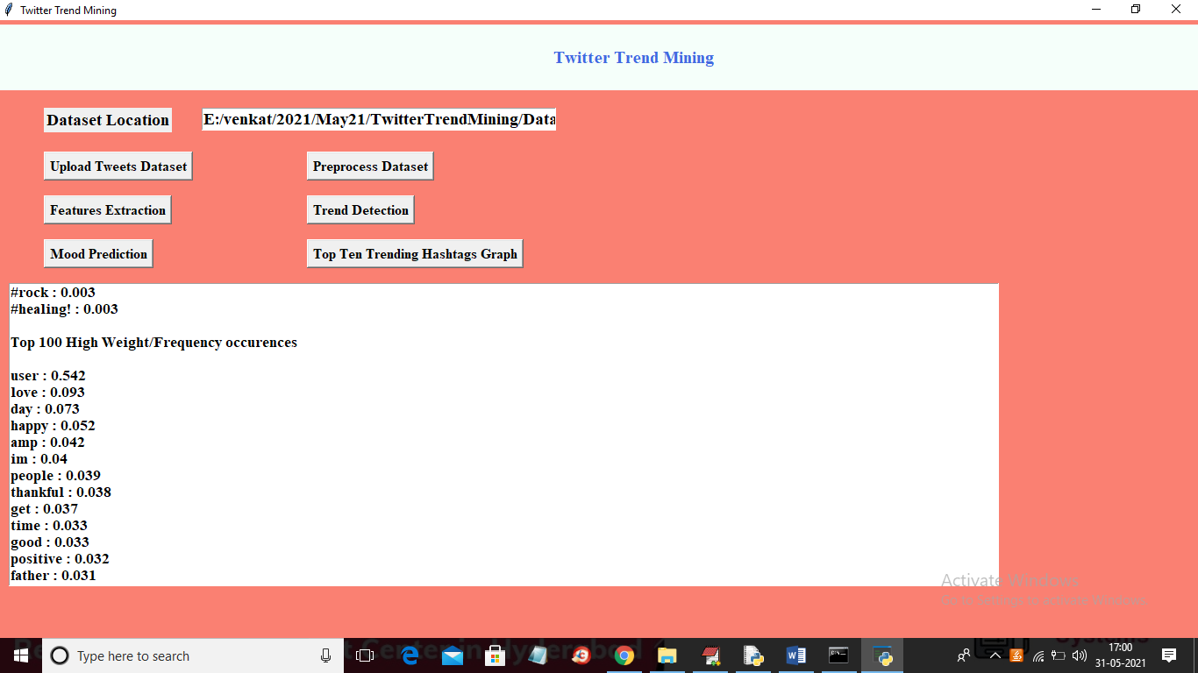

In above screen we can see top 100 high frequency words from high to low weight and now click on ‘Mood Prediction’ button to calculate sentiment from each tweet

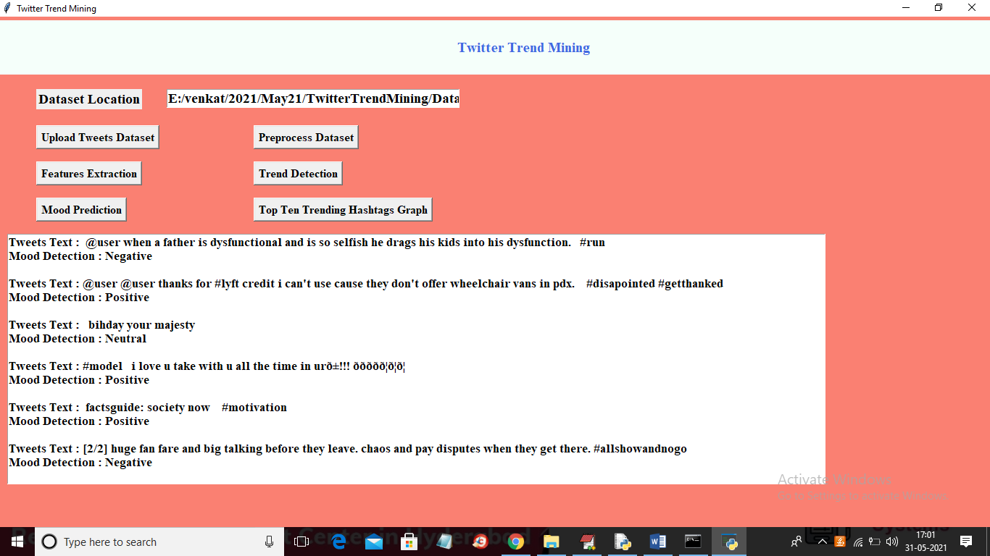

In above screen for each we are calculating mood detection and you can scroll down above text area to view all tweets and mood. Now click on ‘Top Ten Trending Hashtags Graph’ button to get below graph

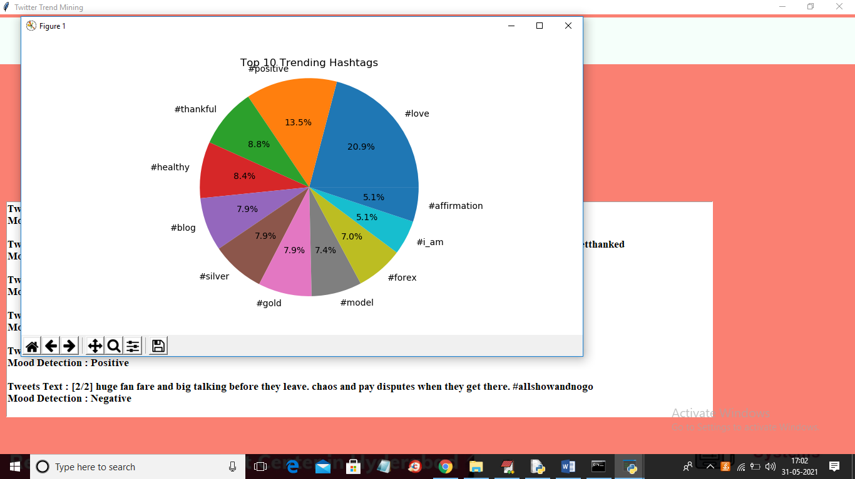

In above pie chart we can see hashtag and its trending percentage