Introduction
Since the huge success of the DeepMind presentation [Dee19] of AlphaStar in 2019, StarCraft2 has been a stable testing ground for advanced reinforcement learning algorithms due to its high complexity and the public api [VEB17]. StarCraft2 is a hard game for a reinforcement learning agent to master. Games often have upwards of 50000 actions done therefore creating a sparse reward setting. Additionally, a big part of the game is anticipating the opponents moves while having imperfect information. Together with a large action space of around 10⁸ possible actions [VEB17] an agent will need a lot of training and many smart adaptations to prevail in a full game of StarCraft2.

StarCraft2 general terminology
Starcraft2 is a real time strategy game that is usually played in a 1 vs 1 setting. A player selects one of three races at the beginning of the game and tries to destroy every building of their opponent. The necessary skillets to accomplish this can roughly be separated into two categories “macro” and “micro”.
The macro aspect contains the building infrastructure (workers to mine more in-game resources, more buildings and upgrades) or building units designed to attack the opponent. To master the macro aspect of StarCraft2, the capability to plan ahead long term as well as the ability to adapt the own strategy on the fly to the opponents moves are crucially important.
The micro aspect describes the players ability to maneuver their own units, select high priority enemy units, attack, and retreat. The speed of someones micro is usually measured in actions per minute(apm).
While the macro aspect of the game has been more or less hard solved, as optimal build orders exists for at least 8 minutes for every match-up and composition, micro capabilities are nearly unlimited.

Motivation
Watching the deep-mind YouTube video [Dee19] back in 2019 was really impressive. A reinforcement learning agent for a game as complex and with as many steps as StarCraft2 could compete with professional players that earn hundreds of thousands of euros playing StarCraft2. A remarkable result. However, there was a big asterisk to their initial result. The agents did not outsmart their opponents, but rather beat them through micro. The agent leveraged its faster and more precise micro to beat the human while having severely worse macro. In a later version [VBC19] this issue was addressed and the current alpha-star variant were tested in the official StarCraft2 ladder, the games competitive, elo-driven gamemmode. The improved agents now have severe apm restrictions and have to use the in-game camera which levels the playing field between the humans and the agents.
Due to apparent difficulty of creating an agent that is good at macro, we chose a task within the pysc2 environment that favors fast precise actions over long term planning. We believed that it would be possible to create an agent that has reasonable chances to beat us mediocre StarCraft2 players in a micro competition. Similar to DeepMind [VEB17] we created a specific minigame for the agent to train in using the pysc2 map editor (see figure 3).

Task and Environment
We chose a micro task known in the sc2 community as “prism-juggling” [3]. The encounter includes the agent playing as the “Protoss” race (the selected units in figure 4) and a ingame-bot playing as the “Zerg” race (see top right units of figure 4). Crucially the agent has a flying unit which can pick up ground units, whereas the “Zerg”-bot has slow shooting units, which can only attack ground only units. Therefore any flying or picked up units of our agent are safe. Theoretically, it is possible for a “Protoss”-player in this situation to:
1. shoot
2. lift its own units to escape the slow shots from the opponent
3. drop down its own unit all without taking damage while damaging the opponent
Once mastered the agent should be able to defeat an unlimited amount of zerg-units in a row without taking damage. Possible additions increasing the difficulty of the task would be adding multiple Immortals that need to be managed as well as increasing the number of enemies giving less time to lift the Immortals. We left out these steps due to poor performance of the agent with only one Immortal, as described in section . The agent

4.1 Interaction with the environment:
Pysc2 follows the rules of typically gym environments, where the agents interact with the functions step, reset and an initialization function.
The initialization function for example defines number of players their respective races, screen resolution and game speed.
As the name implies the reset function, triggers the initialization script within the map-file thereby resetting score and timer and reviving all the units.
The step function works differently from different from normal gym environments. After passing an action id, additional arguments are required. The arguments differ in size shape and type making the action space very complex.
0/no_op()
1/move_camera(1/minimap [64, 64])
2/select_point(6/select_point_act4];
0/screen [84, 84])
3/select_rect(7/select_add [2]; 0/screen [84, 84]; 2/screen2 [84, 84])
The can be actions like 0/no_op that accept no arguments at all while arguments 1/move_camera need additional location for where to move the camera. Actions like 2/select_point can only be executed after certain other actions.

Implementation
Due to overall success of Proximal Policy Optimization (PPO) [4] in many different application fields, fast training times, and good generalization capabilities we decided to use PPO as our training algorithm.
Our implementation on this pseudo-code (figure 1).
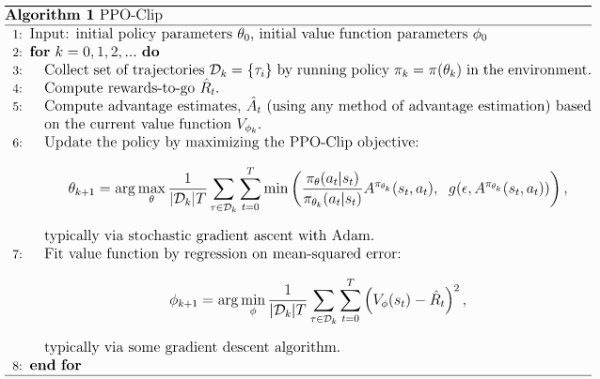Figure 1: Pseudocode PPO
After the setup of the environment the training process repeats for a given amount of episodes.
Next we need to collect a predefined amount of trajectories through our environment by sampling over the training policy parameterized with the initial training policy parameters. Notably the environment restarts after a maximum of 120 steps or the death of all “Protoss” ground units. This ensures that the samples always have relevance and agents that refuse to fight do not take up so much time during training.
Following the collection of the rewards, the advantage for each step is calculated from the rewards from each step and the output of the value function for this step as seen here.
TODO code hierfür einfügen

While updating the policy the new policy θ needs to stay within θ_{old} +- ε . This ensures that the policy updates are not too big. To achieve this the new policy gets clipped after

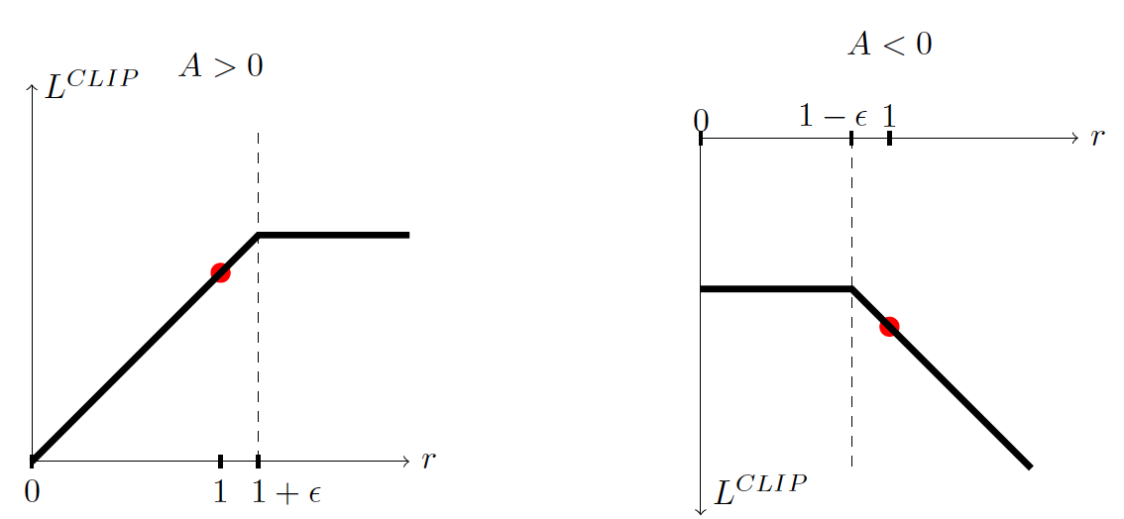Figure 2: Policy Update Clipping

Results and Discussion
We have different ideas why our training might have failed, but did not come around to test all of them.
First, the agent did not learn due to a faulty implementation of PPO and wrong interaction with the environment. It is possible, that during the implementation the PPO algorithm is feed wrong observations or selects the wrong action due to the separation of spatial and non spatial actions. The interaction proved to be more complicated then anticipated and the documentation for example about the games feature layers that completely bloat the observation space are almost non existent.
This is also part of the next possible reason why the agent did not learn the desired behavior. The observation- and action-space, despite massive downscaling through omitting invalid actions and removing feature layers with useless information for the task at hand as seen in section 5, is still too large and convergence might just takes more time.

Bibliography
Dee19: DeepMind, AlphaStar: The inside story, 2019, https://www.youtube.com/watch?v=UuhECwm31dM
VEB17: Vinyals et al., StarCraft II: A New Challenge forReinforcement Learning, 2017, arXiv:1708.04782
VBC19: Vinyals et al., Grandmaster level in StarCraft II using multi-agent reinforcement learning, 2019, https://www.nature.com/articles/s41586-019-1724-z

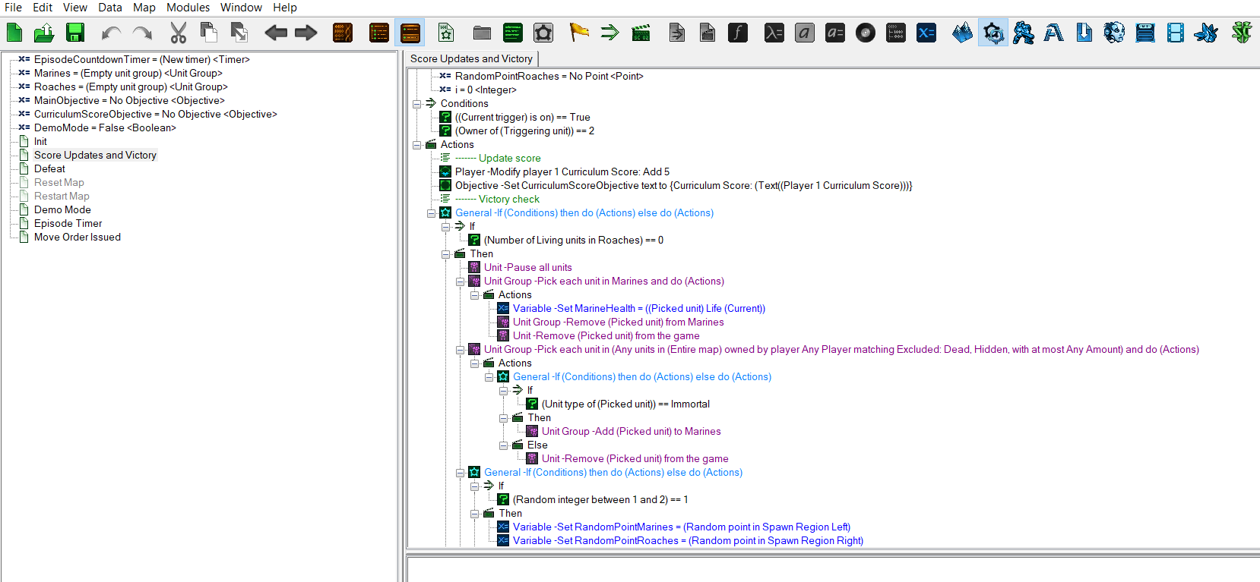Figure 3: Sc2Map-Editor Example
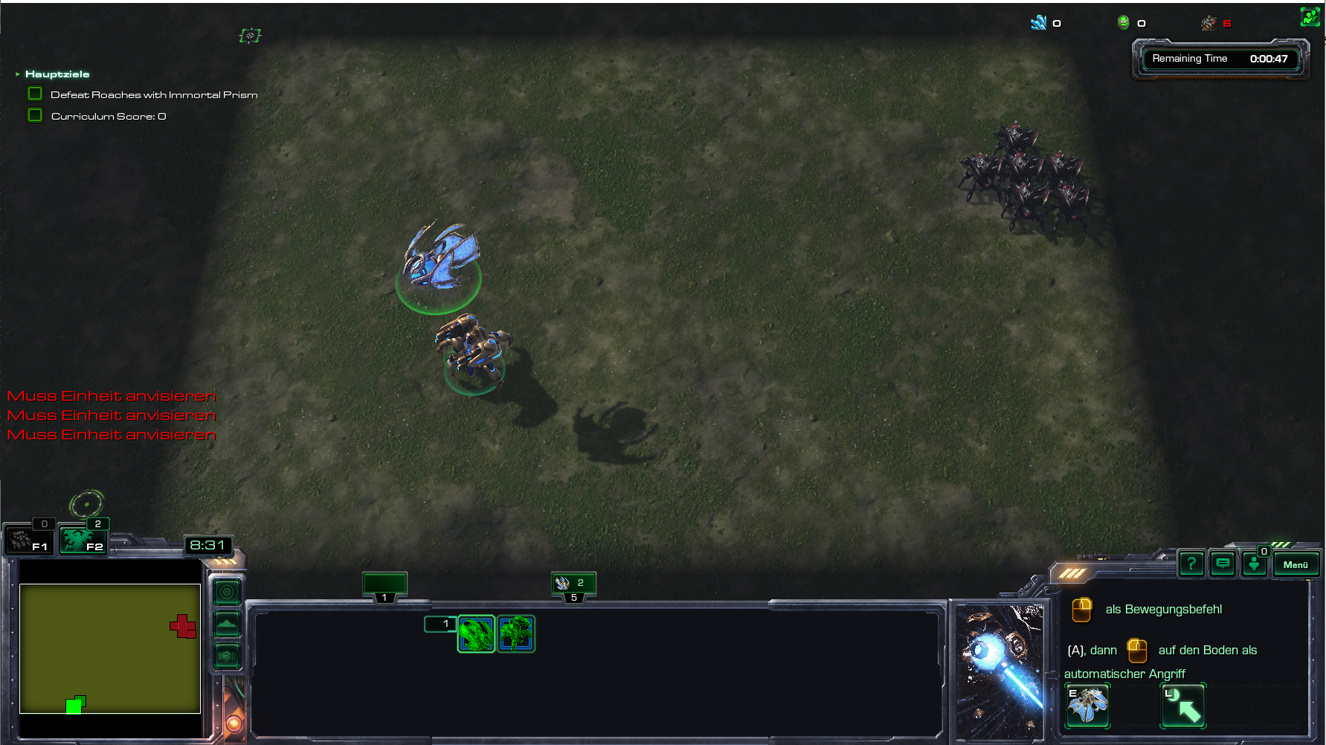Figure 4: Custom Minigame for Prism Micro

