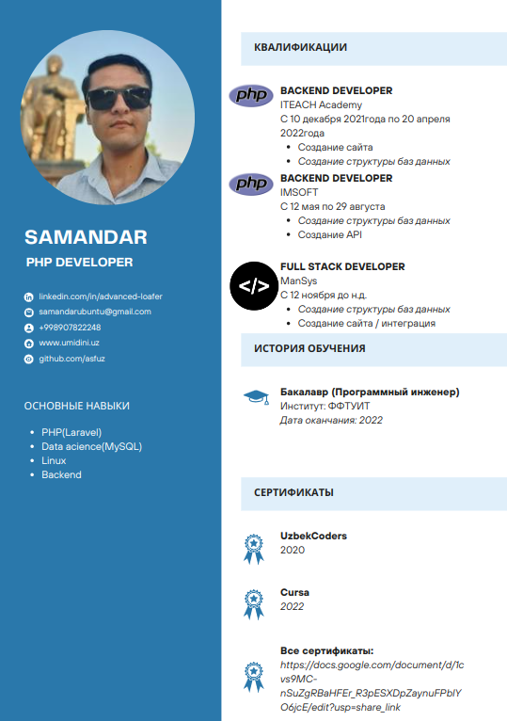

**Abduraxmonov Samandar**

**<https://www.canva.com/design/DAFVkEfN_TY/mXWtZ6mJEoddL1w4u6KzrA/edit>**