**Практическая работа № 15**

**Инструкция по дизайну интерфейса. Создание качественного интерфейса.**

**Цель работы**: разработка итогового дизайна пользовательского интерфейса приложения. Создание качественного интерфейса.

Страница наши гиды

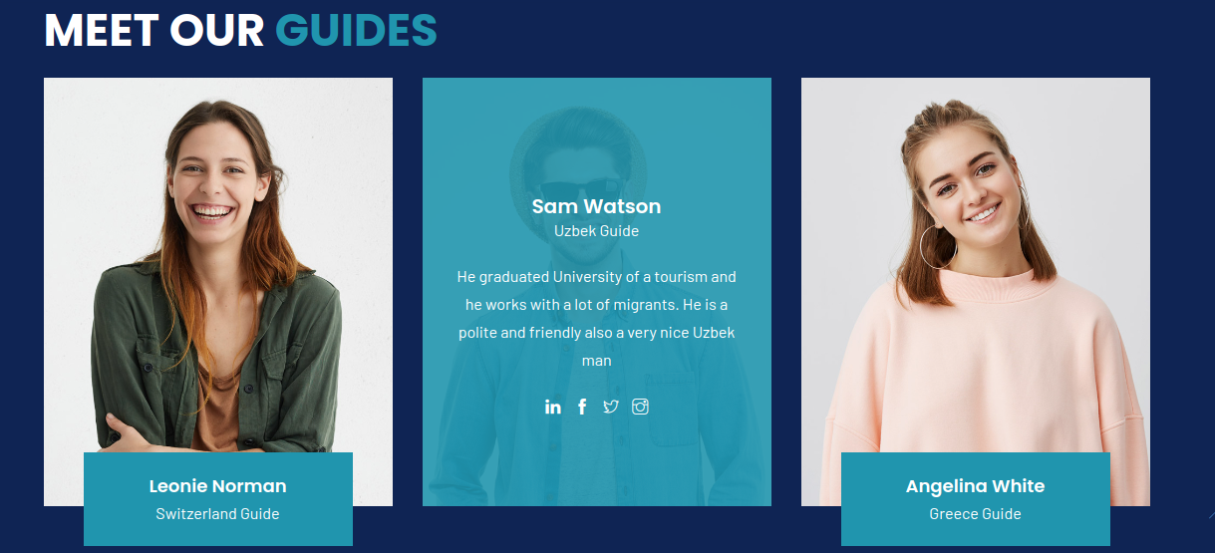

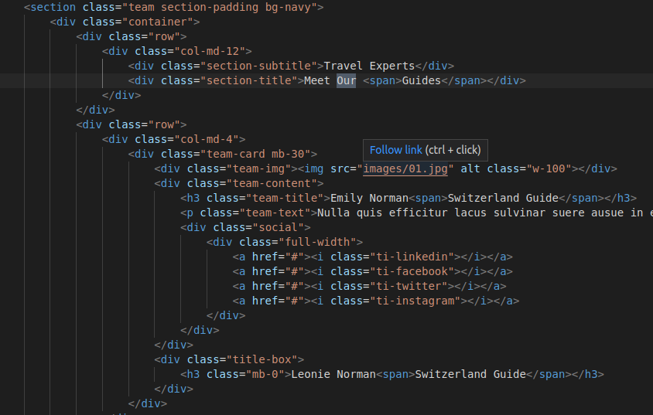

Страница путешествие

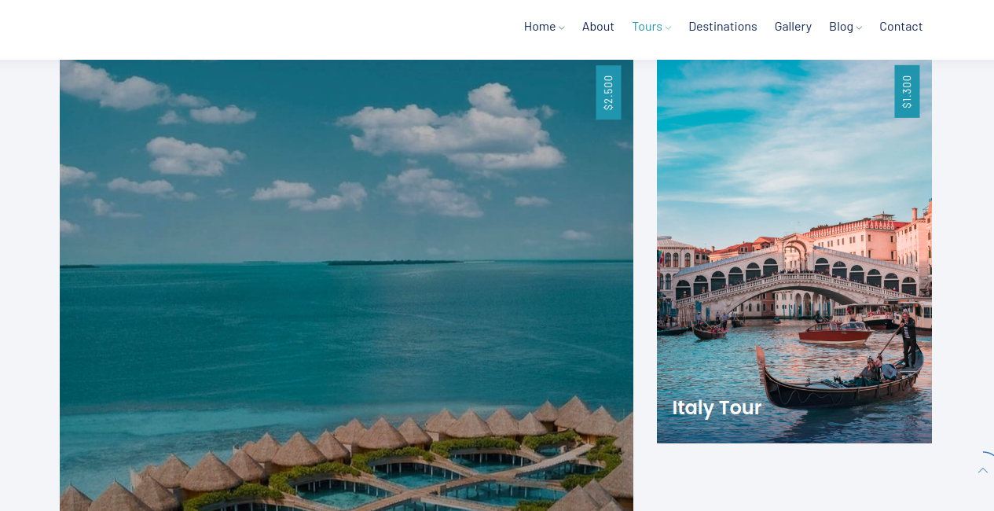

<section class="tours1 section-padding bg-lightnav" data-scroll-index="1">

<div class="container">

<div class="row">

<div class="col-md-12">

<div class="section-subtitle"><span>Choose your place</span></div>

<div class="section-title">Popular <span>Tours</span></div>

</div>

</div>

<div class="row">

<div class="col-md-8">

<div class="item">

<div class="position-re o-hidden"> <img src="images/maldives1.jpg" alt> </div> <span class="category"><a href="#0">$2.500</a></span>

<div class="con">

<div class="rating"> <i class="star active"></i> <i class="star active"></i> <i class="star active"></i> <i class="star active"></i> <i class="star"></i>

<div class="reviews-count">(2 Reviews)</div>

</div>

<h5><a href="tour-details.html">Maldives Tour</a></h5>

<div class="line"></div>

<div class="row facilities">

<div class="col col-md-12">

<ul>

<li><i class="ti-time"></i> 10 Days</li>

<li><i class="ti-user"></i> 12+</li>

<li><i class="ti-location-pin"></i> Maldives</li>

</ul>

</div>

</div>

</div>

</div>

</div>

<div class="col-md-4">

<div class="item">

<div class="position-re o-hidden"><img src="images/italy1.jpg" alt></div> <span class="category"><a href="#0">$1.300</a></span>

<div class="con">

<h5><a href="tour-details.html">Italy Tour</a> </h5>

<div class="line"></div>

<div class="row facilities">

<div class="col col-md-12">

<ul>

<li><i class="ti-time"></i> 6 Days</li>

<li><i class="ti-user"></i> 10+</li>

<li><i class="ti-location-pin"></i> Italy</li>

</ul>

</div>

</div>

</div>

</div>

</div>

<div class="col-md-4">

<div class="item">

<div class="position-re o-hidden"><img src="images/france1.jpg" alt></div> <span class="category"><a href="#0">$400</a></span>

<div class="con">

<h5><a href="tour-details.html">France Tour</a> </h5>

<div class="line"></div>

<div class="row facilities">

<div class="col col-md-12">

<ul>

<li><i class="ti-time"></i> 10 Days</li>

<li><i class="ti-user"></i> 6+</li>

<li><i class="ti-location-pin"></i> France</li>

</ul>

</div>

</div>

</div>

</div>

</div>

<div class="col-md-4">

<div class="item">

<div class="position-re o-hidden"><img src="images/greece1.jpg" alt></div> <span class="category"><a href="#">$500</a></span>

<div class="con">

<h5><a href="tour-details.html">Greece Tour</a> </h5>

<div class="line"></div>

<div class="row facilities">

<div class="col col-md-12">

<ul>

<li><i class="ti-time"></i> 10 Days</li>

<li><i class="ti-user"></i> 12+</li>

<li><i class="ti-location-pin"></i> Greece</li>

</ul>

</div>

</div>

</div>

</div>

</div>

<div class="col-md-4">

<div class="item">

<div class="position-re o-hidden"><img src="images/canada1.jpg" alt></div> <span class="category"><a href="#0">$300</a></span>

<div class="con">

<h5><a href="tour-details.html">Canada Tour</a></h5>

<div class="line"></div>

<div class="row facilities">

<div class="col col-md-12">

<ul>

<li><i class="ti-time"></i> 7 Days</li>

<li><i class="ti-user"></i> 10+</li>

<li><i class="ti-location-pin"></i> Canada</li>

</ul>

</div>

</div>

</div>

</div>

</div>

</div>

</div>

</section>

Основнаые css стили

.tours1 .item,

.destination1 .item {

position: relative;

overflow: hidden;

margin-bottom: 30px;

}

.tours1 .item:hover img,

.destination1 .item:hover img {

-webkit-filter: none;

filter: none;

-webkit-transform: scale(1.09, 1.09);

transform: scale(1.09, 1.09);

-webkit-filter: brightness(70%);

-webkit-transition: all 1s ease;

-moz-transition: all 1s ease;

-o-transition: all 1s ease;

-ms-transition: all 1s ease;

transition: all 1s ease;

}

.tours1 .item:hover .con,

.destination1 .item:hover .con {

bottom: 0;

}

.tours1 .item img,

.destination1 .item img {

-webkit-transition: all .5s;

transition: all .5s;

}

.tours1 .item .category,

.destination1 .item .category {

position: absolute;

top: 15px;

right: 15px;

z-index: 3;

writing-mode: vertical-rl;

-ms-transform: rotate(180deg);

-o-transform: rotate(180deg);

-moz-transform: rotate(180deg);

-webkit-transform: rotate(180deg);

transform: rotate(180deg);

text-orientation: mixed;

color: #fff;

font-size: 13px;

font-weight: 400;

letter-spacing: 1px;

font-family: 'Barlow', sans-serif;

padding: 12px 6px;

line-height: 1.5em;

text-transform: uppercase;

box-shadow: 0px 0px 35px 0px rgb(0 0 0 / 5%);

background: #2095AE;

}

.tours1 .item .category a,

.destination1 .item .category a {

color: #fff;

}

.tours1 .item .category:hover,

.destination1 .item .category:hover {

color: #fff;

}

.tours1 .item .con,

.destination1 .item .con {

padding: 20px;

position: absolute;

bottom: -45px;

left: 0;

width: 100%;

-webkit-transition: all .3s;

transition: all .3s;

text-align: left;

z-index: 20;

height: auto;

box-sizing: border-box;

background: -moz-linear-gradient(top, transparent 0, rgba(15, 36, 84, .1) 2%, rgba(15, 36, 84, .75) 90%);

background: -webkit-linear-gradient(top, transparent 0, rgba(15, 36, 84, .01) 2%, rgba(15, 36, 84, .75) 90%);

background: linear-gradient(to bottom, transparent 0, rgba(15, 36, 84, .01) 2%, rgba(15, 36, 84, .75) 90%);

}

.tours1 .item .con h6,

.tours1 .item .con h6 a,

.destination1 .item .con h6,

.destination1 .item .con h6 a {

position: relative;

color: #fff;

font-size: 13px;

font-family: 'Barlow', sans-serif;

display: inline;

}

.tours1 .item .con h6 i,

.destination1.item .con h6 i {

font-size: 6px;

margin-right: 2px;

}

.tours1 .item .con h5,

.tours1 .item .con h5 a,

.destination1 .item .con h5,

.destination1 .item .con h5 a {

position: relative;

color: #fff;

font-size: 24px;

font-weight: 600;

margin-top: 0px;

margin-bottom: 10px;

}

.tours1 .item .con p,

.destination1 .item .con p {

color: #fff;

font-size: 14px;

margin-bottom: 0px;

}

.tours1 .item .con span,

.destination1 .item .con span {

color: #fff;

font-size: 10px;

}

.tours1 .item .con i,

.destination1 .item .con i {

color: #fff;

}

.tours1 .item .con i:hover,

.destination1 .item .con i:hover {

color: #fff;

}

.tours1 .item .con .butn-light,

.destination1 .item .con .butn-light {

margin-left: 0;

border-radius: 30px;

border-color: #676977;

padding: 11px 30px;

}

.tours1 .item .con .butn-light:hover,

.destination1 .item .con .butn-light:hover {

border-color: #2095AE;

}

/* line animation */

.tours1 .item .line,

.destination1 .item .line {

text-align: center;

height: 1px;

width: 60px;

background-color: rgba(255, 255, 255, 0.2);

transition-property: all;

transition-duration: 0.3s;

transition-timing-function: ease-in-out;

margin: auto 0 20px;

}

.tours1 .item:hover .line,

.destination1 .item:hover .line {

width: 100%;

transition-property: all;

transition-duration: 0.8s;

transition-timing-function: ease-in-out;

}

/* facilities */

.tours1 .facilities ul,

.destination1 .facilities ul {

margin: 0;

padding: 0;

list-style: none;

}

.destination1 .facilities ul li,

.tours1 .facilities ul li {

color: #fff;

font-size: 14px;

line-height: 1.2em;

padding-bottom: 0px;

float: left;

margin-right: 10px;

padding-top: 7px;

}

.destination1 .facilities ul li:last-of-type,

.tours1 .facilities ul li:last-of-type {

margin-right: 0px;

}

.destination1 .facilities ul li i,

.tours1 .facilities ul li i {

font-size: 14px;

margin-right: 1px;

}

Страница контакта

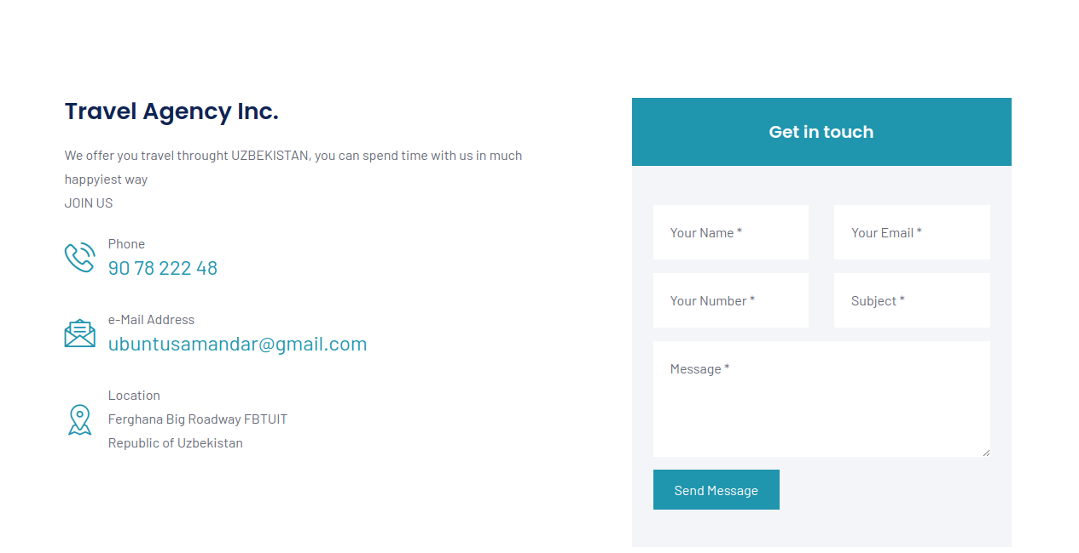

<div class="row mb-90">

<div class="col-md-6 mb-60">

<h3>Travel Agency Inc.</h3>

<p>We offer you travel throught UZBEKISTAN, you can spend time with us in much happyiest way <br>

JOIN US</p>

<div class="phone-call mb-30">

<div class="icon"><span class="flaticon-phone-call"></span></div>

<div class="text">

<p>Phone</p> <a href="tel:998907822248">90 78 222 48</a>

</div>

</div>

<div class="phone-call mb-30">

<div class="icon"><span class="flaticon-message"></span></div>

<div class="text">

<p>e-Mail Address</p> <a href="mailto:ubuntusamandar@gmail.com">ubuntusamandar@gmail.com</a>

</div>

</div>

<div class="phone-call">

<div class="icon"><span class="flaticon-placeholder"></span></div>

<div class="text">

<p>Location</p> Ferghana Big Roadway FBTUIT

<br>Republic of Uzbekistan

</div>

</div>

</div>

<div class="col-md-5 mb-30 offset-md-1">

<div class="sidebar">

<div class="right-sidebar">

<div class="right-sidebar item">

<h2>Get in touch</h2>

<form method="post" class="right-sidebar item-form contact__form" action="mail.php">

<div class="row">

<div class="col-12">

<div class="alert alert-success contact__msg" style="display: none" role="alert"> Your message was sent successfully. </div>

</div>

</div>

<div class="row">

<div class="col-md-6 form-group">

<input name="name" type="text" placeholder="Your Name *" required>

</div>

<div class="col-md-6 form-group">

<input name="email" type="email" placeholder="Your Email *" required>

</div>

<div class="col-md-6 form-group">

<input name="phone" type="text" placeholder="Your Number *" required>

</div>

<div class="col-md-6 form-group">

<input name="subject" type="text" placeholder="Subject *" required>

</div>

<div class="col-md-12 form-group">

<textarea name="message" id="message" cols="30" rows="4" placeholder="Message *" required></textarea>

</div>

<div class="col-md-12">

<button class="butn-dark"><a href="#0"><span>Send Message</span></a></button>

</div>

</div>

</form>

</div>

</div>

</div>

</div>

</div>

Полный проект доступен по ссылке: <https://umidini.uz/air>